Wingfield Swivel Counter Stools - MT104-0185: Remove the squeaking noise.
Step 1: Use the L-shaped hex key to remove the bolt at the bottom.
(Please refer to the attached video for reference.)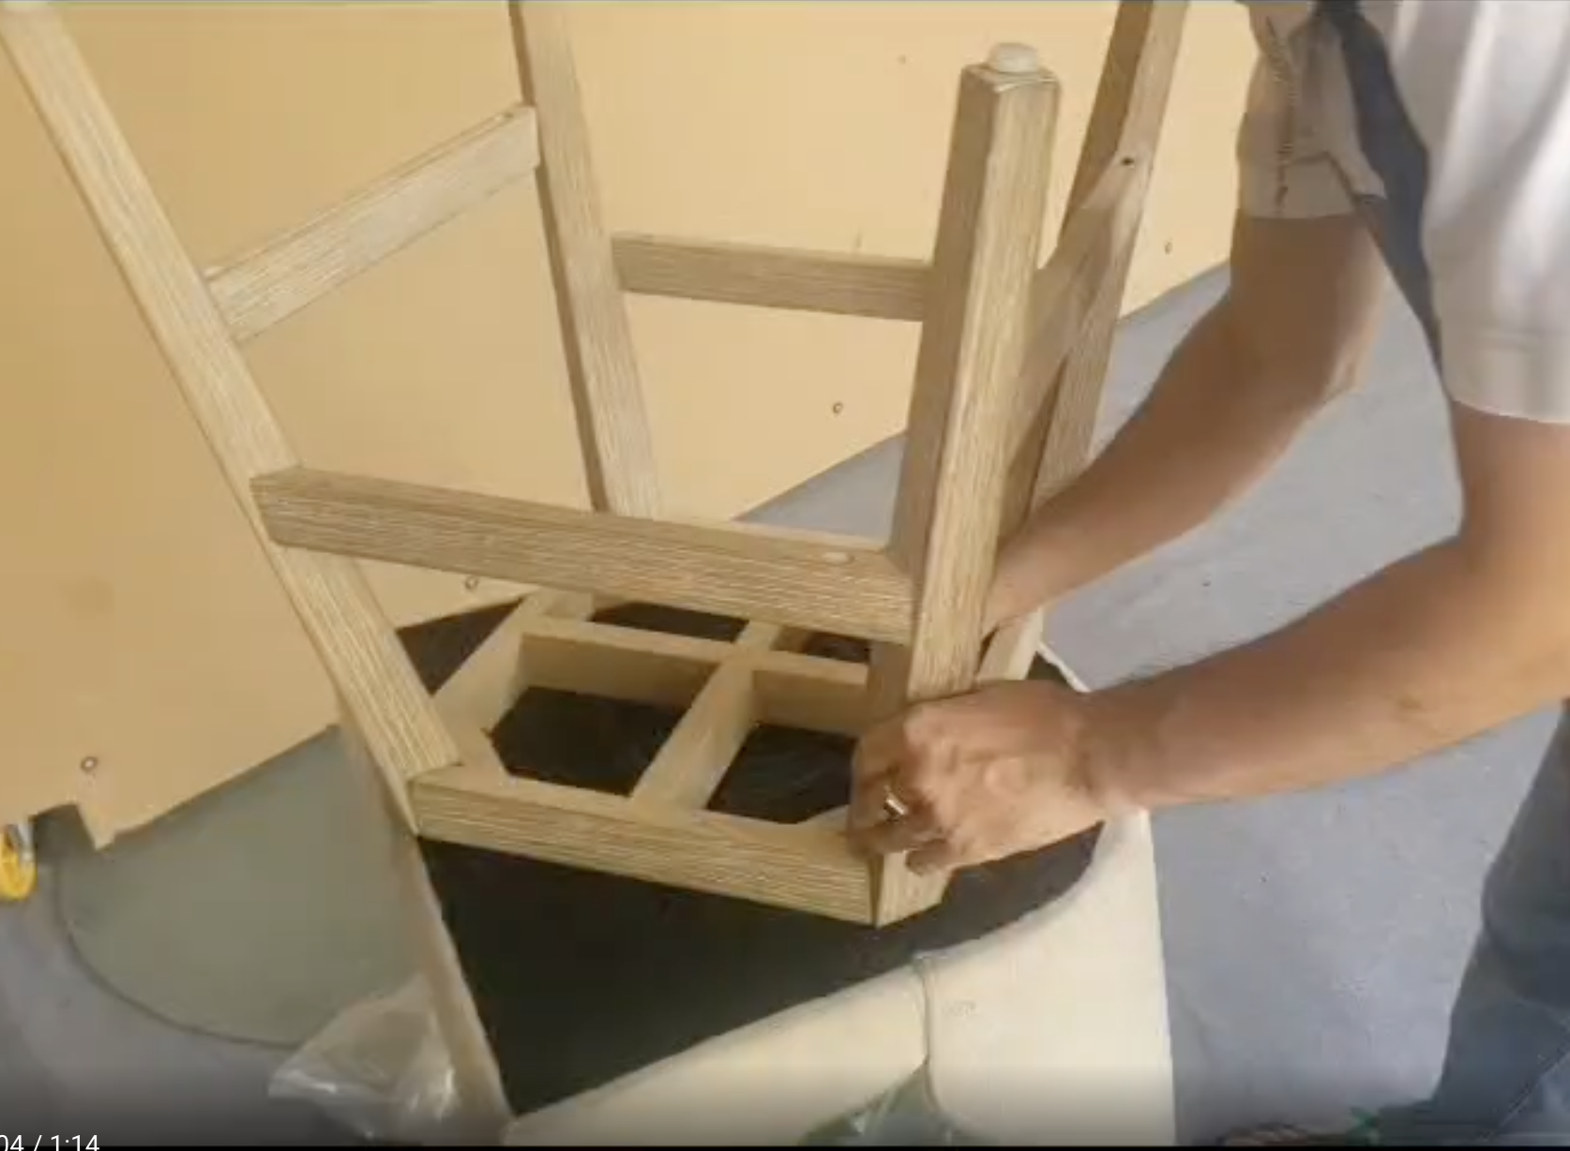
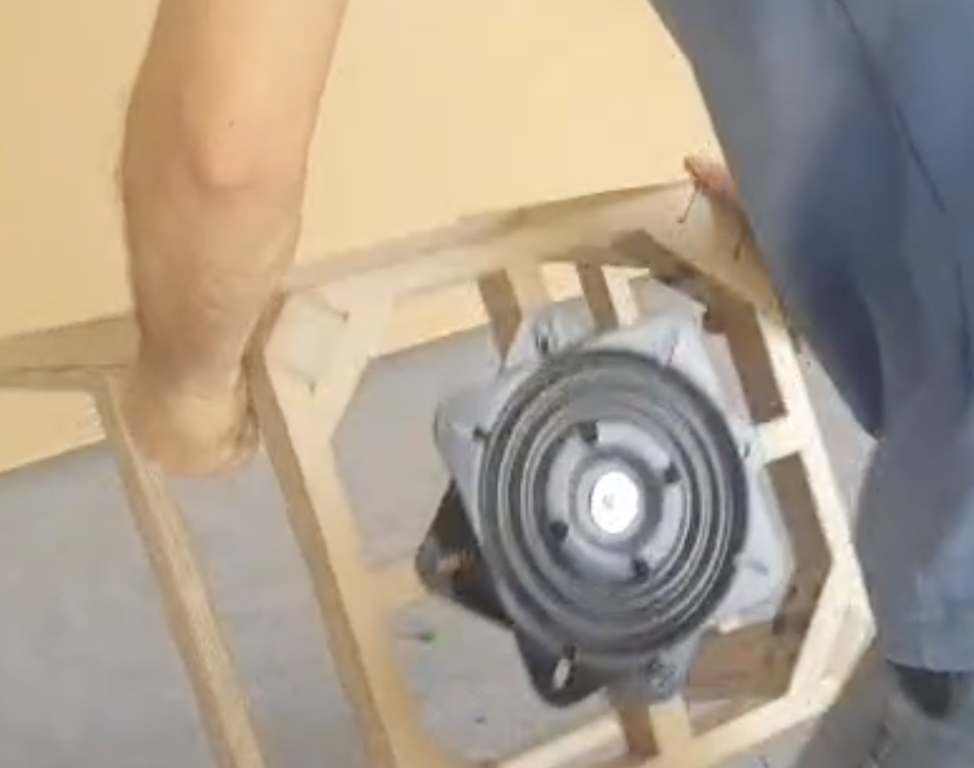

Step 2: Use WD-40 Lubricates apply to the ball bearing area inside the swivel mechanism, rotate it a few times, then reassemble the chair base. This should help reduce the squeaking noise.
Note: Please lay a cloth or paper on the floor and carpet in advance to prevent them from getting dirty during Lubricant filling operation.
