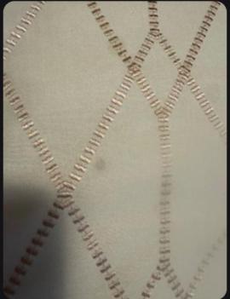
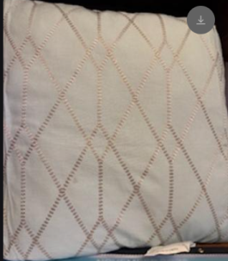
Comforter with Throw Pillows ordered from Kohls.com, received 11/10/25. One pillow has a stain (possibly oil?).

NOTE: Stain is much more noticeable in person. The photos minimize the appearance of the stain.

