View order details
- Order date
Oct 9, 2024
Order #
112-0516577-7061817
Order total
$33.16 (1 item)

Delivered October 11
Your package was left near the front door or porch.
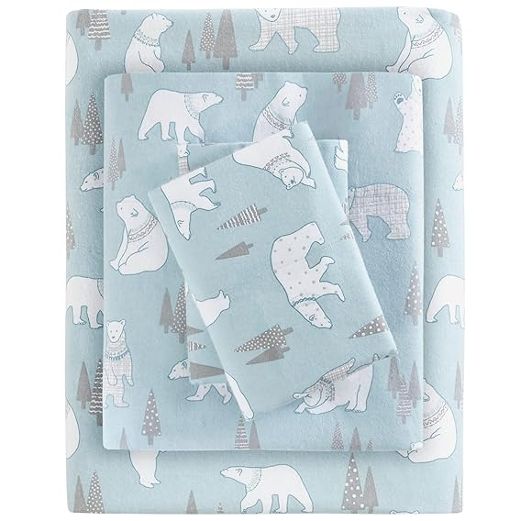
Sleep Philosophy True North Cozy Flannel Warm 100% Cotton Sheet - Novelty Print Animals Stars Cute Ultra Soft Cold Weather Bedding Set, Queen, Blue Polar Bears 4 PieceSleep Philosophy True North Cozy Flannel Warm 100% Cotton S…
Sold by: Amazon.com
Return window closed on November 10, 2024
$41.99

Get product support

Buy it again

Track package

Write a product review

Payment information
Payment method
  - Amazon Visa ending in 3795
  - Earns 5% back

Earned 5% back with your Prime Visa.
See terms and conditions.

Shipping address
- Julie Keyes
66 BYWAY CIR
KILMARNOCK, VA 22482-3890
United States

Order Summary.
- Items: $41.99
Shipping & Handling:
$0.00
Your Coupon Savings
-$10.50
Total Before Tax:
$31.49
Estimated Tax Collected:
$1.67
Order Total
$33.16

Recommended for you based on Sleep Philosophy True

Nor...

