Signature named “C Cindy” matches signature named “SSPOHN”
Delivered on 8/26/2024
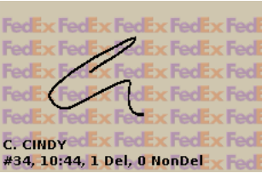
Delivered on 8/29/2024
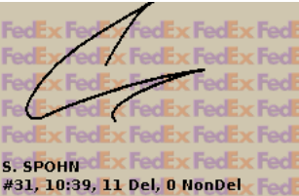

Delivered on 8/27/2024
