Order #6576321367
Sunday, July 28, 2024 at 9:29 AM Central Time

    Shipping to:
    (1 item)
    Gerald Matson
    16456 Chatham Dr
    Clinton Township, MI 48035
    586-530-4199
    Shipping Method
    Standard Ground
    Estimated Arrival
    AUG 01 - AUG 05

  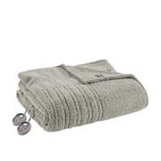
    True North Sherpa Electric Heated Blanket
    Color: Gray, Size: KING, Qty: 1
    SKU: #61873202
    REGULAR $199.99
    Your Price: $199.99

Billing Address:
Gerald Matson
16456 Chatham Dr
Clinton Township, MI 48035

Order Summary
Payment Method:
Kohl's Card x1201 | $158.99

Payment Total: | $158.99

Subtotal: | $199.99

Kohl's Cash & Promos:

SAVEMORE | - $50.00

Free Standard Shipping $49 | - $8.95

Shipping: | FREE

Taxes & Fees:

Sale Tax | $9.00

Order Total: | $158.99

