7/3/24 Sedgwick

E & E Co, Ltd, DBA Jla Home
45875 Northport Loop East
Fremont, CA 94538
Sheila.therrian@jlahome.com

Global General Insurance Services
1801 N California Blvd
Suite 103
Walnut Creek, CA 94596
rossana@globalgenins.com

Re: Insured: Penney OpCo LLC
Claimant: James Thompson
Incident Date: 6/25/24
Claim No.: 4A2406SS2LR-0001
Issuing Co.: National Union Fire Insurance Company of Pittsburgh, PA

To Whom It May Concern:

Sedgwick Claims Management Services, Inc. is the Third-Party Administrator for Penney OpCo LLC. We have been placed on notice of the above-referenced matter. This claim involves the Sweet Philosophy mattress topper. The clmt alleged the topper came without any plastic on the item when it arrived. Then when he used the item he found bed bugs.

The contact info for James is as follows.
James Thompson
713-669-9009
blacklaw_70@yahoo.com
Address is 2700 Westridge St, Apt 267, Houston, TX 77054

It is our position that your company owes JC Penney defense and indemnification for the claims arising out of your product. Our tender is based on the terms outlined in the Trading Partner Agreement.

We refer you to the terms outlined in the Agreement as related below:

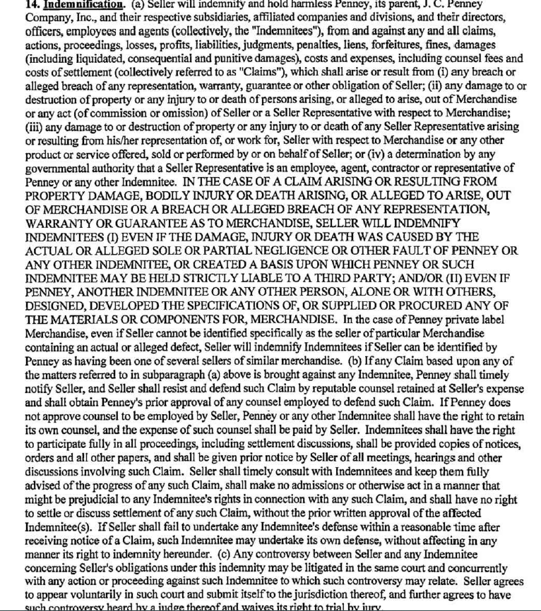



Based upon the terms mentioned in this Agreement, this letter will serve as our formal demand on behalf of JC Penney for E & E Co, Ltd, DBA Jla Home
to indemnify, hold harmless and defend it from any claims arising out of this incident. In addition, JC Penney demands all rights, coverages and privileges afforded to them as an additional insured under the E & E Co, Ltd, DBA Jla Home
product liability policy and/or whatever other policies may provide appropriate coverage.

Please immediately forward this letter to your applicable insurer(s) and then have them acknowledge receipt of this claim to the undersigned. Please make contact with the customer with your position on their claim.

Should you have any questions or wish to discuss this matter, I may be reached at 501-251-2328.

Sincerely,

Kelly Jesse
Claims Examiner
Kelly.jesse@sedgwick.com

