Expense PO Auto Voucher User Manual

Workflow.
- Please note, the Auto upload voucher function has NOT been turned on for now.
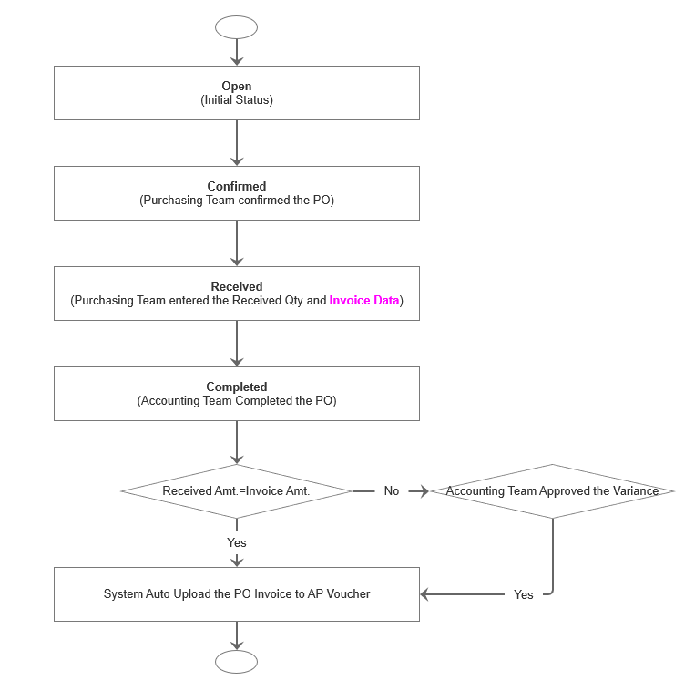

Maintain Cost Center for each Division/Location.
- Cost Center will be used to generate the AP Voucher.
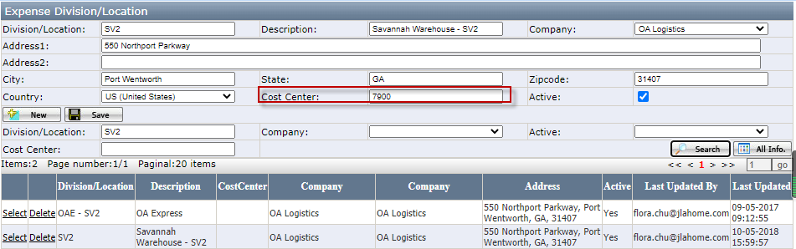

Maintain Vendor Item for Expense Item Master.
- Vendor Item No. is required in order to create Expense PO for related vendor.
- Select Item Master, then click Vendor Item button to add vendor item for related Vendor.
- Vendor Item No., Vendor Item Description and Unit Price is required.
- Vendor Item No. must be unique for the same vendor.
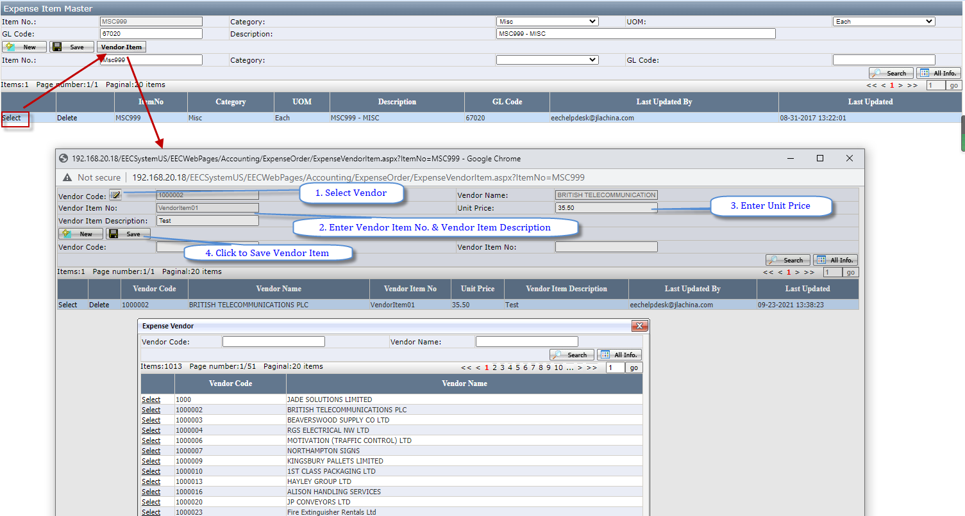

Add Vendor Item to Expense PO.
- System will only list items which has been created vendor item under selected vendor.
- User can enter item No. or Vendor Item No. when add items to expense PO, system will auto get related vendor item/item master data.
- Vendor Item No. & Vendor Item Description can be changed if it is not the data you wanted.
- For Vendors which does NOT have vendor item No, please enter NA as the vendor item No., then change it manually.
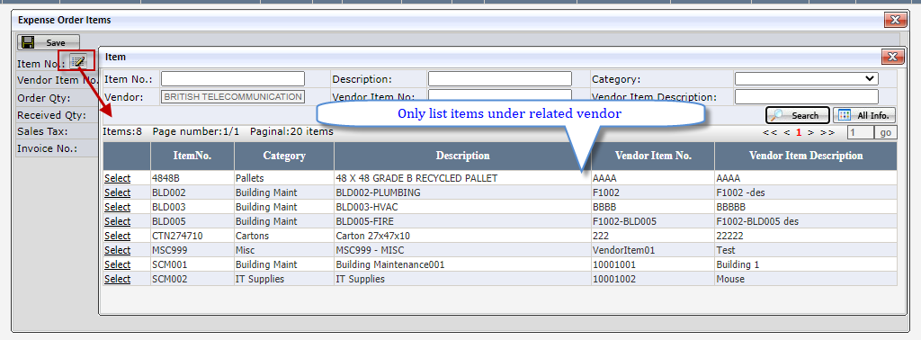
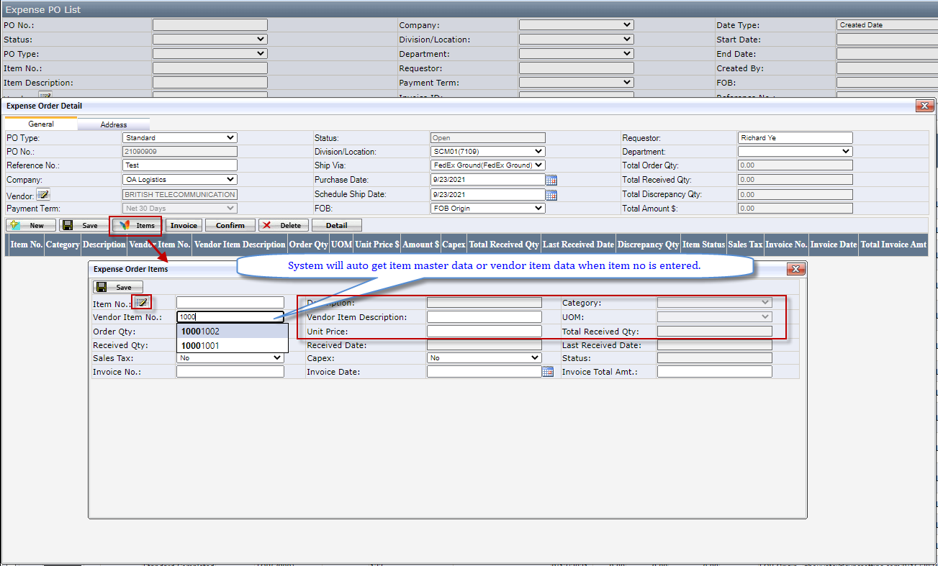

Enter Invoice Data after item is received.
- One PO can have multiple invoice, but one single line item can only have one invoice.
- User can select multiple items to enter invoice data or enter invoice data for each single item when enter received qty.
- Invoice Data is required when complete the PO.
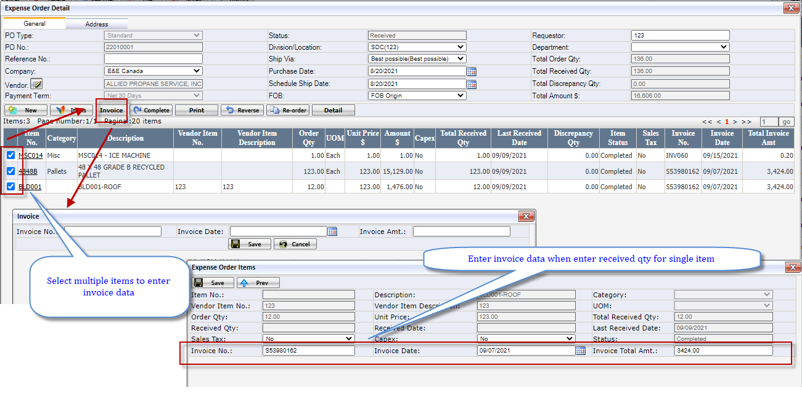
Approve Variance On Invoice Report.
- System will auto approve the invoice if Invoice Amt.=Invoice Received Amt. Otherwise Accounting team need to manually approve the Invoice on Expense PO Invoice Report.
- After the invoice is approved, system will auto upload the Invoice AP voucher to Macola. –This has not been turned on.
