Ecom Return

Background
Some Ecom customer will return pool stock products to our warehouse instead of DA deduction. To improve the efficiency of receiving, we created wireless App Ecom Return, the process include Offload->Sorting->Put Away.

How to Process the Ecom Return.
- Ecom team will create return order for Ecom customer which support Return Order on Return Order List page.
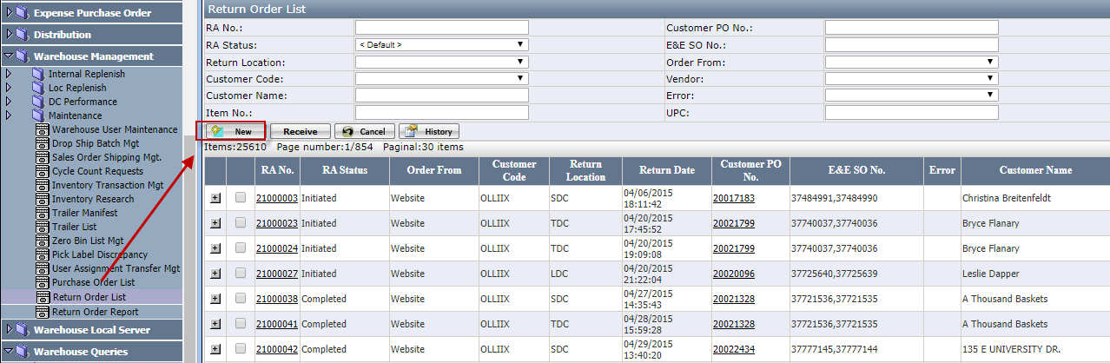

- How to process Offload.
- Open wireless app Warehouse Inventory Mgt and select icon Ecom Return, system will list return order in gird.
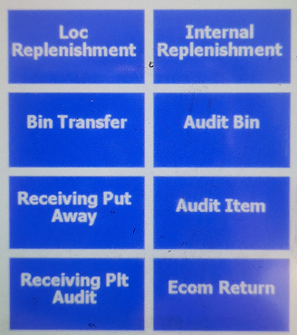

- Scan or click RA No to open offload item Form to offload return order.
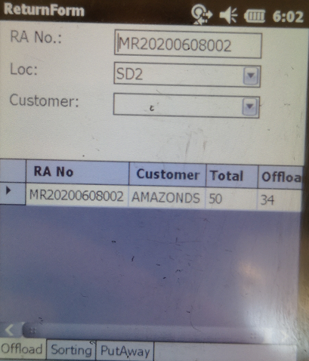

- If UOM =CA , offload item by scanning UPC or entering item no, system will offload item with case pack qty automatically.
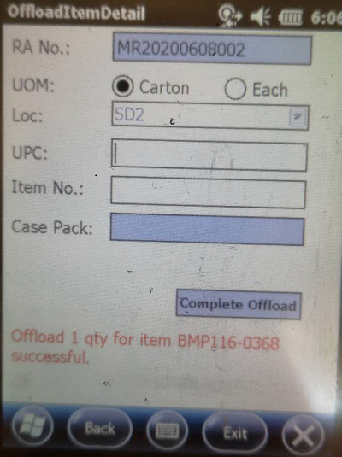

- If UOM = EA, offload item by qty, user need to enter qty and click OK button to finish the offload.
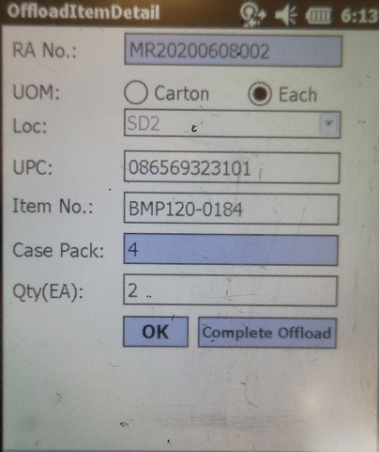
- Support to offload item even though item does not exist in RA order.
- Click Complete offload button to complete offload if all items are offloaded.

- How to process Sorting.
- Select Sorting tab, system will lists all the RAs which need to be sorted.
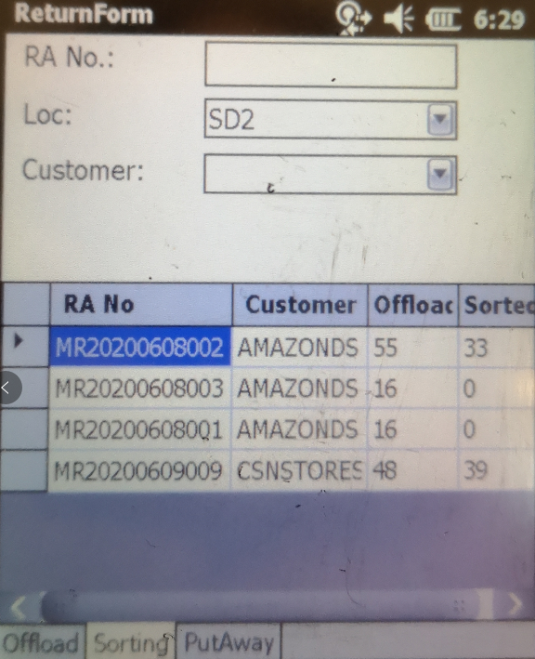

- Scan or click RA No to open Sorting Form to sort item.
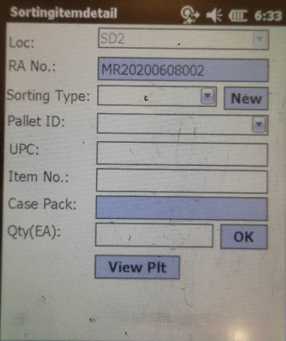

- Select sorting type and click new to generate pallet, system will auto print the return pallet label.
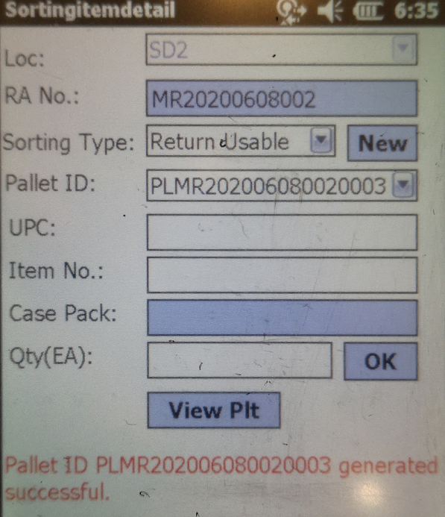

- Scan UPC or enter item, enter qty and click Ok to add the item to selected pallet.
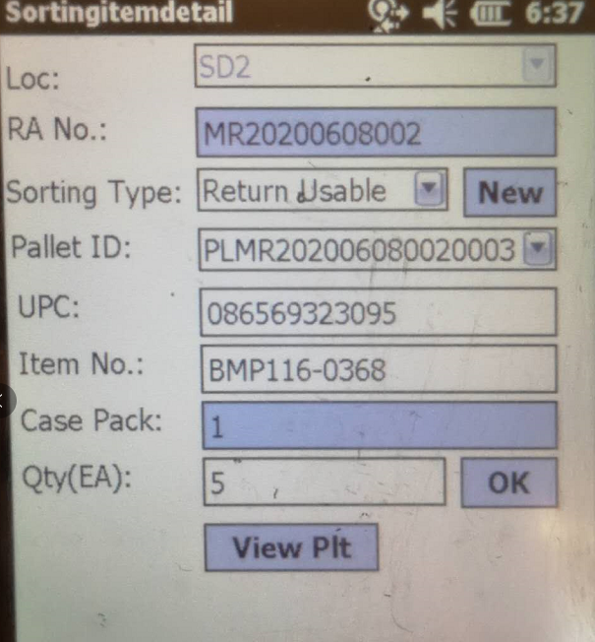

- Click View Plt button to view pallet detail. Allow to re-print pallet label on pallet detail tab.
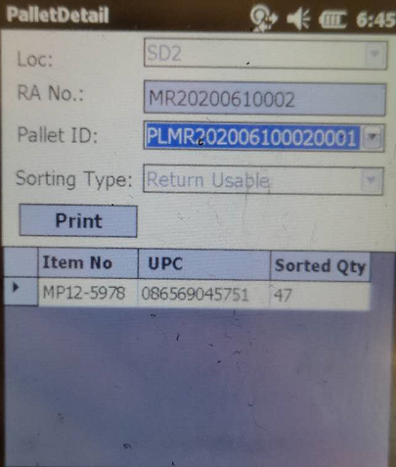

- How to process Put Away
- Scan pallet ID to start the Put Away.
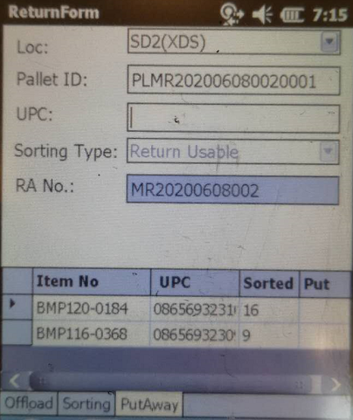

- Open put away detail Form by scanning UPC or click item on the grid.
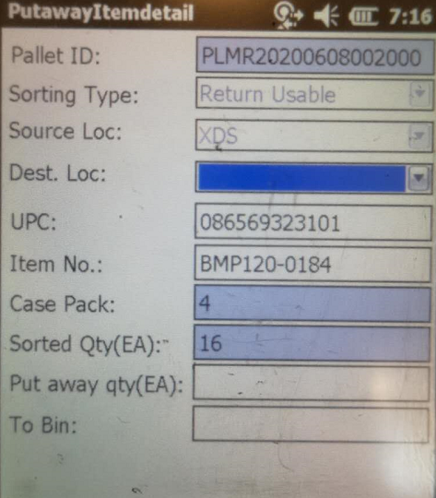

- Select Dest. Loc, enter Put Away Qty and scan the To Bin to finish the put away.