Review Management

Background
We have many Ecom retailers selling our products in USA. Every day, a lot of consumers leave reviews on these retailers’ websites. Some of them are good, some of them are bad. In order to fix the potential quality issue or other issues, we need to have a review management system.

Workflow
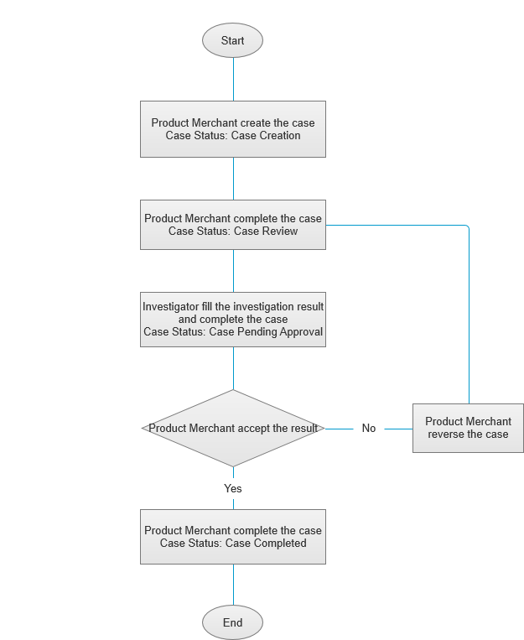

Procedure

Case Creation
- Product Merchandiser go to Review Management page.
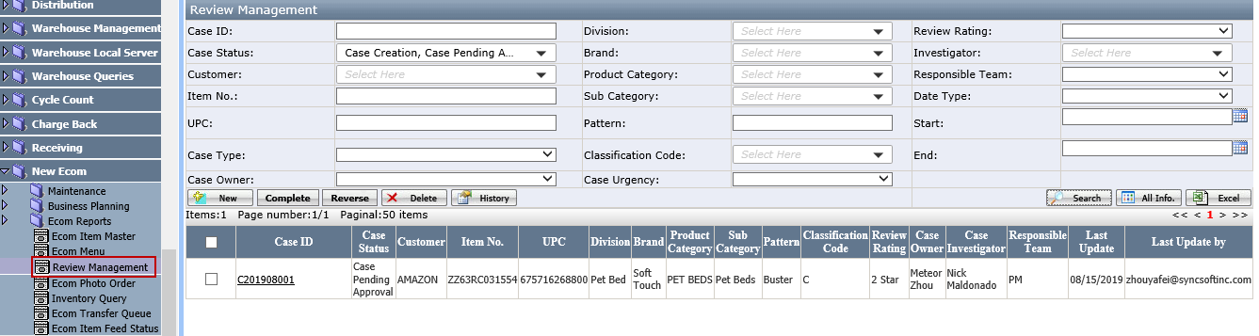
Notes
- The Case Owner in Search Criteria will default to current Product Merchandiser.
- Case Status in Search Criteria will default to Case Creation and Case Pending Approval.
- Click New to open the Case Detail page to create a new case.
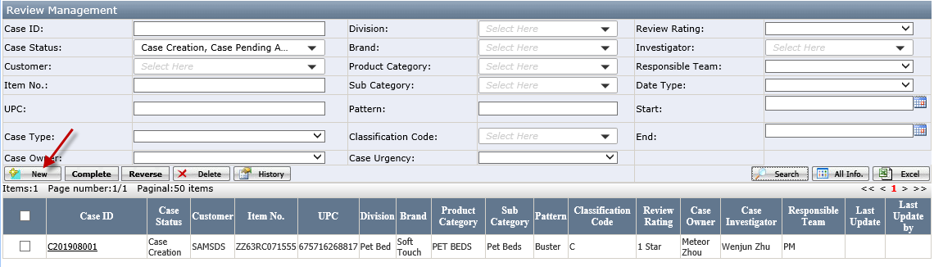
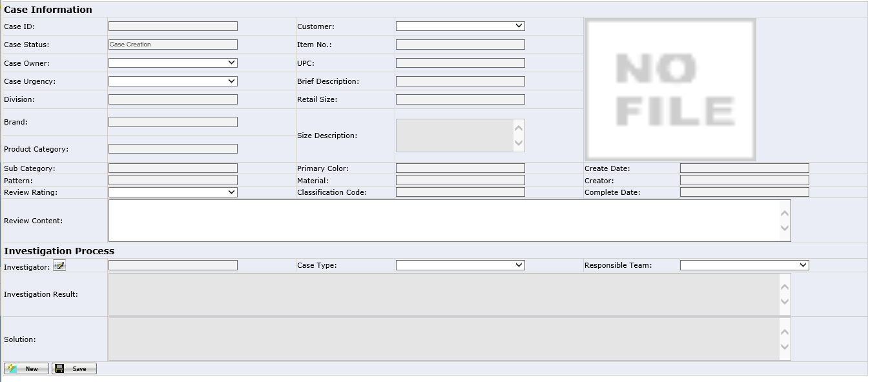
- Select the Case Urgency, Customer, Item No., Review Rating, Investigator, Case Type and Responsible Team, enter the Review Content and click Save.
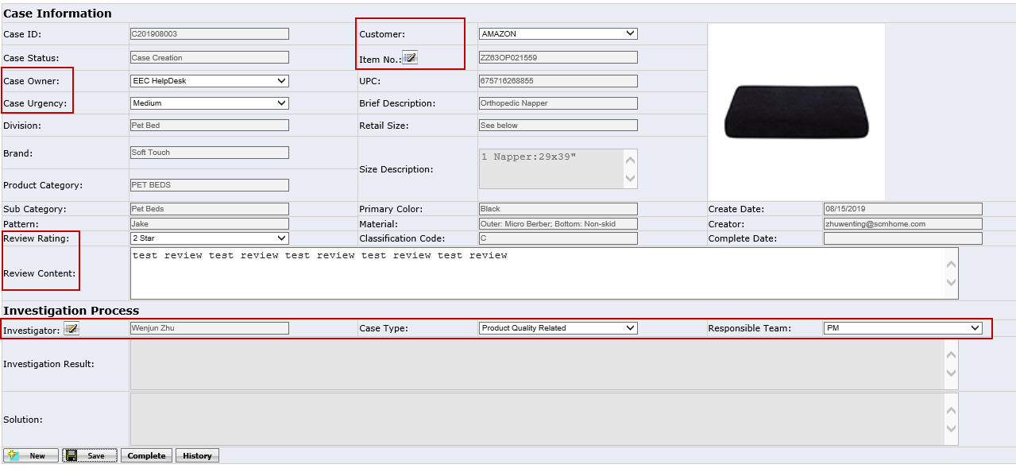
Notes
- Item No. selection will be available after select a Customer.
- Case Owner will default to current merchandiser.
- Click Complete, the Case Status will change to Case Review and system will send a notification email to the investigator.
Notes
- The Case Information can’t be edited anymore in Case Review Status, Merchandiser can ask Investigator to reverse the case if need to update the information.
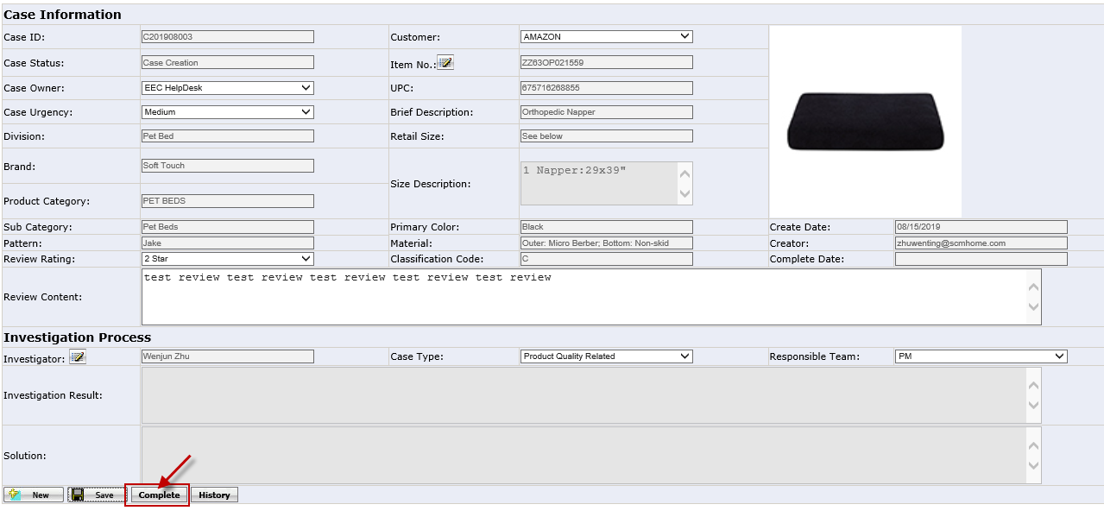

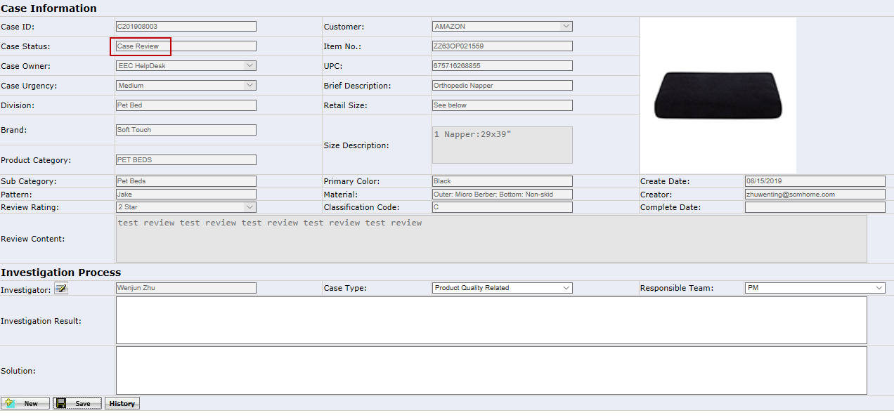

Case Review
- Investigator goes to Review Management page and click the Case ID to open the Case Detail page.
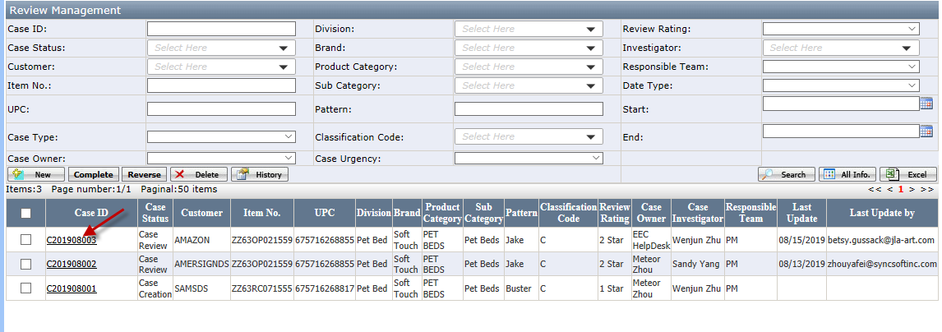
- Investigator can update the Investigator, Case Type and Responsible Team if necessary. Enter the Investigation Result, Solution and click Save.
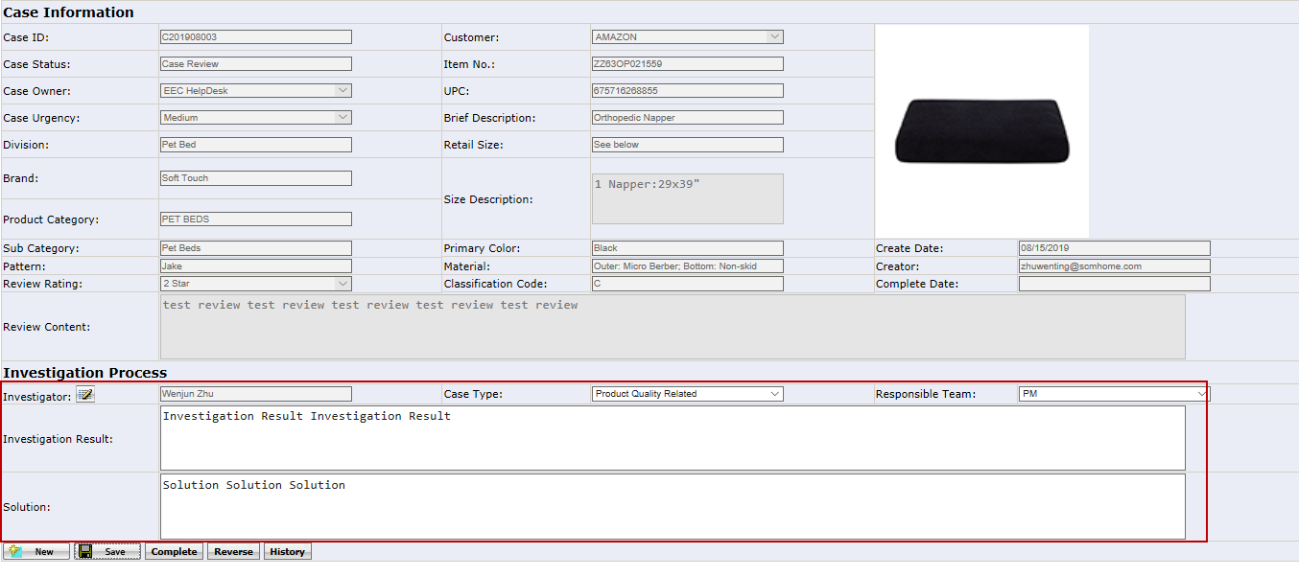
Notes
- Reverse: Click to reverse the Case to Case Creation Status.
- Click Complete, Case Status will change to Case Pending Approval. System will send a notification email to the Case Owner.
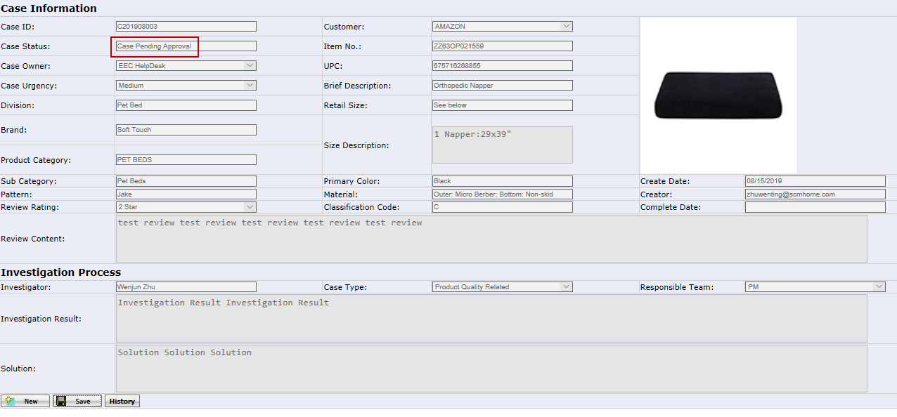

Case Pending Approval
- Product Merchandiser goes to Review Management page and click the Case ID to open the Case Detail page.

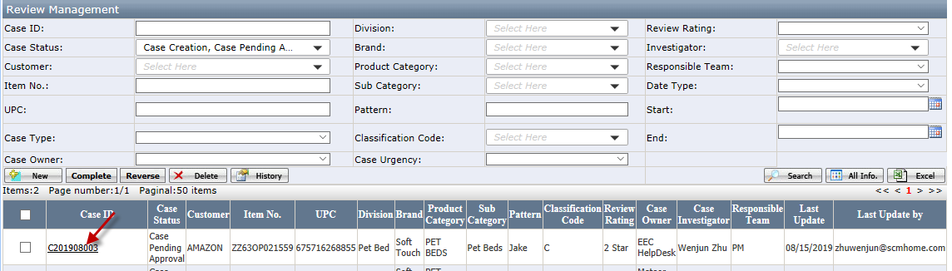
- If accept the investigation result, click Complete to change the Case Status to Case Completed. If don’t accept the result, click Reverse to change the Case Status to Case Review and system will send a notification to Investigator.
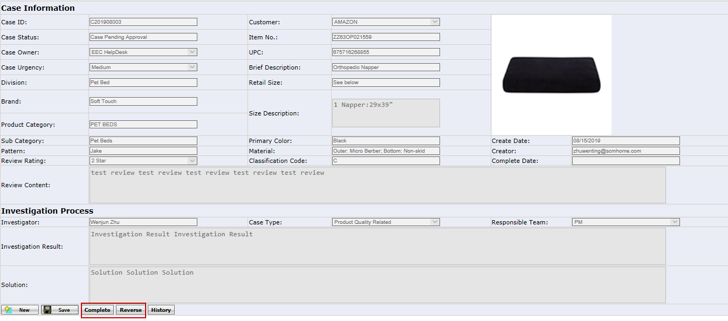

Appendix

How to Delete a Case
Select a case and click the Delete button on Review Management page.
Notes
Case must in Case Creation status.
