How to do Truck Loading

Only the user with truck loader job function and relation location has the access to operate the Truck Loading wireless application.

How to do Truck Loading
- When the order’s shipment created and click <Assign> to assign the shipment to user in wholwasle shipment Mgt page.
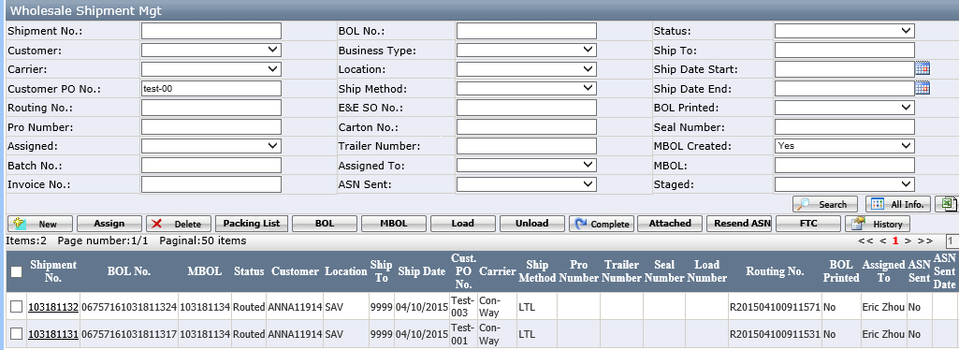
- The assigned user can log in the truckloading application to review this shipment.
The assigned loader log in truckloading application in wireless machine. The log in page is below:
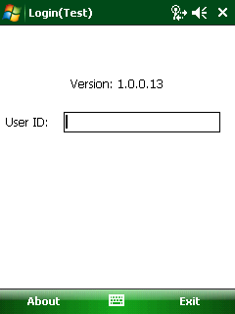
- Scan a user barcode or just type User ID to login shipment list page.
This assigned shipment will be list in the grid.
Please note: the user with job function of truck Loader, DC Manager, Shipment Admin, Developer have this access to log in this application.

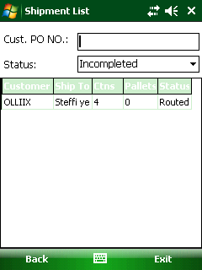
- Select one shipment and click it into load carton page
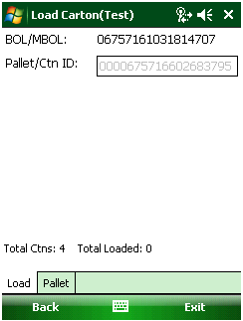
In this page, it has 2 tab: Load and Pallet
- Load tab: It is used to scan carton barcode or pallet barcode if the shipment had created the pallet.
- Pallet tab: It is used to review the pallet information.
- In this case, the user has to create the pallet for this shipment first, the detail see <how to build pallet>.

- Scan one carton/pallet barcode in carton/pallet label, see below.
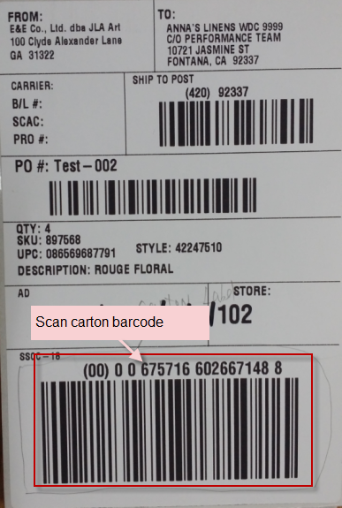
After scanning the barcode, the carton or pallet no will be shown.
If the barcode is damaged, it is allowed to enter it manually.
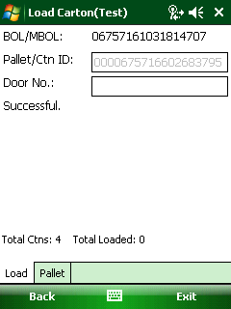

- Then, scan the Door no barcode (if the door barcode is damaged, it is allowed to enter door no manually)and click enter button to pop up message as below
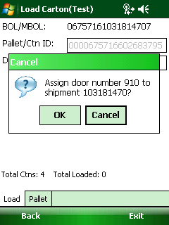
- Click ok to finish the carton/pallet load;
- Click cancel to cancel the operation.

- Click <ok> to finish the carton/pallet load and show message:”load successful.” see below
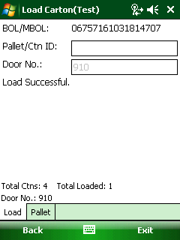
Then, repeat to scan the carton barcode and Door barcode until all cartons/pallets had loaded.
Notes: If the pallet/ctn is not belong this shipment, it will pop up the message:
“The carton/Pallet doesn’t belong to this shipment.”

- When loaded complete, it will show”load complete” and also will show the pro number, trailer number and seal number fields
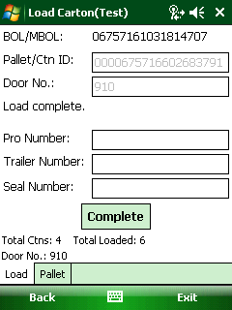
- Enter all required field and click <complete> button to print out the BOL and packing list.
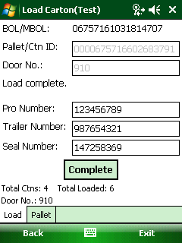
- Complete: it is used to print out BOL and packing list document.
- After print out BOL and packing list document, the shipment is at completed status. go to wholesale shipment Mgt page in EEC, it can see the shipment status is at completed status
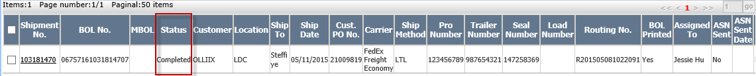

How to review the pallet
- Click the pallet tab to see below:
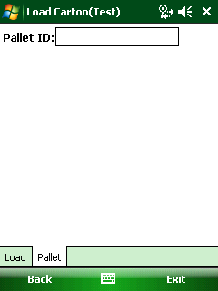
- Scan pallet barcode on the pallet label.
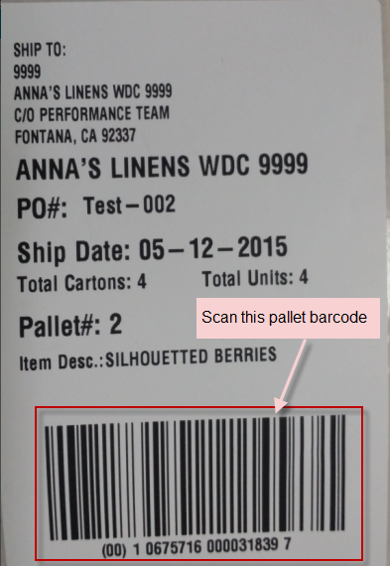
[Pallet label]

- Then the pallet information will show as below:
