Dropship Order Process
Small package order process is used to handle retail sales orders. It has below process steps:
Steps | Process | Detail Process | Operation Team
1 | Create SO | Create sales order | EDI or BDM Team
2 | Validate SO | Validate sales order | System Service
3 | Upload SO | Upload to Macola | System Service
4 | Shipment | Create Batch | System Service or Warehouse
 |  | Generate Pick list | System Service or Warehouse
 |  | Picking | Warehouse
 |  | Sorting(NFC need it) | Warehouse
 |  | Packing(NFC need it) | Warehouse
 |  | Loading | Warehouse
 |  | Shipped | System Service
 |  | Complete | System Service
Please see below manual in detail.

Create Sales Order
There are 3 ways to create sales order: 1)EDI 2)Manual 3)Website

Validate Sales Order
System will do the validation and if the order has problems, it will show error in sales order list page.
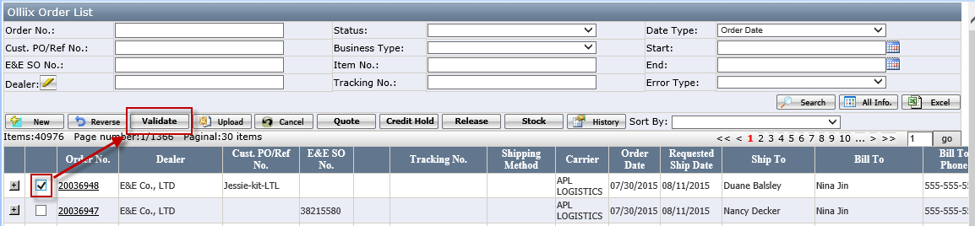

Upload Sales Order
Upload sales order to Macola system and it will generate a Macola order number.
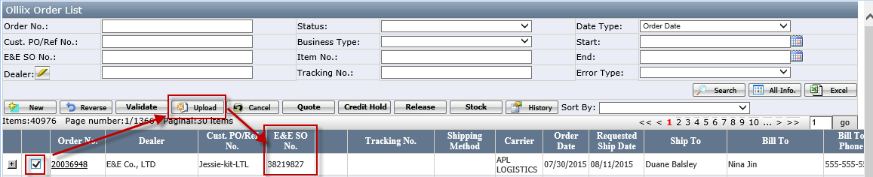

Shipment Process

Shipment Process Flowchart
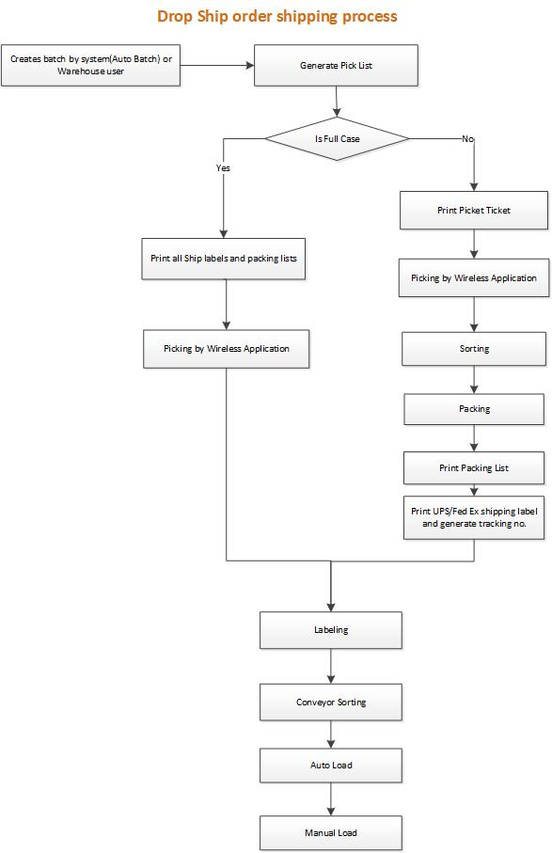

Create the Batch
Batch can be created manually or by EEC service “Generate DS Batch”
- Go to Drop Ship Batch Mgt page, click <New> button to open Batch Creation page.
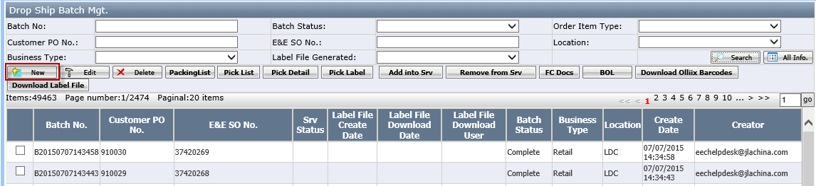
- Select the PO and click <Create> button.
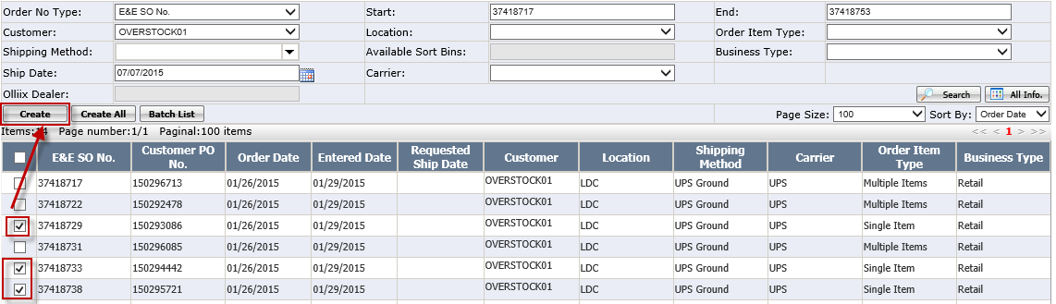
- Go back to Drop Ship Batch Mgt page. The batch has been created and the status is Pre-Prepare Ship Doc.
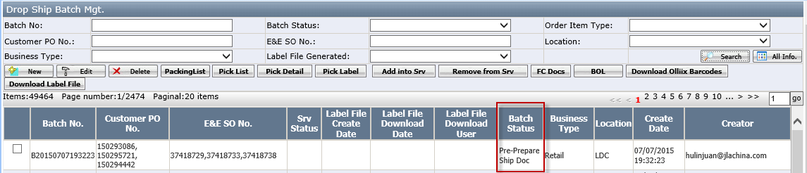

Generate the Pick List
- Go to Drop Ship Batch Mgt page, select one batch and click <Pick list> button to generate the pick list.
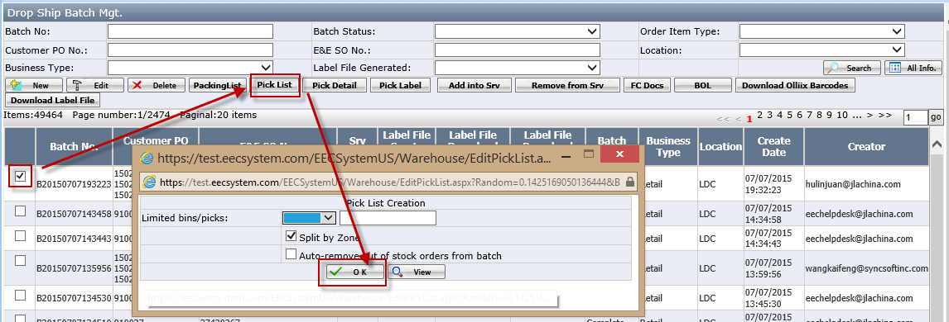
- Limited bins/picks: this field is used to decide how many item in one pick list. It can based on bins or based on picks.
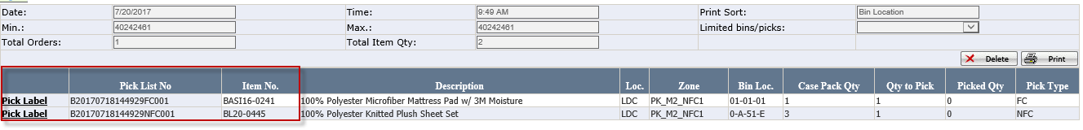
- After generated the pick list, the batch status will be Labels Generated.
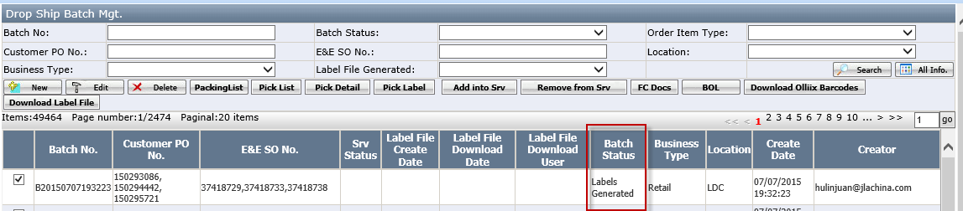
- Print out the pick list
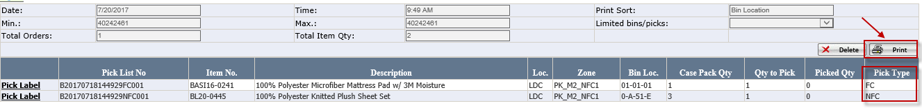
- There are 2 pick types: FC and NFC. FC=Full Case, NFC= None Full Case.

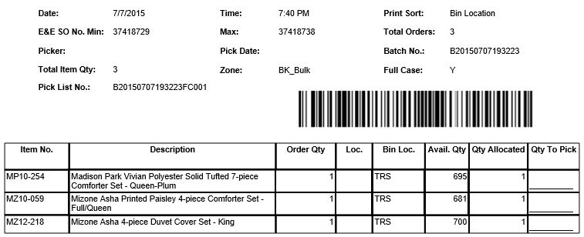

Print Shipping Label for FC Item
- On Drop Ship Batch Mgt page, select one batch and click <FC Docs> button
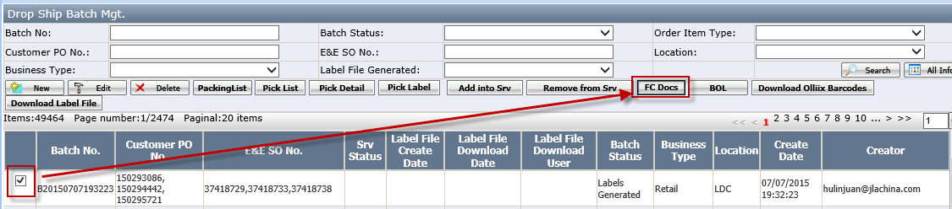
- In FC Docs page, select ship by and click <Gen.Pack> button to generate the carton and shipment.
- Click <Gen.Ship Label> to generate shipping label and tracking number.
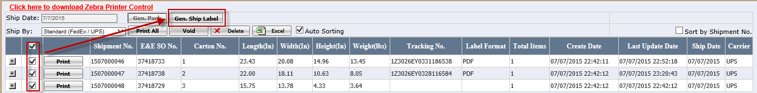
- Void: void the tracking no. If pass the allowed void period, it will pop up message: “No shipment found within the allowed void period.” In this case, ask EEC helpdesk to go to USWarehouse and use “Unpack” button to void the tracking no.
- Delete: delete the carton.
- Click print button to print out shipping label.
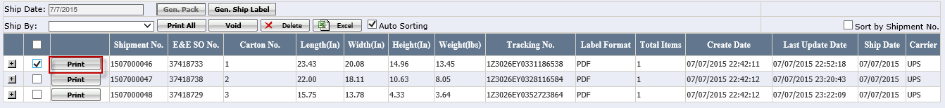
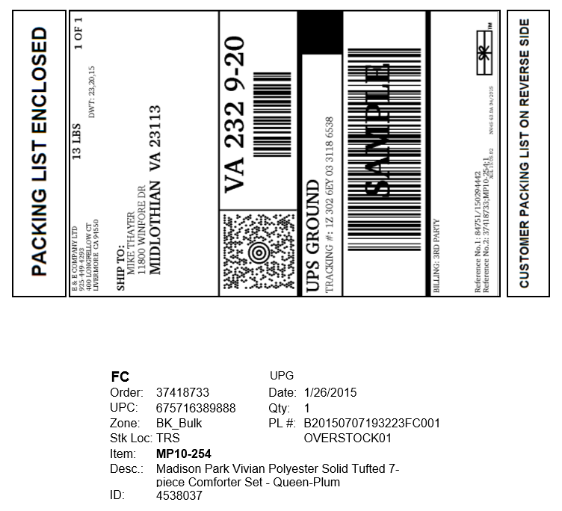
- Notes: When print out the shipping label, the packing list will be print out too. It is two sides document. The picker will put the shipping label and packing list on box when they are picking.

Print Pick Label for NFC Item
- On Drop Ship Batch Mgt page, select one batch and click <Pick Label > button.
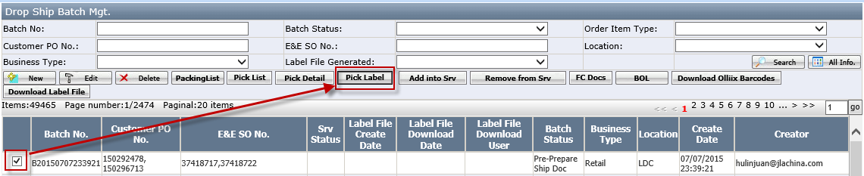
- In pick Label page, click <Print> button to print pick ticket.
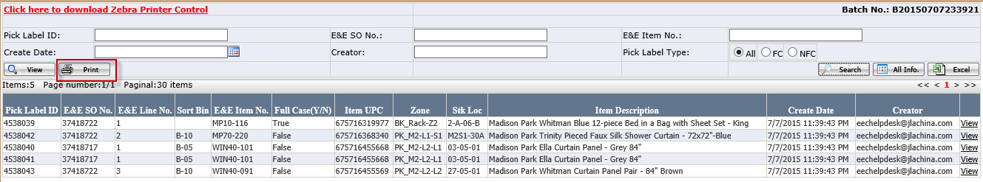
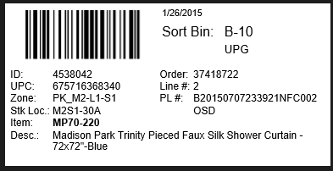

Picking
The picker pick the items by wireless application DSPicking.
- If the item type is FC, before the picking, below documents should be print out
- Pick list
- Shipping Label
- If the item type is NFC or One, below documents should be print out
- Pick list
- Pick Label

Sorting
Only NFC item requires this step. Warehouse user sort the items by wireless application SortingStation.

Packing
Only NFC and ONE item require this step. Warehouse user pack the items in USWarehouse.

Loading
There are 3 ways to load items: by Conveyor, by wireless application PackageAudit or by packing station. 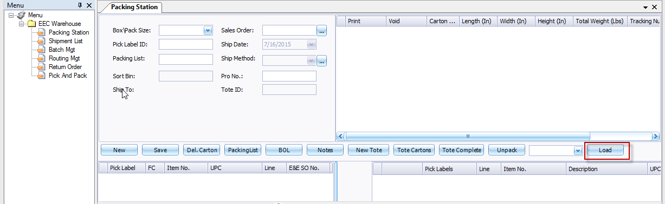

Shipped
- Run <EEC Ship> service to ship it and the batch status will change to Shipped. The EEC shipped date will be set up in packing station/shipment page
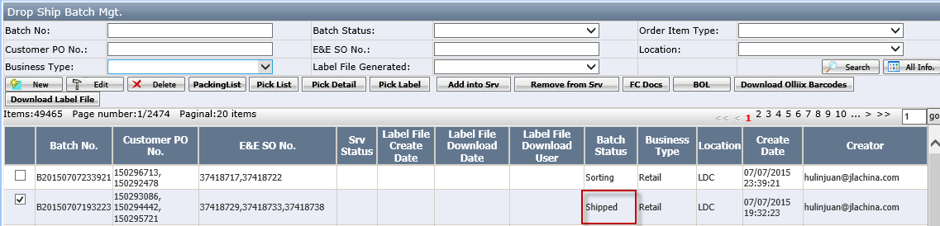
Notes: User can use <Packing list> button to print the packing list or print the packing list on packing station.
- Run <Generate ship confirm>service to send out the ASN. The ASN Send date will be set up.
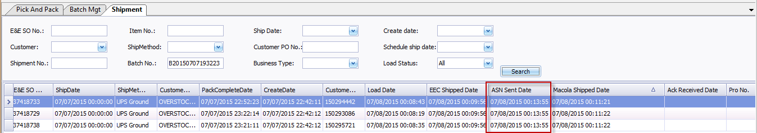
The batch status will change to Wait Ack.
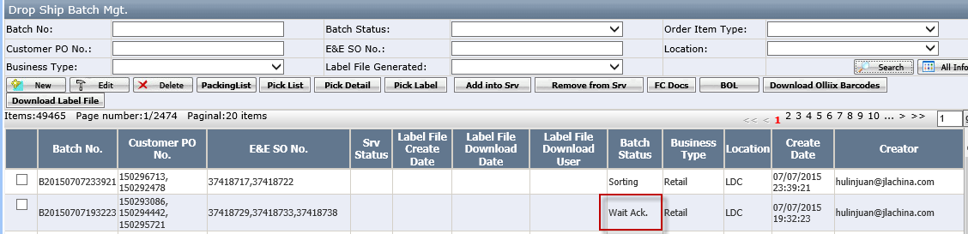
After customer received our ASN and send us the acknowledgement, the Ack Received date will be set in packing station and the batch status will change to Complete.

Appendix

Item Type
- FC Item
Items whose sales quantity is based on case, that is to say the one case is the sales unit.
- One Item
Order only has one item and this item is not full case, or the order has multiple items, after the order quantity/case pack, only one item is not full case. One item doesn’t need to do sorting. It can send to packing station directly.
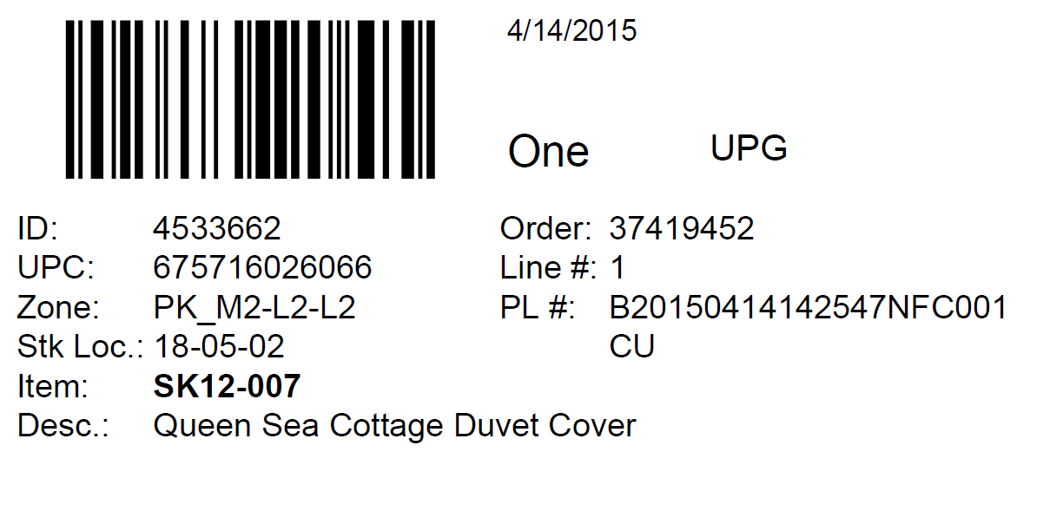
- NFC Item
The item sales quantity is not based on case, that is to say the carton need to be open and split the pieces when pick the item. Order has multiple items need to do sorting before go to packing station.
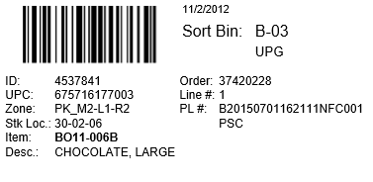

Batch Status
Batch Status | Description
Pre-Prepare Ship Doc | When batch is generated
Labels Generated | When pick list is generated
Sorting | print the pick ticket and operation sorting wireless application
Packing | 1.For NFC, do it on packing station.  2.For FC, Do it in EEC Drop ship Mgt page and use <FC Doc> to print out the shipping label.
Shipped | After run service <EEC Ship>
Wait Ack. | After run service<Generate Ship Confirm>
Complete | Received the 997 from customer

