Cycle Count User Guides

How to Generate Cycle Count List
- Go to Cycle count list Mgt page
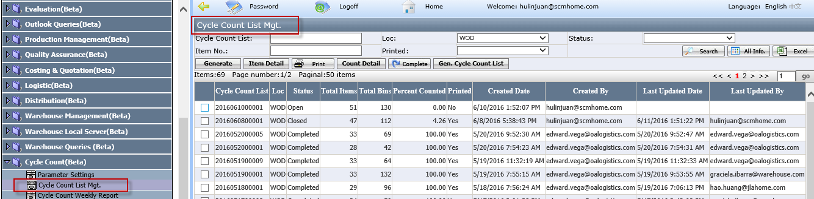
- Generate: to generate the cycle count list
- Item Detail: it is used to review the count item detail page, the detail see <Item detail button> page.

- Click Generate to pop up below page.
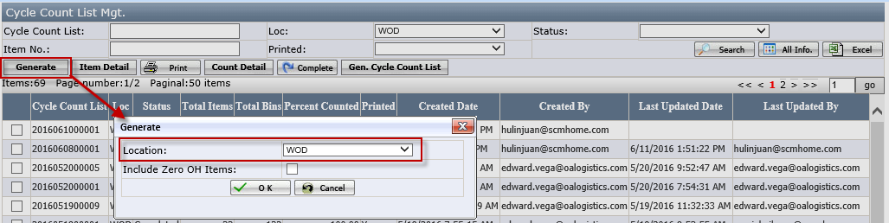
- Location: dropdown list and it is used to select one location
- Include zero OH Items: if it is checked, the generated cycle count list will include the item bin no. which OH hand=0.

- In pop up window, select location, then click OK to generate cycle count list as below:
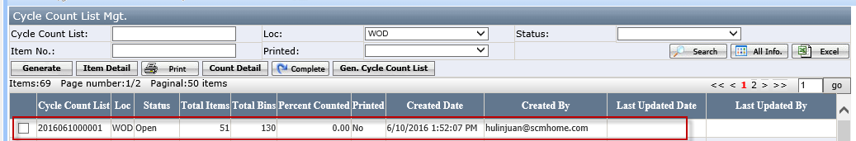

- Select the cycle count list and click Print to pop up below page
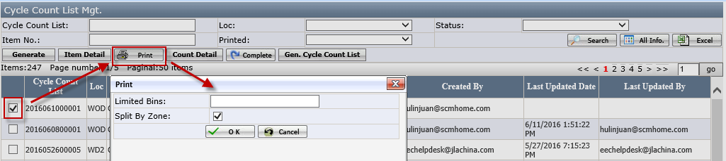
- Limited Bins: it is used to enter bins numbers. It means how many bins will be list in the cycle count list page.
- Split by zone: the cycle count list will be split based on zone.

- Click OK to pop up below

- Click Open to generate cycle count list. The warehouse manager can assign this paper to warehouse user to do cycle count in wireless application.
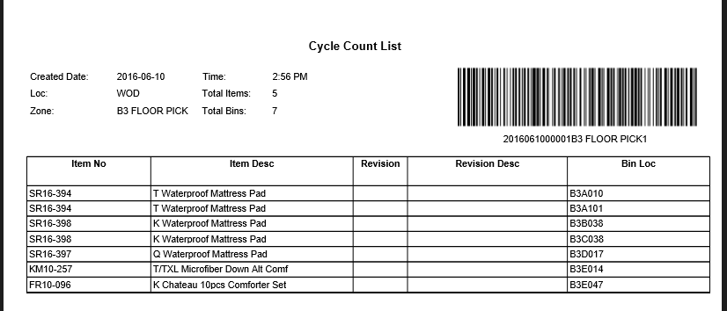

- Go back to the cycle count list Mgt page, the printed column will be “Yes”. It means the cycle count list has been created successfully.
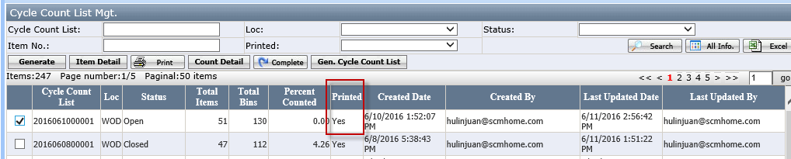

How to Do Wireless Application
- Log in
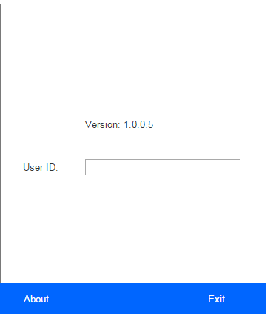

- Scan cycle count list group barcode on the PDF report to assign the cycle count list to current user.
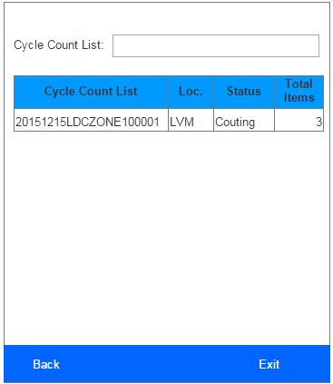
- This form only list the cycle count list which is assigned to current user and has not been closed or completed

- Click the cycle count list to open item detail form as below.
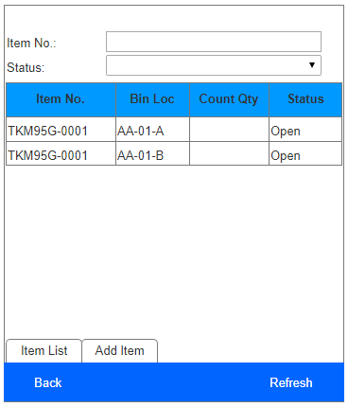
- This form list all the bin locations belong to the selected cycle count list.
- Input item no. or status can filter the item bin loc. list.
- Item status = Completed/Closed/Approved, does not allow to count.

- Click the item no. to open the count item form as below and count the items.
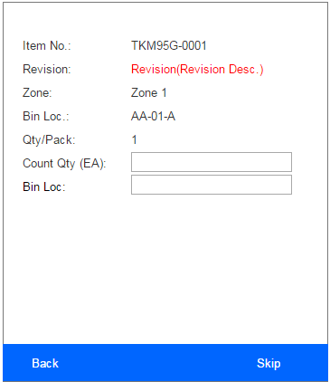
- User need to enter the Count Qty (EA) first, and then scan the bin loc barcode.
- User can click Skip if they want to skip current item and count later. Current item bin loc. status will change to Skip.

- If user find the counting item in a bin which is not include in the cycle count list, user can use Add Item tab to add the item bin into current cycle count list.
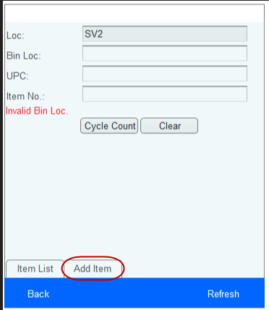

Working Pages
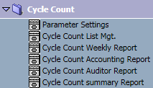

Parameter Settings
This page is used to set cycle count parameters and maintained by Accounting team.
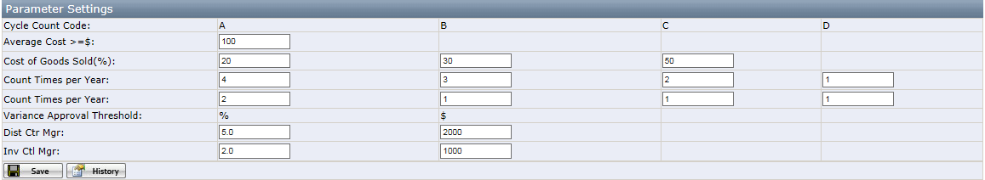
Buttons:
- Save: save the changes of value.
- History: record the changes for all fields.

**Cycle Count Code**
A: average cost >= $100 or cost of goods sold(CoGS) in top 20%
B: CoGS in next 30%
C: CoGS in remaining 50%
D: item status is closeout/donation

Cycle Count List Mgt.
This page is used by Accounting team and Warehouse Inventory Control team.
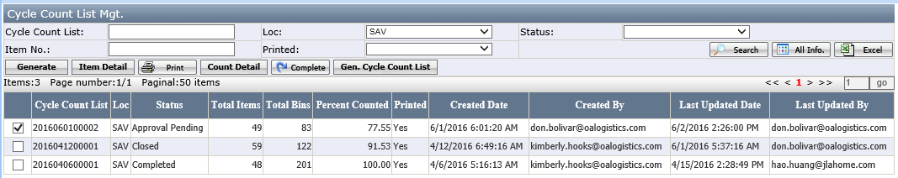

Generate button
Is it used to generate cycle count list. Click to open below page, select location and click OK.
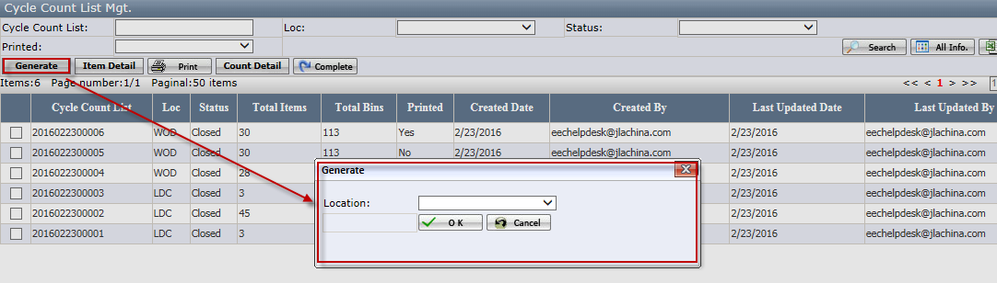
Notes:
- Only Dist Ctr Mgr and Inv Ctl Mgr can see this button.
- Old cycle count list must be closed when generate new one.

Item Detail button
Select the cycle count list and click Item Detail. In this page user can check the item detail and approve variance.
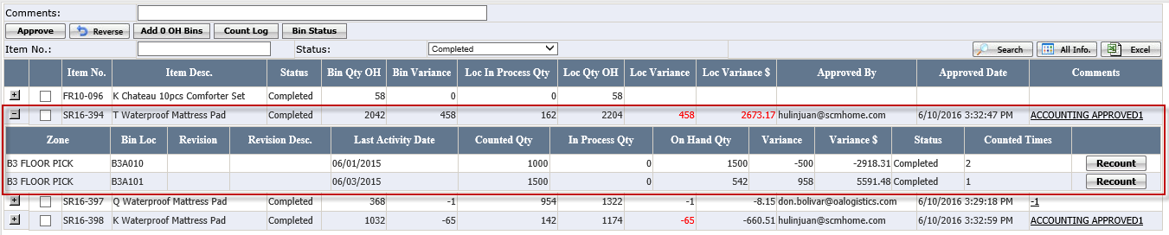
Grid:
- On Hand Qty = On hand qty in Macola
- In Process Qty = Picked but not transferred qty, including wholesale/drop ship pick list, replenishment pick list(In & Out), bin transfer list(In & Out) and manual replenish list(In & Out)
- Variance Qty = Counted Qty - (On Hand Qty + In Process Qty)
- Bin Variance= Sum(Variance Qty for current item in all bins)
- Bin OH Qty = Sum(On Hand Qty in Macola for current item in all bins except Receiving bin , In-transit bin and Billing Only bin)
- Loc OH Qty = Loc On Hand Qty in Macola for current item
- Loc In Process Qty=Sum(On Hand Qty in Macola for current item in Receiving bin , In-transit bin and Billing Only bin).
- Loc Variance= (Bin OH Qty + Bin Variance + Loc In Process Qty) - Loc OH Qty
Buttons:
- Approve: approve the variance of the selected item after counting.
Notes:
- The variance approval threshold is maintained on cycle count parameter page.
- Item status must be Variance/DCM Review/Request Approval.
- Comment is required. Click the hyperlink on Comments column can open Approve Log page.
- Variance approval percentage= ABS(Loc. Variance)*100/ Loc. OH Qty, Variance Amount=Loc. Variance Qty* Item average cost.
- Reverse: reverse the item status to DCM Review.
Notes:
- Only Accounting Controller and Accounting Admin can see this button.
- Item status must be Request Approval
- Add 0 OH Bins: add all bins which bin OH qty=0 to current item except Billing Only, Receiving and In-Transit bin.
Notes:
- Item status must be Open/Counting/Variance/DCM Review
- Count Log: open Count Log page.
- Bin Status: click to open Inventory Detail Report page.
- Recount: click to clear Count Qty, In Process Qty, On Hand Qty and Variance Qty. Set item bin status to Open and Item status to Counting.
Notes:
- Item bin status must be Variance and Item Status must be Counting/Variance/DCM Review

Print button
Select cycle count list and click Print to open the print option as below. Cycle count list will be divided into groups according to the setup.
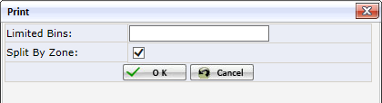
Notes:
- This option only pop up when first click the print.

Grid:
- Limited Bins: Limit the number of bins in each cycle count list group.
- Split by Zone: It is checked by default. When it is checked, the cycle count list will be divided into groups by zone.
Buttons:
- Cancel: Close current page.
- OK: Print the cycle count list PDF report as below.
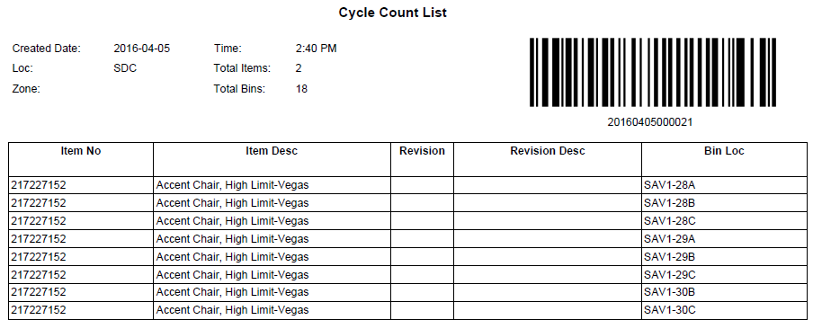

Count Detail button
After printing the PDF, the cycle count list group will be generated. Click Count Detail to open the count detail page of the selected cycle count list. The groups under the cycle count list will list here.
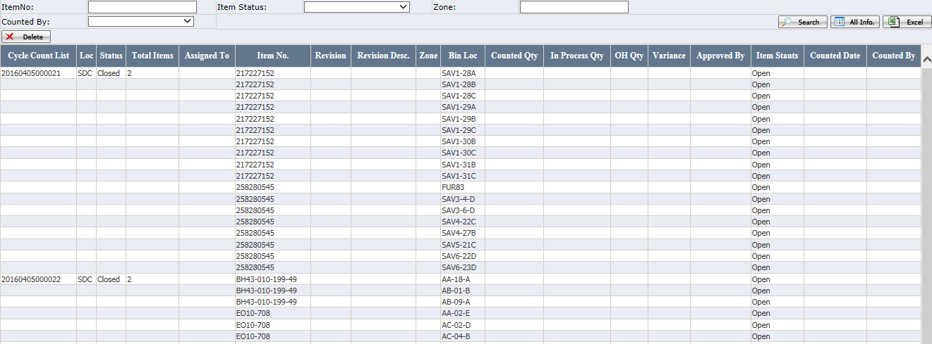
Delete: Delete all the cycle count list group data
Before counting, users can delete the cycle count list group data if they want to change the group.
Notes:
- All the item bin loc. status must be open.
- Count detail can be re-generated by re-printing the cycle count list PDF report.

Complete Button
Click to complete the selected cycle count list.
- There are two scenarios to use this function.
- Fail to finish the cycle count today. After complete, the unfinished items will be in the next day’s cycle count list.
- In order to generate new cycle count list, the old ones must be completed.
Notes:
- Only Dist Ctr Mgr and Inv Ctl Mgr can see this button
- Cycle count list status must be Open or Approval Pending
- Only update the item whose status is Open or Counting to Closed. Does NOT update the status of Variance/DCM Review/Request Approval item.

Cycle Count Summary Report
Generate the variance/total items report by day/week/month.
- If report type=variance, will display the variance percentage.
Variance percentage = ABS (counted qty-on hand qty) * 100 / on hand qty
- If report type= total items, will display the total items counted.
Click the link can open the detail page.
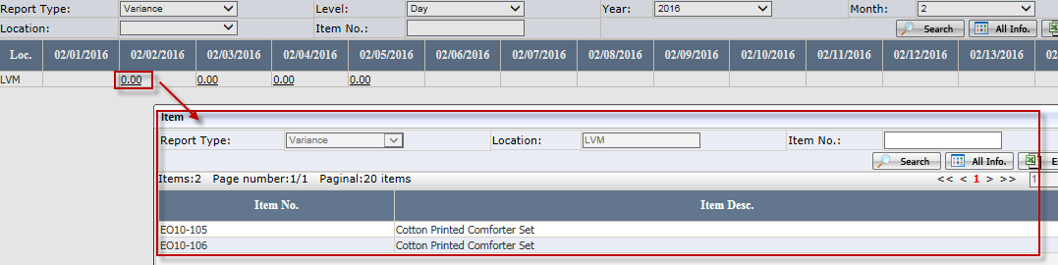

Cycle Count Weely Report
Display cycle count summary information for selected week and location.
There are 2 tabs for this report.
By Item
List all items counted in current week.
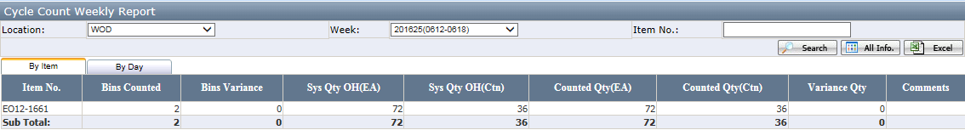
Grid:
- Bins Counted: total bins counted for current item.
- Bins Variance: total bins has variance for current item
- Sys Qty OH: cycle count item Bin OH Qty + Bin In Process Qty for current item
- Counted Qty: Cycle count item Bin Counted qty for current item
- Variance Qty: Counted Qty(EA)- Sys Qty OH(EA)
By Day
List all days in current week
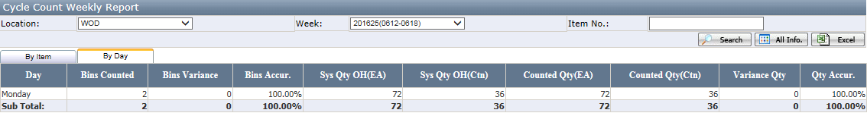
Grid:
- Bins Variance: Total Bins has variance for current day
- Bin Accur.: ((Bins Counted – Bins Variance) / Bins Counted) * 100
- Sys Qty OH: Cycle count item Bin OH qty + Bin In Process Qty for current day
- Counted Qty: Cycle count item Bin Counted qty for current day
- Variance Qty: Counted Qty(EA)- Sys Qty OH(EA)
- Qty Accur.: (1 – (Variance Qty/ Sys Qty OH(EA))) * 100

Cycle Count Accounting Report
This report is used by Accounting team to track item cycle count result. It will list the cycle count list whose status is completed or closed and item status = completed.
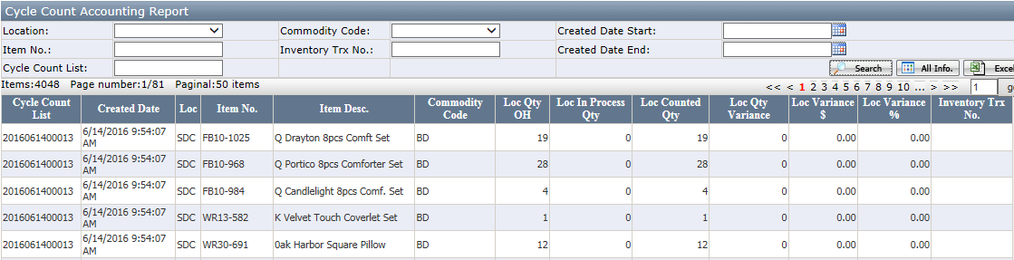
Grid:
- Created Date: cycle count list created date.
- Commodity Code: EEC Division Code.
- Inventory Trx No.: inventory transaction record#.
- Loc In Process Qty: ABS(Loc In Process Qty)
- Loc Counted Qty: Bin OH Qty + Bin Variance
- Loc. Varicance %: (Loc Qty Variance / Loc Qty OH)*100
- Subtotal row shows net variance for all variance columns

Cycle Count Auditor Report
This report is used by Accouting Auditor. This report will list the cycle count list whose status is completed/closed and at least has one item with completed status.
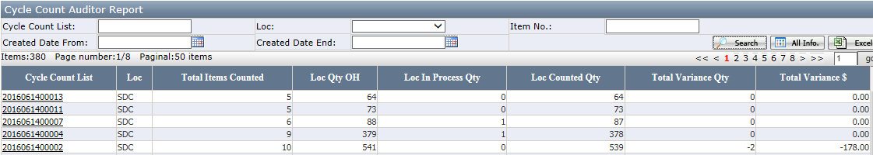
Grid:
- Total Items Counted: Items in the cycle count list with status=Completed.
- Loc Qty OH: Sum( Items' Loc Qty OH in the cycle count list)
- Loc In Process Qty: Sum( ABS(item's Loc In Process Qty in the cycle count list))
- Loc Counted Qty: Sum( Items' Bin OH Qty+Bin Variance in the cycle count list)
- Total Variance Qty: Sum( Items' Loc Variance in the cycle count list)
- Total Variance $: Sum( Items' Loc Variance $ in the cycle count list)
- Click the cycle count list link can open below item detail page.
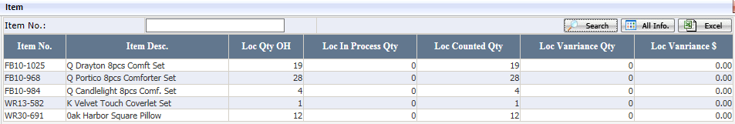
Grid:
- Loc OH Qty = Loc On Hand Qty in Macola for current item
- Loc In Process Qty=Sum(On Hand Qty in Macola for current item in Receiving bin , In-transit bin and Billing Only bin).
- Loc Variance= (Bin OH Qty + Bin Variance + Loc In Process Qty) - Loc OH Qty

Status and Roles

Status

Cycle Count Item Bin Loc. Status | Description
Open | Initial status
Skip | Skip count temporarily
Variance | Bin location has been counted but exists variance. After variance is approved and related Macola Data is updated, status will change to Completed
Completed | Bin location is counted without variance  Or variance is approved and EEC service has updated Macola data
Closed | Cycle count list is completed by user manually without finishing the counting of this item bin

Cycle Count Item Status | Description
Open | Initial status
Counting | At least one bin location has been counted
Variance | All cycle count item bin loc. status is Variance or Completed, but not all completed, or Loc Variance <> 0
DCM Review | After Inv Ctl Mgr clicks “Approve” on items with variance greater than his approval threshold
Request Approval | After Dist Ctr Mgr clicks “Approve” on items with variance greater than his approval threshold
Approved | After variance is approved, status will change to Approved
Completed | All Cycle Count Item Bin Loc. status is Completed after run service””
Closed | Cycle count list is completed by user manually without finishing the counting of this item

Cycle Count List Group Status | Description
Open | Initial status
Counted | All item bin status is Variance, Closed or Completed
Completed | All related cycle count item bin status is Completed
Closed | Cycle count list is completed by user manually without finishing the counting of all item bins

Cycle Count List Status | Description
Open | Initial status
Approval Pending | If any item on the list has “Request Approval” status
Completed | All related cycle count item bin status is Completed
Closed | Cycle count list is completed by user manually without finishing the counting of all items

Roles
Working Page | Page Functionality | Dept. | Roles | Detail
Parameter Settings | Set cycle count parameter | Accounting | Accounting Admin  Accounting Controller
Cycle Count List Mgt. | Generate Cycle Count PDF report; View Count Detail | Accounting  Warehouse | Accounting Admin  Accounting Controller  Dist Ctr Mgr  Inv Ctl Mgr | Generate, Print and Complete button is only visible to user with role Dist Ctr Mgr or Inv Ctl Mgr.  Gen. Cycle Count List is only visible to Developers
Cycle Count List Mgt.  • Count Item Detail | Approve variance; Complete incomplete cycle count list | Accounting  Warehouse | Accounting Admin  Accounting Controller  Dist Ctr Mgr  Inv Ctl Mgr | Approve button is only visible to user with role Accounting Admin, Accounting Controller, Dist Ctr Mgr or Inv Ctl Mgr.
Cycle Count Summary Report | Display cycle count information by Day, Week or Month | Accounting  Warehouse | Accounting Admin  Accounting Controller  Dist Ctr Mgr  Inv Ctl Mgr
Cycle Count Accounting Report | Display cycle count result | Accounting | Accounting Admin  Accounting Associate  Accounting Controller
Cycle Count Weekly Report | Display cycle count summary information for selected week and location | Warehouse | DC Admin  Warehouse Admin
Cycle Count Auditor Report | Display cycle count detail information | Accounting | Accounting Admin  Accounting Associate  Accounting Controller
Wireless Application- Cycle Count | Do physical cycle count | Warehouse | Dist Ctr Mgr  Inv Ctl Mgr  Warehouse User

EEC Service
Assign Cycle Count Code to Item
It is used to assigned cycle count code to each item based on rules setting in parameter settings page.

Cycle Count Data Process
It is used to process approved variance data and update cycle count list status and cycle count list group status.

