Print and Apply User Guide

- Ask Distribution Team to create a separate batch for print & apply orders.
- Go to Wholesale Batch Mgt to generate pick list. Make sure Pick by Routing Sheet is checked.
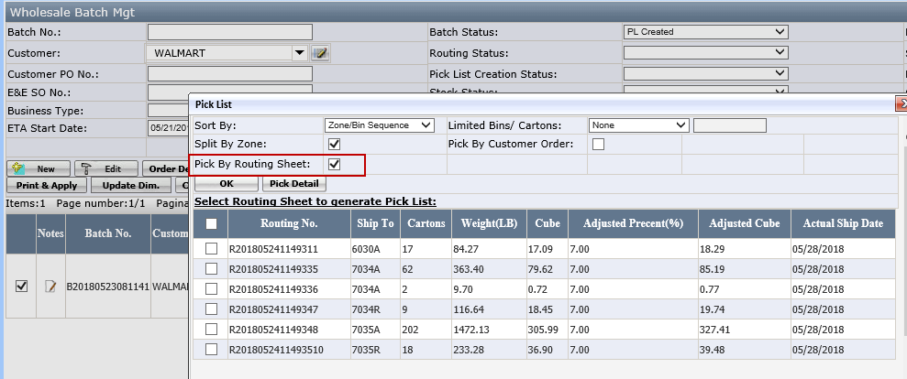
Note:
- Only allow to select a maximum of 10 routing sheets/POs to generate the pick list
- Make sure all other pick list group has been finished print & apply, Group status=Completed
- Click Print & Apply button on Wholesale Batch Mgt page.
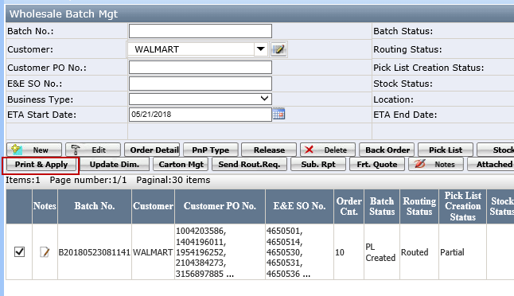
- Assign lane to each Routing Sheet/PO.
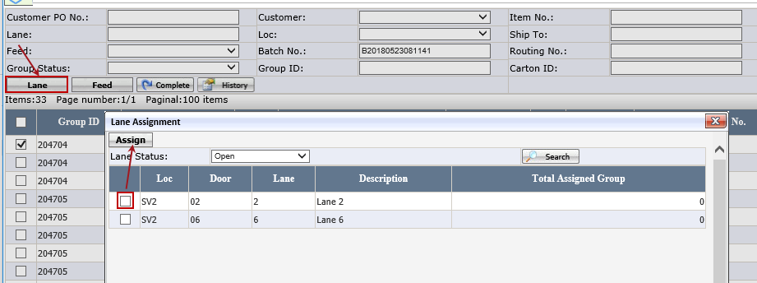
Note:
- Lane assignment is on routing sheet/PO level, each Routing sheet/PO can only assign one lane
- The Lane Status option is Open/Assigned and will default to Open. Assigned means the lane has already be assigned to pick list group that has not been completed.
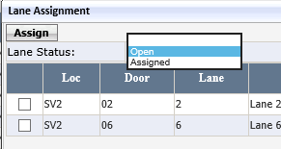
- Click Feed to feed the data.
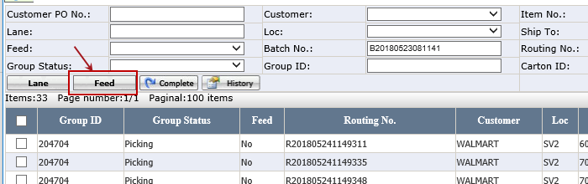
Note: it must be finished at least 20 minutes before physical picking, so EEC service can has enough time to feed the data to conveyor system.
- Click Complete to delete the divert failed cartons.
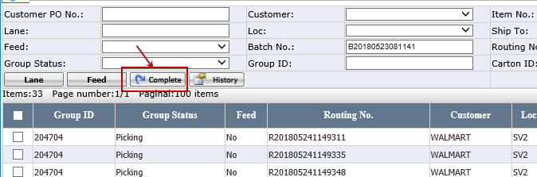
Note: This must be done before you start the next wave of orders, otherwise, the label will mess up.

