Evaluation Manual

Work Flow
Create New Org on Organization Setting Page

Assign User to the Organization

Assign HR to the Organization

Setup the Peer Organization, Glossary, Report Department, etc.

Initialize the User

EEC service change the evaluation period to open when Evaluation start date on Evaluation Name is <=current date. System will send email to the users and user start to evaluate.

EEC service change the evaluation period to closed when Evaluation end date is < current date. System will send closed email to users.

Manually complete the evaluation to change the status to Completed. Users cannot access the Evaluation Application anymore.

Procedure

Create New Organization
- Go to Organization Setting page under Administration HR Admin
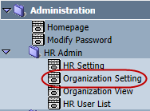
- Select the Organization and click Add Org. to add a child organization under the selected Organization.
- Enter Organization Name and click Save.
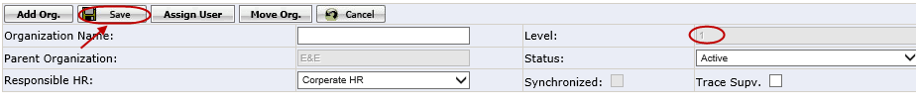
Note:
- The level will be automatically +1. (e.g. the selected organization level is 1, the added child organization will be 2.)
- Responsible HR: Corporate HR is for US corporate and Oversea HR is none US HR
- Trace Supv.: When it is checked, if employee current organization does not have the supervisor, initialization will automatically assign one or two level up organization supervisors as his/her supervisor
Click Add Org. to continue adding child Organization for the selected parent organization.

Assign Users to the Organization
- Go to Organization Setting page. Select the organization and click Assign User button.
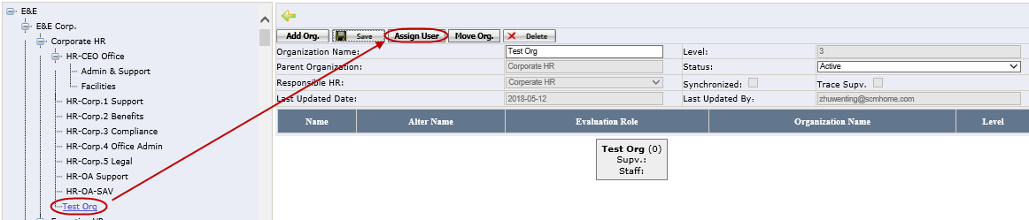
- Select the users in the pop up window and click Add.
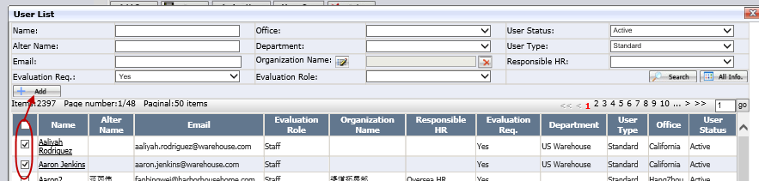
- After user assigned, it can be viewed in the below.
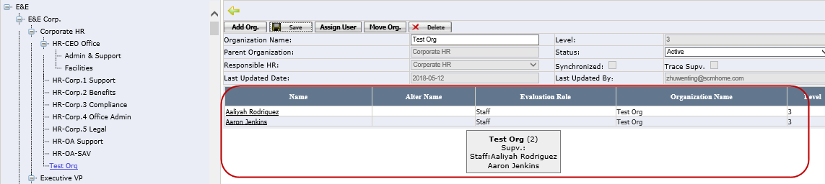
Note: this function can’t be used when evaluation period start. User need to go to HR User List to update the organization. See How to Make Changes to Existing User.

Assign HR to Organizations
    - Go to HR Setting under Administration HR Admin
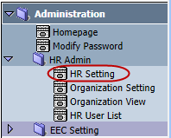
- Assign HR to Organizations.
      - For new HR, please select the Responsible HR, HR User Name, Organization and enter the Name then click Save.
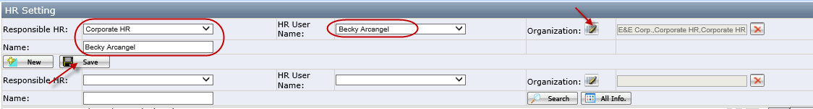
      - For existing HR, please search out and select the HR, then make the changes and click Save.
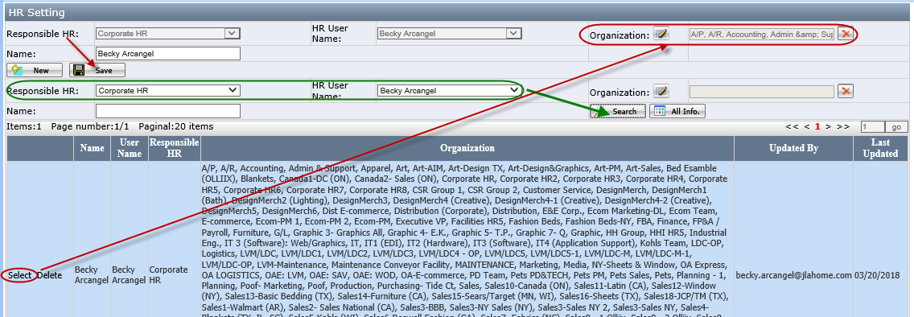

View the Organization Users
    - Go to Organization View page under Administration HR Admin
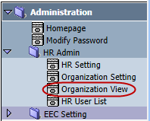
    - Click the Organization Name on the left side, this organization assigned user will be listed in the right side in the grid.
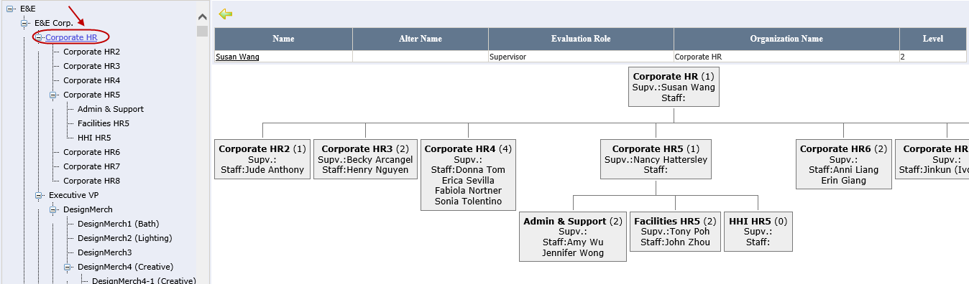
Note:
- HR can only see the Organizations which have been assigned to them on HR Setting page
- If the user is already initialized in the User page, click the name will open this user’s relationship chart
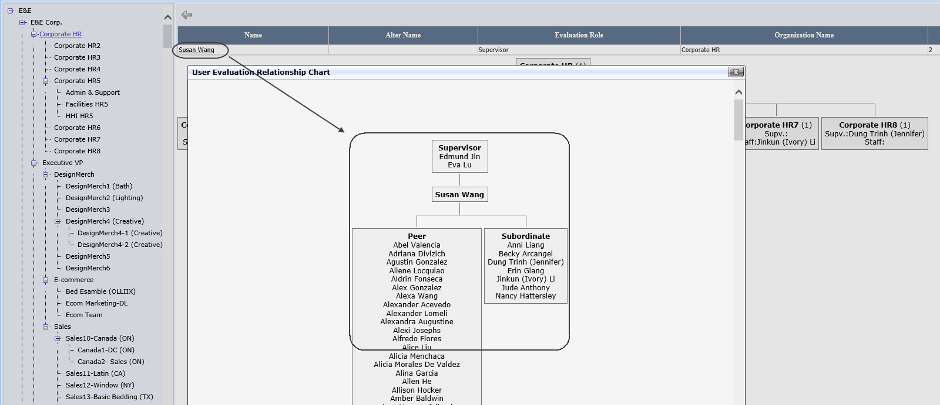

Setup the Peer Organization
    - Open Peer Organization page under Evaluation Maintenance.
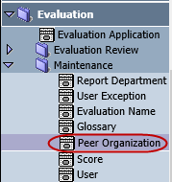
    - Enter the data in the fields and click Save. After saved successfully, the company and Organization cannot be changed. Once the organization has the peer organization, during the “Initialization” process it will automatically assign its peer organization’s users as its peers.
- Organization: List the selected company’s child organizations and it is single selection
- Peer Organization: It is multiple selection
- Apply to Sub-organization: If checked, system will assign the peer organization’s users as the peers to the sub-organization under the selected organization
    - Click the Delete button in grid can delete the peer organization.
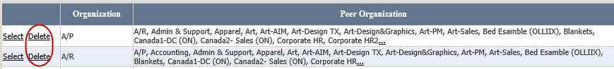

Setup the Glossary
    - Open Glossary page under Evaluation Maintenance
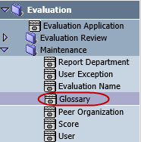
    - Enter the data in the required fields and click Save button to create a new glossary subject.
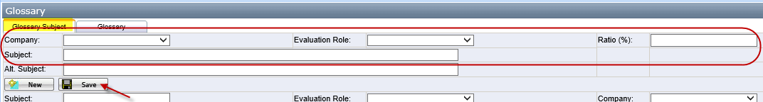
    - After saved successfully, sequence No. will be automatically configured. User can change the No. manually to resort the glossary subject.
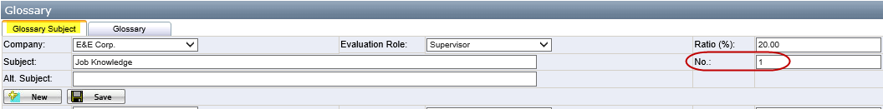
    - Click the Delete button in grid can delete the glossary subject.
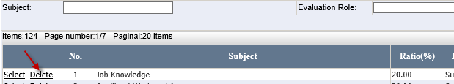
Note: If the subject is used in the glossary page, or Evaluation is “Open” or “Close” status, it cannot be deleted.
    - Go to Glossary tab to setup the glossary. Select Evaluation Role, Company, and Organization, enter Glossary Name, then click Save button. After saved successfully, “Evaluation Role” and “Company” cannot be changed anymore.
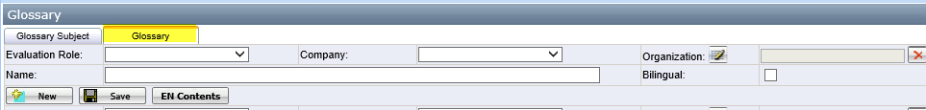
Note: If organization is already assigned to other glossary, the checkbox will be gray out
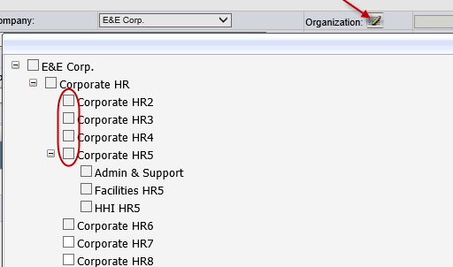
    - After glossary created, click EN Contents button to open glossary contents edit page.
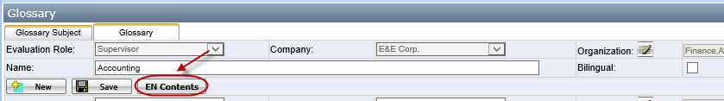
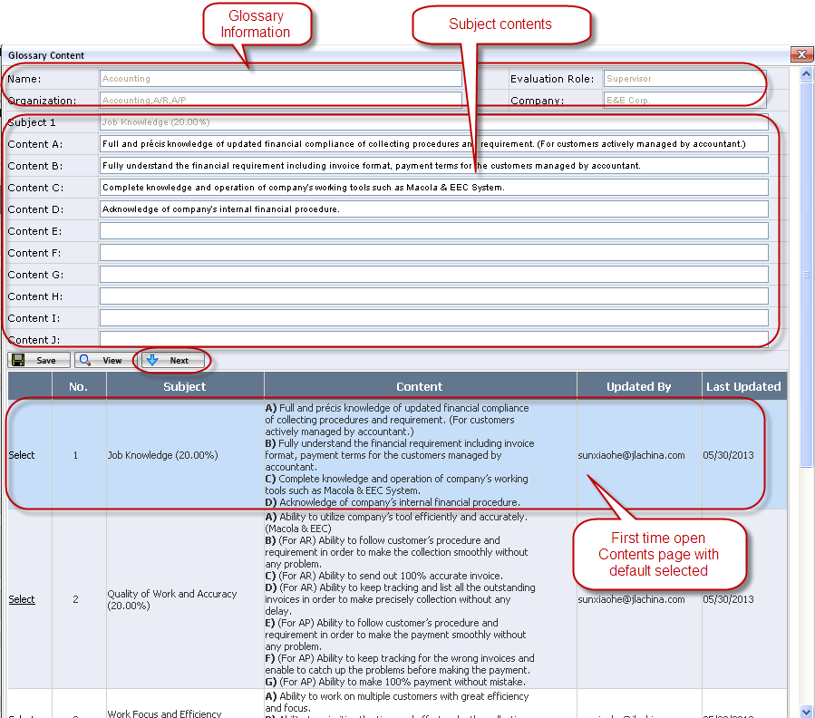
    - Type in the contents for the selected subject and click Save button.
    - Click Next button or directly click Select button in the grid to select the next subject to edit.
    - Click View button to open the Glossary contents preview page.
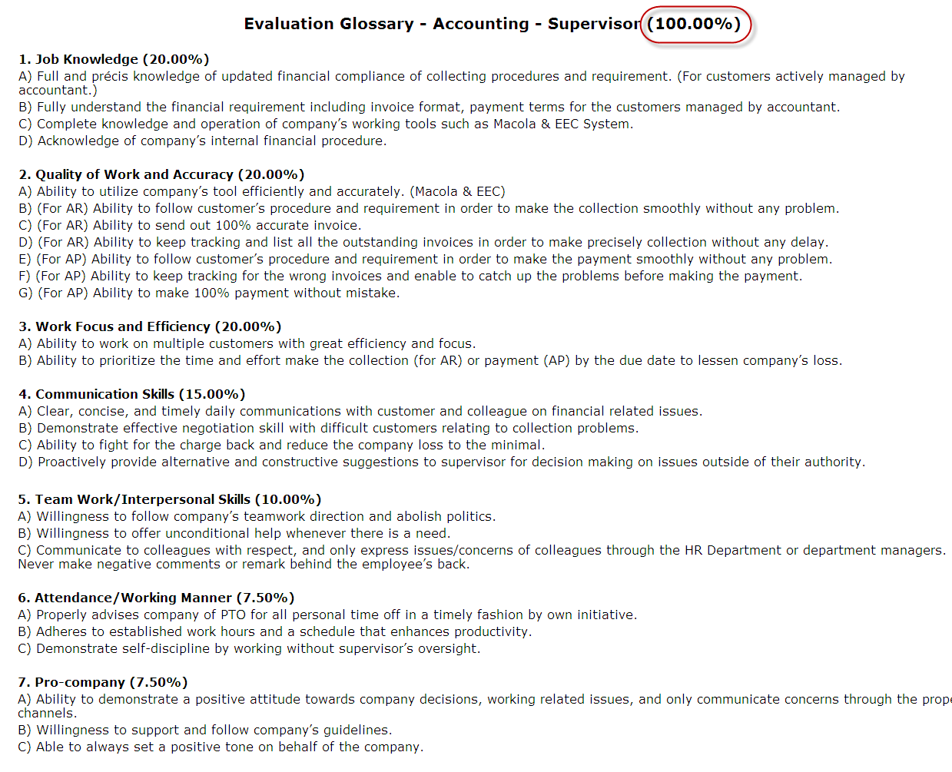

Setup the Report Department
- Open Report Department under Evaluation Maintenance.
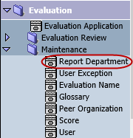
- Enter the data and click Save to create a new report department. Users who with the same report department will compare the scores and list the result in the Self Review page.
- Click Delete button in the gird can delete the report department.

Score Maintenance
    - Open Glossary page under Evaluation Maintenance
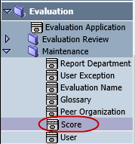
    - Create new score description on Evaluation Criterion tab. Enter the field and click Save button.
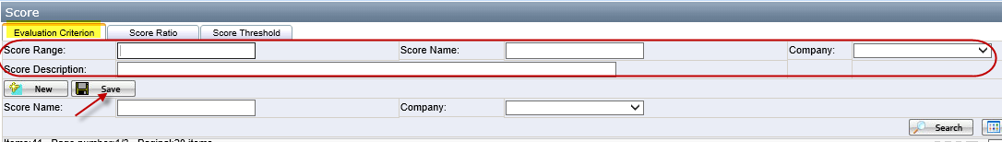
    - After saved successfully, sequence No. will be automatically configured. User can change the No. manually to resort the score description.
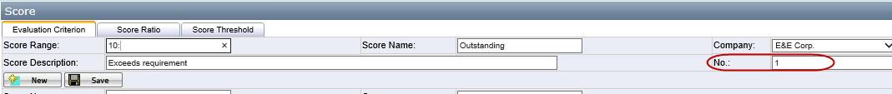
    - Go to Score Ratio tab to setup the score ratio. The final score calculation will based on the ratio.
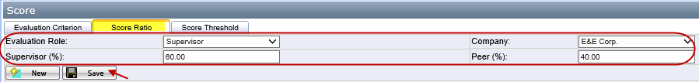
    - Go to Score Threshold tab to setup the score threshold. For evaluation, users have to input comments if their score is not within min-max threshold.

Setup the Email Template
- Go to Email Template under Administration EEC Setting.
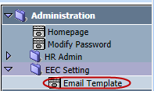
- Select the Email Type and enter the Email Name, then click Save button.
- After saving successfully, there will be Content button appear. Click the Content button to open the Email Detail page.
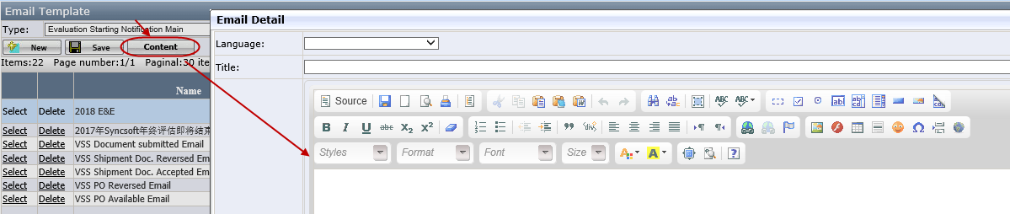
- Editing the email content and click Save. The Email Template will list at the bottom.
- Title: Email subject when send out
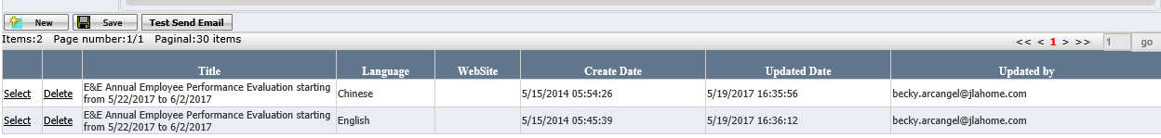
Note: Each Email Template must contain both language
- Select one email and click Test Send Email button, type the valid email address and click OK. This template will be sent out to the email address.
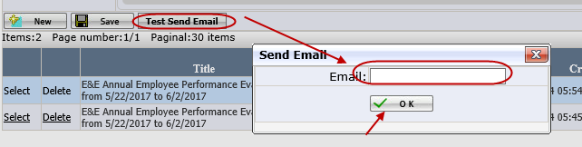

Setup the Evaluation Name
- Open Evaluation Name under Evaluation Maintenance.
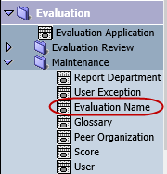
- Enter the required field and click Save.
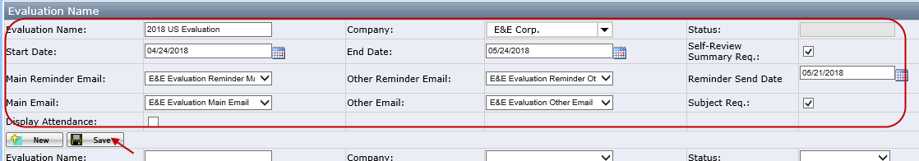
- Start Date: Default =Current date + 1 week
- End Date: Default =Start Date +1 month
- Main Reminder Email/Email Template: Select the email template from dropdown list
- Other Reminder Email/Email Template: Select the email template from dropdown list
- Reminder Send Date: reminder email send date
- Self-Review Summary Req.: If checked, the user must enter self-summary in self-evaluation page
- Subject Req.: If unchecked, user can save and submit the scores even some subjects are missing scores
- Display Attendance: if checked, annually attendance will display on self-evaluation page
- New period is created and the status is Pending.
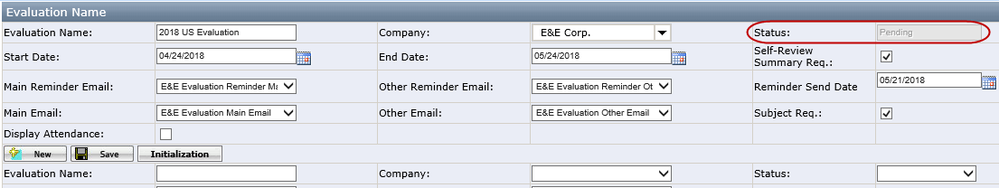
- After run Evaluation Service, if current date is >= Start Date, the status will change to Open, user can do evaluation. Then when current date is > End Date, the status will change to Closed.

Initialize Users
Initialization is used to generate the user’s relationship according to the assigned organization and it’s peer organization. It will update the related users' supervisor, peer and subordinate.

Initialize Multiple Users
There are two ways to initialize multiple users.
- Initialization on Evaluation Name page
After Evaluation Name saved successfully, there will button Initialization appear. Click the button, there will be a warning message “Are you sure to initialize all user evaluation settings for the selected company?” Click “Yes”, all the users under the company and who’s initialization status is “No” will be initialized.
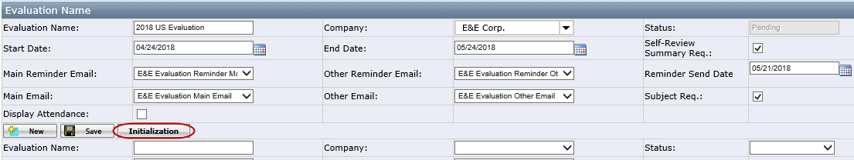
- Initialization on User page
    - Open User page under Evaluation Maintenance.
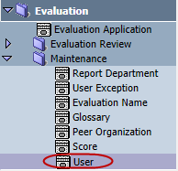
Note: All the users, which are active, checked with evaluation Req., assigned with Evaluation Role and Organization Name will be listed in the user list
    - Select one or multiple users and click Initialization button. There will be a message: “Are you sure to initialize the evaluation setting for the selected user(s)?” Click Yes, the selected users will be Initialized. 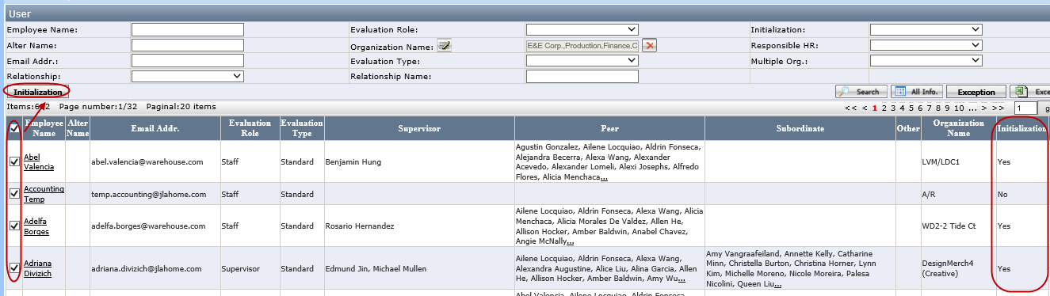
Note:
- If the user is not initialized, the Initialization status is “No” in the grid, otherwise is “Yes”
- When there is score with the user, the checkbox will be gray out. HR can re-initialize the user by clicking each user’s initialization button. See How to Re-initialize User

Initialize Single User
- Click the user name in the grid, whose initialization status is “No”.
- There will be a warning message: “You cannot open this user evaluation setting page since his/her user evaluation setting has not been initialized. Do you want to initialize it now?” Click OK to initialize this user and User setting page will be opened after initialized complete.
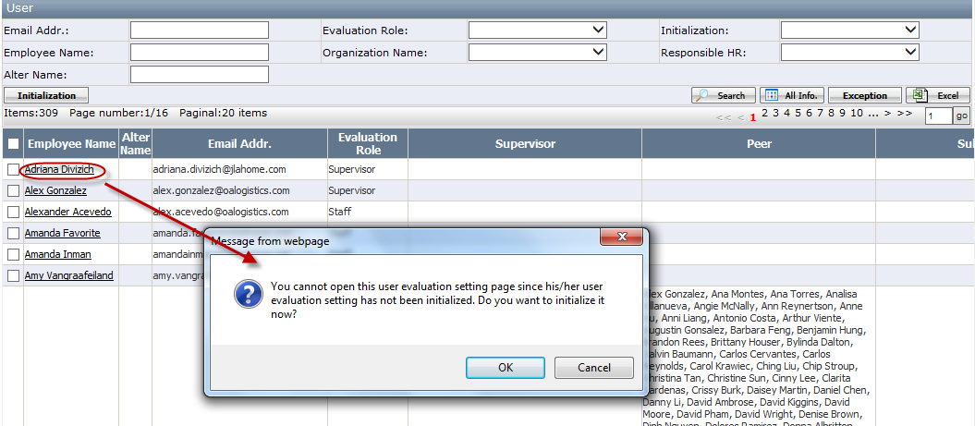

Manually Adjust Relationship after Initialization
After initialization, user’s relationship can be viewed on User Setting page and the relationship can be manually adjust if necessary.
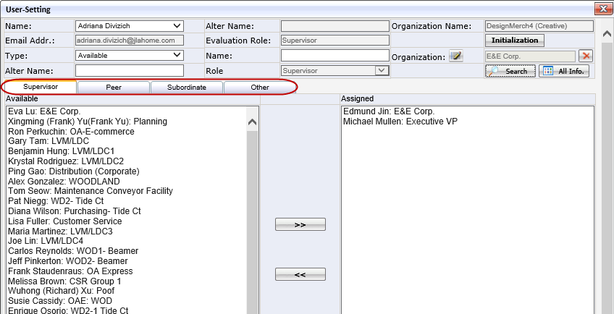
Supervisor Tab
- Available: List all users under the same company whose role is supervisor and the organization level is higher than the user’s organization level.
- Assigned: For supervisor it will automatically assign one level higher organization supervisor as his supervisor; for staff role user, it will automatically assign his current organization’s supervisor as his supervisor.
Peer Tab
- Available: List all users under the same company. If the user who has been assigned to "Supervisor" or "Subordinate", it will not be listed here.
- Assigned: For supervisor role user, it will automatically assign the user whose role is supervisor within the same organization level and the staff users one level higher as his peer; for staff role user, it will automatically assign the user whose role is staff within the same organization level as his peer.
Subordinate Tab
This tab is only available if the user with the evaluation role Supervisor.
- Available: List all users under the same company whose role is staff and the organization level is lower than his own organization level.
- Assigned: For supervisor role user, it will automatically assign one level lower organization supervisor as his subordinates.
Other Tab
This tab is used when some employee who are not involved in evaluation but have to evaluate others.
- Available: List all users
- Assigned: Empty

User can search the user by search criteria, select the users in the available fields and click “>>” icon to add the users to the Assigned field.
User can select the users in the assigned fields and click “<<” icon to delete the users from the Assigned field to the available field.
Note: After Re-initialization, the manual adjustment will be cleared.
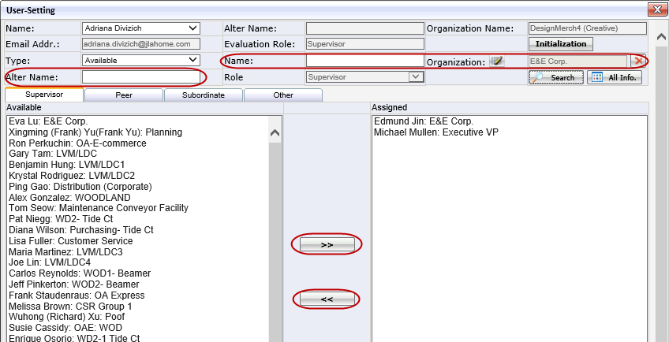

Checking the User Exception
After all the users are initialized, HR can go to User Exception report to check users who are missing supervisor, peer or subordinator.
    - Go to User Exception under Evaluation Maintenance.
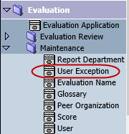
Note: User can also click Exception button on User list to open the exception report.
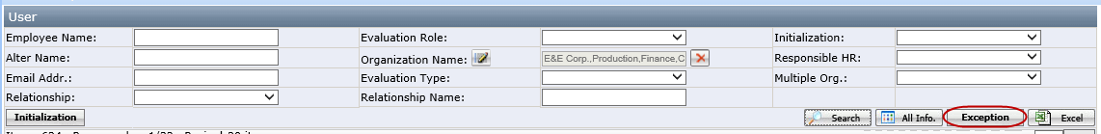
    - Select the Evaluation Name and click Search.
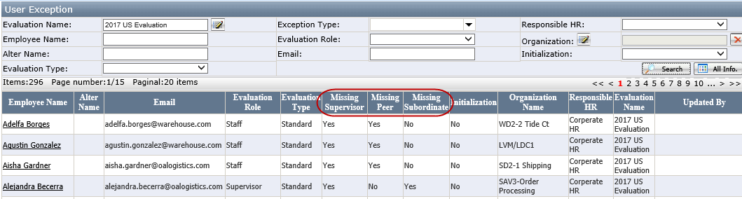

Evaluation Service
Evaluation Service is run regularly.
- If the Evaluation start date on Evaluation Name is <=current date, the status of period will change to Open. System will send email to the Employees and Employees can start to evaluate.
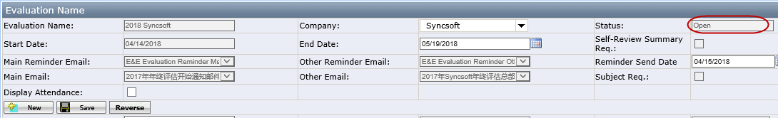
- If Reminder Send Date = current date, system will send a reminder mail to Employees.
- If the Evaluation end date is < current date, the status of period will change to Closed. System will send closed email to the Employees.
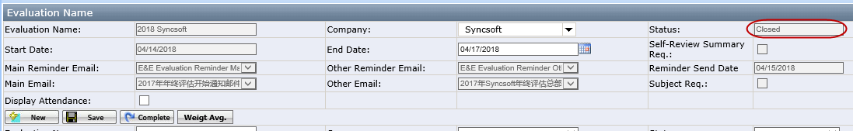
- Click Complete button, the period status will change from Closed to Complete. Users cannot access the Evaluation Application anymore.
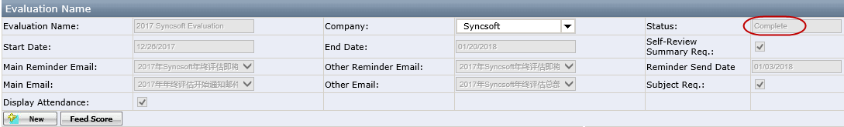

Evaluation Result Review
Supervisor can review his team’s evaluation result on Summary Review page.
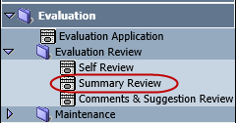
Note:
- This page only allows the employee who has the Supervisor evaluation role to access. Each supervisor can only review his own organization evaluation result. HR Manager can review the whole company evaluation result.
- When the evaluation is in "Open" status, the evaluation result is not finalized. When you click this page, it will get a warning message below. If you click OK, it will open Summary Review page.
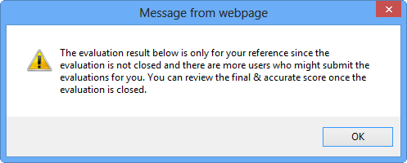

Summary Review
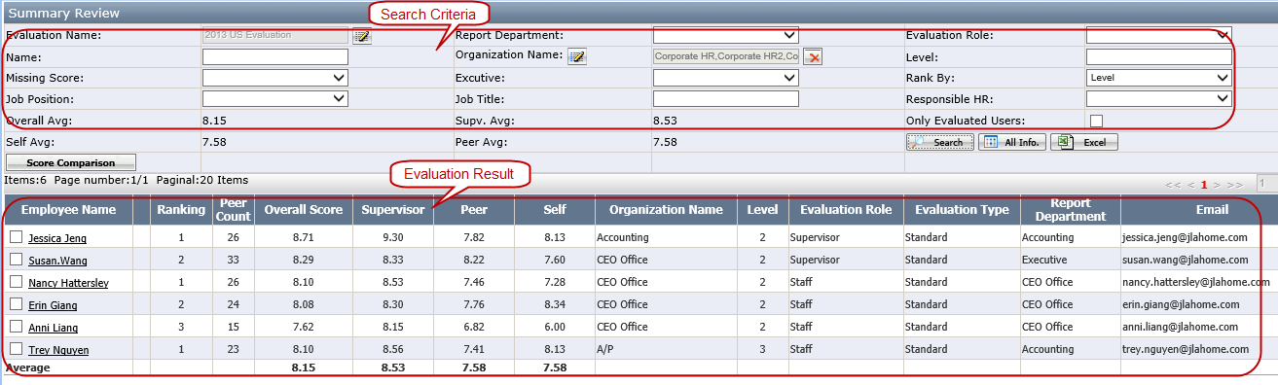

Search Criteria
- Report Department: Search out the employee who have the selected report department
- Organization Name: Search out the employee who are assigned to the selected organization
- Missing Score: Search out the employee missing Peer or Supervisor or Self Score
- Level: The level of the organization
- Rank By: the ranking will be different according to the rank by
Level: It is the default value, result will rank by Level--> Evaluation Role-->Overall score
Overall score: Rank by Overall score
Peer Score: Rank by Peer score
Report Department: Rank by Report Department--> Evaluation Role-->Overall score
Supervisor Score: Rank by Supervisor score
- Executive: Search out the employee having the executive role

Evaluation Result
- Missing Score: If user missing score, there will be a red flag
- Ranking: System automatically generated rank according to the rank by
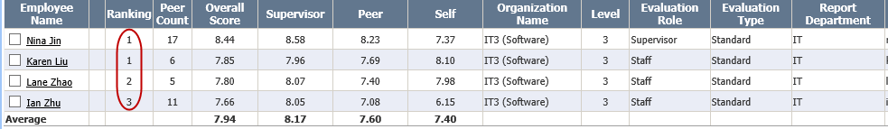
- Overall Avg.: It is average of the peer score based on your search result excluding the employee missing Peer or Supervisor Score
- Self Avg.: = (Employee 1 Self Score + Employee 2 Self Score +…)/Total Employee Number excluding the employee missing Self Score
- Supv. Avg.: = (Employee 1 Supervisor Score + Employee 2 Supervisor Score +…)/Total Employee Number excluding the employee missing Supervisor Score
- Peer Avg.: = (Employee 1 Peer Score + Employee 2 Peer Score +…)/Total Employee Number excluding the employee Peer Score
- Export Button: click to export the result to excel file
- Score Comparison Button: Select the users and click it will group the evaluation result by evaluation role(supervisor/staff)

Individual Employee Review
Click the employee name to open the evaluation result of individual employee.
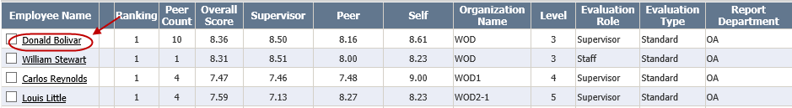

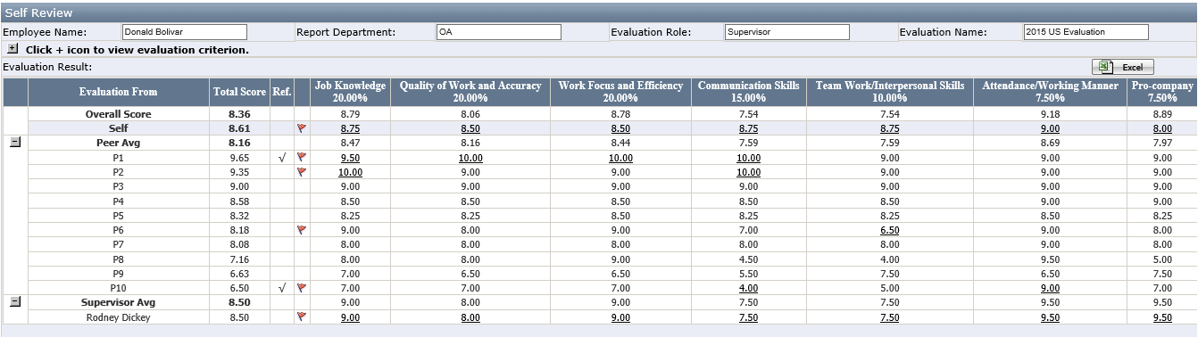
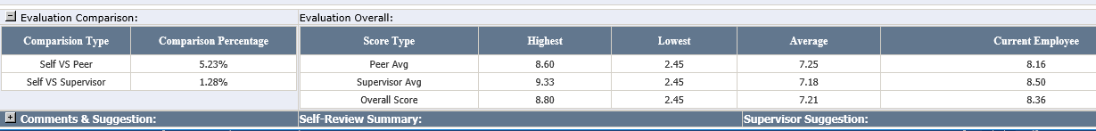

Evaluation Result
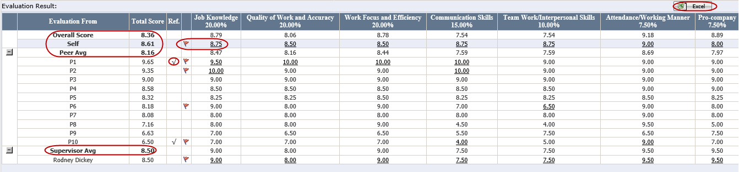
- Total Score:
Overall Score = Peer Avg. * 40% + Supervisor Avg. * 60% (The percentage is maintained by HR on Score/ Score Ratio)
Self = Sum of (Score of each subject* Score Percentage of each subject)
Peer Avg. = (P1 Total Score + P2 Total Score +…)/Total Peer Number
Supervisor Avg. = (Supervisor1 Total Score + Supervisor2 Total Score +…)/Total Supervisor Number
- Ref.: the highest and lowest score will have a check
- Comment Flag: If there is a comment for any score, it will have a red flag. You can click the score having the hyperlink to review the comment
- Excel: export the evaluation result to an excel file
- The score for each subject is an average score = Peer Avg. of each Subject * 40% + Supervisor Avg. of each Subject * 60%

Evaluation Comparison
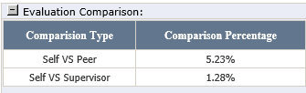
Self VS Peer: (Self -Peer Avg.)/Self * 100%
- If the percentage is positive, it means self-score is higher than Average Peer Score
- If the percentage is “0”, it means self-score is equal to the Average Peer Score
- If percentage is negative, it means self-score is lower than Average Peer Score

Self VS Supervisor: (Self -Supervisor Avg.)/Self * 100%
- If percentage is positive, it means self-score is higher than Average Supervisor Score
- If the percentage is “0”, it means self-score is equal to the Average Supervisor Score
- If percentage is negative, it means self-score is lower than Average Supervisor Score
Note: If the employee has no Self Score, Evaluation Comparison will be blank.

Evaluation Overall
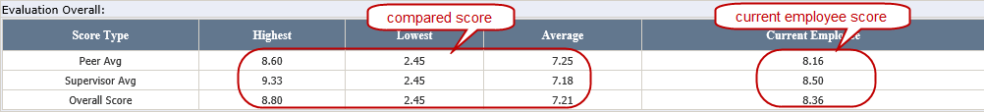
- Compared Score
List Highest, Lowest and Average of Peer Avg. Score/ Supervisor Avg. Score / Overall Score in the same report department
Note: If the employee is missing supervisor or peer score, it will not be counted as part of Highest, Lowest and Average of Peer Avg. Score/ Supervisor Avg. Score / Overall Score.
- Current Employee Score
See Overall Score, Peer Ave. Score and Supervisor Avg. Score in Total Score of Evaluation Result

Appendix

Page Role Control
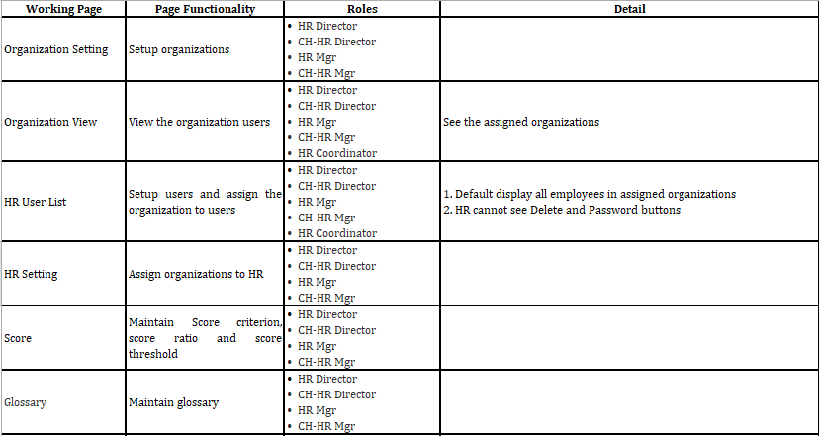
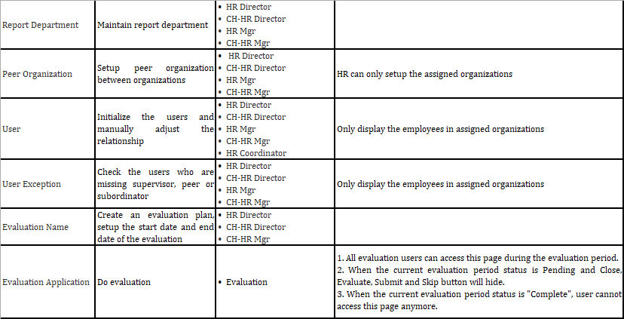
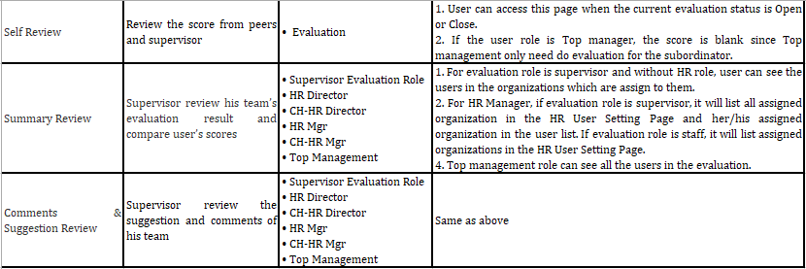

FAQ

How to Move the Organization
- Select an organization and click Move Org. button.
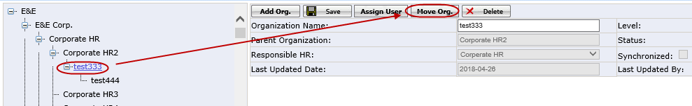
- Choose an organization in the pop up window and click OK.
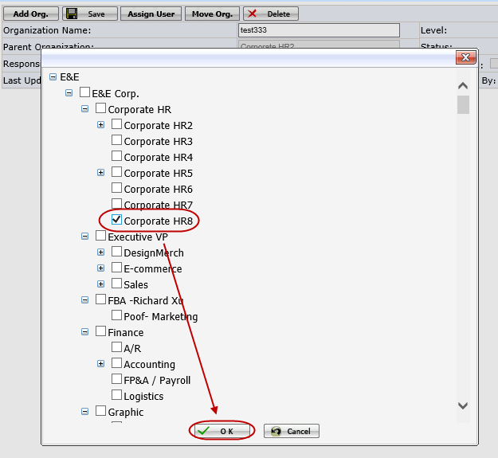
- There will be alert message, click OK to continue to move the organization.
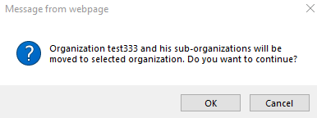
- After the organization moved successfully, it will list under the selected organization.
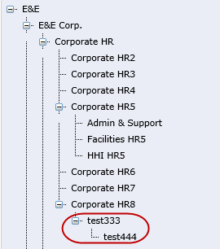
- The Glossary, Peer Organization and Report Department will be removed after Organization moving. Go to the maintenance page to setup accordingly.
Note: Move Org. function can’t be used when evaluation period start

How to Delete the Organization
Select one organization and click Delete button to delete the selected organization.
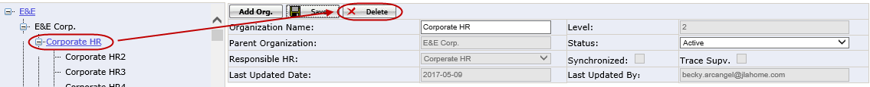
Note: User will receive below error if there is user assigned to the organization or the organization has the peer organization.
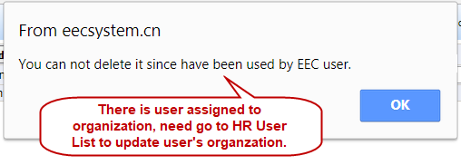
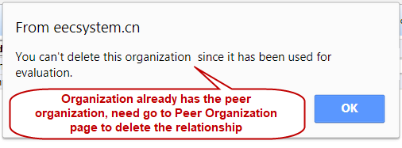

How to Create a New User
- Go to HR User List page under Administration HR Admin
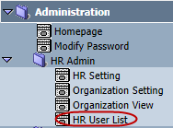
- Click New to open Edit User page. Put in Name and email address. Select Organization Name, Evaluation Role and Evaluation Type, then check Evaluation Req. checkbox for the user.
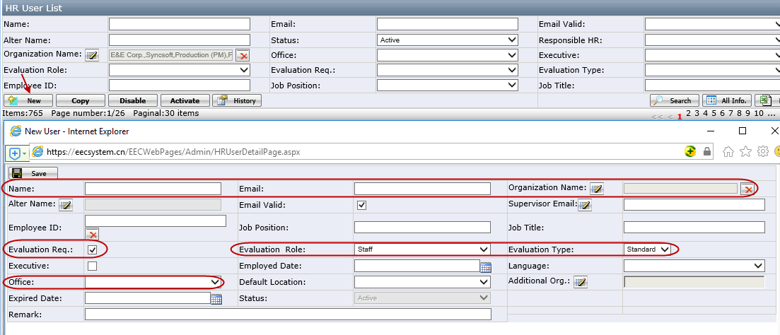
Note
- Users who check the Evaluation Req. checkbox will be listed in the “Organization view” page and “User” page
- Evaluation Type: Standard/No Peer/Other. No Peer means users have no peers. Other means users only need to evaluate their supervisors
- Supervisor Email: If user’s mail is invalid, system generated mail will send to this address
- Additional Org.: only enabled for users whose evaluation role is supervisor. It is used when users are in charge of more than one organizations
- Click Save button to save the changes.

How to Make Changes to Existing User
- Go HR User List page under Administration HR Admin.
- Search Out the user by the search criteria.
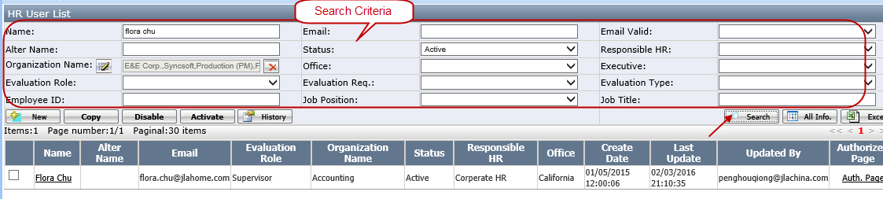
- Click the user name and update the info on the User Edit page, then click Save.
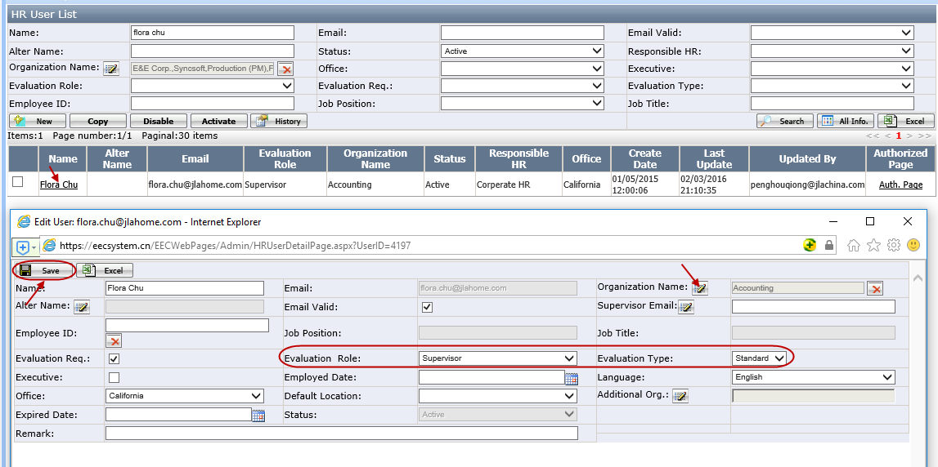

How to Add New Organization to the Existing Glossary
1) Search out the glossary by select an organization.
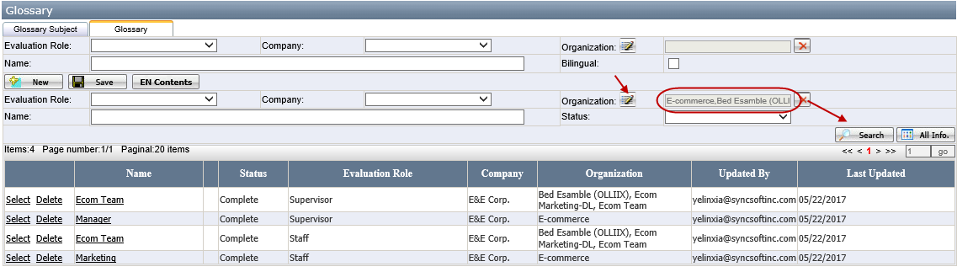
2) Select the Glossary and open the organization selection page. Select the newly add organization and click OK.
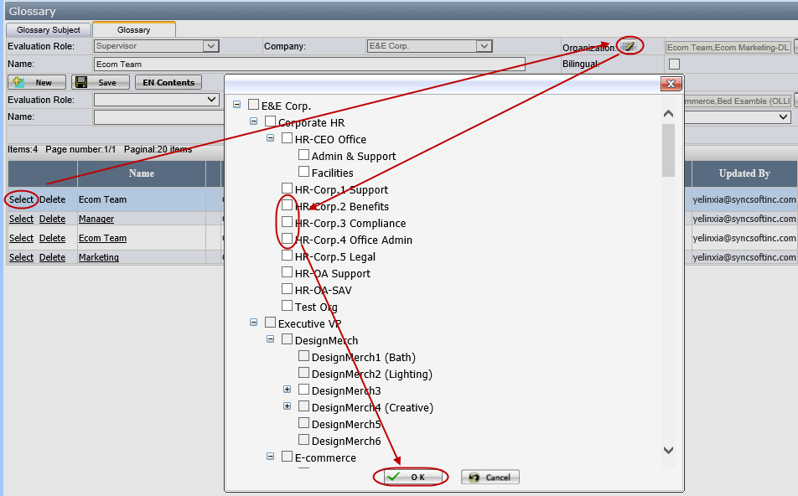
- Click Save button to save the changes.
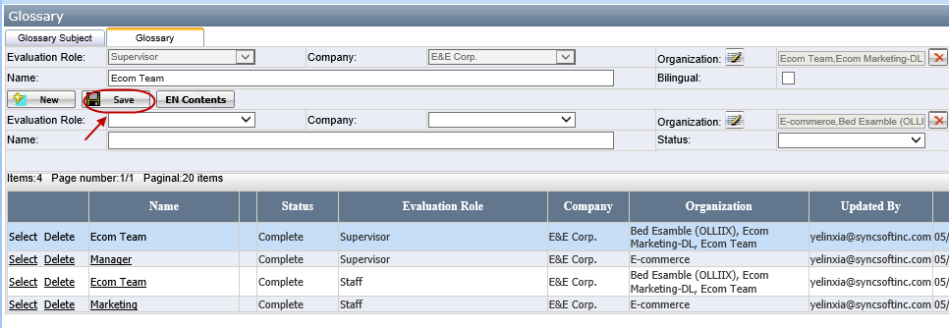

How to Re-initialize User
Click an initialized user (whose initialization status is “Yes”) to open the user setting page. There is another Initialization button in User setting page. By clicking this button, user can be re-initialized.

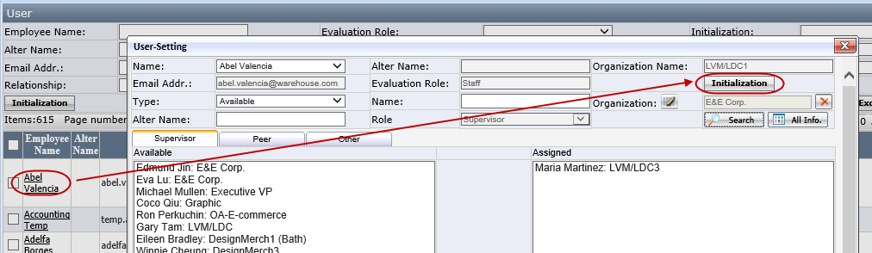
Note: This Initialization button can be used even if the period is started or there is score with this user. After initialization completed the scores will be cleared.

