Audit Bin
Wireless application Audit Bin is used to check the bin inventory accuracy, add item bin to cycle count request or directly cycle count certain item. Only User with job function Wireless Admin allow to login.

Audit Bin Tab
This tab is used to audit the item inventory under the current bin. User can add the item to cycle count request when there is inventory discrepancy.
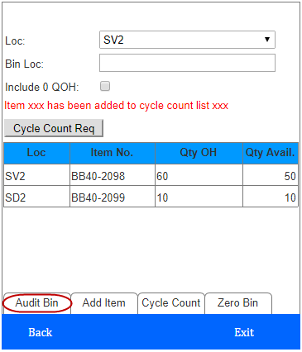
- Enter or scan the bin location barcode, the gird will display the item inventory of current bin for selected location and its related dotcom location.
- If Include 0 QOH is checked, it will display item with Qty OH<=0
- Select item and click Cycle Count Req button, the item will be added to cycle count request.

Add Item Tab
The tab is mainly used when user find item exists in bin which does not exist in system, user can use this tab to add the item bin into system, then cycle count it.
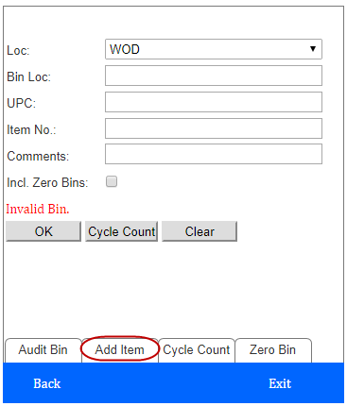
- Enter or scan bin location barcode.
- Scan the UPC or Item no.
- Put in the comments.
- Clear button: Click can clear all textboxes
- There are 2 ways to cycle count the item.
- Click OK, the item will be added to cycle count request.
- Click Cycle Count, will generate cycle count list for the item and open the Cycle Count Item List Form to cycle count the item.

Cycle Count Tab
This tab is mainly used when user want to cycle count certain item.
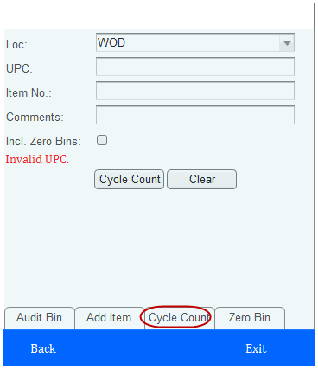
- Scan the UPC or Item No.
- Put in the comments.
- Clear button: Click can clear all textboxes
- Click Cycle Count, will generate cycle count list for the item and open the Cycle Count Item List Form to cycle count the item.

Zero Bin Tab
This tab is used to generate zero bin list and verify zero bins.
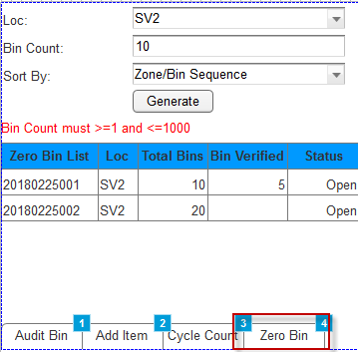
- Enter the Bin Count and select the Sort By then click Generate to generate zero bin list.
- Bin Count must >=1 and <=1000
- Sort By option:
Zone/Bin Sequence -- zero bin list will be sorted by Zone priority, Bin pick sequence & Bin No.
Bin Sequence -- zero bin list will be sorted by Bin pick sequence & Bin No
- Click Zero Bin List to open below Zero bin List Form.
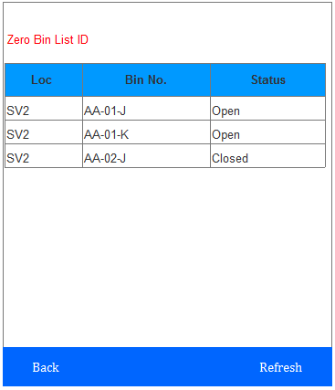
- Click the Bin No. to open below Zero Bin Verify Form.
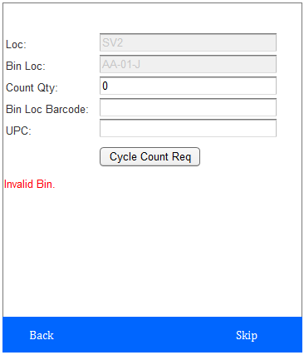
- Enter the Count Qty and scan the Bin Loc Barcode.
- If Count Qty = 0, system will automatically go to the next bin and update the current bin status to Closed.
- If Count Qty > 0, scan the UPC and click Cycle Count Req button to add the item to cycle count request.
- If Count Qty = Macola OH Qty - Inprocess Qty, message "System qty match count qty, do you still want to cycle count the item bin?" will pop up, click Ok to add item bin to cycle count request page

