Internal Replenishment

Background
Warehouse users transfer best-selling items from storage area to picking area every day. The problem is it’s not easy for them to find which item and bin need to replenish, and how many to replenish. The internal replenishment function will help to generate the replenish list which will indicate the item bins need to be replenished, replenish quantity, and where the quantity to pick from. The wireless application will help to transfer the inventory from storage area to picking area.

Maintenance
- Maintain the Bin Capacity (Cube) and Min (Cube) on Bin Location page.
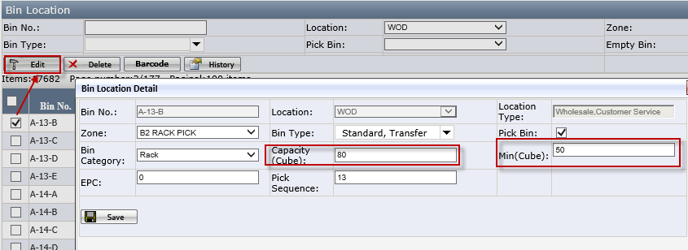
- Capacity (Cube): it is the maximum storage volume of the bin, this decides how many qty to replenish for this bin.
- Min (Cube): when bin allocated cube <Min Cube, system will replenish this bin. This decides when to replenish this bin.

- Maintain item bin location on Item Bin Maintenance page – this page will decide which item bins system will generate the replenish list.
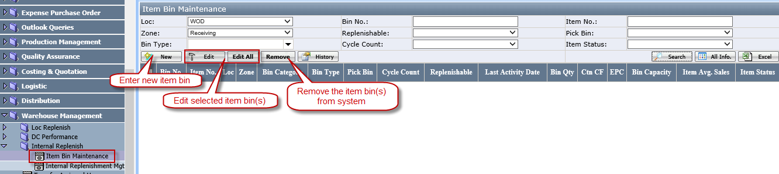
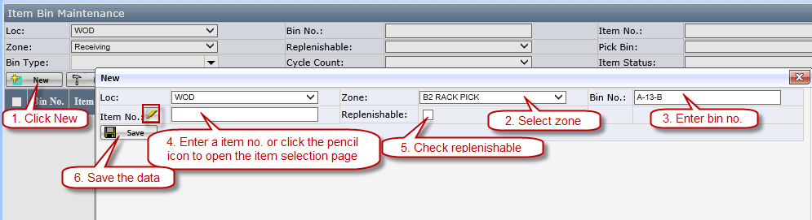
- Replenishable: system will generate replenish list for item bins which Replenishable=Yes.
- System allow to click Edit All button to edit Replenishable flag for all bins under the selected Zone.
- When Item Bin is set up as Replenishable, other items will not be able to transfer to the same bin.
- Contact EEChelpdesk to initialize all item bins setup.

Generate Replenish List
- Go to Internal Replenishment Mgt page.
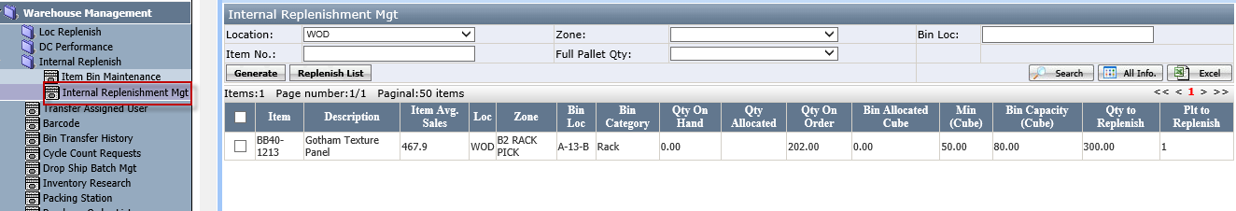
- Grid will list the items with Replenishable=Yes on Bin Maintenance page

- Generate internal replenish list.
- There are 2 ways to generate internal replenish list.
- Click Generate directly, system will generate replenish list for all items with Replenishable=Yes.
- Select the item and click Generate, system will generate the list for the selected items.
- Configure the Generation Option and click OK.
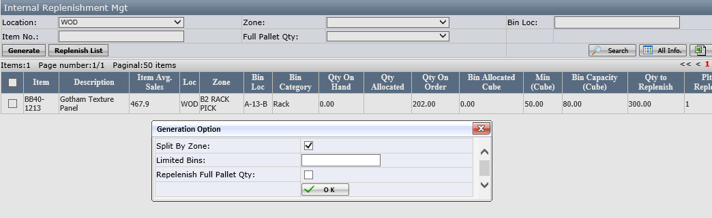
- Split by Zone: when this is checked, system will split replenish list by Zone name
- Limited Bins: if this has value, system will split replenish list according to total bins in each list
- Replenish Full Pallet Qty: when this is checked, system will only replenish full pallet qty (The data is from carton/pallet on Rec. Item Carton Per Pallet page).

- Print the internal replenish list.
- Click Replenish List button to open Replenish List page. This page lists all the internal replenish lists.
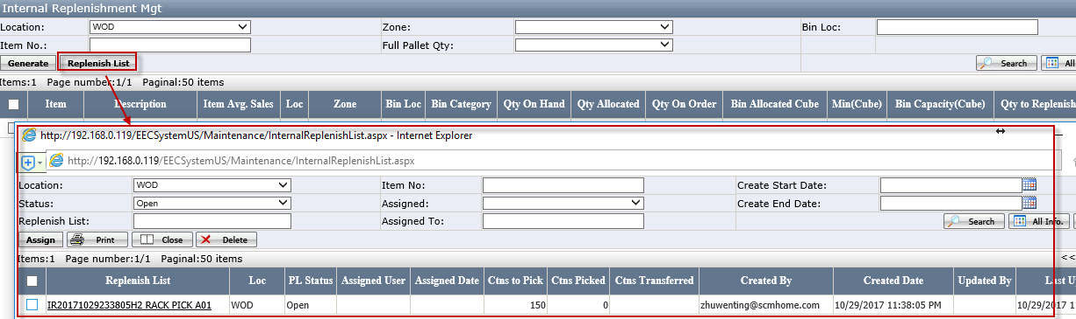
- Assign: assign the selected Replenish list(s) to user
- Close: close the replenish list without finish the picking & transfer
- Delete: delete open replenish list
- Click Replenish List link will open the detail page
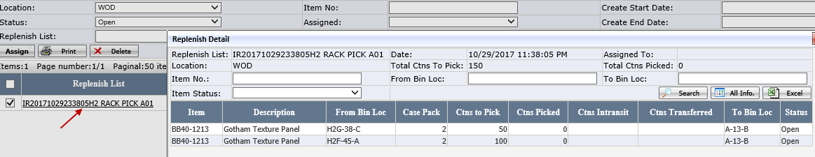
- Select one replenish list and click Print button. Select the sort by and click OK.
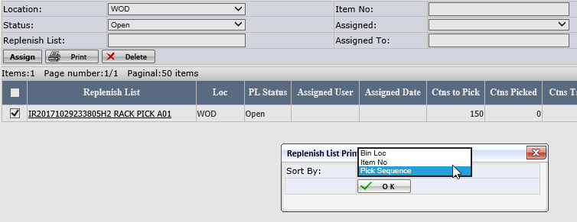
- Bin Loc: Sort by Bin Loc, Item No.
- Item No.: Sort by Item No, Bin Loc.
- Pick Sequence: Sort by Pick Sequence, Bin Loc & Item No.
- System will open replenish list PDF report
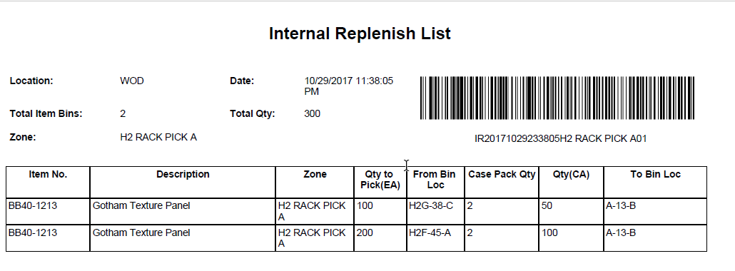

Wireless Application – Internal Replenish

Install the new application
- Go to http://192.168.0.94/m/
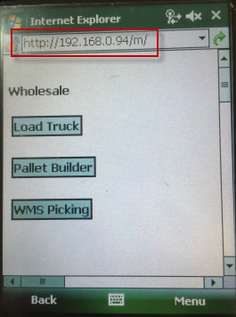
- Scroll down to find the Internal Replenish.
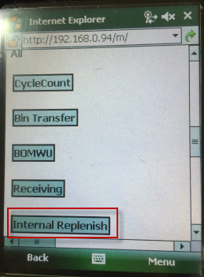
- Click to download the file.
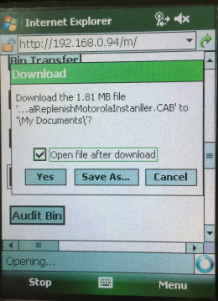
- Install the application under Application folder.
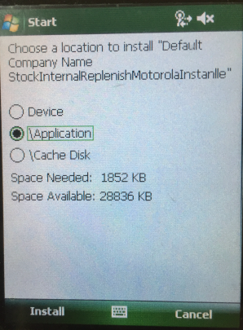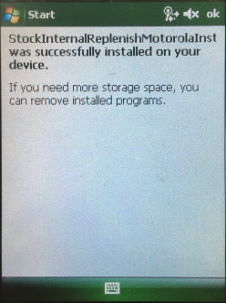

Do Internal Replenish with the wireless application
- Scan the replenish list barcode
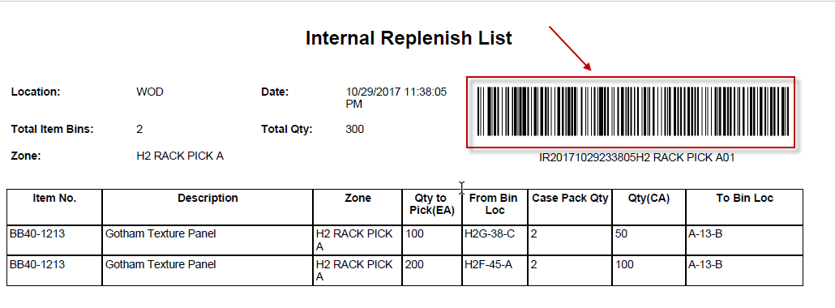
- Click the replenish list to open replenish list item form.
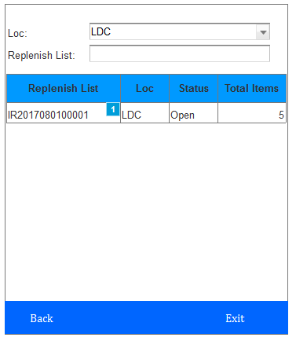
- Click the item on Picking tab to open Picking Form.
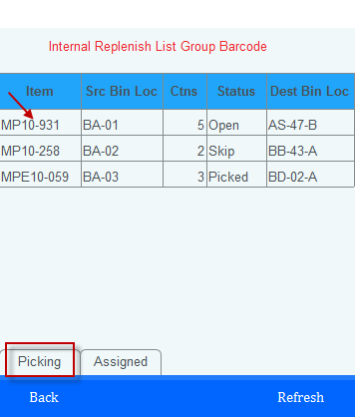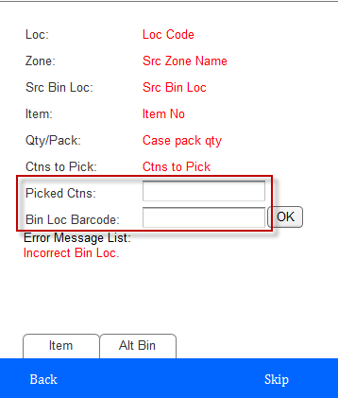
- Enter the picked ctns.
- Scan the bin loc barcode or click the OK button to finish the picking.
- User can click the Alt Bin to pick from an alternate bin.
- Skip pick items if Src Bin Loc is closed to Dest Bin Loc, this may due to item bin maintenance problem.

- Click the item on Assigned tab to open put away tab.
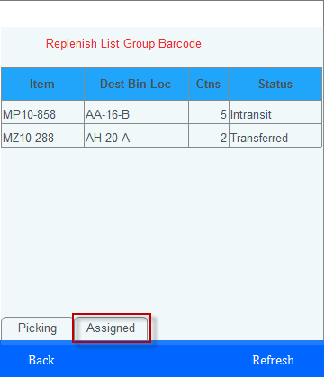

- Scan the bin loc barcode or click the OK button to finish the put away.
