Generate Dropship Label File User Guide

How to Generate Label File
We don’t use Warehouse live to print label from now on. There are other two ways to generate the label:
- Automatically Generate
- Manually Generate

Automatically Generate – Recommend to Use
Add Batch to ServiceService generate Label fileDownload Label file in the Batch list

Manually Generate – Only apply to FC cartons
Open FC Docs pageGenerate PacksPrint Labels (Check Generate Label File) Download Label file in the Batch list

Automatically Generate – Recommend to Use
- Open Drop Ship Batch Mgt. page.
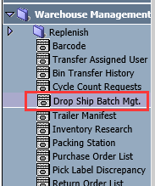
- Select a batch with Pre-Prepare Ship Doc status. Click Pick List button to generate the pick list.
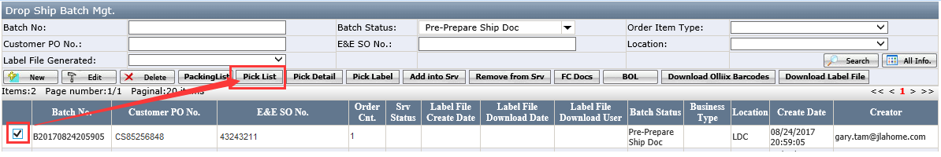
- Click Add into Srv button.
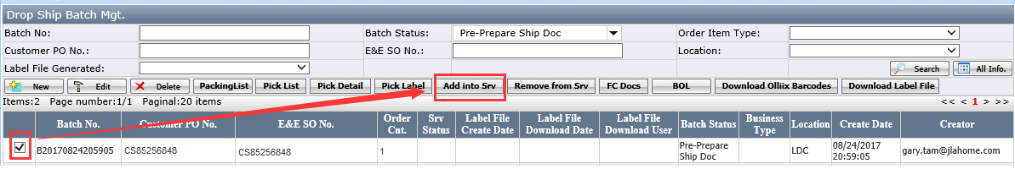
- Batch is added successfully and Srv Status changes to Waiting.
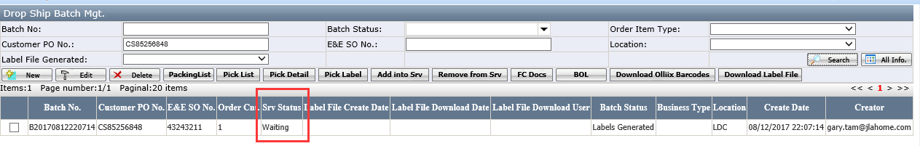
- After Service generated label file successfully the Srv Status become Complete. Label File Create Date displays.
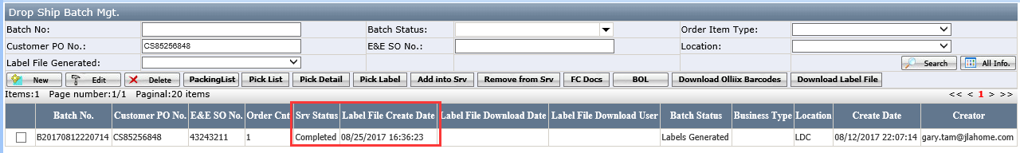

Manually Generate
If batch has less than 50 cartons and all cartons are FC, label file can be generated manually in EEC
- Open Drop Ship Batch Mgt. page
- Select a batch with Pre-Prepare Ship Doc status. Click Pick List button to generate the pick list.
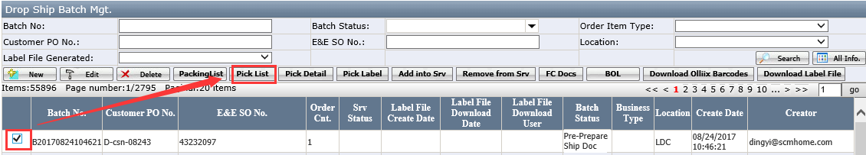
- Click FC Docs button.
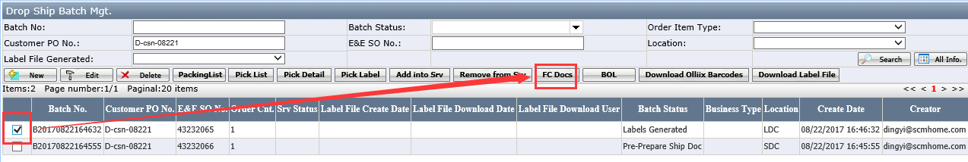
- Click Gen. Pack button.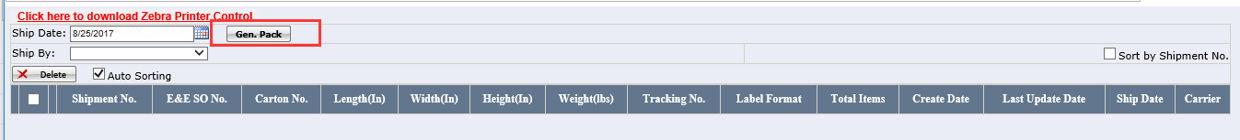
- Select Ship By and check Generate Label Files, then click Print All button.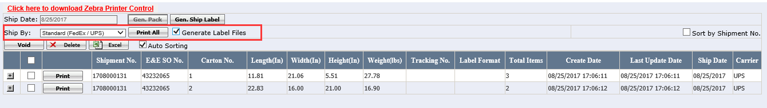
- Generate Label Files checkbox is disable after file generated.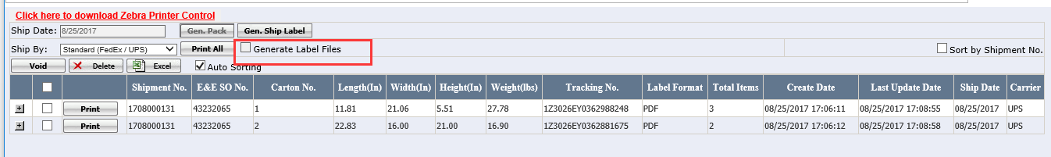
- Back to Batch List page and the Label File Create Date displays.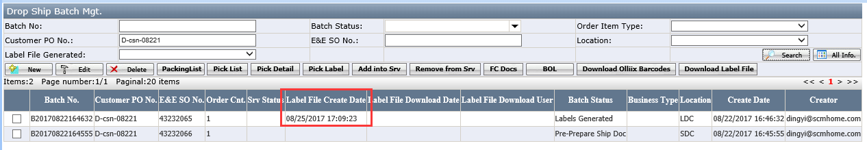

How to Download Label File
- Open Drop Ship Batch Mgt. page.
- Select Label File Generated as “Yes” and click Search button.
- Select a batch and click Download Label File button.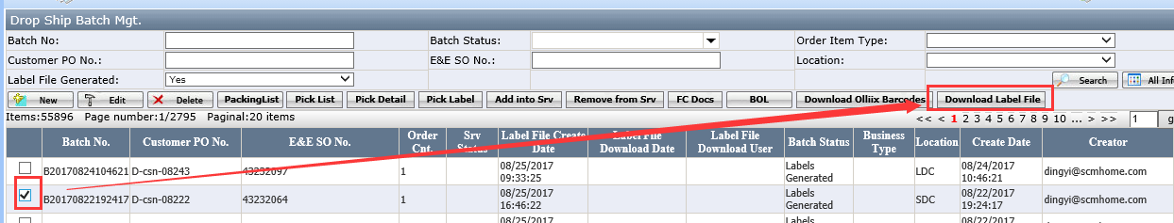
- Click Download or file name in the grid to download the label file.