How to Cancel Item Due to Inventory Issue
- If item has been packed, Warehouse Admin needs to follow below steps to delete the item carton first.
- Go to packing Station to void the shipping label.
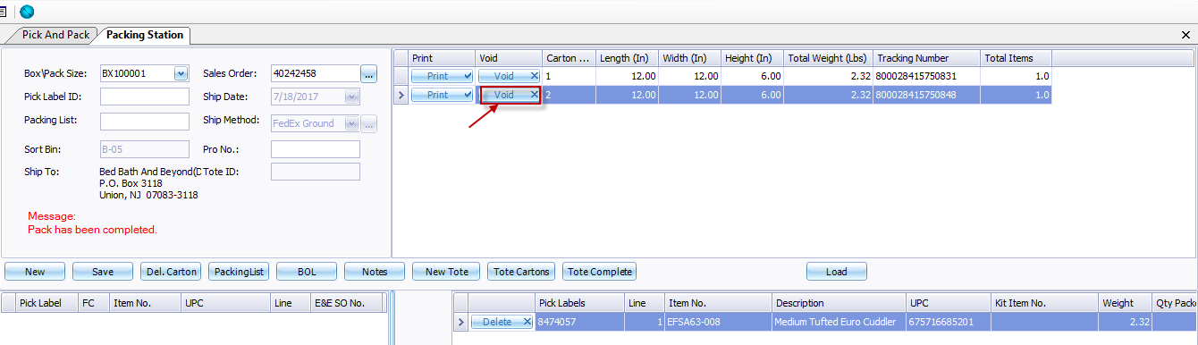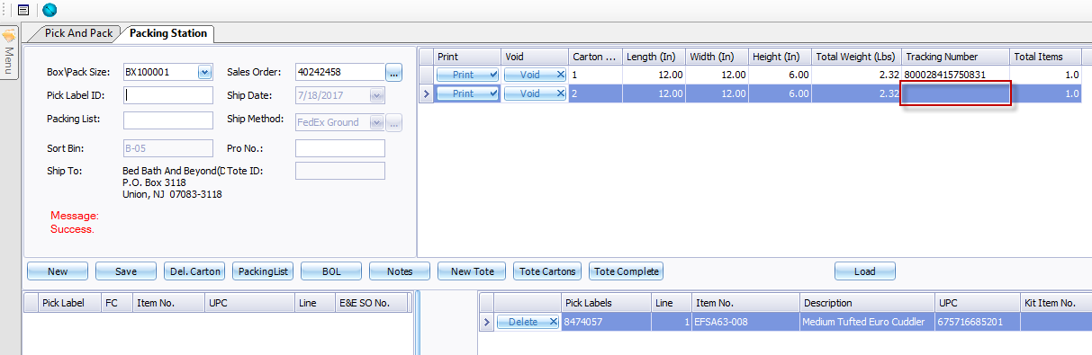
- Delete the carton.
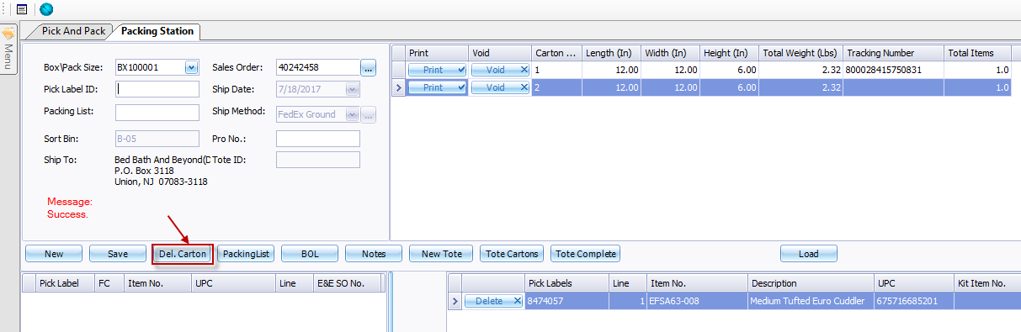
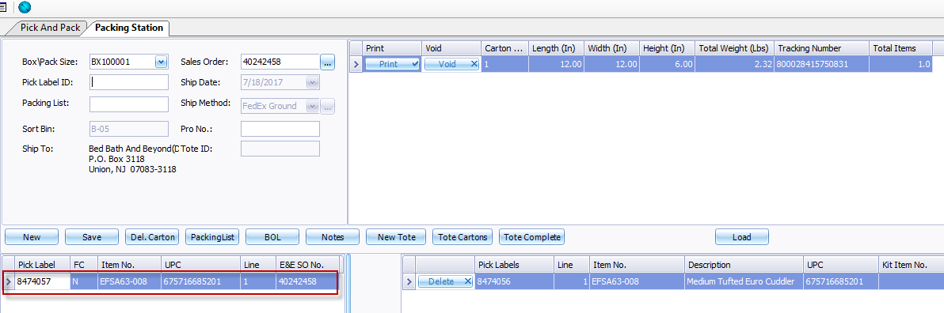

- Customer service goes to cancel the item on order item detail page.
- Customer service allows to cancel the entire item, or cancel partial qty for the item.
- If item has been picked, only customer service admin allows to cancel it.
System will mark the pick list item bin as cycle count bin, please notify warehouse to return the inventory from 000 to physical bin, and cycle count the item.
