DC Performance User Guide

Maintenance

Activity- Set up Activity Priority
When the same operation can apply to multiple activity type, system will use the activity priority to decide which activity type the operation belongs to. So please make sure the activity priority is correct in the Activity Type page.
- Open Activity Type page.
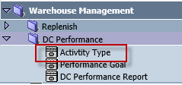
- Select an Activity Type.
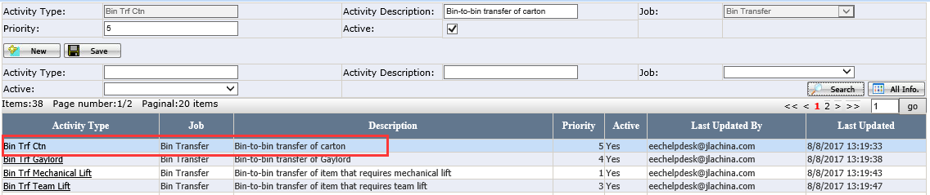
- Enter Priority and click Save.

Performance Goal – Set up Performance Goal
- Open Performance Goal page.
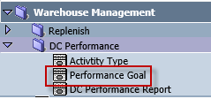
- Click New.
- Select Location, Zone, Job and Activity. Enter Goal and click Save.
- A new Goal will display.
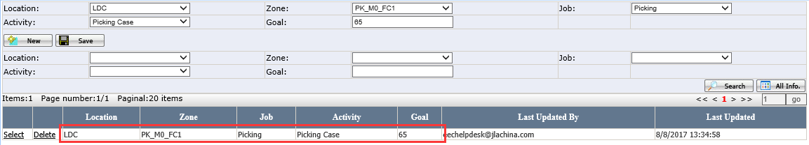
- Users can delete a Goal by clicking Delete.
- Zone is an optional field. Following Jobs doesn’t need Zone in the Goal page.
- Truck Load
- Pallet Build
- Packing

DC Performance Report
This report is used to show the working performance for warehouse user.
- Open DC Performance Page. User can do search by Job, Activity, Location, User and Date.
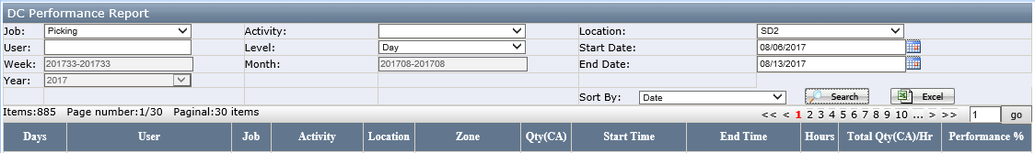
- Formula
- Qty(CA): total quantity or cartons in the time frame.
- Start Time and End Time: wireless app login and logout time
- Hours = End Time-Start Time. It is the actual working hours.
- Total Qty(CA)/Hours = Qty(CA)/Hours
- Performance %= [(Total Qty(CA)/Hours)/Goal]*100

- Working hours are calculated by Login and Logout time. So please remember to logout the wireless App and USWarehouse when:
- take a break more than 15 mins
- switch the job
- switch the activity
- switch the zone when do following jobs
- Picking
- Cycle Count
- Put Away
- Replenishment
- Bin Transfer

- Example of user doesn’t logout APP when switch the activities or zones:
- When switch jobs to other activities without logging out. Time frame and Hours are the same for the job activities, so the performance for both job activities will be lower than it should be.
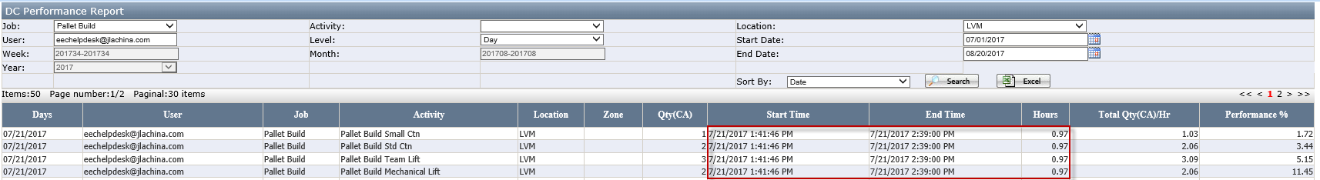
- When switch jobs to other Zones without logging out the App, time frame and hours are the same for the activities in these zones, so the performance in these zones will be lower than it should be.
