AIM Licensing Contract User Guide

Maintenance

Licensing Category - How to Create a Licensing Category
- Open Licensing Category page.
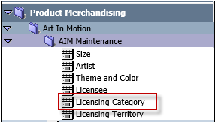
- Click New.
- Enter Category Code, Description, check Parent Category and click Save.
- A new Parent Category will display.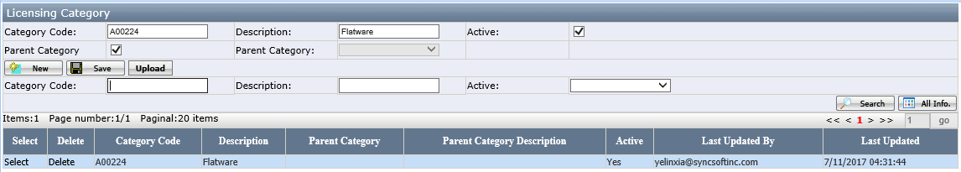
- Click New. Enter Category Code, Description, select Parent Category and click Save.
- A new Sub-Category will display.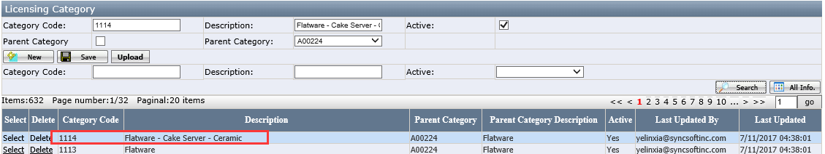
- Users can delete a category by clicking Delete. If any category is used by contract, then the category cannot be deleted and users will see a message as in below screenshot.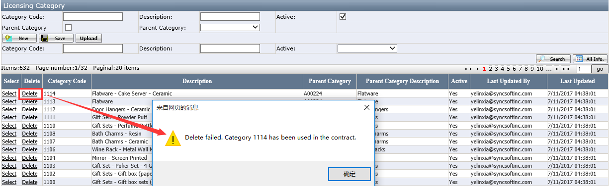

Licensing Territory - How to Create a Licensing Territory
- Open Licensing Territory page.
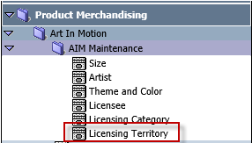
- Click New.
- Enter Territory Name, Description and click Save.
- A new territory will display.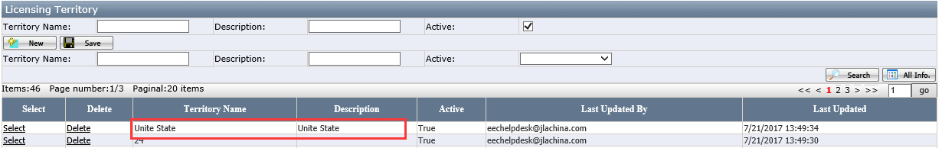
- Users can delete a territory by clicking Delete. If any territory has been used in contract, then users will not be able to delete it.
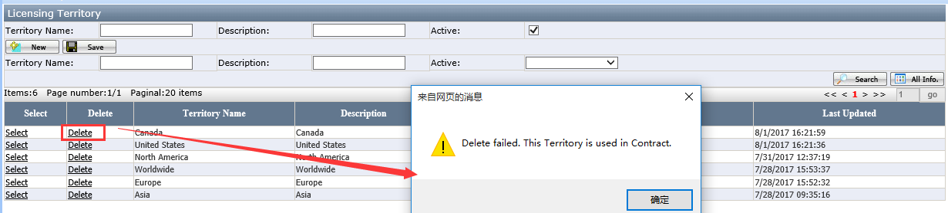

Licensee - How to Create a Licensee
- Open Licensee page.
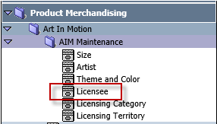
- Click New.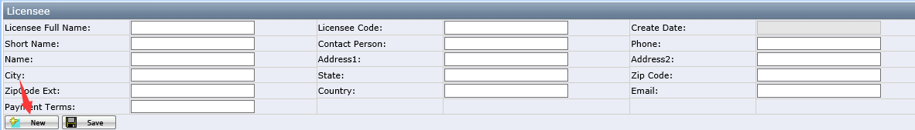
- Enter Licensee Full Name, Licensee Code, Short Name, Contact Person, Name, Address, Email, Payment Terms and click Save.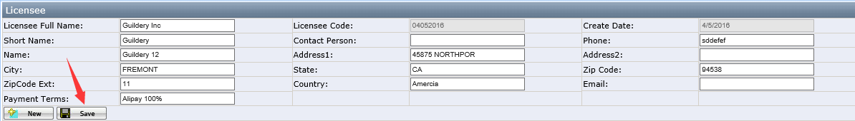
- A new licensee will display.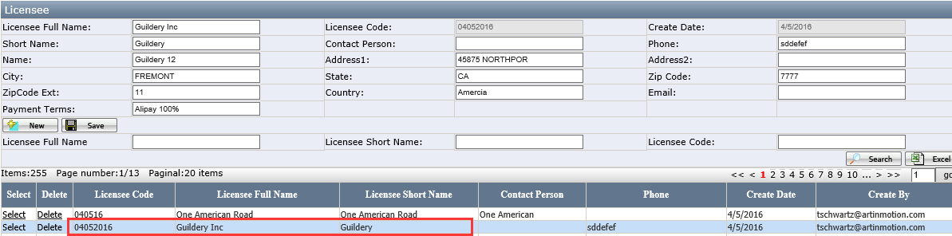

AIM Licensing Contract
It is an overview of all Contracts. Users can perform searching on this page.

How to Create a Contract
- Open AIM Licensing Contract List Page.
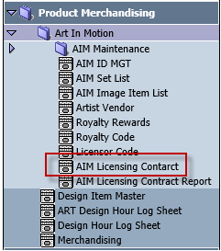
- Click New.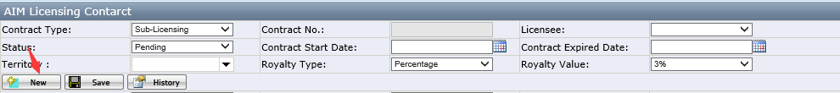
- Select Licensee, Contract Start Date, Contract Expired Date, Territory, Royalty Type, Royalty Value. Click Save.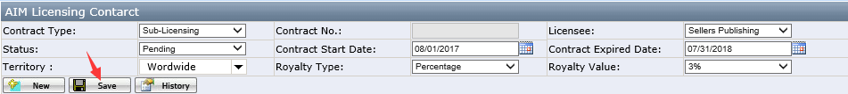
- Allow select multiple Territories.
- Contract No will be automatically generated.
- A new Contract will display.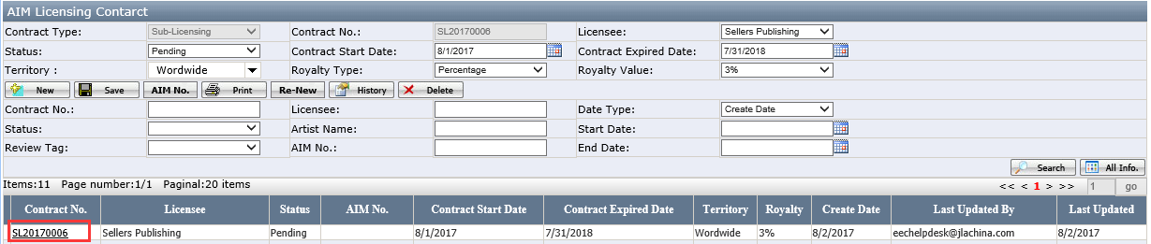

How to Add AIM No to Contract
- Click AIM No.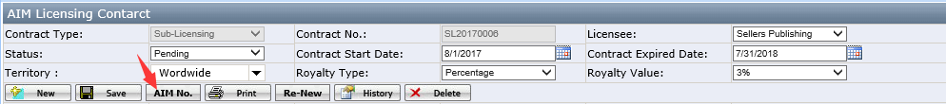
- Click the pencil icon near AIM No.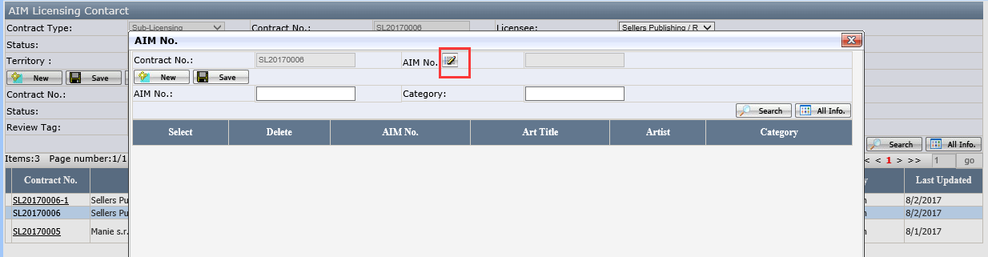
- Select an AIM No.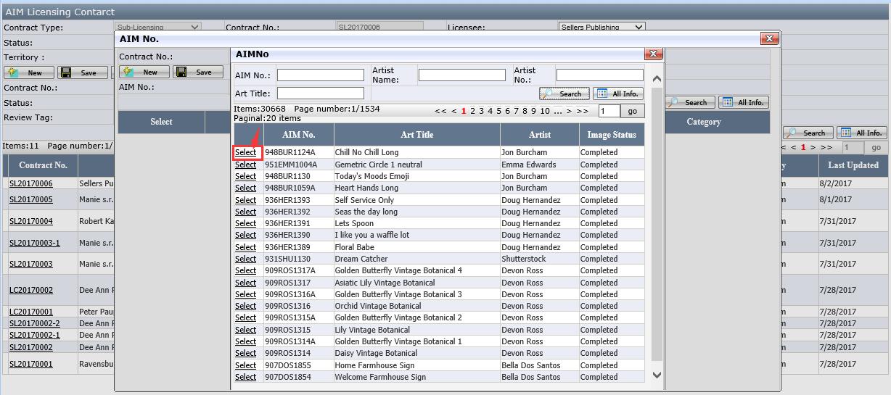
- Click Save button in the AIM No page.
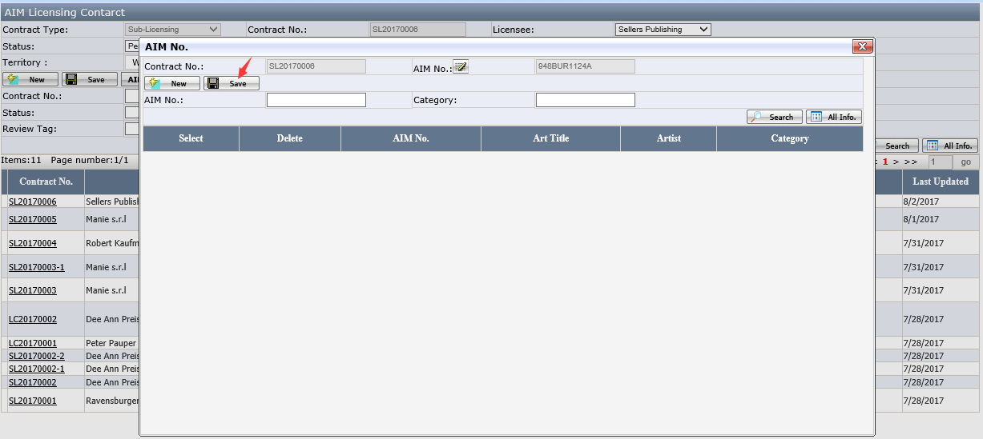

- A new AIM No record will display.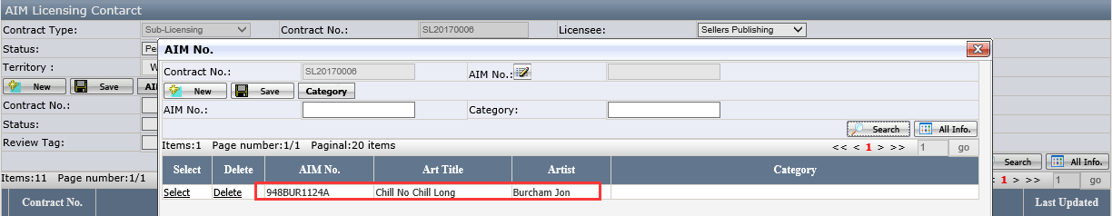
- Users can continue to add more AIM Nos under this contract by repeating the previous step.
- Click Delete to delete the AIM No.
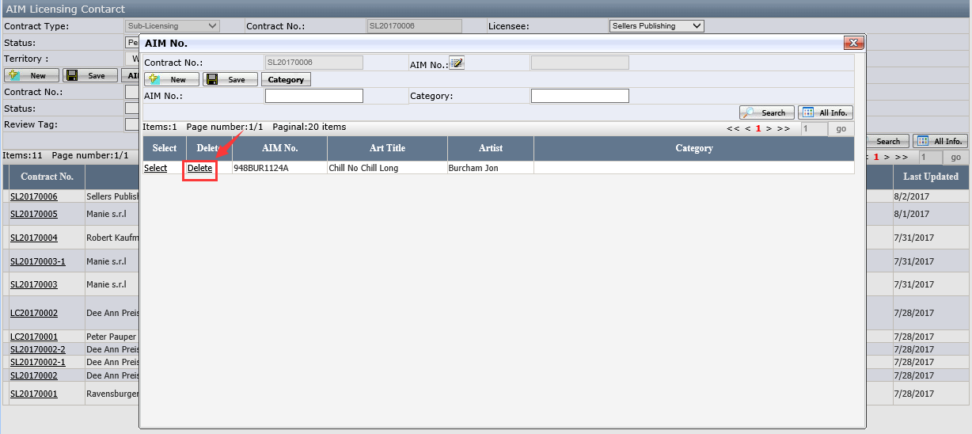

How to Add Category to AIM No.
- Select AIM No, click Category button.
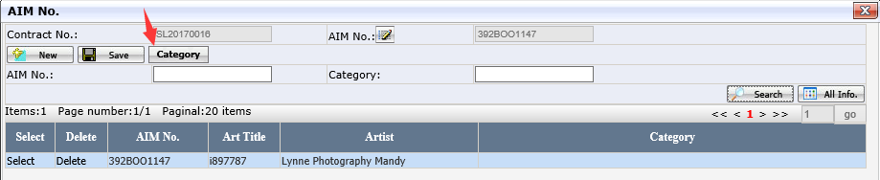
- Select Categories, click Add. One or multiple categories can be selected.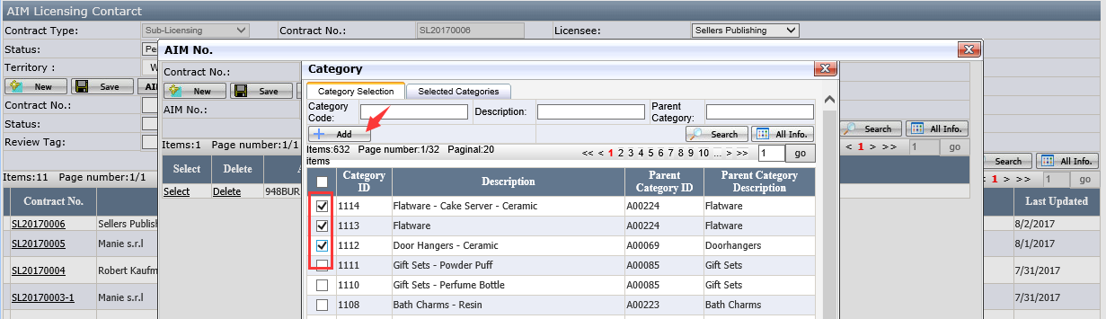
- Categories will display in the grid.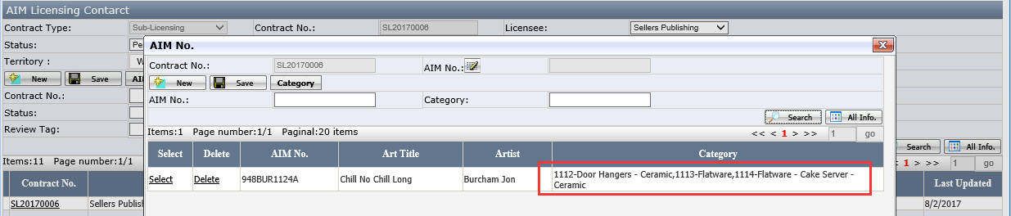
- Select Categories in Selected Categories Tab. Click Delete to delete the categories.
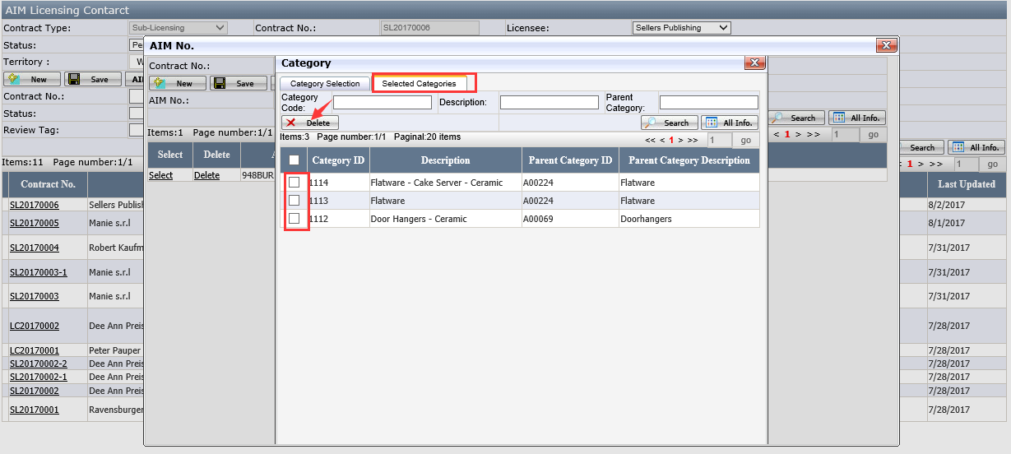

How to Change Contract Status
- Select a Contract.
- Select the Status and click Save.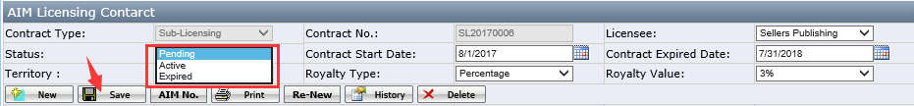
- When contract status is Active or Expired, Contract Start Date and Contract Expired Date are required.

How to Re-New a Contract
- Select a Contract and click Re-New button.
- New Contract will display.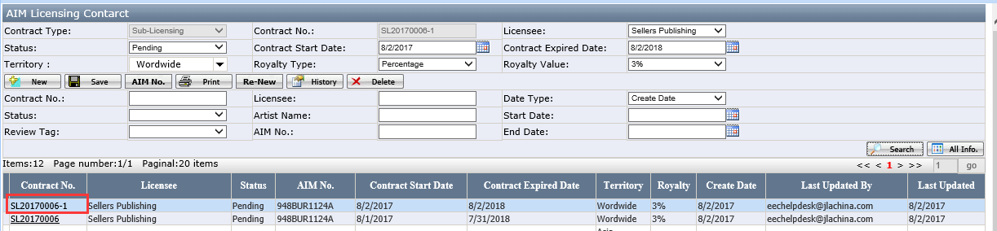

How to Print a Contract
- Select a Contract, click Print button.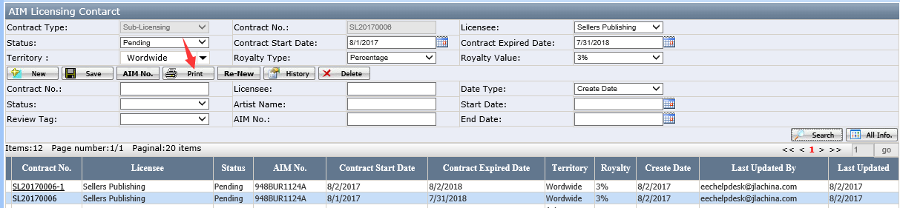
- A bar is displayed in the bottom. Users can select to open or save the PDF file.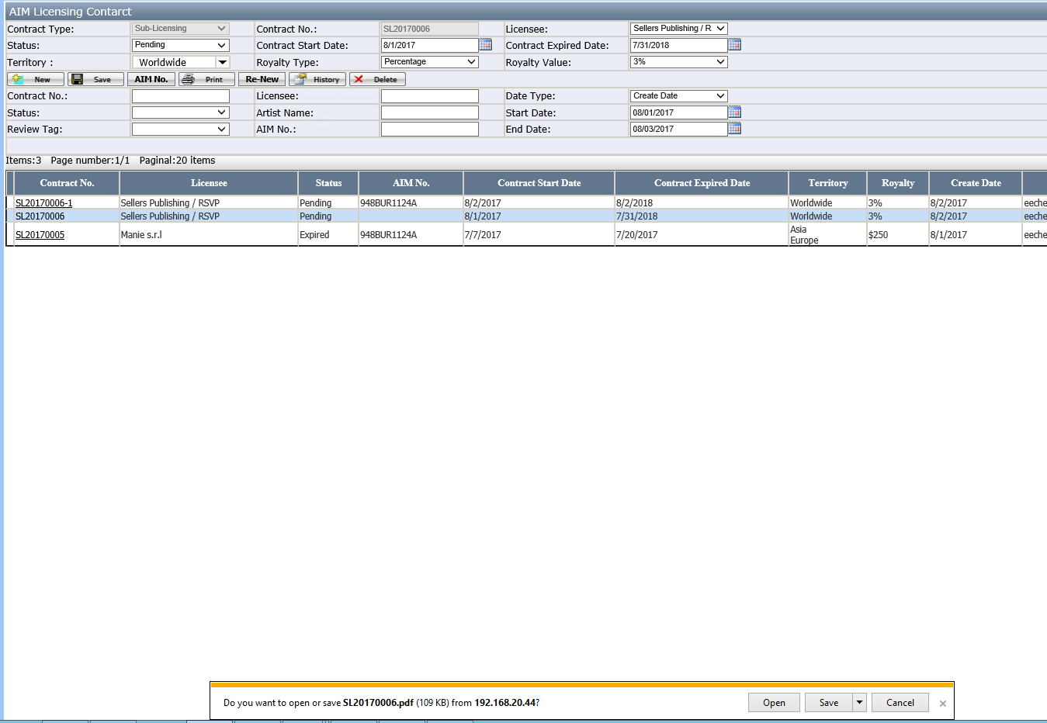

How to Search a Contract
Fill in any parameters and click Search.
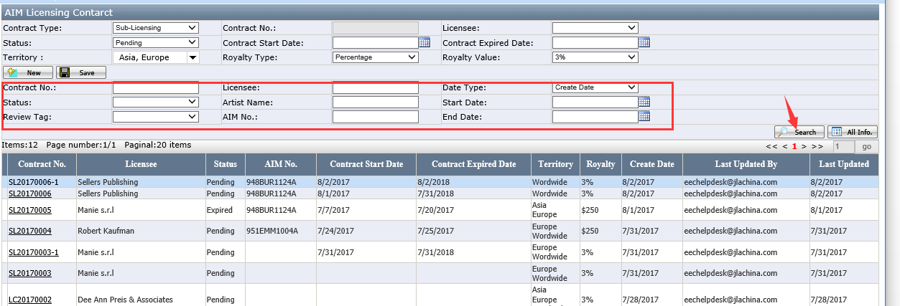

How to Delete a Contract
Select the Contract and click Delete. Contract won’t be deleted if its status is not Pending.
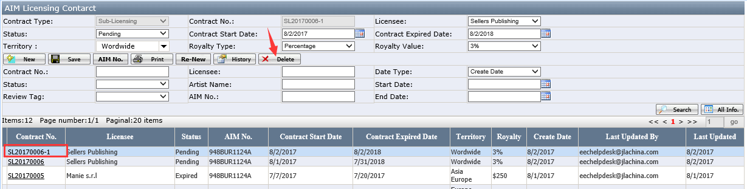

How to Review Contract History
Select the Contract and click History.
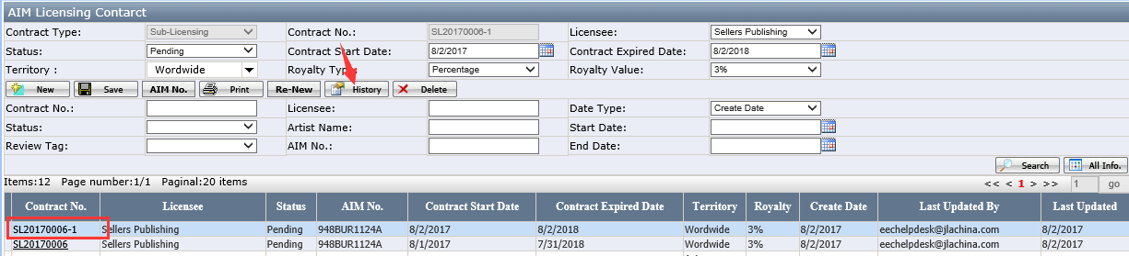

AIM Licensing Contract Report
It is an overview of all Purchase Orders on AIM No level. Users can perform searching on this page and export to excel.
