User Guide - Expense Purchase Order

Maintenance

Expense Division/Location - How to create an expense division/Location
- Open Expense Division/Location page
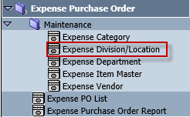
- Click New
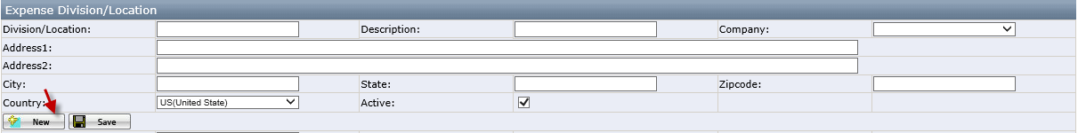
- Enter Division, Description, Company, Address, City, State, Zip Code and Country. Click Save.
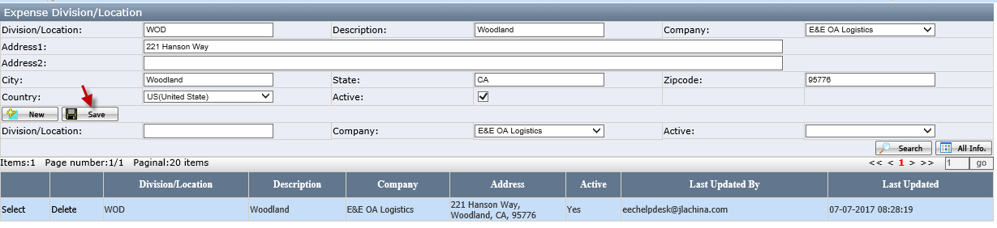
- A new Division/Location will display.
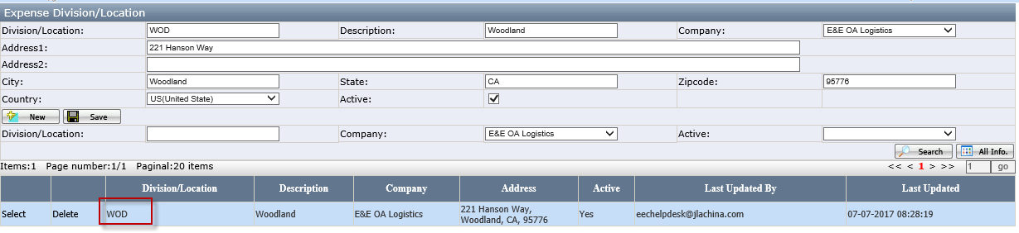
- Users are able to delete a division by clicking Delete. If any Expense PO is created under this division, then the division cannot be deleted and users will see a message as in below screenshot.
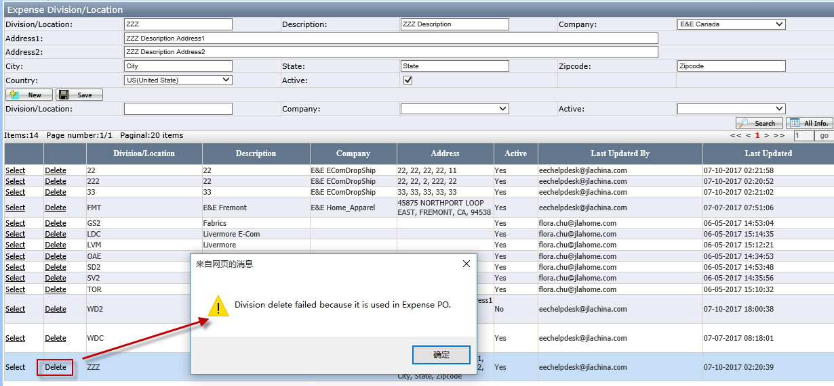
- Users are able to inactivate a division by unchecking Active. Active status will change to No after that.
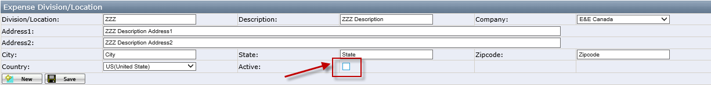

Expense Department - How to create an expense Department
- Open Expense Department page
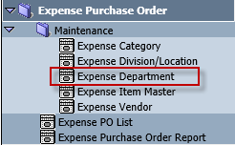
- Click New
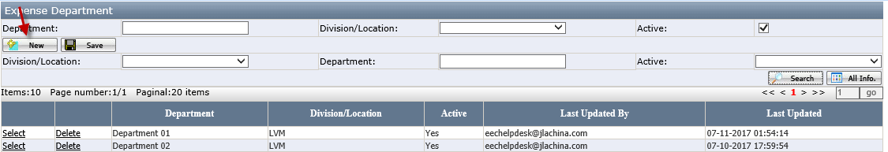
- Enter Department. Select Division/Location. Click Save.
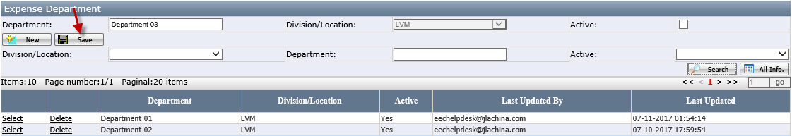
- A new department will display.
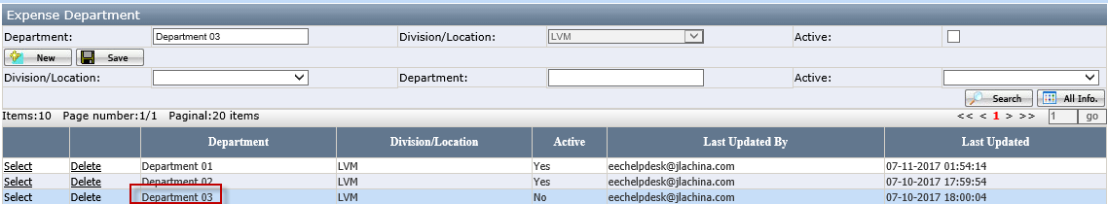
- Users are able to delete a department by clicking Delete. If any department has been used in expense PO, then users will not be able to do it.
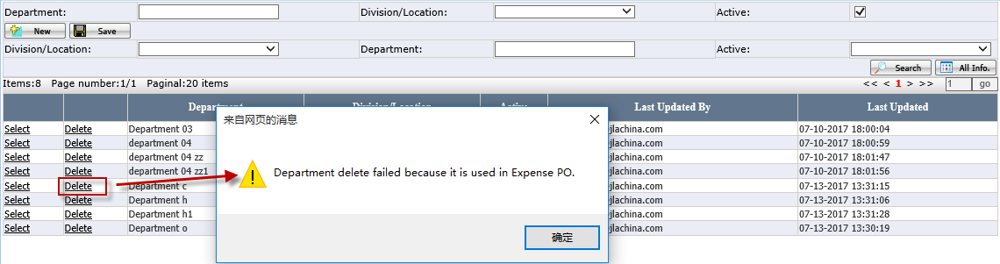

Expense Vendor - How to create a vendor
- Open Expense Vendor page
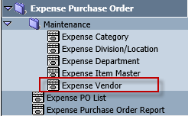
- Click New
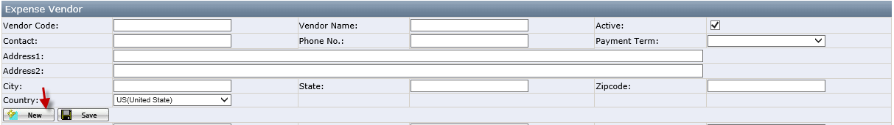
- Enter Vendor Code, Vendor Name, Contract, Phone No., Address, City, State, Zip Code and Country. Select Payment Term. Click Save.
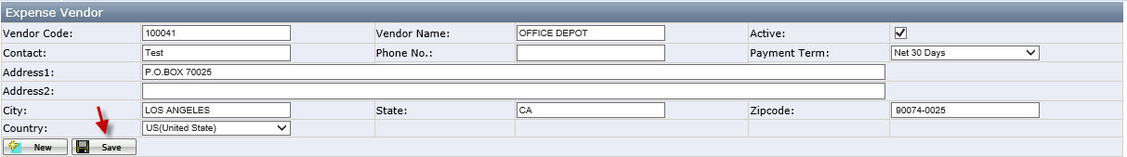
- A new vendor will display.
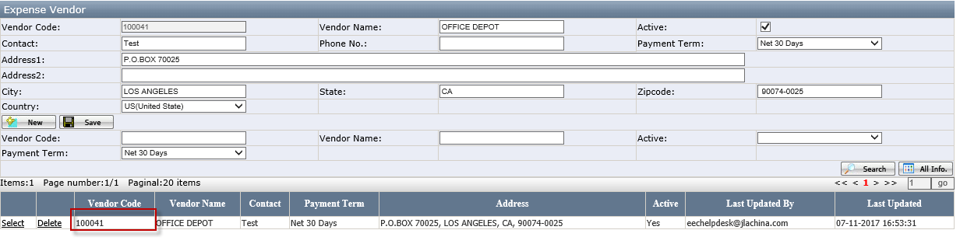
- Users are able to delete a vendor by clicking Delete. If any vendor has been used in expense PO, then users will not be able to do it.
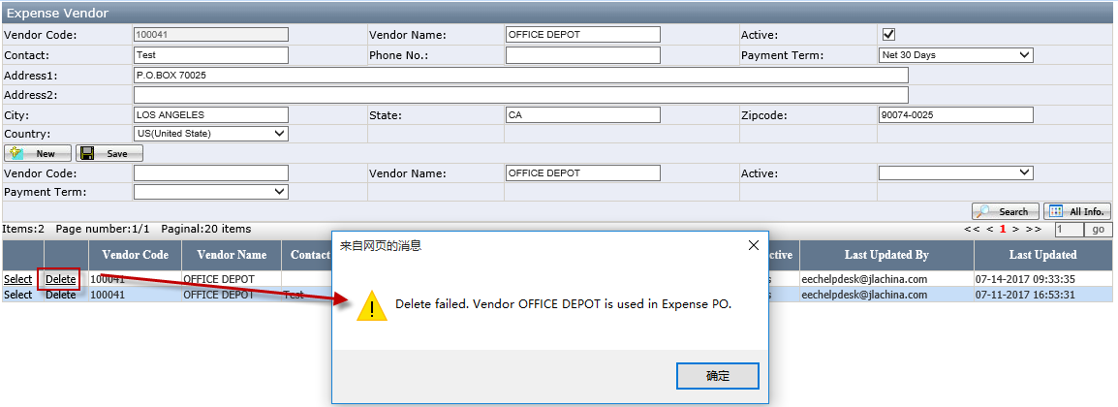

Expense Category - How to create an expense category
- Open Expense Category page
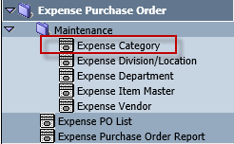
- Click New
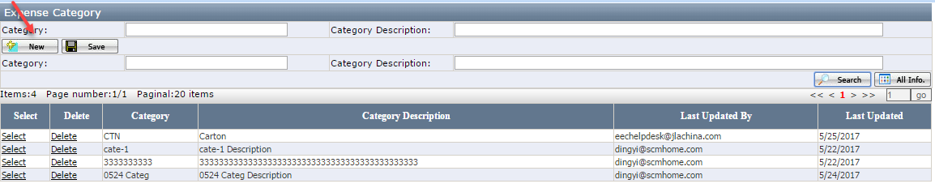
- Enter Category and Category Description. Click Save.
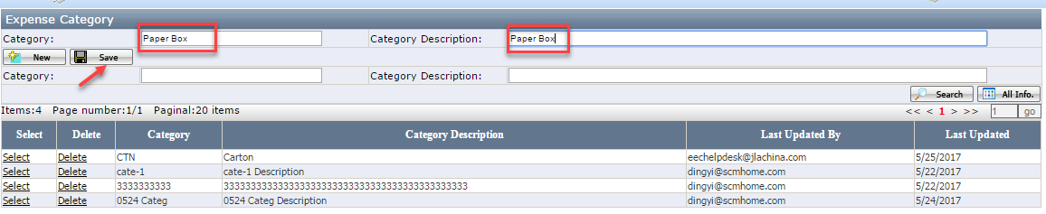
- A new category will display.
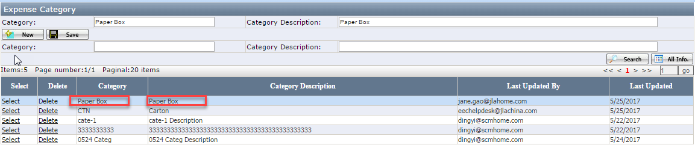
- Users are able to delete a category by clicking Delete. If any Expense item has been created under this category, then users will not be able to do it.
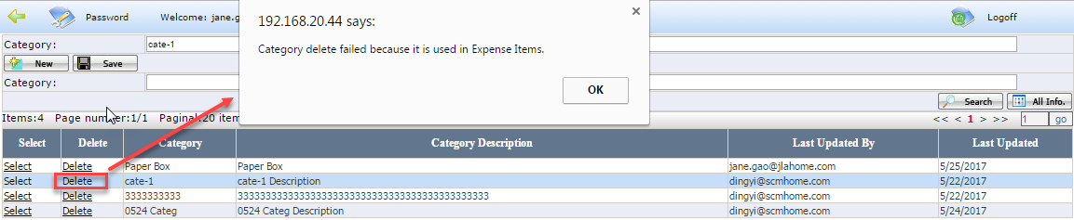

Expense Item Master - How to create an item
- Open Expense Item Master page
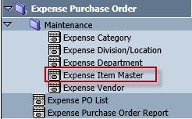

- Click New
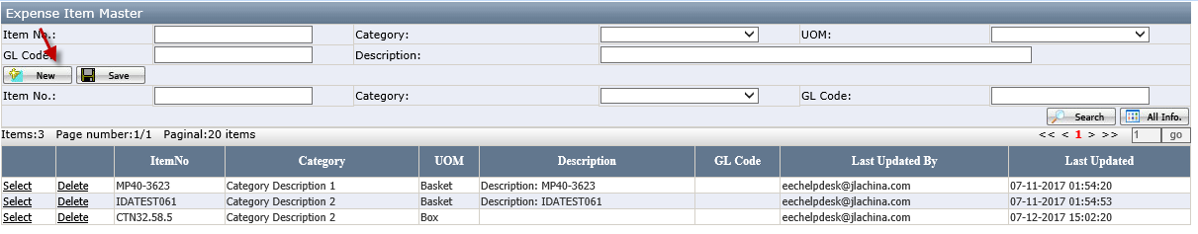
- Enter Item No., Description and GL Code. Select Category and UOM. Click Save.
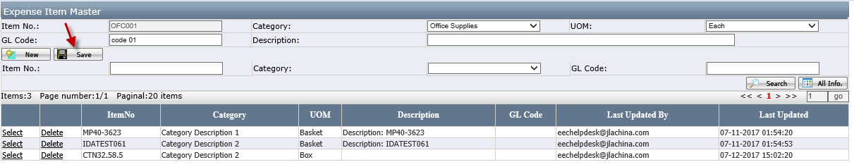
- A new Item will display.
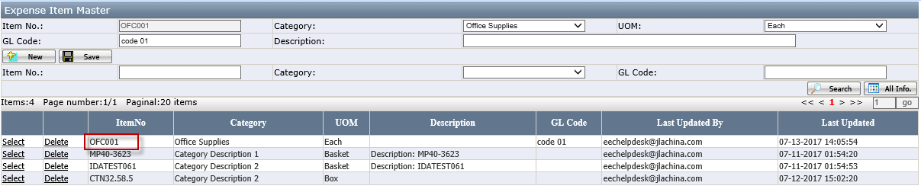
- Users are able to delete an item by clicking Delete. If an item has been used in a PO, then users will not be able to do it and will see a pop-up message shown in the below screenshot.
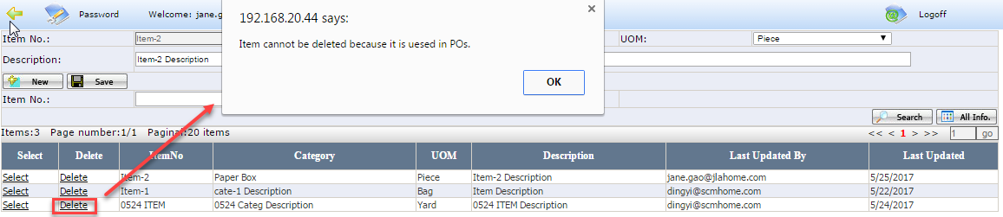

Expense PO List
It is an overview of all Purchase Orders on PO level. Users can perform searching on this page.

How to create a PO
- Open Expense PO List Page
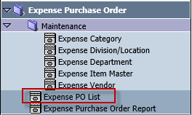
- Click New.
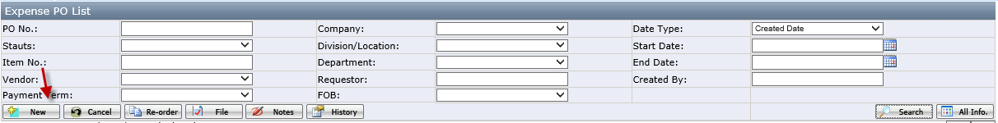
- Enter Reference No., Requestor. Select Company, Division/Location, Vendor, Ship Via, Payment Term, FOB, Purchase Date and Division. Enter Address Information in address tab. Click Save.
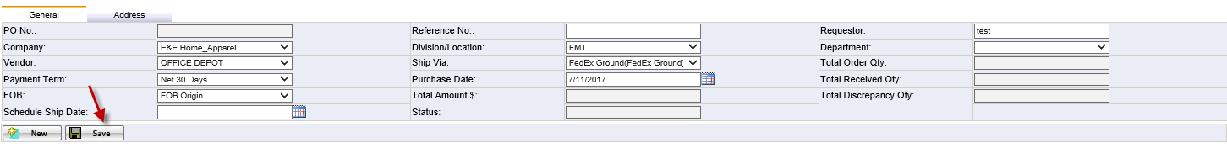
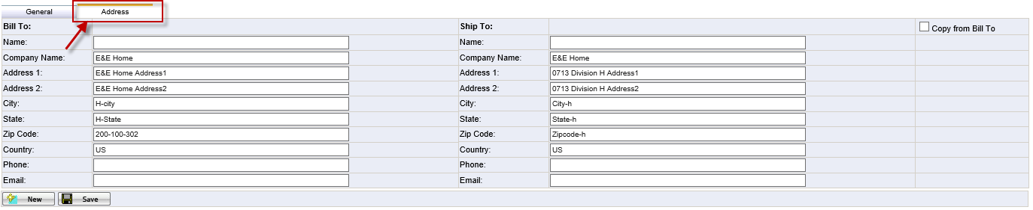
- Click Item
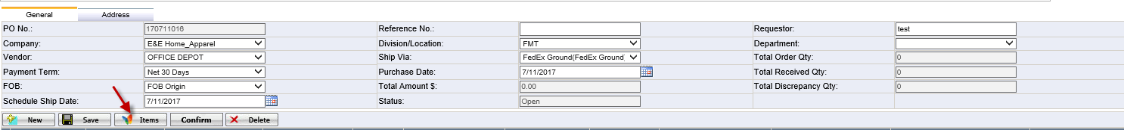
- Enter Item No., Order Qty and Unit Price. Change Description if necessary. Click Save and close the window.
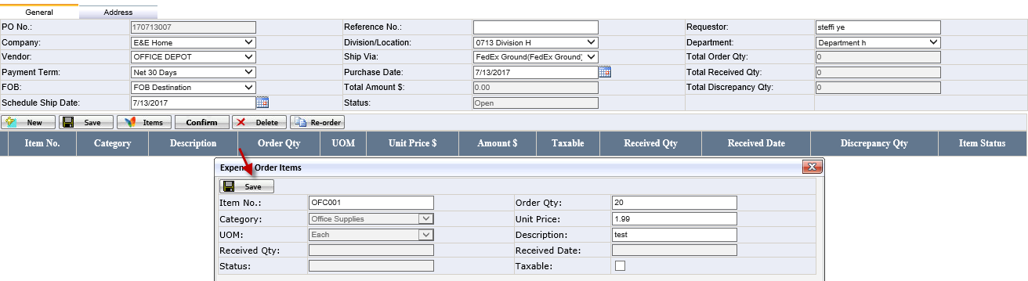
- Users can continue to add more items under this PO by repeating the previous step.
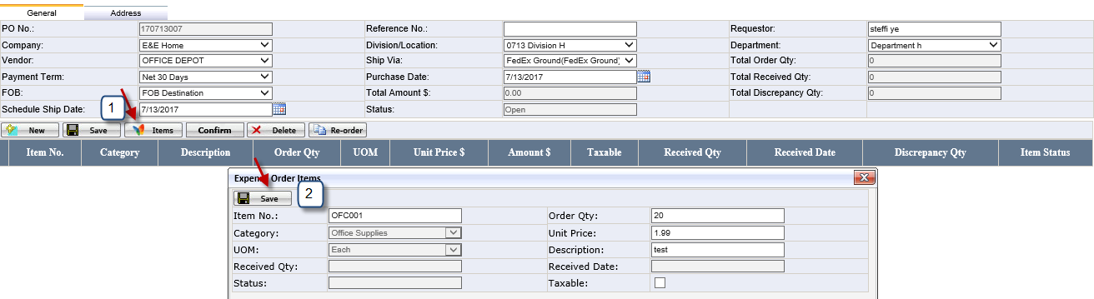
- Select an Item, click Delete to delete the item.
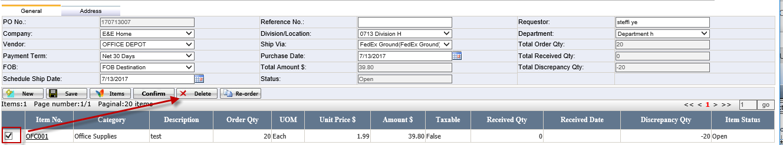
- Click Confirm, PO status changes to Confirmed
- Item Information is not editable after PO Confirmed.
- PDF with PO details opens automatically.
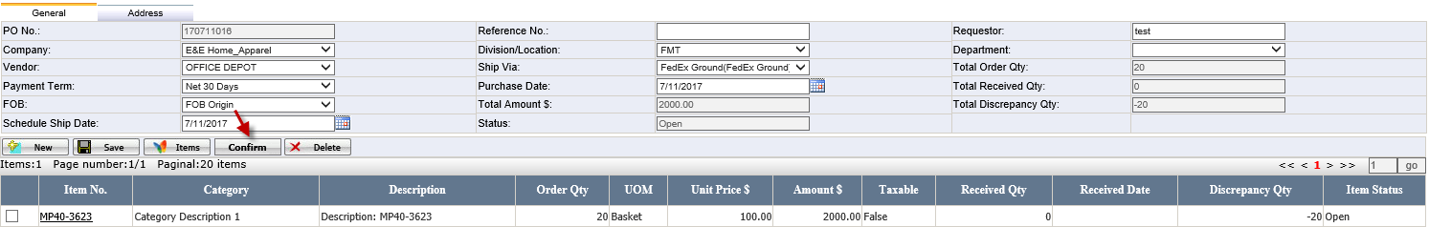
- After receive the order, update Received Qty and Received Date in Item detail. Click Save.
- Item status changes to Completed automatically if Received Qty = Order Qty
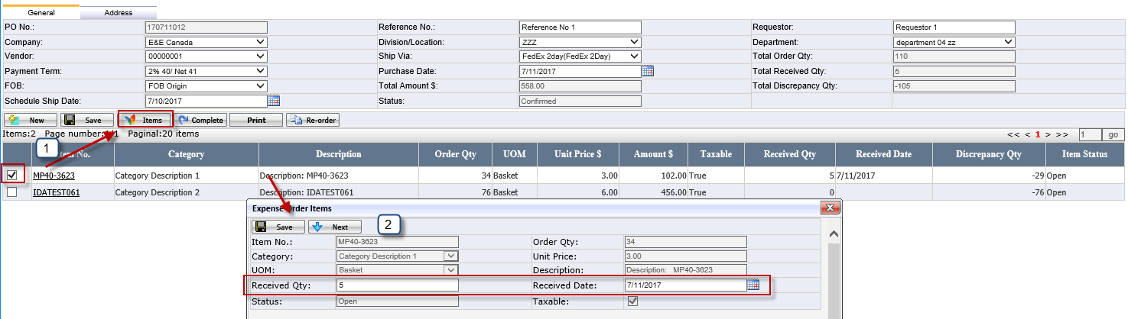
- Continue to update Received Qty for the next item by repeating the previous step.
- PO Status changed to Completed automatically if Total Received Qty=Total Order QTY.
- Click Complete button to manually complete PO status to Completed if Total Received Qty<Total Order QTY.
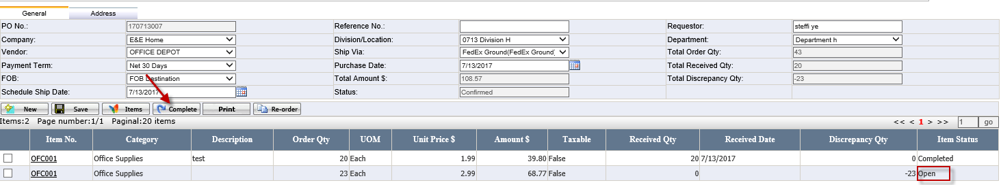
- After Paid accounting users login and click Complete button to change the PO status to Closed.
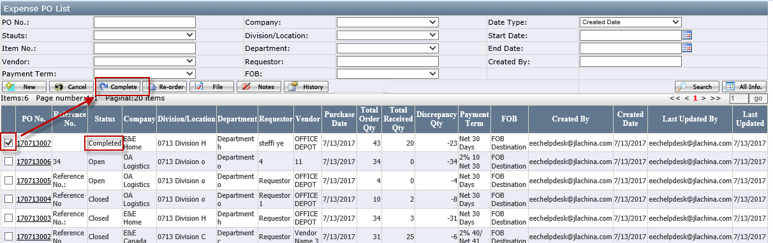

How to re-order a PO
- Select a PO and click Re-Order button.
- PO information is copied and displayed in the PO creation page
- Copied fields are editable
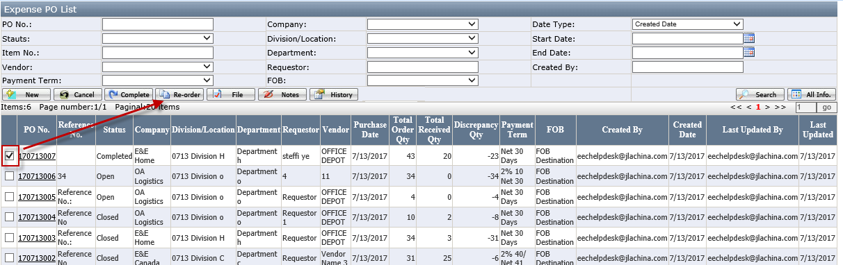
- Click Save button in the PO creation page.
- Items are copied after click Save.
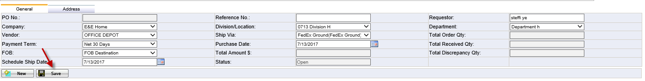

How to re-print PDF
- Select a confirmed PO, click Print button
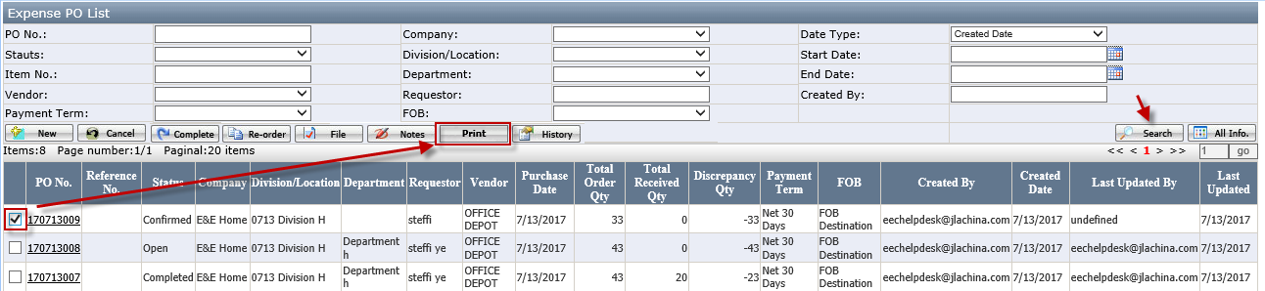
- A bar is displayed in the bottom. Users can select to open or save the PDF file.
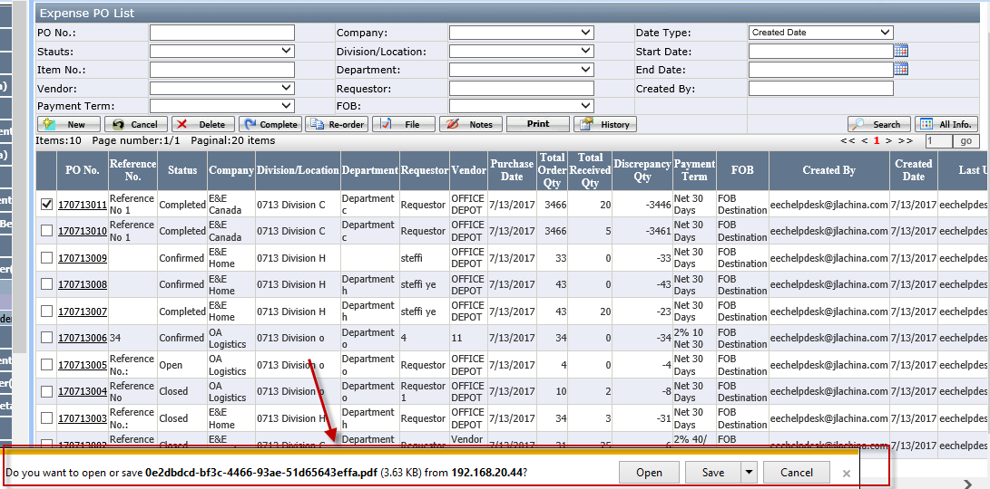

How to search a PO
Fill in any parameters and click Search.
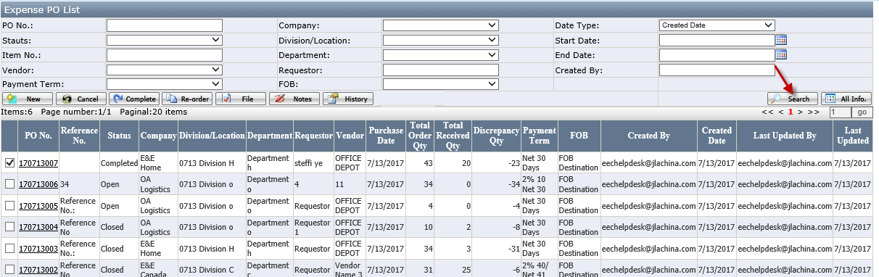

How to cancel a PO
Check the PO and click Cancel. PO won’t be cancel if it has Received Qty.
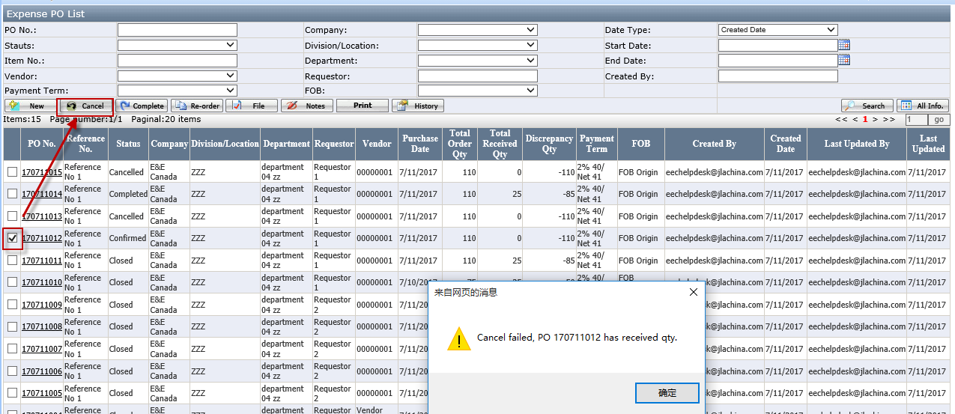

How to create and delete a note
- Check PO# and click Notes.
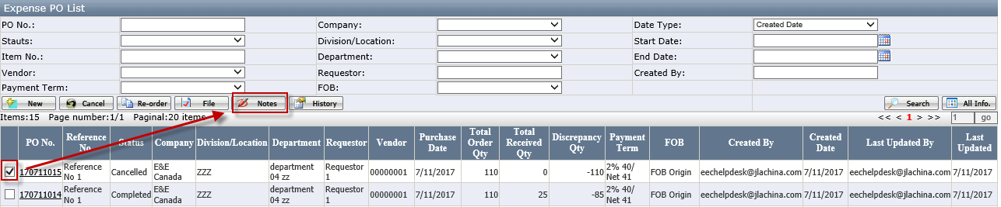
- Enter notes and click Save.
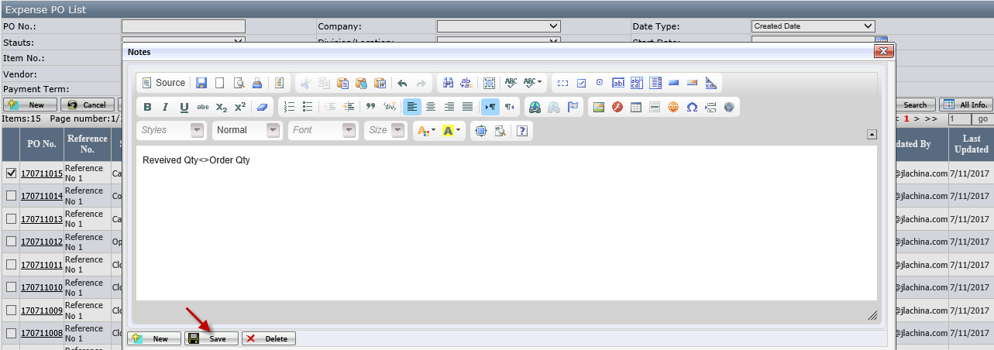
- Click New to add more notes.
- Select a note and click Delete to remove a note.
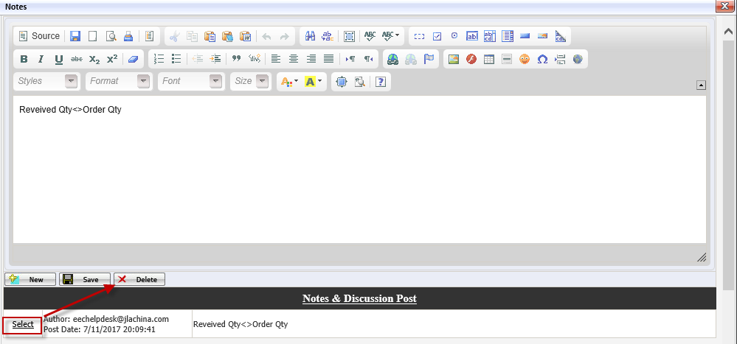

How to attach reference files
- Check a PO and click File.
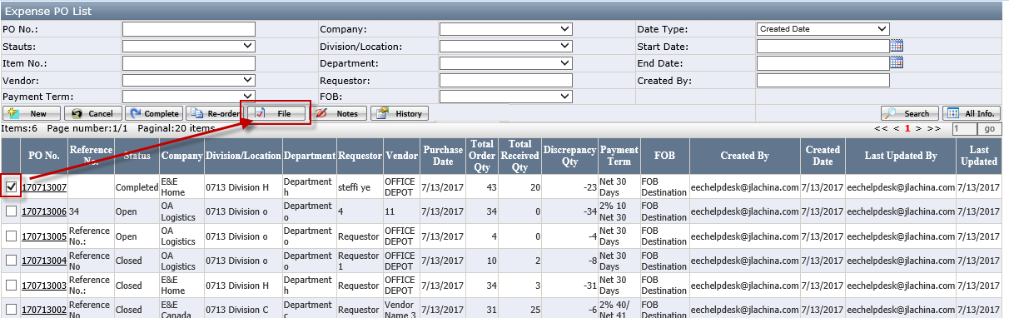
- Upload a file by clicking Choose File. Click Save.
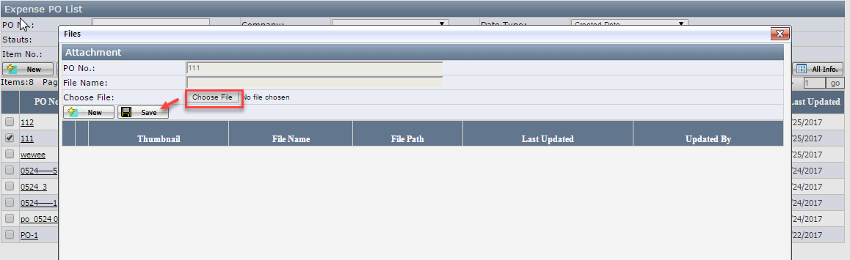

How to review PO history
Check a PO and click History.
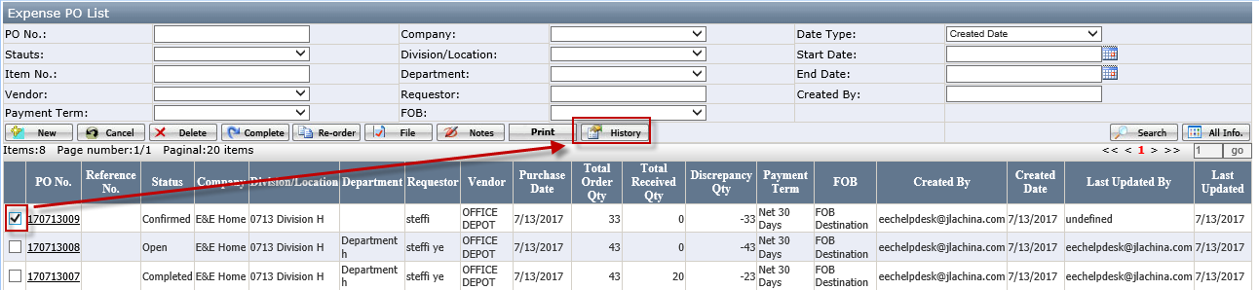

Expense Purchase Order Report
It is an overview of all Purchase Orders on item level. Users can perform searching on this page and export to excel.
