Stage Bin Guideline
- Maintain the Stage Bin on Bin Location page.
- Stage Bin should be maintained as Special Bin and Stage Bin

- Generate pick list and assign stage bin to pick list.
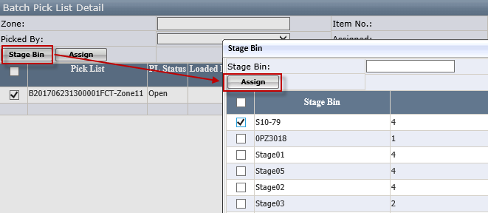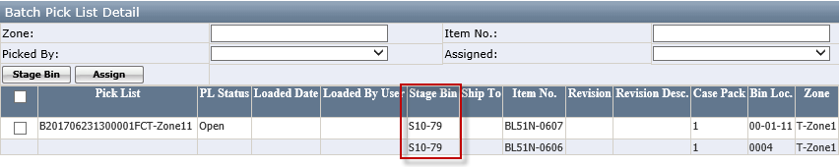
- Allow to select multiple pick lists to assign stage bin
- Only allow to assign one stage bin to the pick list each time

- Pick items and transfer inventory to Stage Bin by WMS Picking wireless application.
- Pick item on picking form.

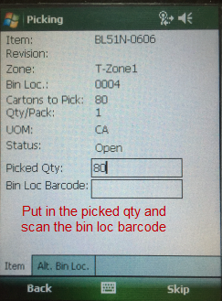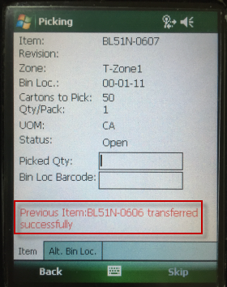

- Select picked/transferred items on pick list item detail form. Double click to open stage form.
- Allow to select multiple items to stage at the same time
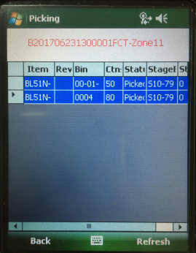
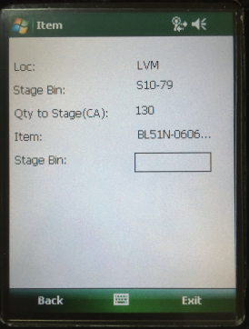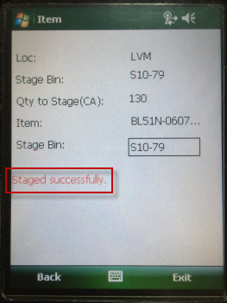

- The staged qty will be updated, and the inventory will be transferred to Stage Bin.
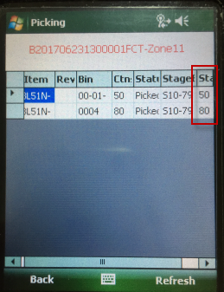

- Assign the Stage Bin to related shipment after shipment is created. Stage Bin must be assigned before assign truck loader.
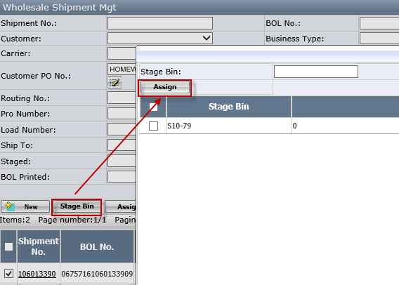
- This page will only list the stage bin which is assigned to the related batch but not assigned to other incomplete shipment
- Multiple stage bins can be assigned to one shipment but one stage bin cannot be assigned to multiple shipments
- After shipment complete, the inventory will be deducted from the stage bin

- Use In-transit Inventory Report to check the inventory in Stage Bin.
