Ecom Photo
- EEC(https://eecsystem.cn/Index.htm)
We need to create a qualified PO (see the figure1);
- Customer Code: JLA Home & Designer Living Inc.
- Program: Initial Rollout or Replenishment;
- Merchandiser will be required if the customer code is JLA Home and Program is Initial Rollout or Replenishment
Click the Complete button to put the Current Step from Order Creation to Order Review and system will auto generate the Related Ecom Photo (see the figure2);
System will auto generate a Email to notice the Merchandiser (see the figure3);
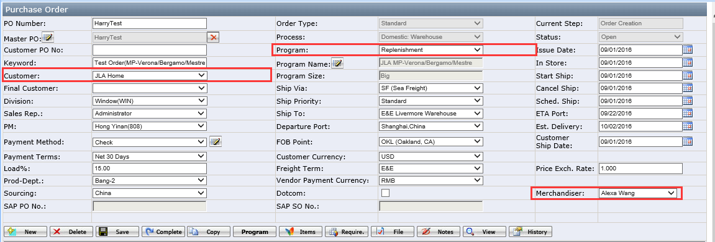
(figure1)
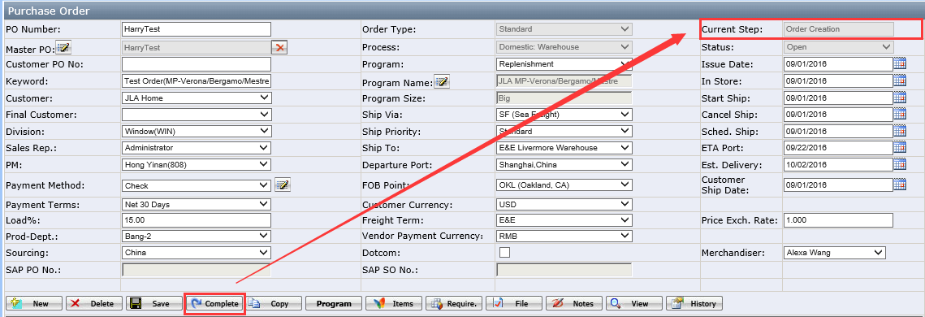
(figure2)
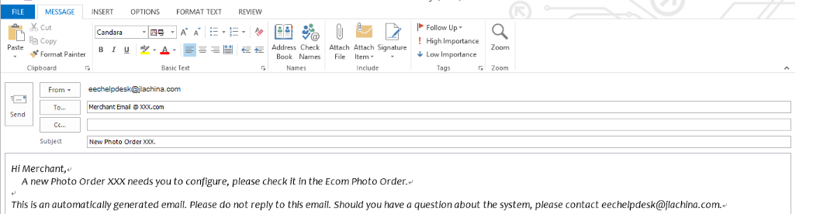
(figure3)
- Ecom Photo(http://plus.eecsystem.cn/)
- System will default to log in the Ecom Photo Order page and default to blank (see the figure4);
- Click the search button or All Info. Button to show the Photo Order No. (see the figure5);
- Find out the related Photo Order No. which belong to you and click the Photo Order No. to open the Ecom Photo Order Detail page (see the figure6);
Photo Order Status: Order Creation
- Merchandiser needs to select the Merchandiser and PM;
- Merchandiser needs to click the Edit to open the Photo Required page;
- Merchandiser needs to select the Life Style, Photo Type, Photo Qty. which are required fields and Notes and Reference are optional;
- Click the ‘+’ to add the Photo Type;
- Click the Clear button to clear out the Photo Required page;
- Merchandiser click the Complete button to put the Photo Order Status from Order Creation to Order Review;
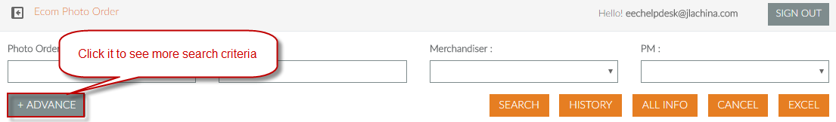
(figure4)
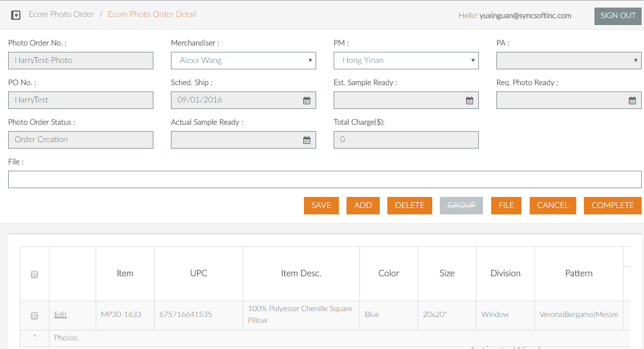
(figure5)
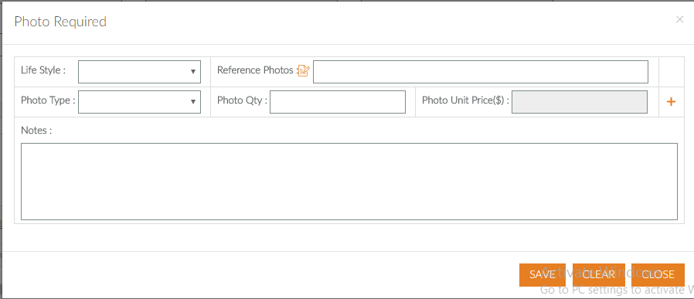
(figure6)
Photo Order Status: Order Review
- PM needs to add the PA, Est. Sample Ready and Req. Photo Ready which are required fields;
- PM can click the File button to upload the file;
- PM click the complete button to put the Photo Order Status from Order Review to Order Studio;
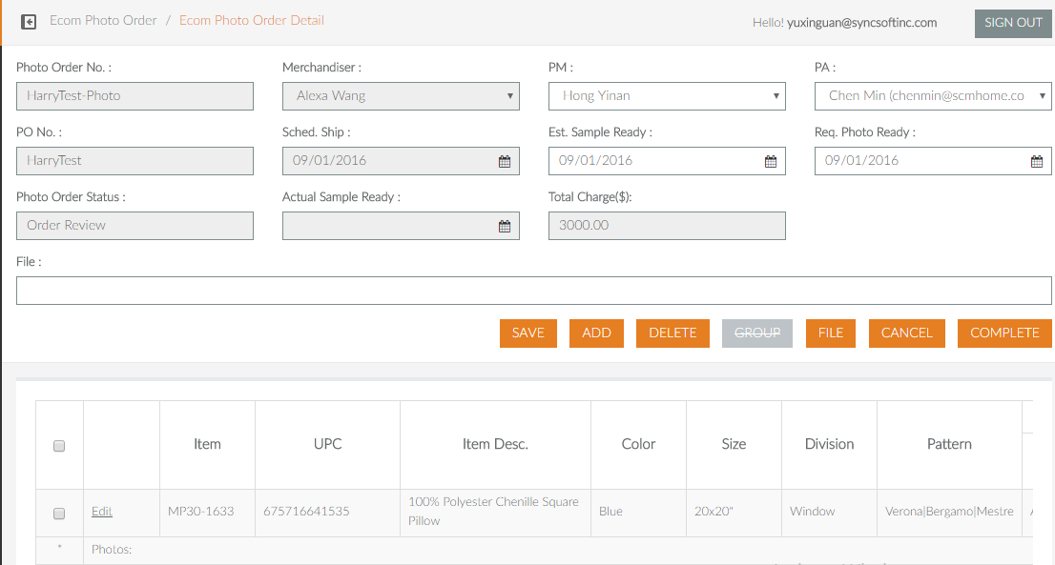
(figure7)
- EIP (http://192.168.20.13/Login/Index)
System default to show the main page and we only use the Ecom拍照单列表and Ecom分单列表;
Ecom拍照单列表
- Firstly, click the Ecom拍照单列表 to find out the related Ecom Photo Order No.;
- Select the Ecom Photo Order No. and click the 受理分配 and system will open the new page 受理分配;
- Choose the Photo and click the 按人员分配 button and system will auto pop up a window for you to select the staff;
- Finish this work and you can find out your Ecom Photo Order No. in the Ecom 分单列表;
Ecom分单列表
- Select the related Ecom Photo Order No. and click the 传图 button to open the detail page;
- Choose the 样品 and click the 传图 button to upload the photos and photo name must include the photo type code and the type should be jpg.
- The Photo Qty. must be the same as the upload photo Qty.
- Click the 提交 button to finish the EIP work;

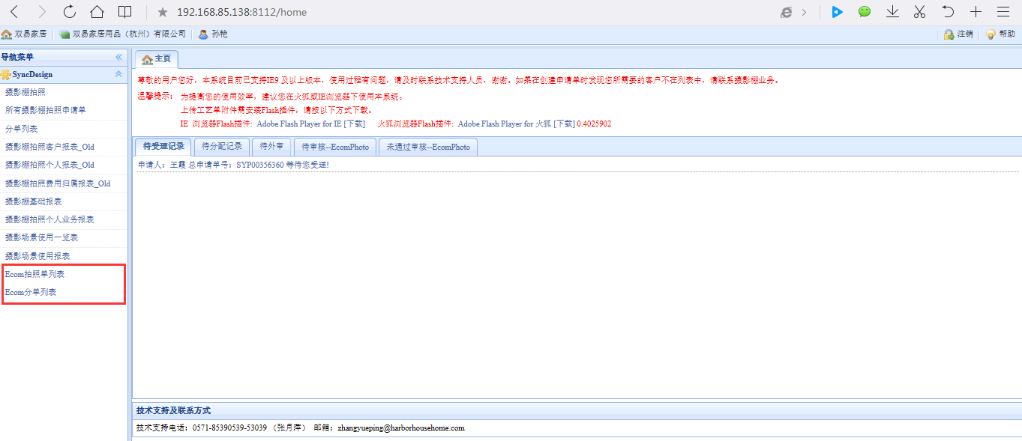
(figure8)
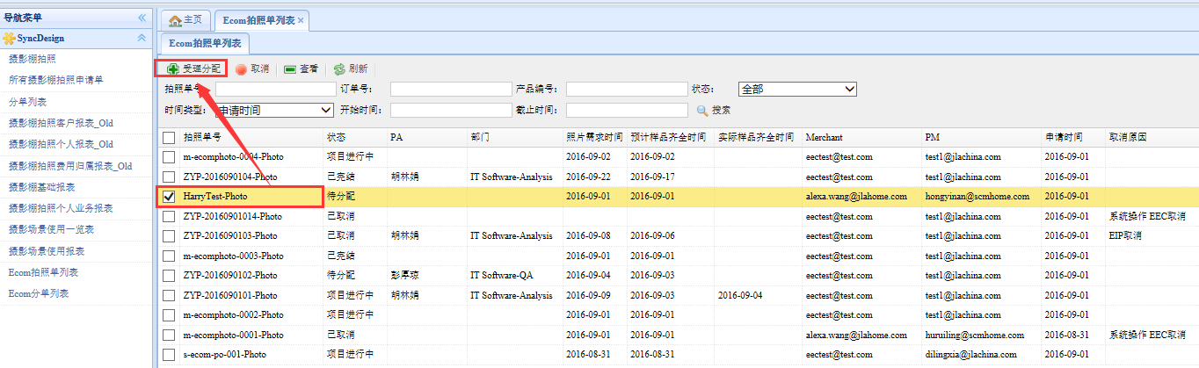
(figure9)
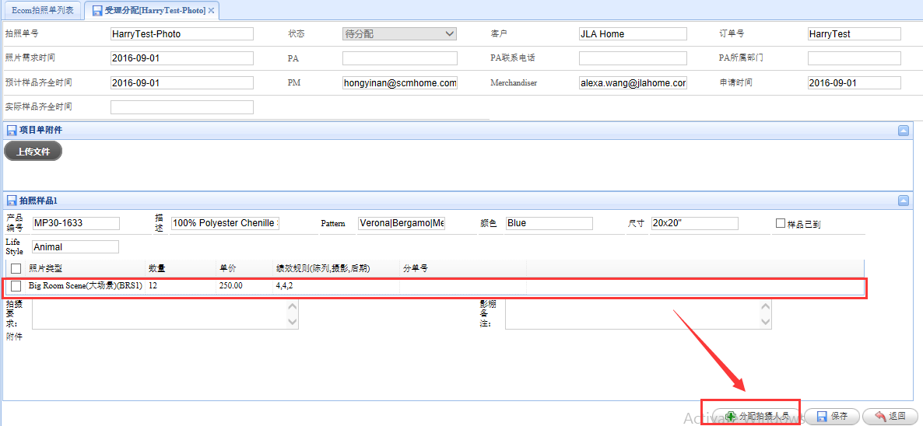
(figure10)

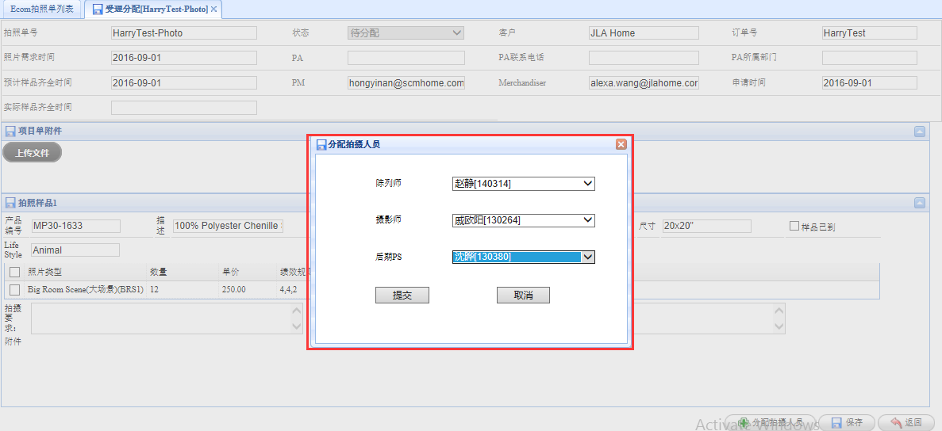
(figure11)
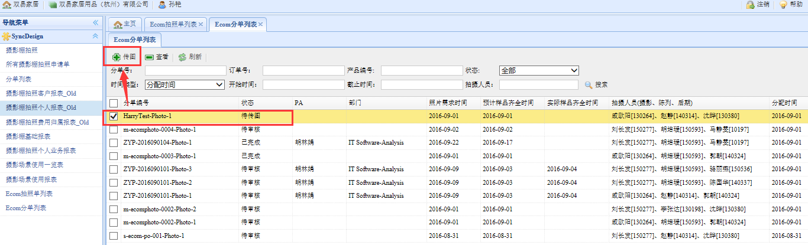
(figure12)
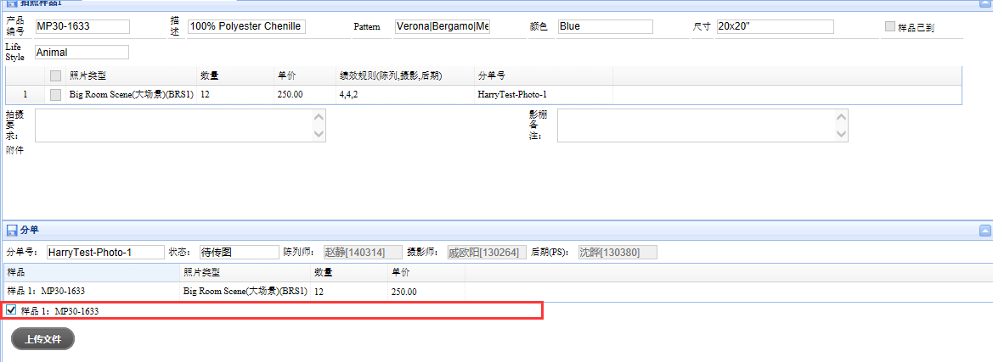
(figure13)
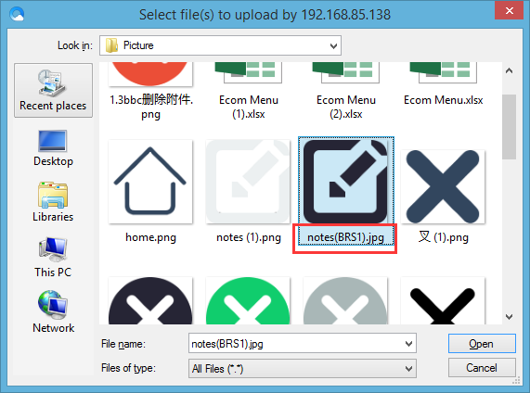
(figure14)
- Ecom Photo
- Come back to Ecom Photo and find the related Ecom Photo Order which Ecom Photo Status has changed to Pending Approval automatically;
- Merchandiser clicks the Item No. to open the Order Photo Detail page;
- Merchandiser needs to evaluate the photos, Approve or Deny and system will feed back the evaluated result to EIP for Studio Staff;
- If the EIP upload new photo for deny photo, system will add the ‘-vx’ behind the Photo ID;
- Finish the evaluation work, Merchandiser needs to come back to Ecom Photo Order Detail page to complete the Photo Order No.
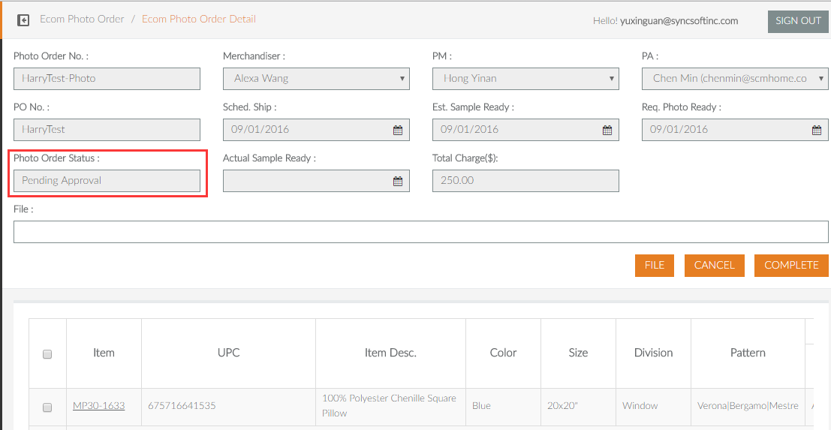

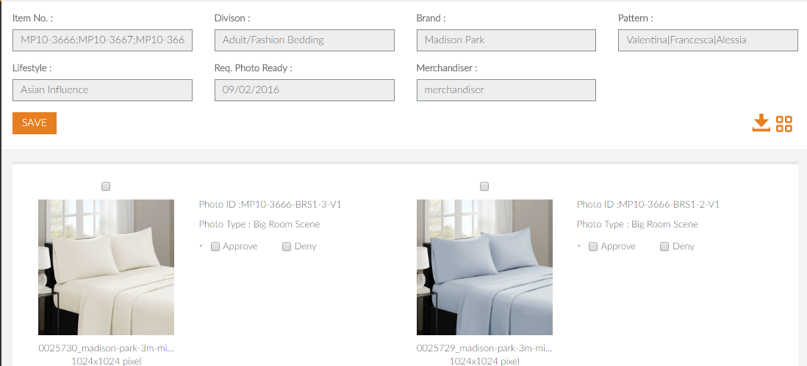

More information please see the Ecom Photo Detail word.

