Bin Transfer Manual

How to Transfer Inventory between warehouses
- Log on Bin Transfer application
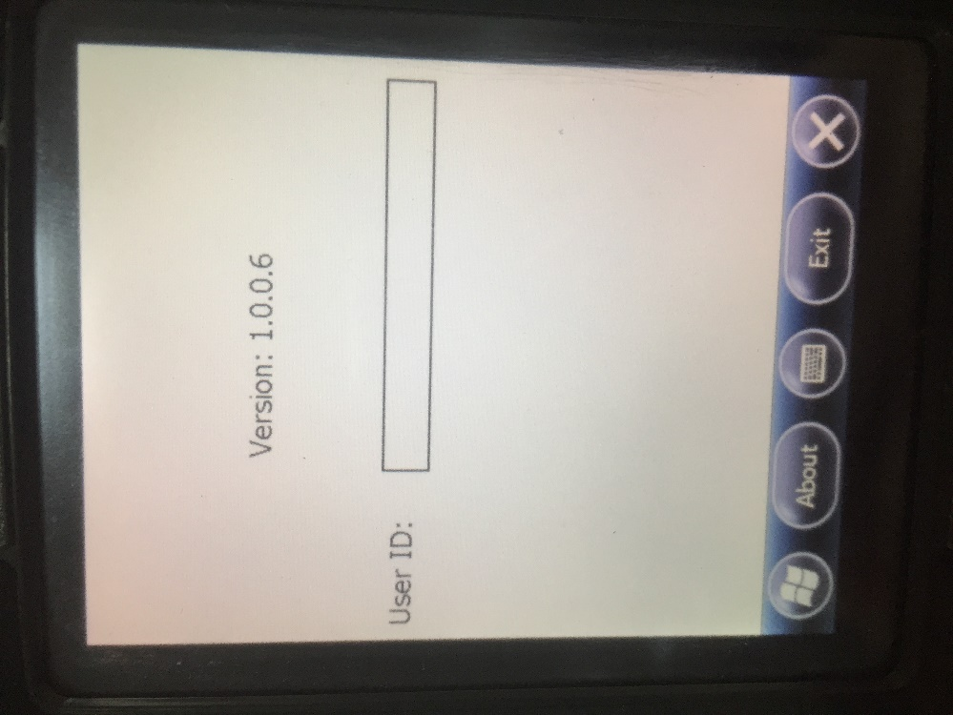
- Select the Src Loc, Dest Loc, bin type and enter the UPC
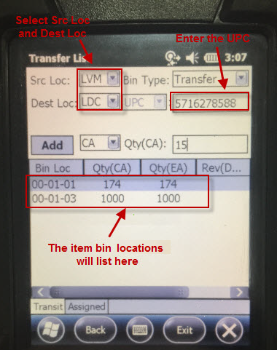
- Select the bin in the grid. Put in the Qty(CA) and click Add. The Qty(CA) is default as the selected bin Qty and allow to change.
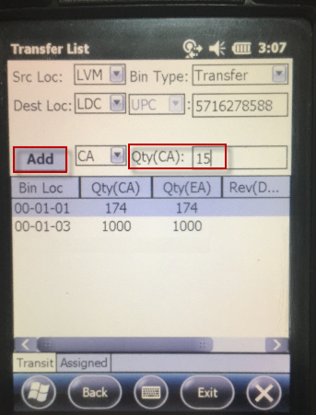
- Go to Assigned tab, the added qty is list here and in Intransit status.
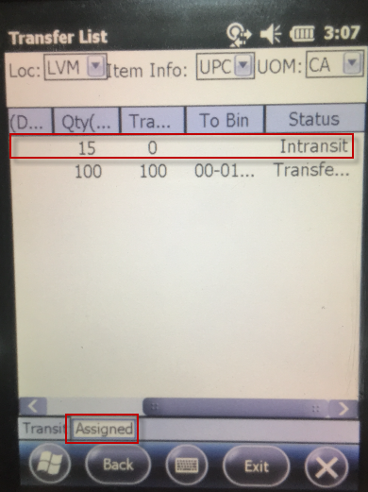
- Click the item to open the Transfer page, put in the transfer qty. The Trans Qty can be partial.
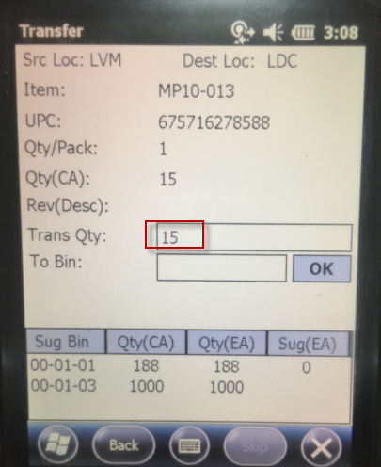
- Select the suggest bin list below or put in the bin no. and click OK. Then the item status will change to Transferred.
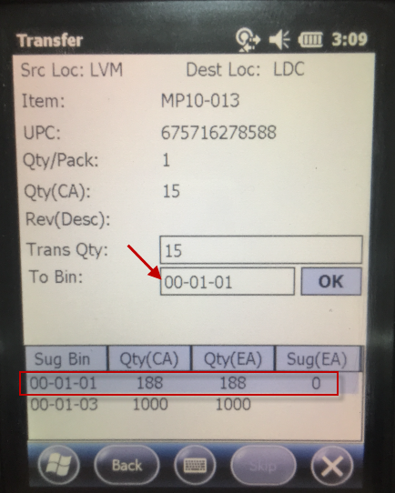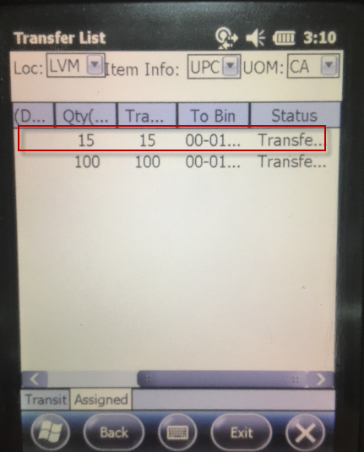

How to Transfer Inventory from Billing Only bin within warehouse
- Log on Bin Transfer application
- Select the Sourcing Location and Billing Only Bin Type, enter the UPC. The Billing Bin will list in the grid.
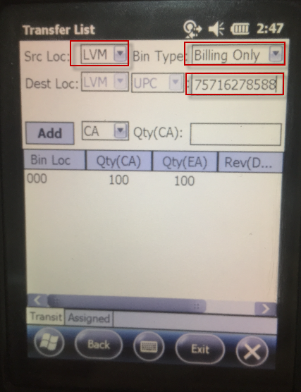
- Select the bin in the grid. Put in the Qty(CA) and click Add. The Qty(CA) is default as the selected bin Qty and allow to change.

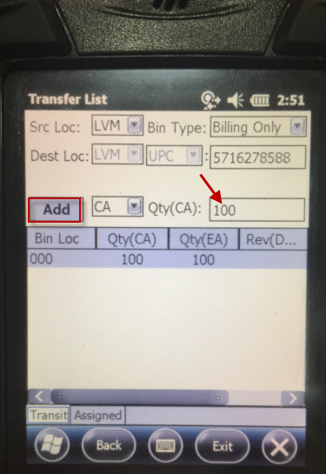
- Go to Assigned tab, the added qty is list here and in Intransit status.
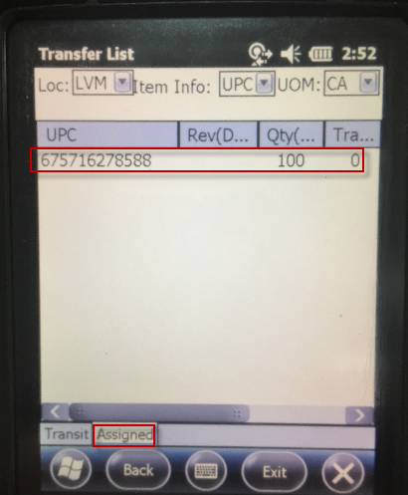
- Click the item to open the Transfer page, put in the transfer qty. The Trans Qty can be partial.
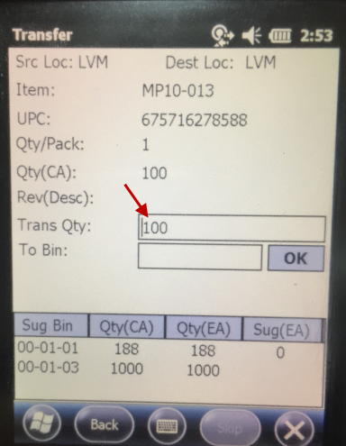
- Select the suggest bin list below or put in the bin no. and click OK. Then the item status will change to Transferred.
