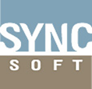
Syncsoft Costing System Manual


VERSION: 1.0

Table of Contents
Syncsoft Costing System Introduce 3
How to Log in Syncsoft Costing System 3
Project Mgt 3
Page Introduction 3
New/Edit Project page 3
Add task page 4
Documents page 5
How to create a project 6
How to add tasks to the project 7
Way1. Use “Add Task” to create a project task. 7
Way2: Use ‘Template’ to create project task. 8
How to assign users to the project 10
How to fill in actual start and end hours for tasks 12
How to add remark to the project. 12
How to fill in documents completion 14
How to complete the project 16
How to view and download project plan. 17
How to reverse the Project 17
How to evaluate the docs 18
How to evaluate the project’s timeline and project quality 20
Quotation List 22
Page introduction 22
How to fill in quotation detail 23
How to do quotation 23
How to add other fee to the quotation. 26
How to add remark to the quotation 27
How to view quotation 28
How to complete quotation 30
How to cancel quoation 30
Weekly Report 30
Page introduction 30
How to do weekly report 31
Evaluation 32
Evaluation Report 32
Page Introduction 32
How to ask for Cust.satisfaction survey & Self evaluation 33
Evaluation 34
Page Introduction 34
How to make Cust.satisfaction survey & Self-evaluation. 34
Accounting 37
Payment Process 37
Page introduction 37
How to add payment to the project. 38
Expense List 40
Page introduction 40
How to record expense 40
Running Account 41
Page introduction 41
How to record running account 42
Outlook 42
Revenue Outlook 42
Project Progress Outlook 43
Profit and Loss Amount 44
Po Summary Outlook 45
Project Hours 47
Organization Hours 48
Appendix 51
Project status and the according operation 51
Quotation status and the according operation 52
Evaluation operation 53

Syncsoft Costing System Introduce

Syncsoft Costing system is a system that can manage the project, evaluate Syncsoft team work performance and record Syncsoft company’s expense and revenue. It includes Project Mgt, Quotation List, Weekly Report, Evaluation, Accounting, Outlook, total 7 models.

How to Log in Syncsoft Costing System
The log in address is http://192.168.20.22/SyncCosting

User name and password are the same as EEC account
(If you don’t know your EEC account ID, please send email to eechelpdesk@scmhome.com to ask for it)

Project Mgt

Page Introduction

New/Edit Project page
This page is to record the project’s detail information, it is as below:
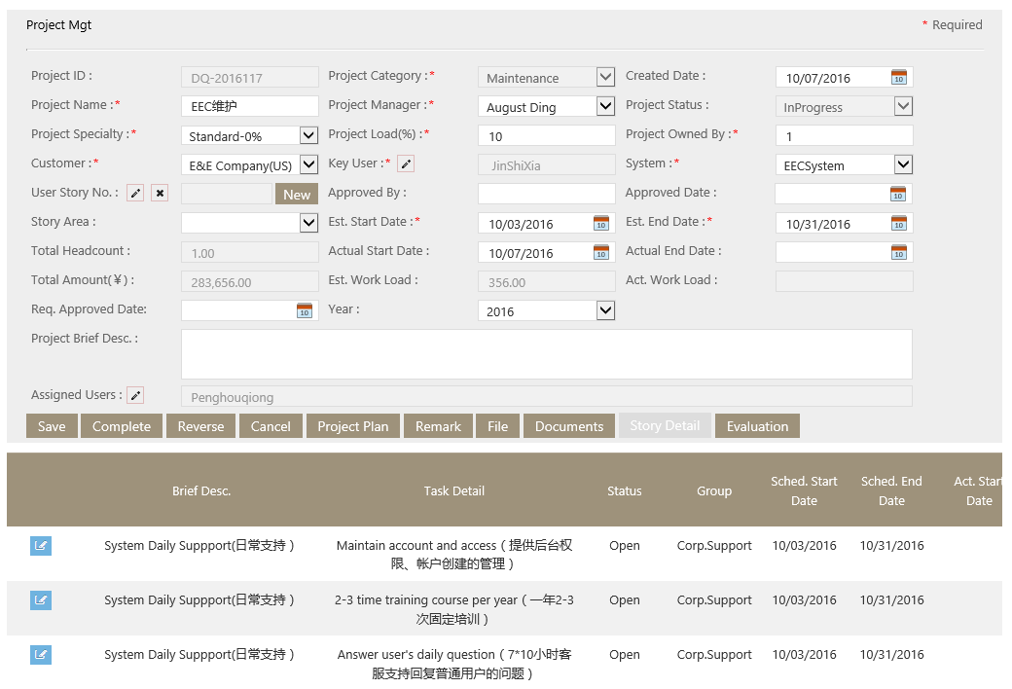
Key Fields
- Project Load: User fill in profit rate here.
- Project Owned by: User fill in the department that will use the project here.
- Key User: User can select one or more users by clicking the pencil icon.
- User Story No.: If the project already has user story in TFS, user can select the user story by clicking the pencil icon, if the project has no user story in TFS, user can create a user story for this project by clicking ‘new’ button.
- Story Area: User fill in which TFS’s area that the user story exist. It’s a requested field if “User Story No.” is not null.
- Approved By: User fill in the persons’ name that approve the project here.
- Est. Start Date, Est. End Date: The dates that the estimates start (end) date of the project.
- Act. Start Date: The date that the actual start date of the project. When the project is completed to "Quotation" step. System will automatically set actual start date = system date.
- Project Brief Desc: Text field, user enter the project brief description here.
- Assigned Users: User click the pencil icon and assign users to this project. The detail please see How to assign users to the project:
- Act. End Date: A read-only field. When the project is completed to "Complete" step. System will automatically set actual end date = system date.
- Total Amount(￥): A read-only text. It’s sum of each task’s ext. price.
- Total Headcount: A read-only text. System will automatically count how many users are assigned to the project and display in “Total Headcount” field.
- Est. Devl. Days: A read-only text. Its sum of each task’s Est. Man. Day.
- Act. Devl. Days: A read-only text. Its sum of each task’s Act. Man. Day.
- Project Status: A project has 5 statuses: creation, quotation, in progress, complete and cancel. The operation in each progress , please see Project status and the according operation

Key button
- Add Task: It’s used to add tasks for this project. The detail see Way1. Use “Add Task” to create a project task.
- Template: It’s used to select a template for this project. The detail see Way2: Use ‘Template’ to create project task.
- Complete: It’s used to complete the project to status.
- Remark: It’s used to add remarks. The detail see Add remark for the project
- File: It’s used to upload files.
- Document: It’s used to fill the documents completion of the project. The detail see How to evaluate the docs
- Story Detail：It’s used to view or edit the story detail.
- Project Plan: It’s used to view the project.
- Evaluation: It’s used to evaluate the project timeline and project quality. The detail see How to evaluate the project’s timeline and project quality

Add task page
This page is to add task to the project, it is as below:
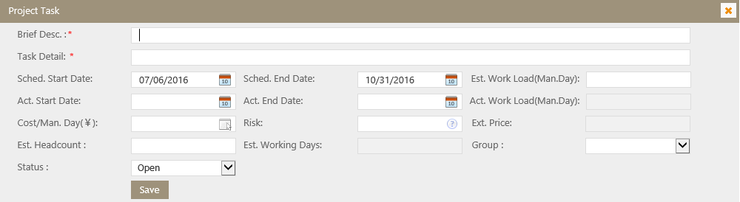
Key Fields
If project category is New Development, Optimization, Enhancement and Implementation
- Est. Work Load(Man.Day): Users fill in the Est. Man Day here
- Est. Working days: System calculate it automatically, it = Est. Work Load/Est. Head Count*Risk
- Ext. Price: System calculate it automatically, it= Est. Work Load*Cost/Man Day * risk
If project category is System Support, Maintenance, and M&Support
- Est. Work Load(Man.Day),it changes to a read-only field, it = Est Working days*Est Head Account*Adj Factor
- Est. working days: Users fill in the Est. working Data here
- Cost/Man. Day: User fill the cost per man day.
- Est. Headcount: User fill in how many users will responsible for the task.
- Risk: User use it to balance the est. work load field. The project Risk Factor is generally set between 1.0 ~1.5
(If project category is M&Support、 "System Support" or "Maintenance", "Risk" changes to "Adj. Factor".)
- Ext. Price: System calculate it automatically , it= Est. Work Load*Cost/Man Day
- Act. Work Load (Man.Day): System calculate it automatically, it= (its total working hours/8). Total working hours is the sum of all working hours which are filled by assigned users on weekly report page.

Documents page
The page is to fill in documents completion and make documents evaluation, it is as below:
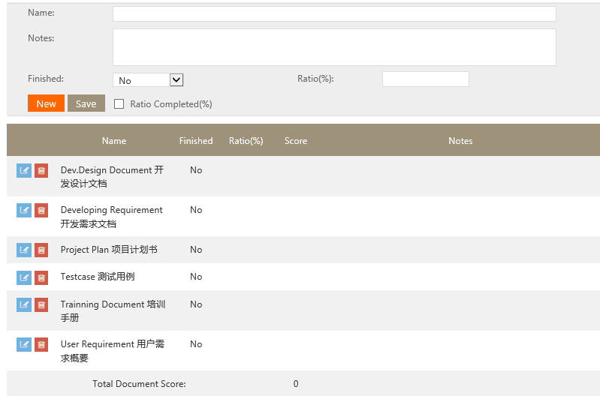
Here, some docs are added by default. The detail see above screenshot and user can delete or edit it according to project.

Key fields:
- Finished: If the doc is finished, user need to select ‘Yes’ here.
- Ratio: the percentage of the selected doc in all docs. Only available for general manager.
- Ratio Complete (%): if the ratio is completed filling. Only available for general manager.

How to create a project
This function is to create the basic information for the project.
- Go to Syncsoft costing System-->Project Mgt page, Click “New” button
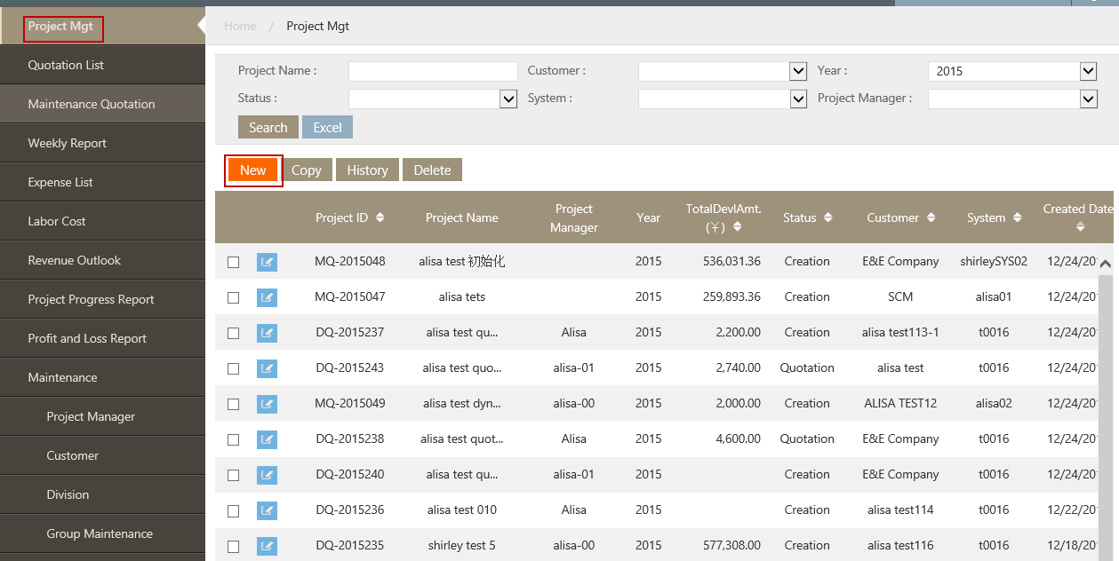

System will pop up Project Mgt page, see below
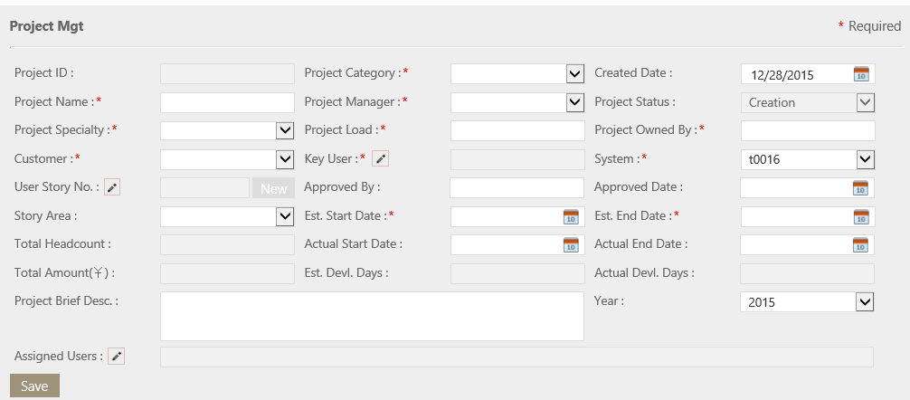
Fill in the fields per request, click “Save”, the other buttons will appear as below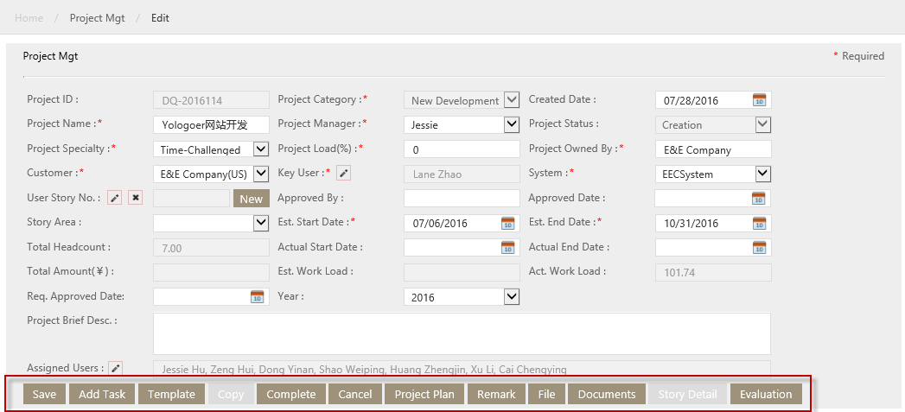

How to add tasks to the project
After the basic project information is created, user need to add task to the project.
There are two ways to add project tasks.

Way1. Use “Add Task” to create a project task.
- Go to Syncsoft costing System-->Project Mgt page, select the project.
- On the pop up page, click “Add Task” button, System will pop up Edit Project Detail page, see below:
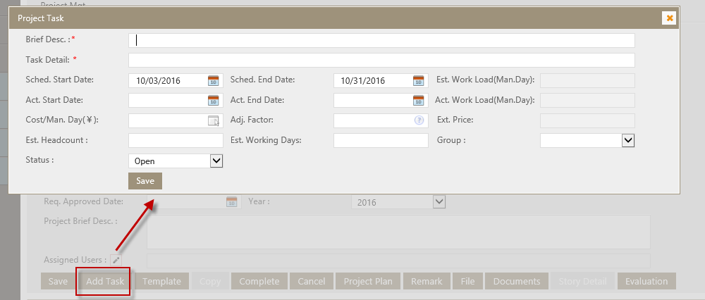

- Fill in fields per request and click save
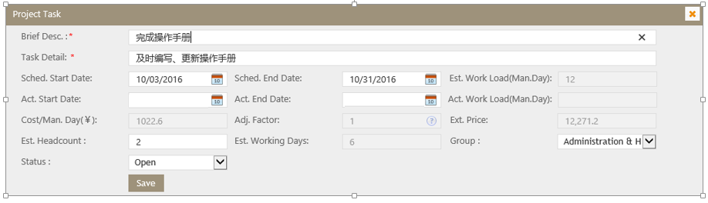
The task will be in the task list of the project:
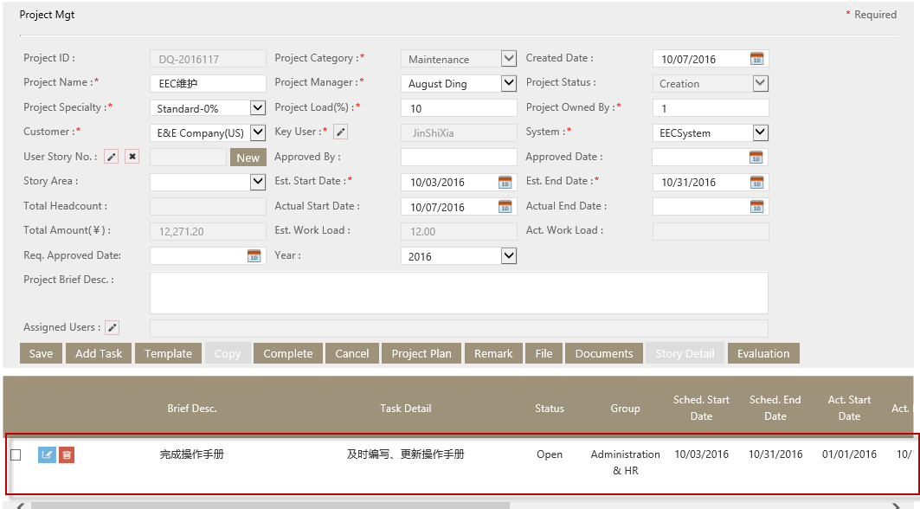

Way2: Use ‘Template’ to create project task.
- Click Template button on Project detail page. System will pop up template page as below:
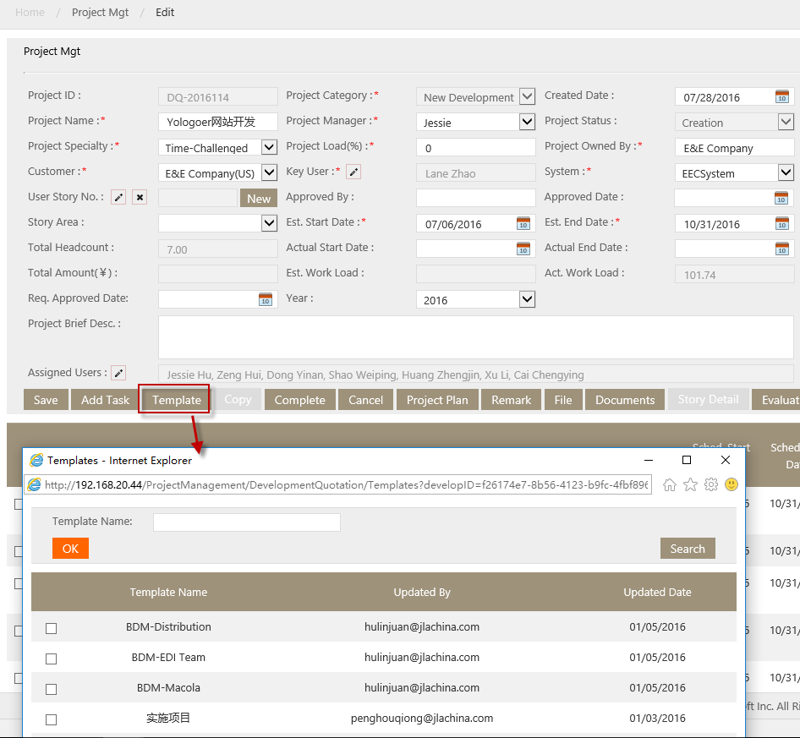

- Select one template, click OK button.
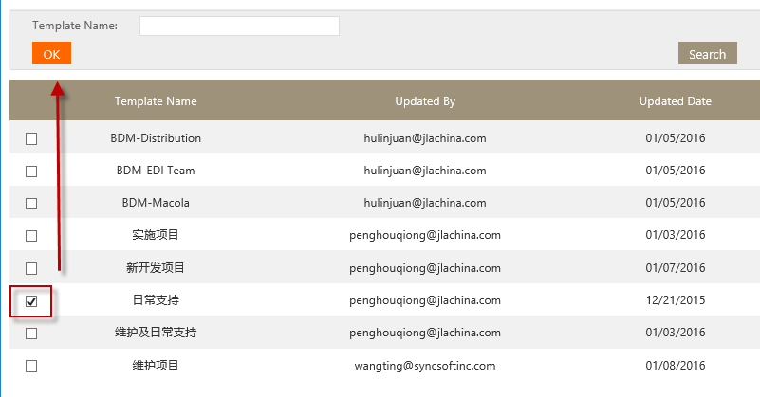

All task details in selected template are added to this project and displayed on the Project Mgt page. See below

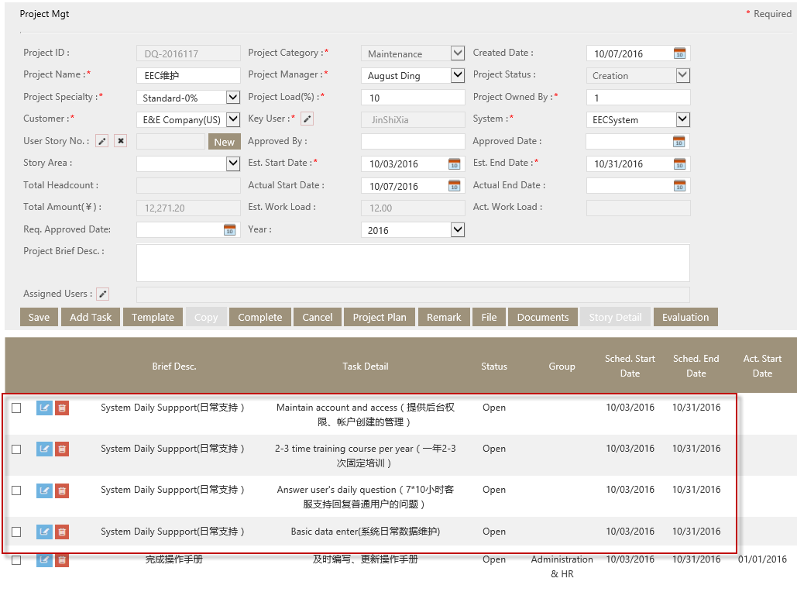
- User can edit or delete tasks as need.
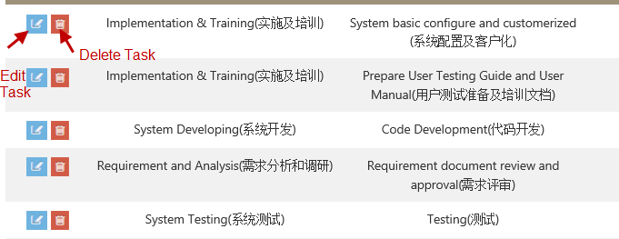

How to assign users to the project
User (Currently its project manager) need to assign the project to other users, such as developer, tester, supporter and the project manager himself (herself).
- Go to Syncsoft costing System-->Project Mgt page, select the project.
- Click the pencil beside Assigned Users
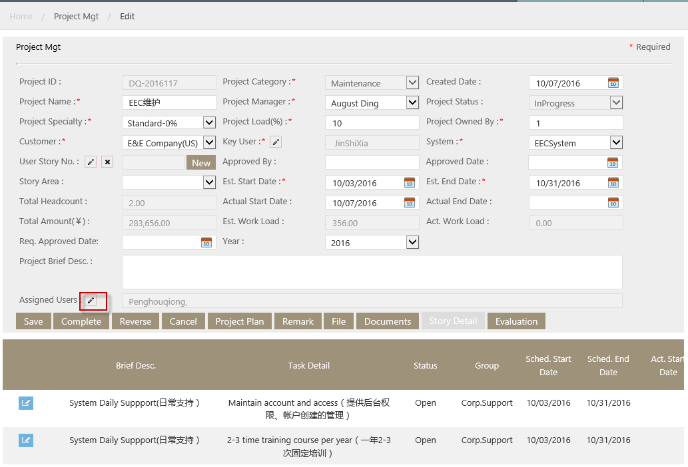
- In the pop up window, select the users need to assign.
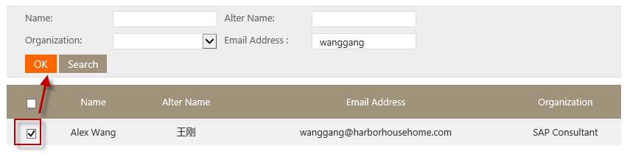
- Click Save on the Project Mgt page
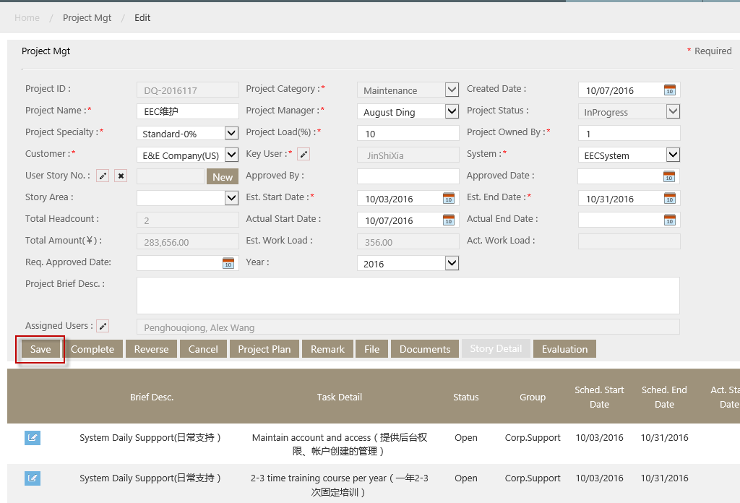
The user will see the project assigned to him (her) on his (her) weekly report page.
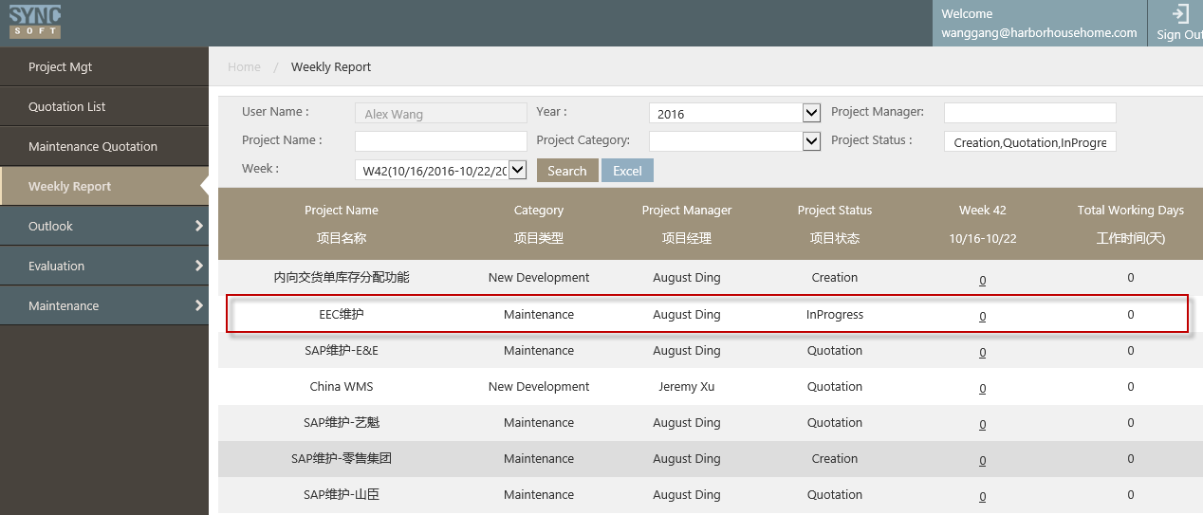

How to fill in actual start and end hours for tasks
User need to fill in the actual start and end hours for each task.
- Go to Syncsoft costing System-->Project Mgt page, select the project
- In the pop up window, select the task need to fill in actual start and end date
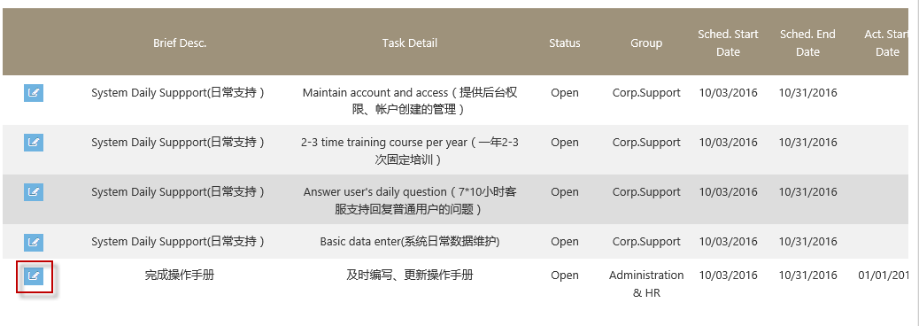
- In the pop up window, fill in actual start and end date
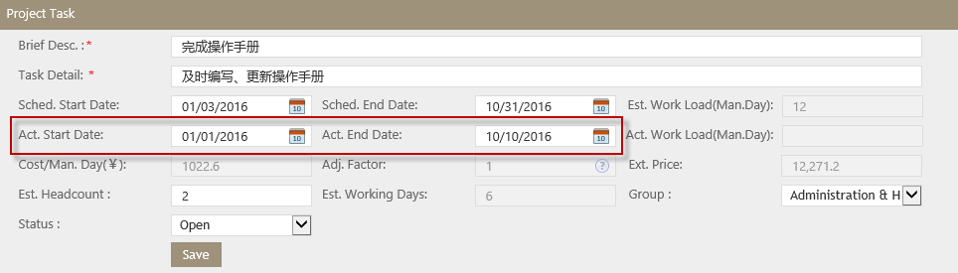

How to add remark to the project.
If there’s other information user need to add to the project, he (she) can click remark to do it.
- Go to Syncsoft costing System-->Project Mgt page, select the project.
- On the pop up page, click Remark button.
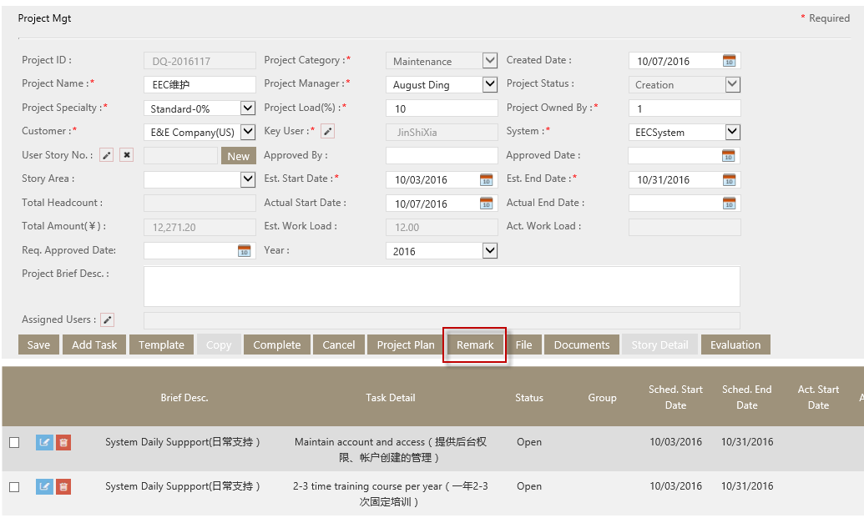

In the pop up window, some remark topics are added by default, user can delete or edit it according to project.
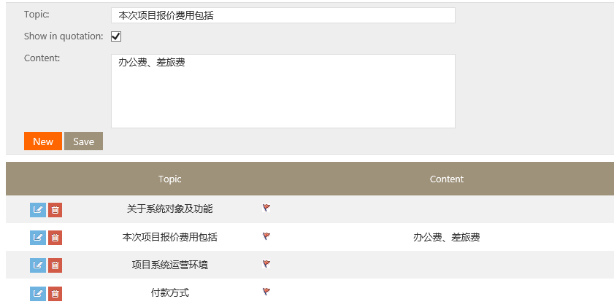

If user want to create a new remark, click new button to create.
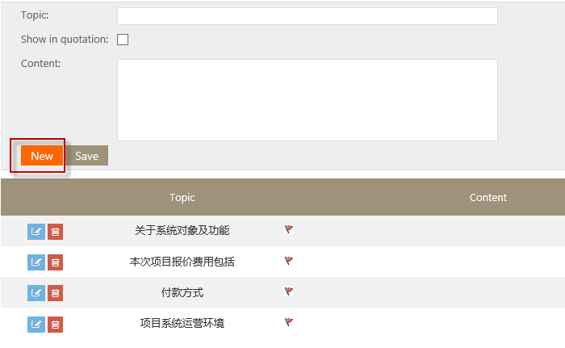
If need to show the remark in quotation, check the box after ‘Show in quotation’
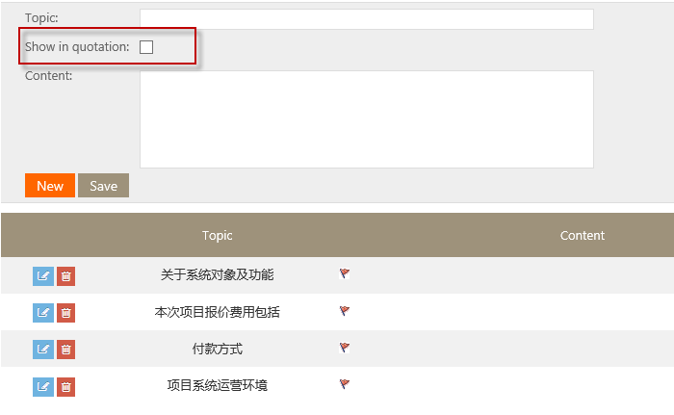

How to fill in documents completion
User need to fill in documents completion when complete the project to complete status.
- Go to Syncsoft costing System-->Project Mgt page, select the project
- In the pop up window, click Documents button,
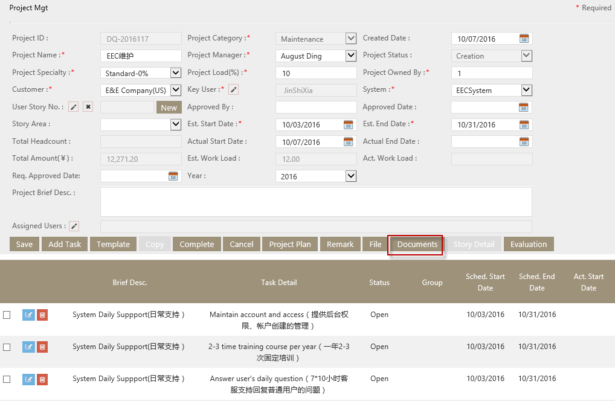

System will pop up documents window, see below.
Here, some docs are added by default, user can delete or edit it according to project.

- Fill in docs completion
If the doc is default in the grid, select the docs and fill in the completion.
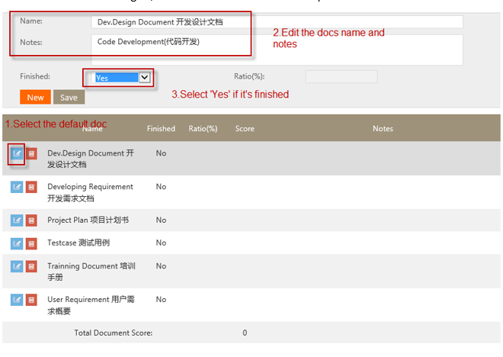

If the doc is not default in the grid, click ‘new’ to add docs. See below.

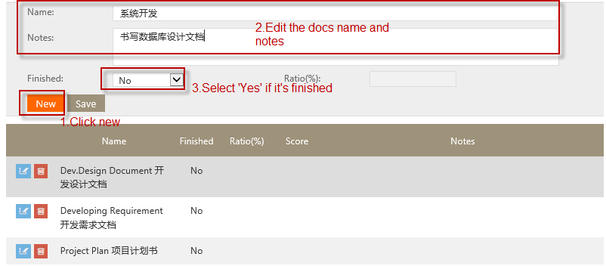

How to complete the project
User need to complete the project per the project’s procedure.
- Go to Syncsoft Costing System-->Project Mgt page, select the project.
- In the pop up window, click Complete button to complete it to next status
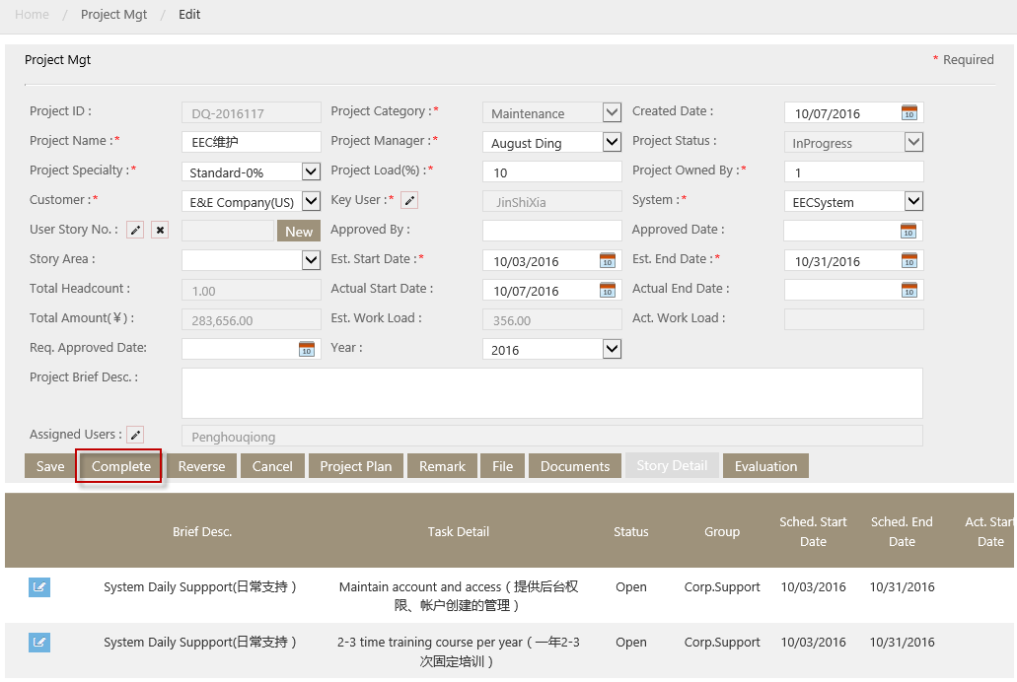

Notes
Role with Analyst only can complete or cancel projects which are created by himself/herself.

How to view and download project plan.
- Go to Syncsoft Costing System-->Project Mgt page, select the project.
- In the pop up window, click “Project Plan” button.
The Software Project Plan will pop up as below:
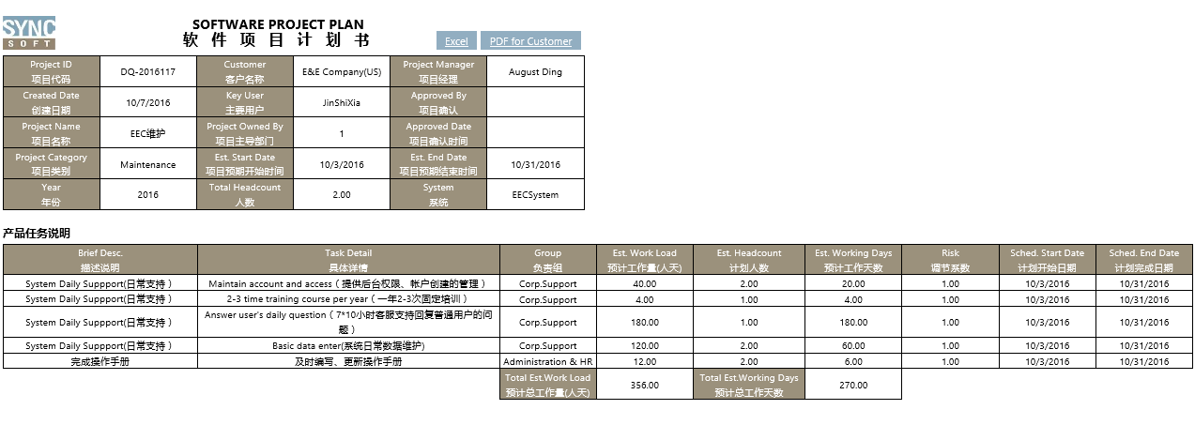
User can click Excel or PDF to Customer to download the Project Plan.

How to reverse the Project
- Go to Syncsoft Costing System-->Project Mgt page, select the project.
- In the pop up window, click Reverse button
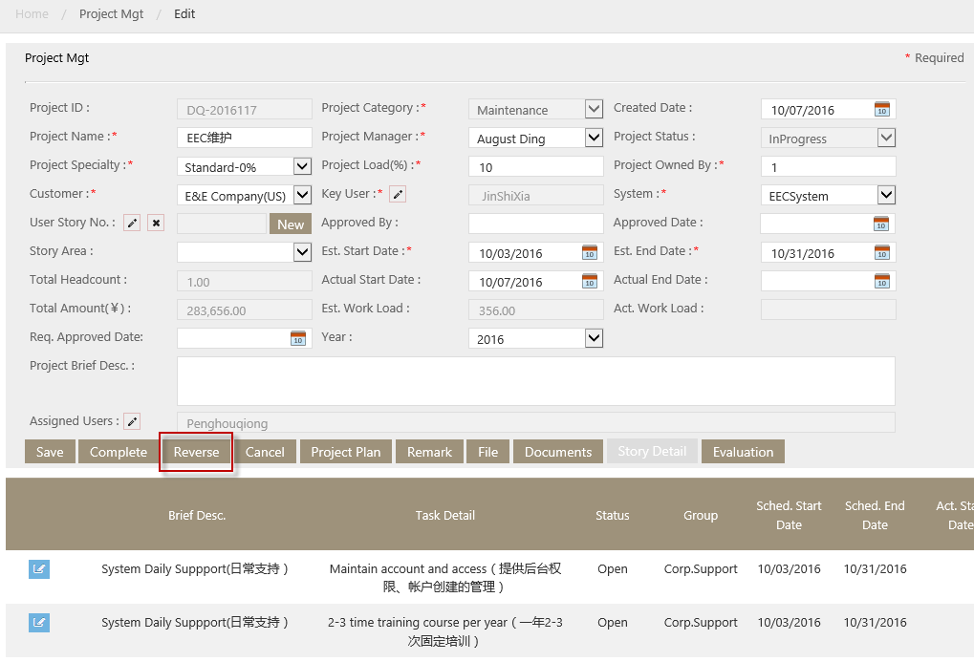
The project will be reversed to previous status.

How to evaluate the docs
User (Currently its department manager) need to evaluate the docs when it’s completed.
- Go to Syncsoft Costing System-->Project Mgt page, select the project.
- In the pop up window, click “Documents”
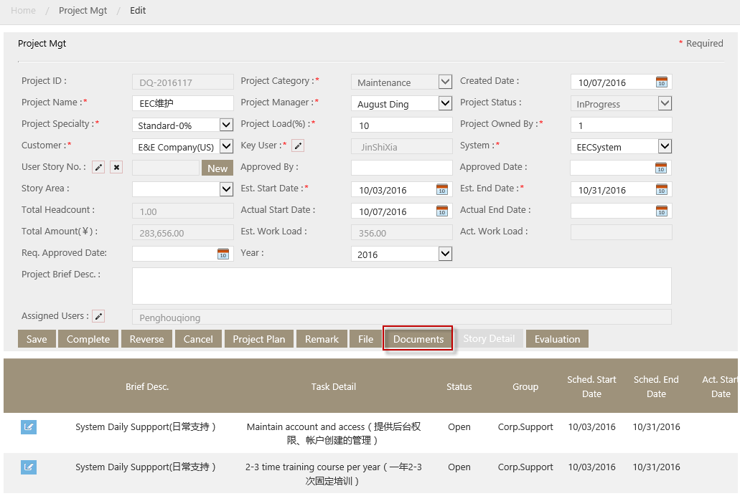

- In the open page, fill in Ratio, and change score if need.
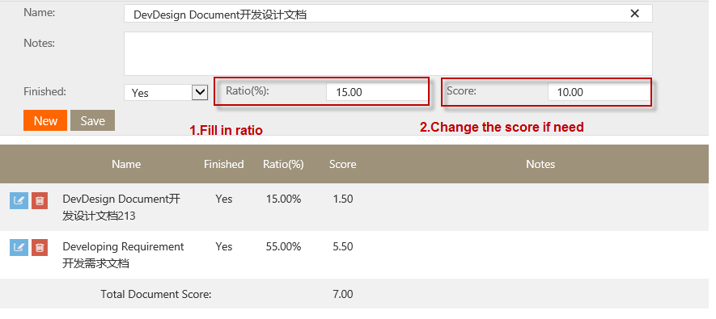

After save, system will calculate out the total docs score:
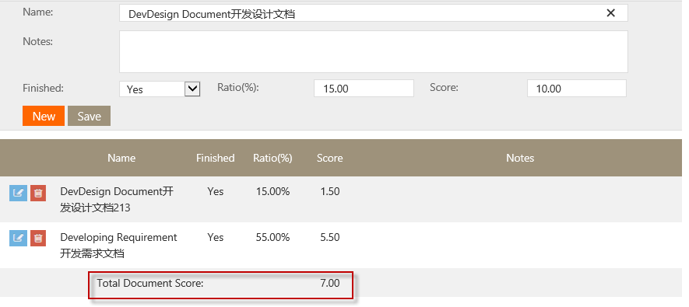

It will be shown on manager’s ‘Evaluation’ page:
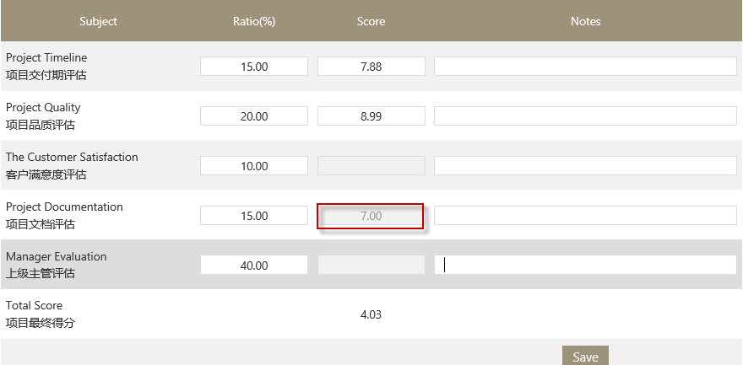

How to evaluate the project’s timeline and project quality
User (Currently its department manager) need to evaluate the project’s timeline and project quality when it’s completed.
- Go to Syncsoft costing System-->Project Mgt page, select the project.
- In the pop up window, click Evaluation
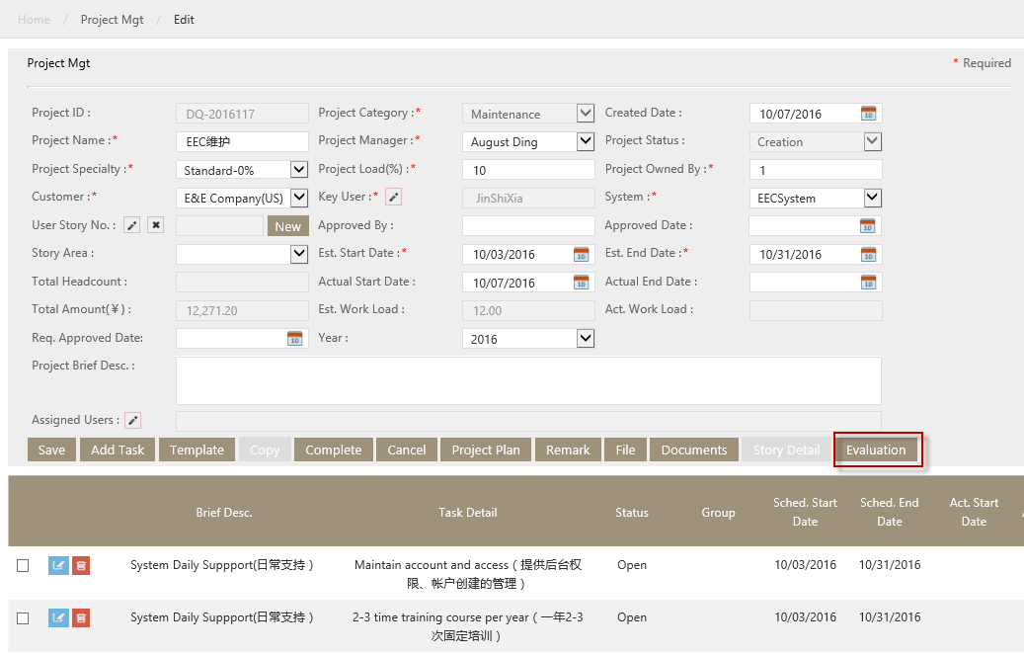

- In the pop up window, fill in all aspects ratios and the scores of Project Timeline & Project Quality
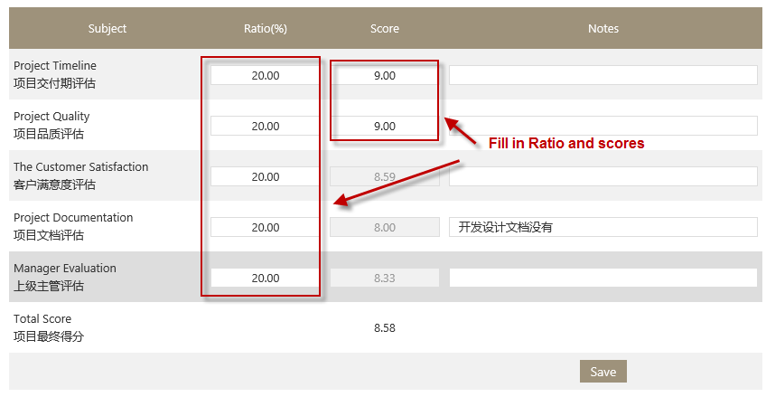
System will calculate out the total score:
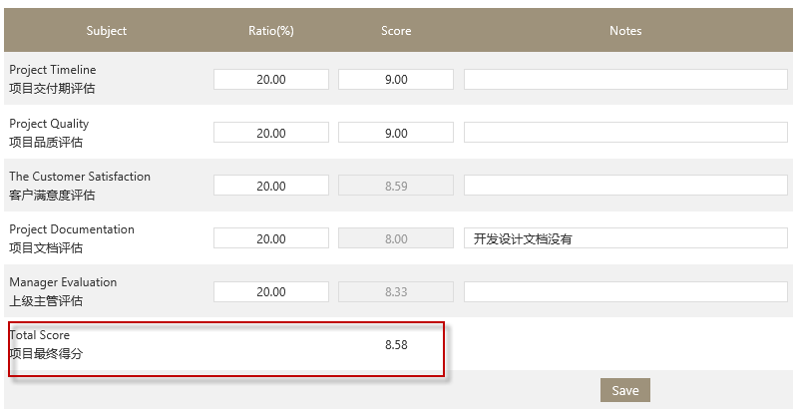
Notes: The Scores of Cust.satisfaction survey and Self evaluation is linked from Evaluation module, (the detail see How to make Cust.satisfaction survey & Self-evaluation.) and read only here. The score of Project Documentation linked from Project Mgt-Documentations module (the detail see How to evaluate the docs )and read only here.

Quotation List
Quotation List is to manage the quotation to customer.

Page introduction
The page is as below:
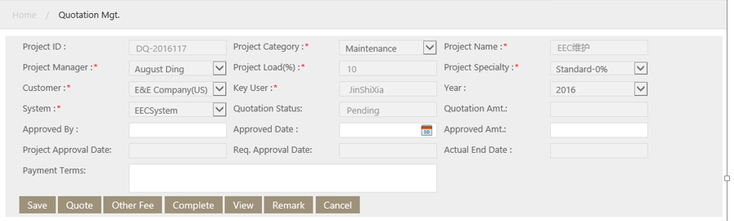

Key Field
- Quotation Status: Quotation have 7 statuses: pending, quotation review, final quotation, approval, gathering, complete and cancelled.
The according operation in each status please see Quotation Status and the according operation

Key button
- Quote: It’s used to select how to quote for this project , the detail see How to do quotation
- Other fee: It’s used to fill in other fee.
- Remark: It’s used to add remark for the quotation

How to fill in quotation detail
System create quotation automatically when the project is completed to quotation status. User can see the quotation on the Quotation List.
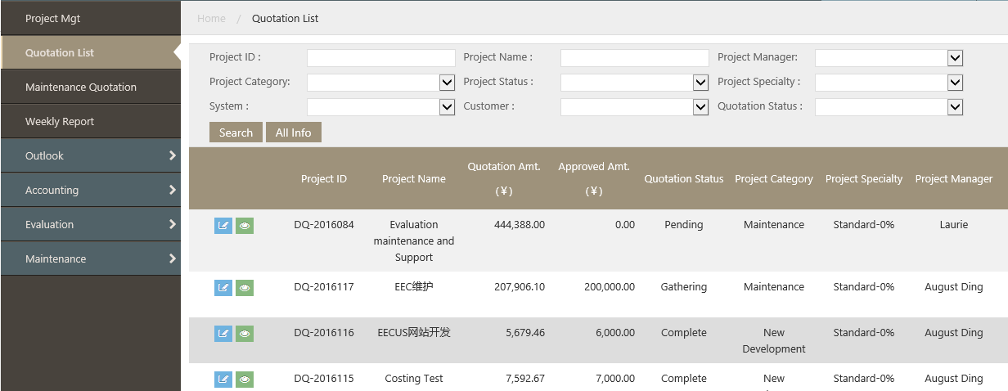

User need to fill in other detail information.
- Click the edit icon beside the quotation, pop up the Quotation detail page:
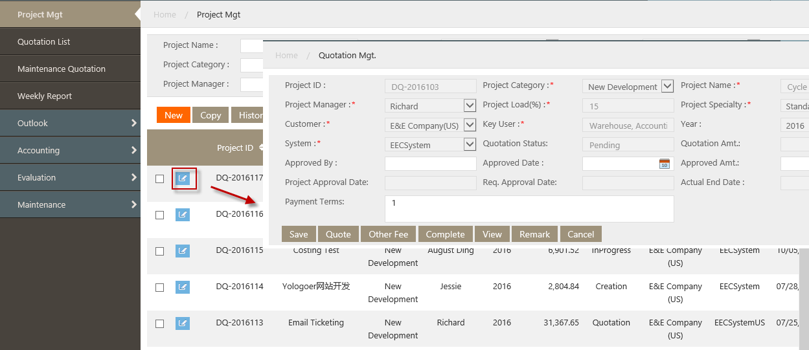

- User need to fill in Approved By, Approved Date, Approved Amt in the page.

How to do quotation
User (Currently its general manager) need to quote to customer on the project.

- Go to Syncsoft Costing System-->Quotation List page, select the quotation
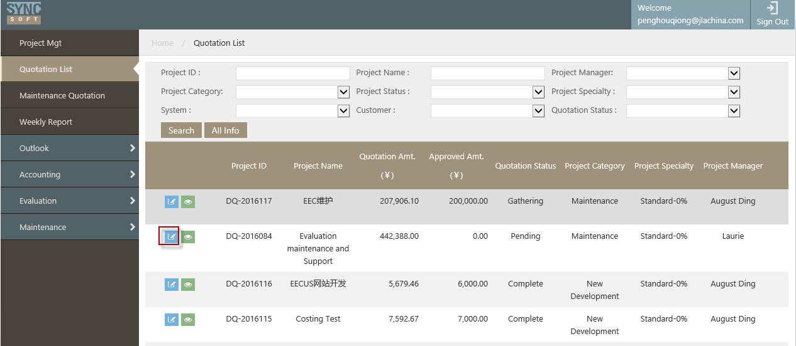

The Quotation Mgt page will open:

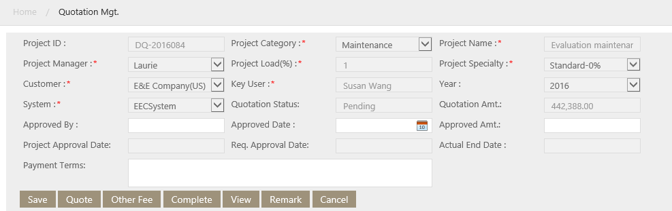

- In the pop up Quotation Mgt window, Click Quote button to open the quote window:
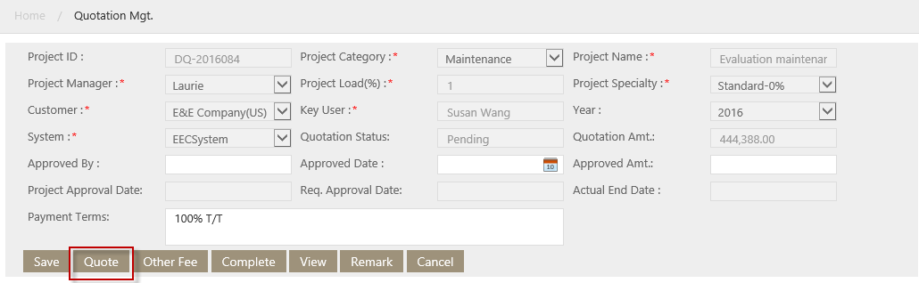
System display the quotation detail window as below:
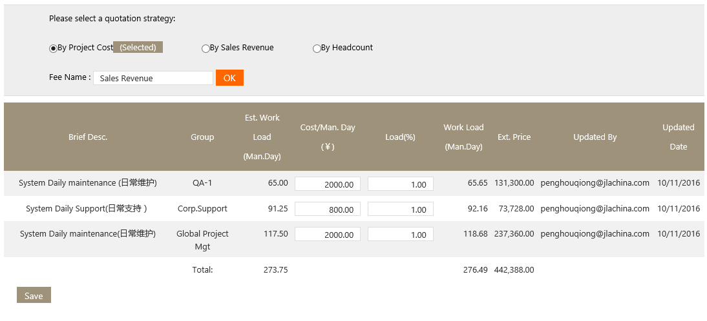

- Fill in quotation detail.
- If quote by ‘By Project Cost’, fill in fields in above pop up window.

Notes:
- System show quote By Project Cost by default (as above)
- The Cost/Man.Day and Load % is from Project Mgt module by default, user can edit it.
- The Work Load (Man.Day) =Est. Work Load* Cost/Man.Day*Load (%)

- If quote by Sales Revenue , select By Sales Revenue, the window will be as below:
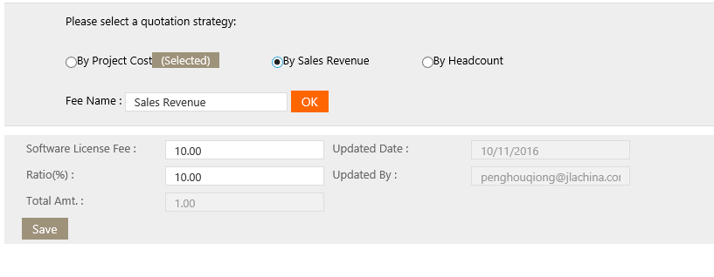
Notes:
- Total Amt=Software License Fee*Ratio (%)

- If quote by headcount, select By Headcount, the window will be as below:
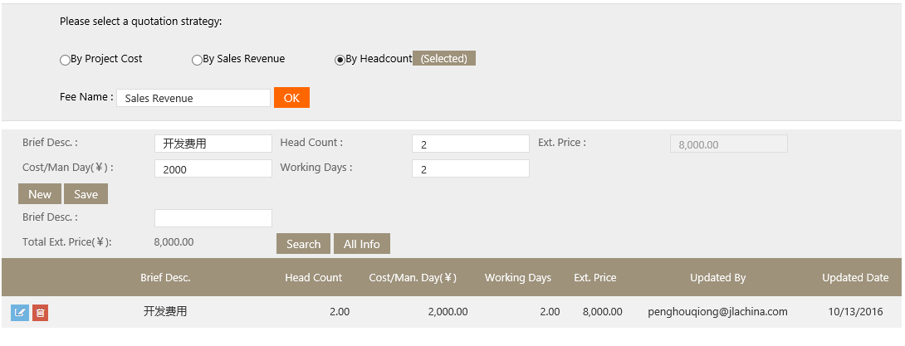
Notes:
- The Ext.Price=Cost/Man Day(￥)*Head Count*Working Days

After saving, the quote detail will be shown in Quotation Mgt.
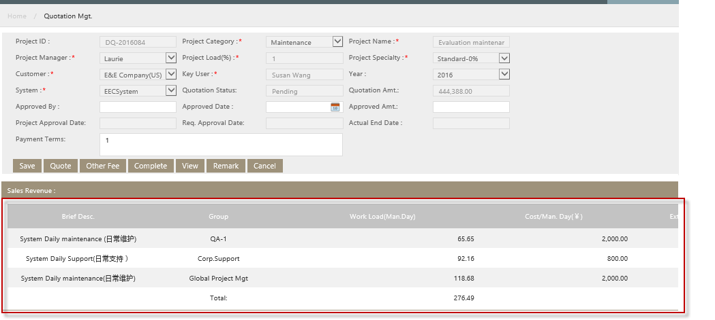

How to add other fee to the quotation.
If the quotation item is not in the default list, user can add Other Fee.
- Go to Syncsoft costing System-->Quotation List page, select the quotation
- In the pop up Quotatio Mgt page, Click Other Fee

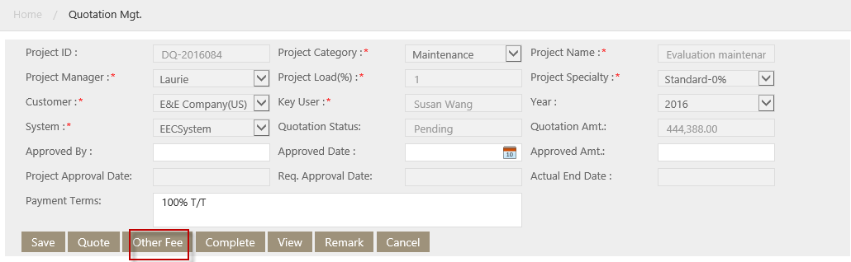
- In the pop up window, fill in the fields per request, and save.
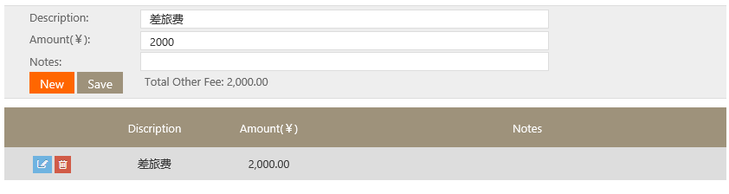
The other fee will show in Quotation Mgt.
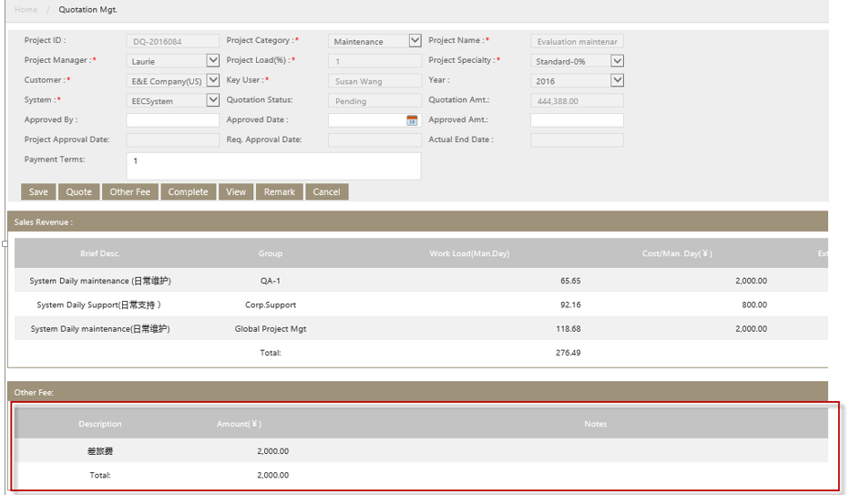

How to add remark to the quotation
If there’s other information user need to add to the quotation, he (she) can click remark to do it.
- Go to Syncsoft costing System-->Quotation List page, select the quotation
- In the pop up Quotatio Mgt page, Click Remark
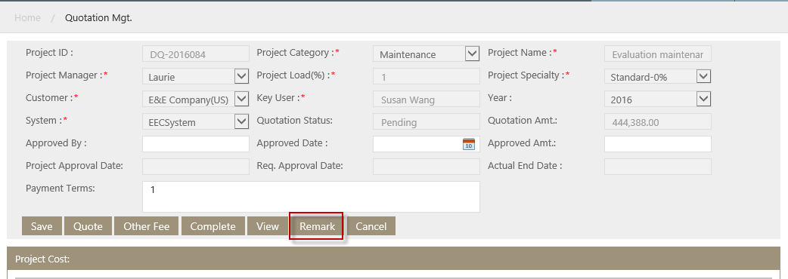

- In the pop up window, fill in fields per request.
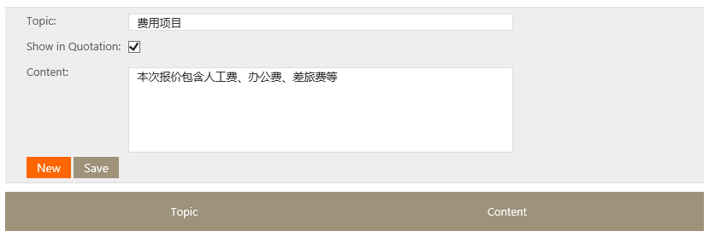
If check after Show in Quotation, the remark will be shown on the quotation:
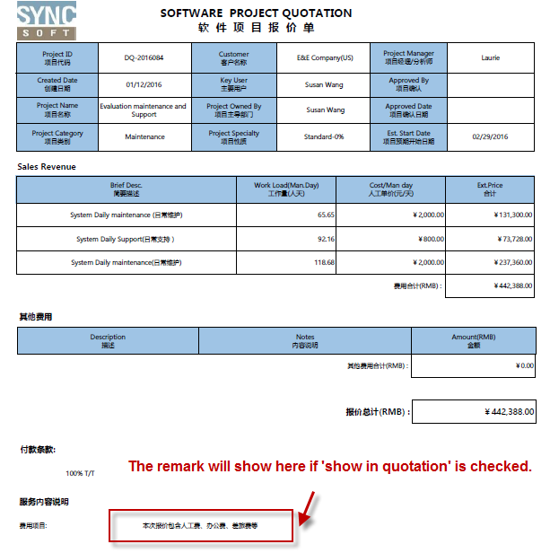

How to view quotation
- Go to Syncsoft Costing System-->Quotation List page, select the quotation
- In the pop up Quotation Mgt page, click View.

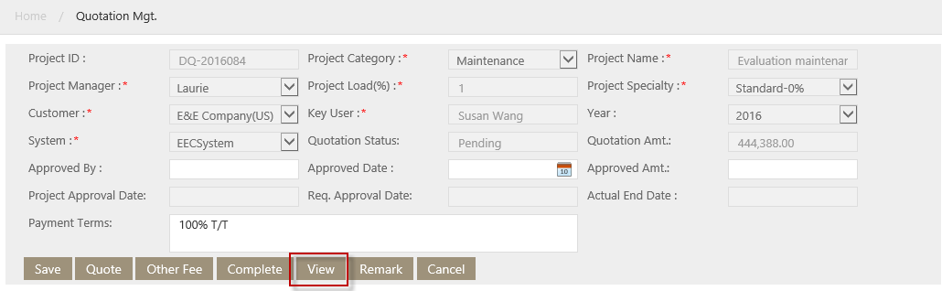

The quoation view page will pop up:

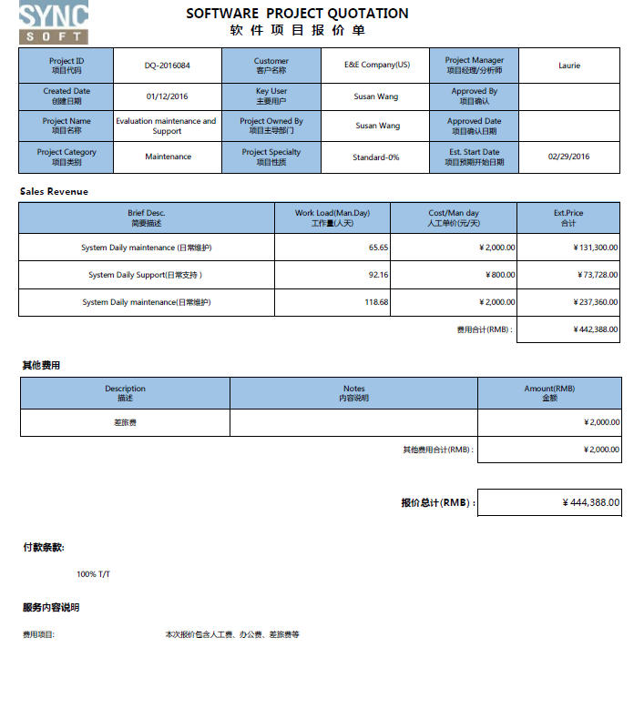

How to complete quotation
User need to complete the quotation per the quotation’s procedure.

- Go to Syncsoft costing System-->Quotation List page, select the quotation
- In the pop up Quotatio Mgt page, Click ‘complete’
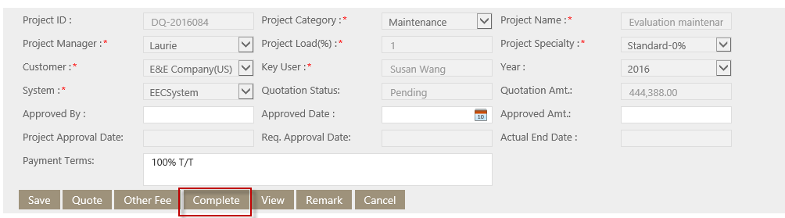
The quoation will be compeleted to next status.

How to cancel quoation
- Go to Syncsoft Costing System-->Quotation List page, select the quotation
- In the pop up Quotatio Mgt page, Click Cancel

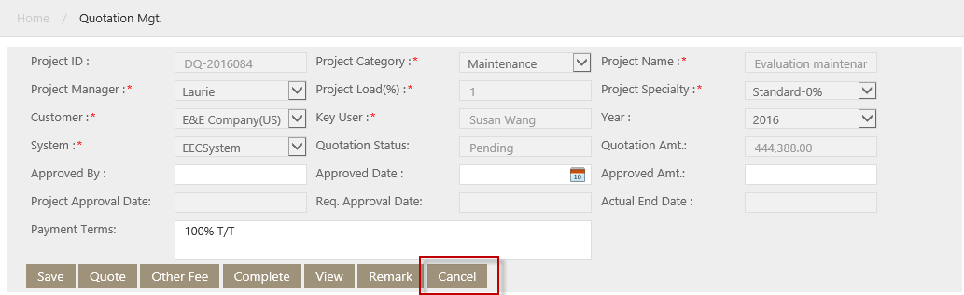

The quotation status will be cancelled.

Weekly Report

Page introduction
On this page, user fill in how many hours he/she contributes to projects.
The page is as blow:
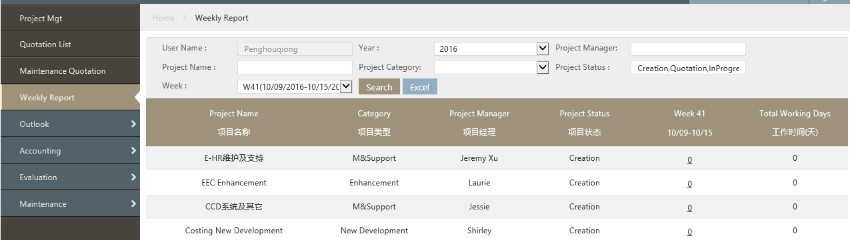
Key fields
- Week column: This column is to display the sum of working hours which current user fills in for this project. The column name is changeable. It’s the selected options of “Week” in search area. For example, select “39W (09/20/2015-09/26/2015)”, then column name is “39W (09/20/2015-09/26/2015)”.
- Total working days: its unit is “Day”. The value = value in week column/8.

How to do weekly report
- Go to Syncsoft Costing System -->weekly report page.
- Select one project and click week hyperlink, System will open working hour page, see below.
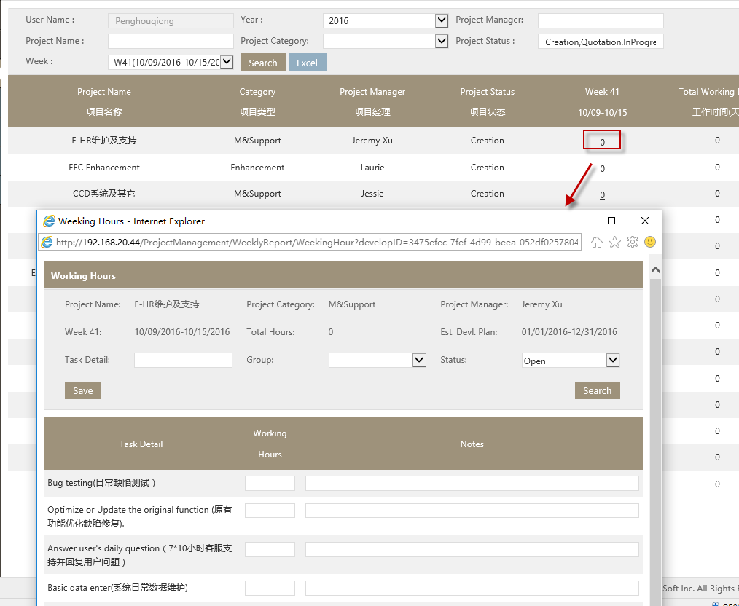
- Fill in the Working hours in above page and save. The working hours and days will be in the grid

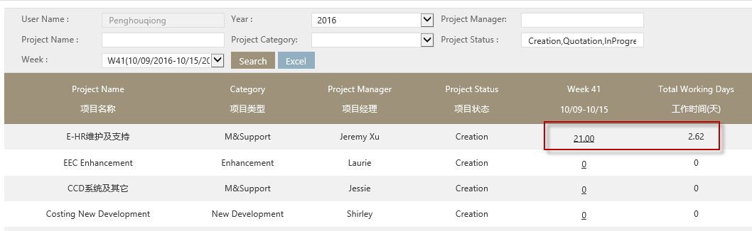

Click Excel button to export the report by excel, the exported excel format is as below
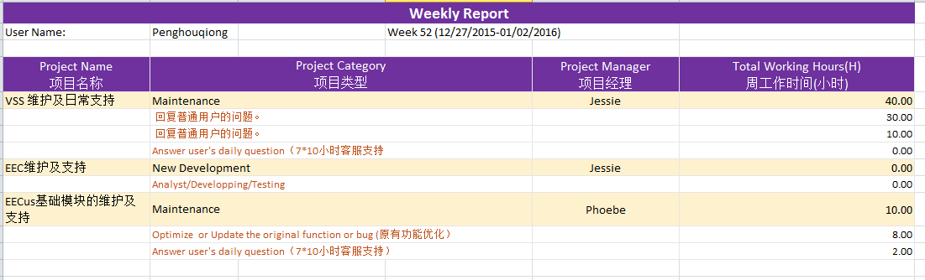

Evaluation

Evaluation Report

Page Introduction
The Evaluation report is to ask for Cust.satisfaction survey & Self-evaluation, the page is as below:
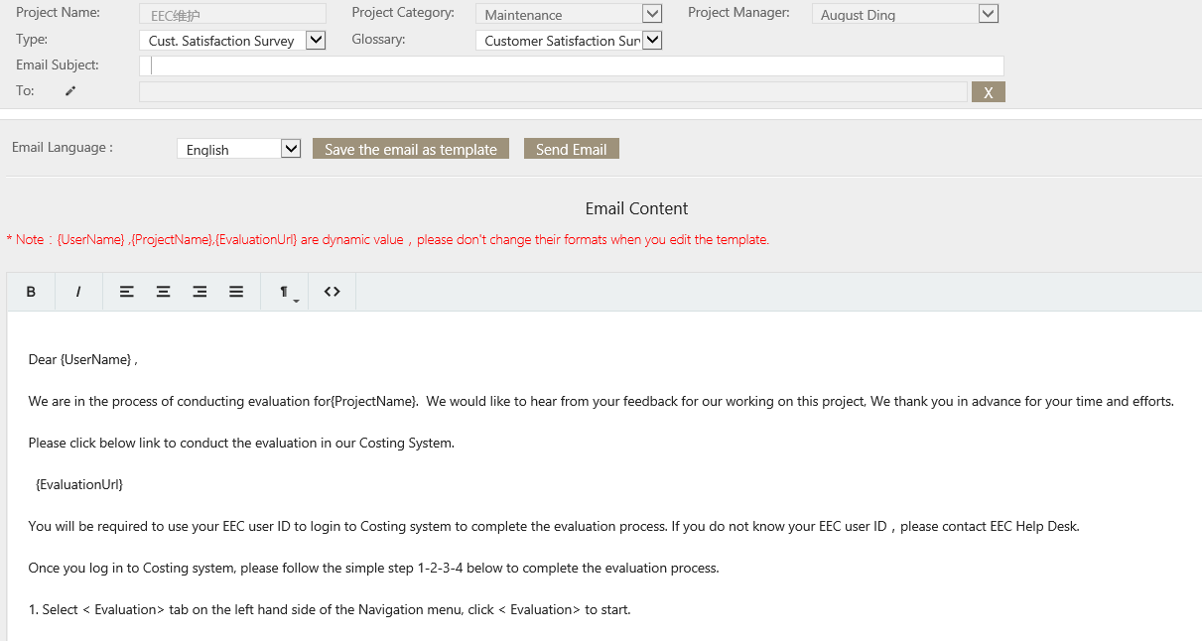
Key fields
- Type: User select ‘Cust.satisfaction survey’ or ‘Self-evaluation’ here.
- Glossary: User select which score glossary here.
- To: User open the pencil icon to select who evaluate the project.
- Email content: This is the content that will be sent to selected persons. User can edit the content as need, but do not change the fields in {}.
Key buttons
- Save email as template: If user need to keep the updated email content as template, click this button.
- Send email: User click this button to send email to the selected persons to ask for evaluation.

How to ask for Cust.satisfaction survey & Self evaluation
- Go to Syncsoft Costing System --> Evaluation report, select a project and click email,
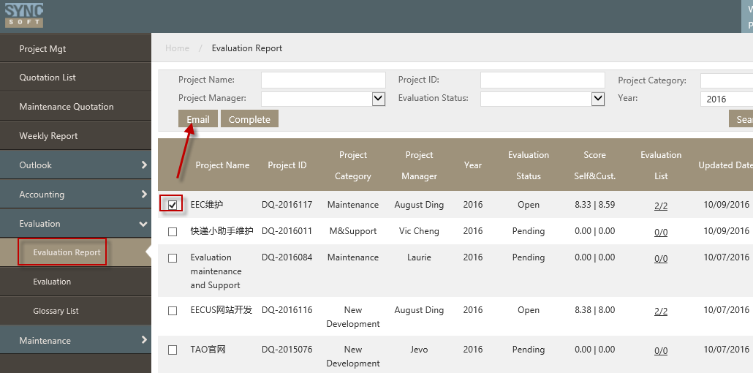

- The evaluate window will open, user fill the fields per request
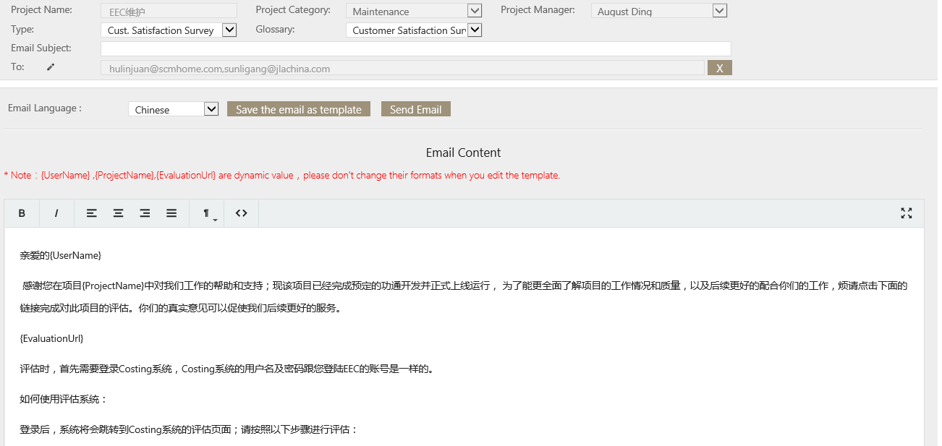

Then click Send Email.
The selected persons will receive the email that ask for evaluation.
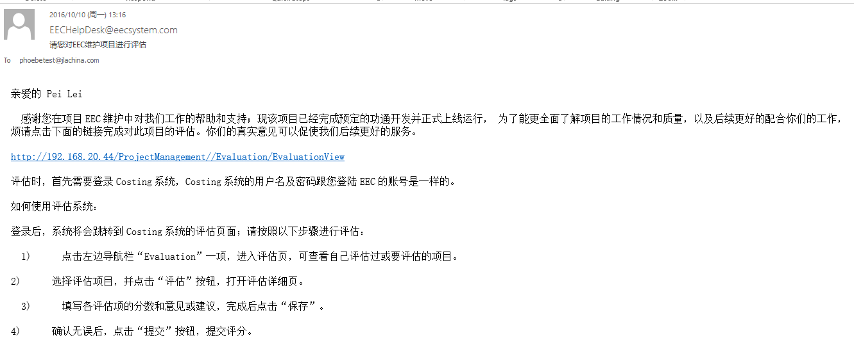
On their evaluation reportevaluation page, they will see the project(s):
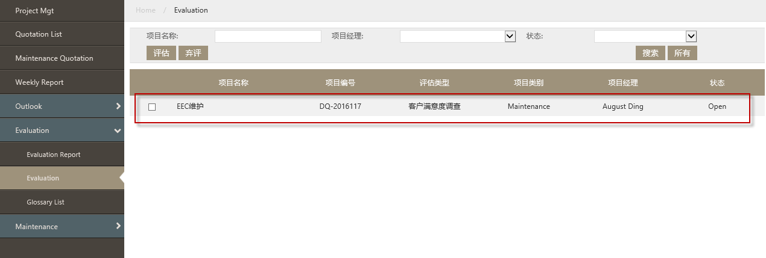

Evaluation

Page Introduction
It’s where user evaluate the project. The page is as below:
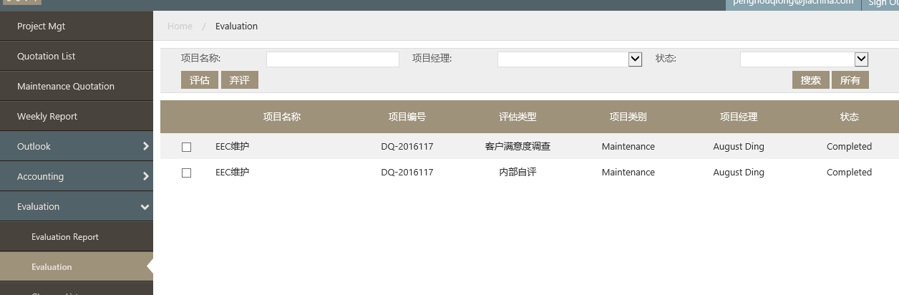

How to make Cust.satisfaction survey & Self-evaluation.
If user receive the email for evaluation, he (she) need to evaluate the project on syncsoft costing system.
- Go to Syncsoft Costing System -->Evaluation ReportEvaluation page, select the project and click Evaluate.
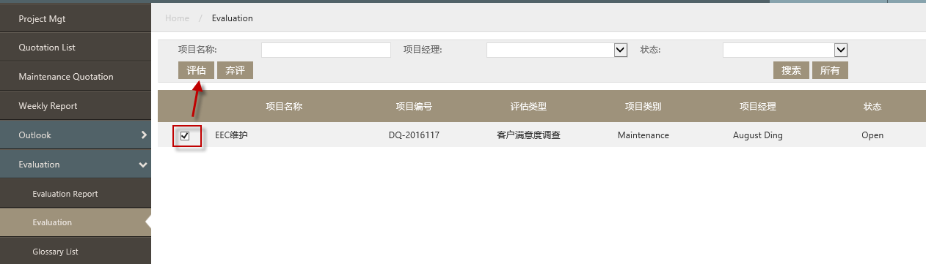

Below page will open:
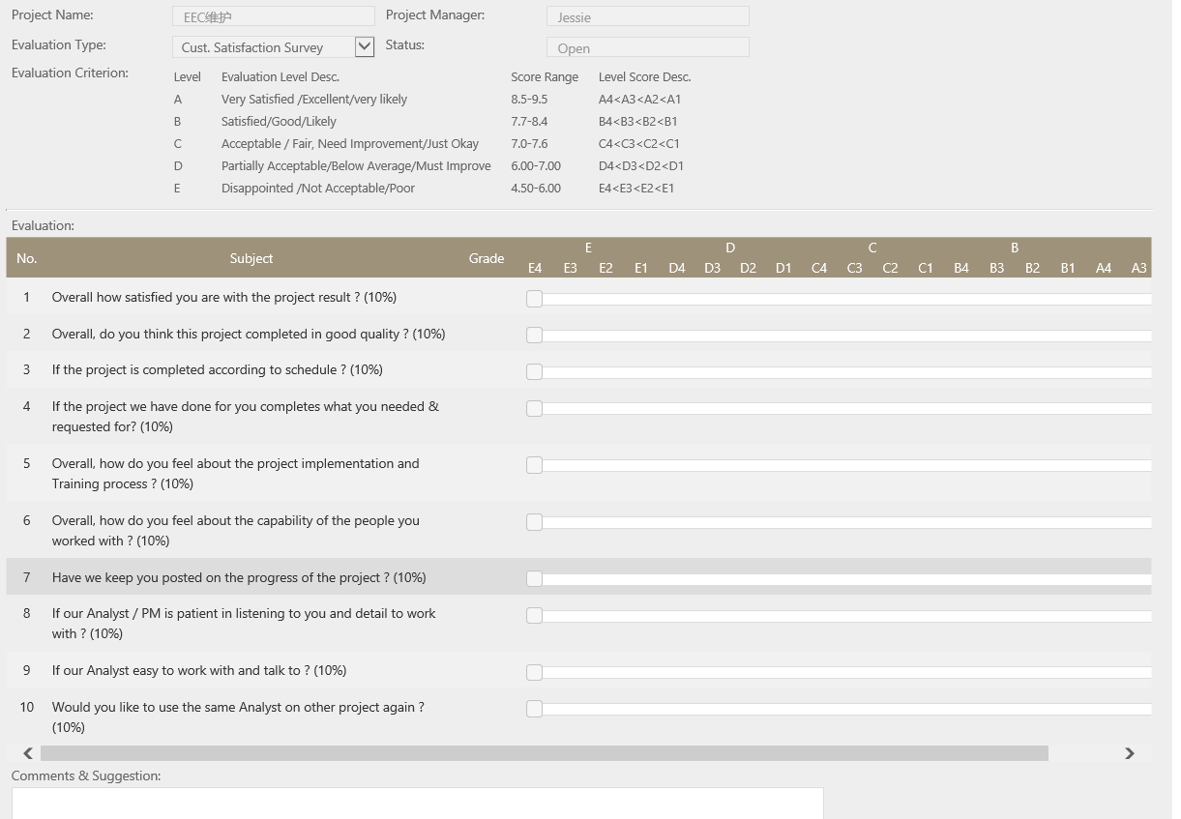

- Give scores:
Click the score level for all items on this page:
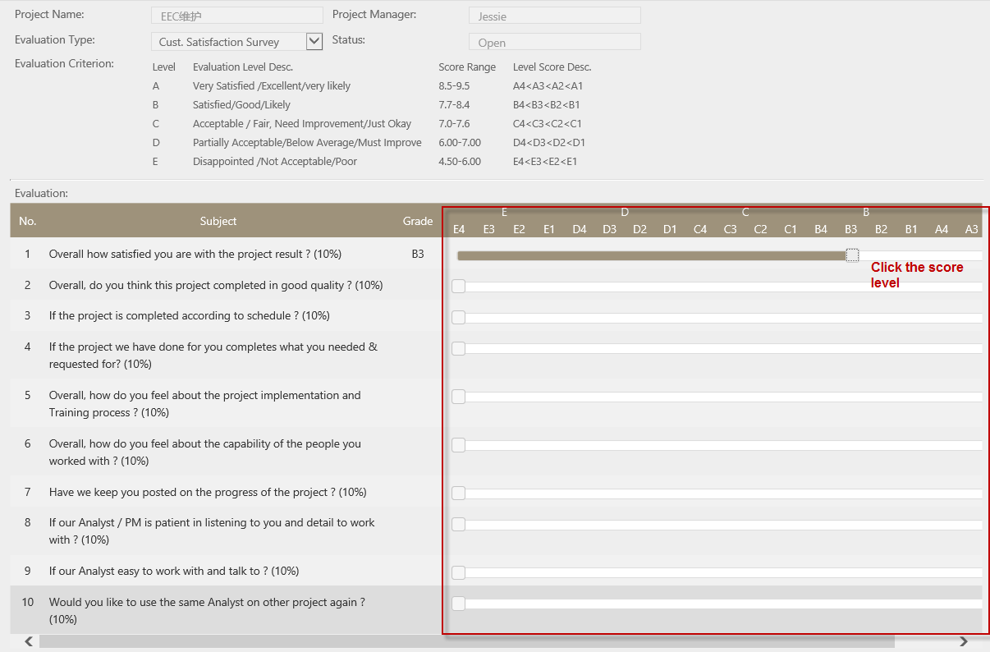

- Enter Comments & suggestion
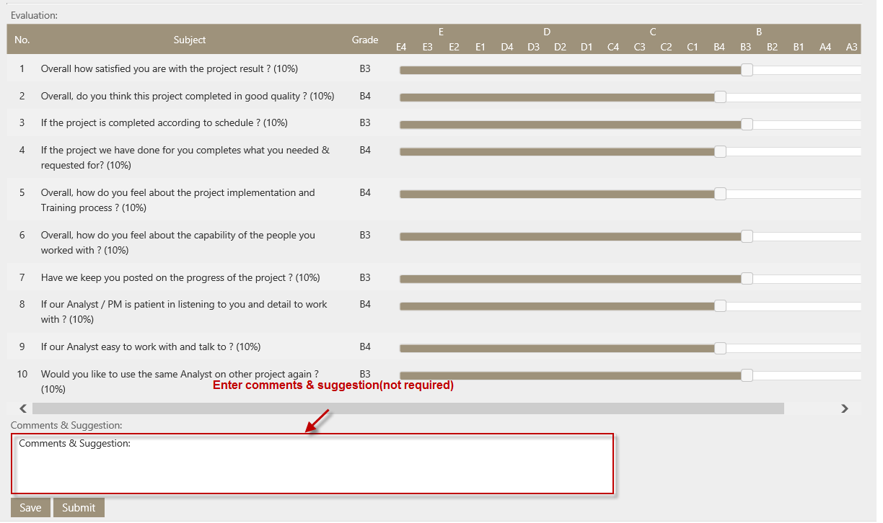

- Submit:
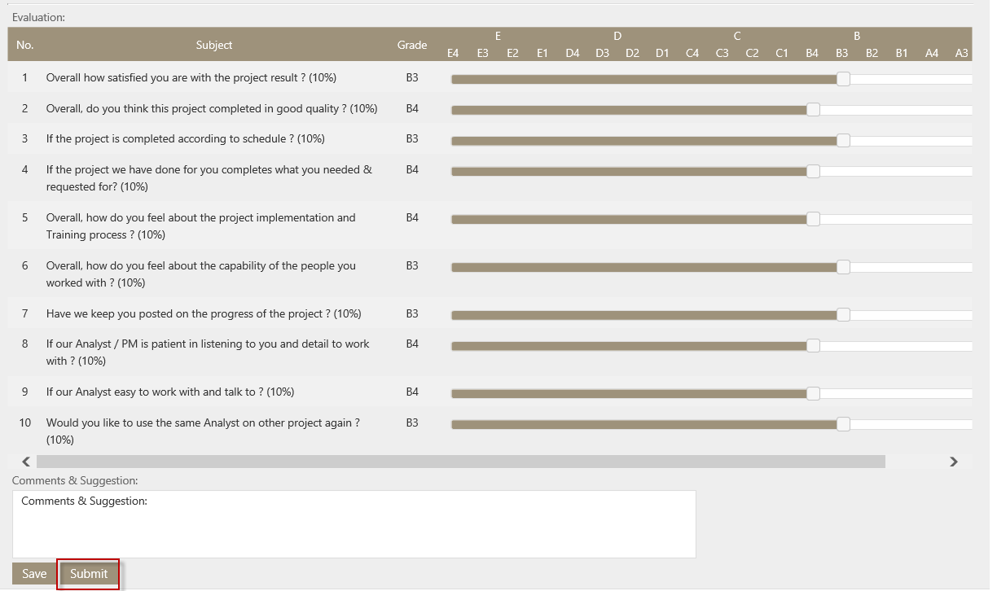
The Average score of Cust.satisfaction survey & Self evaluation will be on project evaluation page:
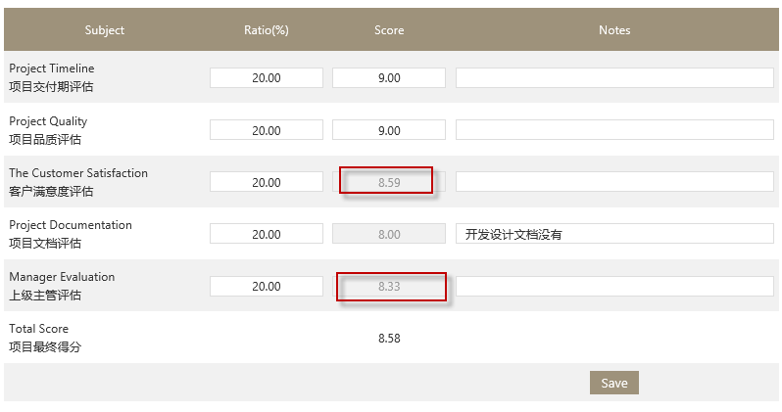

Accounting

Payment Process

Page introduction
It is used to record the payment that customer paid to Sync Soft Company. It is as below:

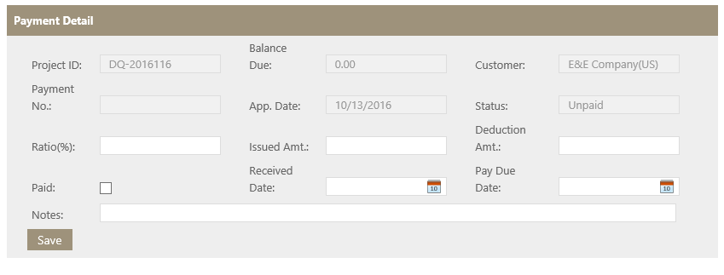
Key fields
- Status:the payment has 2 status, unpaid and paid.
- Ratio(%):It’s payment percentage.
- Issued Ammount:= Approved Amt*Ratio(%)

How to add payment to the project.
- Go to Syncsoft Costing System -->Accounting-->Payment Process page, select the project and click ‘Add payment’
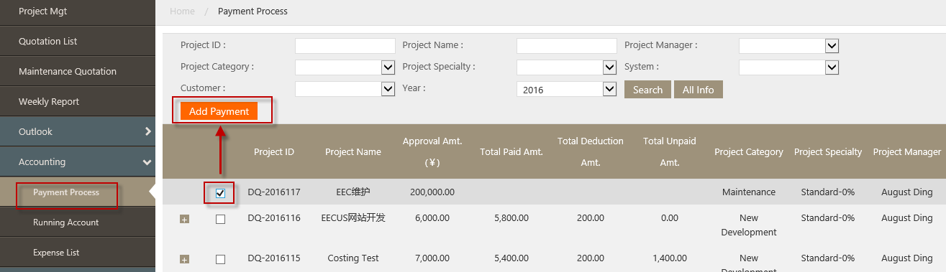

The payment detail window will pop up:
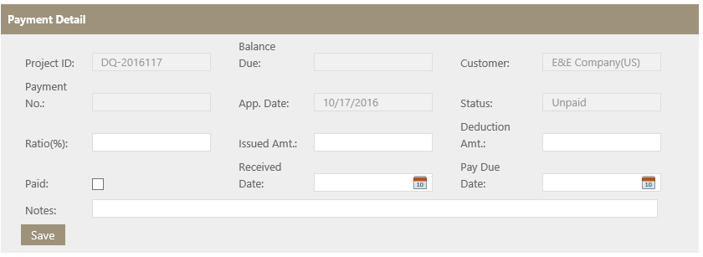
- In the pop up window, fill in the fields per request.
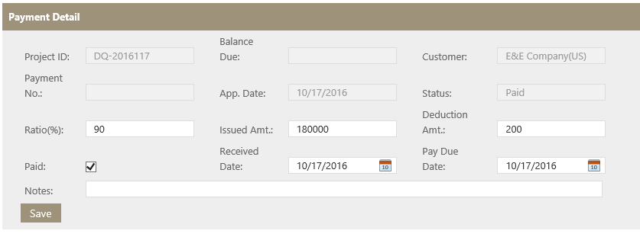
After save the payment detail, there will be a ‘+’ before the project ID in the grid of Payment Process page:
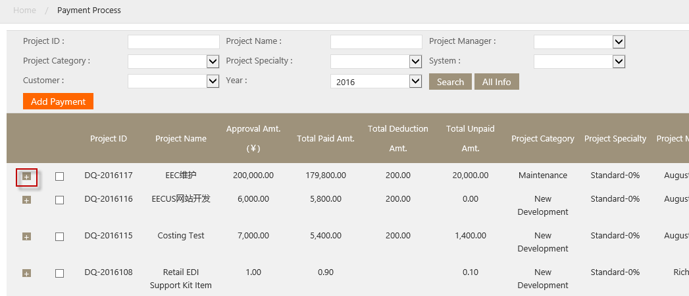
Click ‘+’ can see the payment detail.
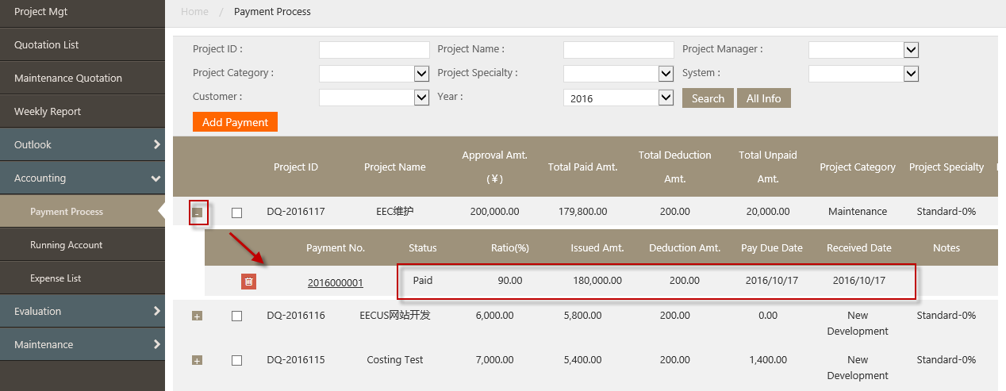

Notes:
- Total paid amount=Total Issued Amt. of the payment that the status is paid-Total Deduction of the payment at both paid and unpaid status. =Total Revenue (in revenue outlook page)

Expense List

Page introduction
It is used to record Sync Soft Company’s expense, the page is as below:
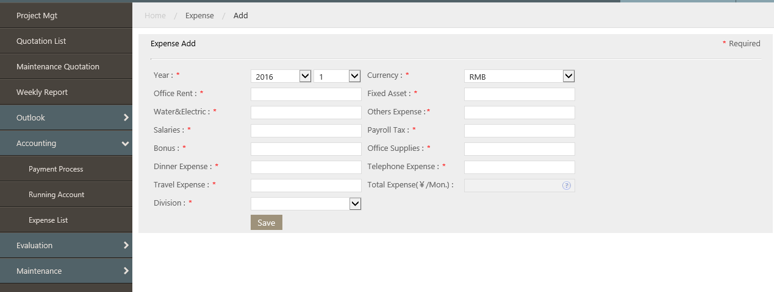

How to record expense
- Go to Syncsoft Costing System -->Accounting-->Expense List, click New
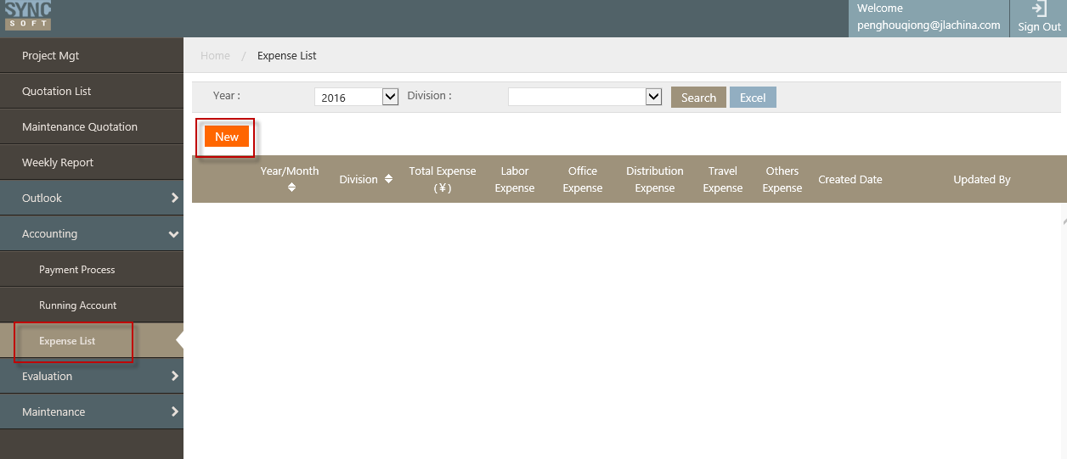

2. In the pop up window, fill in the fields per request.
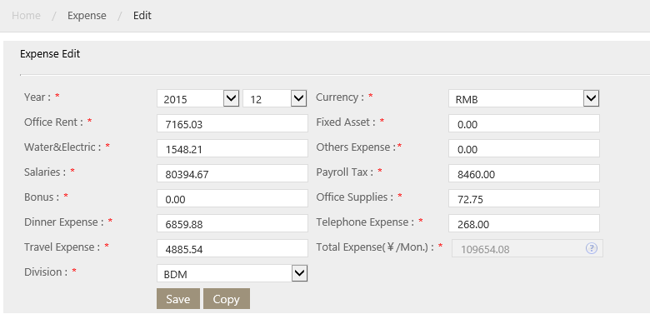
After save, the total expense of each year will be shown in the report Profit and Loss Report
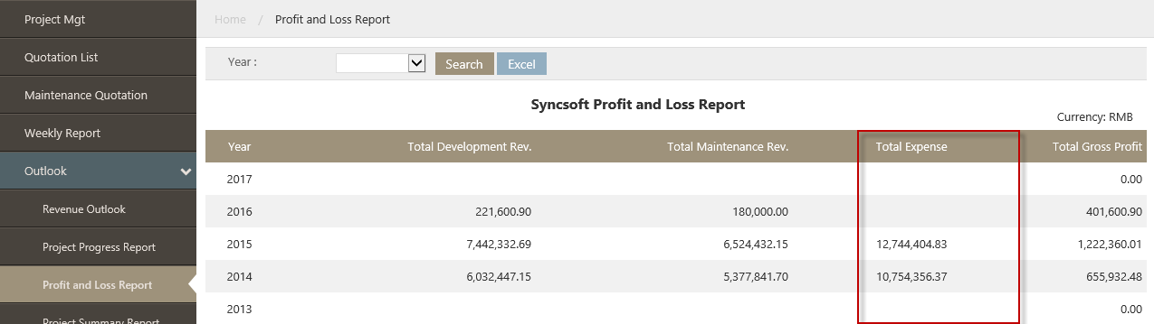

Running Account

Page introduction
It is used to record the receivement that Sync Soft receive. The page is as blow:
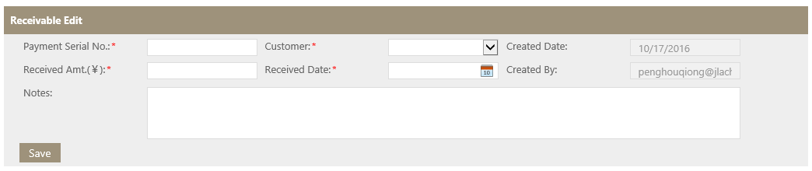

How to record running account
- Go to Syncsoft Costing System -->Accounting-->Running account
- Click ‘New’
- In the pop up window, fill the fields per request
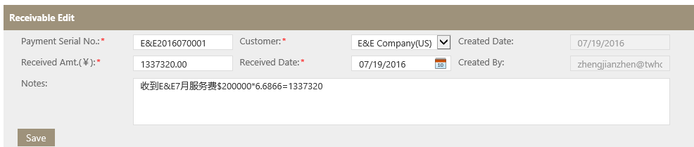

Outlook

Revenue Outlook
It is to report the revenue of Sync Soft Company. The page is as below:
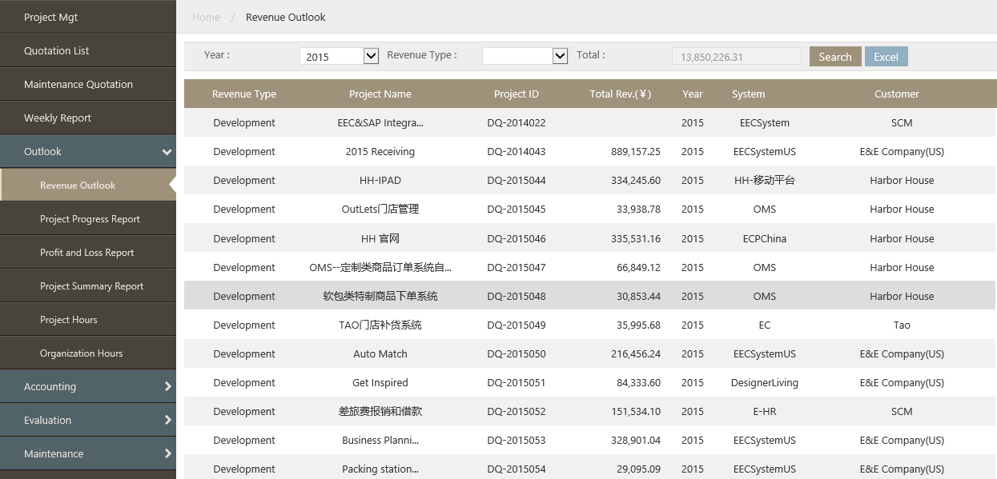
Notes: The Total Rev. (￥) =Total paid amount (on Accounting-->Payment Progress page)

Project Progress Outlook
It is to report the projects’ progress:
The page is as below:
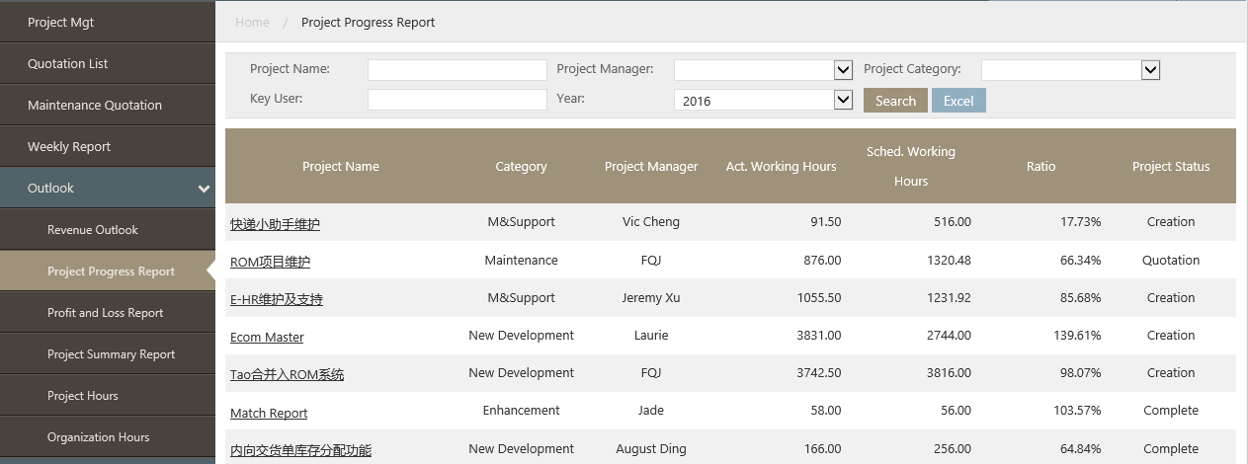

Click the Project name link, can see how many time spend on each tasks:

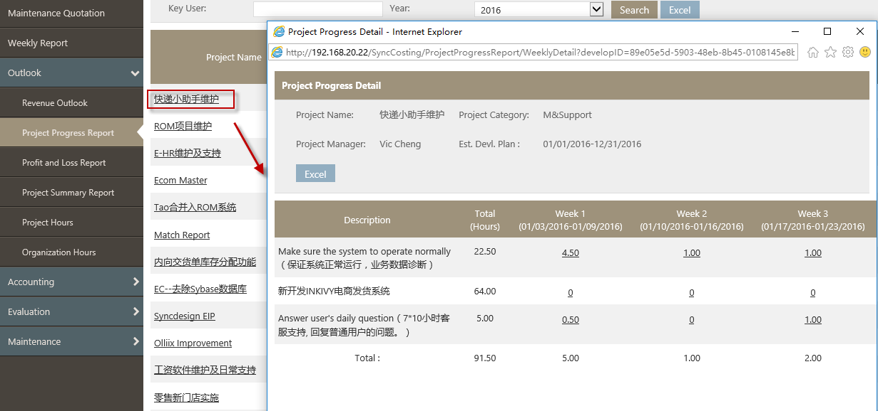

And click the hours, can see who spend time on the task:
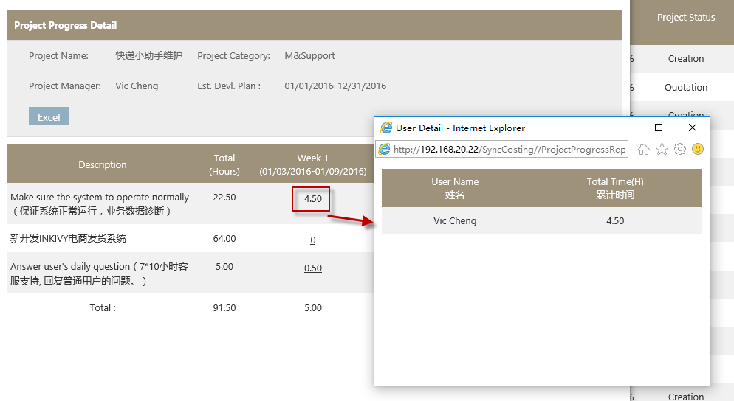

Profit and Loss Amount
It is to report Syncsoft Company’s profit and loss
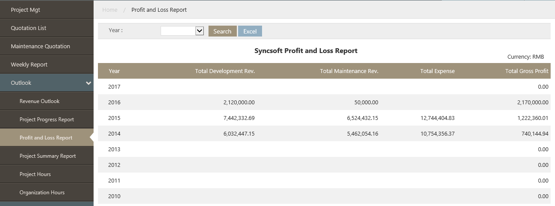
Notes:
- Total Development Rev. = Total Rev. of the project that the category is New Development, Optimization, Enhancement and Implementation
- Total Maintenance Rev. = Total Rev. of the project that the category is Maintenance, System Support, M&System Support

Po Summary Outlook
It is to report the scores and participants of the projects, the page is as below:
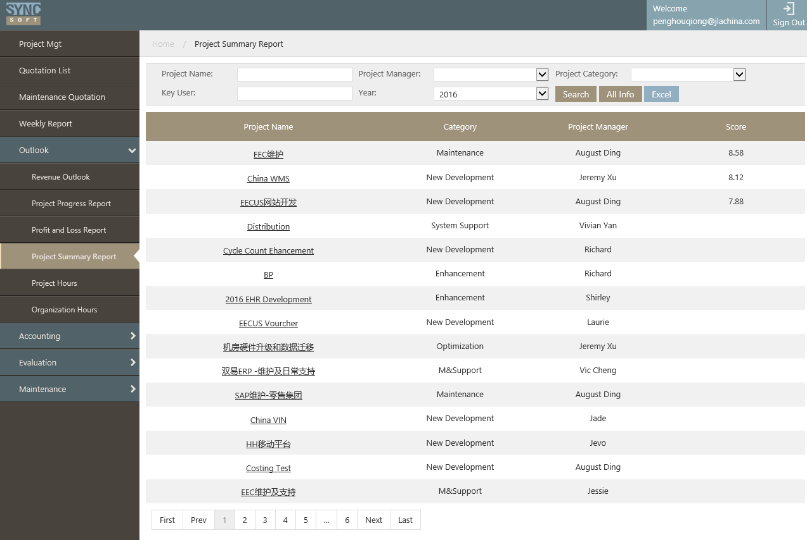

Click the project name can see the detail scores

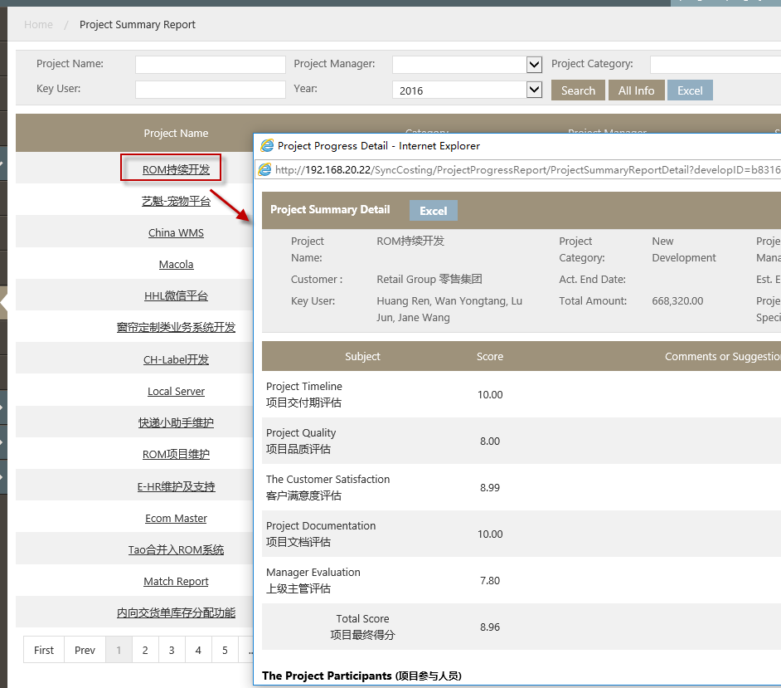

The project participants(项目参与人员) are in the bottom of the page:
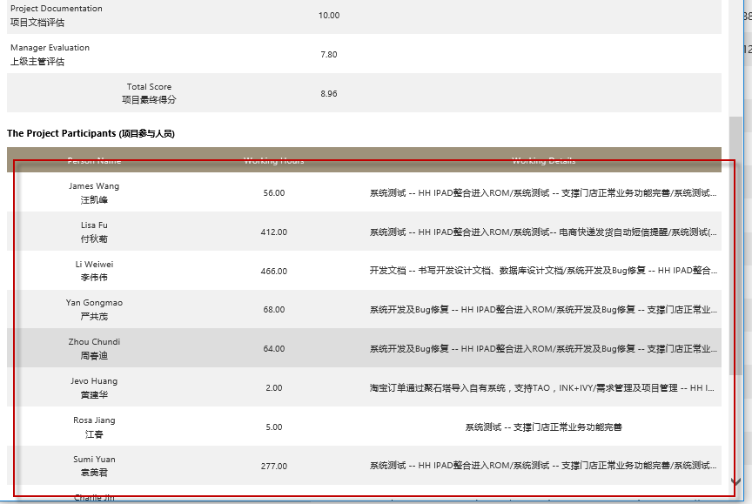

Project Hours
It is to report how many hours spent on the projects in each week.
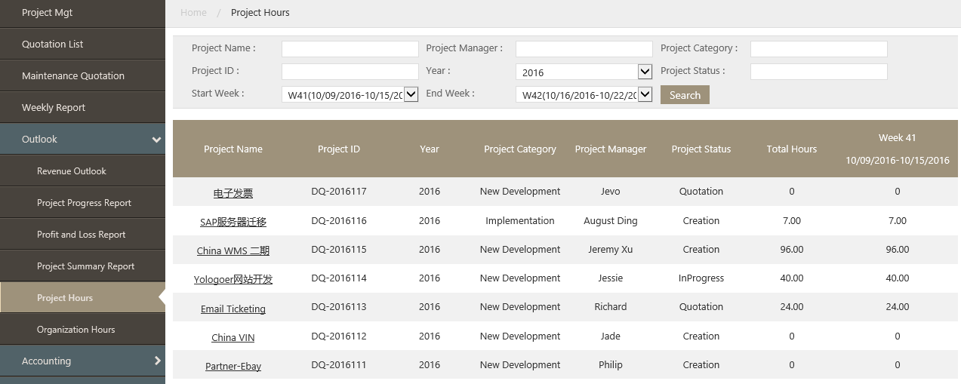

User can select weeks in search fields Start Week and End Week.
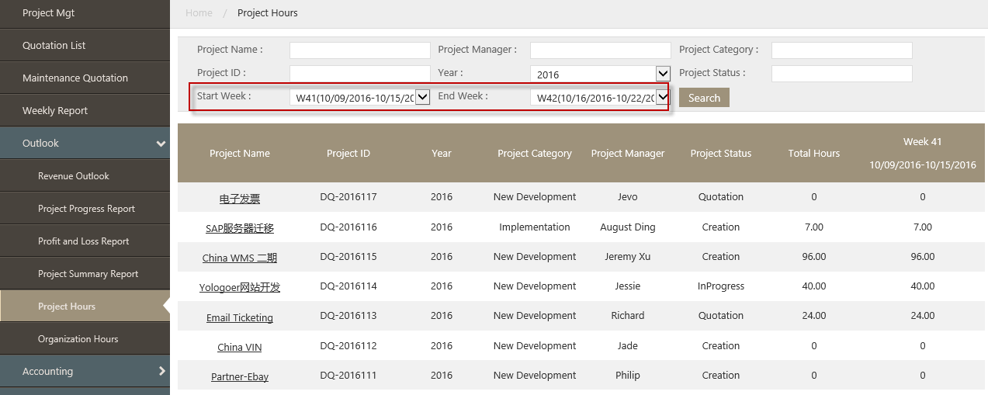
Click the Project Name to see who spend hours on the project.
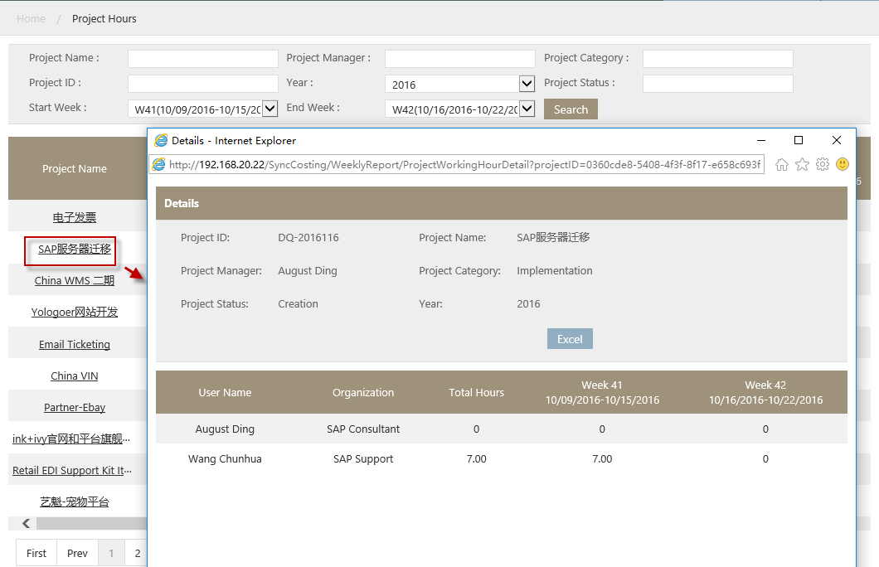

Organization Hours
This page is to report how many hours each users spend on projects.
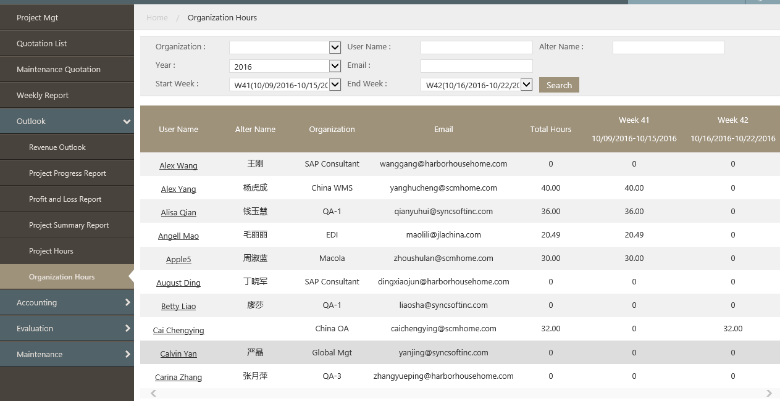

User can select week in search fields Start Week and End Week.
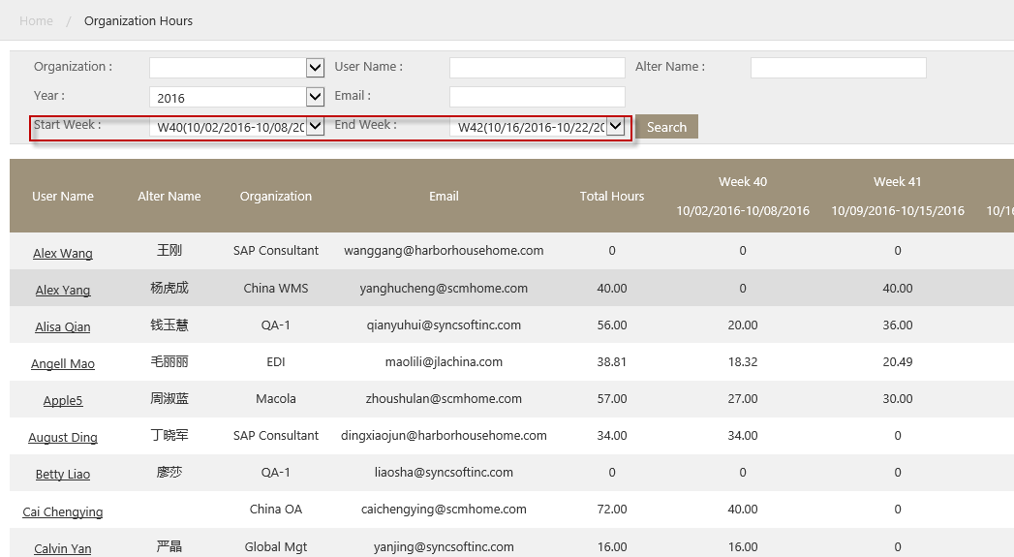

Click user name can see he (she) spend time on which projects:
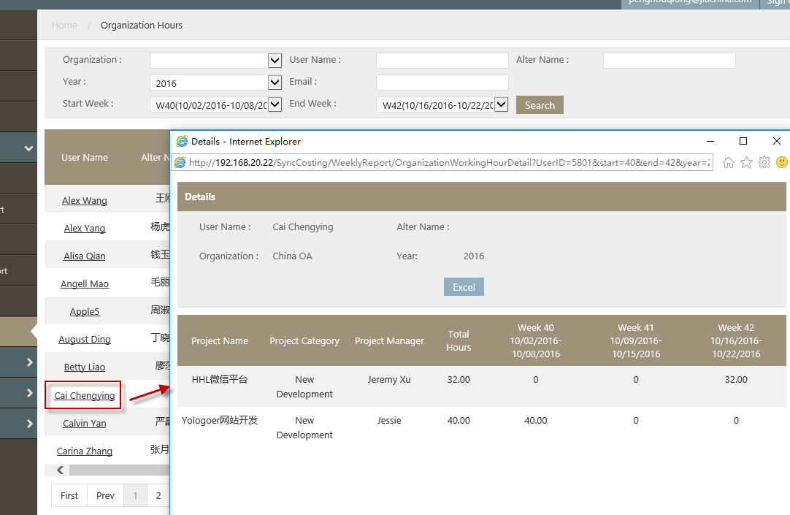

Appendix

Project status and the according operation
Status | Operation | Operation module | Operation Manual link | Responsible Person
Creation | Create a new project in Project Mgt page, Fill in basic information, Add tasks、Remarks、Docs completion to the project. | Project Mgt | How to create a project;How to add remark to the project;How to fill Documents completion | Analyst or PM
Quotation | Make quotation in Quotation list page | Quotation List | Quotation List | General Manager
In Progress | Assign users、follow the project and update the actual start date and end date. | Project Mgt | How to assign users to the project:How to add actual start and end hours of tasks | Analyst
In Progress | Fill in working hours | Weekly report | How to do weekly report | Users
Complete | Complete the project when it finished. | Project Mgt | How to Complete the Project | Analyst
Cancel | No operation

*PM=Project Manager

Quotation status and the according operation
Status | Operations | Operation Manual link | Responsible person
Pending | Fill basic information, such as: payment term, product fee. | How to create quotation;How to add Other Fee to the quotation; How to add Remark to the quotation | General Manager
Quotation Review | Review the quotation | How to View the Quotation | General Manager
Final Quotation | Quote to customer, Fill in Approved By, Approved Date and Approved Amt | How to create quotation;How to do quotation;How to View the Quotation | General Manager
Approval | Just complete(If approve) |  | General Manager
Gathering | Gathering the payment(not on system) |  | General Manager
Complete | No operation
Cancelled | No operation

Evaluation operation
Project Mgt
Evaluation content | Operation module | Evaluation Person | Operation Manual link
Documents | Project Mgt | General Manager | How to evaluate the docs
Timeline and project quality | Project Mgt | General Manager | How to evaluate the project’s timeline and project quality
Customer Evaluation | Evaluation | Customer | How to make Cust.satisfaction survey & Self-evaluation.
Self-Evaluation | Evaluation | Managers | How to make Cust.satisfaction survey & Self-evaluation.

