Wireless Application Auto Log off Resolution

- Go to Programs - BTScannerCtlPanel
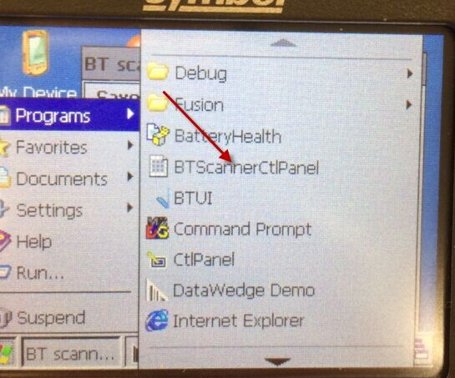
- Uncheck BT Scanner and click Save and Exit.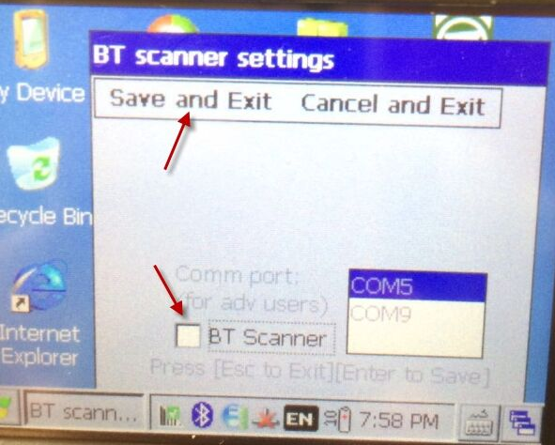

- Go to DataWedge on Control Panel.
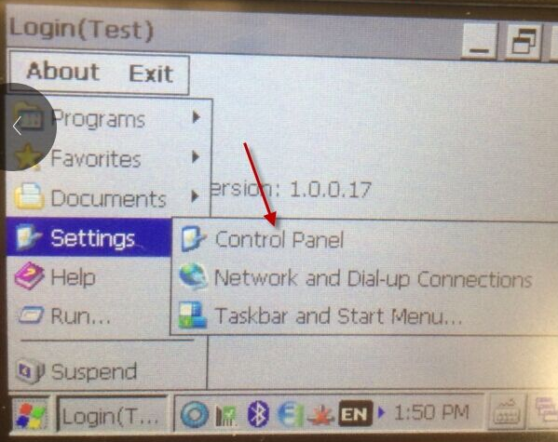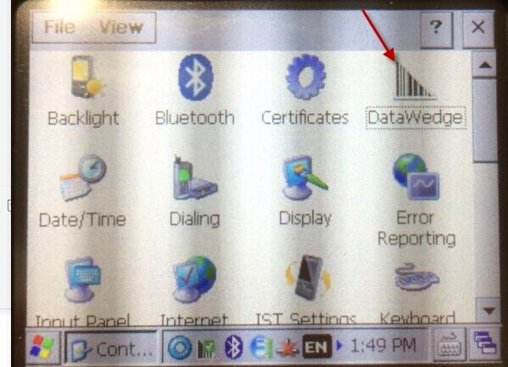

- Turn on the Data Wedge.
