Cycle Count Requests Guideline
How to Access Cycle Count Requests Page
Click Cycle Count Requests under Warehouse Management module.
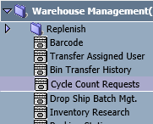

Page Overview
This page is used to maintain cycle count bins and manually generate cycle count list for items which has cycle count bin. Then use cycle count process to check and adjust the inventory for cycle count bins. With this function, user will no longer need to go to Macola to adjust inventory for cycle count items.
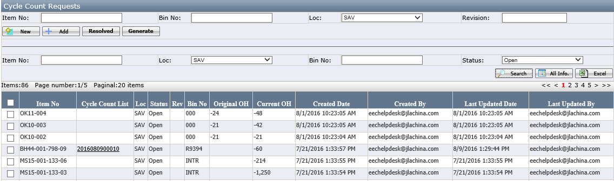
Buttons:
- New: clear all the fields to add new record.
- Add: save the record.
- Resolved: change the item status to Resolved. It is used when the item is already in an open cycle count list, so system does not need to generate a new one.
- Generate: generate cycle count list for selected items.
Grid:
- Original OH: on hand qty when item added.

How to Generate the Cycle Count List for Items
- Manually input the item and bin information and click add.
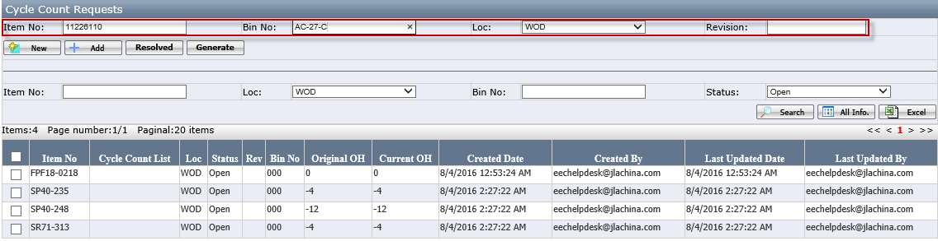
The newly added item can be found in the grid.
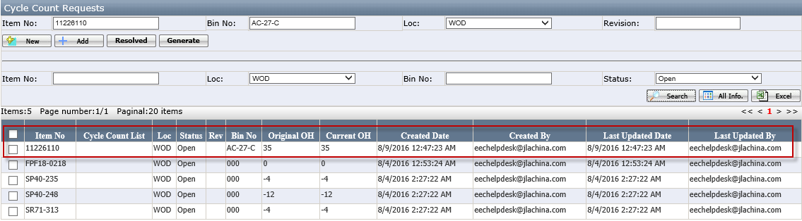
Click New if there is more items need to be added or go to next step.

- Select item(s) and click Generate.
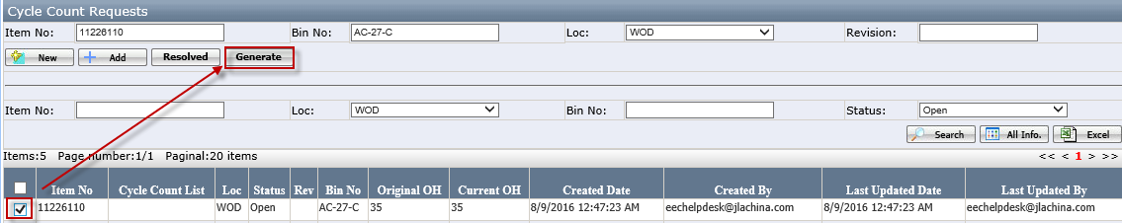
There will be a cycle count list no. show up in the grid.
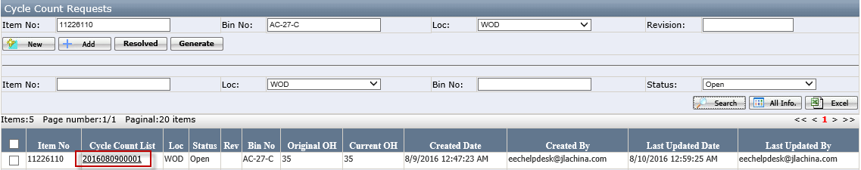
Click the cycle count list link will open cycle count item detail page. In this page user can check the item detail.
