Receiving User Guideline
Version: 2.0 12-6-2015

Background Description
Currently, we did wholesale receiving process offline through email, access and excel sheet. We manually update the macola inventory and there are lots of delay. Due to the inaccuracy inventory, large customer like Walmart etc. cannot be online in the current EEC WMS system and our planning system also cannot be launched. In addition, the warehouse user can go to container take the item away for the incoming order. When there are receiving qty discrepancies, it is hard to determine if it is supplier faults or not. Since we did not container system track, we delay return empty container and chassis, we get the huge amount of charge backs.

Overview
The purpose of Receiving Mgt. is to link to the current EEC PO and Shipment. Therefore, US Logistic, OA Express and US Warehouse can be easy process and track the incoming containers easily in one system. Warehouse can receive the items of the incoming container through Receiving Application.

Receiving Business Process

Receiving Steps and Main Functions
Container Step | Main Functions | Operation Detp. | Roles
Pending Release | Set up the container's priority. | Distribution Team | Dist-Vp
Released | 1. Click<Schedule In> to assign carrier and schedule in date. 2. Print Daily schedule; 3.click<step complete> to next step. | OA Express | Transportation Admin  Transportation Coordinator
Scheduled In | 1. Set DC Arrived Date, Door No., Chassis Brand, Chassis No.  2. Click <Step complete> to <Arrived> Status. | Warehouse Team | Ctnr. Log Admin
Arrived | 1. Generate "Offload Sheet" and print offload sheet,  ( It do in "Arrived" step or in "scheduled In" Step)  2. Do receiving on wireless App.--by Warehouse user  3.Click<offload complete> button to complete offload. | Warehouse Team | DC Receiver
 | Run service "Receiving Stock", The inventory will be saved in R bin. At this time, we can do putaway tab in wireless application | System Sevice
Received | Fill in "DC Pull Date" etc. field | Warehouse Team | Ctnr.Log Admin
 | 1. Enter Ctnr. return Date and check Chassis Brand, Chassis no. 2. Bobtail Out, Bobtail In, Street Turn etc.  3. Complete<Step complete> to complete status. | OA Express | Transportation Admin  Transportation Coordinator
Complete

How to Access Receiving
- Login Receiving Testing Site: http://192.168.0.83/EECSystemUS/
- Enter User Name is your email address and password is 12345678
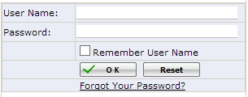
- Click Receiving
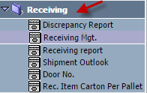

Receiving Mgt.: It’s used to check and record the container receiving information.
Discrepancy Report: a report of receiving discrepancy for containers
Receiving Report: a report for container receiving records.
Shipment Outlook: It’s used to check the incoming shipments and download the shipment packing list.
Door No.: It’s used to maintain the warehouse receiving door no.
Rec. Item Carton Per Pallet: It’s used to maintain the receiving item per pallet.

Receiving Mgt. Overview
Click Receiving Mg.
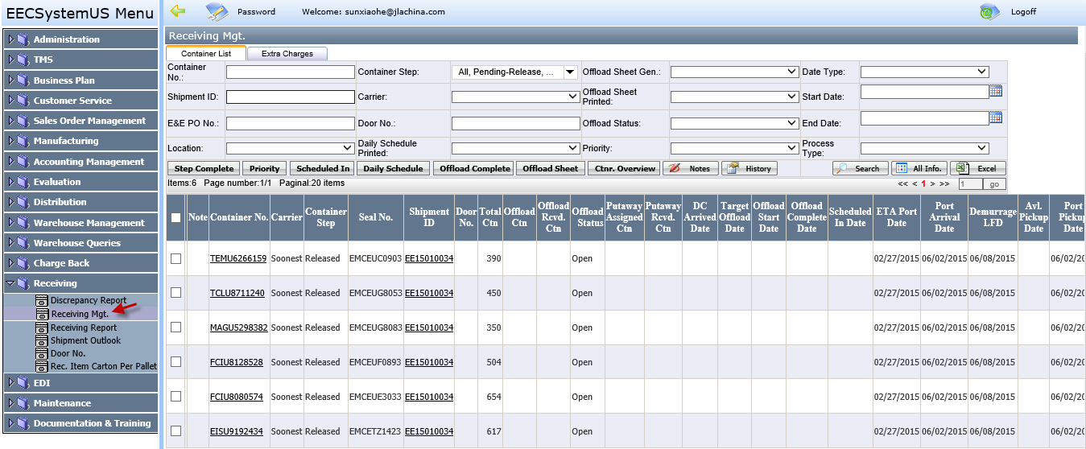

Buttons
- Step Complete: Used to complete the container step
- Priority: It' for Distribution Team use to assign a priority (See Priority for more details)
- Scheduled In: It’s for OA Express Team assigns a carrier and scheduled in Date (See Scheduled In more detail)
- Daily Schedule: It’s used to generate daily schedule report (See Daily Schedule for more details)
- Offload Complete: It’s for DC Receiver Team completes the container when the warehouse user finishing the offloading. (See Offload Complete for more details )
- Offload Sheet: It’s for DC Receiver Team generate the offload sheet and review item receiving information. (See Offload Sheet for more detail)
- Ctnr. Overview: Review Offload item receiving status (See Ctnr Overiew for more detail)
- Notes: Enter the note for a container (See Notes for more detail)
- History: review the container update history (See History for more detail)

Grid
- Container No.: Click container no to open the container edit page. (See Container Edit for more detail)
- Offload Ctn: Click this to open Offload Ctn Report (See Offload Report for more detail)
- Putaway Assigned Ctn: Click this to open Putaway Report (See Putaway Report for more detail)
- Shipment ID: Click Shipment ID to review or download the Container Packing List (See below Packing List Picture)
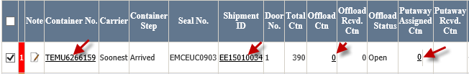

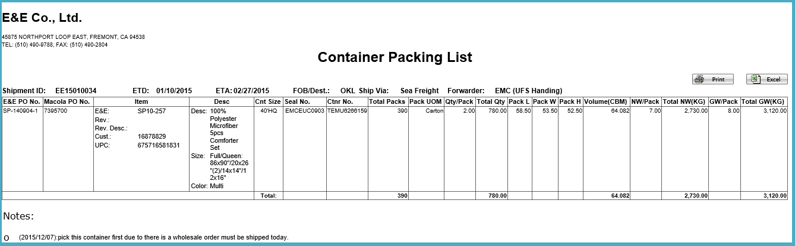

Container show here condition:
- Shipment Process Type: Ship: Domestic warehouse” or “Ship: Int-Domestic warehouse”
- Shipment Step: After “Shipment Review”

Container Detail page
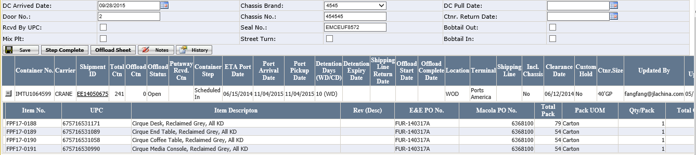
- Rcvd by UPC: If it is checked this button, in receiving wireless application, The user only can scan UPC to receive the item. If it is not checked, the user will receive the item based on ctrn.
- Mix Plt: it is mixed pallet. if it is checked, it means the pallet is made of mix items instead of one item.

Team and Roles and Users
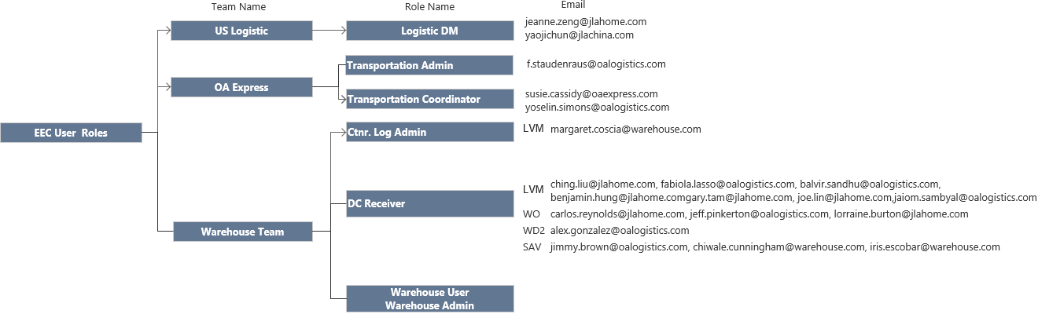

Role and Default Steps
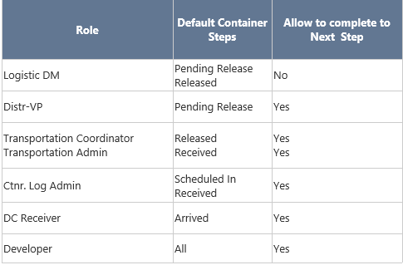

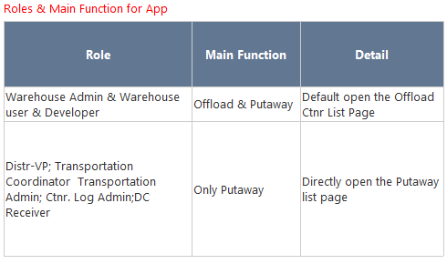

Receiving Mgt. Procedure
For OA Express and Warehouse Team have the read only access for “Pending Release” containers.

Logistic Team Release shipment’s container
- In Shipment Review Page, review the shipments going arrived at warehouse in 3 weeks and click “Complete” to complete shipment from “Shipment Review” to “Shipment Pending Release” (Related Container Step: Pending-Release). Logistic team can continue updating the container information such as Terminal, Carrier, etc. When the shipment is going to arrive in 1 week, logistic team will double check all shipment and container information, update ETA Port Date, Clearance Date, Port Arrival Date, Available Pickup Date, Port Pickup Date etc. and complete the shipment to “Shipment Transit” (Related Container Step: Release). Once the container is in “Release” step and having offload sheet generated, if Logistic team wants to make any changes for the container, they have to notify OA Express and Warehouse Team before reversing the shipment to make the change. (See Shipment Step and Container Step Relationship)
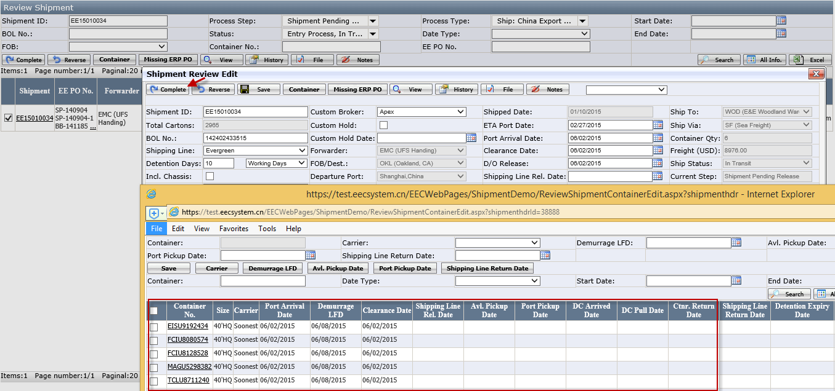

Distribution Team prioritize to a container in “Pending Release”
- In Receiving Mgt., by default Distribution VP see the container whose step is in “Pending-Release”. They will assign a priority for the urgent container by clicking Priority, select a Priority and click OK. If they want to see the container which is in the other step, please change the container step.
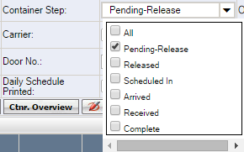
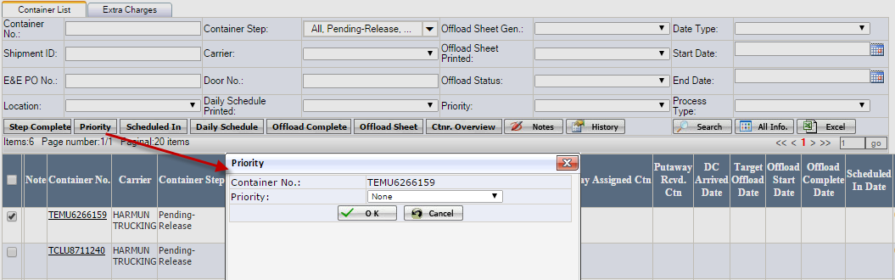
- Once it is saved successfully, the container having 1st priority (Red Color) will list on the top and then the container has 2nd Priority (Orange Color).
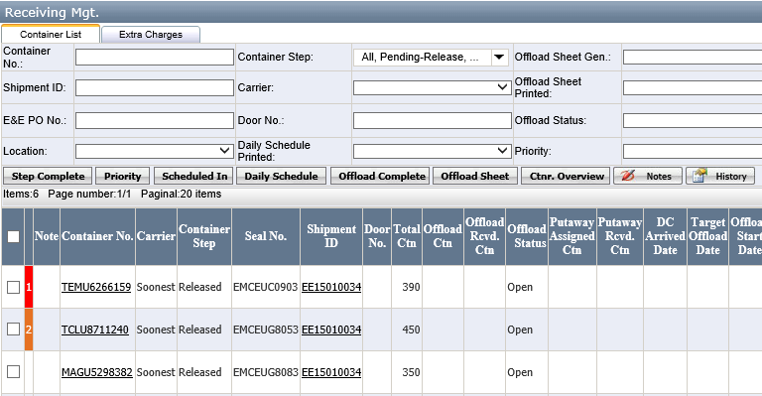

Note:
- Red has 1st priority
- Orange has 2nd priority
- None has no priority (Default)

OA Express Team operation in Receiving Mgt.
In Receiving Mgt., by default OA Express Transportation Coordinator and Transportation Admin only see the container whose step is Released or Received. They can change the default container step.

How to release step
- Go to Receiving Mgt page and search for the container whose step is “Release”.
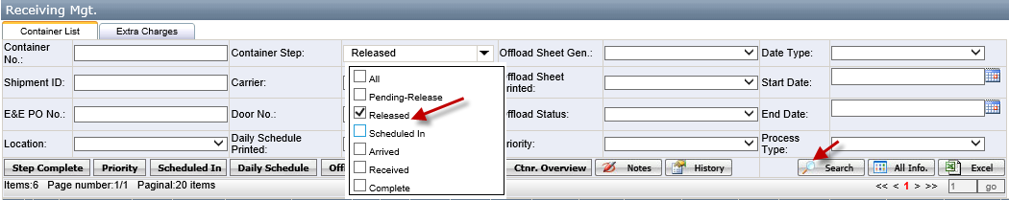
- Put the check for the container and click Scheduled In.
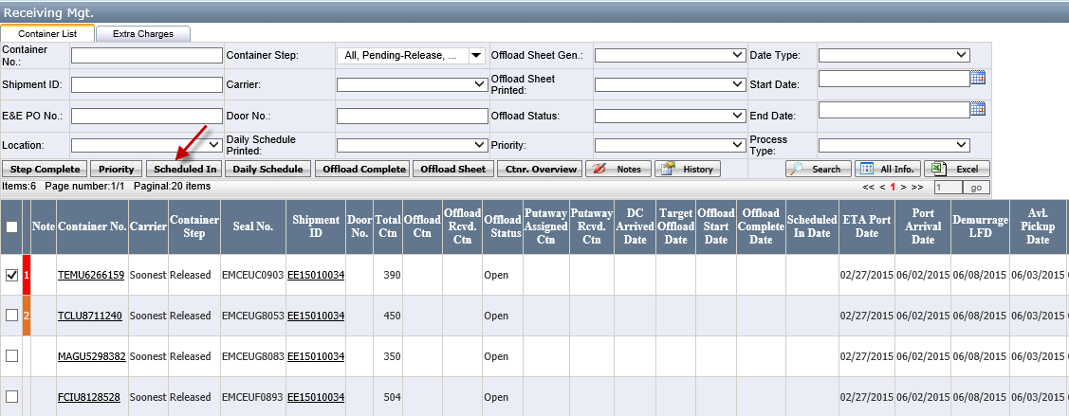

- Enter the carrier and Schedule In Date and click OK.
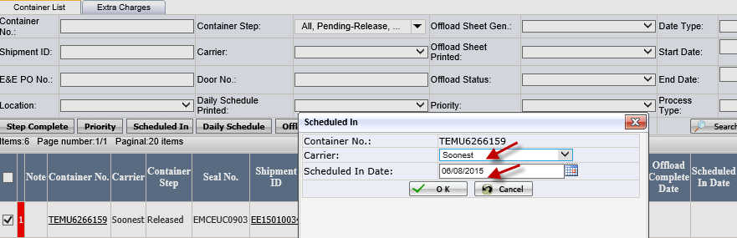

- Select the scheduled in container, click Daily Schedule to open the daily schedule. You can print it or export to excel.
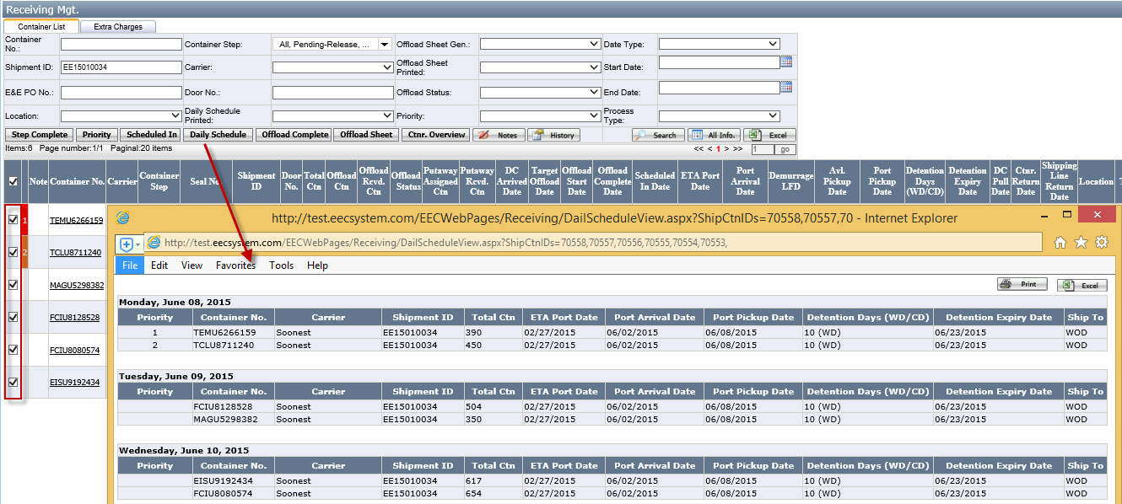

- Select the container and click Step Complete to complete to “Scheduled In”. You can select multiple containers having the same “Released” step to complete it.
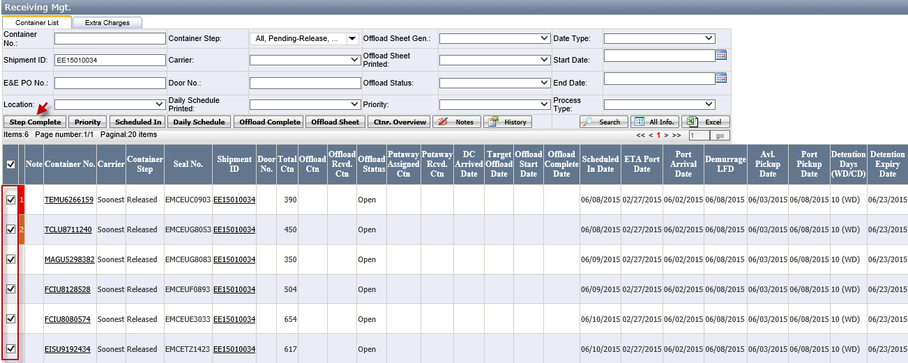

How to do Received step
- Search for the container whose step is “Received” status and click container No. to pen Container Edit Page.
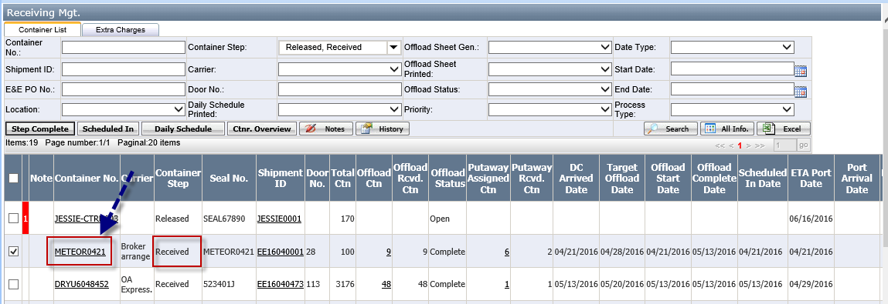
- Go to container detail page, Enter DC Pull Date and Ctnr. Return Date. If it is Bobtail In and Bobtail Out, please put a check for them. If it is a street turn container, please also put check for Street Turn. Help Warehouse Team to enter Chassis Brand, Chassis Number, Seal No. if they are missing.
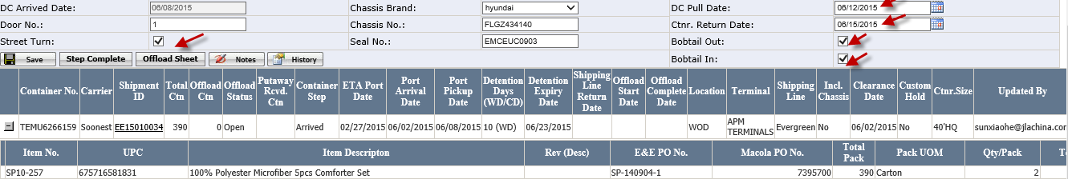
- Click Step Complete to complete to “Complete”. Once the container is completed, you cannot modify any information.

Warehouse Team

Ctnr. Log Admin Team
By default, Ctnr. Log Admin Team will see Scheduled In and Received containers. They can change the default container step to see other containers.
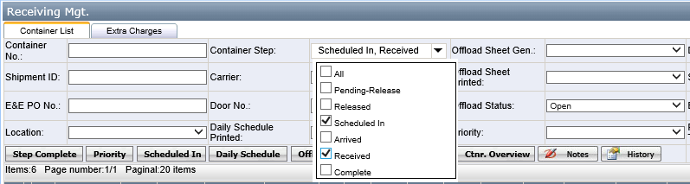

How to do Scheduled In step
- Click Container no whose step is Scheduled In, enter DC Arrived Date, select Door No., Select Chassis Brand, Seal No. and click Save.
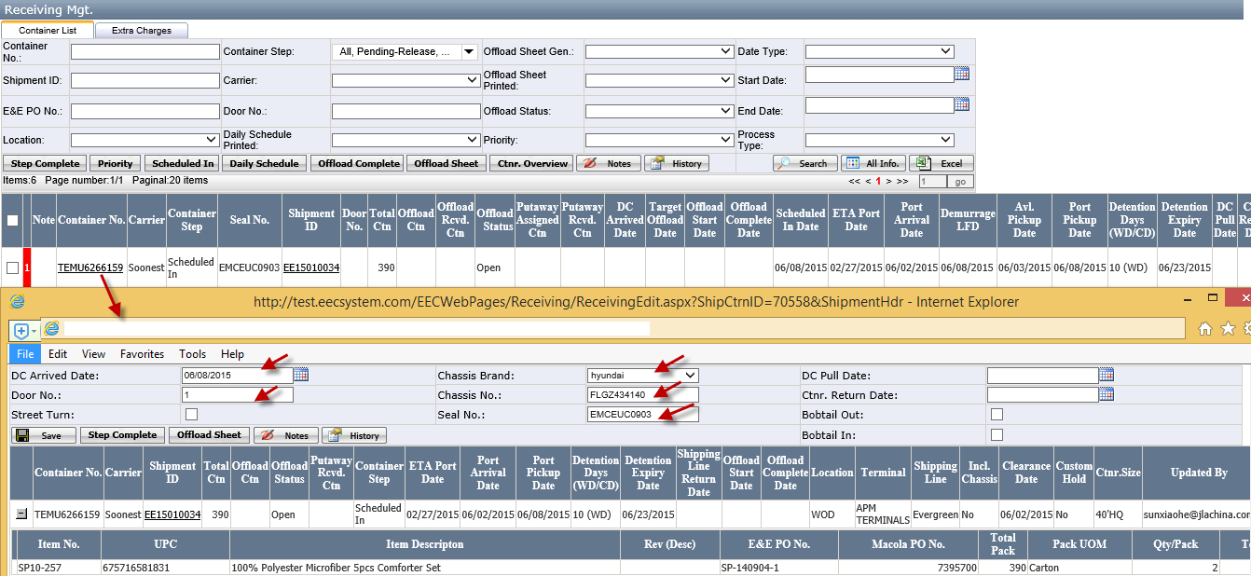
Note:
Door No. : If it is a new door, please request warehouse team to maintain it in Door No Page (See Door No Page)
Chassis Brand: If it is a new chassis brand, please OA Express team to maintain it in Chassis brand Page (See Chassis Brand Page)
- Click Step Complete to complete it to “Arrived” Step.
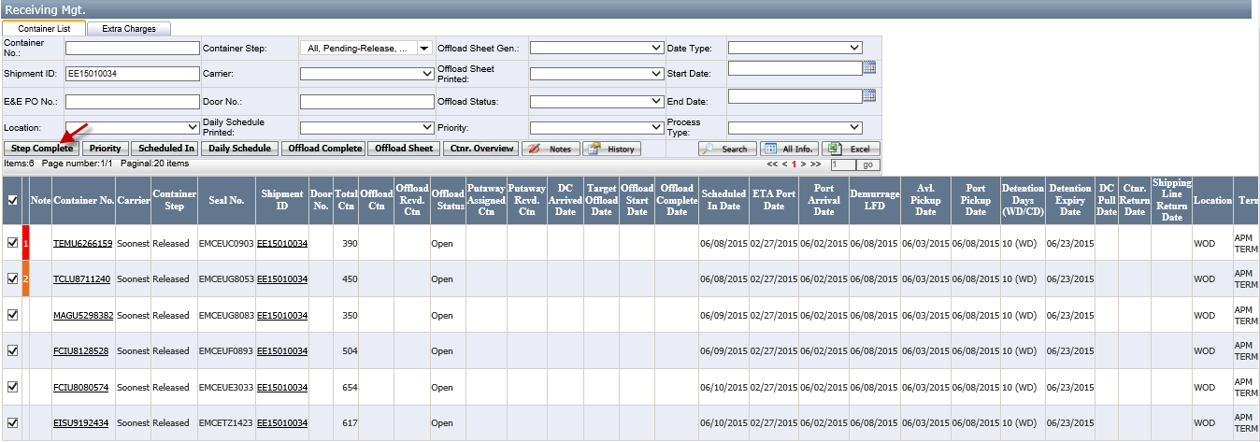

How to do Received step
- Click the container no whose step is Received, enter DC Pull Date and click Save.
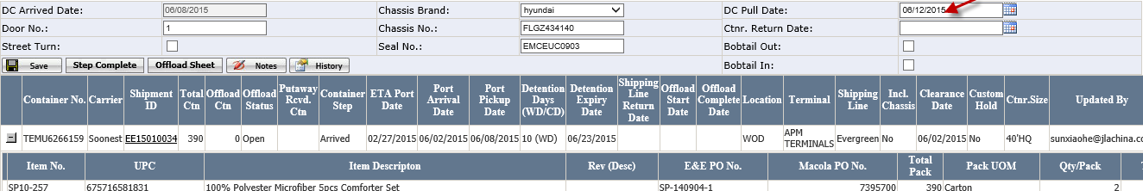

DC Receiver Team
By default, DC Receiver Team will see Arrived containers. They can change the default container step to see other containers.

How to do “Arrived” step by DC Receiver Team
- Put a check for the container no whose step is Arrived, click Offload Sheet and click OK.
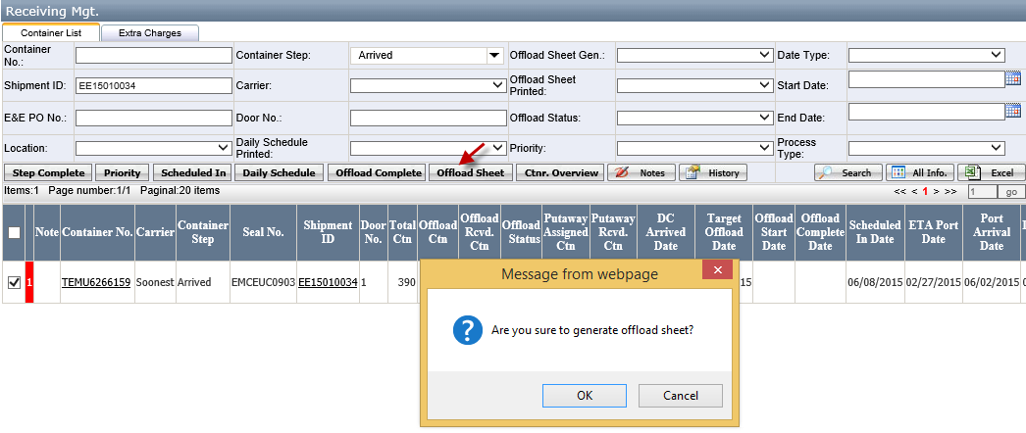
- In the generated offload sheet, click print to print offload sheet.
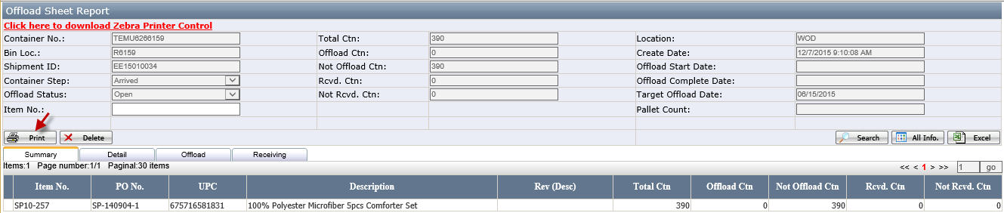
- If popping the below warning window, just click Open.

- It will open a PDF Offload Work Sheet and print it (See below printed layout). You can assign to a warehouse user to offload the item of this container by using receiving apps. (See Receiving Apps)
Offload Type Definition:
- Expedite:
- EECUS Wholesale batch has been released and out of stock. To Loc is the configured "Rcvd. Location" in EECUS Location Page. If there is no "Rcvd. Location" configured, it will use from Loc as To Loc.
- Rework:
- Retail location has the rework flag in retail item master (111) or Any Revision item (Item master's Serial/Lot is Lotted in 001) Transfer from wholesale to Dotcom is considered as a rework item. To Loc is configured "Rcvd. Dotcom Location" in EECUS Location Page.
- Dotcom: Retail location has no rework flag in retail item master (111). To Loc is the configured "Rcvd. Dotcom Location" in EECUS Location Page.
- Putaway: Left over qty after deducting the above three types. To Loc is used the configured "Rcvd. Location". If there is no "Rcvd. Location" configured, it will use from Loc as To Loc.

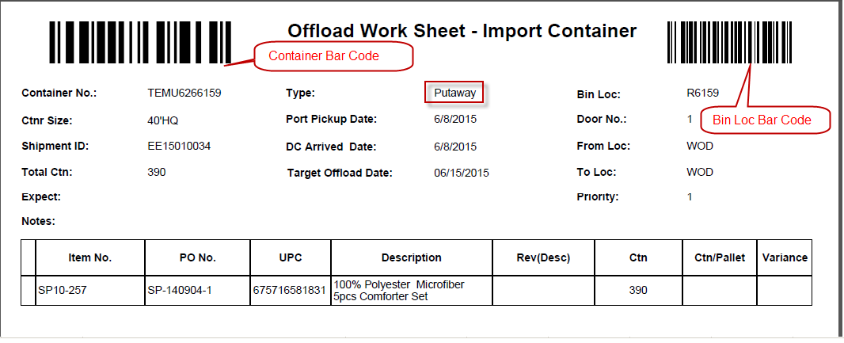

- When the warehouse user finishes the offload, turn this offload sheet back to DC Receiver. After reviewing the variance, DC Receiver will complete the container by clicking Offload Complete. Therefore, OA Express can book a truck to pick the empty container. When there are some items whose Discrepancy Ctn is > 3.00% or < -3.00% or Total Discrepancy Amount is > 10% or < -10%, you will get the below message. For item Discrepancy Ctn is > 3% or < -3%, please review them in Detail of Offload Sheet Report and request the warehouse user to recount cartons before completing it. For total Discrepancy Amount is > 10% or < -10%, please review them in Warehouse of Discrepancy Report and send email to Accounting Department gl.dept@jalhome.com for approval first before completing it.
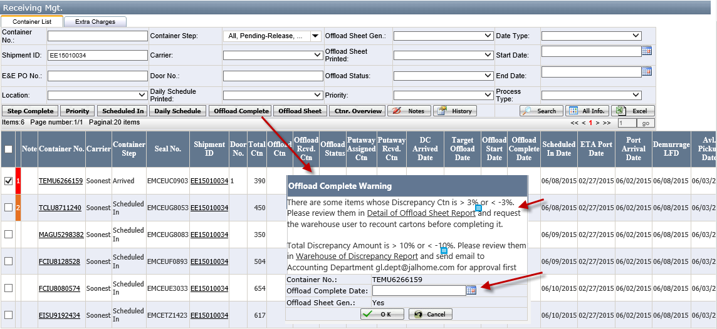

- After you review or get the account approval, Enter Offload Complete Date and click OK. System will automatically complete the container to “Received” step if the container’s current step is “Arrived”. Otherwise, you have to put a check for the container and click Step Complete to complete it from “Arrived” to “Received” manually.
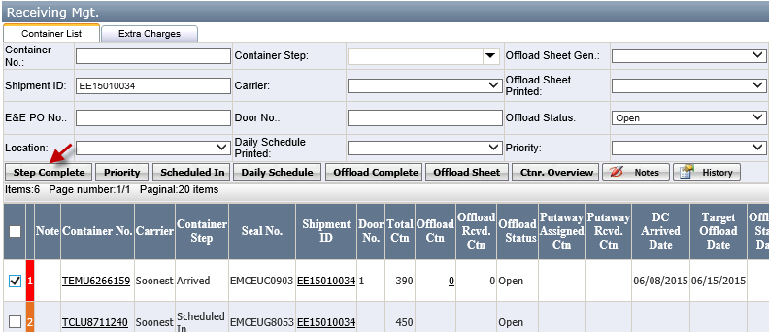

How to Enter notes
- Put the check for a container and click Notes. In the notes page, click New Notes.
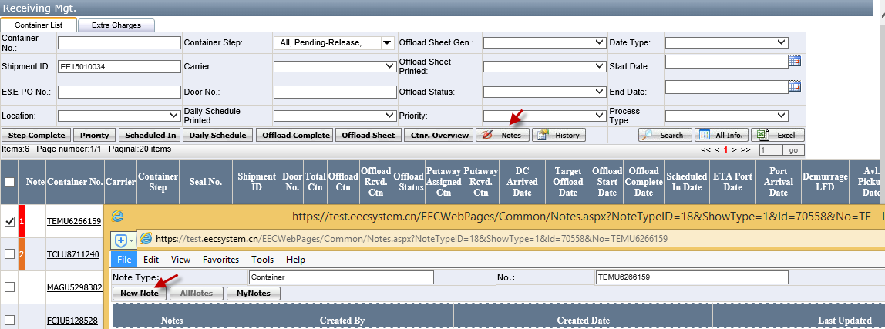

- Enter the note and click Save. If you want the notes be displayed on note of Offload Sheet, put a checkbox for Displayed on printout.
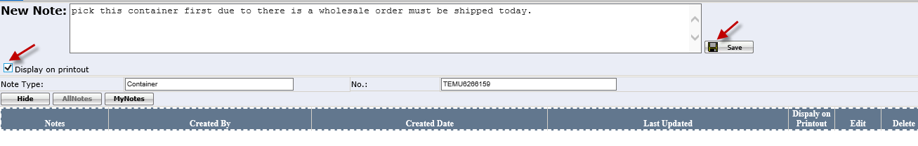
- If the container has the notes, it will have the note icon. You can click this to view or add notes.
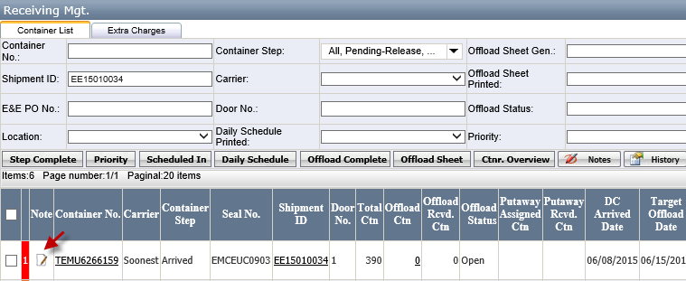

How to Review History
- Put a check for the container and click History
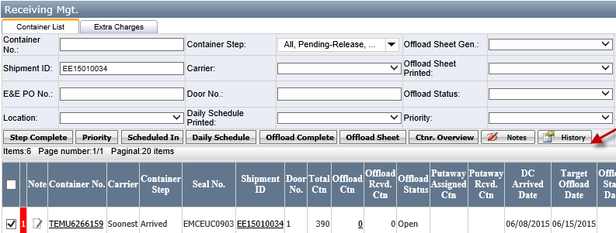
- It will the container update records.
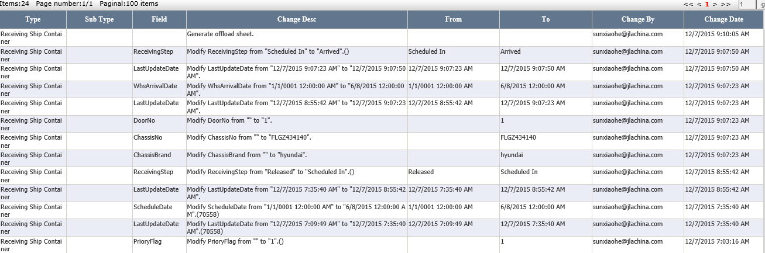

Offload Report
- In Receiving Mgt, click the quantity in Offload Ctn or click put a check for a container and click Offload sheet.
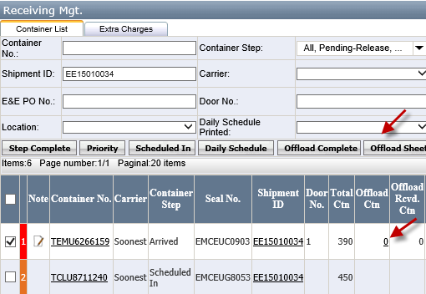
- You can click Summary, Detail, Assigned and Receiving to view item offload detail information
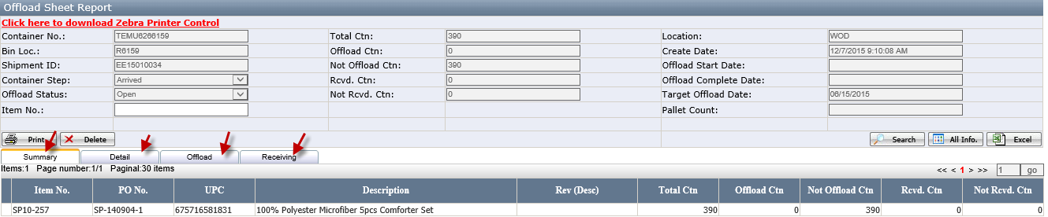
- Summary: It is the summary for an item
- Detail: It is summary for an item per receiving type
- Assigned: It’s the offload item detail
- Receiving: It’s the receiving item detail

Putaway Report
- In Receiving Mgt, click Putaway Assigned Ctn.
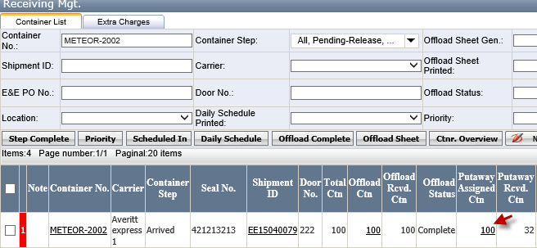
- You can click Summary, Detail, Assigned and Receiving to view item offload detail information
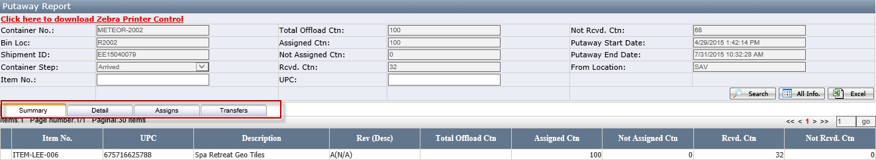
- Summary: It is the summary for an item
- Detail: It is summary for an item per receiving type
- Assigns: It’s the assigned item detail
- Transfers: It’s the putaway item detail

Ctnr. Overview
- In Receiving Mgt, click Ctnr. Overview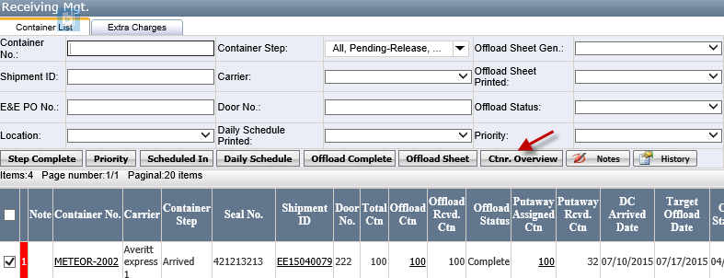

- It will open Ctnr. Overview. By default, it will list item which has been receiving and not and putaway (Not Putaway Assigned Ctn> 0. However, you can click All Info to view all items receiving and putaway status.
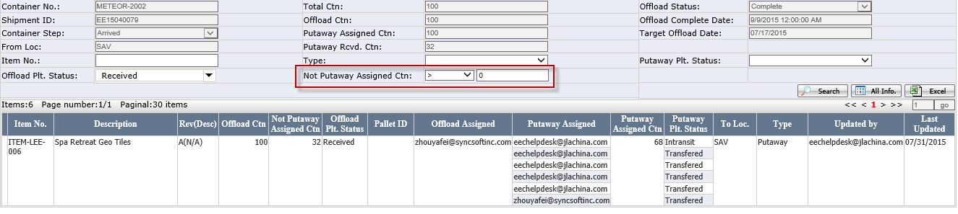

How to Use Receiving Apps

How to offload the items from a container
- Scan container bar code in the Offload Work Sheet (See Printed Offload Sheet for details) .
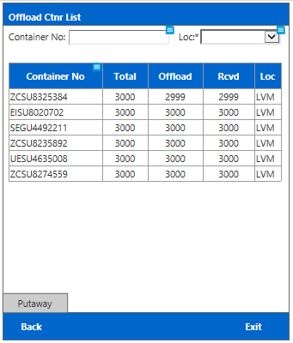
- It will the scanner container offload list items. To the item detail, select any item to click Detail. For overage receiving, please click Over.
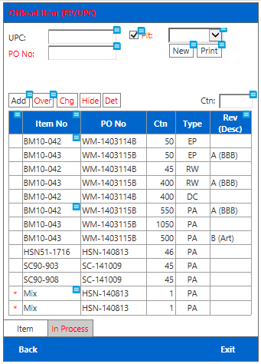
Function Button:
- Add: If receiving by Ctn., user needs to select a item and enter Ctn No. first, then click the Add button to receive the Item. If receiving by pallet, Add button is useless.
- Over: Click it to open the Over page which likes the Offload page. Only the item which has offloaded all Qty can list in the Over page. If there is over Qty, system will show it in the Over column.
- Chg.: It is search criteria, when user clicks it to open the Change page. Change page includes Item type and Mix. System will flit items according to the Change page.
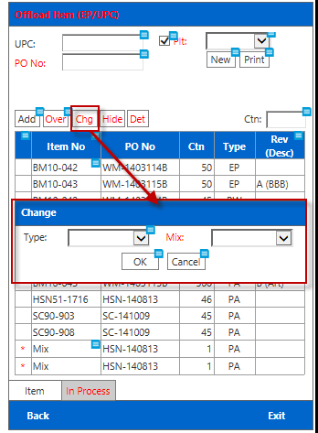
Notes:
There are four types: EP=expedite, RW=Rework, DC=Dot.com, PA=Put away
- Hide: Click it to hide the title and auto change file name to “Show”
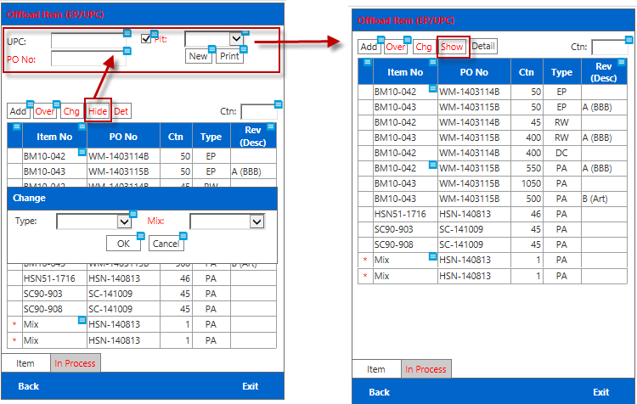
- Det.: select a item and click it to show the item detail.
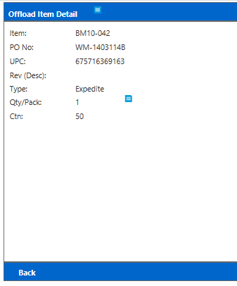
- In the Offload Item List, put a check for Pit if you create a Pallet and then Scanner a UPC. In the grid, select the found item and click Add.

- Once it is successfully added it, it will move the item to In-Process tab. Click In Process Tab, it will list all item which has been scanned. By default, it will only list items created by using Pallet. 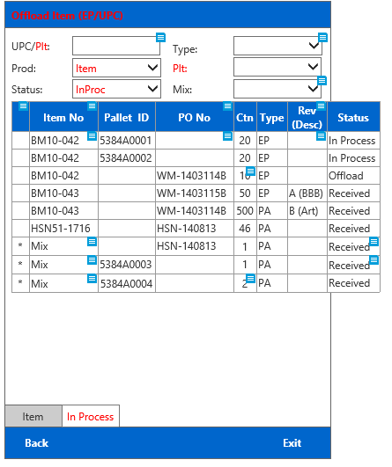

- In Grid, click any item No, it will open Item Page.

- If it is Carton Item, Item Page will looks like below.
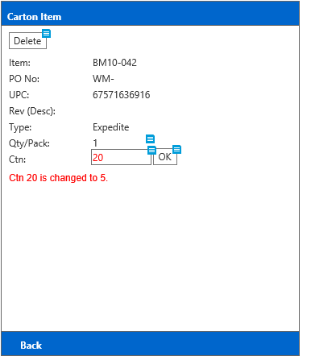
- If it is Pallet Item, Item Page will looks like below.

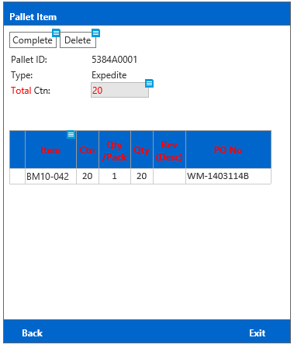

- For Pallet item, Page, click Complete in Pallet Item Page, it will print Pallet Label to a Zebra Print.

Pallet Label for not mixed item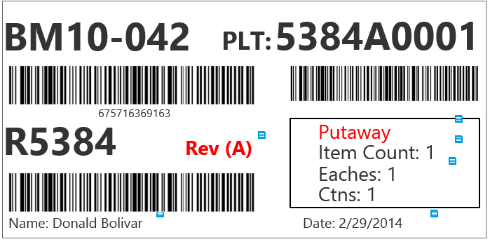
Pallet Label for mixed item
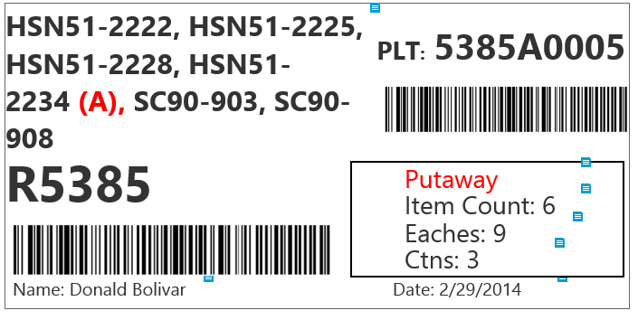

How to putaway the items
- Click Putaway
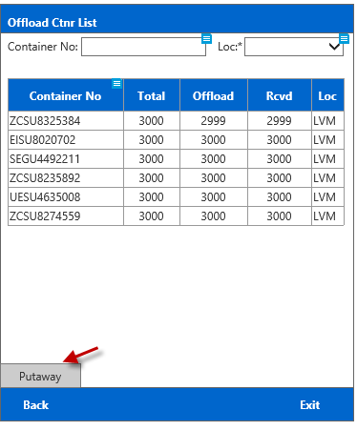
- Scan a UPC or Pallet ID. If it scanned Pallet ID, it will automatically move the item to Assigned Tab.
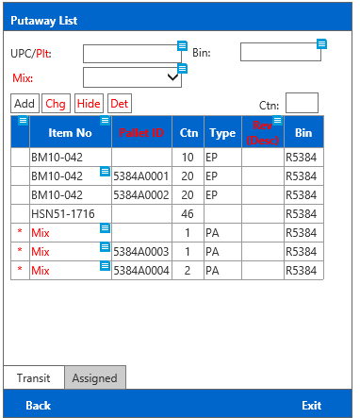
Notes: if the user default location is not same as the from location in offload sheet, click Chg button to update the location.
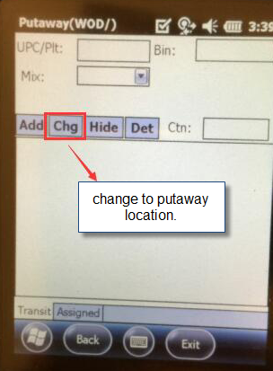
- If you scan a UPC, in grid select the found item, click Add. It will automatically more item to Assigned page. Click Assigned, it will list all item has been picked.
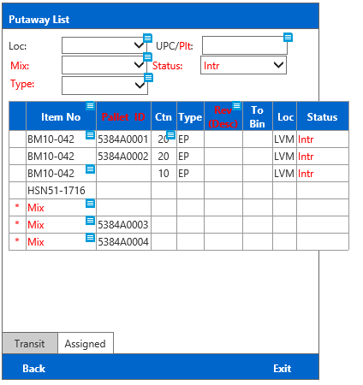

- Scan a UPC or Pallet ID to filter the grid item. Click the item no, it will open Transfer Page.
- For carton item, it will look like below. Change Trans Ctn and scan or enter <To Bin> and click OK,
The item status will be changed from Intr to tranf.
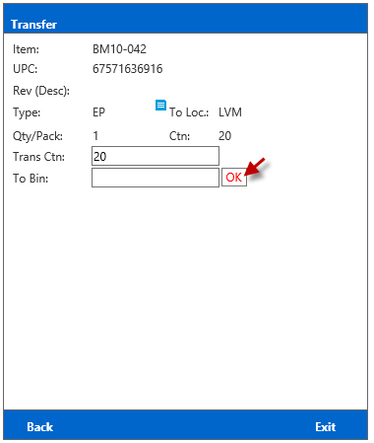
- For Pallet item, it will look like below. You only need scan To Bin and click OK
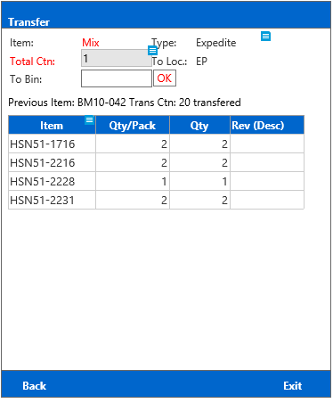

Reports

Receiving Reports
Default to Offload, you can click Putaway or Overview to view all container Putaway and Overview report.
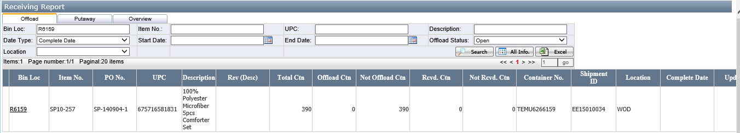

- Offload: It’s all container’s offload report.
- Putaway: It’s all containers’ putaway report.
- Overview: It’s all container’s overview report.

Discrepancy Report
Once the container is offload completed and if there is any variance, it will list here. Accounting tab is accounting team per which is against the PO Line Item and warehouse tab is for warehouse team which is against the shipment packing
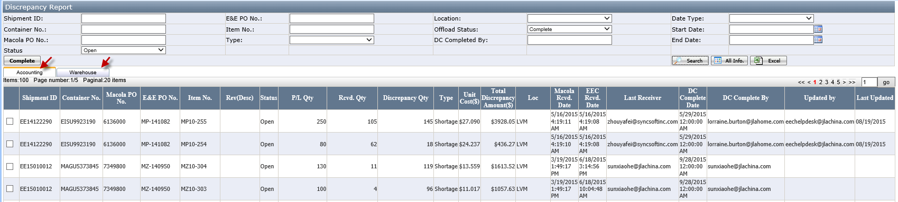

Extra Charges
In Receiving Mgt., click Extra Charges. If the container did not return to the port before the expiry detention day, it will be list here. The Total charges highest will be list at the top.
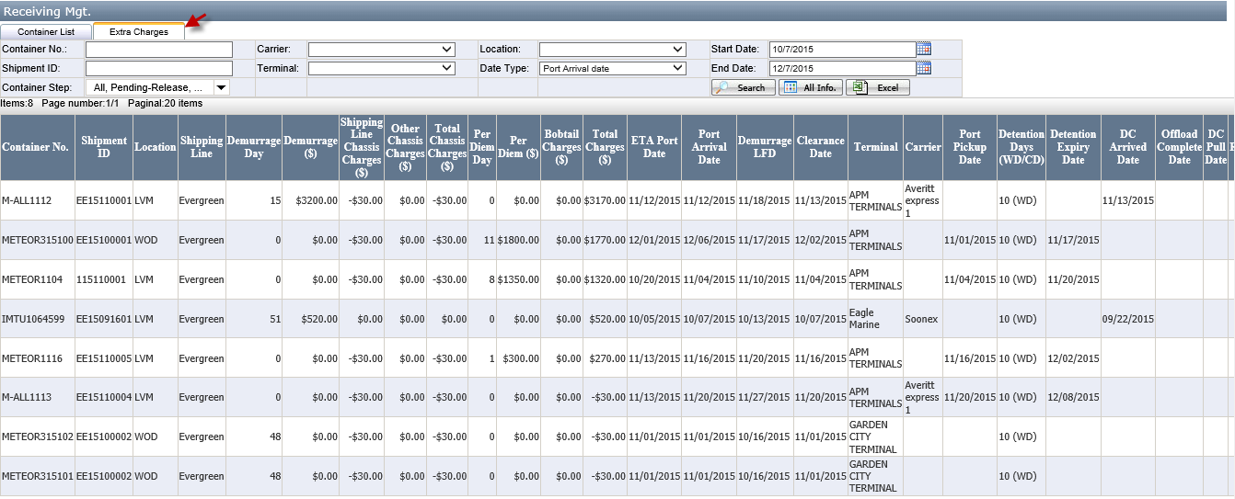

Shipment Outlook
- Business unit is default to your user account assigned default business. However, you can change business unit to find your related business unit shipments.
- Click Shipment ID to open the packing list and download them in the packing list
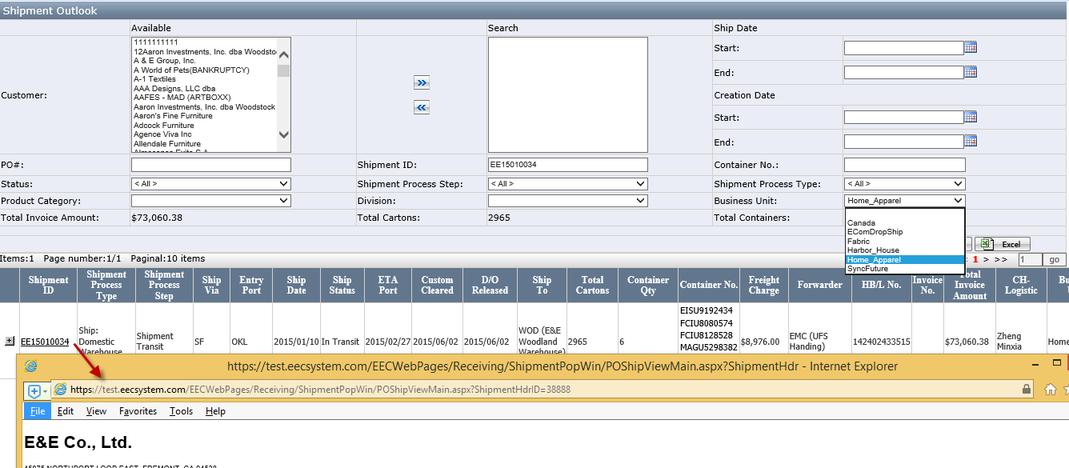

Maintenance

Door No.
- Click Receiving Door No.
- Select the location, Enter Door No. can click Save.
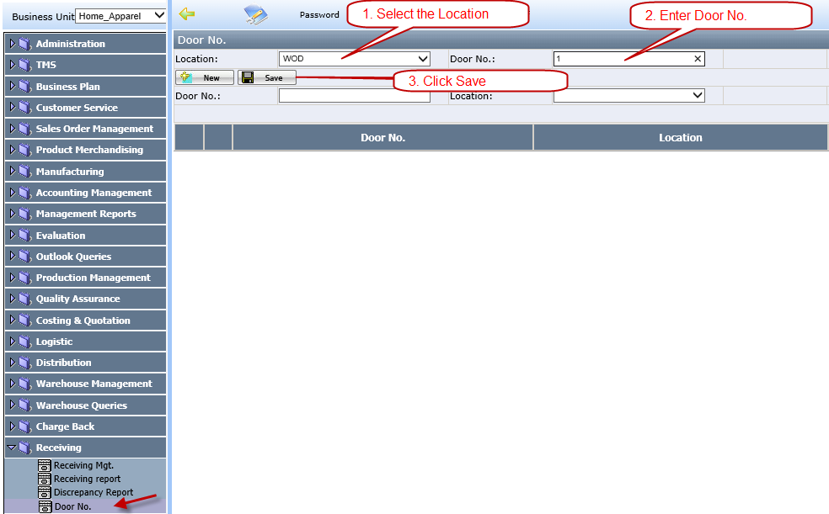

Rec. Item Per Pallet
- Click Receiving Rec. Item Per Pallet
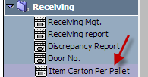

- Select the location and enter Item No and Ctn/Pallet, click Save
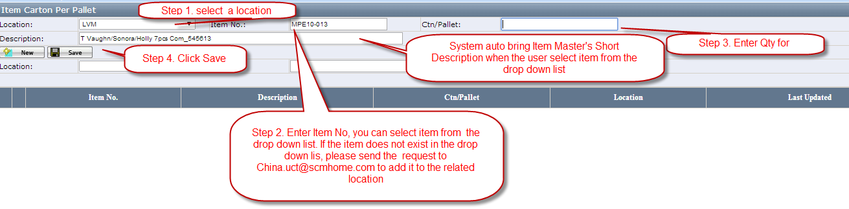

How to maintain the Chassis Brand and its rate
- Click MaintenanceChassis Brand, click New
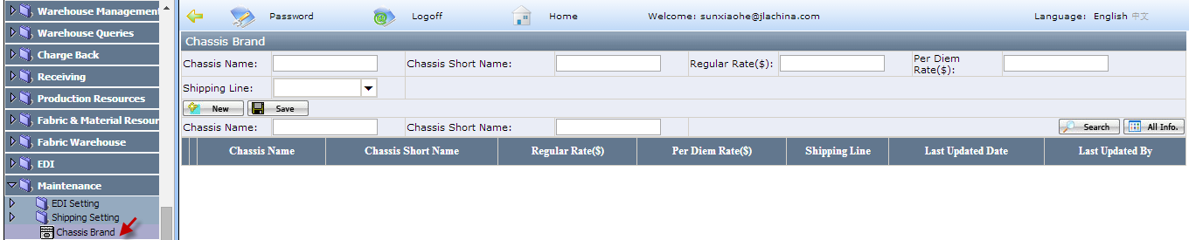

- Enter Chassis Name, Chassis Short Name, Regular Rate, Per Diem Rate. If it is not specify to a shipping line, leave it blank and click Save
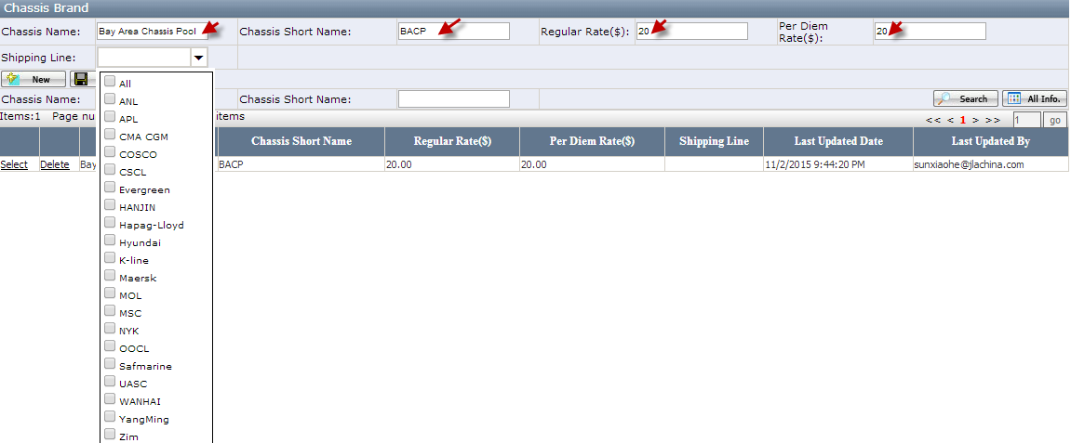
- If it is only assigned for a specific shipping line, please select a shipping line. For example, Trac Chassis currently is only assigned to Evergreen to use, in shipping line field select “Evergreen”. You can select multiple shipping line for one chassis name.
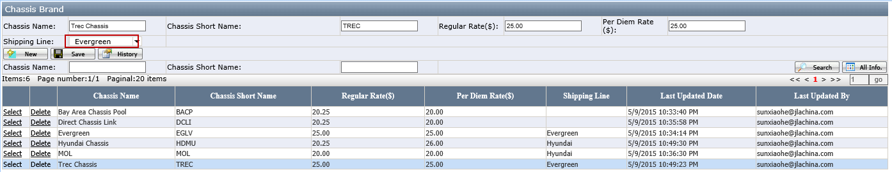
- Click History to view the update records.
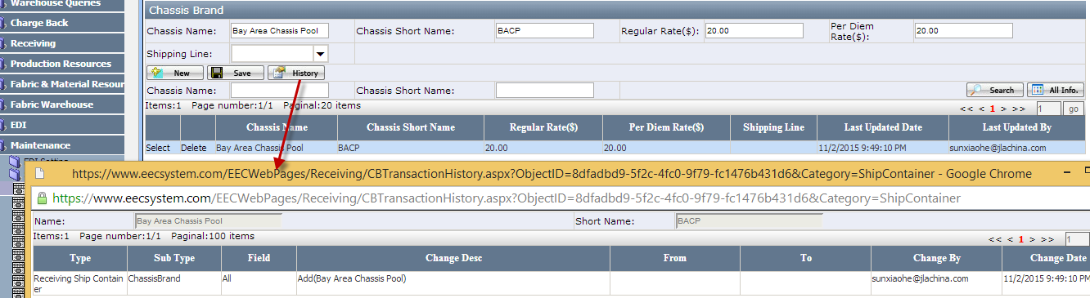

How to update Shipping Line Per Diem Rate
- Click Production ResourcesGeneral Data Shipping Line
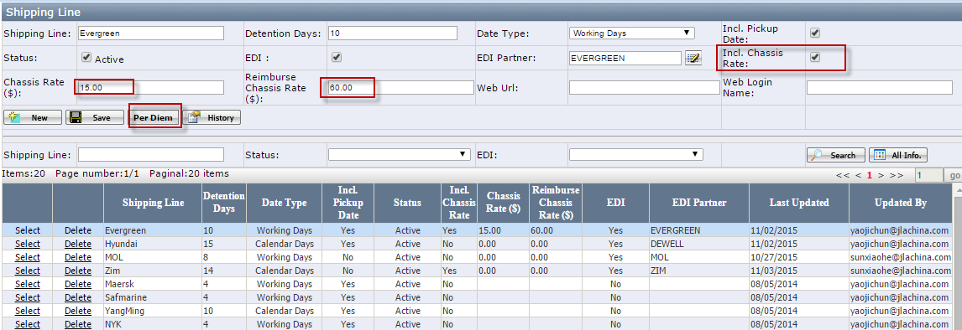

- Select a shipping click Per Diem
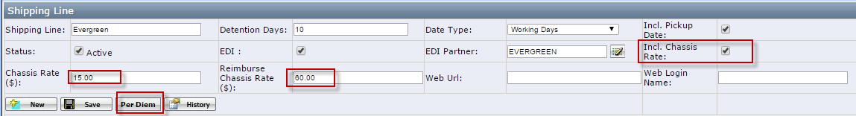
Note:
- Incl. Chassis Rate: If the shipping line includes the chassis, it will have the check.
- Chassis Rate: It is used to deduct from Per Diem Rate if the shipping line includes chassis
e.g. For Evergreen which includes Chassis Rate, if Small Container is $110 and we have 1 day per diem and we did not use their chassis PerDiem=$110-$15=$95.
- Reimburse chassis rate is used to return the chassis if we did not use the shipping assigned free chassis.
e.g. For Evergreen which includes Chassis Rate, if we did not use their chassis, we will get Reimburse chassis fee $60

- In the PerDiem Page, enter the name and day range and select the container size, enter Rate and click Save.
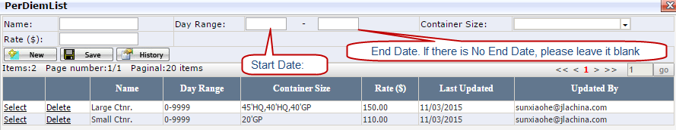

How to maintain the Carrier’s Bobtail Rate
- Click MaintenanceCarrier and select Carrier Type “FCL” which list full container carriers and click Search.
Note: Do not change Carrier Type is not “FCL” settings!
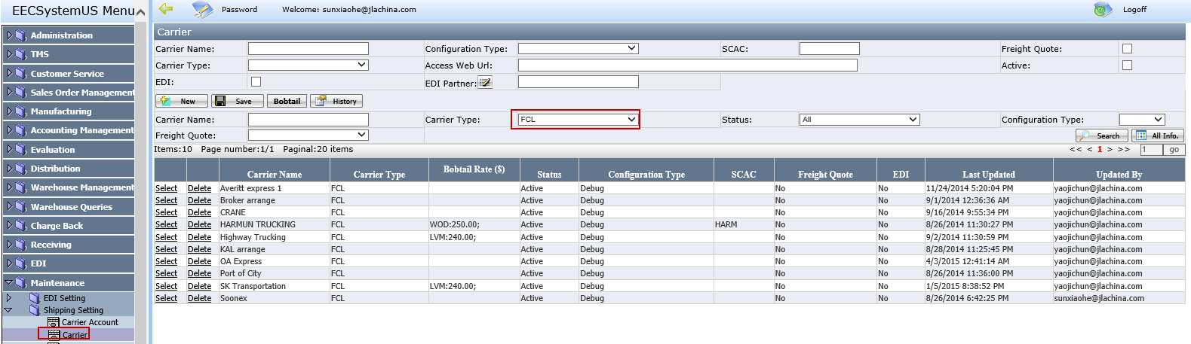

- In grid, select the carrier, e.g. HARMUN TRUCKING, click Bobtail, it will open bobtail list page. In Location, select WOD and enter rate $250 click Save.
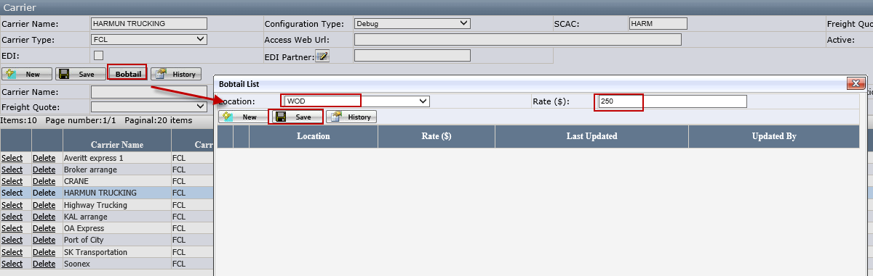
- Once it is saved successfully, you will see grid WOD in both Bobtail List and Carrier Page. If you have multiple locations for a carrier, please follow the step 2 to add rates for all locations.
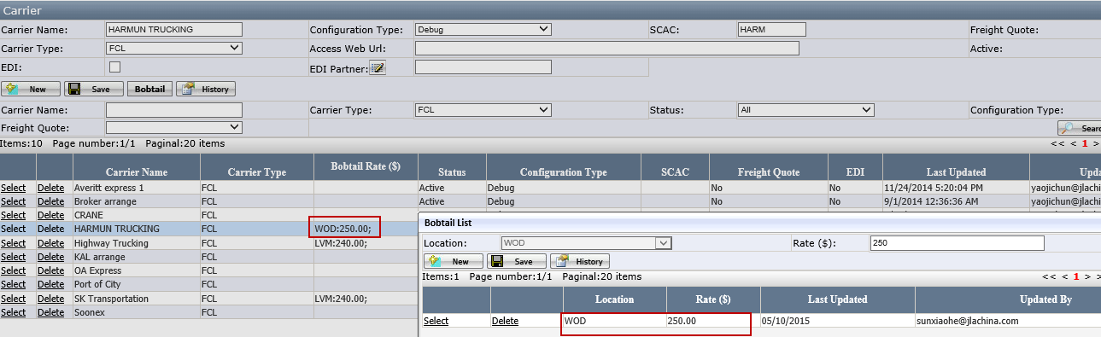

- Follow step 1-3 to add bobtail rates for all carriers. You can click History to see the updated records.

How to maintain Terminal’s Demurrage
- Click Production ResourcesGeneral Data Terminal and select the terminal. E.g. Select Oakland SSA Terminals, click Demurrage
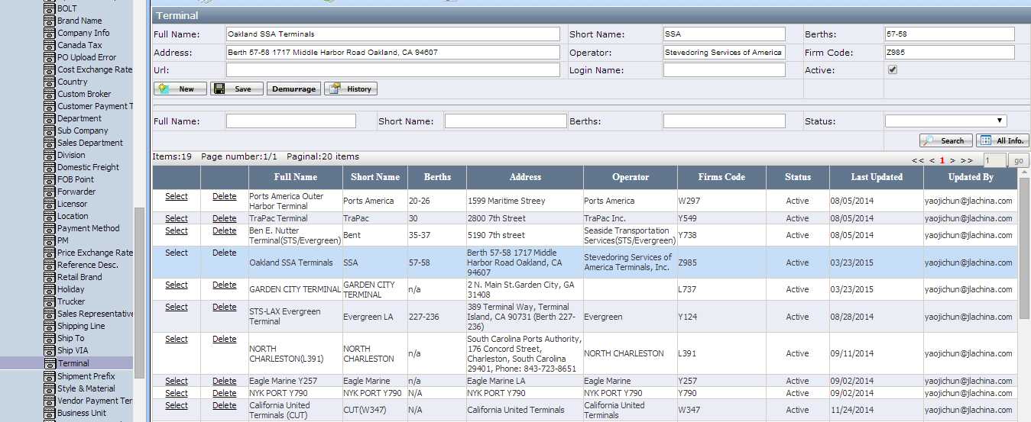

- Select the Shipping line Evergreen, enter Date Start Range 1 and Enter Date End Range 5, enter Rate ($) 120 and click Save. Once it is saved successfully, it will list the demurrage rate in the grid.
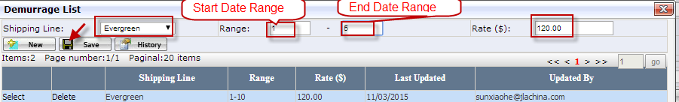
- Click New and follow the same step 2 to enter 175 for days after 6th. If you do not have the end Day of Range, just leave it to blank (See Picture 1), system will auto use 9999 as the end date of range once it is saved successfully (See Picture 2).
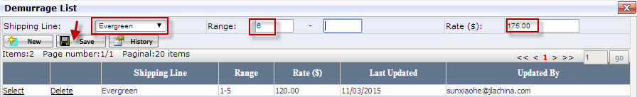

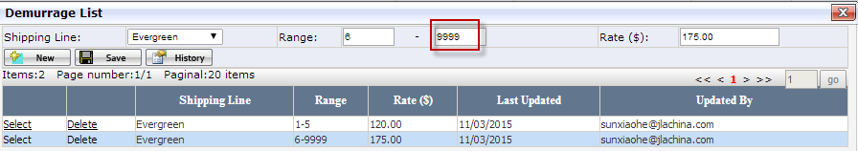
- Follow the step 1-4 to set all demurrage for all terminals.

Appendix

Receiving Flow Chart
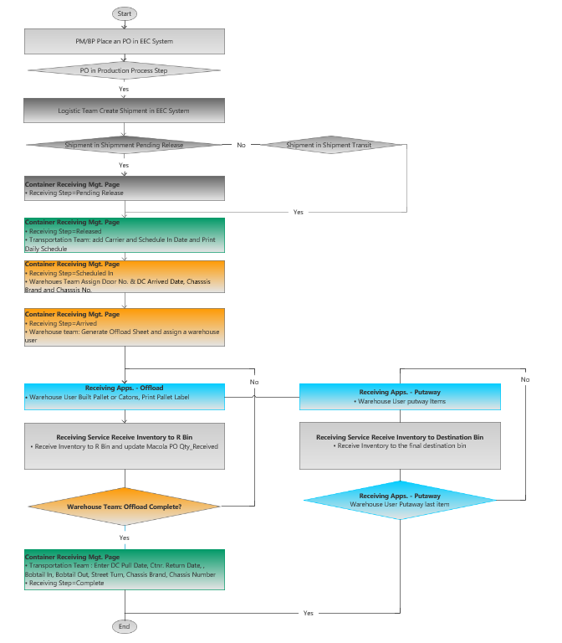

Teams, Roles, Job Function and Default Receiving Step
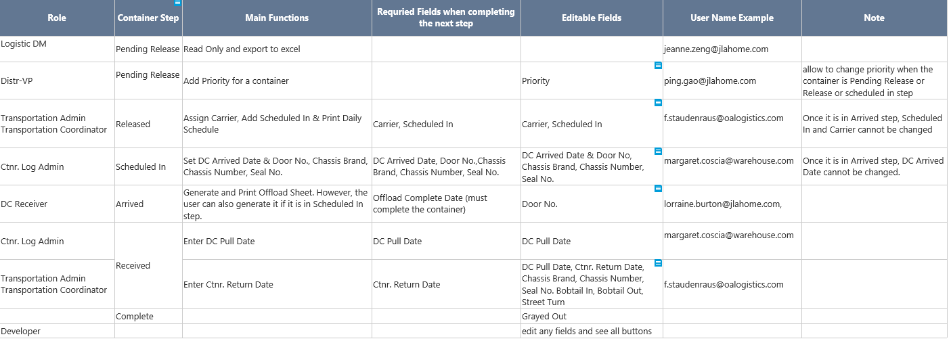

Shipment Step and Container Step Relationship
