Local Server Guideline
Background
Now we have four warehouses and all the warehouse applications need to connect to the main server and database. This will cause a lot of problems like database deadlock, concurrency conflict and performance issue. The worst of it is if warehouse lost connection to main server, they will not be able to ship the order, and this will cause high chargeback. In order to resolve these problems and make warehouse work more efficient, each warehouse needs to have a local server, so warehouse application can use its local service and database.

EEC Configuration for Local Website
- Configure the local server information on location maintenance page.
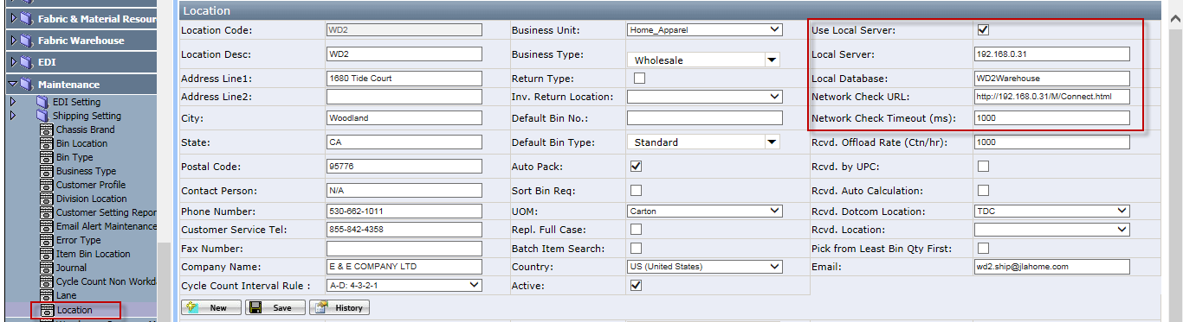
- Assign the default location to warehouse user. System will use this location to get local server information when login wireless application.
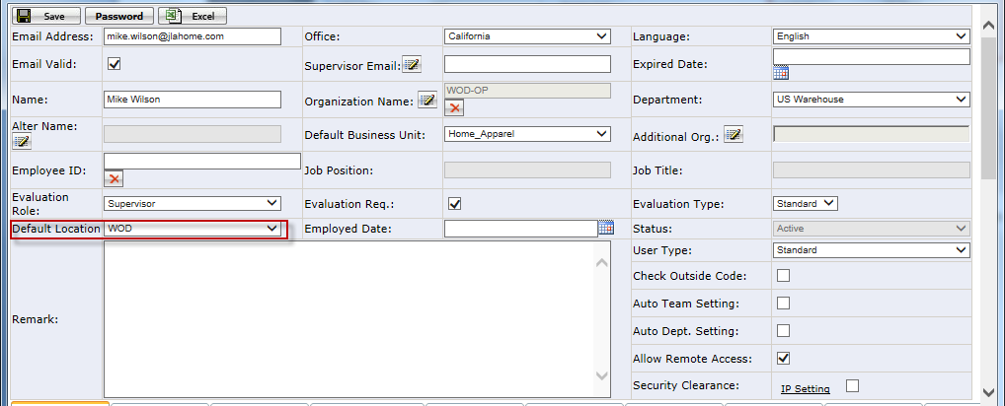

How to Access the Local Website
There are 2 ways to access the local website.
- EEC – Warehouse Local Server Menu, most of time, user will use this way to access local website, so you do NOT need to login another website.
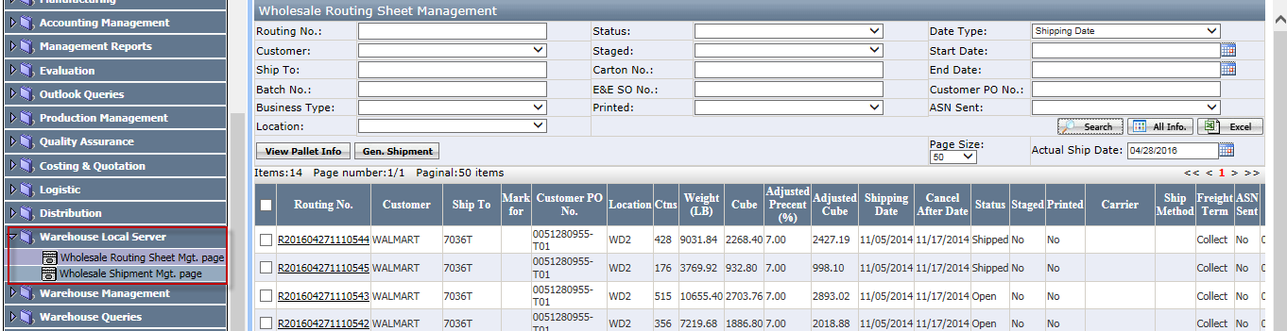
- Directly login local website(LocalEECSystemUS), this is used when warehouse lose the connection to Fremont, use the same EEC account to login the local website.
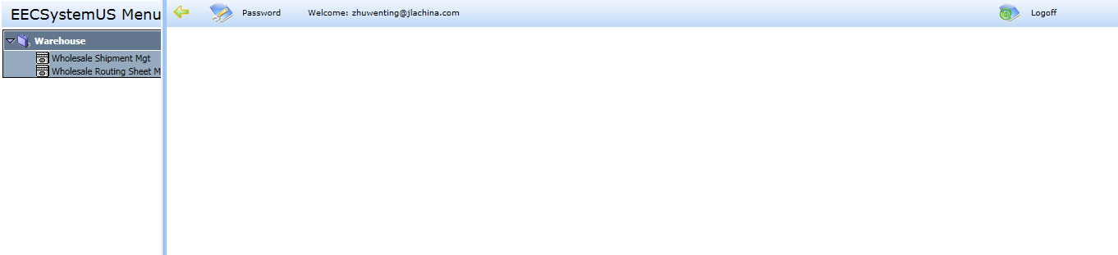

Working Procedure
- All the label process and routing sheet process need to be done in the main website. The procedure is same as before. Like print carton label, print routing sheet, Combine routing sheet, etc.
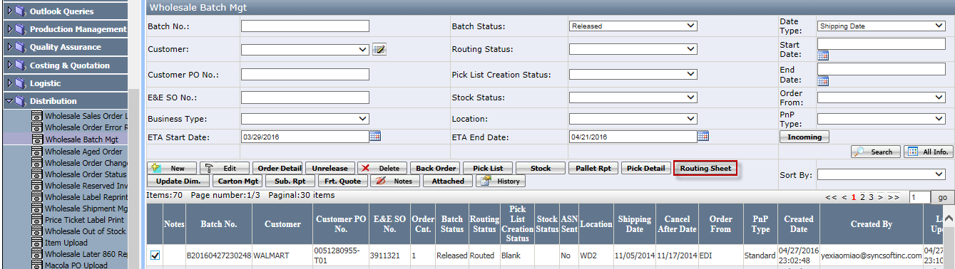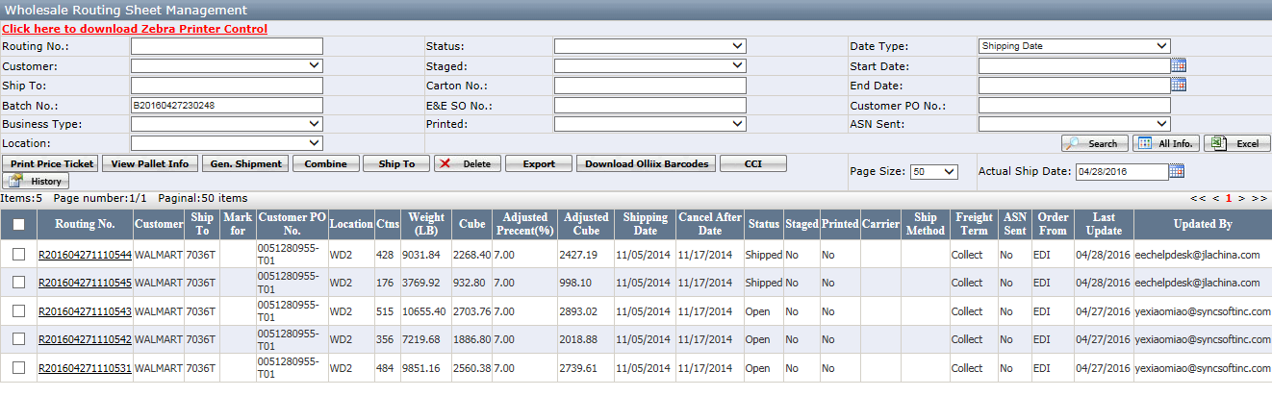

- Generate shipment on local website.
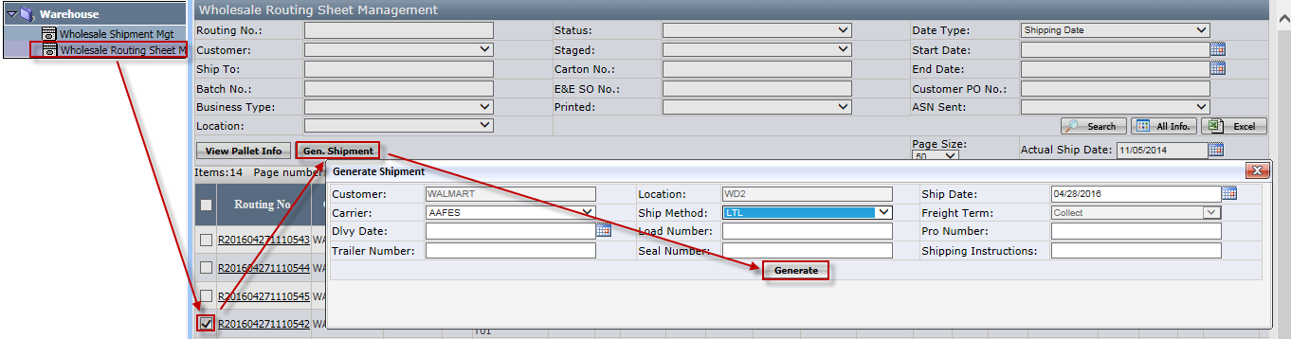

Notes:
- Pallet and shipment information will not display on the main website until shipment complete on local website.
- Removing cartons is not allowed when pallet is built or shipment is generated on local website.
- Can’t add the cartons to routing sheet when shipment is generated on local website.
- Combining routing sheet is not allowed when shipment is generated on local website.
- Ship to changing is not allowed when shipment is generated on local website.
- Deleting routing sheet is not allowed when pallet is built or shipment is generated on local website.

- Process shipment on local website. Include assign shipment, print packing list, BOL, create MBOL, load, complete, etc.
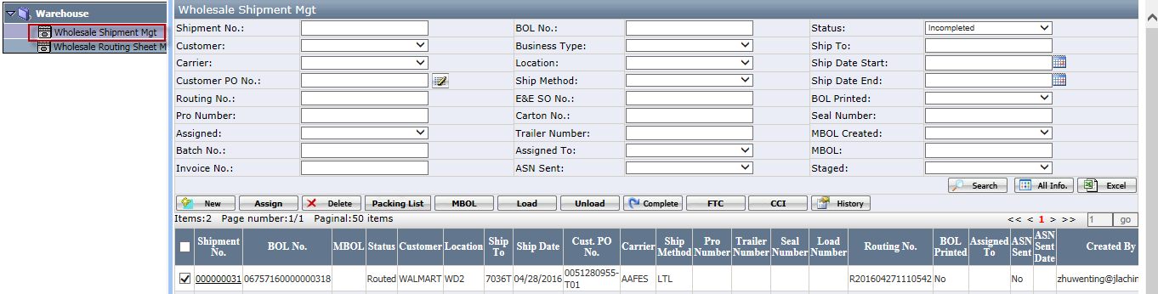

- After shipment is complete on local server, EEC will synchronize the shipment and pallet data to main server. By now the pallet and shipment information can be viewed on main server.

