Cycle Count

Workflow

Accounting team maintain cycle count parameter

Assign cycle count code to item

Generate and manage cycle count list on Cycle Count List Mgt. page

Do physical cycle count with wireless application

No
Exists Variance
(Re-count)

Yes
No
Variance Approved

Yes
Cycle count data process
(EEC update Macola data)

Generate cycle count report

- EEC Service
Assign cycle count code to item
Cycle count data process

Set Cycle Count Parameters
EEC – Cycle Count – Parameter Setting
This page is maintained by Accounting team.
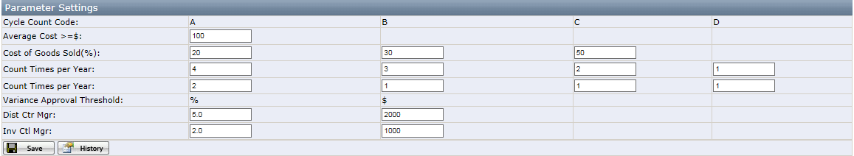
Save: save the changes of value.
History: record the changes for all fields.

**Cycle Count Code**
A: average cost >= $100 or cost of goods sold(CoGS) in top 20%
B: CoGS in next 30%
C: CoGS in remaining 50%
D: item status is closeout/donation

Manage Cycle Count List
EEC – Cycle Count – Cycle Count List Mgt
This page is used by Accounting team and Warehouse Inventory Control team.
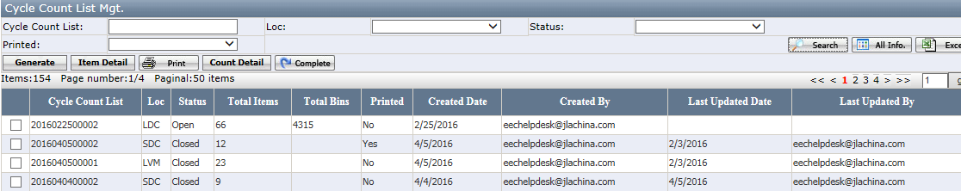
- Generate cycle count list.
Click Generate to open below page. Select location and click OK.
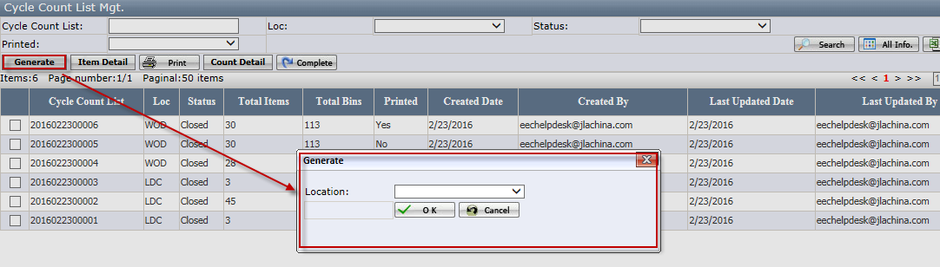
Notes:
- Old cycle count list must be closed when generate new one.

- Check item detail.
Select the cycle count list and click Item Detail. In this page user can check the item detail and approve variance.
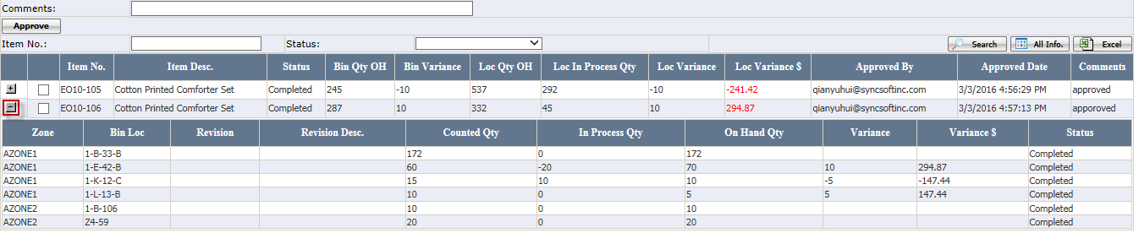
- On Hand Qty = On hand qty in Macola
- In Process Qty = Picked but not transferred qty, including wholesale/drop ship pick list, replenishment pick list(In & Out), bin transfer list(In & Out) and manual replenish list(In & Out)
- Variance Qty = Counted Qty - (On Hand Qty + In Process Qty)
- Bin Variance= Sum(Variance Qty for current item in all bins)
- Bin OH Qty = Sum(On Hand Qty in Macola for current item in all bins except Receiving bin , In-transit bin and Billing Only bin)
- Loc OH Qty = Loc On Hand Qty in Macola for current item
- Loc In Process Qty=Sum(On Hand Qty in Macola for current item in Receiving bin , In-transit bin and Billing Only bin).
- Loc Variance= (Bin OH Qty + Bin Variance + Loc In Process Qty) - Loc OH Qty

Approve: approve the variance of the selected item after counting.
Notes:
- The variance approval threshold is maintained on cycle count parameter page.
- Variance exceeds approval threshold need to be approved by Accounting team.
- Item status must be variance.
- Comment is required.

- Print the cycle count list PDF report.
Select cycle count list and click Print to open the print option as below. Cycle count list will be divided into groups according to the setup.
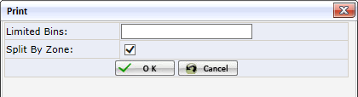
Notes:
- This option only pop up when first click the print.

Limited Bins: Limit the number of bins in each cycle count list group.
Split by Zone: It is checked by default. When it is checked, the cycle count list will be divided into groups by zone.
Cancel: Close current page.
OK: Print the cycle count list PDF report as below.
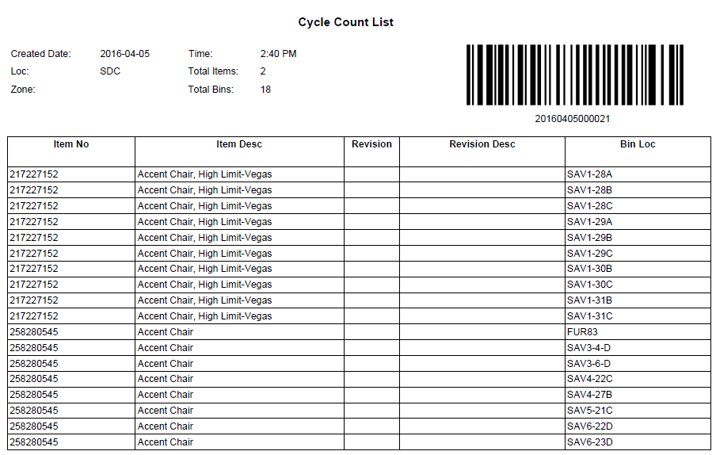

- Check the count detail.
After printing the PDF, the cycle count list group will be generated. Click Count Detail to open the count detail page of the selected cycle count list. The groups under the cycle count list will list here.
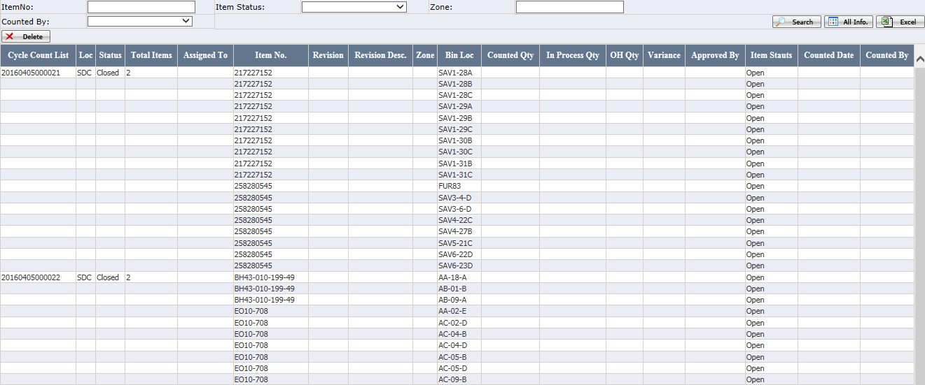
Delete: Delete all the cycle count list group data
Before counting, users can delete the cycle count list group data if they want to change the group.
Notes:
- All the item bin loc. status must be open.
- Count detail can be re-generated by re-printing the cycle count list PDF report.
- Complete the cycle count list.
Click Complete to complete the selected cycle count list.
- There are two scenarios to use this function.
- Fail to finish the cycle count today. After complete, the unfinished items will be in the next day’s cycle count list.
- In order to generate new cycle count list, the old ones must be completed.
Notes:
- Item status must be open or counting.

Cycle Count Summary Report
EEC – Cycle Count – Cycle Count Summary Report
Generate the variance/total items report by day/week/month.
- If report type=variance, will display the variance percentage.
Variance percentage = (ABS (counted qty-on hand qty) / on hand qty)*100
- If report type= total items, will display the total items counted.

Click the link can open the detail page.
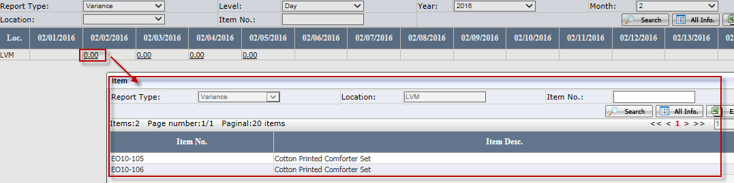

Status

Cycle Count Item Bin Loc. Status | Description
Open | Initial status
Skip | Skip count temporarily
Variance | Bin location has been counted but exists variance. After variance is approved and related Macola Data is updated, status will change to Completed
Completed | Bin location is counted without variance  Or variance is approved and EEC service has updated Macola data
Closed | Cycle count list is completed by user manually without finishing the counting of this item bin

Cycle Count Item Status | Description
Open | Initial status
Counting | At least one bin location has been counted
Variance | All cycle count item bin loc. status is Variance or Completed, but not all completed, or Loc Variance <> 0
DCM Review | After Inv Ctl Mgr clicks “Approve” on items with variance greater than his approval threshold
Request Approval | After Dist Ctr Mgr clicks “Approve” on items with variance greater than his approval threshold
Approved | After variance is approved, status will change to Approved
Completed | All Cycle Count Item Bin Loc. status is Completed
Closed | Cycle count list is completed by user manually without finishing the counting of this item

Cycle Count List Group Status | Description
Open | Initial status
Counted | All item bin status is Variance, Closed or Completed
Completed | All related cycle count item bin status is Completed
Closed | Cycle count list is completed by user manually without finishing the counting of all item bins

Cycle Count List Status | Description
Open | Initial status
Approval Pending | If any item on the list has “Request Approval” status
Completed | All related cycle count item bin status is Completed
Closed | Cycle count list is completed by user manually without finishing the counting of all items

Wireless Application

- Log in
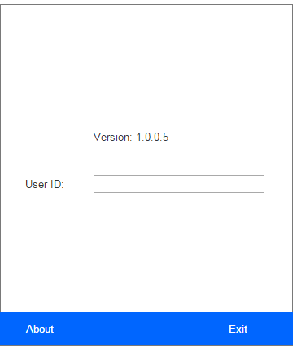

- Scan cycle count list group barcode on the PDF report to assign the cycle count list to current user.
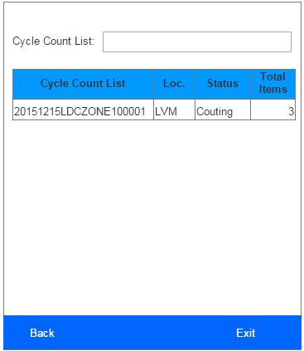
- This form only list the cycle count list which is assigned to current user and has not been closed or completed

- Click the cycle count list to open item detail form as below.
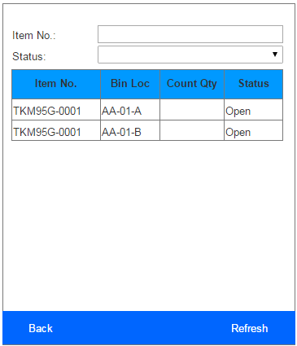
- This form list all the bin locations belong to the selected cycle count list.
- Input item no. or status can filter the item bin loc. list.
- Item status = Completed/Closed/Approved, does not allow to count.

- Click the item no. to open the count item form as below and count the items.
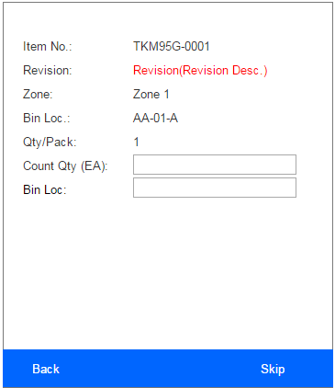
- User need to enter the Count Qty (EA) first, and then scan the bin loc barcode.
- User can click Skip if they want to skip current item and count later. Current item bin loc. status will change to skip.

