New Ecom User Guideline
Version: 1.0 25-1-2016
Click here to see New Ecom Demo Site

How to log into EEC
- In IE browser, type EEC Testing address: https://eecsystem.cn
- In EEC Login Page, type your User Name, Password and Check Code. (See Figure 1-1). EEC Helpdesk will send you user name and password if you do not have an account. If you have a user ID but forgot the password, please click Forgot Your Password to reset your password.
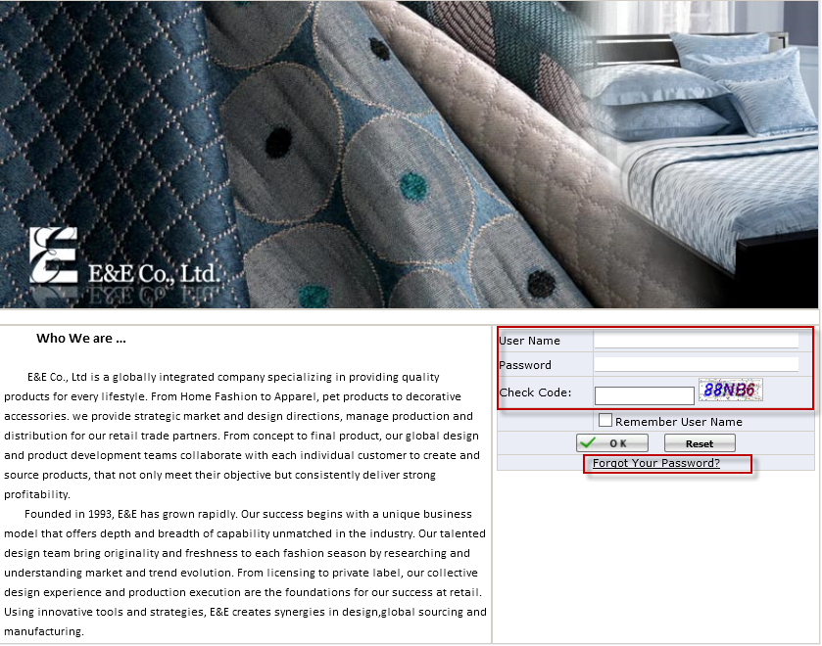
Figure 1-1 EEC Login Page

How to use Ecom Item Master
- Select Business Unit “EComDropShip” and click New Ecom Ecom Master Ecom Item Master to open the Ecom Item Master Page. If Business Unit is not EComDropShip and click Item Master List, system will give the message” This Page is used by EComDropShip Business Unit.”
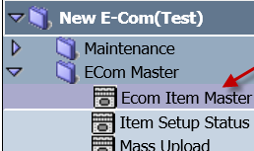
Figure 2-1
- Ecom Item Master
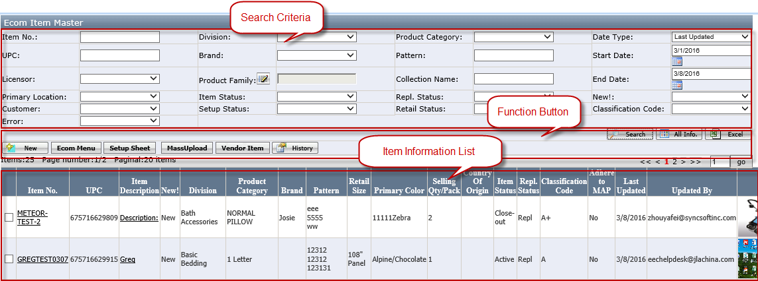
Figure2-2
Search Criteria
- Date Type: Default to Last Update
- Start Date: Default to the Current Date – 7 days
- End Date: Default to the Current Date
- Special condition: Customer, Setup Status, Retail Status and Error.
- If user only selects the Setup Status or Error, system will show the Items which related Customers have the same Setup Status or exist the Error.
- If user selects both the Customer and Setup Status, system will show the Items which have the same Setup Status under the selected Customer.
- If user selects both the Customer and Error, system will show the Items which have the error under the selected Customer.
- If user selects both the Customer and Retail Status, system will show the items which have the Retail Status under the selected Customer.

Function Button
- New: Click it to open the new Item Detail Page.(See the Item Detail Page for detail)
- Ecom Menu: Click it to open the Ecom Menu Page and you can click Excel to down Ecom Menu. Since it contains item picture and item information, we recommend you to narrow down your search criteria first before clicking it. Besides, click the photo to open the Original picture and click the Excel Button to export the Excel.
- There is a with photo checkbox beside the Excel Button and default to check. If with photo is not checked and click the Excel button, system will export the item without photo.
- New: If the Inv. Avail. Date + 14days > Current Date, system will auto set the item as New. Otherwise, New! Column is blank.
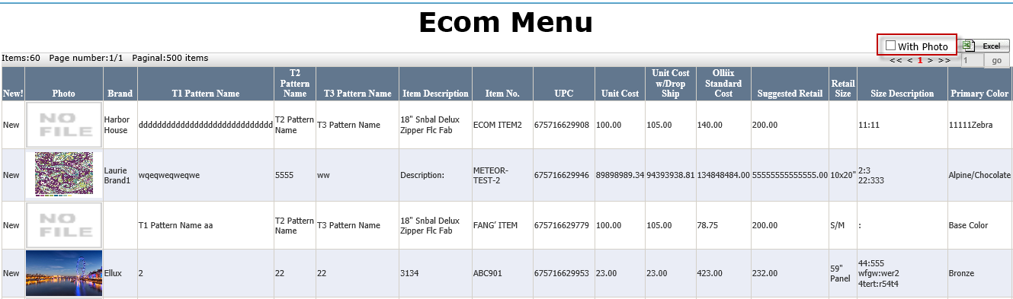
Figure 2-3
- Setup Sheet: Select one Customer and choose multiple Setup Sheet Templates if having multiple. (See the Setup Sheet Template for detail)
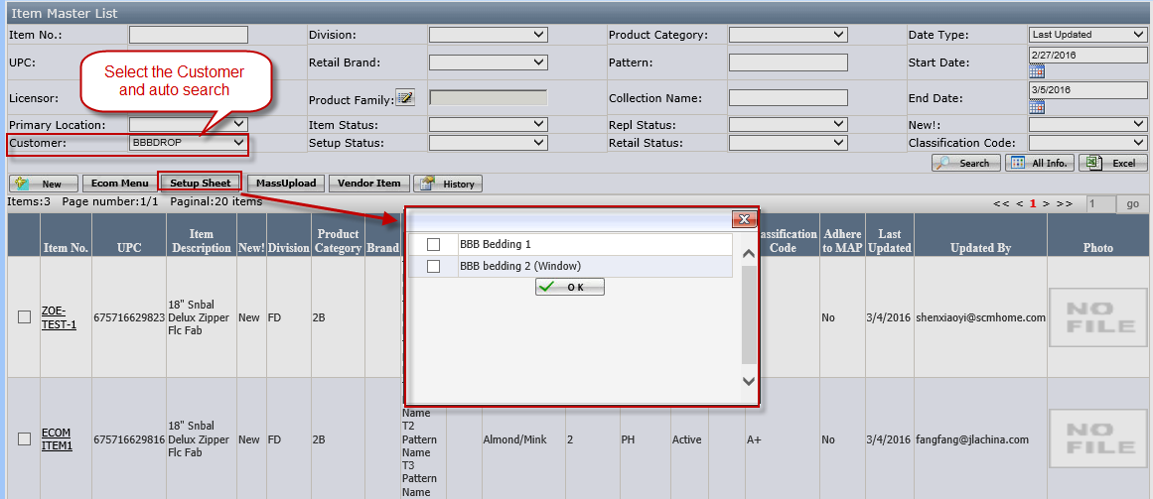Figure2-3
Click the Ok to generate the combined Excel. (See the below Picture)
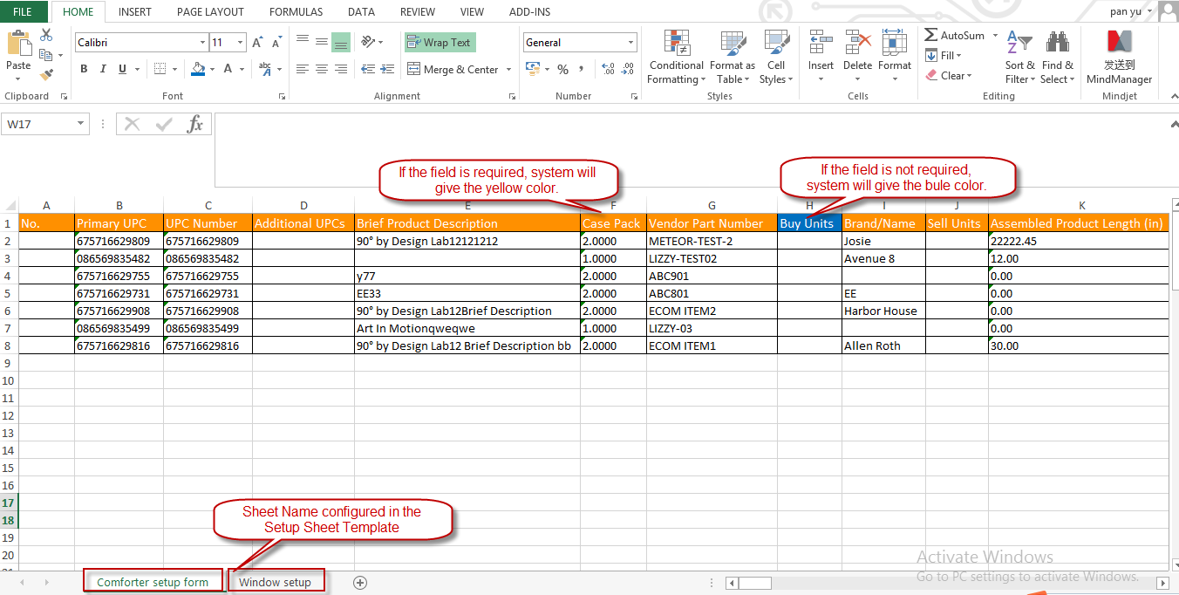
Figure 2-4
- If it without selecting the Customer, system will pop up the warning ”Please Select Customer First”;
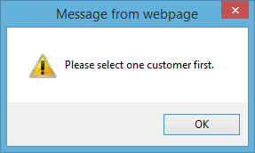
Figure2-5
- If the selected Customer is not configured with Setup Sheet Template, system will pop up the warning” No Customer Template Configured!”
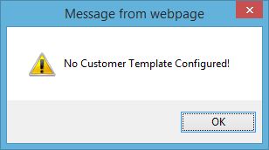
Figure2-6
- If the selected multiple Setup Sheet Templates to down, the name of the exported excel is Customer Name-_Template Name1_ Template Name 2. e.g. If selected template Bedding 1 and Bedding2 (Window), the exported excel name is Kohl-_Bedding 1 _ Bedding2.xlsx
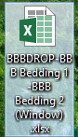
Figure2-7
- Mass Upload: Click it to open the Mass Upload Page.(See the Mass Upload for detail)
- Vendor Item: Put a Check and click it to open the Vendor Item. System will pop up the warning “Please select one item” when user puts multiple checks or none.
- History: Put a Check and click it to open the History page. This History will record the changes of Item Master Fields.
- Excel: Click it to export the Excel File.

Grid
- Item No.: Click it to open Item Detail Page.(See the Item Detail Page for detail)
- Item Description: Click it to open the Retail Item Detail. (See the Retail Item Detail for detail)
- New!: If current date = < Inv. Avaibli. Date + 14, it is New; otherwise, it is blank.
- Photo: You can click it to see the original picture.

How to go to Item Detail
- Click New or click Item No. to open the Item Detail Page and there are two tabs.

Item Master

Common Part
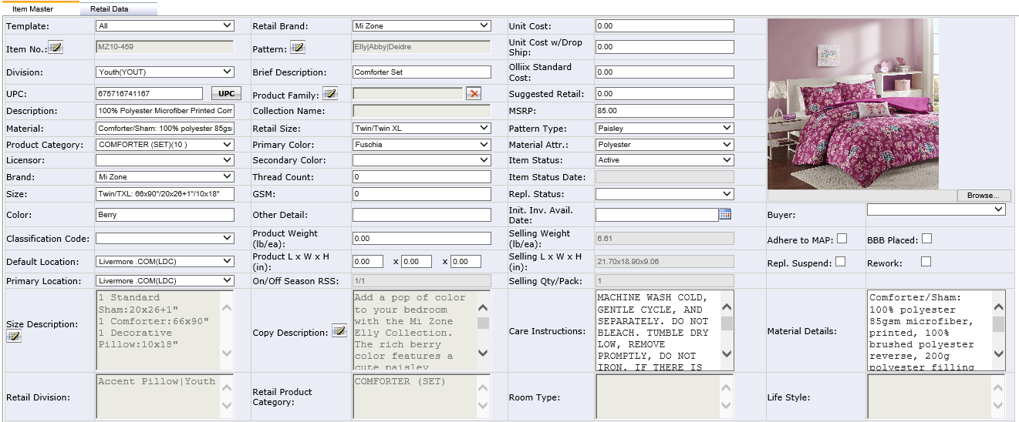
Figure 3-1
- System will give the below warning message and also has * for the required Field when saving.
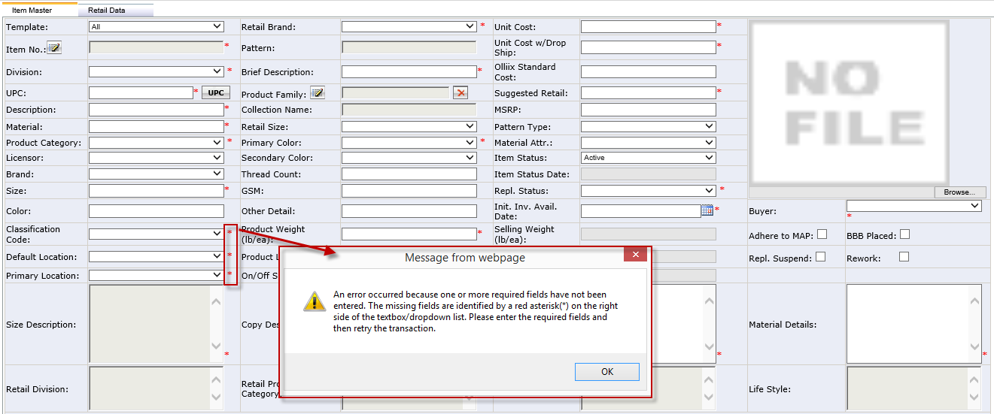
Figure3-2
- Unit Cost w/ Drop Ship: Default = Unit Cost * (1+5%) and allowed to modify. It is also allowed to enter 0.
If the saved value which is is not 0 or blank, the modified Unit cost has no affect for it.
Olliix Standard Cost: Calculation rule is below
1. For Brand Hampton Hill bedding items, use unit cost w/ drop ship divided by 0.65.
2. For Pet division, Blanket division, Product Category: Mattress Pad (16) and Pillow (30), use unit cost w/ drop ship divided by 0.70.
3. For all other items, use unit cost w/ drop ship divided by 0.75.
If the item belongs to the above 1and 2 rules at the same time, it will use unit cost w/ drop ship divided by 0.70 .
- MSRP: System will auto calculate the default value according to the below rule and allow the user to modify. It is also allowed to enter 0. If saved value which is not 0 or blank, the modified Suggest Retail has no affect for it.
1. MSRP = Suggested Retail Price x (1+ percentage listed below base on brand).
2. Echo - 40%, Harbor House Bedding - 40%, Harbor House Bath - 70%, Hampton Hill - 40%, Natori/N Natori/Josie - 40%, Met Home - 70%, INK+IVY - 70%,
Woolrich - 70%, Bombay - 70%, All other brands - 70%.
- Init. Inv. Avail. Date: It’s the item inventory available date. It affects item setup status which is “Pending”. If Inv. Avaibli. Date - Today >= N Days (N=Pending Days, most N=180), EEC Initialization service will auto change the status to “Open”.
- Product Family: Click it to open the Product Family Page. User can search the Product Family and select one Product Family for the Item.

- If the Product Family is blank, system will give the warning (see the below picture) and auto generate the Product Family according to the Rule: Product Family = Retail Brand + T1 Pattern + Brief Description.
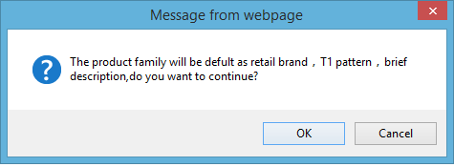
Figure 3-3
- Once generating the Product Family, system will grey out the Retail Brand, T1 Pattern and Brief Description.
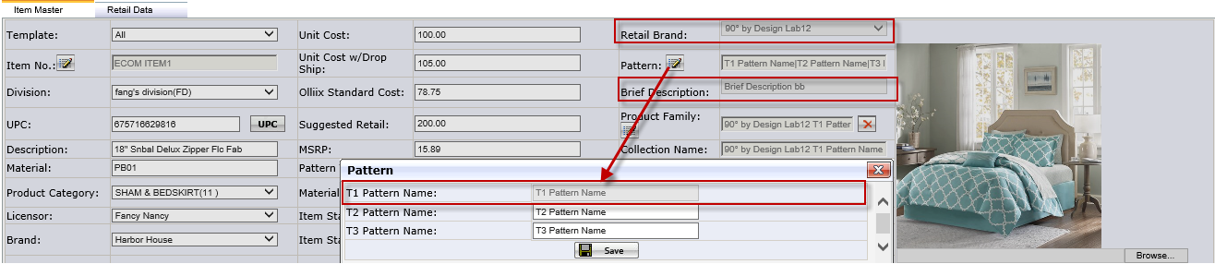
Figure 3-4

Figure3-3
- Collection Name: The value depends on the selected Product Family and is only read.
- Product L x W x H (in): It’s Product Length, Product Weight and Product Height. If the item contains the multiple items such as a comfort set, it is the main product dimension.
- On/Off Season RSS: It’s On Season Safety Stock and Off Season Safety Stock
- Buyer: The user has the buyer role which is configured by eechelpdesk@syncsoftinc.com in Administration Privilege Setting.
- Size Description: It’s the combination of Set Includes Value and Size Details Value. Click the icon located at Size Description to open the Size Description Page and it have Set Includes and Size Details.
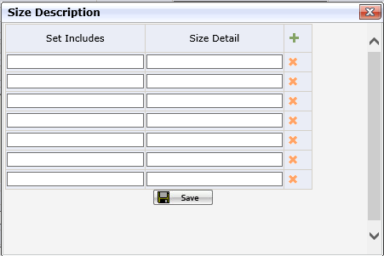
Figure 3-4
- Copy Description: Click it to open Copy Description Page which includes T1 Copy Desc., T2 Copy Desc. and T3 Copy Desc.
T1 Copy Desc. is required and click the Save Button, system will auto copy the T1 Copy Desc. for T2 Copy Desc. and T3 Copy Desc. T2 Copy Desc. And T3 Copy Desc. are allowed to be modified. If T1 Copy Desc has no value, system will give the warning message “T1 Copy Desc is required”.
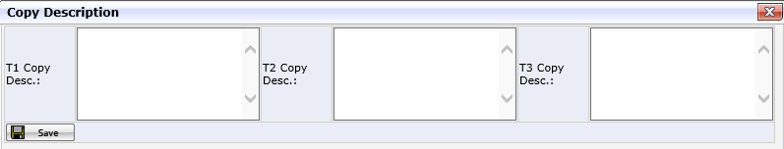
Figure 3-5
- Room Type, Life Style, Classification Code and Retail Product Category are maintain in Category Page to by clicking Category Button.
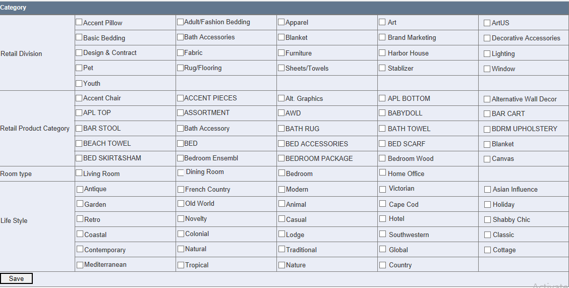
Figure3-6
- Primary Location: If the customer needs State, system will get the state code according to Primary Location.
Notes:
- Now some fields not only exist in the Ecom Item Master but also exist in the Retail Item Data, user have to modify the value of fields in the two pages.
- Please see the excel for detail.

Additional Part
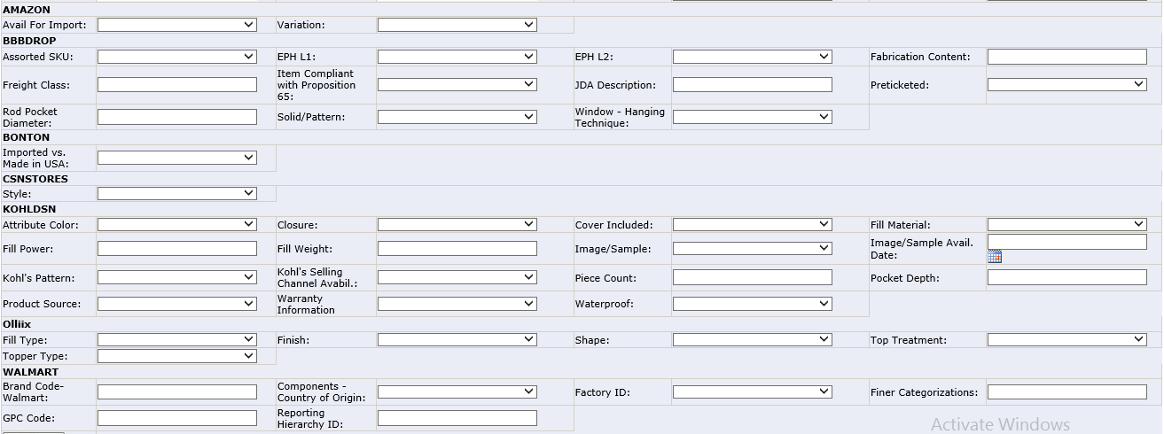 Figure 3-6
- These fields are configured in the Customer Template Page. (See the Customer Template for detail ) If you want add or remove any field for a customer, please send email to eechelpesk@syncsoftinc.com
- Customer Name and Field Name both sort by sequence.

Retail Data
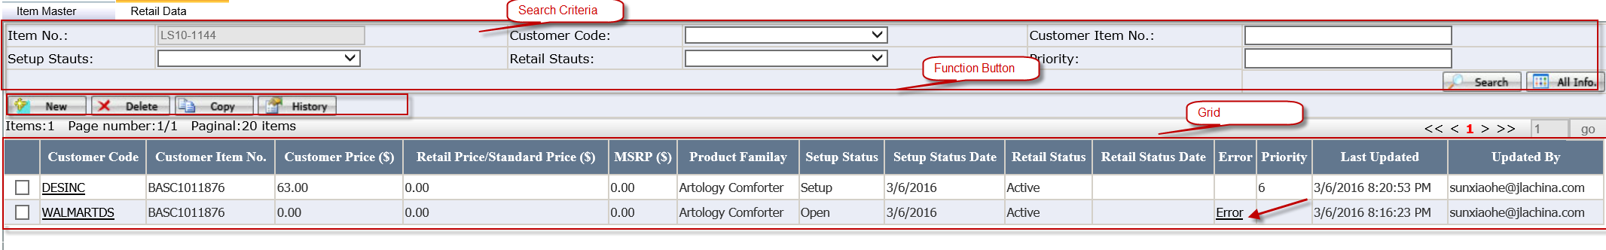
Figure3-7
- Search Criteria
Item No. It’s grayed out. It’s the item no selected in Ecom Item Master.
- Function Button
New: Click it to open new Retail Item Detail. (See Retail Data Detail for detail)
Copy: It’s used to copy one customer item information to other customers. Put a check for a customer code and click Copy button, system will auto pop up the Customer Selection page and click OK. (See Copy Function for detail)
History: Put a Check and click it to open the History page. It will record the changes of Retail Data Detail.
- Grid
Customer Code: Click it to open the Retail Data Detail. (See Retail Data Detail for detail)
Error: Click it to open the Error Page for each customer.

Copy Function
- Copy Pre-condition: The Setup Status of the selected customer is Setup and there isn’t error.
- Copy content
- All fields in the Retail Data Detail will be copied, but some fields will be changed according to the different Rules.
- Customer Code: It’s the selected Customer Code.
- Customer Price will auto calculate according to the below Rule if the customer price does not exist in item master’s customer item page. If existing, it will use the existing customer price instead.
- For DL=EEC Cost * (1+50%) If the Retail Status is out-close or donation, DL=EEC Cost * 0.5.
- For Olliix= blank
- For Kohl=Unit Cost
- For Amazon and HSNDS= Unit Cost/ (1-10%)
- For Macy's Division=Unit cost x 1.2 x 1.05
- For Other customer except above= Unit Cost * (1+5%)
- Customer Item No.: It is required.
If the Customer Code is DL, system will auto general the Customer Item No. according to the DL Rule
Designer living customer item number name rule and it will grey out.
i. 3-alpha Division SAP Code.
ii. 3-alphanumeric Product Category SAP Code. If missing the SAP Code, system will give the warning” The Item doesn’t have Product Category SAP Code”
iii. 5-numeric system generated sequential #
Example: EEC Item No DFF1104-387 could become FURF1100387, FUR is furniture division SAP Code, Product Category SAP Code: F11, 00387 is the sequence no.
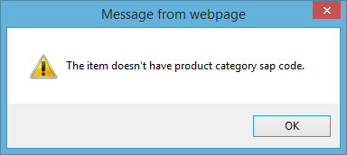
Figure 3-8
If the Customer Code is Ollix, system will auto general a N/A for Customer Item No.
If the Customer Code are other Customer, system will auto set the blank as the Customer Item No.
If the Customer Item No has existed in the Customer Item Page, system will auto attain the value from the Customer Item Page when copying or New.
- Retail Pattern will get the value according to the Item Setup Rule Configuration for each customer.
- Setup Status will default to open and Setup Status Date will default to current date and will be changed according to Setup Status changes.
- If there is Customer Price existed in the Item Master, system will auto get the Customer Price from Item Master when copying.
- When you copy from other Customer Item information, system will auto judge whether the required fields which are configured in the Customer Template have been filled. If it’s not filled, there will be an error in the Error column in the Retail Data Page and you can click the Error to see the error detail.
- Copying for Olliix
- If copying for Olliix and the Item Repl. Status is Repl., system will not limit the item and it is allowed to change the Setup Status.
- If copying for Olliix and the Item BBB Placed is checked, the Item Retail Brand also has been configured in the Item Setup Rule, system will auto set the Setup Status as Restricted.
- If copying for Olliix and the Item BBB placed is checked and Repl. Status is Repl. at the same time, system will auto set the Setup Status as Restricted.
Notes:
- Related Item and Dealer Qty/Pack will not be copied.
- The initial setup status of copy customer item is Open (Except the item which has been configured with Pending or Restricted in Item Setup Rule).

How to go to Retail Data Detail
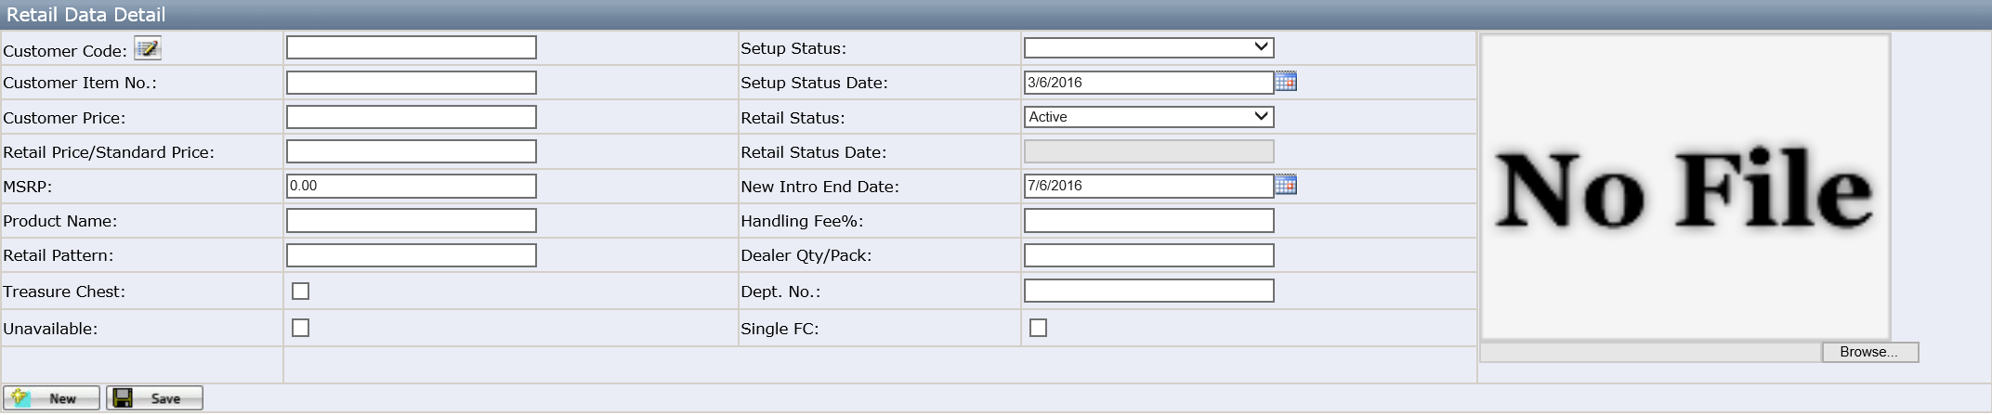
Figure 4-1
- Click Customer Code or New to open the Retail Data Detail.
- If missing the required field, system has * for that field when saving and also will give the below message
Figure 4-2
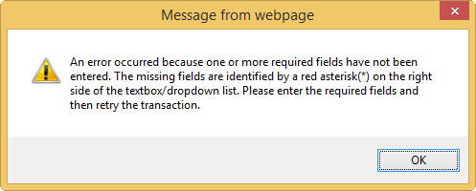
Figure 4-3
- Click Save Button to save information.
- If the user wants to change the Setup Status to Setup, system will auto judge whether there is an error or not. If existing an error, system fail to save the changes.
- If the item Setup Status is Pending or Restricted according to Item Setup Rule , you cannot change to other setup status unless you change the Item Setup Rule first.
- System will feed the item information and inventory to third part website such as Designer Living or Olliix website if the Setup Status is Setup and Retail Status is Active.
- The Special Field explanation
- Customer Code: Click it to open the Customer Selection Page.
- Retail Price/Standard Price:
- For DL it is the retail price selling in the DL website regular price if the regular price has no discount.
- For Ollix, it is Olliix web site Standard Price.
- MSRP: Get the value from Item Master and it’s only read.
- Product Name: Default to Retail Brand + Retail Pattern + Brief Description and it is required.
- Retail Patten: Default value depends on Customer -->Item Setup Rule Configuration.
- Retail Item and Dealer Qty/Pack will only be visible when the Customer Code is Olliix.
- Handling Fee%: Default value depending on the configuration in the Item Setup Rule and if user clear it to blank and save successfully, system will auto set the 0.00 as the value to record in the database.
- Retail Status: Default to Active.
- Retail Status Date: Record the Date when the Retail Status changes to Discontinued.
- Additional Images: It is visible for customer “Olliix” and “DESINC” and is allowed to add multiple images.
- Customer Price: If click the New to generate a new one, system will auto generate the Customer Price according to the Rule. if the customer price does not exist in item master’s customer item page. If existing, it will use the existing customer price instead. (See detail customer price rule)
- Related Item: It is visible only the Customer Code is Olliix and the click the iron which will be visible after saving to open the Related Item page.
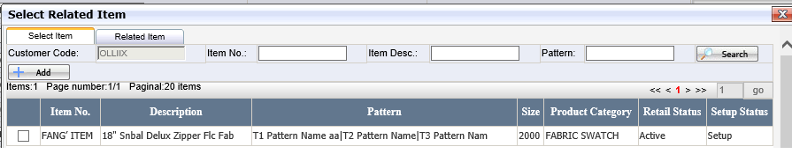
Figure 4-4

Setup Status
Setup Status business flow chart (except Olliix)
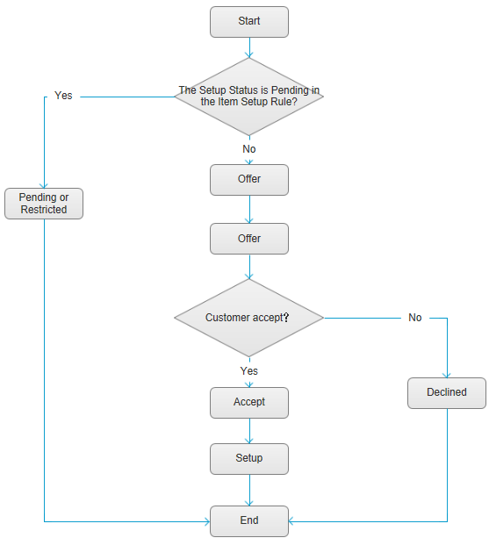
Figure 4-5

  - Open: It means can be offered to customer.
  - Offer: It means the item has been offered to customer.
  - Declined: It means the item has been declined by customer.
  - Accept: It means the item has been accepted by customer.
  - Pending: It means the item will not be sold for the configured customer until Pending days over. The item will keep Pending Status if the Inv. Avail. Date + N days (Set up in the Item Setup Rule) >Current Date, Otherwise, default to Open.
  - Restricted: It means the item is banned to sell.
  - Setup: It means the item has already been sold. Only there isn’t error and Setup Status is Pending or Restricted can change to Setup.
Setup Status business flow chart (for Olliix)
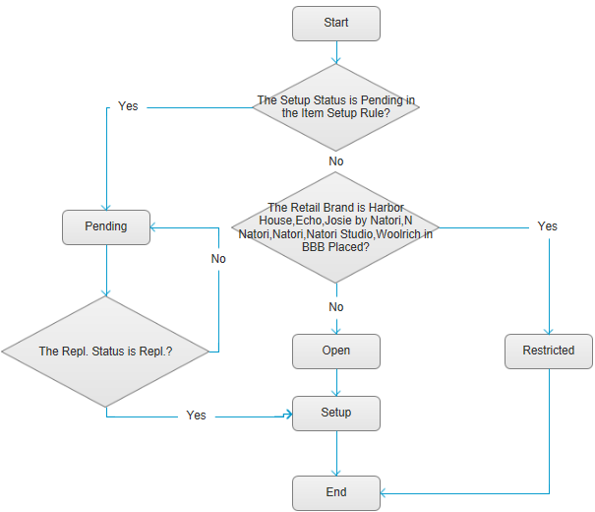
Figure 4-6
- If the Retail Brand is Harbor House, Echo, Josie by Natori, N Natori, Natori, Natori Studio, Woolrich in BBB Placed, system will not allowed to change to other Setup Status and only set as Restricted.
- If the Repl. Status is Repl., user can change the Setup Status from Pending to Setup.
- The Olliix configuration in the Item Setup Rule: all divisions (except the Furniture, Adult/Fashion Bedding), Classification Code is C, D, E and all Retail Brand (except INK+IVY) will be configured as Pending.
The division which is Adult/Fashion Bedding, Classification Code which is C, D, E and Retail Brand which is all(except Bombay, Met Home) also will be configured as Pending.
As a result, the configure could make sure that the Olliix Item which Classification Code is A or B or Division is Furniture or Division is Adult/Fashion Bedding and Retail Brand is Bombay or Met Home can change the Setup Status to Setup.

How to go to Retail Item Setup Status Report
- Click New E-com Ecom Master Retail Item Setup Status Report
Search Criteria
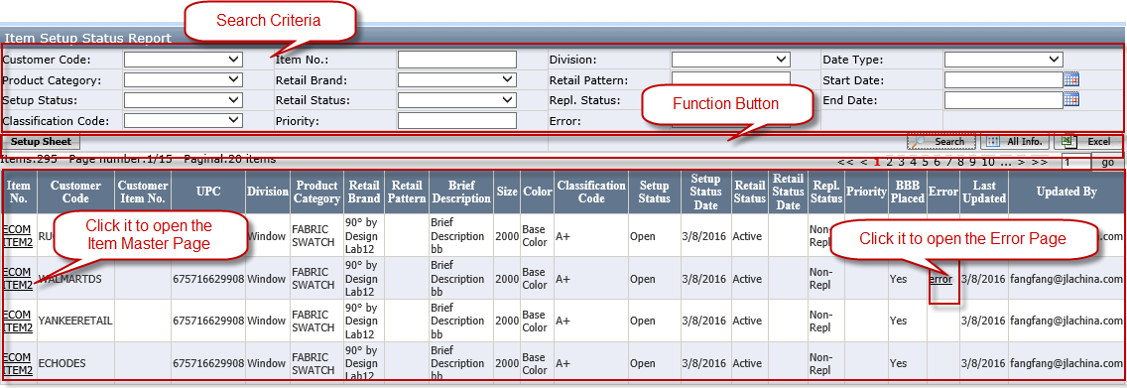
Figure 5-1
Item Information list
- Customer Code: Click it to open the Retail Data Detail.
- Error: Click it to open the Error Page.
Setup Sheet Function (See the How to go to Item Master List)

How to Maintain Product Family
- Click Product Resources Maintenance Product Family
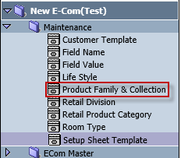
Figure6-1
- Click the Select to choose one Product Family.
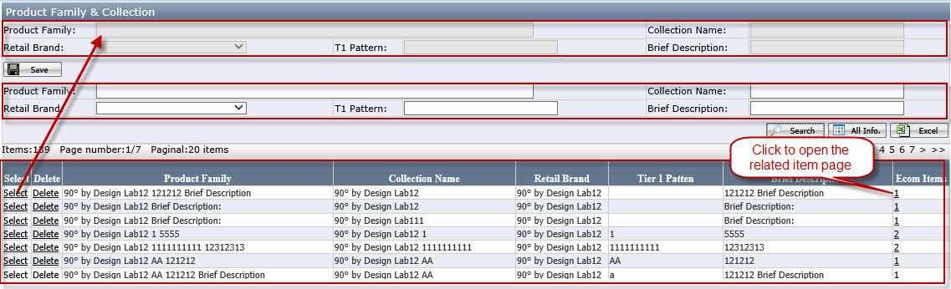
Figure6-2
- Generate the Product Family
- If user modifies the existed Product Family, system will auto use the modified result to march the current existed Product Family. If marching successfully, system will auto put the item under the Product Family; otherwise, system will auto generate new Product Family ID for the modified Product Family.
- If changing the Retail Brand or T1 Pattern or Brief Description, system will auto update all related Items.
- If the Item is related to the existed Product Family, system will auto update Retail Brand, T1 Pattern and Brief Description according to the related Product Family.
- If user wants to delete the Product Family, system will give the warning and auto judge whether has been used in the Item. If the Product Family has been used in any item, system will not allow to delete the Product Family.
- It is not allowed to set the T1 Pattern as blank.
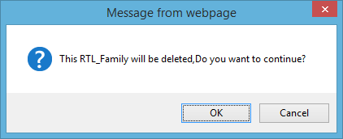
Figure 6-3

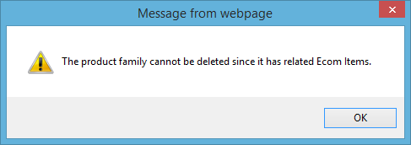
Figure 6-4

- Related Item
- The number means how many related items there are.
- Click it to open Related Item Page to see details.
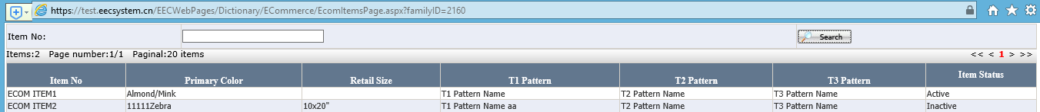
Figure 6-5

How to Mass upload
- Click New E-com Mass Upload
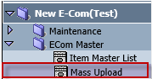
Figure7-1

- Select a tab from 6tabs. Click the Template to load down the Excel Template. Different upload type has different Template. It is not allowed to change the excel template format. Otherwise, system will pop up the warning “Fail to upload due to the excel template format is wrong!”
- Any change by uploading will plus into the History.
- If there is any error, system will show the error in the Grid.
- Click the Error to open the Error Page for detail.
- Click the File Name to open the uploaded excel.

- Classification Code should be fielded according to the Note.
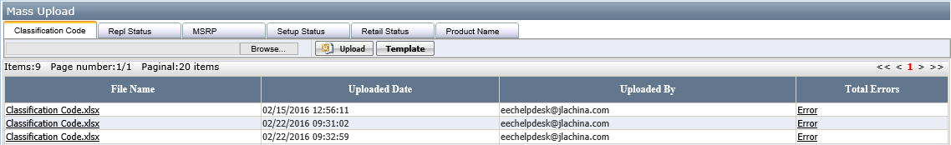
Figure7-2
Classification Code Template
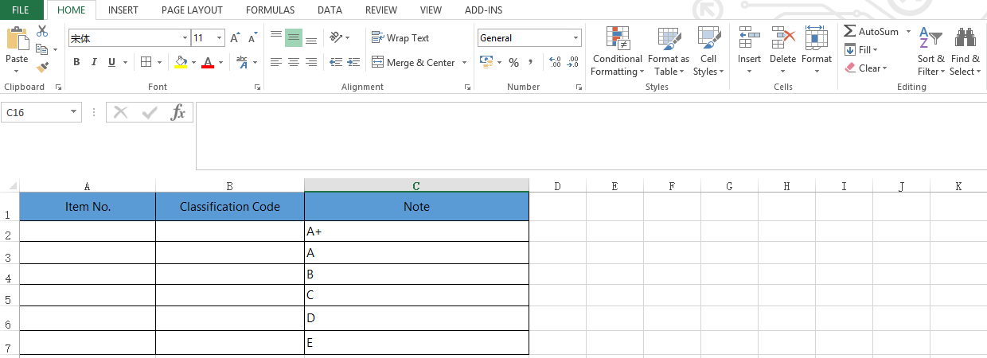
Figure 7-3

- Repl. Status
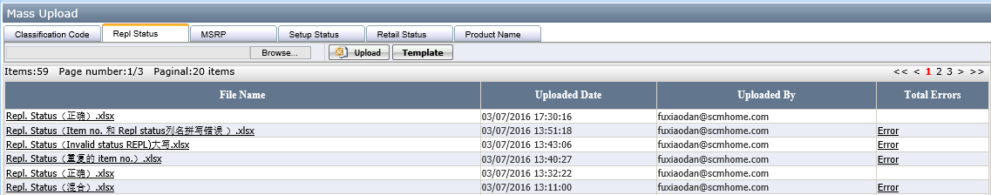
Figure 7-4
Repl. Status Template
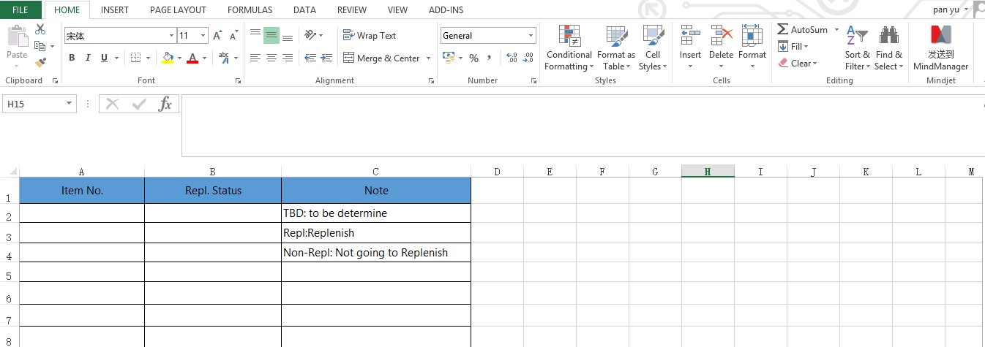
Figure 7-5

- MSRP
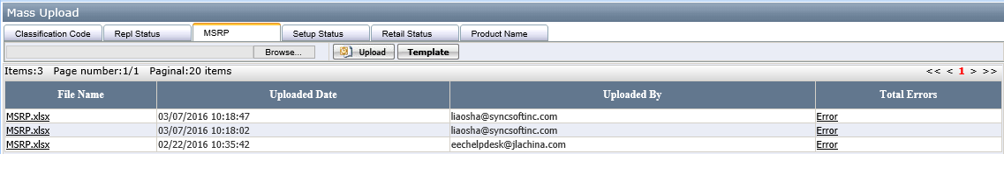
Figure 7-6
MSRP Template
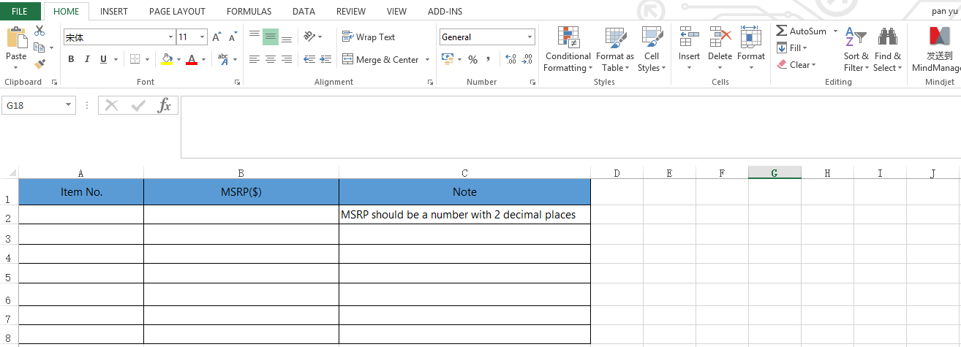
Figure 7-7

- Setup Status Select the Customer Code first!
If uploading Setup Status, system will auto judge whether Item Setup Status is Pending or Restricted in the Item Setup Rule. If Item Setup Status is Pending or Restricted in the Item Setup Rule, system will not allow to upload the Setup Status and pop up the warning “Fail to upload due to the Item Setup Status in Item Setup Rule is Pending or Restricted for Customer Code XXX ”.
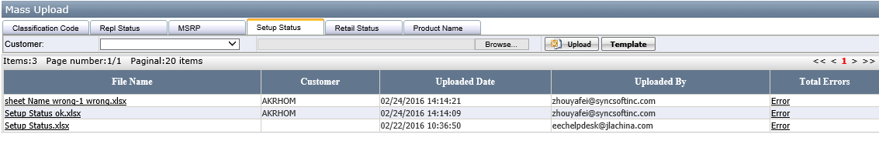
Figure 7-8
Setup Status Template
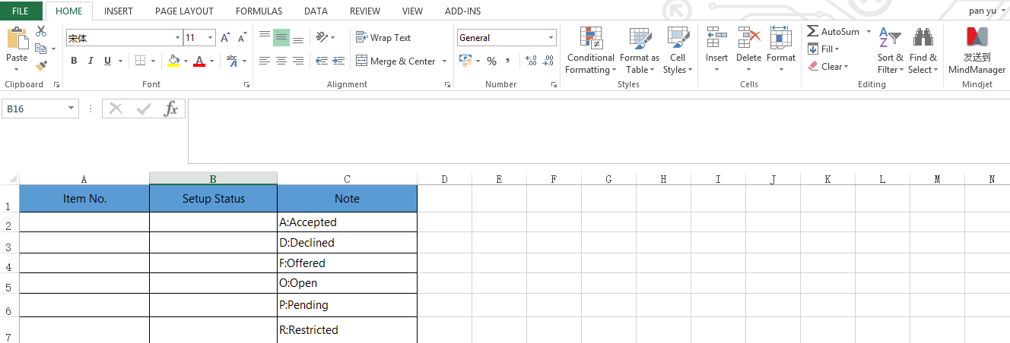
Figure 7-9

- Retail Status Select the Customer Code first!
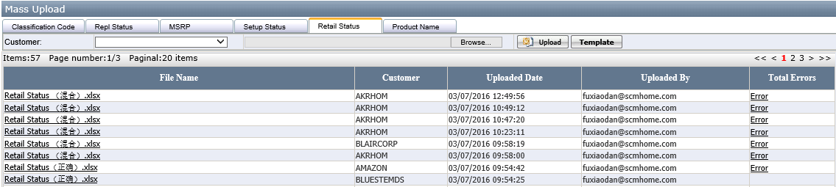
Figure 7-10
Retail Status Template
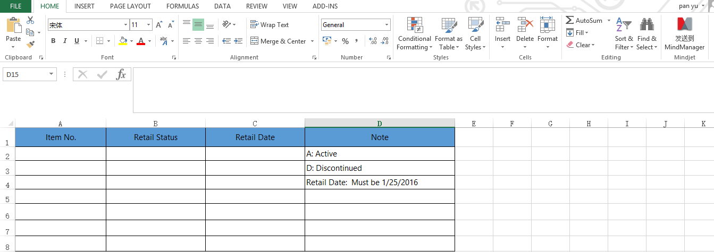
Figure 7-11

- Product Name Select the Customer Code first!
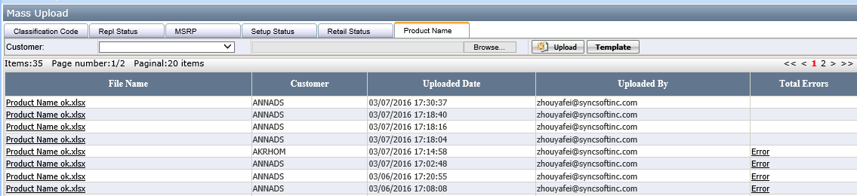
Figure 7-12
Product Name Template
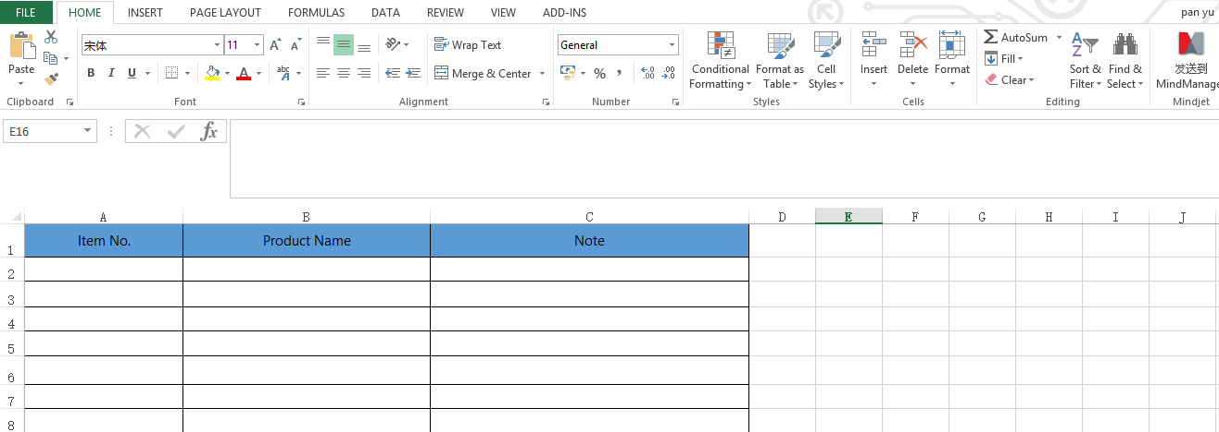
Figure 7-13

- If the uploaded information is not right and need to correct, system will generate Error and plus the error information in the Error page. System will give the related warning in the Error Description.
If the upload the Setup Status and the item Setup Status is Pending or Restricted, system will not allow upload successfully and pop up the warning “Fail to upload due to the Item Setup Status in Item Setup Rule is Pending or Restricted for Customer Code XXX.”
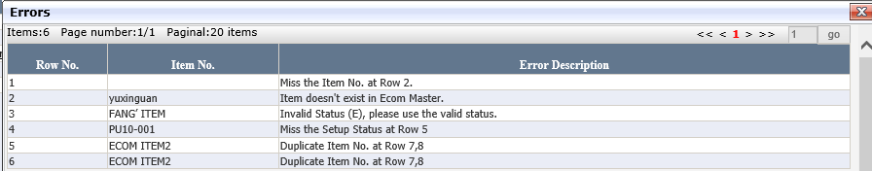
Figure 7-14

How to Maintain Field Name
- Click New Ecom Maintenance Field Name to open this Page. It is maintained by EEC Help Desk. If you having any new field to add, please send email to eechelpdesk@syncsoftinc.com.
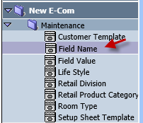
Figure 8-1

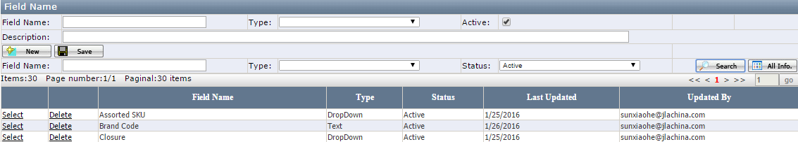
Figure 8-2

- Click New and enter Field Name, Select Type and enter Description if having and click Save. Description will be used as tool tips in the Ecom Item Master Item DetailItem Master page.
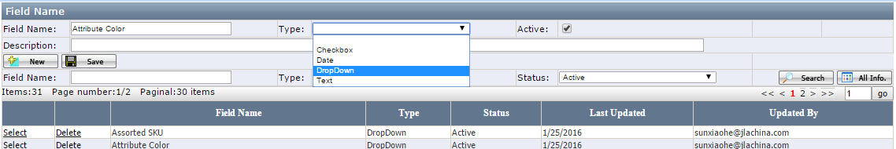
Figure 8-3

Note:
- Field Name: It is not allowed to be duplicated. When duplicating, it will give the warning message "Fail to save due to the Field Name XXX is duplicated！" If it is used in the Customer Template or Customer Setup Sheet or Field Value or Ecom Item, you have to remove it from those pages first before deleting.
- Type: The drop down list contains Blank, Text, Date and Checkbox, Dropdown. Default to blank. Type is grayed out once it is successfully saved.
- Active: If the field name is no longer used for any customer, you can remove them in the Customer Template and Customer Setup Sheet first and uncheck it. The warning will be "This Field has been used in Customer Template and Customer Setup Sheet, please delete them first.” If you do not remove them in the Customer Template and Customer Setup Sheet first

How to Maintain Customer Template
- Click New Ecom Maintenance Customer Template. This page is maintained by EEC Help Desk. If you have any new customer setup sheet to add to system or a new field need to add to Ecom Item Master Item Master page, please send request to eechelpdesk@syncsoftinc.com.
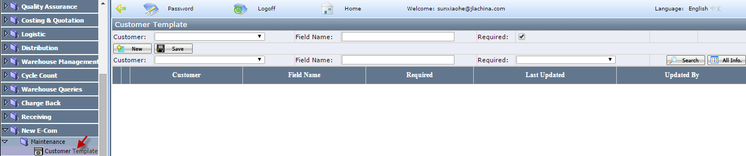
Figure 9-1
- Click New, select Customer and enter Field Name or type partial field name and select it from the drop down list and click Save.
Notes:
- Field Name: It is not allowed to duplicate in the same Customer.
- Required: If having the check, when creating Retail Data for a customer (Ecom Item Master Item DetailRetail DataRetail Data Detail), it will have the error flag when missing value.
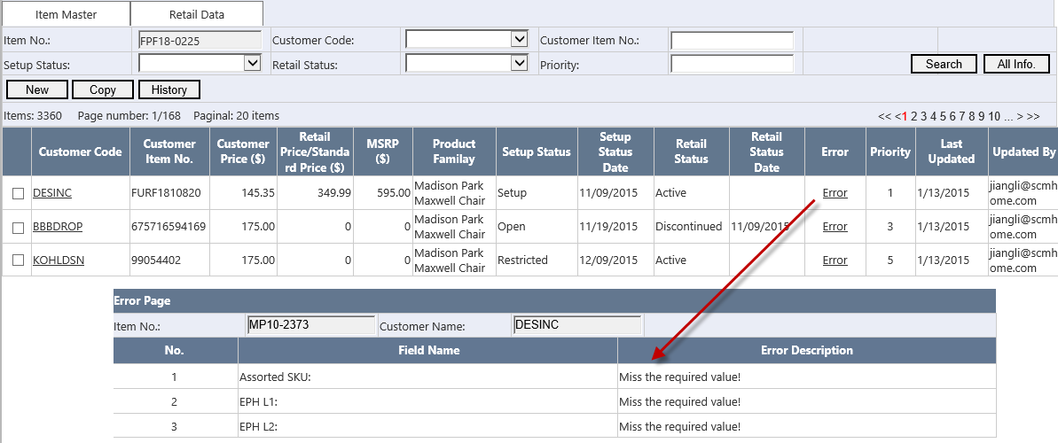
Figure 9-2

How to Maintain Field Value
- Click New Ecom Maintenance Field Value to open Field Value page. For any field name having the drop down list, you must maintain the value here.
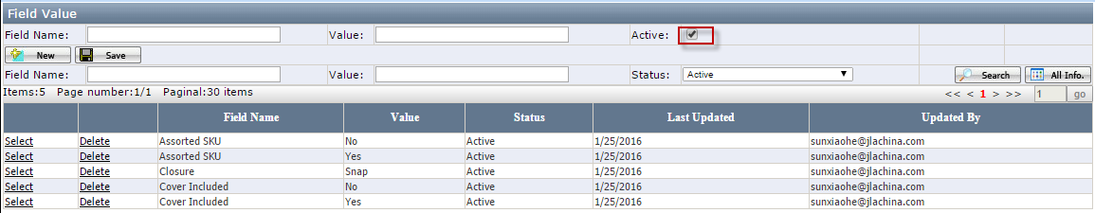
Figure 10-1
- Click New and type the field name has been existed in Field Name page or type partial field name and select from the drop down list, enter the Value and click Save. If the Field Name does not existing in the drop down list, please send your request to eechelpdesk@syncsoftinc.com . EEC Help Desk will add them in Field Name page.
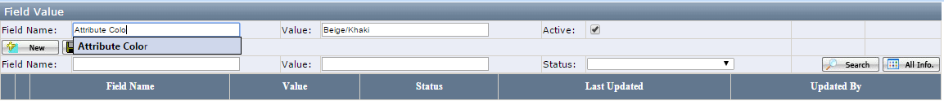
Figure 10-2
Notes:
- Value: It is not allowed to duplicate in the same Field Name.
- Active: If it is not used, please uncheck Active. That way, the drop down list of the related field name in Ecom Item Master Item DetailItem Master page will not display the inactive value.
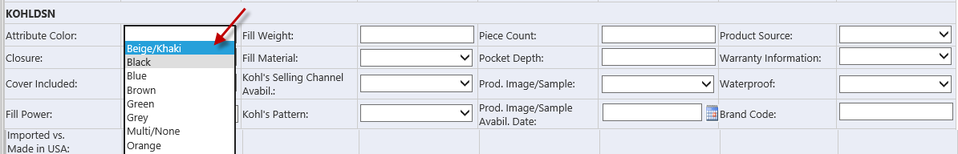
Figure 10-3

How to Maintain Setup Sheet Template
- Setup Sheet Template to open Setup Sheet Template page
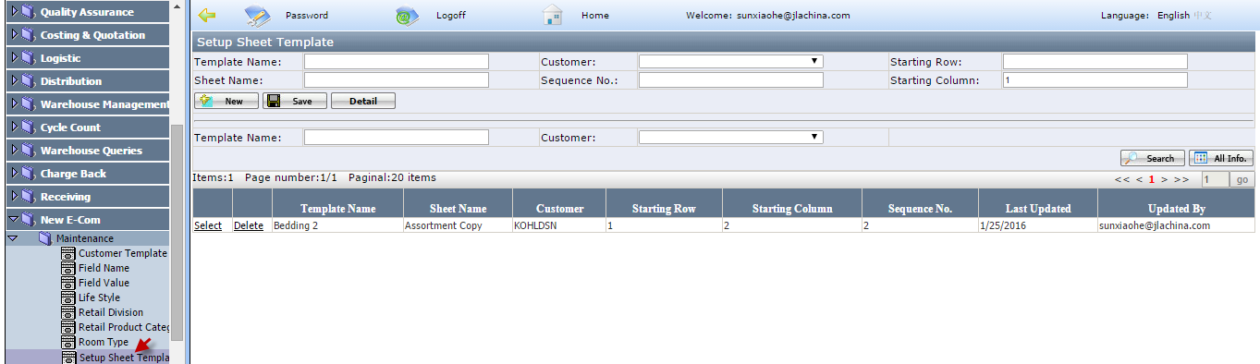
Figure 11-1
- Enter Template Name, Select Customer from the drop down list, enter Starting Row, Sheet Name, Sequence No and Starting Column No and click Save
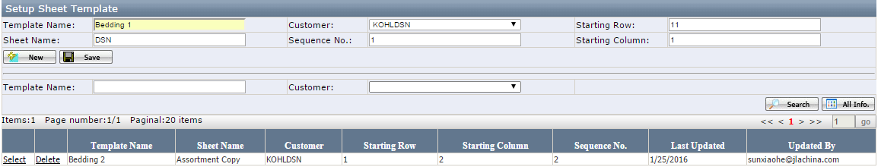
Figure 11-2
Note:
- Template Name: It is required and manual enter. It is not allowed to duplicate in the same Customer. For Kohl, since different division has the different setup sheet and one division setup sheet has multiple sheet name. For Kohldsn bedding setup sheet “Khol.com DSN Assortment” (See Figure 11-), you need to create two setup sheet templates “Bedding 1” for “DSN” and “Bedding 2” for “Assortment COPY”. (See Figure 11-)
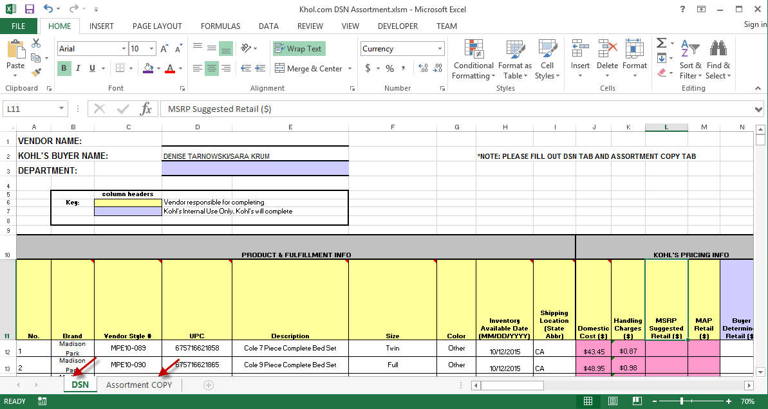
Figure 11-3
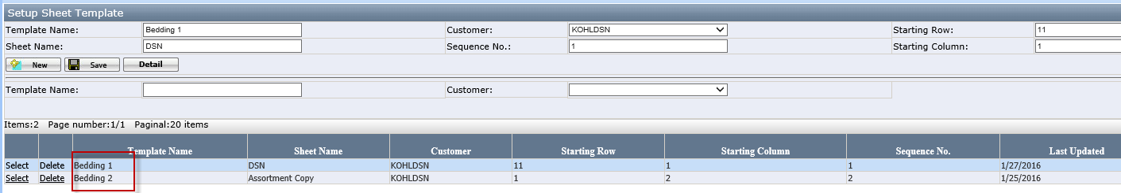
Figure 11-4
- Starting Row: It means which row starts to have column name in the Excel. E.g. For Kohldsn Bedding setup sheet template “Bedding 1”, the starting row is 11 (See Figure 11-)
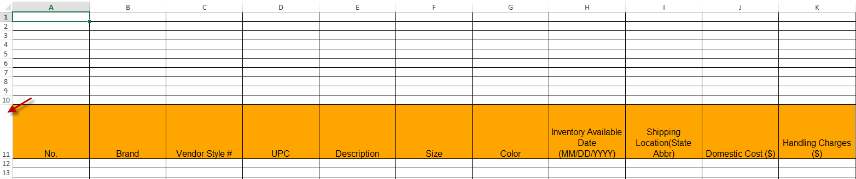
Figure 11-5

- Starting Column: It means which column starting to have item information and default to 1 such as Kohldsn Bedding setup sheet template “Bedding 1” (See Figure 11-). If original customer setup sheet has beginning hidden 2 column A and B such as BBB 2nd Form - long form.xls (See Figure 11-), Starting Column is “3”, the setup sheet preview will be like Figure 11-.
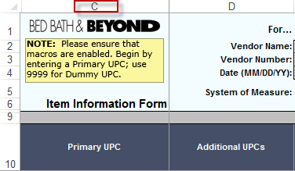
Figure 11-6
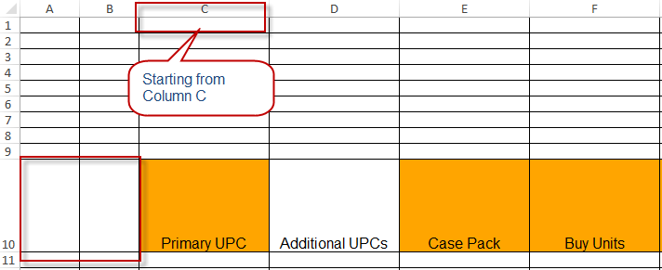
Figure 11-7
- Sheet Name: It is required and is the exported excel sheet name (See Figure 11- )
- Sequence No.: It’s the sheet sequence no shown in the exported excel if you select multiple setup sheet templates to export.
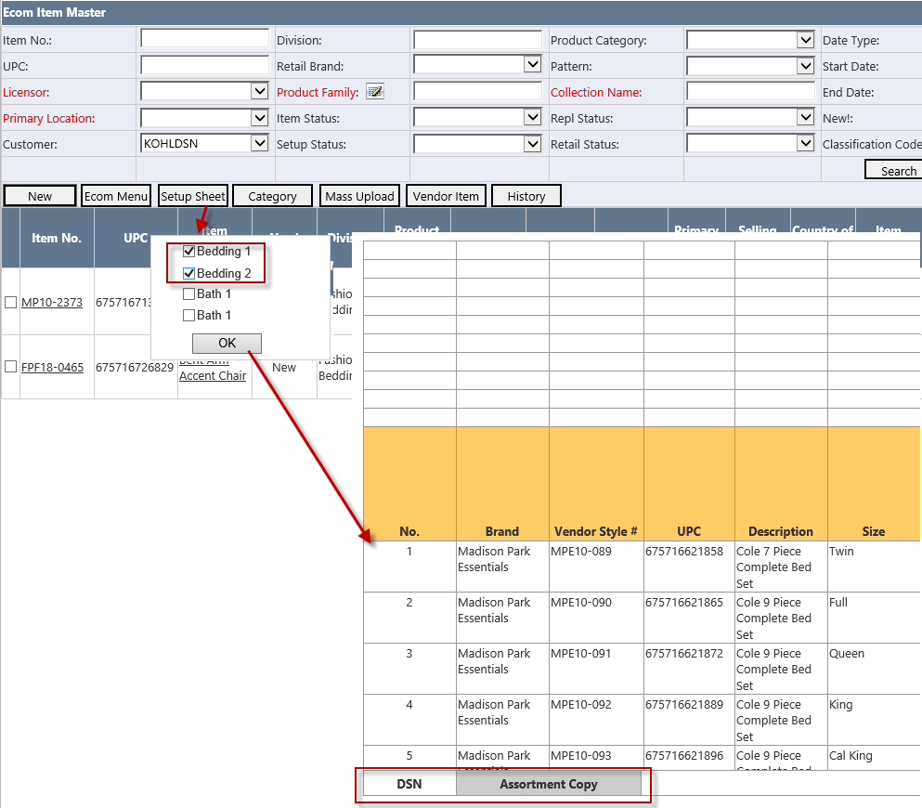
Figure 11-8

- Click Detail to open Setup Sheet Template page
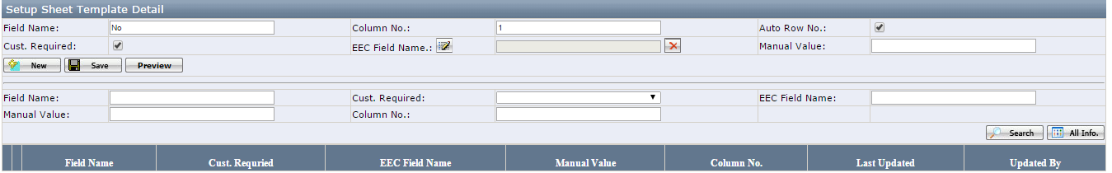
Figure 11-9
- Enter Field Name shown in customer setup sheet. User can enter any character and does not depend on configuration in the Field Name. (It is different with the Field Name in the Customer Template.)
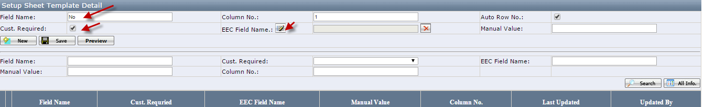
Figure 11-10
- Put a check for Auto Row No. if the field name is used to show the item count.
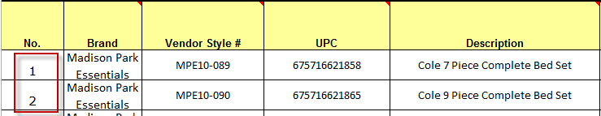
Figure 11-11
- Puta check for Cust. Required if this field is required for the customer setup sheet.
- Select EEC Field Name by clicking to open the EEC Field Name Selection page if the field name is getting from EEC specified field. In the selection page, find EEC Field Name and click Select.
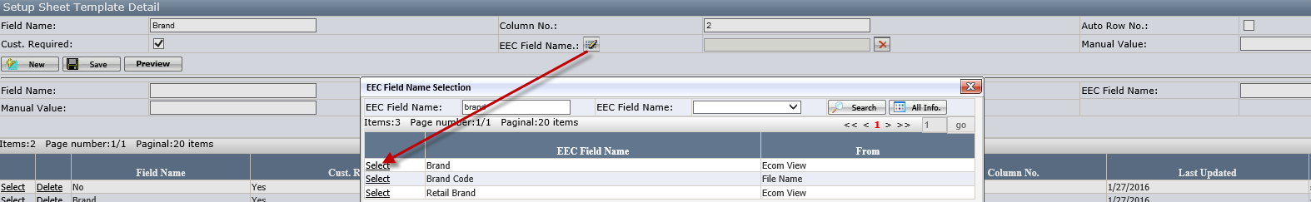
Figure 11-12
- Ecom View: It is the existing EEC fields added by EEC Help Desk. If it is missing, please send email to eechelpdesk@syncsoftinc.com
- Field Name: It is from Field Name Page.
- Enter Manual Value if the field name in customer setup sheet always has the same value such as “Yes” or “No”
For example, “Recycled and/or Organic Material” in Assortment COPY of KOHLDSN, the value is always “No”. Therefore, the user enter “No” in Manual Value. When exporting to in Assortment COPY of KOHLDSN Setup Sheet, all item have the value “No” in this field.
- Click Save to save the field name.

Note:
- Column No.: It is column no where the field name will be shown in customer setup sheet. The first field added to be template Default to 1. And will auto add 1 when user clicks New Button and allow the user to make the change
Field Name | Column No | After Delete Field B |  | After insert D with Colum No 2 between A and C
A | 1 | Field Name | Column No | Field Name | Column No
B | 2 | A | 1 | A | 1
C | 3 | C | 2 | D | 2
 |  |  |  | C | 3

- Cust. Required: If it is checked, the preview of the Field Name is highlighted in orange color in the preview (
See Setup Sheet Preview) or the exported setup sheet.

- Setup Sheet Special Cases:
- Merged Field Names: If the customer setup sheet has the merged cells in the Excel such like Kohl’s and the user has to add three field names such as “Fill Material 1”, “Fill Material 2”, “Fill Material 3” in the Detail of Kohldsn Setup Sheet Template.
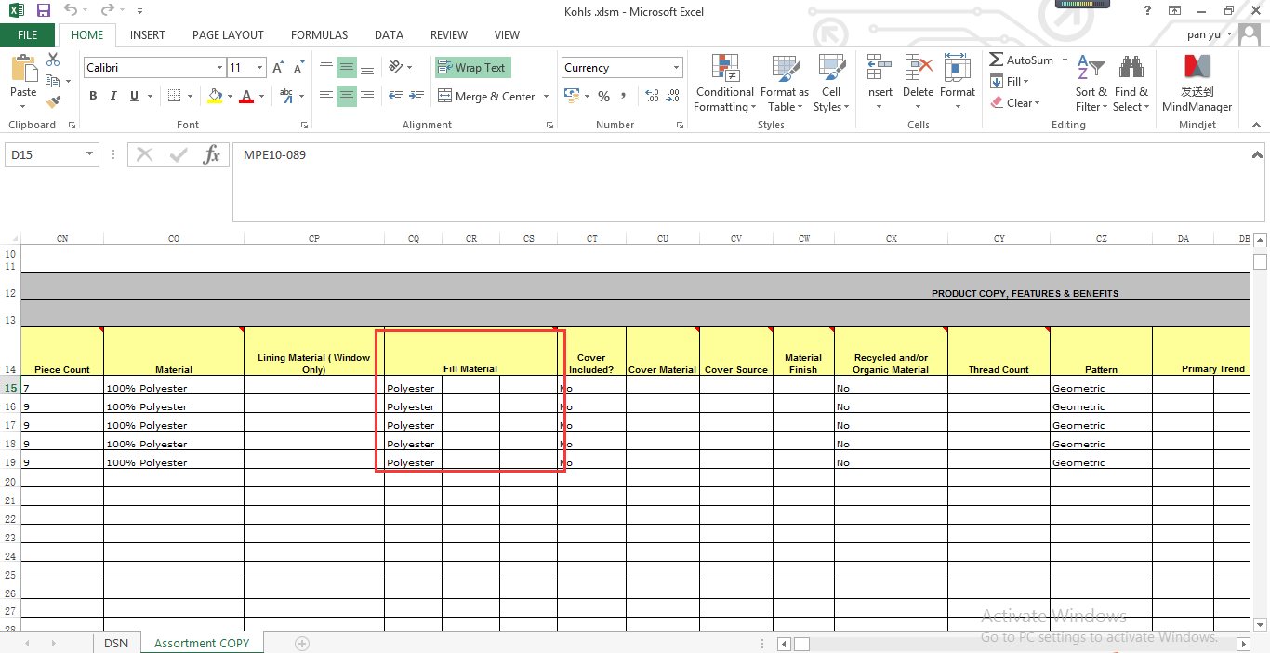
Figure 11-13
- Hidden Field Names: If customer setup sheet has hidden Fields in the Excel and the user has to add those hidden field names as well in order to have the customer to get the correct data from system generated Setup Sheet. E.g. such as BBB 2nd Form - long form for column AN (field Name “What is the Destination Country?” and column AQ (“Country”)
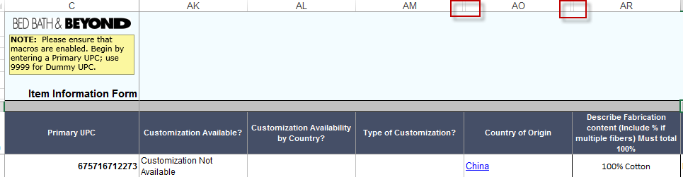
Figure 11-13
- Click Preview to preview the setup sheet
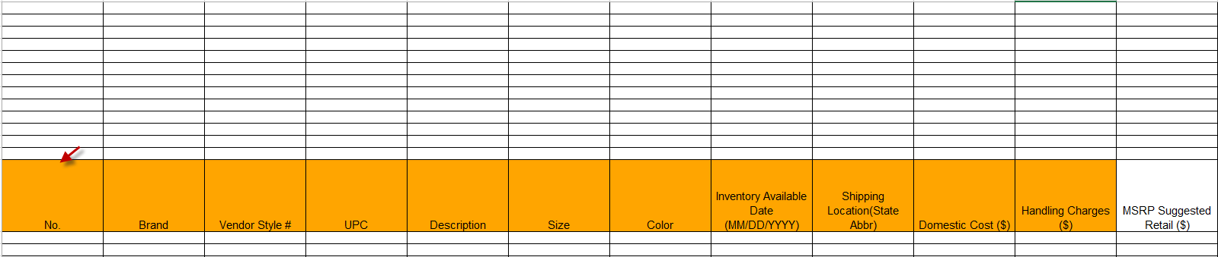
Figure 11-14

How to maintain Item Setup Rule
- Select the business unit “EComDropShip”, select Product ResourceCustomer
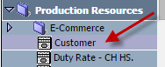
Figure 12-1
- Select the customer
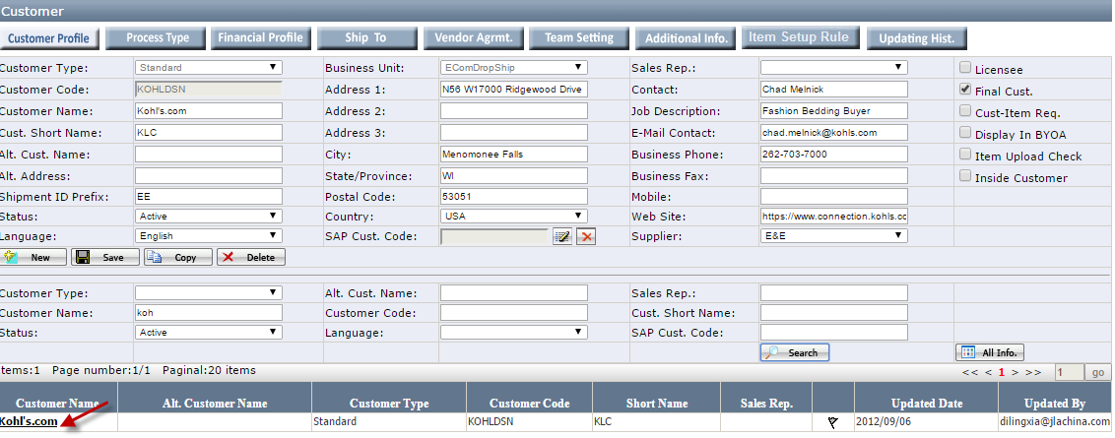
Figure 12-2
- Click Item Setup Rule
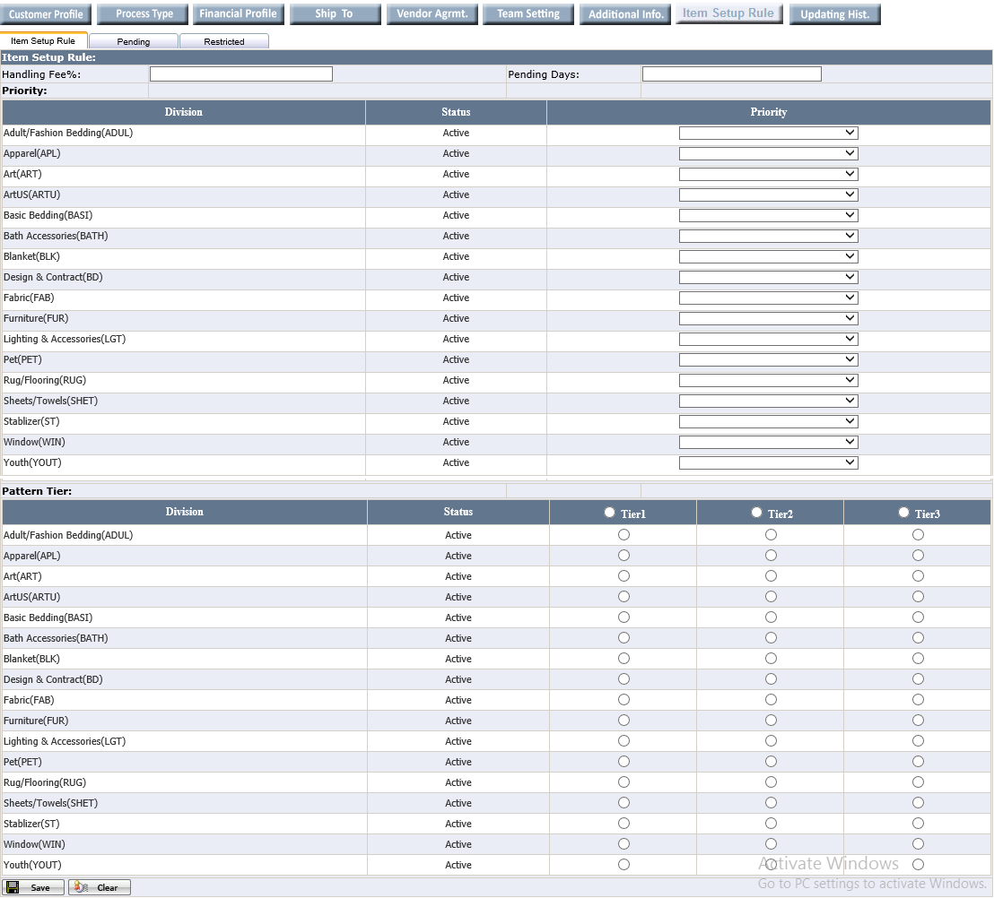
Figure 12-3
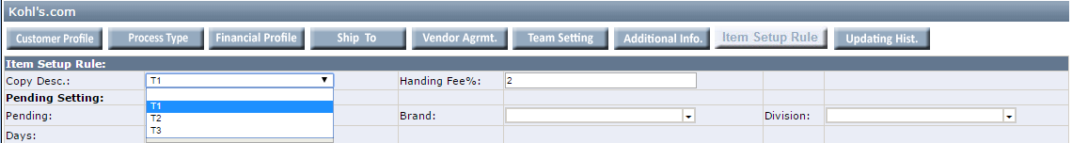
Figure 12-4
  - Priority: Set the priority for each division for the selected customer. Priority cannot be duplicated for 1 customer.
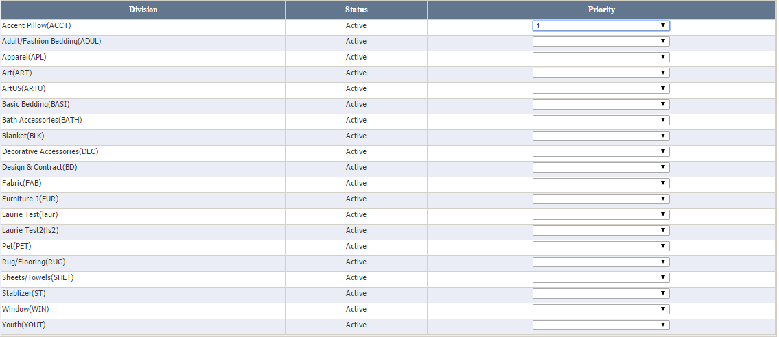
Figure 12-5
  - Pattern Tier: Set Pattern Tier for each division. For quick setting, you can put the check for Tier 1 for all division and change the each division Tier
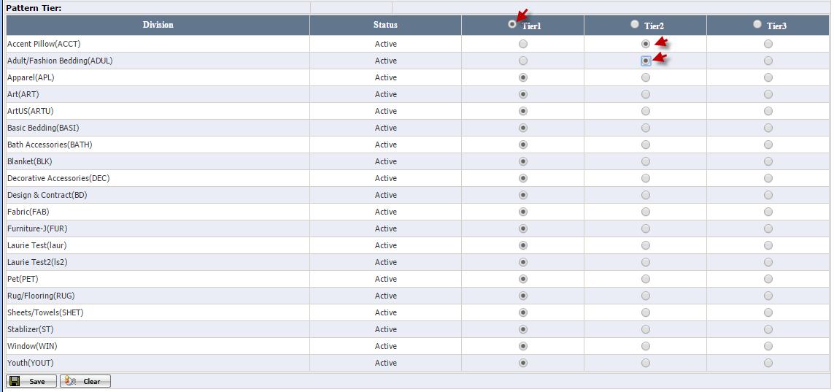
Figure12-6
  - Enter the Pending Days and enter Handling Fee%. For Kohldsn, enter 2 and Pending Days is required and default to the 180.
  - Pending Tab: Select the Pending tab and select Division, Classification Code and Retail Brand. If Days= 180, Today - Inventory Available Date > 180, EEC service will change the item setup status from “Pending” to “Open” for this customer.
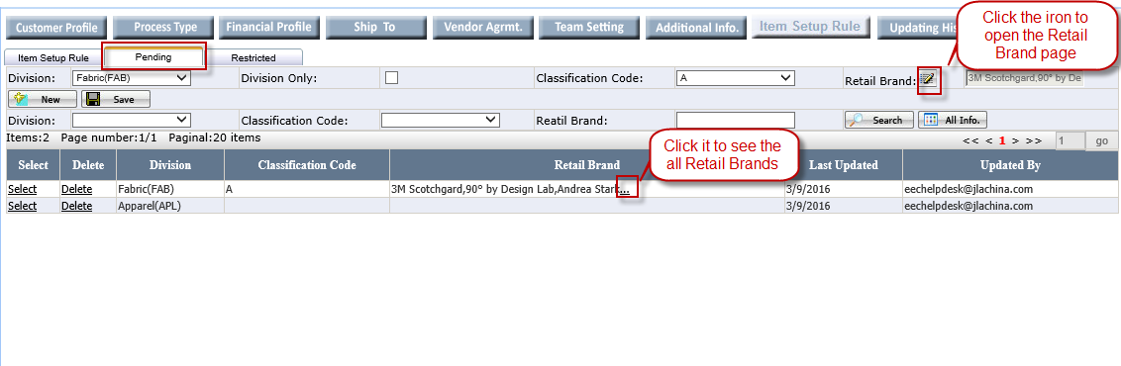
Figure 12-7
- Retail Brand: It is multiple selection. Click the iron to open the Retail Brand. The selected Retail Brand will be list in front. In the Gird, if the Retail Brand is more than 3, system will give the “…” and click the “…” to see the all selected retail brands.
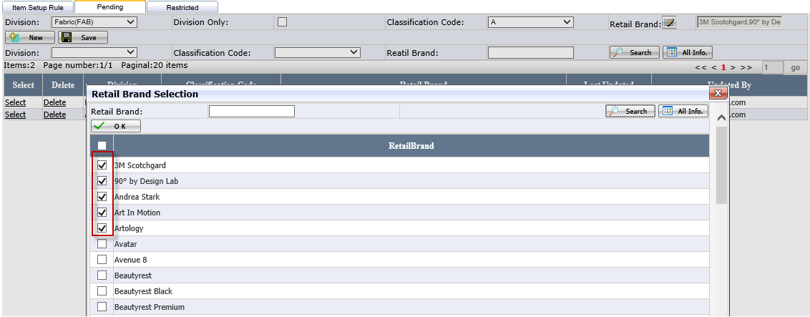
Figure 12-8
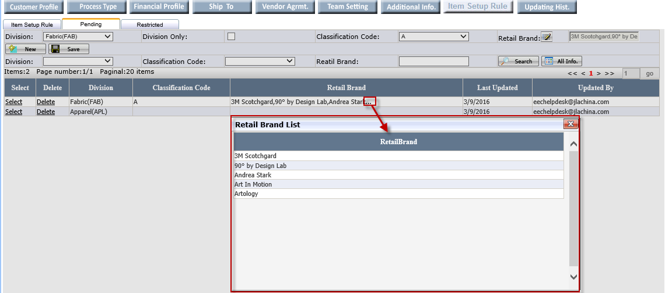
Figure 12-9
- Division and Classification Code are required and single selection.
- If putting a check in the Only Division Checkbox, system will grey out the Classification Code and Retail Brand which means set the All Classification Code and Retail Brands under the Division as Pending.
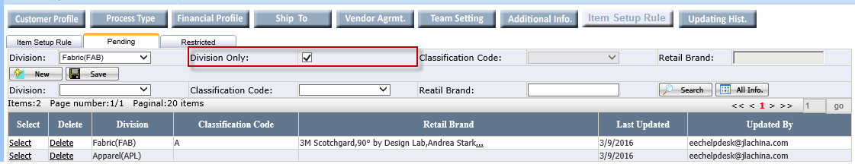
Figure 12-10
  - Restricted Tab: Select the Restricted tab and select Division, Classification Code and Retail Brand.
If putting a check in the Only Division Checkbox, system will grey out the Classification Code and Retail Brand which means set the All Classification Code and Retail Brands under the Division as Restricted.
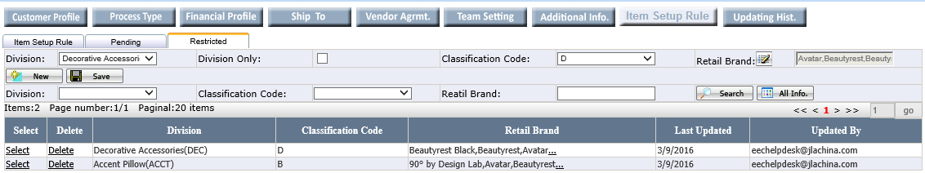
Figure 12-11
- Click Save
Notes:
  - Pending or Restricted is not allowed to duplicate and system will pop up the below warning 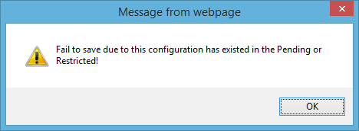
Figure 12-12
  - If the Division and Classification Code has been configured in the Pending, system will not allow to configure the same Division and Classification Code
  - The configuration for Olliix
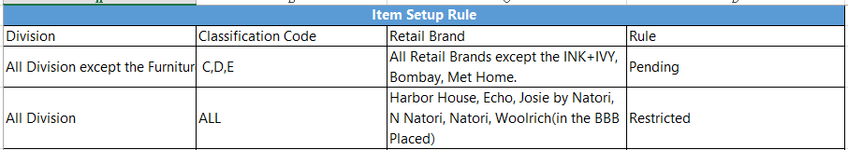
Figure 12-13
  - If the Customer is Olliix and Repl. Status is Repl., system will allow to change the Setup Status to Setup.
  - If the Customer is Olliix and want to change Setup Status to Restricted, system will auto judge whether the item has configured as Restricted in the Item Setup Rule Page and BBB Placed is checked. Only safety the both conditions can change the Setup Status to Restricted.

How to Maintain Life Style
- Click New E-com Maintenance Life Style
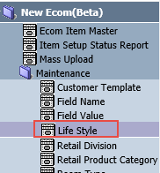
Figure13-1
- Users can new/edit/delete Life Style Name and Life Style Description here, it’s a property of the Ecom Item, the Life Style data in the Item MasterCategory is from here, refer to Figure3-6.
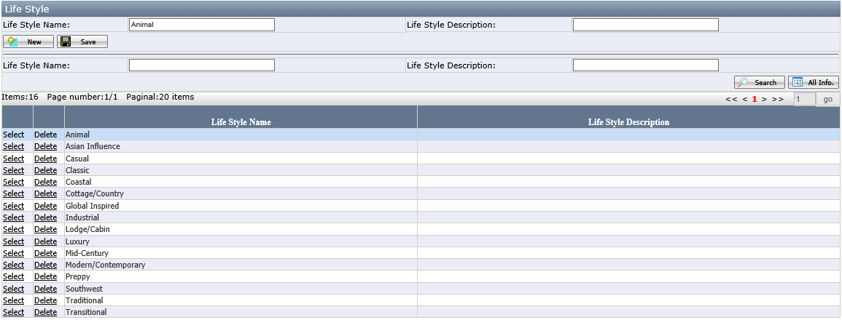
Figure13-2

How to Maintain Room Type
- Click New E-com Maintenance Room Type
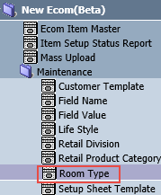
Figure14-1
- Users can new/edit/delete Room Type Name and Room Type Description here, it’s a property of the Ecom Item, the Room Type data in the Item MasterCategory is from here, refer to Figure3-6.
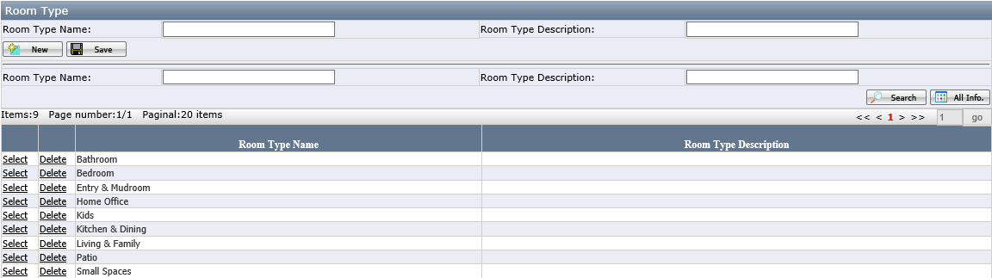
Figure14-2

How to Maintain Retail Division
- Click New E-com Maintenance Retail Division
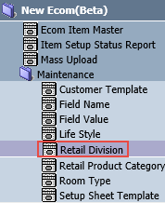
Figure15-1
- Users can new/edit/delete Retail Division Name and Retail Division Description here. The Initial data is from Division. Retail Division is a property of the Ecom Item, the Retail Division data in the Item MasterCategory is from here, refer to Figure3-6
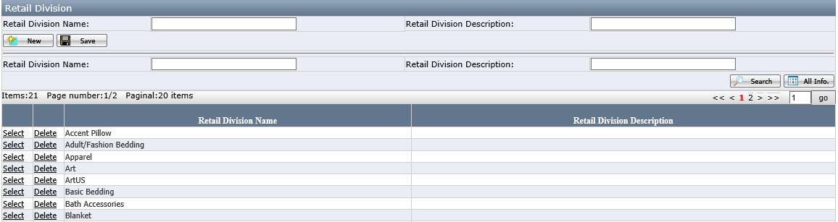
Figure15-2

How to Maintain Retail Product Category
- Click New E-com Maintenance Retail Product Category
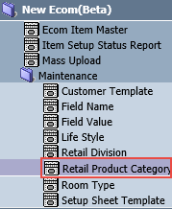
Figure16-1
- Users can new/edit/delete Retail Product Category Name and Retail Product Category Description here. The Initial data is from Product Category. Retail Product Category is a property of the Ecom Item, the Retail Product Category data in the Item MasterCategory is from here, refer to Figure3-6
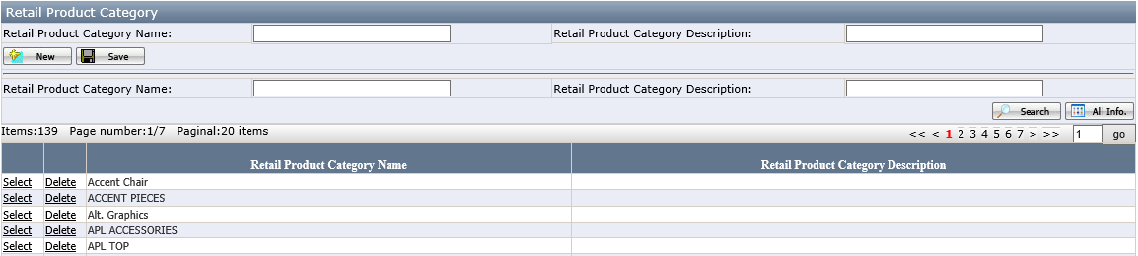
Figure16-2

