Q: Carton contents label didn’t print out after the regular carton label for the order.
A: Setup the customer in customer profile to print the content label.
Step1:
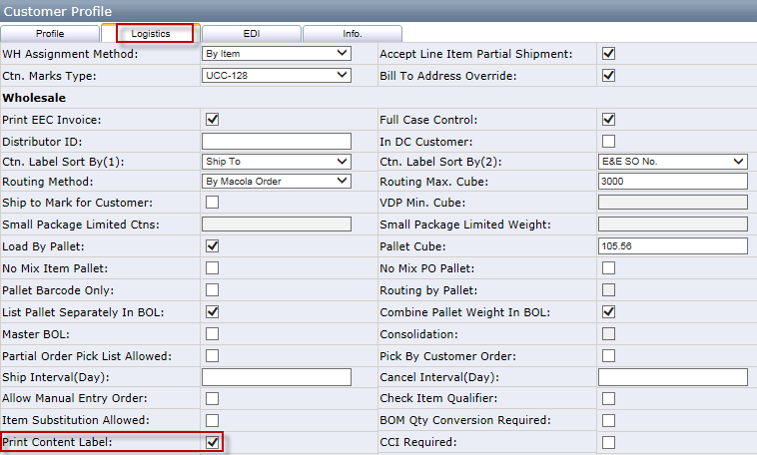
Step 2:
