New Conveyor System
Configuration screen in EEC
The following configuratoin page is under EEC/Maintenance/ Warehouse Conveyor Mgt
- Lane Assignment:
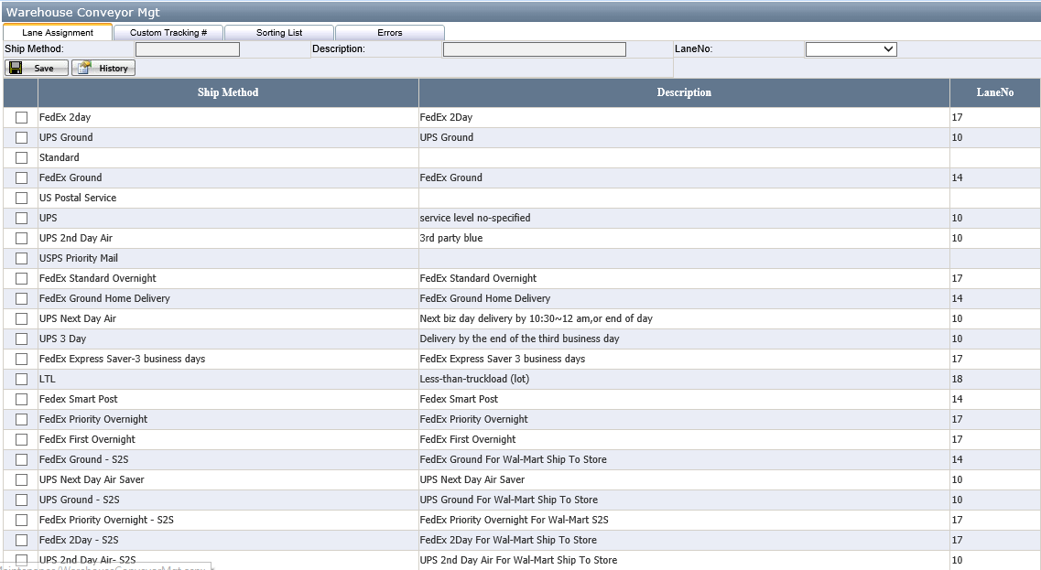
User can assign the logical lane no. to each Ship Method. This logical lane no. will send to Warehouse Control System (by Dematic) along with the carton. This will be used by WCS to route the container to the proper shipping lane. The logical lane will be mapped to a physical lane through the WCS user interface.

- Custom Tracking #:
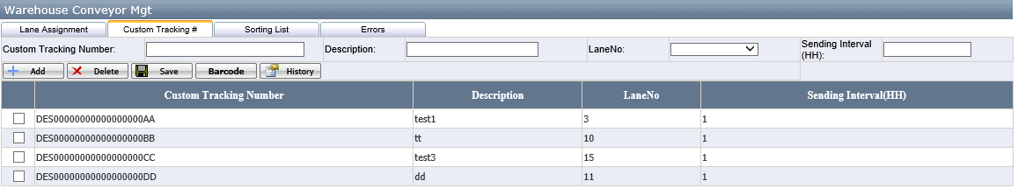
User can add/edit/delete Custom Tracking # and assign the logical lane no. to them. If user set 2 for the field Sending Interval (HH), it means the Custom Tracking # will send to WCS at 2-hour intervals. If user adds any new or edits the existed Custom Tracking #, the Custom Tracking # information will send to WCS immediately.

- Sorting List:
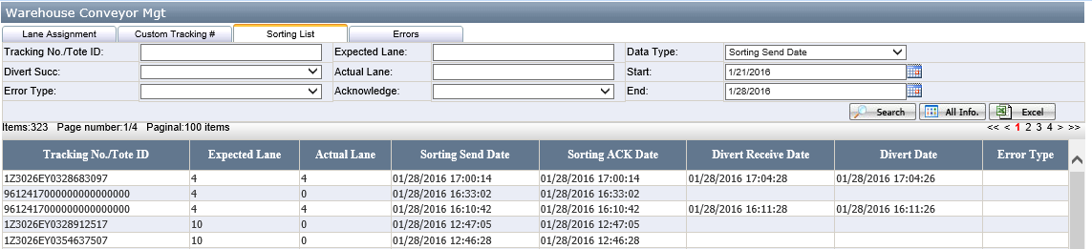
User can search the carton send/divert inforamtion based on the fields in the search critiria:
Tracking No./Tote ID | Tracking No./Tote ID
Expected Lane | The logical lane no.
Data Type(Start/End) | User can search the carton based on the start and end time of Sorting Send Date, Sorting ACK Date, Divert Receive Date and Divert Date.
Divert Succ | Yes, No. it means if the carton is diverted successfully.
Actual Lane | The phyiscal lane where the carton diverted.
Error Type | All possible error types:  NoRead  NoCode  MultiLabel  Untranslatable  MaxRecirculation  UPCNoMatch  Start Server Error  Stop Server Error  No Response Error  Send Limitation Error  Parsing Message Error  No Tracking No. Error
Acknowledge | Yes, No. it means if receive ACK from WCS for the certain carton.

It lists the following information related to carton’s status in this Sorting List Page:
Tracking No./Tote ID | Tracking No./Tote ID
Expected Lane | Logical lane no
Actual Lane | The phyiscal lane where the carton diverted.
Sorting Send Date | When the carton information send to WCS.
Sorting ACK Date | When receive the ACK from WCS for the certain carton.
Divert Receive Date | When receive the carton divert confirmation from WCS.
Divert Date | When the carton diverted in the WCS.
Error Type | The error type when diverting the carton.
- Errors.
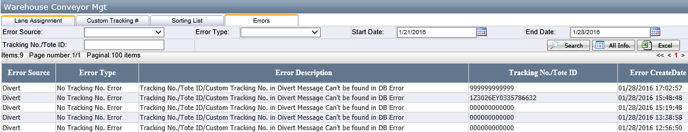
User can search errors happened on carton sorting and divert process based on the following fields in the search critiria:
Error Source | The error happened on which Server: Sorting Server or Divert Server
Error Type | All possible error types:  NoRead  NoCode  MultiLabel  Untranslatable  MaxRecirculation  UPCNoMatch  Start Server Error  Stop Server Error  No Response Error  Send Limitation Error  Parsing Message Error  No Tracking No. Error
Start Date/End Date | The date period when the error happened.
Tracking No./Tote ID | Tracking No./Tote ID

It lists the following error information in this Errors Page:
Error Source | The error happened on which Server: Sorting Server or Divert Server.
Error Type | Error Type
Error Description | Error Description
Tracking No./Tote ID | Tracking No./Tote ID
Error Created Date | When the error happened.

- EEC Conveyor System Service Controller
  - Sorting Server
The following Sorting Server is always open to send carton information to WCS.
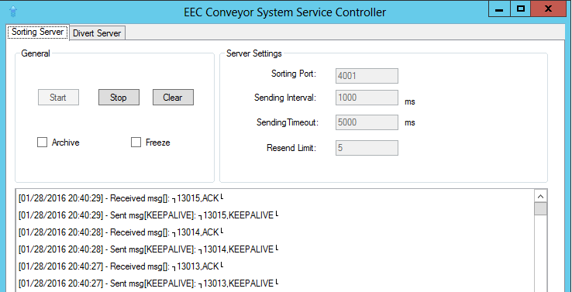
  - Divert Server
The following Divert Server is always open to receive the carton divert confirmation message from WCS.
