Label Application User Guideline
Version: 1.0 9-29-2015.

How to log into EEC
- In IE browser, type EEC address: https://eecsystem.cn
- In EEC Login Page, type your User Name, Password and Check Code. (See Figure 1-1). EEC Helpdesk will send you user name and password if you do not have an account. If you have a user ID but forgot the password, please click Forgot Your Password to reset your password.
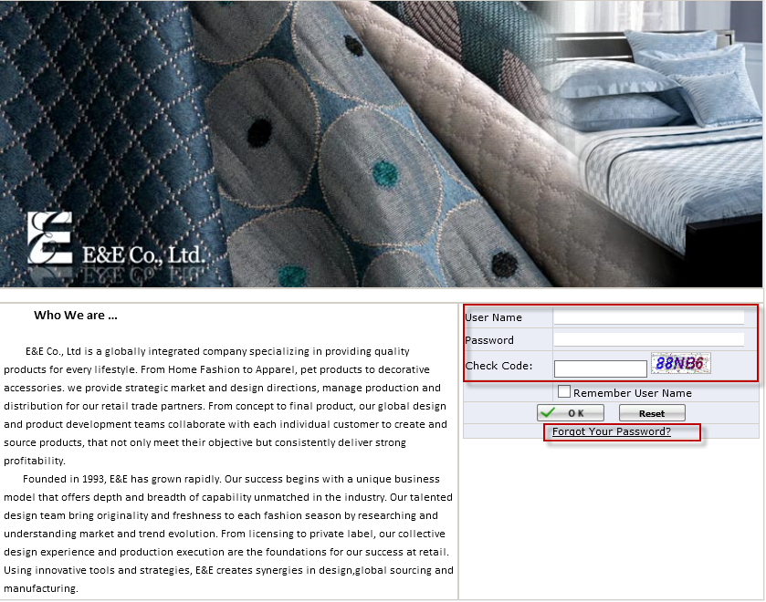
Figure 1-1 EEC Login Page

Label Application Overview
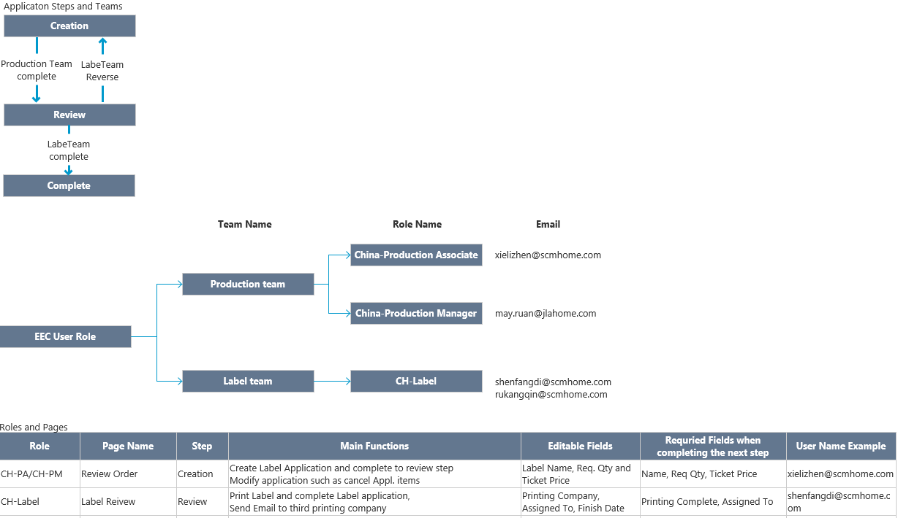
Figure 2-1 Roles and Teams and Main funcitons

How to create a Label Application (Production Team）
- Click Review Order under Production Management to Open Review Order Page. (See Figure 3-1)
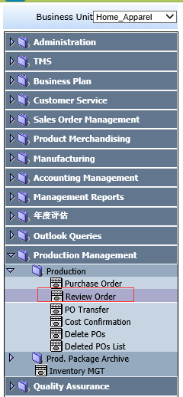
Figure 3-1 Review Order Page Path
- Put a check for a PO and Click New Label (See Figure 3-2).
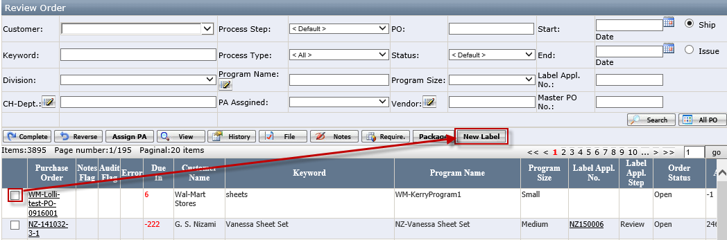
Figure 3-2 Review Order Page

Note:
- If the PO is missing the Vendor, the user cannot create new application and system will pop up the warning message as below.
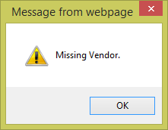

- Master PO must be change if the new split order having a different vendor (See Figure 3-3 or See How to modify Master PO Page.) If Label Application created before Master PO correction and its step is not Cancel, system will give the warning (See Figure 3-4).
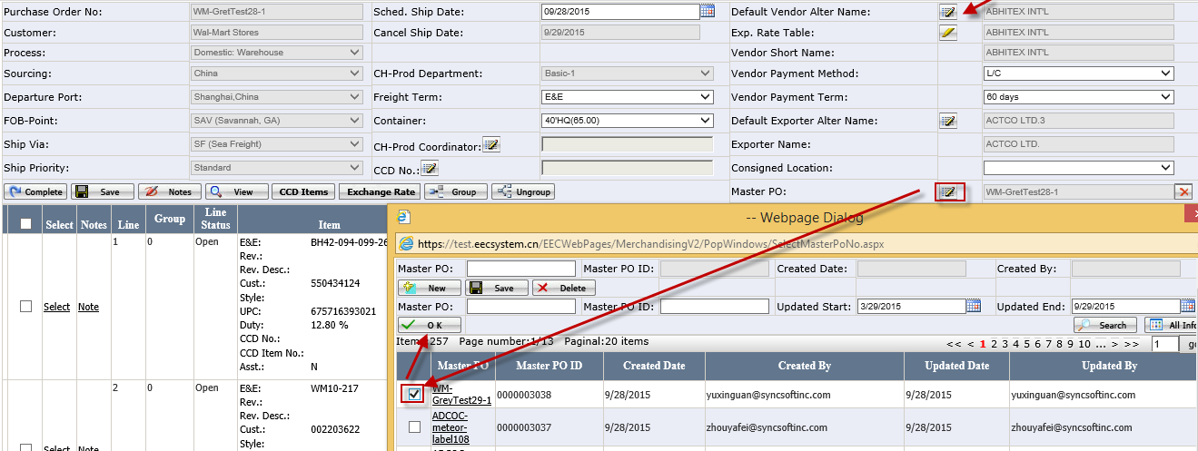Figure 3-3

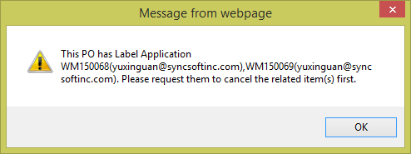
Figure 3-4

- It will open Label Application Page. (See Figure 3-5) (See Appendix A for Label Application Page Layout Introduction)
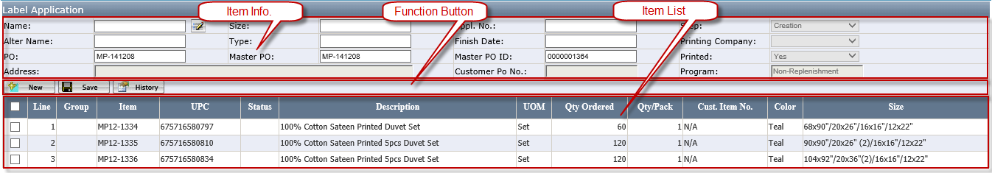
Figure 3-5 Label Application Page

- Click the Pencil iron near to Name to open Label Name selection Page (See Figure 3-6 Name Selection Page) and click Label Picture to select the Label name and also return to Label Application Page and click Save (See Appendix C for Label selection Page Layout Introduction).
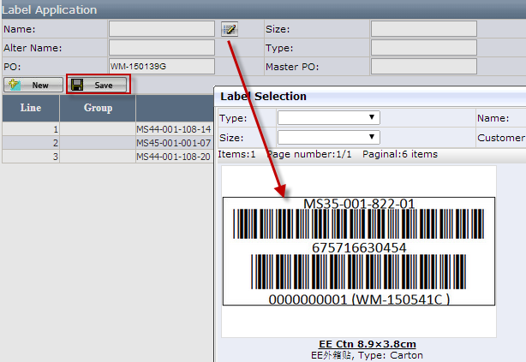
Figure 3-6 Name Selection Page

- Label Selection will auto filter label according to Customer and PO Program.
- Label will be configure Customer and PO Program in the Label Name. ( (See Appendix F: Label PDF Page Layout Introduction.)
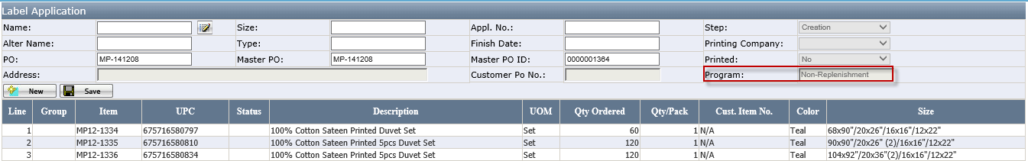

- Master PO: (See Master PO in Purchase Order). For EE Ctn Label, please double check Master PO before submitting the label application to barcode team since Master PO is used in the each item label (See Figure 3-8) . If the same label name for the same Master PO has been created, system will give the message “There is Label Application (PO: WM-150139G Appl. No: WM150029) existing for the same master PO WM-150139G and the same Label Name. Are you sure to continue?” to prevent to submit the duplicated label application due the split order (See Figure 3-7). If the user click OK, it will continue to create the label application. Otherwise, it is cancelled。
In principle, if the order is split, Master PO will add the “-No.”, e.g. HG-151209-1 and the field before “-No.” will be equal to PO. If the order is not split, Master PO=PO.
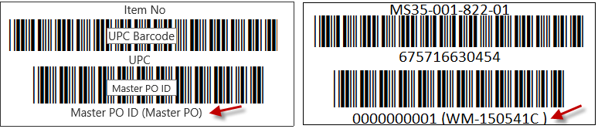
Figure 3-7 EE Ctn Label: Having Master PO ID and Master PO
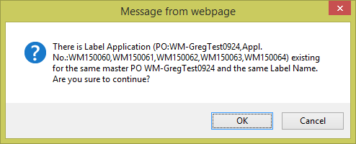
Figure 3-8

- Initial Req. Qty = Qty Ordered ÷ Qty/Pack. If there is a remainder, Initial Req. Qty= Integer of [Qty Ordered ÷ Qty/ Pack] + 1.
- User can click Initialization to set all items initial Req. Qty. In Initialization Page, the user enters Ratio and click OK (See Figure 3-9). System will auto calculate the Req. Qty accordingly (See Figure 3-10). Req. Qty = Qty Ordered × Ratio ÷ Qty/Pack. If there is a remainder, Req. Qty= Integer of [Qty Ordered ÷ Qty/ Pack] + 1. The user can further modify initialized Req. Qty and click Save.
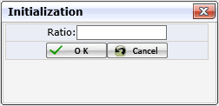
Figure 3-9 Initialization Page

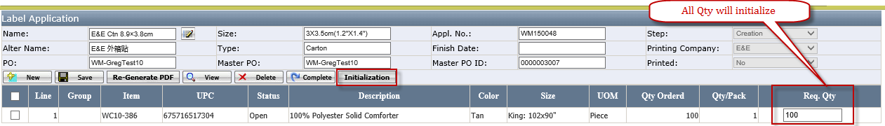
Figure 3-10 System auto calculates Req. Qty = Qty Ordered × Ratio ÷ Qty/Pack

- Ticket Price only shows when the selected label has Ticket Price requirement. (See Figure 3-11).
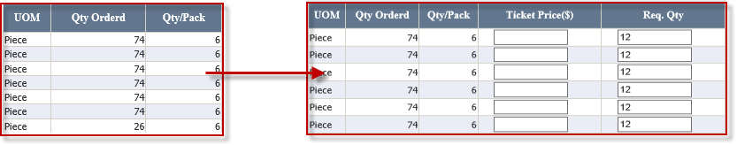
Figure 3-11

- If the Label configures Address, the Address Button will appear in the Function Button. (See Appendix F: Label PDF Page Layout Introduction.)
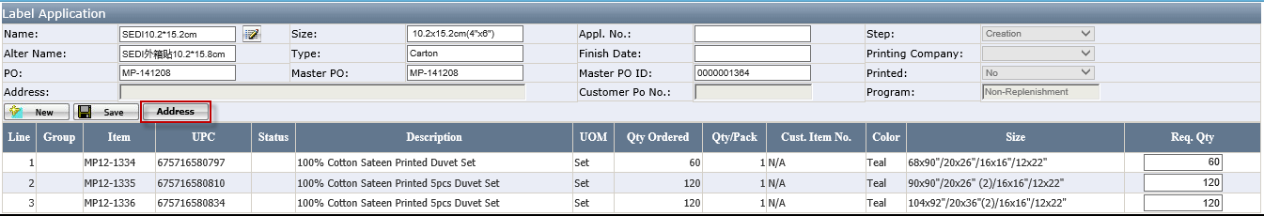
Figure 3-12

Address Maintenance: User can use new and modify Address here, Full Name and Address are required.
- Click Full Name to select Address.
- Check Checkbox and click Ok Button to choose the Address for label.
- Address list will auto fitter according to Customer.
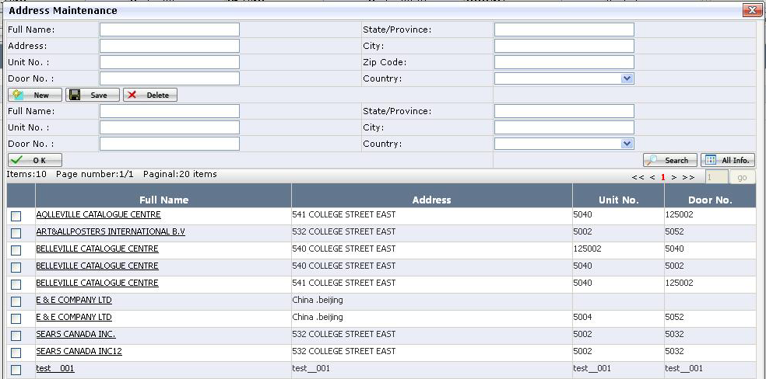

If the Full Name, Address, Unit No., Door No both are the same, system will pop up the warning
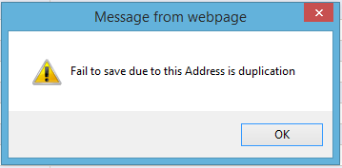

- Click Gen File to create Label PDF file and click View to preview how the Label looks like in advance (See Appendix E: Label PDF Page Layout Introduction.) Please double check UPC, Item No, Ticket Price, Master PO and Master PO ID etc. since the Label PDF file will be sent the third printing company if each item req. qty >=2000. If the user does not click Gen File, the application complete to next step “Review”, system will automatically generate it.
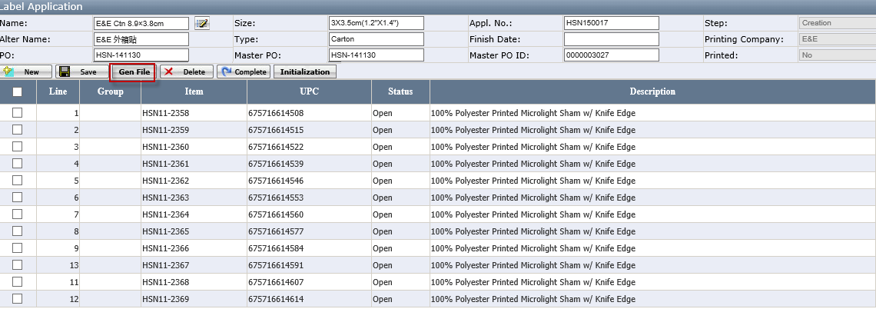
Once Label PDF file is generated, the button will automatically change to Re-Gen File. If any item is cancelled, the previous generated PDF file will deleted. The user need to click Gen File to create a new Label PDF file if they want to preview it by click View (See Appendix E: Label PDF Page Layout Introduction.)
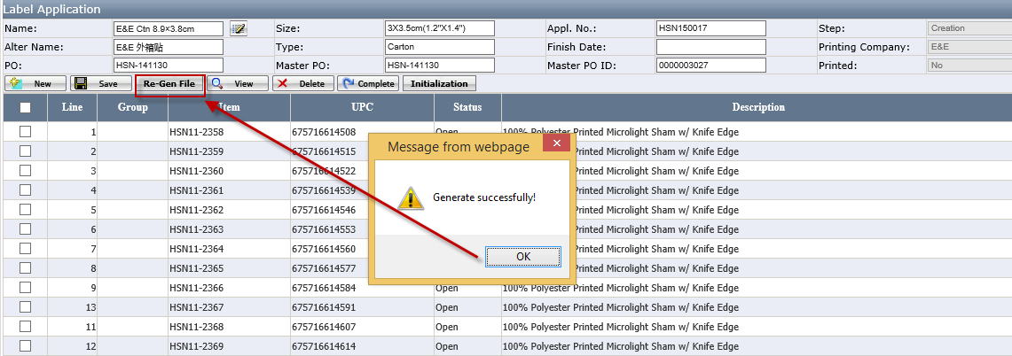

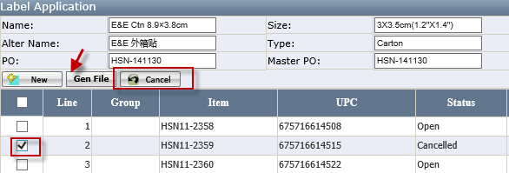

- If UPC is wrong, please delete/cancel application first. Then, request UCT Team to correct from PO and click Save again and click Gen File to generate a new PDF file.
- If Ticket Price is wrong, please change Ticket Price and click Save again and click Re-Gen File
- If Master PO and Master PO ID is wrong due to the new split order having the different vendor, please delete/cancel the Label Application and correct Master PO in the review order page (See Change Master) and then click New Label to create a new label application.

- Click Complete to submit the application. The application status will be changed from Creation to Review.
- Once the application is successfully completed, you can click View to how the printed label look like in PDF file (See Appendix E: Label PDF Page Layout Introduction.)
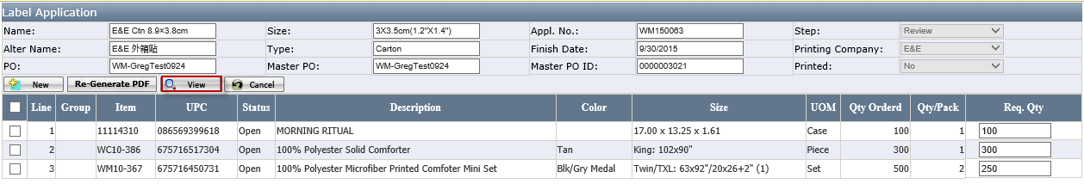
Figure 3-13

- After the application is submitted, if finding some item information is wrong, the user can select items and clicks Cancel to cancel some items.
- Or send email to barcode team bc@scmhome.com to request them to reverse the application.
- Once the item is cancelled, the item Status will change from Open to Cancelled. (See Figure 3-14 ) and system will also auto send Email to notify the related persons (See Figure 14-1 Email for Cancelled items). If the item is cancelled before printing, the barcode team will not print the cancelled items.
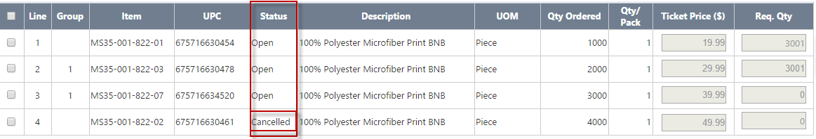
Figure 3-14 Item Status

- If the application is created wrongly, the user can click Delete to delete the whole application (See Figure 3-15). Delete is only visible when the application step is in Creation step.
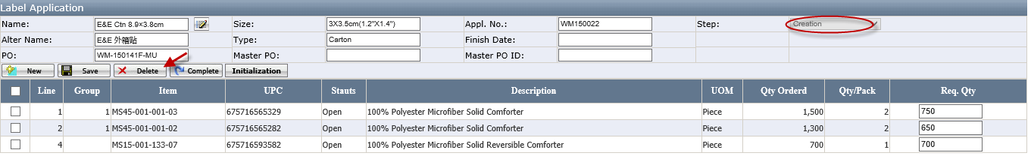
Figure 3-15 Delete the application

- Once the label is printed, you will get the email to request you to pick the label next day. (See Figure 14-2 Email for Complete). If the labels is printed by third printing company, you will get the third party email. (See Figure 14-3 Email for the third printing company )

How to Print Label (Label Team)
- Click Label Review under Label Mgt. to Open Label Review Page (See Figure 4-1)
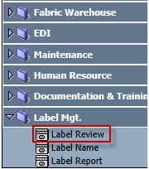
Figure 4-1Label Review Page Path

- Click the Appl. No to open the Label Detail Page (See Appendix B for Label Review Page Layout Introduction)
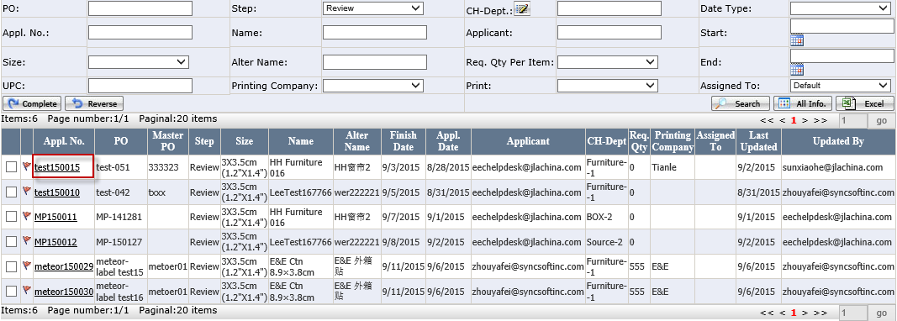
Figure 4-2 Label Review Page

- It will open Label Detail Page (See Appendix D for Label Detail Page Layout Introduction)
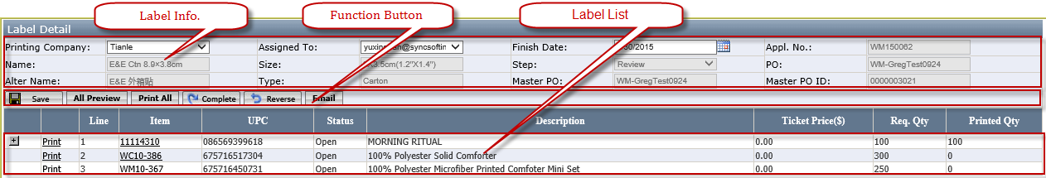
Figure 4-3 Label Detail Page

- Select Printing Company and Assigned To
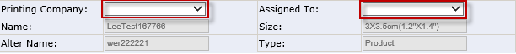
Figure 4-4

- Click Save and other Buttons will appear. System will not allow to save and will appear * unless Printing Company and Assigned To has been selected.
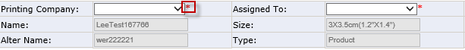
Figure 4-5

- Click All Preview to review all Labels (See Appendix E: Label PDF Page Layout Introduction.) OR click Item No can view each item PDF Label (See Figure 4-6)

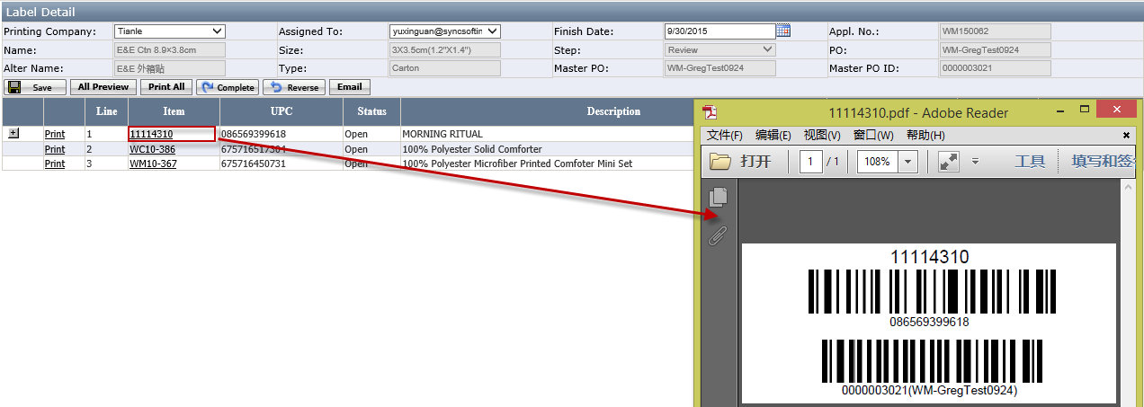
Figure 4-6 One item PDF Label

- Print all item labels click Print All (See Appendix E: Label PDF Page Layout Introduction.) To print an individual item, click Print. In open Print Label Page Enter/modify New Print Qty and click Print.
- The Initial value of New Print Qty = Req. Qty – Printed Qty. If Initial value is < 0, system will auto set New Print Qty to blank and the user has to enter New Print Qty.
- If the sum (=New Print Qty + Printed Qty) > Req. Qty, system will give the warning message “The summary of Printed Label is over the Req. Qty, Are you sure to continue?" when click Print. If you click OK, it will print.
- Click Next to move to the next tem and click Prev to move to the preview item. It the previous item or next status is Cancelled, system will auto skip it. When the selected items is successfully printed, it will auto move the next item whose status is not Cancelled.
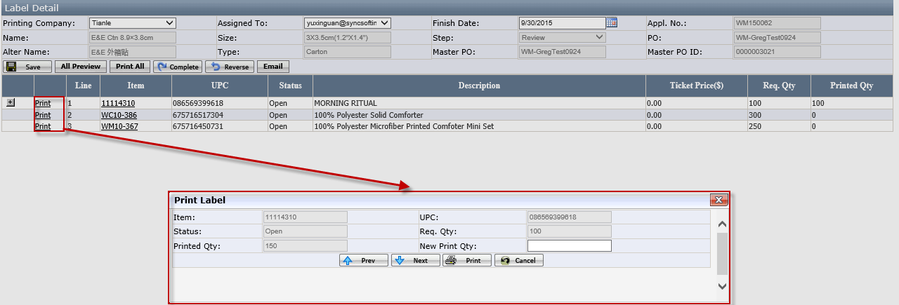
Figure 4-7

- If Printing Company is the third printing company, click Email to send the label print request email with PDF.
Figure 4-8

- Once the label application is successfully printed, click Complete and system will auto send the complete email to the applicant (See Complete Email)

If the Printing Company is the Third Vendor, click Complete and system will auto pop up Enter Print Qty Page.
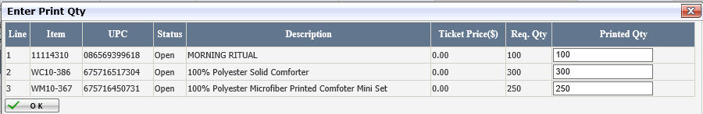
OK: It is the same as the Complete Function.
- Click Reverse to reverse application from review to creation step if label applicant request to modify the applicant information.

How to upload a Label Name (See Appendix F: Label Name Layout Introduction.)
- Click Label Name under Label Mgt. to Open Label Name Page (See Figure 5-1)
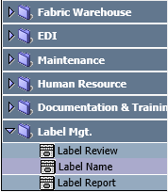
Figure 5-1 Label Name Page Path
- It will open Label Name Page
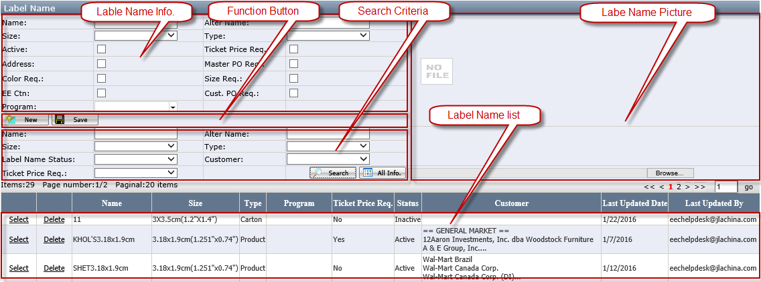
Figure 5-2 Label Name
- Enter the Name, Size, and Type. Alter Name, Customer is optional.
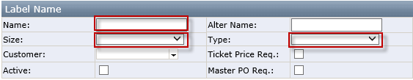
Figure 5-3

- If Label Name is EE Ctn 8.9x3.8 (3.5”x1.5”), put a check for Master PO Req.
- If Ticket Price is required, put a check for Ticket Price Req.
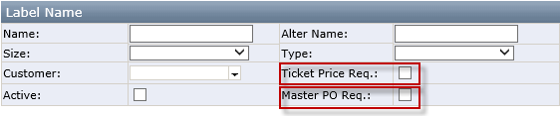
Figure 5-4

- If Color and Size is required, put a check for Color Req. and Size Req.
- If Address and Cust. PO Req. is required, put a check for Address.
- If put a check for EE, user can configure Program.
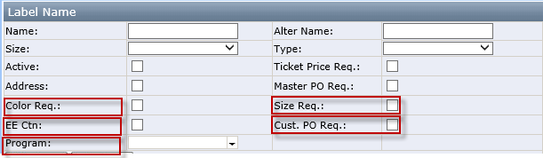

- Click Browse to upload a Label Picture
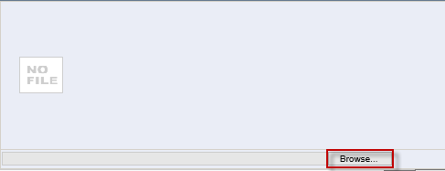
Figure 5-5

- Click Save and once saving successfully, system will give below message.
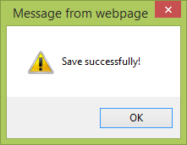
Figure 5-6

Master PO in Purchase Order (UCT Team)

Master PO in Purchase Order
- Click Purchase Order under Production Management to Open Purchase Order Page.(See Figure 6-1)
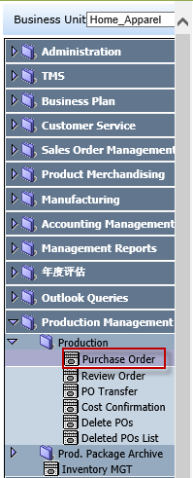
Figure 6-1 Purchase Order Page Path

- Master PO is used to solve the problem that if the E&E PO is split, printed EE Ctn. labels do need to be reprint (See Figure 6-2)
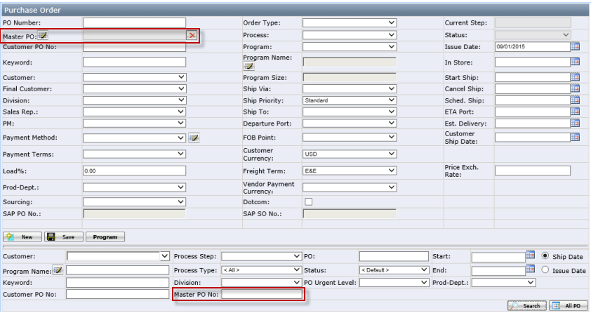
Figure 6-2 Master PO

- In Home-Apparel and Canada business unit, when the user clicks New button for Order Type is Domestic: Warehouse or Intl.- Domestic: Warehouse, to create PO, once it is successfully Save, system auto sets Master PO = PO No.
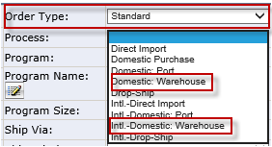
Figure 6-3

- Click the Pencil Iron to open the Master PO Page to change Master PO (See Master PO Page) by put a check for Master PO and click OK (See Master PO List ). To clean the wrongly selected Master PO, you can click the X to. (See Figure 6-4). Pencil Iron is hidden for order when order status is partial shipped, ship complete, complete.
Figure 6-4

- When the user click Delete in Purchase order Page, system will auto send email to the related applicant and barcode team (See Figure 14-4 Email for delete in Purchase Order or Delete POs Page)
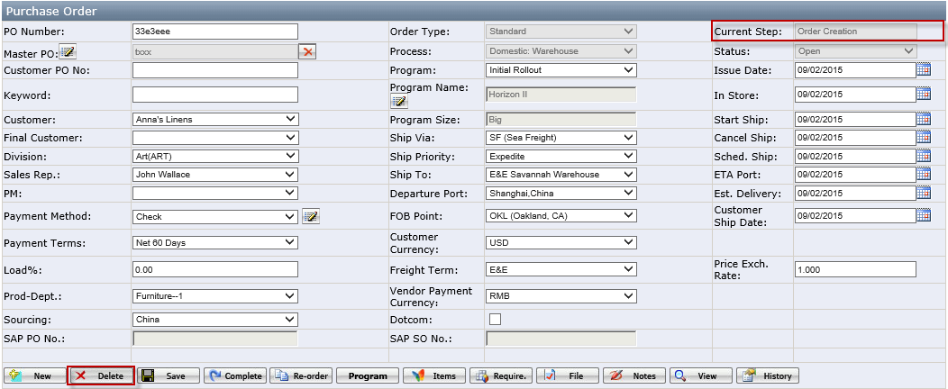
Figure 6-5

- Click Re-order and system will auto copy original Master PO.

Notes:
- If it’s replenish order, please change Master PO manually after Re-order
- Due to the vendor changes, please change Master PO manually after Re-order. Due to other reason excluding vendor changes, do not need to change Master PO.
E.g. If PO WM-150541C is split into PO WM-150541C, PO WM-150541C-1 due to vendor changes, Master POs needs to be different. Otherwise, our warehouse will have the difficult to receive and decide which vendor has the discrepancy
- In principle, if the order is split, Master PO will add the “-No.”, e.g. HG-151209-1 and the field before “-No.” will be equal to PO. If the order is not split, Master PO=PO.

How PO affects the Label Application
- If the PO is cancelled or deleted after the application is created, when UCT cancelled/delete PO, it will auto cancel the related label application (See Figure 6-6) and send the email to the related team (See Figure 14-1 Email for Cancelled items).
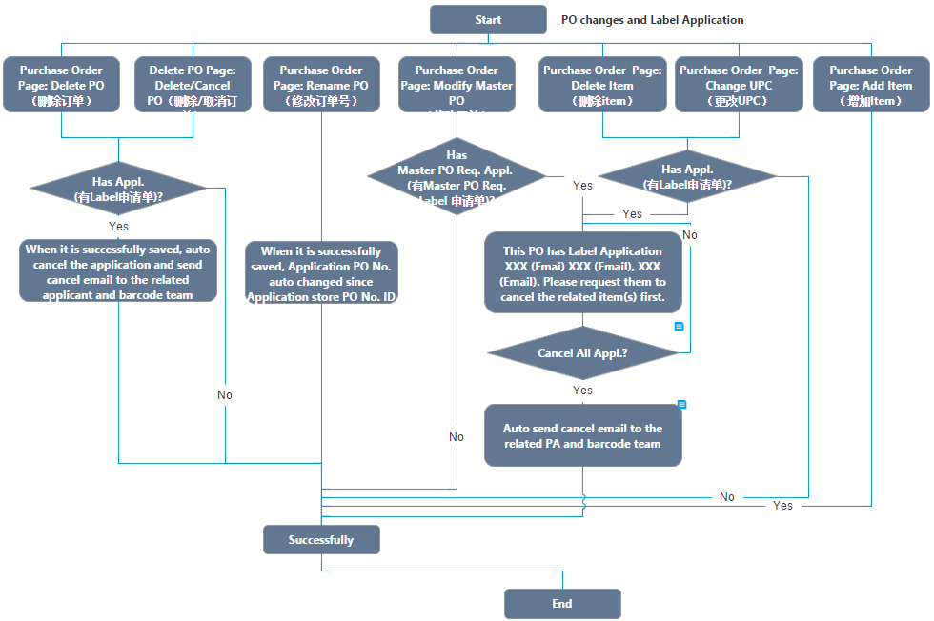
Figure 6-6 PO and Label Application relationship

- If there is a label application existing when deleting item or changing UPC or modifying Master PO, UCT Team has to manually send the cancel items request email to the applicant. Only the related item in the application is cancelled or deleted, UCT can make those changes.
- If the item is added to PO after the application is created, please submit a new label application after the same name label application has been completed.

Master PO Page
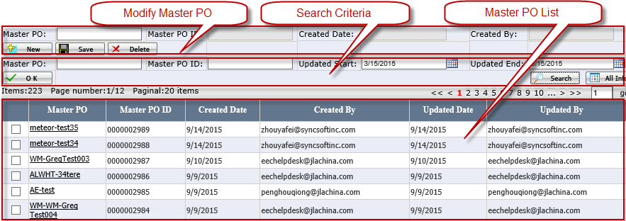
Figure 6-7 Master PO Page

Modify Master PO
- Master PO: a free text; user can type in as he/she likes.
- Master PO ID: it's automatically generated by EEC system. It begins with 0000000001.
- Created Date: the created date, automatically recorded by system.
- Created By: to record the user who created the master PO.
- Delete: Don't allow to delete master PO on Master PO Page if the master PO is used by one or more PO. When user tries to delete master PO which can't be deleted, pop up message: "Fail to delete since it's used in PO(s)."
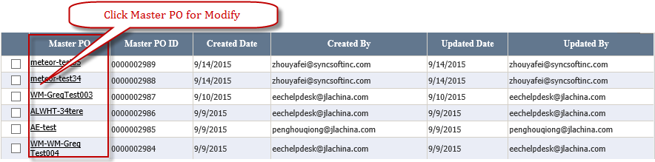
Figure 6-8

Search Criteria
- Updated Begin/Updated End: default search master PO updated in last 6 months.

Master PO List
- Put a check for Master PO and Click the OK to select Master PO for Purchase Order.
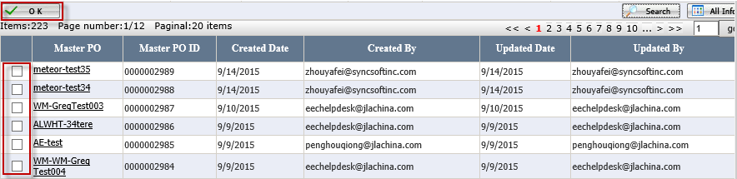
Figure 6-9

Report
- Click Label Name under Label Mgt. (See Figure 7-1) to Open Label Name Page (See Figure 7-2)
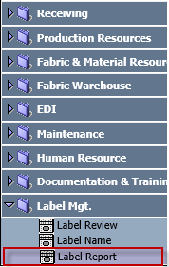
Figure 7-1 Report Page Path
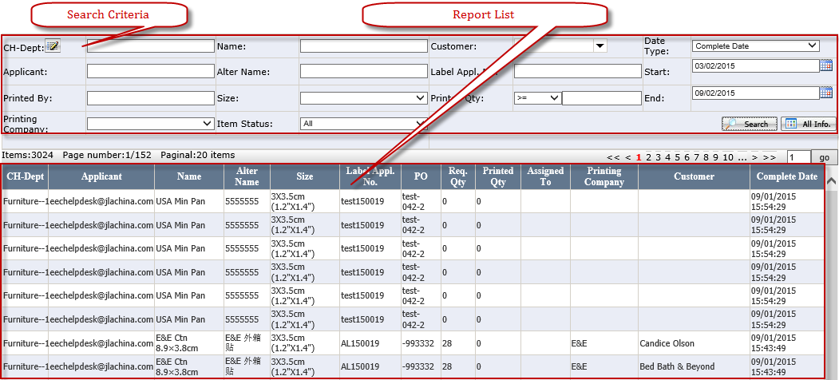
Figure 7-2 Report Page

Search Criteria
- CH-Dept.: When click the icon near CH-Dept., it will open department popup window.
- Customer: Multiple selection.
- Start and End: default to previous half year.
- Item Status: The drop down list contains All (Default), Open, Cancelled. The search result of Printed Qty will be changed according to Item Status changes.
- Date Type: The content of Date Type is Default, Complete Date, Cancelled Date, and Finish Date. Default to Default. Default means Complete Date and Cancelled Date.
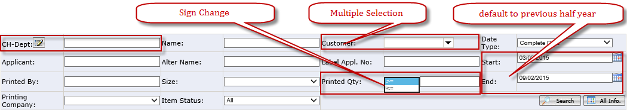
Figure 7-3

Report List
- Only list application’s step is complete.
- Sort by: Complete Date > CH-Dept. >PO.
- Printed Qty: It’s actual Printed Qty
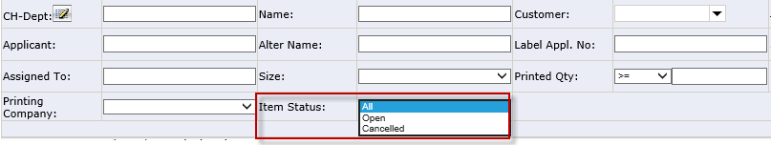
Figure 7-4
- The search result of Printed Qty will be changed according to Item Status changes.
- E. g. If the Item Status is Open, System only calculate application whose Item status is open. If the Item Status is Cancelled, System only calculate application whose Item status is Cancelled. If the Item Status is All, Printed Qty is sum of each PO.
- Printed Qty. attains from Label Detail Page according to Printing Company.
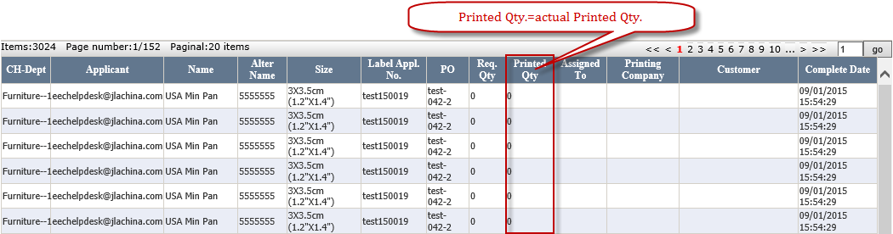
Figure 7-5 Report List

Where to get the help if you have question or problem
If you have any questions and issues during the process, please send email directly to eechelpdesk@jlachina.com

Appendix A: Label Application Page Layout Introduction
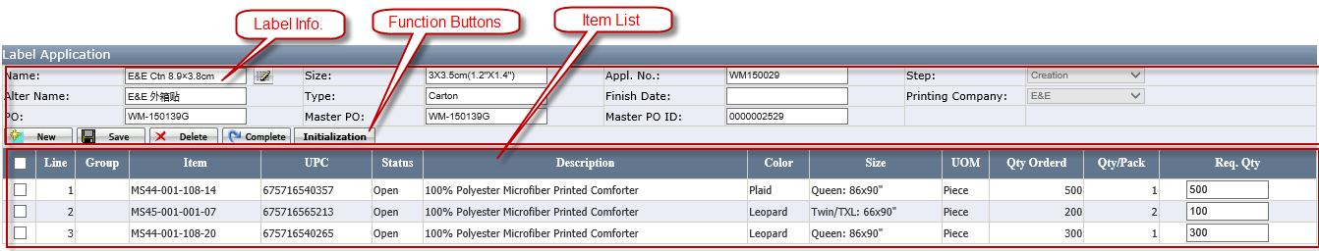
Figure 9-1

Label Info.
- Name: Click the Pencil Iron to open the Label Selection Page.
(See Appendix C for Label Selection Page Layout Introduction)
- Size, Alter Name, Type: Auto generate according to the related Label Name and an only read field.
- Finish Date: When the application complete from Creation to Review, system will auto calculate Finish Date. Submit Date + 5 working day (excluding weekend) e. g submit date= 8/21, finish date=8/28.
- Appl. No: System will auto generate if Complete successfully.
- Appl. No. format: {Prefix} + {Year} + {NNNN}. Year=2digits, NNNN=4 numbers. If PO No has dash "-", Prefix=PO No Prefix (characters before "-") e.g. PO= WM-150541C, Appl. No. = WM150001. Otherwise it’s Cust. Short Name, e.g. PO=150723, Cust. Short Name = HRS, Appl. No. = HRS150001
- PO, Master PO and Master PO ID: System will auto bring according to the selected Purchase Order. (See Master PO in the Purchase Order)

Function Button
- Save: allow the user to save selected Label Name and save Req. Qty and Ticket Price. The Initialization Button and Complete Button will be visible after the application is successfully saved. (See Figure 9-2)
Figure 9-2

- Gen File: Click this Button to generate PDF file.
- View: If generate PDF successfully, View will appear. Click it to view the PDF.

- Initialization: Click it and system will pop up the Initialization Page. (See Figure 9-3)
Req. Qty = Qty Ordered × Ratio ÷ Qty/Pack
Figure 9-3 Initialization Page

- Complete: If complete successfully, the Cancel Button will be visible and the Save, the Complete Button, Initialization Button will be hidden.(See Figure 9-4)
Figure 9-4

- Cancel: It is multiple selection. If items are cancelled successfully, the Item Status will change to Cancelled and system will auto send Email. (See Appendix D for Email Page Layout Introduction) At the same time, system will auto clean the PDF file and the Button Re-Gen change to Gen.
Figure 9-5

- Delete: Allow to delete the application when the step is Creation
Figure 9-6

Item List
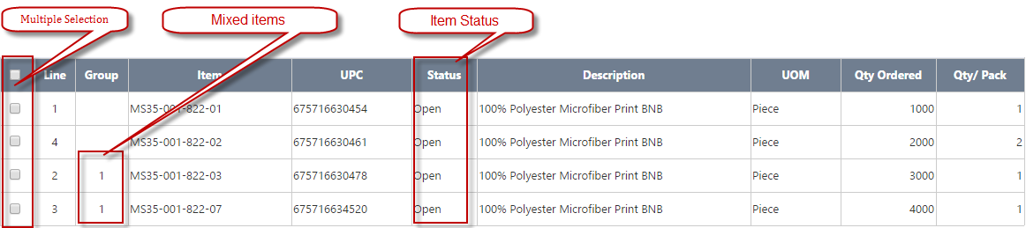
Figure 9-7 Item List

- Mixes Items: If group is not blank, system will not allow enter Req. Qty >0 due to label application does not support the mixed items.
- Default sort is by Line No.
- If Save successfully, Req. Qty and Ticket Price will appear. (See Figure 9-8). Ticket Price only appears when the selected label required Ticket Price.
Figure 9-8 Table change

Appendix B: Label Review Page Layout Introduction
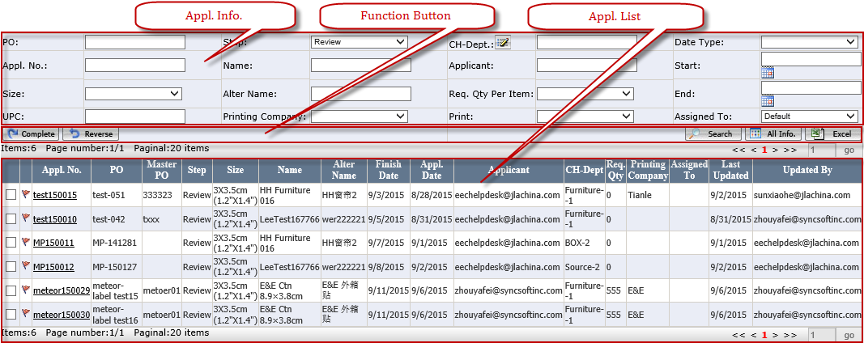
Figure 10-1 Label Review Page

Appl. Info.
- Step: It is one selection.
- Assigned To: Default to Default. The Default means the Appl. No has not been assigned to and has assigned to the person who is using at current (See Figure 10-2)
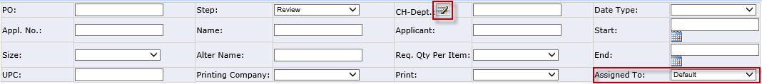
Figure 10-2

- CH-Dept.: Click it to open Select Department Page (See Figure 10-3)
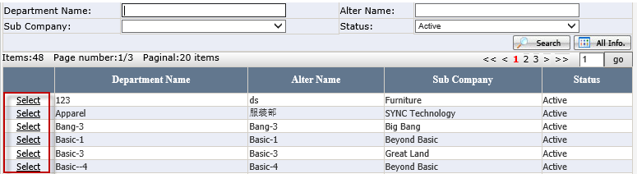
Figure 10-3 Select Department Page

Function Button
- Complete: Change Step from Review to Complete. System will auto send notified Email (See Figure 14-2 Email for Complete)
- Reverse: one selection and allow to reverse the application to previous step.

Appl. List
- Red Flag: Display it when Finish Date - Today <=2, No print date, step <> complete.
- Checkbox: One selection.
- Default sort: Red Flag, Finish Date, Step.
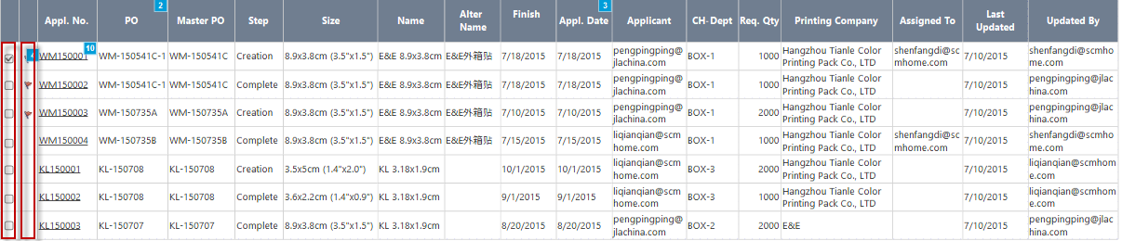
Figure 10-4

Appendix C: Label Selection Page Layout Introduction. (See Figure 11-1)
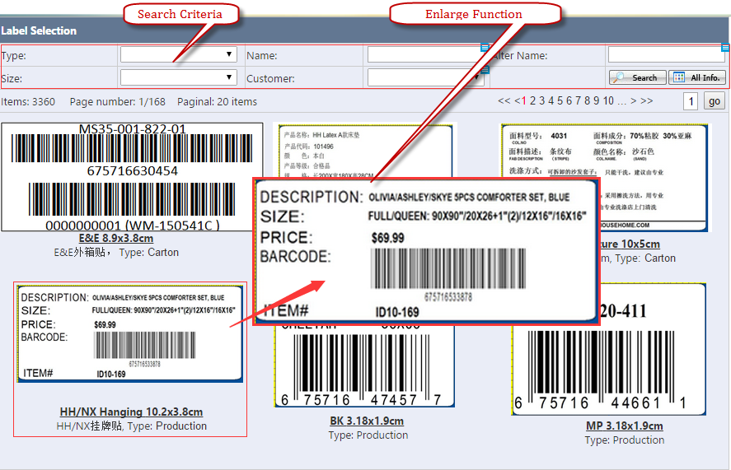
Figure 11-1 Label Selection Page

Search Criteria
- Customer: Default to the selected PO customer and it is multiple selection.( See Figure 11-2 )
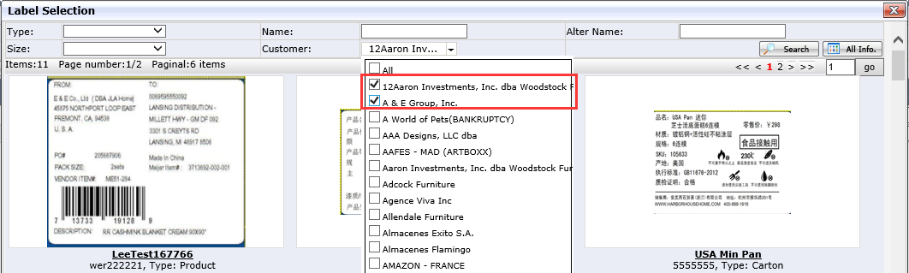
Figure 11-2 Label Selection

Enlarge Function
- Cursor move on the picture and system will auto pop the enlarged Picture (enlarge 1.5—2 times) in the best suitable position. (See Figure 11-1 Label Selection Page)

Appendix D: Label Detail Page Layout Introduction.

Label Detail Info.
- Printing Complete and Assigned To: It is required.
- Finish Date: If Printing Company is the Third Printing Company, it is allowed to be modify; otherwise, it is grayed out.
- Other information will get from Appl. No.
Figure 12-1

Function Button
- Save: Only Printing Company and Assigned To is selected can save successfully. If saving successfully, other Buttons will appear.
Figure 12-2
- All Preview: Pop up PDF file (See Appendix E for Label PDF Page Layout Introduction)
- Print All: Print all items Label.
- Reverse: Change from Review to Creation.
- Complete: Change Step from Review to Complete and auto send notification Email (See Figure 14-2 Email for Complete).
- Email: It is visible when the Printing Company is the Third Printing Company. It is used to send Email (See Figure 14-3 Email for the third printing company).
- Print: Use to print individual item.
- If the New Print Qty is changed and the sum (=New Print Qty + Printed Qty)>Req. Qty, click it and system will warn “The summary of Printed Label is over the Req. Qty, Are you sure to continue?" If the No. <0, Default to blank. (See Figure 12-3).
- Click Next to move to the next tem and click Prev. to move to the Previous item. It the previous item or next status is Cancelled, system will auto skip it.
Figure 12-3 Print Label

Item List
- Default sort: By item line No.
- Plus Iron: When click it, system will open the print detail which includes Req. Qty, Printing By, Printing Date.
- Item No. Hyperlink: Open this item zebra printed PDF Preview.
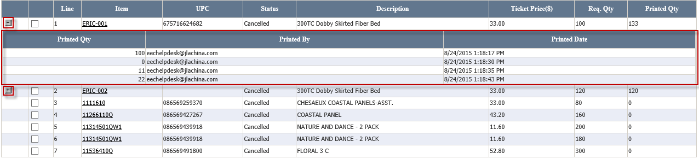
Figure 12-4 Item List

Appendix E: Label PDF Page Layout Introduction.
- All Preview like this:
One page can have multiple different items and each item label count=1.
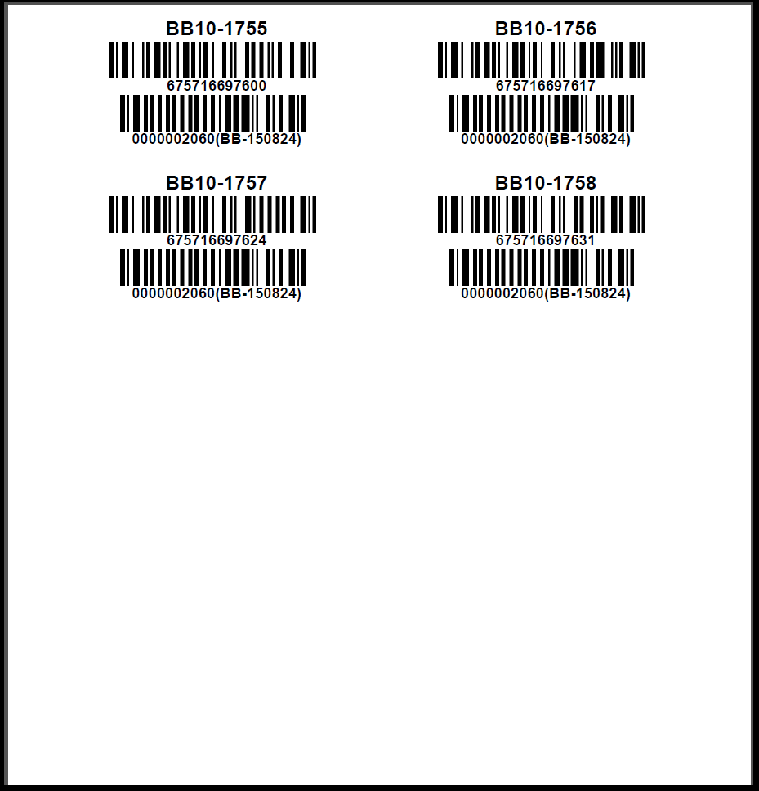
Figure 13-1 EE PDF View

Appendix F: Email Page Layout Introduction.

Cancelled items Email
- If cancel successfully, system will auto send to the related applicant.
- Whether Ticket Price exist or not depending on the category of Application. E.g. If there is Ticket Price in the Application, the content of Email includes Ticket Price.
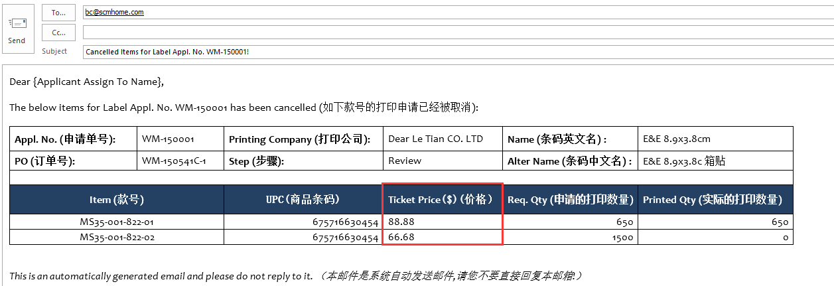
Figure 14-1 Email for Cancelled items

Complete Email
- Applicant Name and Address will reset according to the applicant.
- Whether Ticket Price exist or not depending on the category of Application. E.g. If there is Ticket Price in the Application, the content of Email includes Ticket Price.
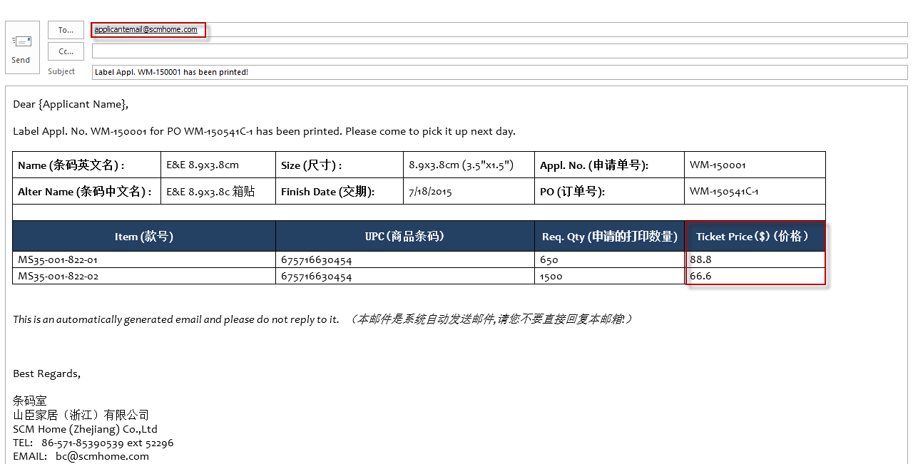
Figure 14-2 Email for Complete

Third Printing Company Email
- Whether Ticket Price exist or not depending on the category of Application. E.g. If there is Ticket Price in the Application, the content of Email includes Ticket Price.
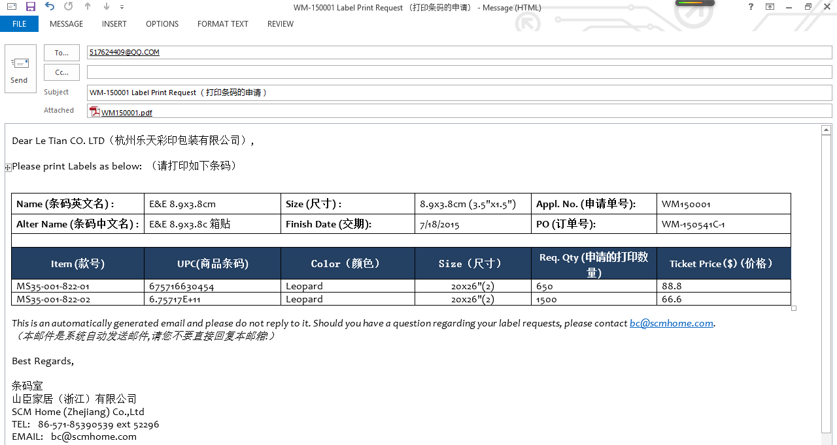
Figure 14-3 Email for the third printing company

Delete or Cancel PO Email
- Whether Ticket Price exist or not depending on the category of Application. E.g. If there is Ticket Price in the Application, the content of Email includes Ticket Price.
- The user name will reset according to the applicant.
- If there has not been assigned to, only appear Applicant Name.
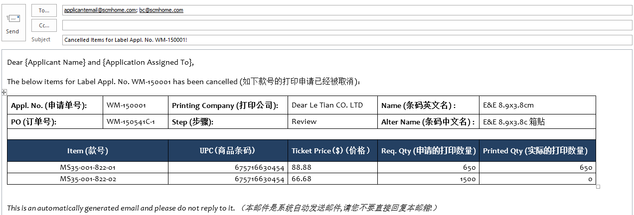
Figure 14-4 Email for delete in Purchase Order or Delete POs Page

Appendix F: Label Name Layout Introduction.

Label Name Info.
- Name, Size, Type: a required field.
- Alter Name: an optional field and not allow duplication.
- Customer: an optional field and multiple selection.
- Master PO Req.: If it is checked, PO is required to have Master PO No.
- Ticket Price Req.: Default no check. When it is check, the related Label Application will show Ticket Price on Label Application and Ticket Price is a required field.
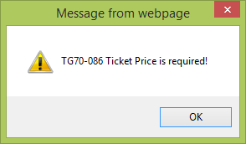
Figure 15-1

- Active: default no check. If it is checked, it will show label selection page.

Function Button
- Save: Once it is saved successfully, it will display upload picture in the top right corner.
- New: Create a new label Name.
- Configuration: Click this Button, system will open the Configuration Label Page.
Figure 15-2

- Configuration Label Page (See Figure 15-3 Configuration Label Page)
Only Configure Label Page is successfully saved, user can put the check for active. Otherwise, it will give the message "Fail to save due to missing label configuration.
- Label Class: an optional field and it is used to confirm what the content of the selected label is.
- Label Template: an optional field and it is used to confirm where the every part of label content is put.
- PDF Class: A optional field
- PDF Template: A optional field
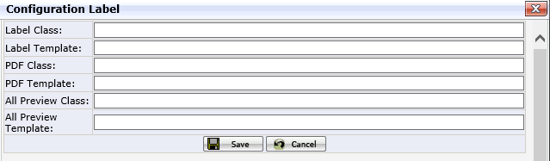
Figure 15-3 Configuration Label Page

Search Criteria
- Customer: It is one selection. If you search the label has no customer assigned, please choose N/A.
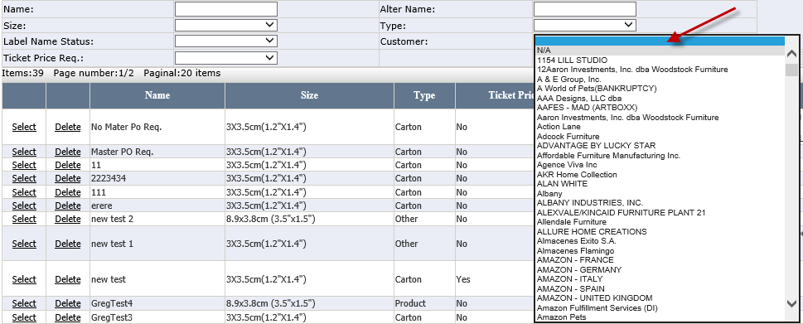
Figure 15-4

Label Name List
- Delete: Once it is used by any application and cannot be deleted and warning message "Failed to delete since it has been used.” Otherwise, it is allowed to delete.
- Select: Select Label Name to modify.

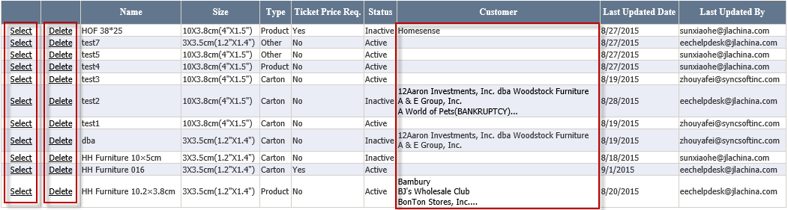
Figure 15-5

- Customer: If having more than three customers, there will appear three dots. The user can select Label Name to view all selected customers.
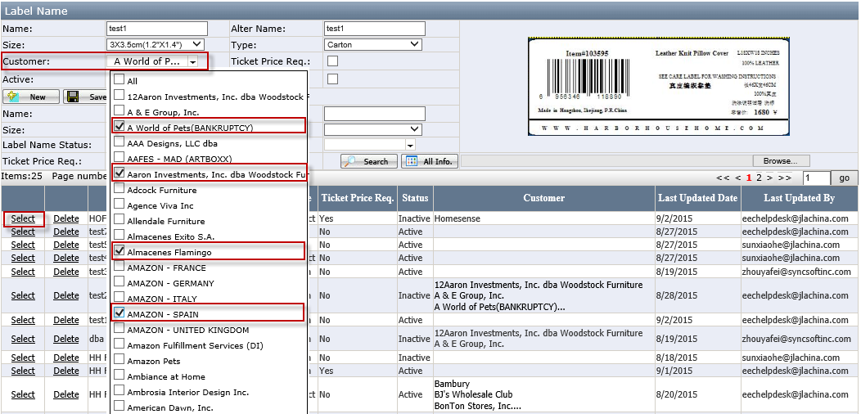
Figure 15-6

