Tablet Shopping Manual

How to add item to My Wish List
- Log on Olliix website and click my account, select tablet shopping. It will go to tablet shopping page.
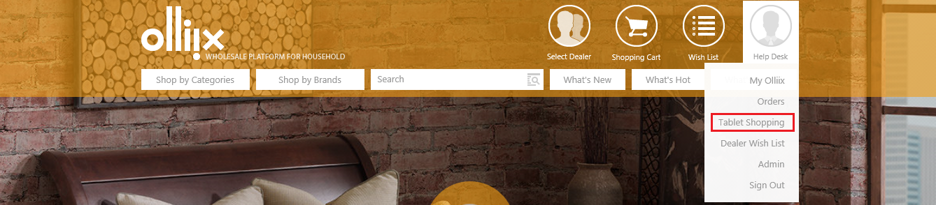
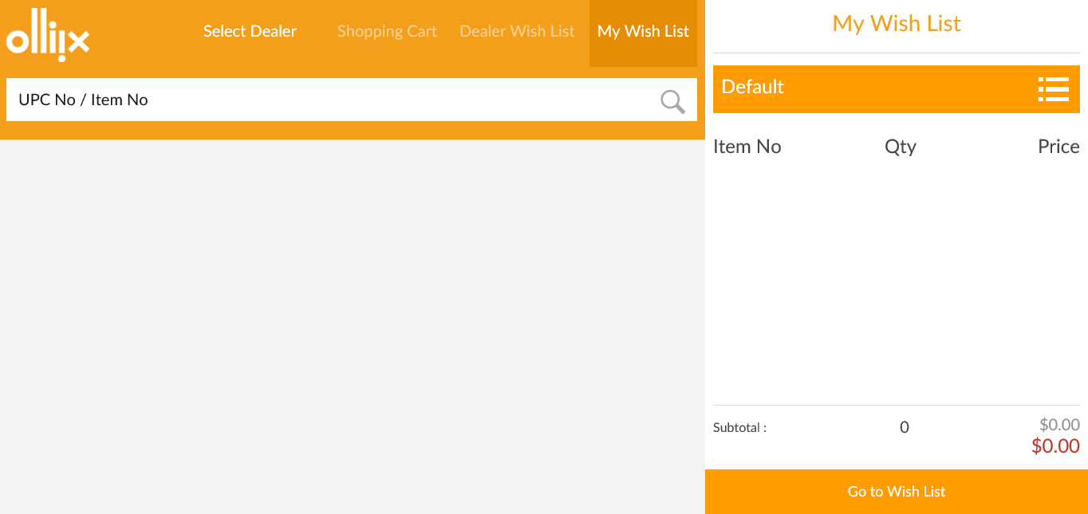
Tips:the default focus on my wish list.

- Scan/input the UPC no. or item no. into tablet shopping, the item’s detail will be displayed. Click Add to Wish List after selecting the size/color/qty. Item will be added to the my wish list successfully.
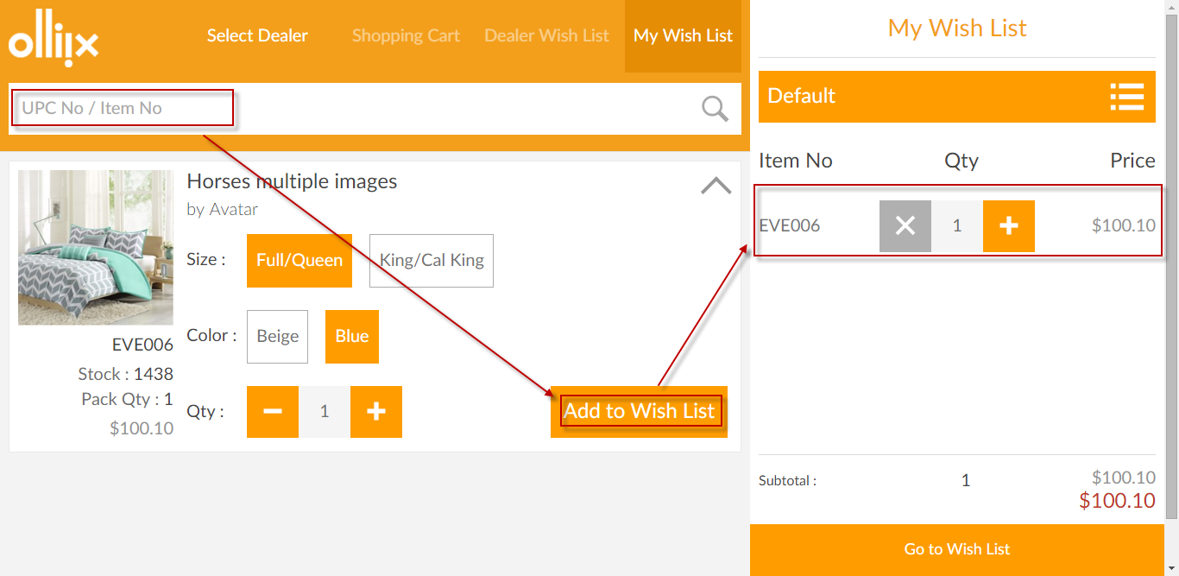

Tips:
- When scan/input the second UPC no. or item no. into tablet shopping, the latest item will in the expanded status by default and the previous one will in the collapsed status. User can click the expanded/collapsed button to switch the item’s display status: expanded or collapsed.
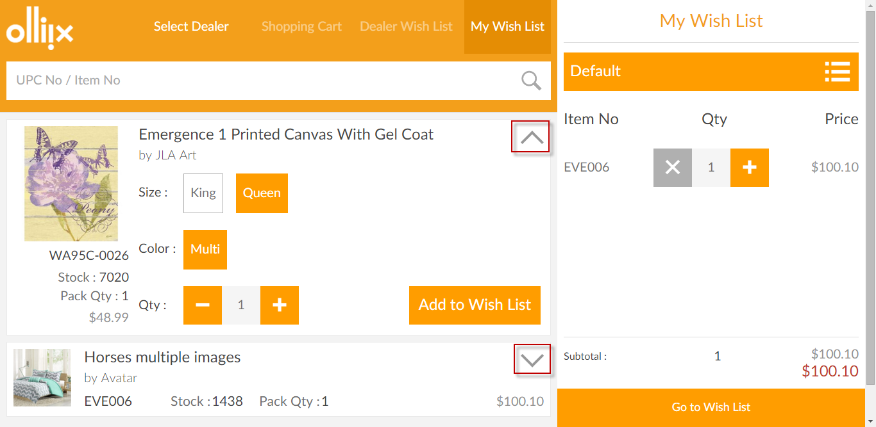

How to Adjust the Qty in My Wish List
By clicking “+”, “-”, user can increase/decrease the item’s quantity.
When qty =1, click “×” can delete the item.
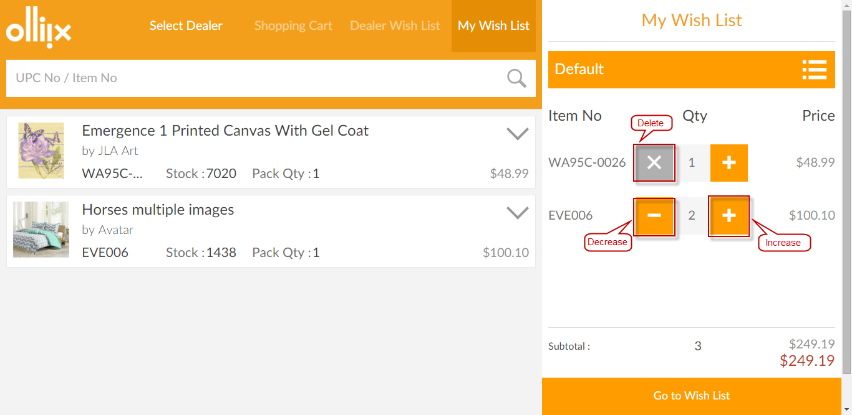
A confirmation message will show up when click delete button, click ok to delete the item.
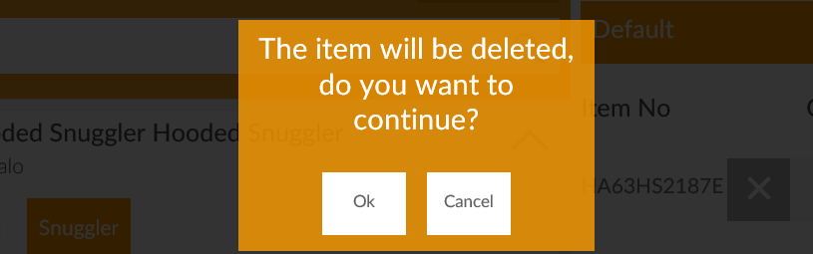

How to Maintain My Wish List
Click wish list name to open wish list maintenance page. User can add a new wish list, edit/delete the existed wish list or switch to other wish list.
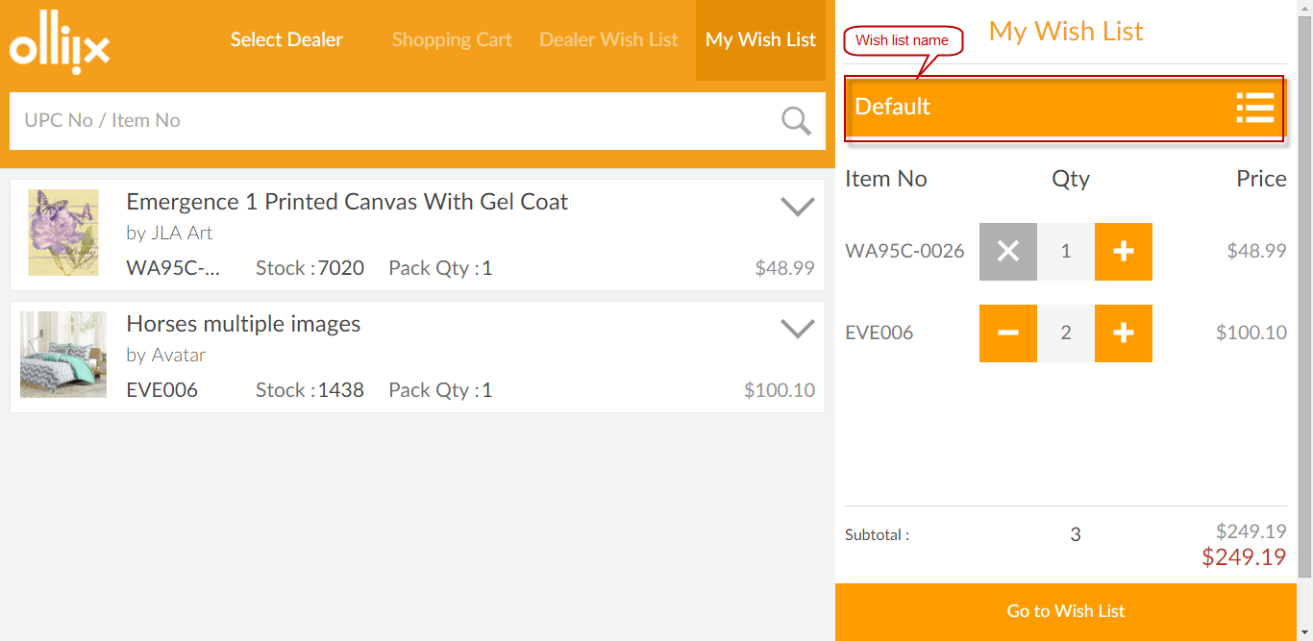
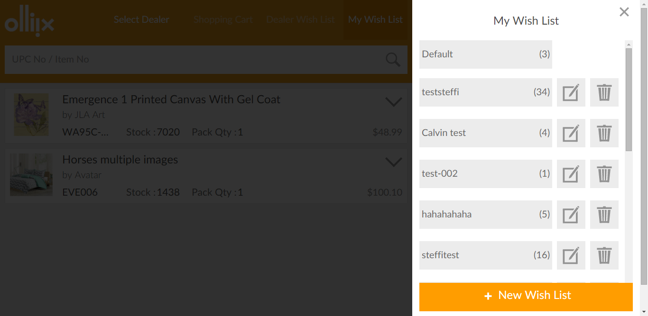

- Add new wish list by clicking “+ New Wish List” , Put in the wish list name and click √.

- Edit the wish list by clicking  then edit the wish list name.
- Delete the wish list by clicking  then click ok for the confirmation message.

How to Operate Dealer Wish List
- Click Select Dealer to open a pop up window to select a dealer.
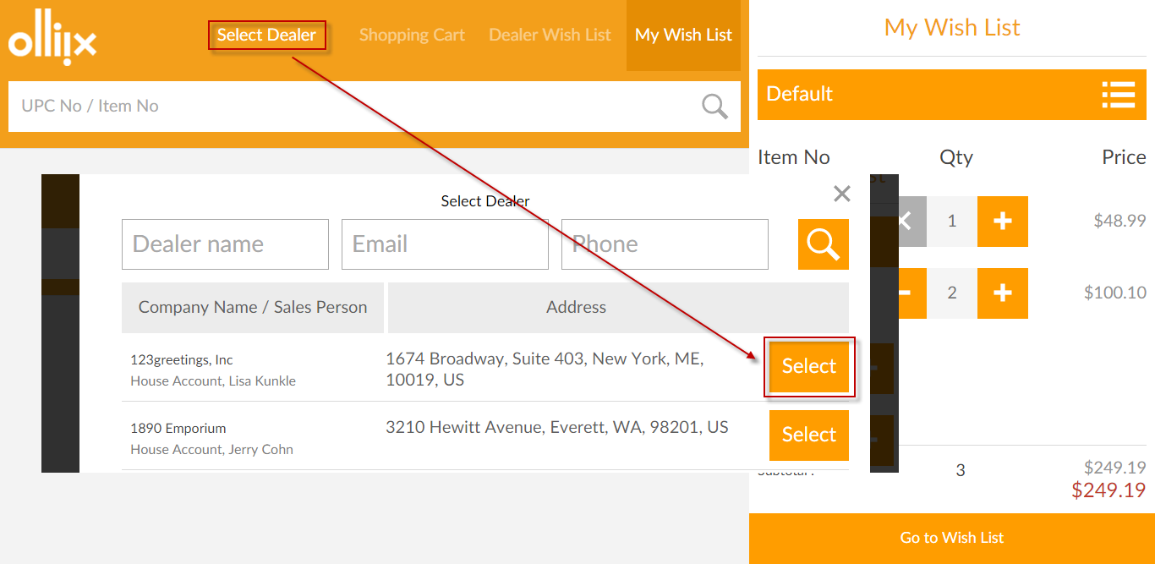

- Once a dealer is selected, the dealer name will display, the Shopping Cart and Dealer Wish List tabs become enabled.
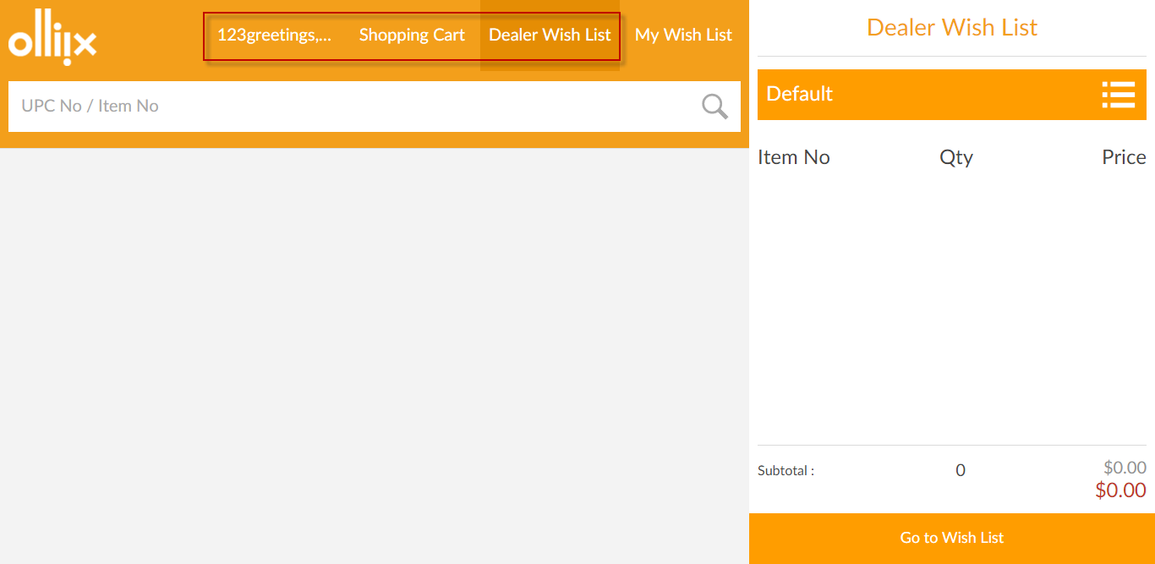

- Then user can add/adjust/delete the item in wish list or maintain the dealer wish list in wish list maintenance page. The procedure is the same as My Wish List.

How to Add item to Shopping Cart
- Scan/input the UPC no. or item no. and click Add to Shopping Cart.
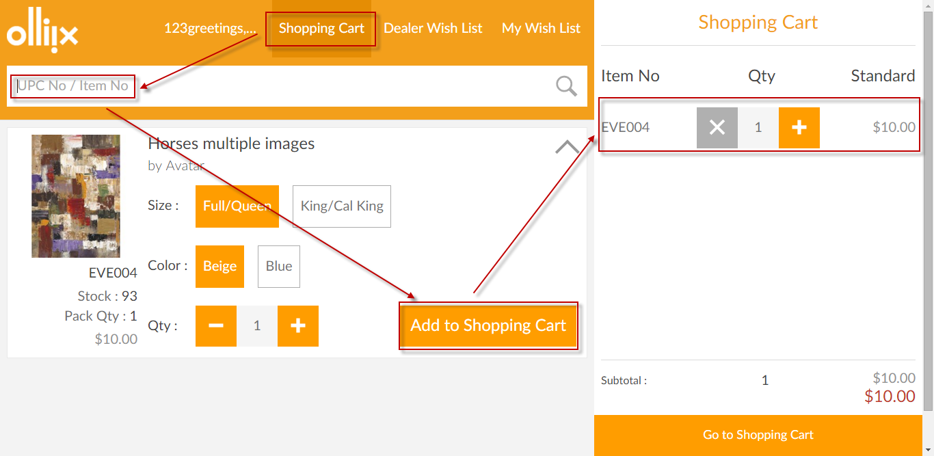

How to Adjust the Qty in Shopping Cart
By clicking “+”, “-”, user can increase/decrease the item’s quantity.
When qty =1, click “×” can delete the item.
