Designer Living - LTL Process
Background
The Designer Living orders will go through different processes based on different shipping method.
- Shipping method is LTL Business type is Ecom Wholesale Go WMS process
- Shipping method is UPS Business type is Retail Go drop ship process
This manual is about how to process Designer Living orders by WMS process.

Service Auto Read Designer Living Orders
Designer Living orders are read from Designer Living website by EEC service Get Retail Sales Order. When cube amount > 50, there will be a green flag on the Freight Review.
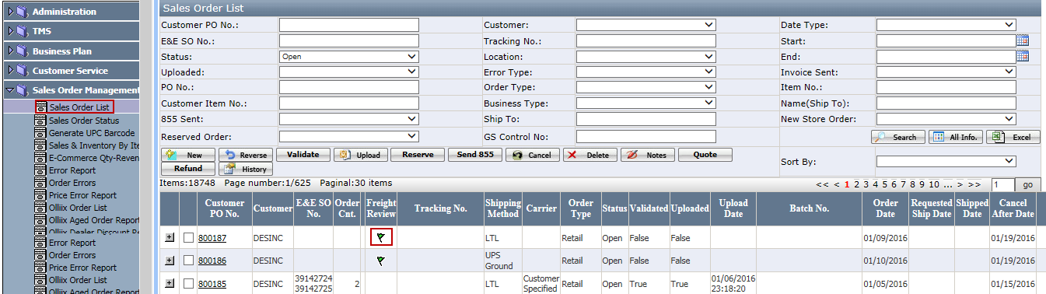

Decide Order’s Business Type
Business type is decided by shipping method.
Select the order and click Quote to open the freight quote page to check the freight. System will choose the lower one as the ship method.
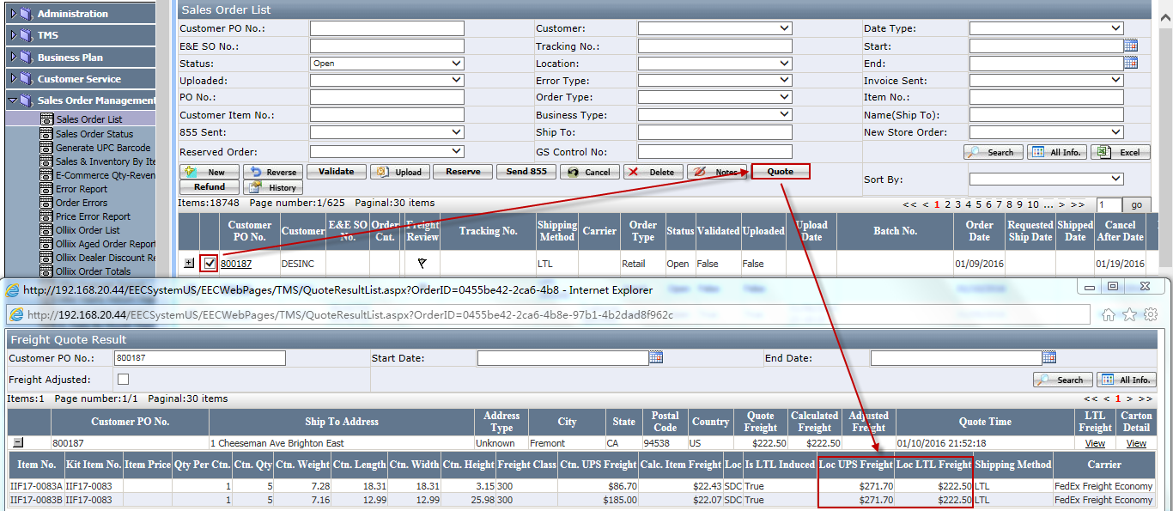
- Before PO uploading to Macola, user can change the ship method if necessary. Click the Customer PO no. to open the sales order detail page as below. Change the shipping method and click save.
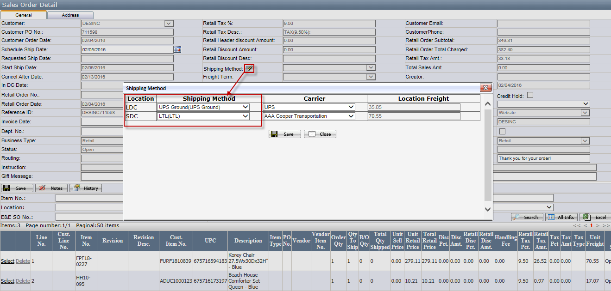
Notes:
- For one location POs, if any of the item ships through LTL, the PO’s business type will be Ecom Wholesale, and the entire PO will go through WMS process.
- For multi-location POs, different locations may have different ship method according to the freight.
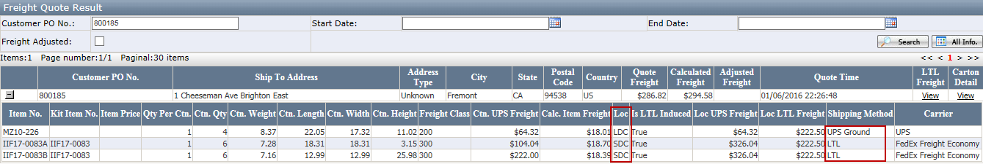
- Before PO uploading to Macola, location can be changed for Ecom Wholesale pos.
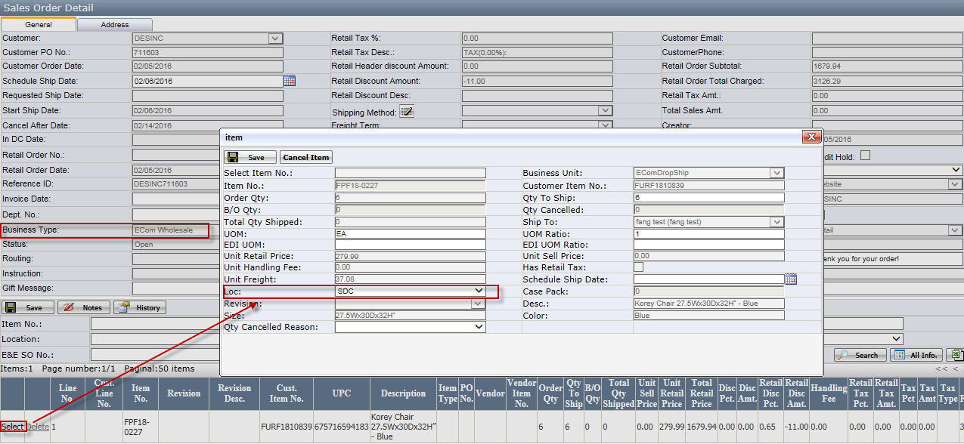
- Checking the inventory when the inventory quantity is short.
Select and click Stock to open the stock page. In this page, user can review the inventory.
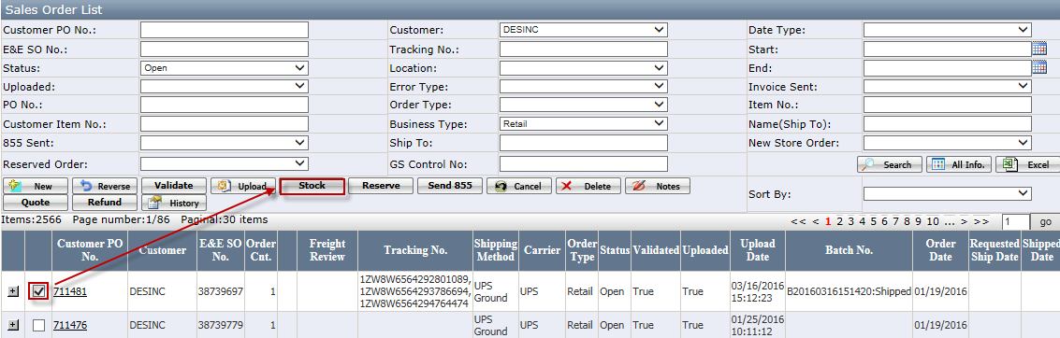
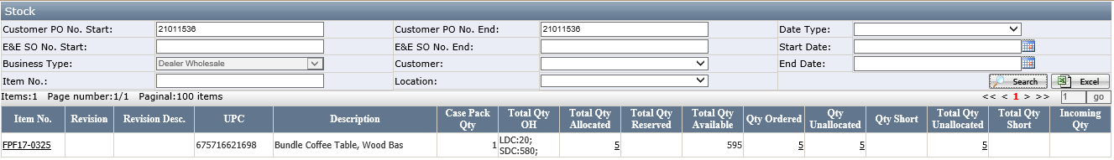
Notes:
- Item no. will be a link for kit item. Click the item link can open the component items stock page.

Validate and Upload Orders
EEC service will validate the order. After passing validation, EEC service would upload it to Macola and the green flag will be gone.

Create Batch
Distribution – Wholesale Batch Mgt – New
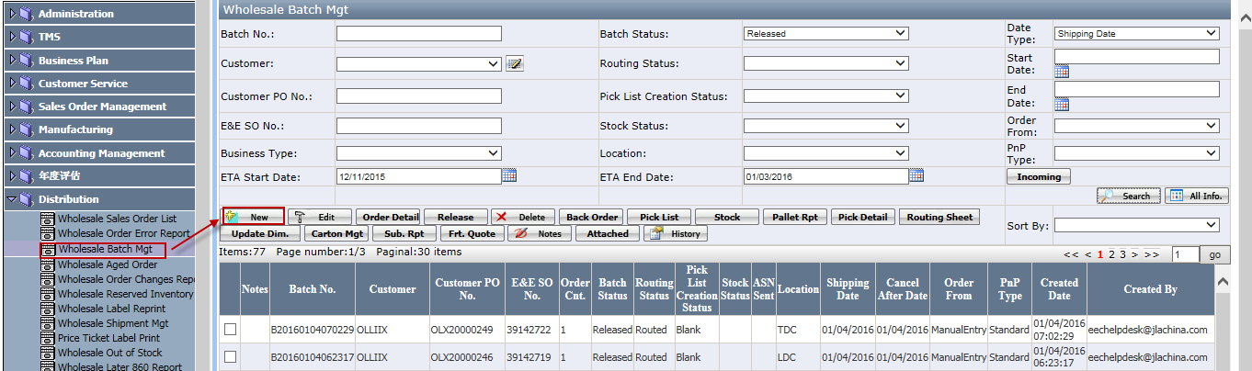

Release Status = Release Required, Business Type = ECom Wholesale
Select the order(s) and click Create.
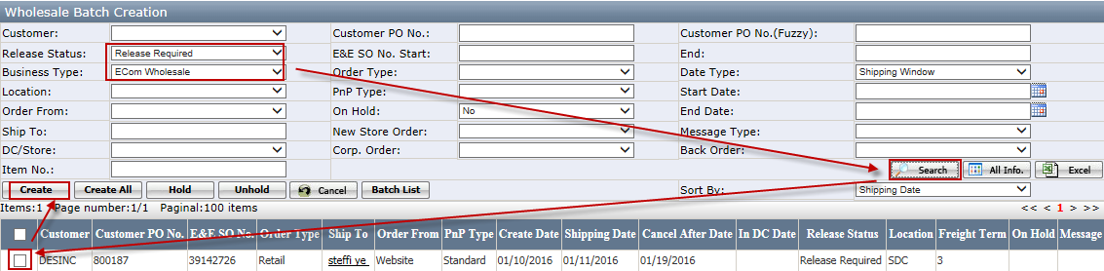
The newly created batch’s status is Pending.

Release Batch
Select the batch and click Release.
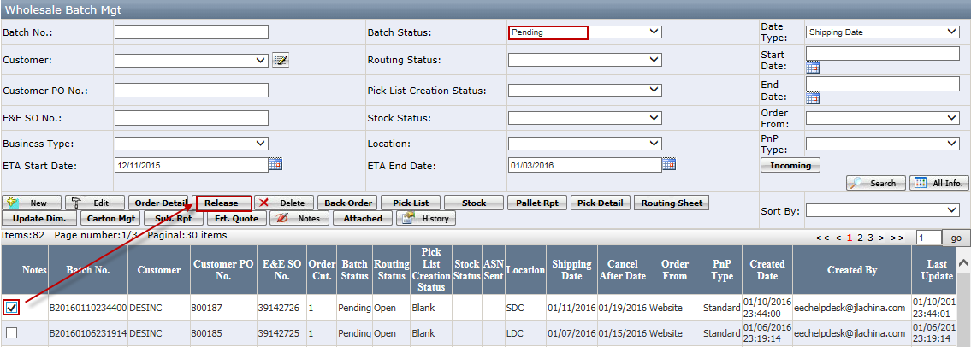
Batch’s status changes to Released.

- Inventory Checking
When inventory is short, need to check the inventory.
Select the batch and click Stock.
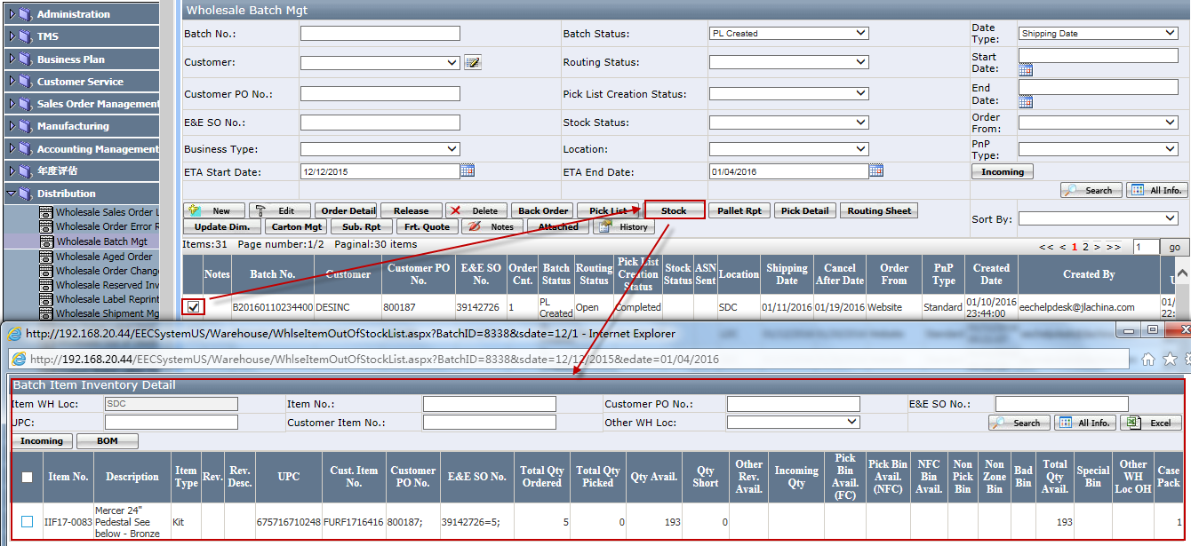
- For kit item, click BOM to open the component items information.
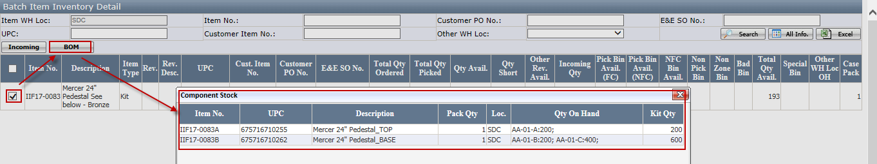
Kit item qty = the minimum qty of component items

Generate Pick List
Select the released batch and click Pick List.
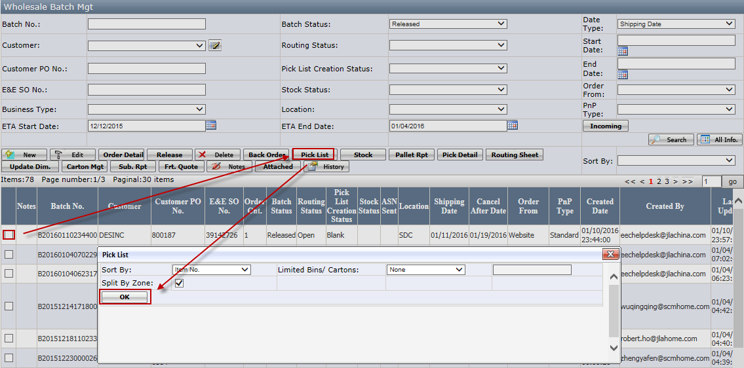
Sort by: item no or bin loc.
Limited Bin/Carton: Select limited bins/cartons, and enter the number of bins/cartons if you want to limit the number of bins/cartons in each printed pick list.
After click OK, pick list will be generated.
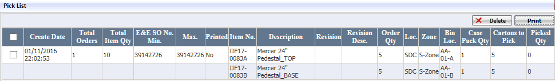
- If the item is not kit item, in the pick list, the item no. = order item no.
- If the item is kit item, in the pick list, the item no. = component item no.

Select and click print to print the pick list as below.
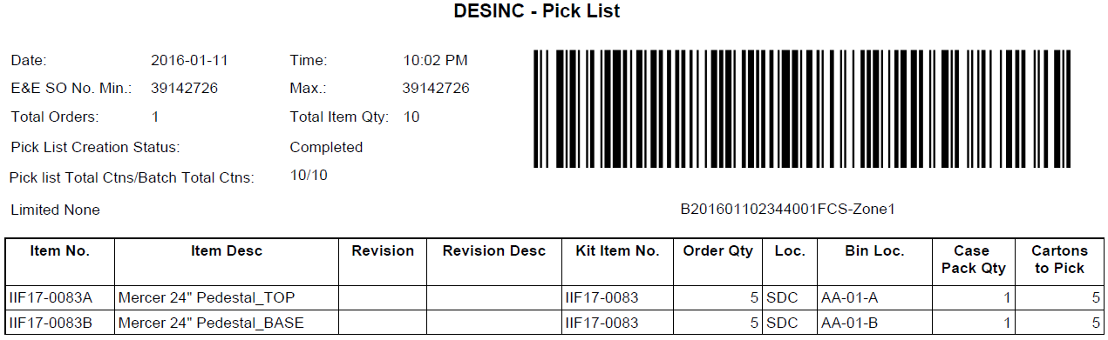

Batch status changes to PL Created after pick list generating.

Generate Routing Sheet
Select batch and click Routing Sheet to generate routing sheet.
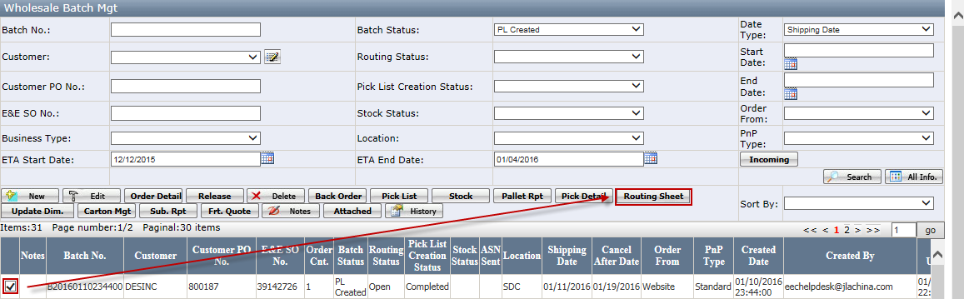
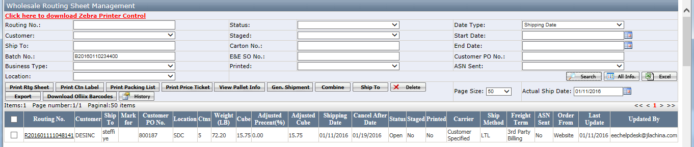
Print Rtg Sheet: print the routing sheet.
Print Ctn Label: print the carton label.
- For kit item, will print the component items label
Click the routing no. to open the routing sheet detail page.
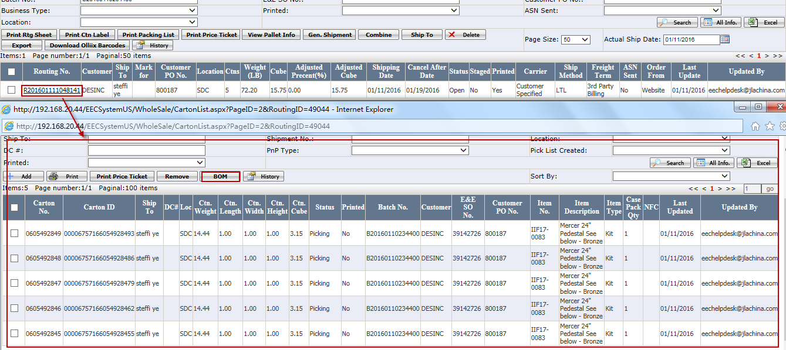
Click BOM to check the component carton detail.
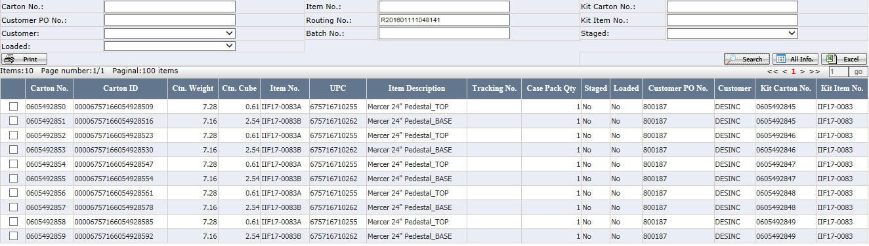
View Pallet Info: check the pallet information if there are pallets created. Add/remove carton(s) to a pallet manually.
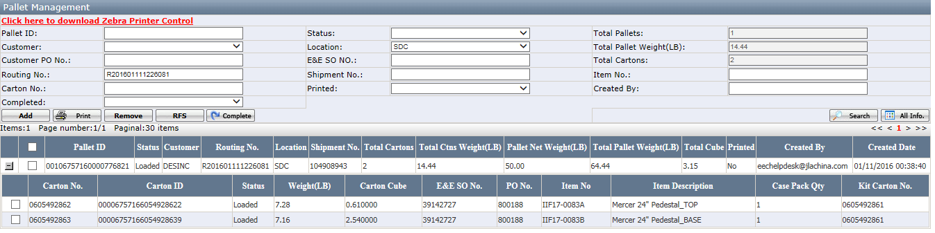

Create Shipment
On routing sheet management page, click Gen.Shipment. Put in the information and generate the shipment. (By this way, order’s freight, carrier and ship method will relate to the shipment automatically)
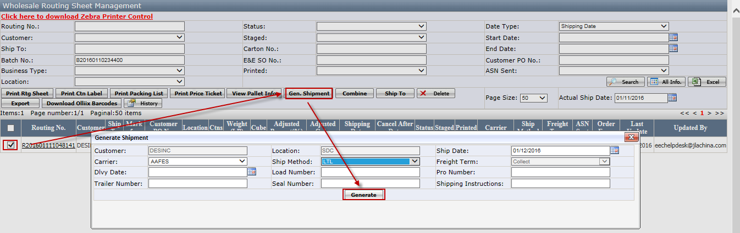

Assign Shipment to Truck Loader
Assign the truck loader(s) to a shipment.
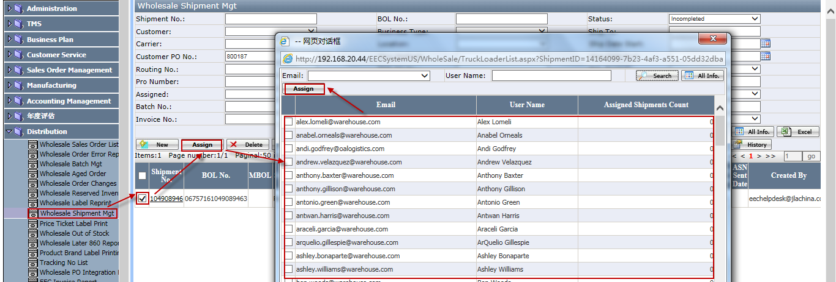

Load Cartons/Pallets to Truck
There are two ways to load carton.
- Wireless application.
See <how to do Truckloading> manual in detail.
- Click load button to load it.
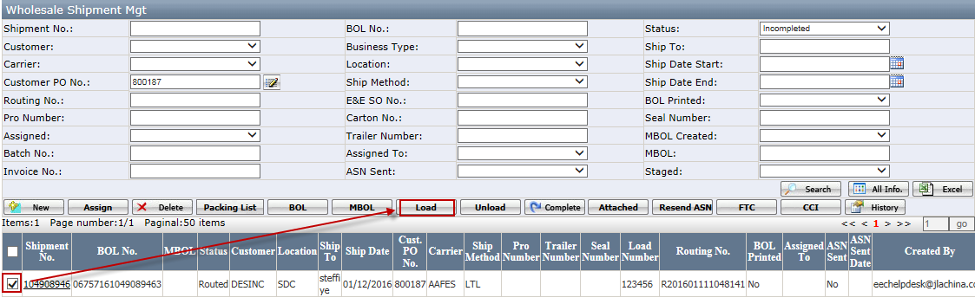
- User with role Shipment Admin has the access to operate the load button.
After loading, the shipment status becomes loaded.

Print BOL
Select the shipment and click the BOL to print the bol.
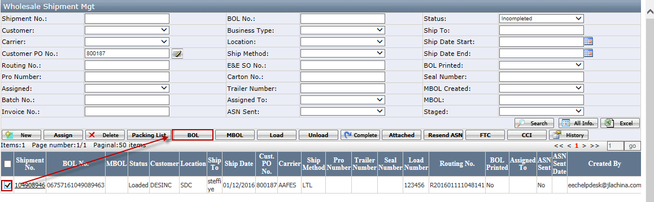
- BOL can’t be printed if shipment status is Open or Routed.
- If shipment status is Loading, the BOL will only show the cartons that have been loaded to truck.

Print Packing list
It is the same function as Print Packing list on routing sheet page.
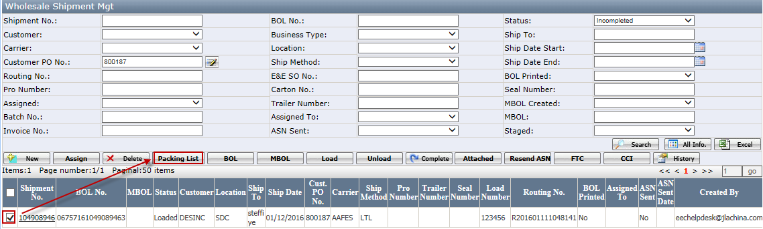
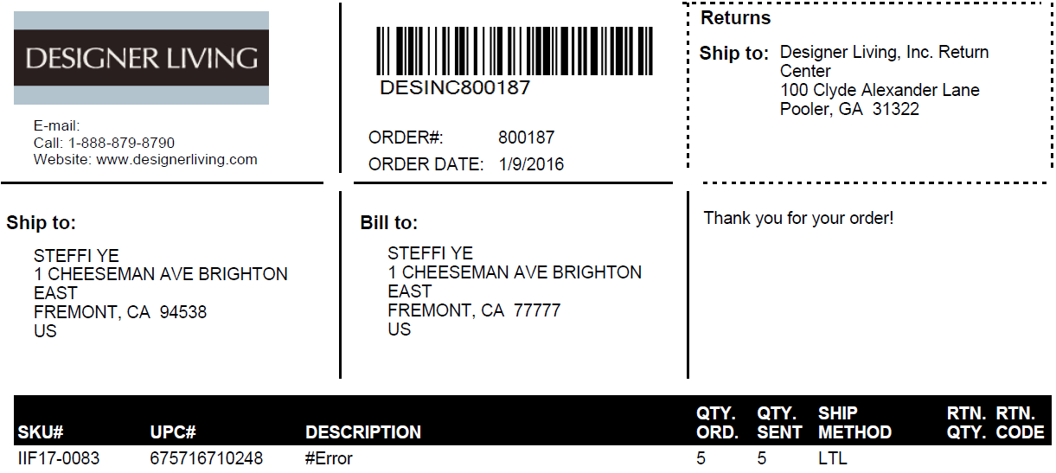

Complete a Shipment
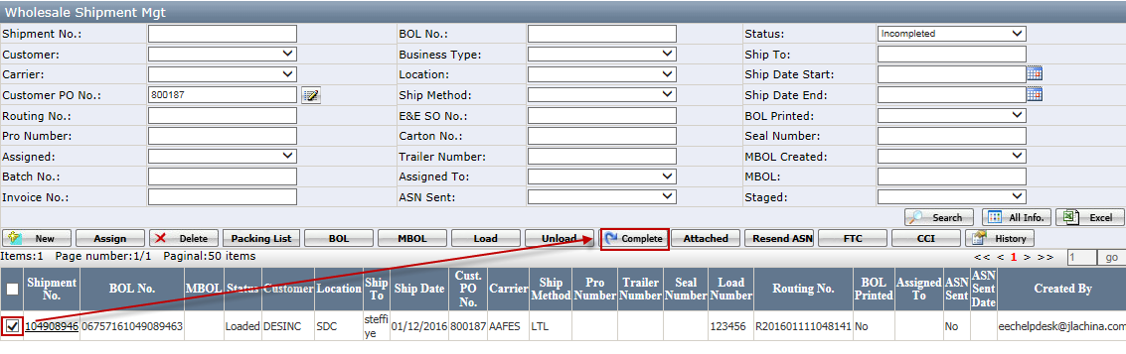
Shipment status becomes to Completed after completing successfully.
- Shipment status must be Loaded.
- Only Shipment Admin has the access.

