AIM Manual
Contents
How to do AIM ID 2
How to create and complete AIM ID 2
How to reverse AIM ID 6
How to Cancel AIM ID---IAN Please check these, I am not sure 8
How to do AIM Item 9
How to create AIM Item 9
How to reverse AIM item status—not finished 10
How to cancel AIM item status –not finished 10
How to create Artist 11
How to setup Licensor Code 12
How to maintain Prints Vendor 13

Background
The purpose of the AIM Module is to manage and to follow the AIM ID and AIM item case. The AIM ID and item will follow three steps as below:
AIM ID Step Name | AIM Status | Item status
Creation | Pending/Open | Open
Prep Process | In Prepress/Completed | In Prepress
Completed | Completed | Completed
The roles Art Admin and Art Users can review and operate this module. The detail access is as below:
  - Art Admin assigned three process steps with write function.
The user will be able to do any functions in AIM ID MGT page. In the real business, Armaine Neale will be this person.
  - AIM Users and assigned Prep Process step with write function.
This user should be able to complete and reverse the AIM ID page at Pre Process, What’s more, they should be able to check the image Improve button.
In the real business, Darrell Dugas will be such person.
  - AIM users without assign any process step.
The user can’t change any things but review the AIM ID MGT page at any process steps.
In the real business, Cori Young, Tracy, Darrell will be such person.

How to do AIM ID

How to create and complete AIM ID
- Go to Art In Motion--> AIM ID MGT. Click "New" button to see below window[Pict-1]:
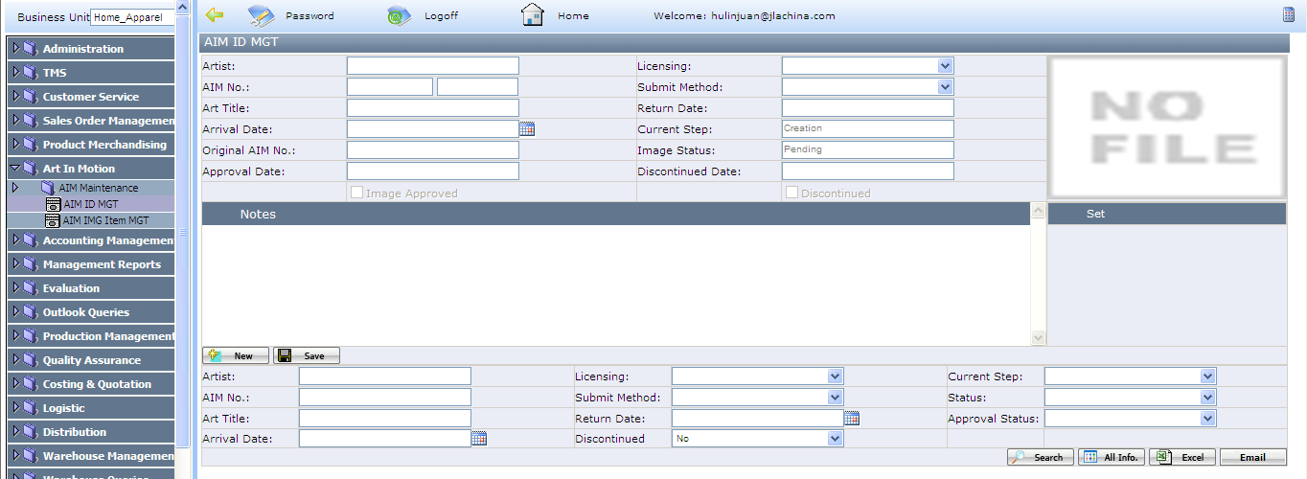
[Pict-1]
**********************************************************************************************************
Notes:
  - Artist: this field data is linked with Artist page. type the artist name and select it. if the artist is not exist in Artist
Page, you have to set up the artist information in Artist page at first.
  - AIM No.: generate by system.
**********************************************************************************************************
- Fill all the required fields and save it. the AIM ID is created. Now, the current process step is creation and the status is pending. See [Pict-2]
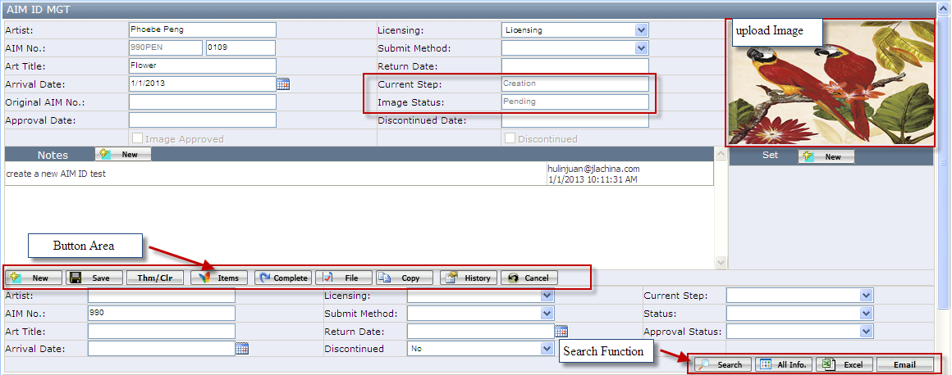
[Pict-2]
In this page, The main button functions are below:
- File: click this button to attach image file.
- Items: click this button to create items. ( see the <How to create AIM item>)
- The AIM status will become “Open” if one item is created
- Copy: Copy this AIM to create a new AIM.
- Notes: Click new button to add new notes.
- Set: Click New button to create new Set.
- Upload image: Click empty field to upload image to this AIM ID
- Thm/Clr: Click this button to maintain the theme and color in the window pop up as below.

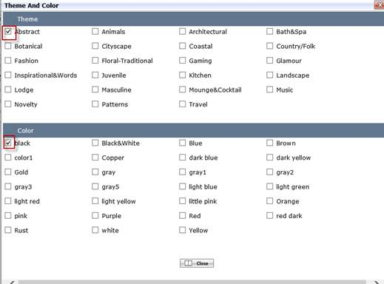

[Pict-3]
Search button functions:
  - Email: Click this button, system will open up a window to send email with empty recipient and empty subject. This button applies to one or multiple records selected in the grid.
  - Excel : Click this button to export all the information of the selected AIM ID and the selected AIM Items

3. Click the button "Complete", the current process step will be from "Creation" to "Prep Process" and the status become "In Prepress", see [Pict-4]
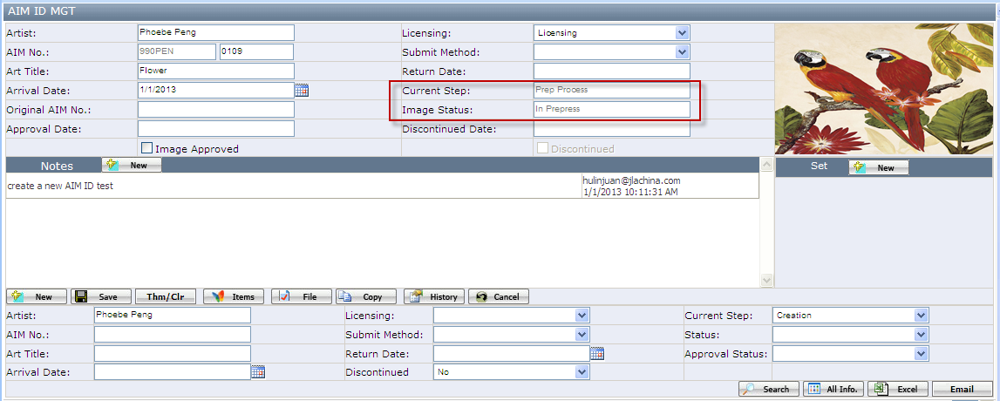

[Pict-4]
In this step, the user will approve the image. Otherwise, you can see the "Complete" button.

4. Click the "Image Approved" checkbox(see[Pict-5]) ,You will see the current step is still at Prep Process. But The AIM ID status is from "In Press" to "Completed". The approve date is also created by system.
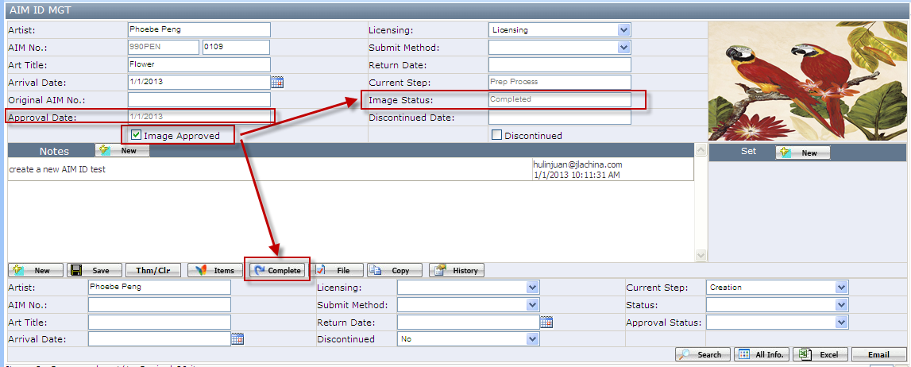
[Pict-5]
What's more, you will see the "complete" button now. Click the <Complete> button to finish the AIM ID create process.
Here, we have different conditions to do the "Complete" button.
Case1. AIM ID without items.
Click the "Complete" button [Pict-5], You will see the current process step will be from "Pre Process" to "completed" (see[Pict-6]). You can search out the AIM ID in the search out grid. The AIM ID without items has no "plus" icon.
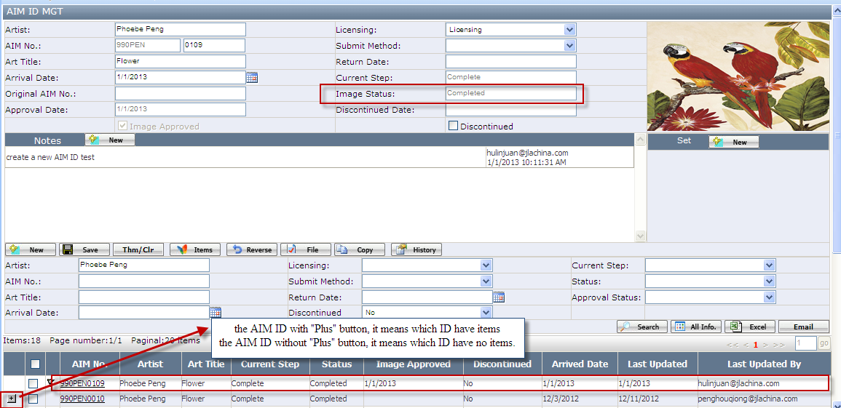
[Pict-6]

Case2. AIM ID with items.
a.) Click the "Complete" button to pop up Complete/Reverse Items windows as below([Pict-7])
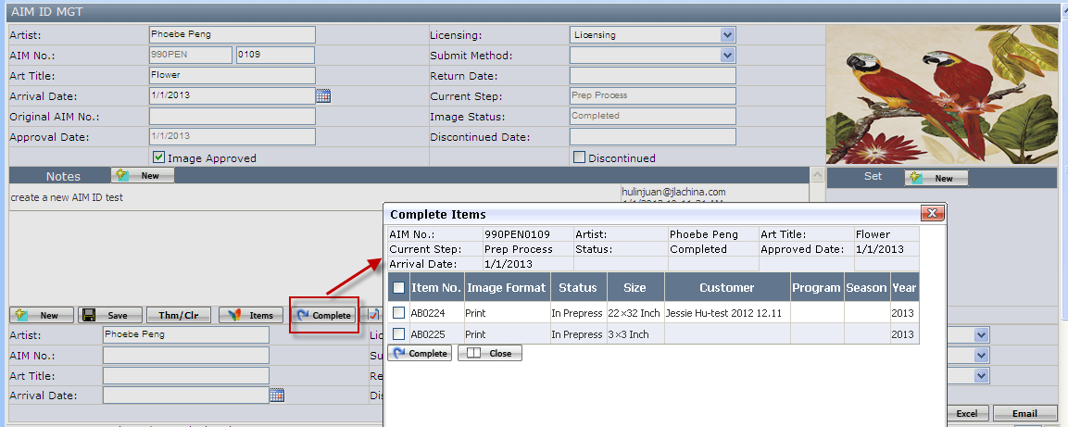
[Pict-7]
b. )Select the all the items and click the complete button
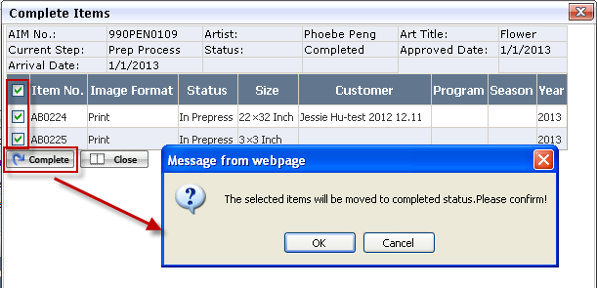

c.) Click the <ok> button to pop up below message:
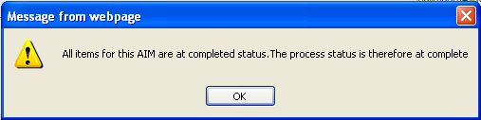
d.) Click<ok> to complete the AIM ID, you will see the current process step will be from "Pre Process" to "completed" (see[Pict-8])
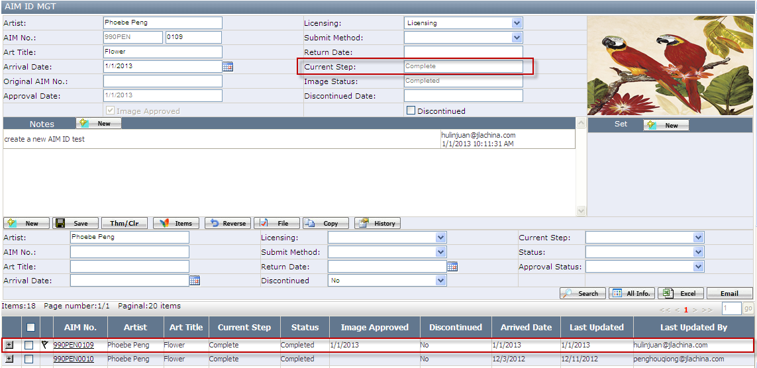
[Pict-8]

How to reverse AIM ID
AIM ID allow to be reversed from current step “Complete” to “Prep Process”. It is not allowed to reverse from “Prep Process” back to “Creation”.
Here, we have different conditions to reverse AIM ID.
Case1. AIM ID without items.
  - Click the "reverse" button, the current process step from "Complete" to “Prep Process”, The AIM status stays at “Completed”, the image Approved box become available.
  - Remove" Image Approved" checkbox, the current process step will stay “Prep Process”, the status will back to “In Prepress”.

Case2. AIM ID with items.
  - Click the "reverse" button and pop up the reverse items windows as below:
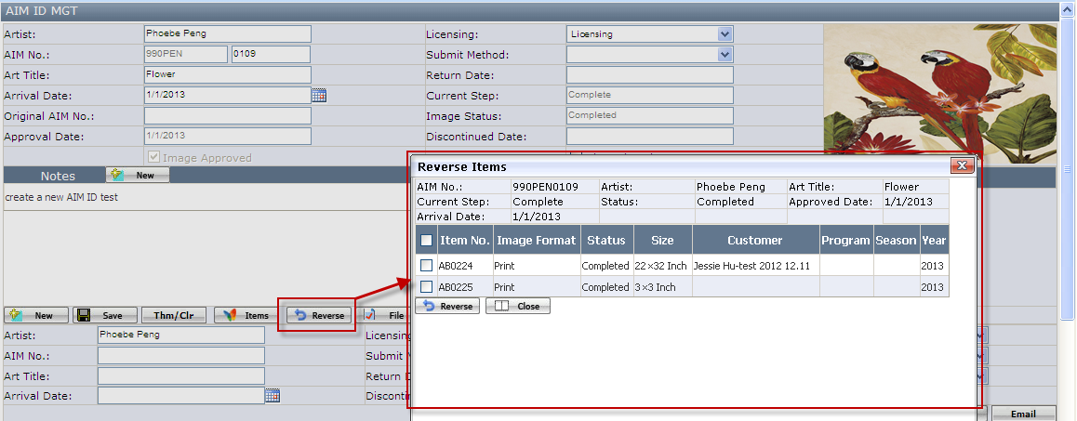
  - Select all items and click "reverse" button in Reverse items pop up windows.
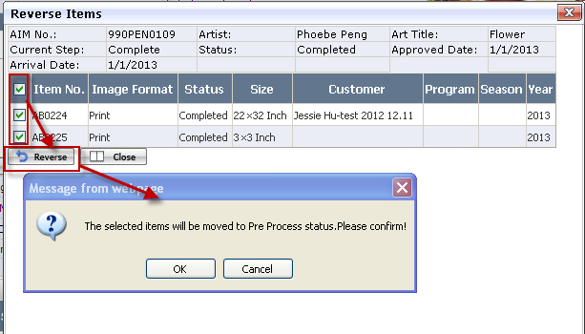
  - Click the ok button and the AIM ID Process reverse from "completed" to "Pre Process".
At this time, the image approved checkbox is checked and image status is completed.
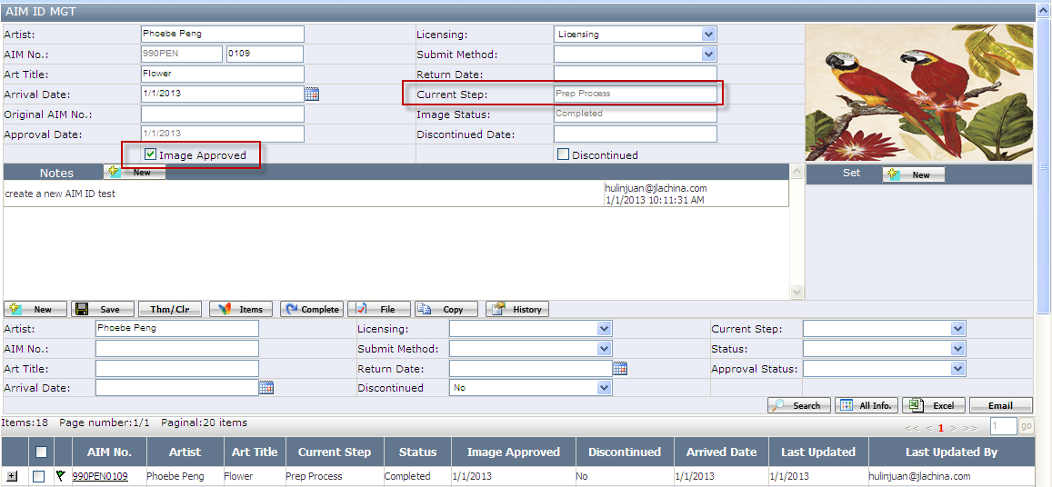
  - Remove" Image Approved" checkbox, the current process step will stay “Prep Process”, the image status will back to “In Prepress”
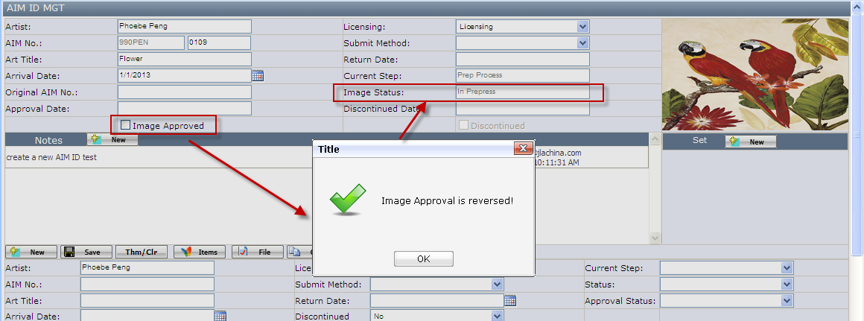

How to Cancel AIM ID
The AIM ID can be canceled only when the image approved checkbox is unchecked. Click the “Cancel” button on AIM ID web page, the AIM ID and all the Aim items will be canceled.
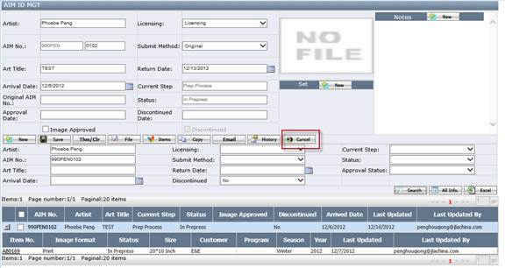

How to do AIM Item

How to create AIM Item
The AIM item can be created when the AIM ID current step is creation, Prep Process and Complete
Click the button “items” at AIM ID webpage and pop up the item create page as below:
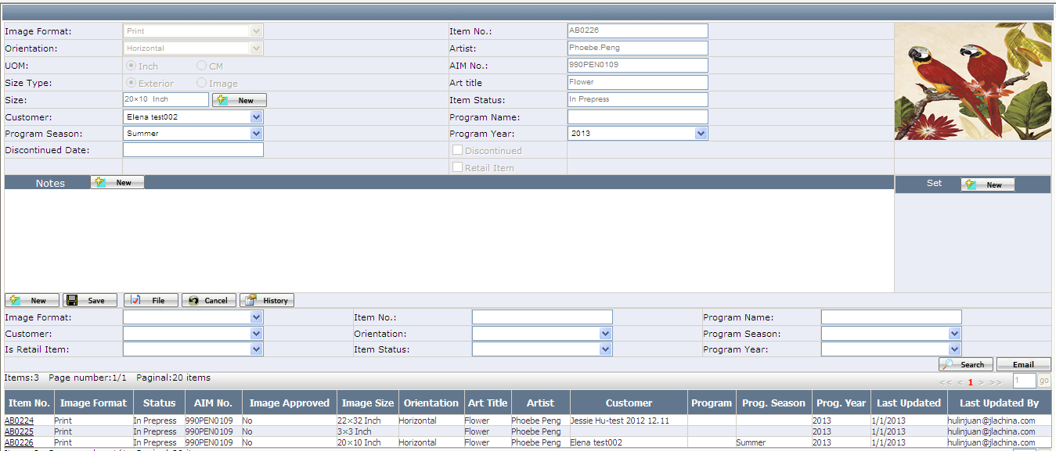
[Pict-1]
Key fields:
  - Image format: Drop down list and 2 options: print and canvas.
If the Image Format is print, the page stay as above.
If the image format is Canvas, the Item page layout will show as below [Pict-2]

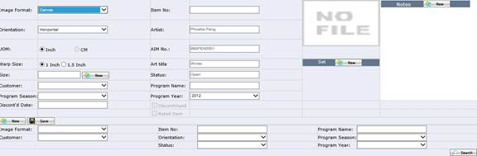
[Pict-2]
  - Size: click size field to pop up size selection page.
  - The “new” button beside "size": click the “new” button to open the "size" page to create a new print size.
  - Item No.: Generated by system.
**********************************************************************************************************
Notes: Item status: this item status is changed with AIM ID, the rule is as below:
a.) When we create the items at AIM ID process "Creation", the item status is “open”.
b.) When we create the items at AIM ID process "Prep Process" or Complete, the item status is “In Prepress”.
**********************************************************************************************************

How to reverse AIM item status—not finished
The AIM item reverse linked with AIM ID, If you want to reverse item, you have to find the AIM ID at first.

How to cancel AIM item status
- The AIM item can be canceled only when the image status is at “In Prepress” and Current step is at “Prep Process. Click the “Cancel” button on AIM Item Edit page, and the AIM item will be cancelled.
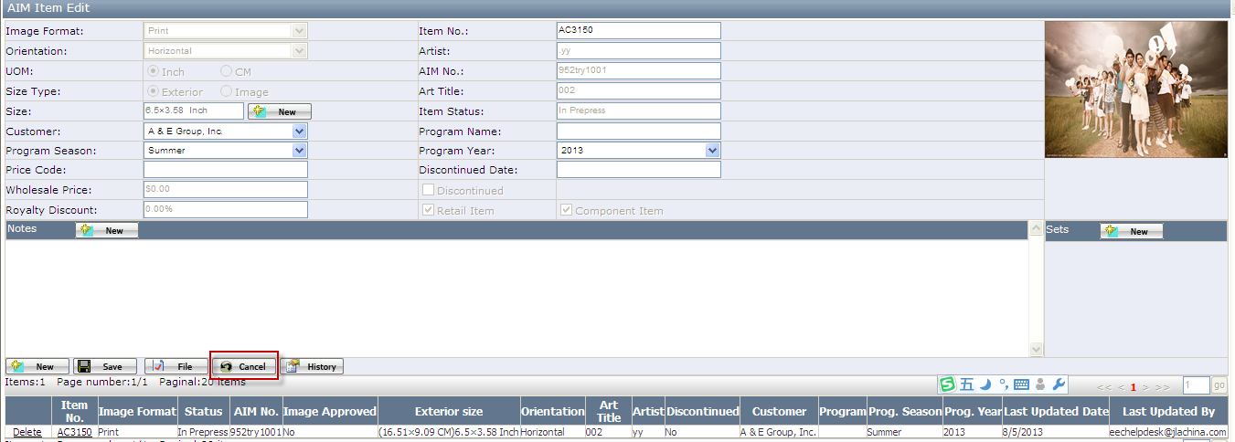
After click<Cancel> button as below
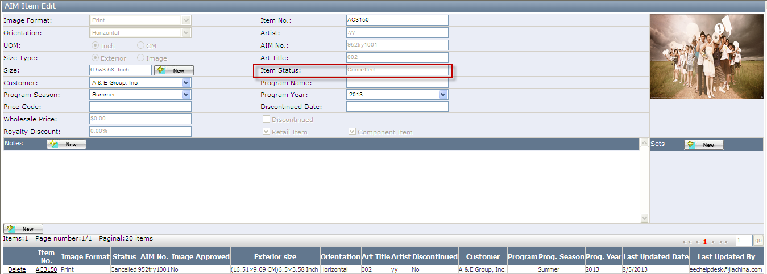

How to create Artist
1. Go to Art In Motion-->AIM Maintenance-->Artist, click the <New> button:
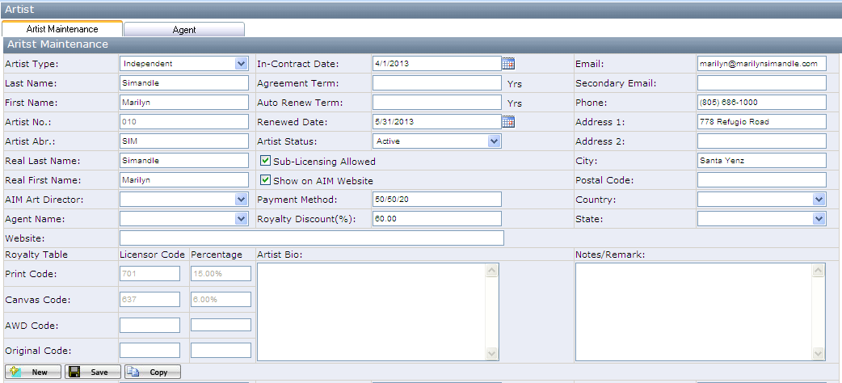
[Pict-19]
KEY Fields:
- Artist Type.：Dropdown List with three options：Independent, In-house, In-house with royalty.
- Artist No.: Generate by system.
- Artist Abr.: Generate by system.
- Aim Art Director: dropdown and values is all Vancouver office person.
- Print Code: Generate with system. Don's allow to editable.
- Canvas Code: Generate with system. Don's allow to editable.
- AWD Code: Generate by system.
- Artist Status: Dropdown List with three options: Active, Inactive and Released. Default is Active.
Active: Artist who is currently in contract with Art box, submitting artwork;
Inactive: We don't make the contract with artist but we still use artist's old artwork.
Released: We don't make the contract with artist and don't use artist's artwork too. the related AIM ID and item should be discontinued.
- Sub-Licensing: It means this artist’s Artwork can be used to other products. Default is checked.
- Shown on AIM Website: Checked this box means this artist information will show at AIM Website backend. Default is unchecked.

2. Fill all the required fields in the artist page and click the save button. Then the new artist is created in our system.

How to setup Licensor Code
1. Go to Art In Motion-->AIM Maintenance-->Licensor code, click <New> button.
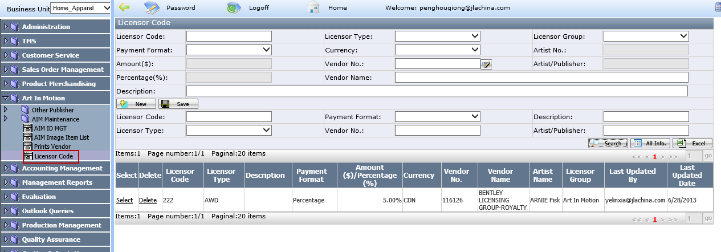
KEY Fields:
- Licensor Code: it is a required field and need to manually type, At most 5 digitals are allowed here.
- Payment Format: Dropdown list with 2 options: Pre Piece and Percentage.
- Amount: it is required field when the payment format is Pre Piece, need to type manually
- Percentage: it is required field when the payment format is Percentage, need to type manually
- Licensor type: Dropdown list with 4 options: AWD, Canvas, Original and Prints.
- Currency: Dropdown list with 2 options: USD and CDN.
- Licensor group: Dropdown List with 2 options: “Art in Motion” and “Outsider publisher”. Art in motion means this licensor code for art in motion publisher, “outside publisher” means the licensor code is for outside publisher.
- Artist No.: if the licensor group is “Art in Motion”, the Artist No. is a required field; User can type Artist no. or Artist name to search the artist from the dropdown list. If the licensor code is “outside publisher”, the field can’t be edited.
- Artist/Publisher: if the licensor group is Art in Motion and the Artist no. is selected from the dropdown list, the Artist name will be automatically displayed in the Artist field. If the Licensor Group is outside publisher, the Artist/Publisher field is editable
- Vendor No.: it is required field. Click the pencil button () to open Vendor Search page. The information is from Vendor page. If you can’t find the Vendor No., you need to add it in Prints Vendor page firstly.
- Vendor Name: will be Linked from Prints Vendor page when select Vendor No.

2. Fill all the required fields in the page and click the save button. Then the licensor code is created successfully.

How to maintain Prints Vendor
1. Go to Art In Motion-->Prints Vendor, click <New> button.
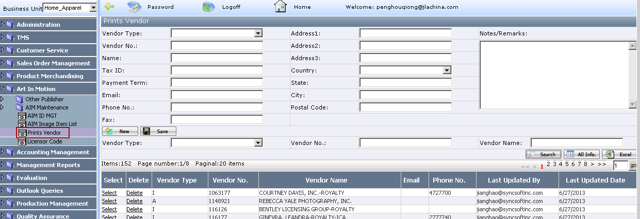
Key field:
- Vendor Type: Dropdown list with 2 options: A and I. Not required field
- Vendor No.: it’s a required field and need to filled by user manually。
- Name: it’s a required field Need and need to filled by user manually。

2. Filled the required field and save.

