New E-com User Guideline
Version: 1.0 27-1-2016

How to log into EEC
- In IE browser, type EEC Testing address: https://eecsystem.cn
- In EEC Login Page, type your User Name, Password and Check Code. (See Figure 1-1). EEC Helpdesk will send you user name and password if you do not have an account. If you have a user ID but forgot the password, please click Forgot Your Password to reset your password.
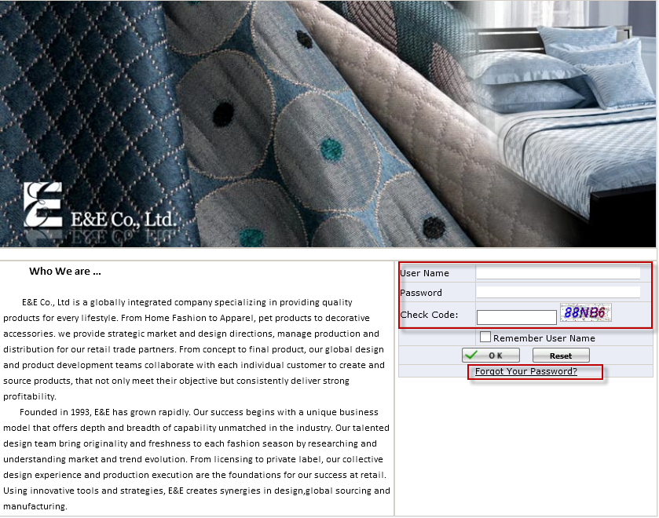
Figure 1-1 EEC Login Page

How to Maintenance Field Name
- Click Field Name to open Field Name Page
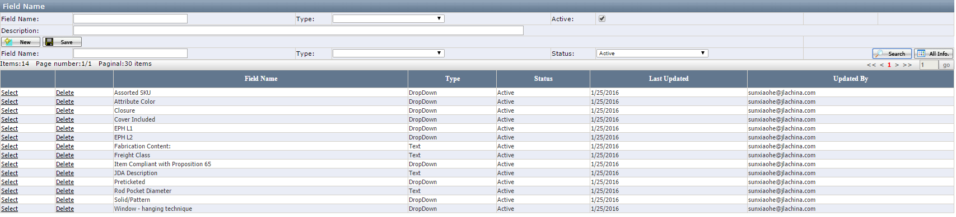

- Enter Field Name, Select Type and enter Description if having and click Save. Description field will be used as tool tips in the Ecom Master Item Master page.
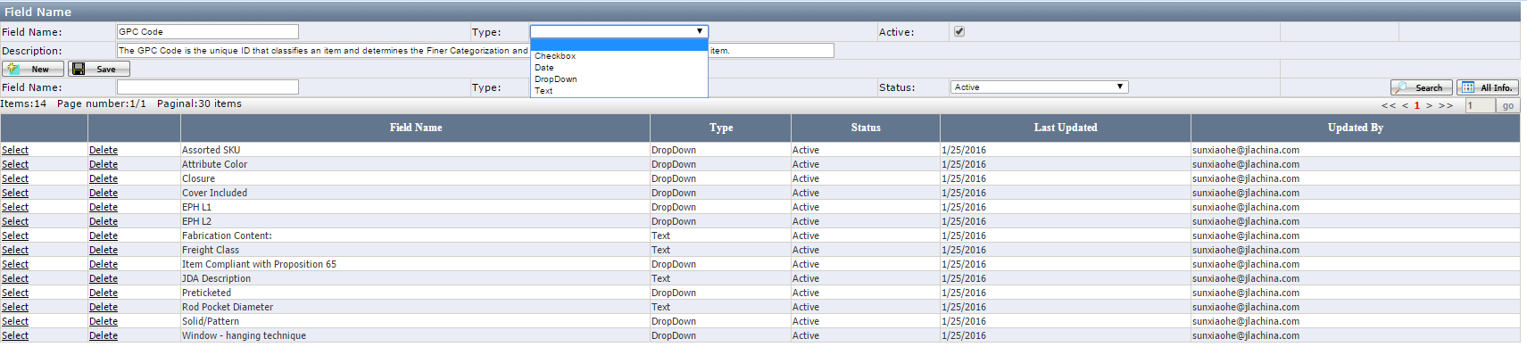

Note:

- Field Name: It is not allowed to be duplicated. When duplicating, it will give the warning message "Fail to save due to the Field Name XXX is duplicated！" If it is used in the Customer Template or Customer Setup Sheet or Field Value or Ecom Item, you have to remove it from those page first.
- Type: The drop down list contains Blank, Text, Date and Checkbox, Dropdown. Default to blank. Type is grayed out once it is successfully saved.
- Active: If the field name is no longer used for any customer, you can remove them in the Customer Template and Customer Setup Sheet first and uncheck it. The warning will be "This Field has been used in Customer Template and Customer Setup Sheet, please delete them first.” If you do not remove them in the Customer Template and Customer Setup Sheet first

How to Maintenance Field Value
- Click Field Value to open Field Value page (See Figure 2-3)

a．Build
- Field Name: It is required and auto Complete Field that’s to say user has to select the field name from the drop down list. (Developer will configure the Field Name)
- Value: It is required and manual enter.
- Active: Default to check and it is not required.
- Notes: Field Value is not allowed to duplicate in the same Field Name.
b. Search
- Field Name: Auto Complete Field that’s to say user has to select the field name from the drop down list. (Developer will configure the Field Name)
- Value: Manual Enter.
- Active: Default to Active.
- Grid: Click Grid Title to sort information.

How to maintenance Setup Sheet Template

1) Setup Sheet Template to open Setup Sheet Template page (See Figure 2-4).
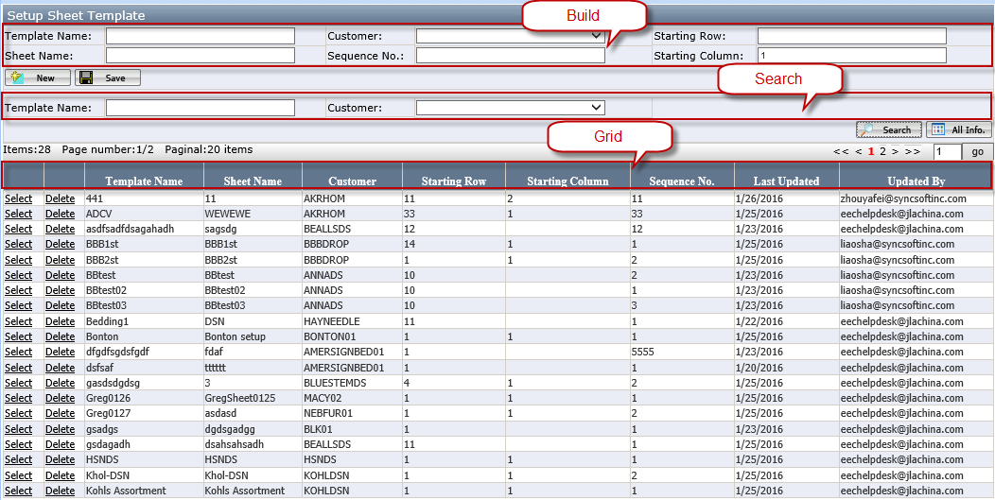
Figure 2-4 Name Selection Page
a．Build
- Template Name: It is required and manual enter, it is not allowed to duplicate in the same Customer.
- Customer: It is required and select the value from dropdown list.
- Starting Row: It means data beginning to record from which row in the Excel.
- Starting Column: It means data beginning to record from which column in the Excel. Default to 1.
- Sheet Name: It is required and manual enter.
- Sequence No.: It means Order. e.g. If the A Sequence No. is 1 and B Sequence No. is 2, use combine A with B in a Excel, A sheet will put in front of B Sheet. Besides, the Sequence No. is not allowed to duplicate in the same Customer. Besides,
If one of the Column No. is changed or the column no is deleted, it is auto calculated the Column No.
If the new Column No is greater than maximum Column No, system will give the warning and not allow to save successfully.

Field Name | Column No | After Delete Field B |  | After insert D with Colum No 2 between A and C
A | 1 | Field Name | Column No | Field Name | Column No
B | 2 | A | 1 | A | 1
C | 3 | C | 2 | D | 2
 |  |  |  | C | 3

b. Search
- Template Name: Manual Enter.
- Customer: Select the value from the dropdown list.
c. Grid: Click Grid Title to sort information.

- Click Detail to open Setup Sheet Template page (See Figure 2-5).
Note: Only select ant Template can see the Detail Button.

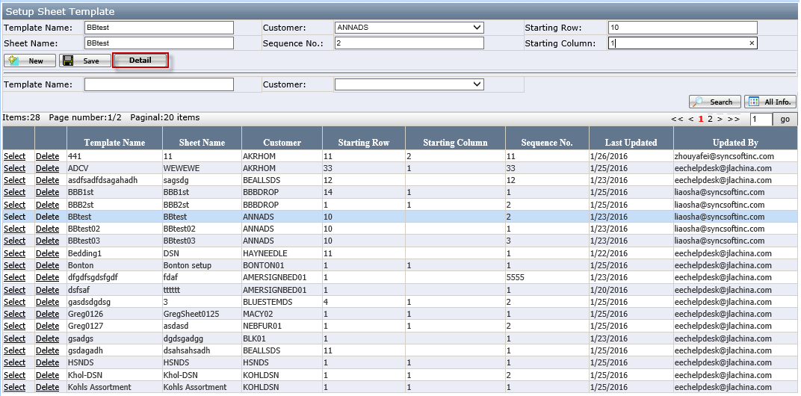
Figure 2-5 Detail Button
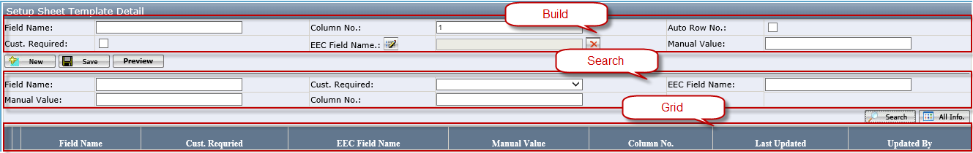
Figure 2-6 Setup Sheet Template Detail page
Build
- Field Name: It is required and auto Complete Field that’s to say user has to select the field name from the drop down list. (Developer will configure the Field Name)
- Column No.: Default to 1. It will auto add 1 when user clicks New Button. It is required.
- Auto Row No.: Default to not check. It is optional.
- Cust. Required: Default to check. It is optional. If check the Cust. Required, the background of Field Name is orange in the exported excel; otherwise it is blank.
- EEC Field Name: Click to open the EEC Field Name Selection and it is optional.(See Figure 2-7)
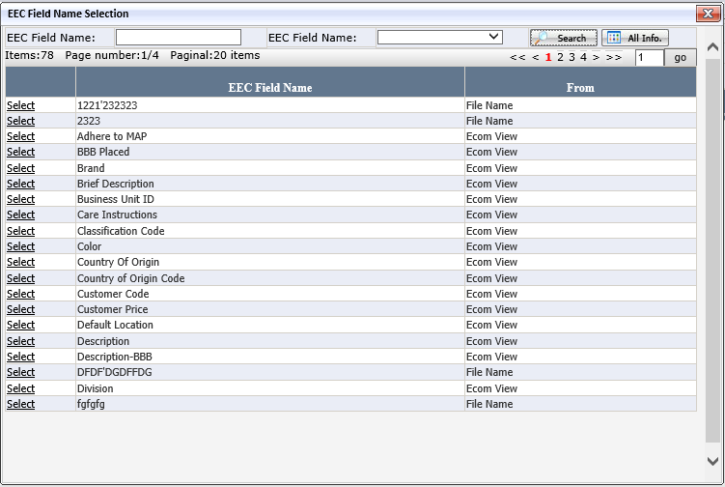
Figure 2-7 EEC Field Name Selection page
- Manual Value: It is not required and manual enter. E.g. If user fields “A” in the Manual Value, the value of Field Name will default to “A” in the exported Excel.
b. Grid: Click Grid Title to sort information.

Notes:
- If the customer provided sheet has the merged cells in the Excel such like Kohl’s and the user has to configure three field names such as “Fill Material 1”, “Fill Material 2”, “Fill Material 3”.(See Figure 2-7).
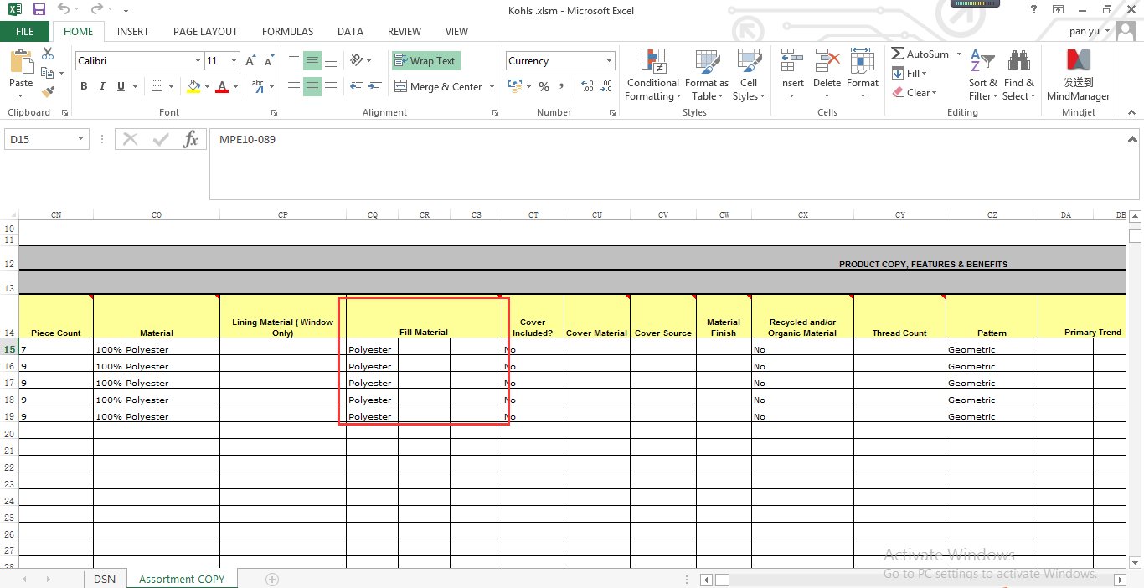
Figure 2-7 Kohl’s Excel
- If the customer provided sheet have hidden Fields in the Excel and the user has to configure this hidden field to make sure the customer can get the right data.

How to Maintenance Customer Template
- Click Maintenance under New E-com (See Figure 2-1)
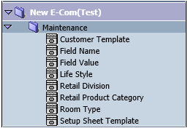
Figure 2-1 Ecom Maintenance

- Click Customer Template to open Customer Template page (See Figure 2-2)

- Build
- Customer: It is required and select the value from dropdown list.
- Field Name: It is required and auto Complete Field that’s to say user has to select the field name from the drop down list.
- Required: Default to check and it means whether appear in the Item Detail Page; if yes, this field will be show in Item Detail Page; otherwise, it will not appear in the Item Detail Page. (Item Detail Page will be published in 2/25/2016, Now please see the Item Detail Demo)
- Notes: Field Name is not allowed to duplicate in the same Customer.
- Search
- Customer: Default to blank and blank means all.
- Field Name: Default to blank and blank means all.
- Required: Default to blank and blank means all.
- Grid: Click Grid Title to sort information.
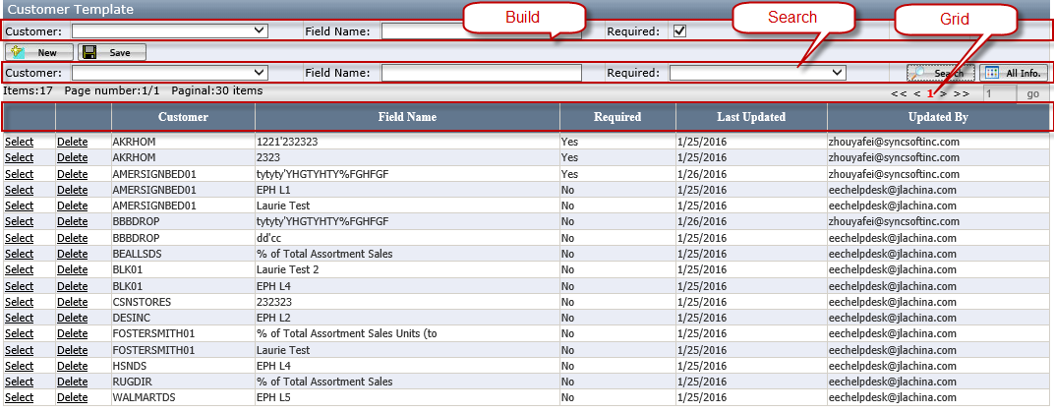
Figure 2-2 Customer Template Page
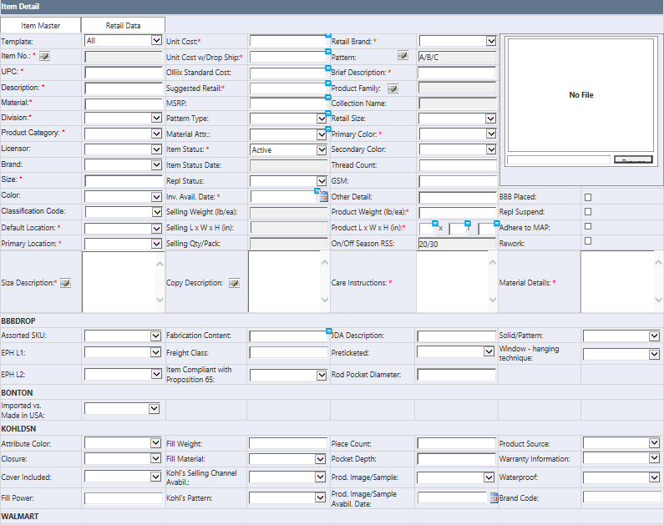
Figure 2-3 Item Detail Demo

