Match Report User Manual

Goal
This module is mainly used for accounting department to ensure the compliance between invoices and cash through an efficient way. If the amount of invoices we received is inconsistent with the amount of cash, the accounting team will initiate some credit memo or debit memo, and this module enable to automatically link those memos, to make a match check with corresponding invoice.

Work Flow
For the match report function, there are below process steps:

Generate Report
Invoice Check
Import 820/ excel file
Start

Run Service to do Macola Match
Link Sales Trx
Match Check
End

Notes:
1. Below process step are doing by accounting team:
- Import invoice by excel file
- Generate Report
- Invoice check
- Link sales Trx
- Pre-Match
2. Below process steps, system will do it.
- Import 820
- Macola Match

How to Make a Match Report

Import Invoice File
- System will use below two ways to import invoices.
- For 820 document, system will automatically import by below service (“ReadEDI”).
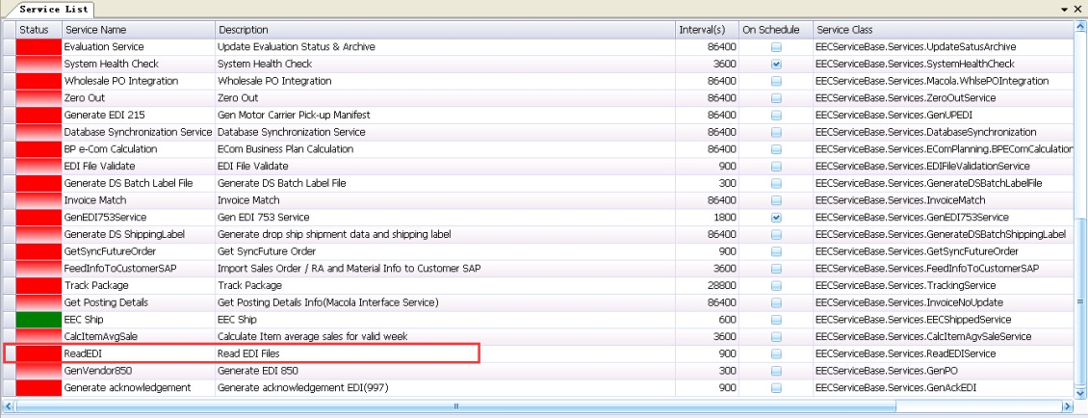

- For excel file, accounting need import the files manually. Go to match report, click <Import File> button to import it.
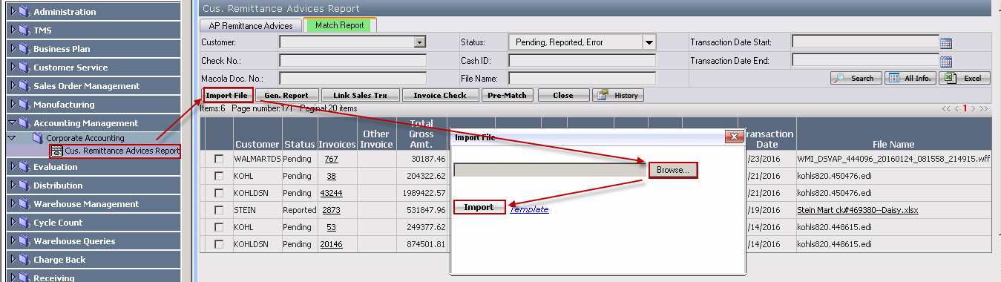

Template of the excel file:
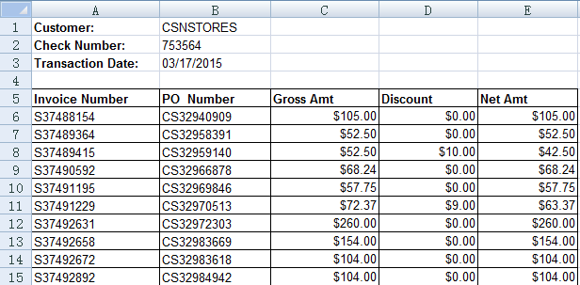
Notes:
- For DESINC, put invoice no. in invoice number column.
- For others, put the order no. with prefix S in invoice number column.
- Check Number: It is check number and entered by user.
- Transaction Date: It is check created date.
- Po Number in the grid: It is Customer PO No in EEC sales order list.

- After successfully imported the files, the invoices will be listed under Accounting Management/Corporate Accounting/Cus. Remittance Advices Report/Match Report tab and the status will be pending.
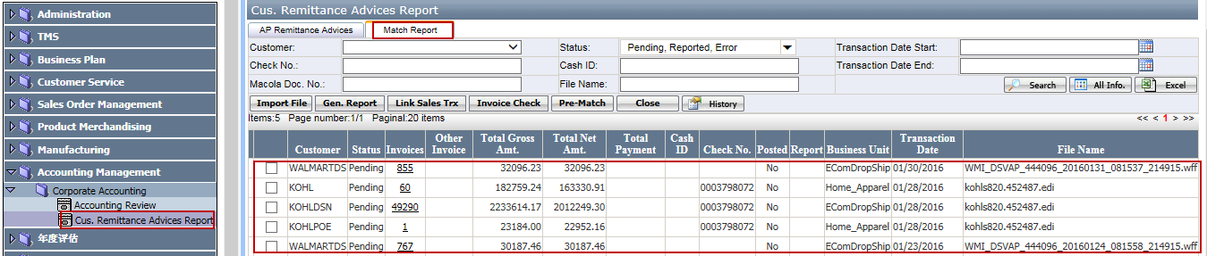
Search Criteria:
- Customer: it is dropdown list for customer
- Status:
- Pending: When the record is initialized from 820/excel file.
- Reported: When the record has been generated excel report.
- Ready to Match: When EEC has done the match check and there is no error.
- Matched: When service has successfully done the match process.
- Error: When service fails to match or there is error during match check.
- Closed: When it is closed manually by user. (If you don’t want EEC to deal with the record, you can close it manually).
- Transaction Date Start & Transaction Date End: refers to the date of EDI 820/excel file
- Check No.: which imported from EDI 820 file/excel file
- Cash ID: the cash ID stored in Macola
- Macola Doc No.: the number of sales transaction which created in Macola
- File Name: the name of EDI 820/excel file
Button function:
      - Search button: which is used to search out the results based on entered search option(s)
      - All Info. Button: which enable to export all of the information, and empty the search criteria
      - Excel button: which enable to export the report as an Excel format

Notes:
- One imported 820 file may generate one or multiple records based on different customer code in Macola. In below example, one 820 file generates 3 records: Kohl, KohlDSN and KOHLPOE.
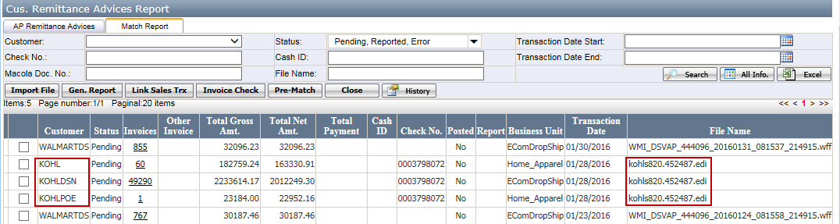
- The number of invoices involved in each customer record will be calculated out

Generate Report
- Select 820 file which the status is pending and click <Gen.Report> button to generate report, please see the below screen shot.
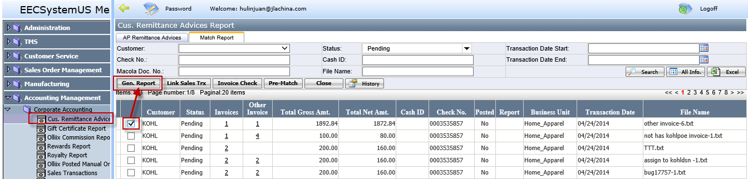

- Click <Gen.Report> button to pop up the message: “System will generate report for records in the same file, do you want to continue?” Click ok to generate report for the invoices. Then the Status will change from Pending to Reported. The report column will show “View” button(see below screenshot)：
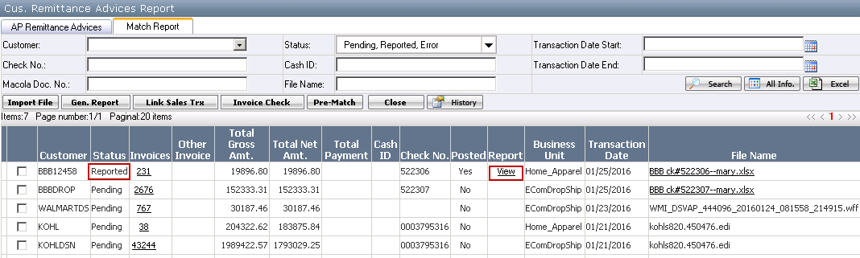
Buttons:
- Gen.Report: This button is used to generate report. It has three functions.
  - Generate the report. The report column will show the view button.
  - Merged the repeated records. The merged the repeated records will show in invoice column and click the links to open the detail page.
  - Change the record status from pending to reported.
- Link Sales Trx: This button is used to link with credit memo or debt memo with invoice.
- Invoice check: It is used to check the selected record’s macola invoice status and compare the macola invoice amount with the 820 invoice amount. The detail see <How to Make the Invoice Check>
- View links: It will show in Report column. Click<View> links to open and view the report.
- Invoices column: The number of invoices in this column may be changed when status change from pending to reported because some records will be merged. The merged rule is as below:
  - If customer’s Business Unit is Home_Apparel, the record will be merged based on invoice number. That is to say, if two or multiple records’ invoice number is same, these records will be merged into one. Meanwhile, Net Amount, Discount Amount & Gross Amount in each record will be merged as well.
  - If customer’s Business Unit is EComDropShip, the records will be merged based on Macola order number. Other things are same as business unit home_apparel.
- Invoices links: clicking on Invoices links to open below pages.
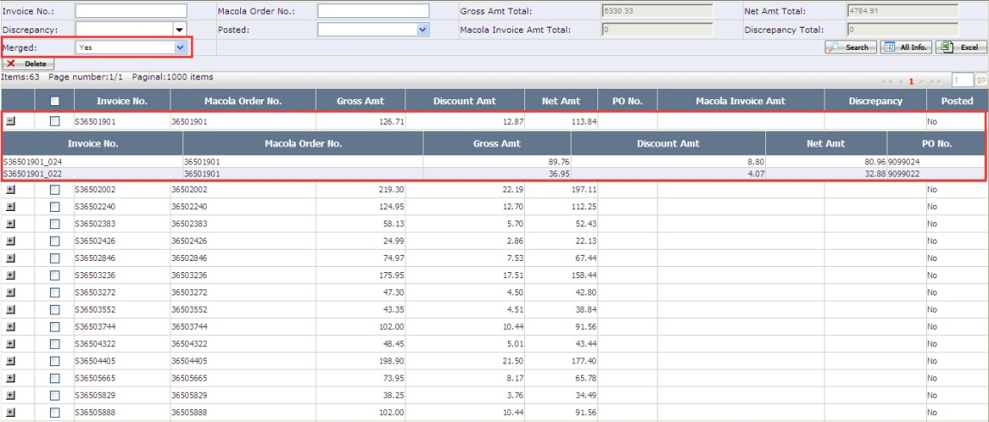
Notes:
- Delete: this button is used to delete the invoice which is matched or not belongs to this customer code.
- In the page, there is a dropdown list field called “Merged”，user can use this field to know which record is merged.
- If selecting “Yes”, all of the merged records will display on this page. And there will be a plus icon appear in front of each record, which enable to expand the duplicate records
- If selecting “No”, all of the unmerged records will display on this page
- If selecting none, all of the records will display on this page
- Other Invoice column: This column is used to store some invoices that cannot be determined customer account which belongs to KOHL, KOHLPOE or KOHLDSN. Please see the detail in <How to Assign Invoice to Customer Account>

Invoice Check
- Select one record and click on <Invoice Check> button.
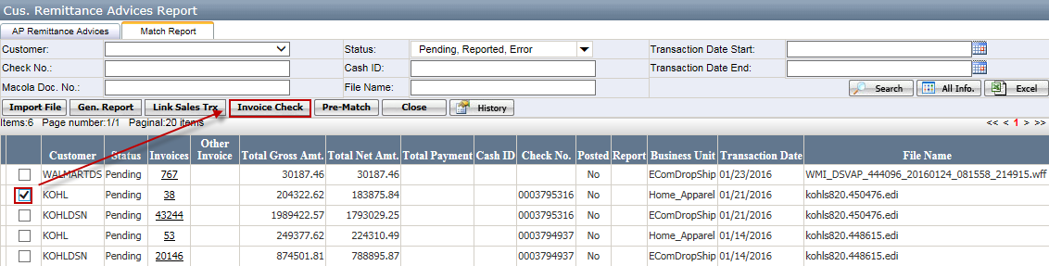
- If its related invoices have not been posted in Macola (C001 or C111), it will display a warning message, saying like: “Some invoices have not been posted yet.” User can go to invoice detail pop up window and use the <posted> search criteria to find out which records are not posted and manually posted them in Macola.
Notes: If the invoice is posted, user can find this record in database table “oehdrhst_sql”
- If the related invoices have been posted in Macola, system will check whether the invoice is open status (In database table banktransaction’s status=”C”). That is to say, this invoice is not match with any orders. If it is not open status, it means this invoice has matched with orders and user should delete this invoice. In the invoice links page, use<delete> button to delete this invoice.
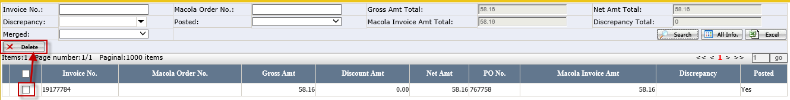
  - <Delete> : It is used to delete invoice which has matched.
- If the related invoices are open, system will check whether the Macola invoice amount is same as EEC invoice amount. If it is same, the discrepancy=0 in invoice detail page. If it is not same, it will pop up message: “There are some invoices are different from the amount in Macola.” User can go to invoice detail page and review the discrepancy (see below screenshot). Then user can generate credit memo or debit memo in Macola.
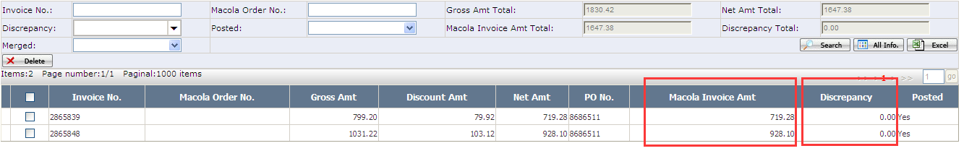
- If all check is passed, will pop up a message, saying: “Check Successfully”.

Link Sales Transaction
This step is not required unless the invoices have the discrepancy in the amount and have been created the Credit memo and Debt Memo in Macola.
- Select one record by clicking on <Link Sales Trx> button to link related sales transaction(s). When it is clicked, sales transactions selection window opens.
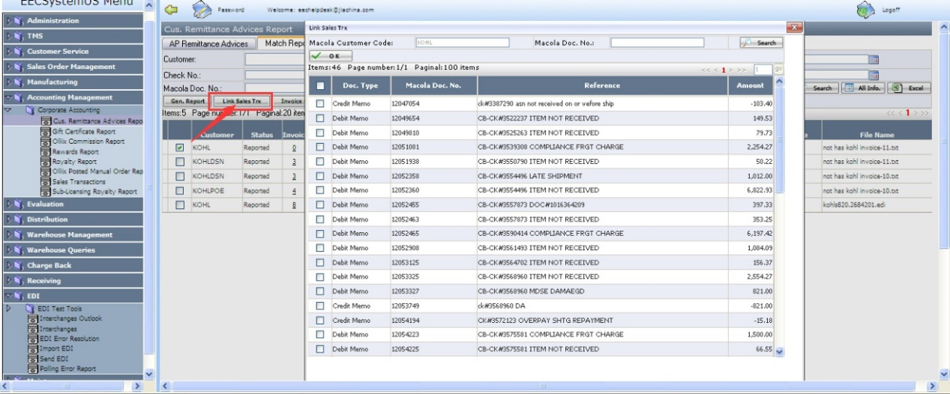
Notes:
- Only display the selected customer’s sales transactions
- Those sales transactions should be the ones that have not been linked or matched
- Allow to multi-select sales transactions to link.
- The button is only used when the record is reported status. If the record is “Ready to Match” or “Matched”, when user clicks <Link Sales Trx>, pop up message: “You cannot link any sales transactions to it because it is ready to match or has been matched.”
- Selected the links sales Trx and click ok, the sales Trx will be added into the record. See below:
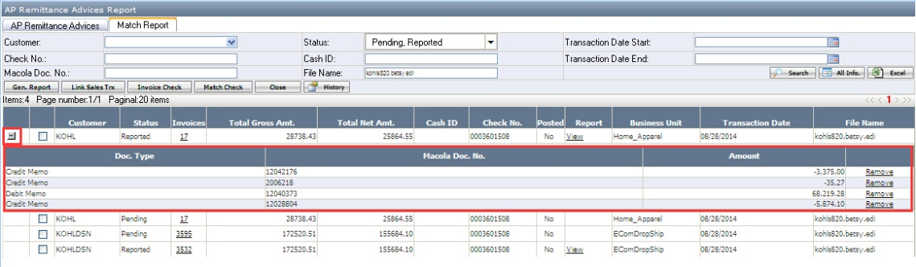
Notes:
- The linked sales transactions will display under the selected record.
- The user can remove the linked sales transactions from the match report if the links are not correct. But if the record status is “Ready to Match” or “Matched”, “Remove” will be disabled.

Do Pre-Match
- Select one record which status is “reported” and click on <Pre-Match> button to check if it is ready to match in corresponding Macola database (please see the below screen shot):
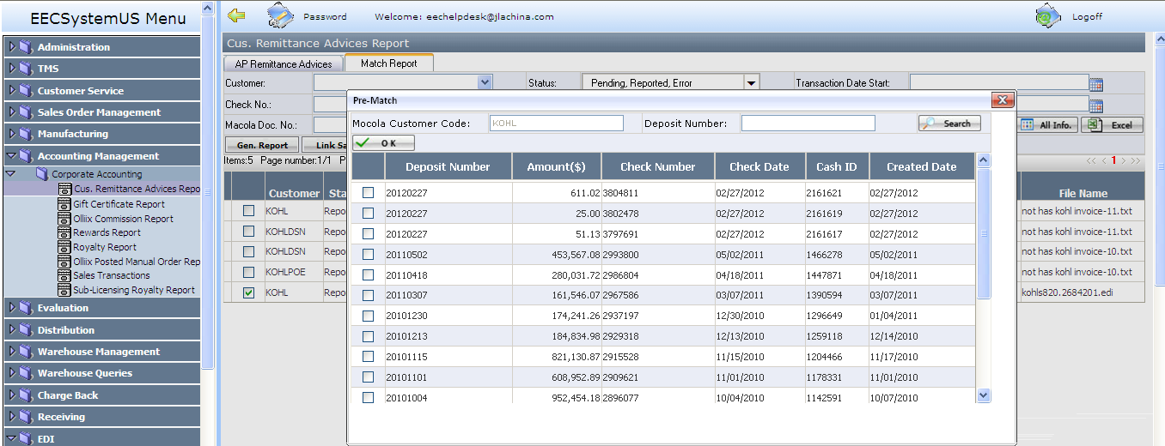
Pre-Match button function:
- Pop up pre-match window. If selected deposit number has been done match check for another record in the same business unit, a warning message will display, saying like: “ Cash ID xxxxxx has passed match check, duplicated cash ID is not allowed”
- Do amount check:
The amount of selected deposit number = all related invoices/macola orders amount + all related debit memo amount + all related credit memo amount.
- If all check is passed, the status will change to “Ready to Match”,
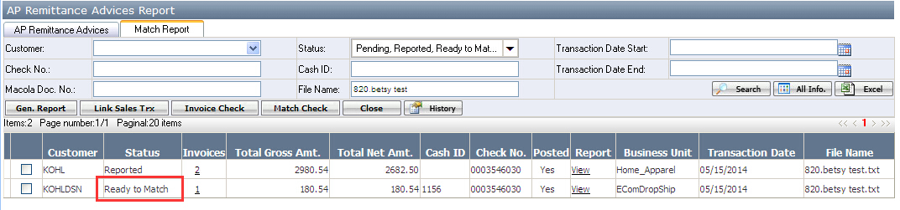
- Otherwise, an Error hyperlink will appear, to allow the user to click it to see the error details

Macola Match
- Run EECService (“Invoice Match”) automatically
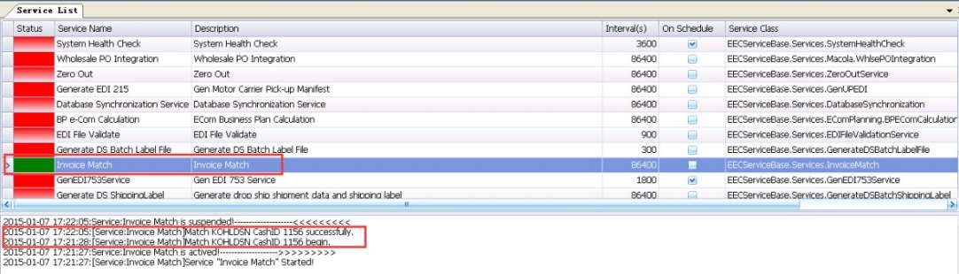

- Once it is successfully matched, its status will change to “Matched”
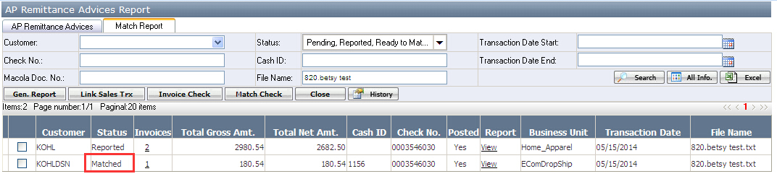

How to Assign Invoice to Customer Account
When system read the 820 document, system will follow the specific rule to assign the customer account to the invoices, but there are some invoices, system can’t figure out it. For such case, the user needs to assign it manually. The details are as below:

- Click the hyperlink of the “other invoice” column. See below:
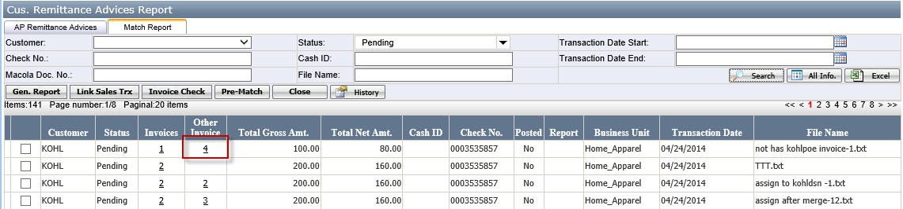
- Then it will be open the other invoice page as below
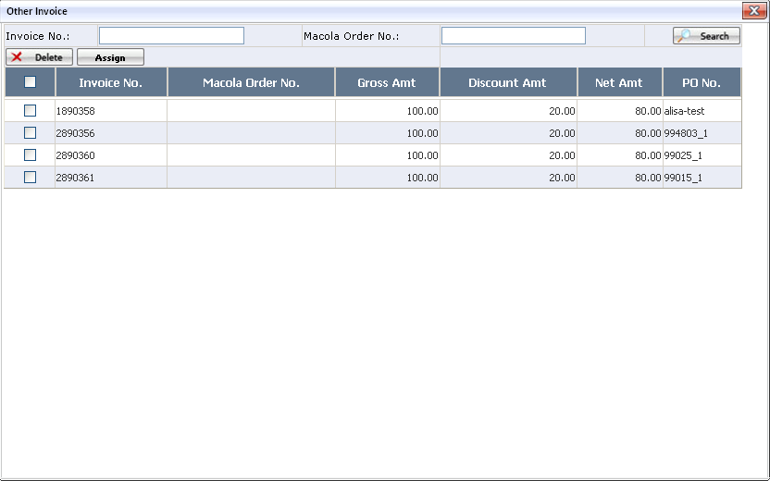
- Select one or multiple invoices, then click on <Assign> button:
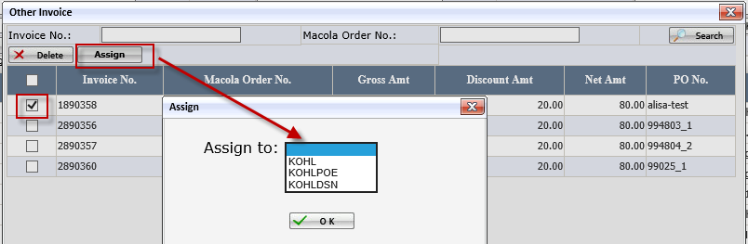
After selecting one customer and clicking <OK> button, there will be a confirmation message with <Yes> and <No> buttons appear. The message is saying: "Are you sure to assign selected invoice(s) to KOHLPOE?” Click <yes> button and assign successfully. The invoice no. will disappear from other invoice page and go to the assigned customer account page.
- Once successfully assign the invoice to the specified customer. Please note:
- the assigned invoice might be merged if meet merging demands.
- Gross Amt Total & Net Amt Total in the specified invoice list will be updated accordingly.
- the number of invoices on both of "Other Invoice" and "Specified Customer" will be updated accordingly.
- User should finish all of the invoices in "Other Invoice" invoice list before clicking on <Invoice Check> button, otherwise, there will be a warning message appears, saying like: "Please deal with other invoices of KOHL in the same 820 file first".

