Label Application User Guideline
Version: 2.0 1-19-2016

How to log into EEC
- In IE browser, type EEC Testing address: https://eecsystem.cn
- In EEC Login Page, type your User Name, Password and Check Code. (See Figure 1-1). EEC Helpdesk will send you user name and password if you do not have an account. If you have a user ID but forgot the password, please click Forgot Your Password to reset your password.
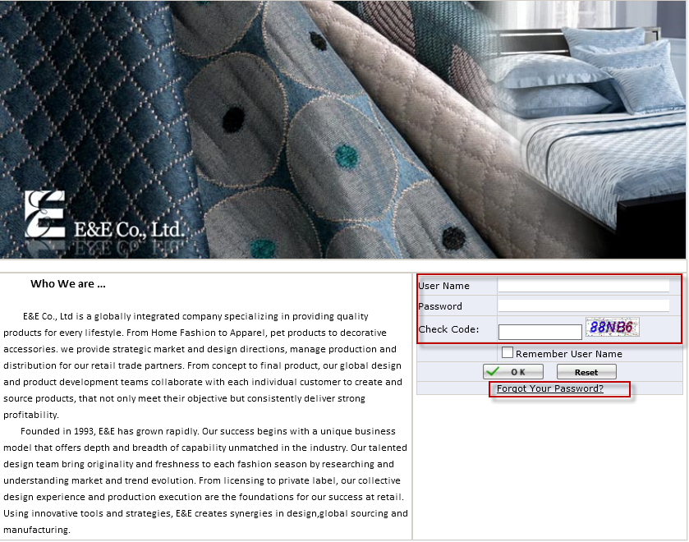

How to create a Label Application（Production Team）
- Click Review Order under Production Management to Open Review Order Page.
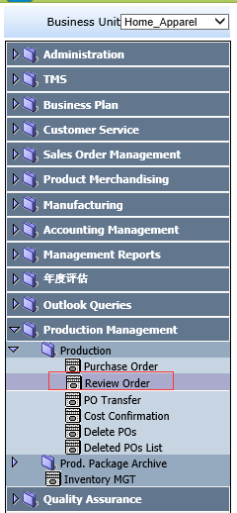

- Put a check for a PO and Click New Label
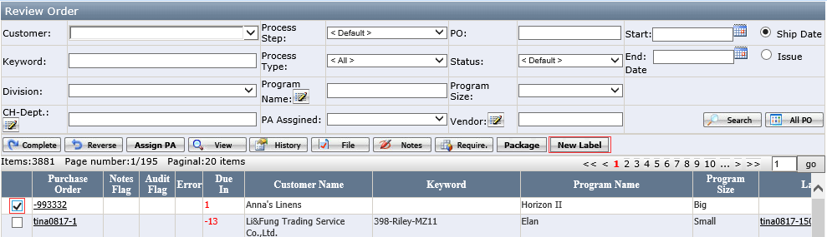

It will open Label Application Page.
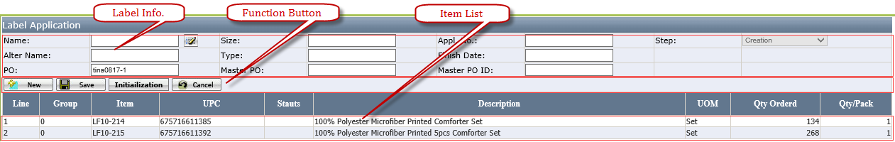

- Click the Pencil icon near to Name to select Label Name you request. (See Appendix C for Label selection Page Layout Introduction)

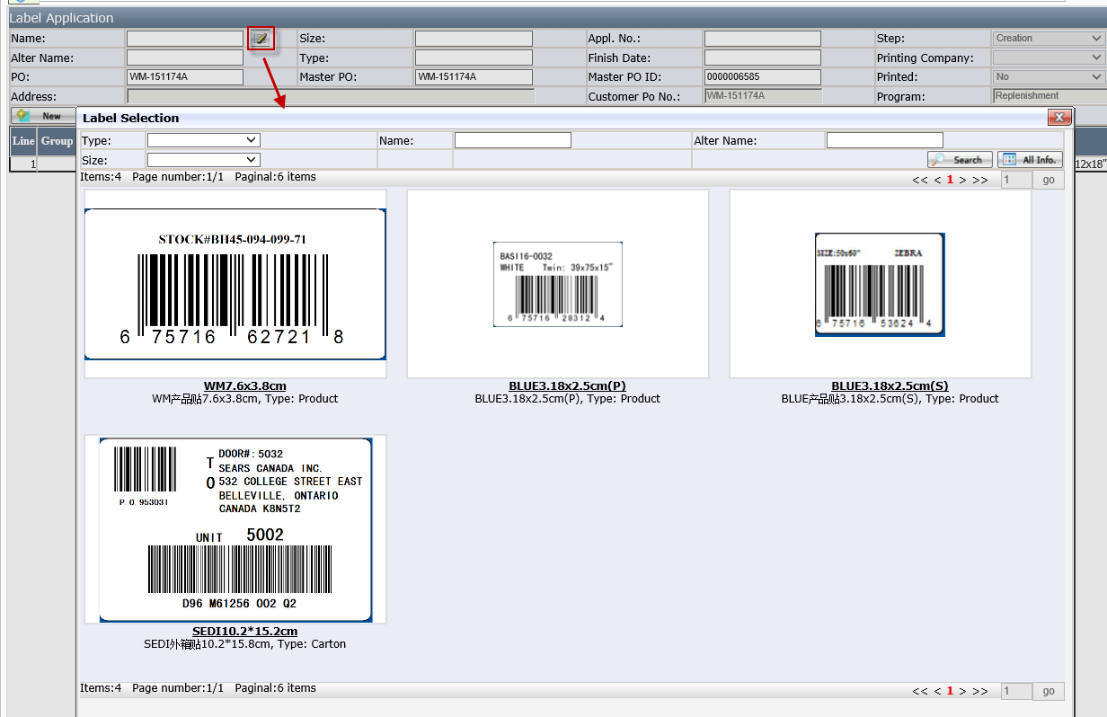
- Edit Color、Size、 Req. Qty. 、Ticket Price manually per request
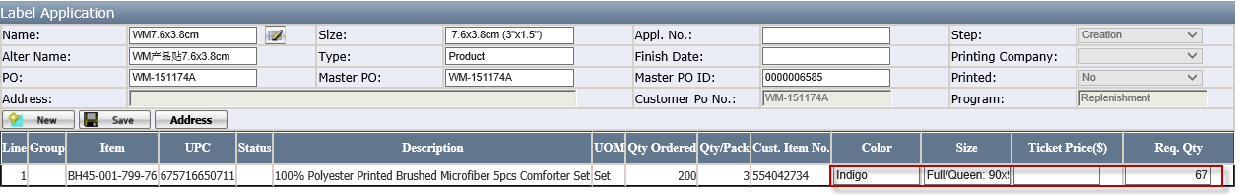
Notes：The Initial Req. Qty. = Qty. Ordered ÷ Qty. / Pack. If there is remainder, system will auto add 1
Or click Initialization to set all initial Req. Qty. In the Initialization Page, the user enters Ratio No and click OK. System will auto calculate the initial Req. Qty. accordingly. Req. Qty. = Qty. Ordered × Ratio No ÷ Qty. / Pack. The user can further modify the initialized Req. Qty. and click Save.
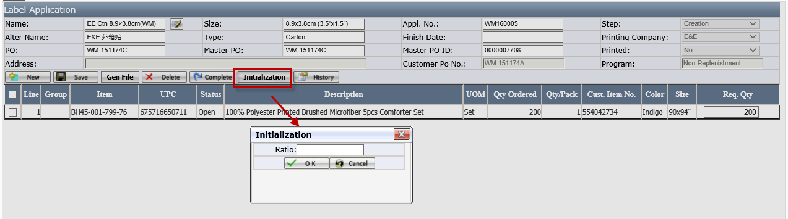

- Click “Address” button to maintain address if needed.
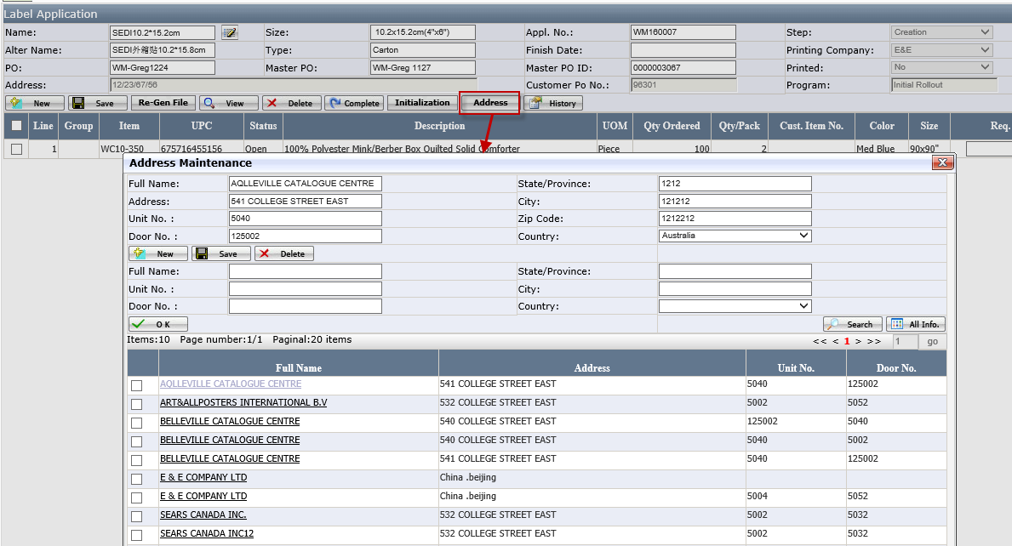

- Click “Gen File”to generate Label PDF file 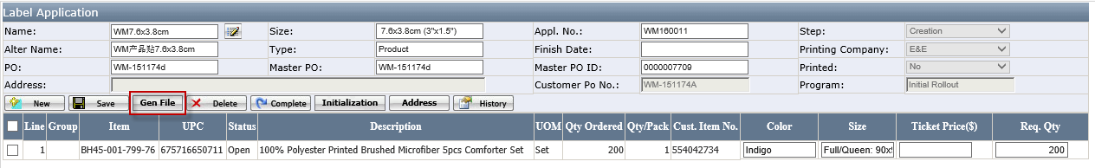
after that ,the view button will pop up.User can click this button to view the Label.

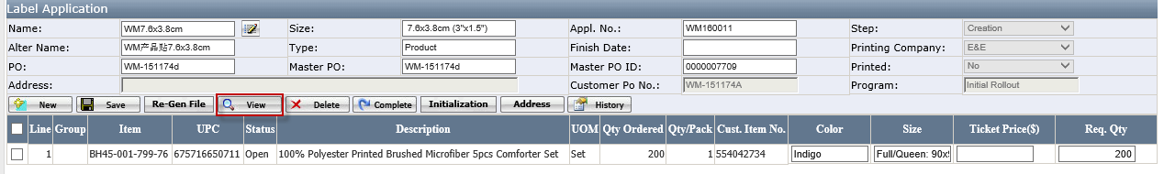
- Click Complete to submit the application. The application status will auto changed from Creation to Review.
- After the application submitted, if finding some items information is wrong, the user can select items and clicks Cancel to cancel some items.
Or send email to barcode team bc@scmhome.com to request them to reverse the application.
Once the item is cancelled, the item Status will change from Open to Cancelled. and system will also auto send Email to notify the related persons (See Figure 14-1 Email for Cancelled items). If the item is cancelled before print, the barcode team will not print the cancelled item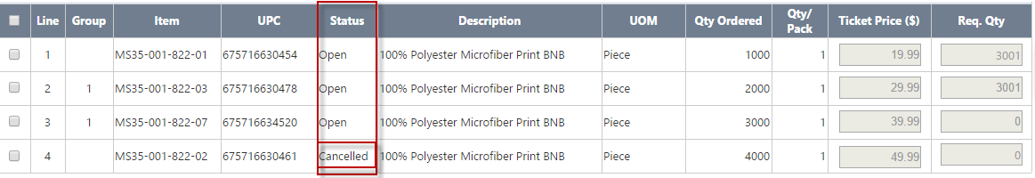
- If the application is created wrongly, the user can click Delete to delete the application. Delete is only visible when the application step is in Creation.
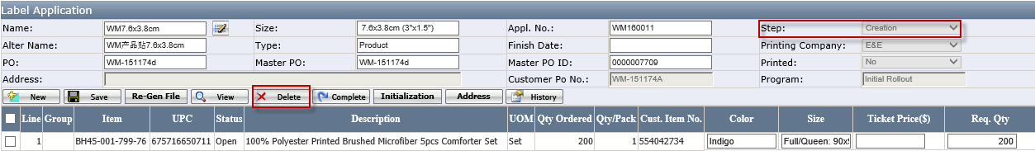

When to pick the printed labels
- If it is printed by our E&E Company, once the label is printed, you will get the email to request you to pick the label next day. (See Figure 14-2 Email for Complete)

- If the labels is printed by third printing company, you will get the email to follow it up (See Figure 14-3 Email for the third vendor )

How to Print Label (Label Team)
- Click Label Review under Label Mgt. to Open Label Review Page (See Figure 4-1)
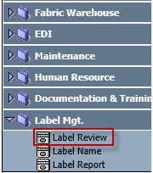

- Click the Appl. No to open the Label Detail Page
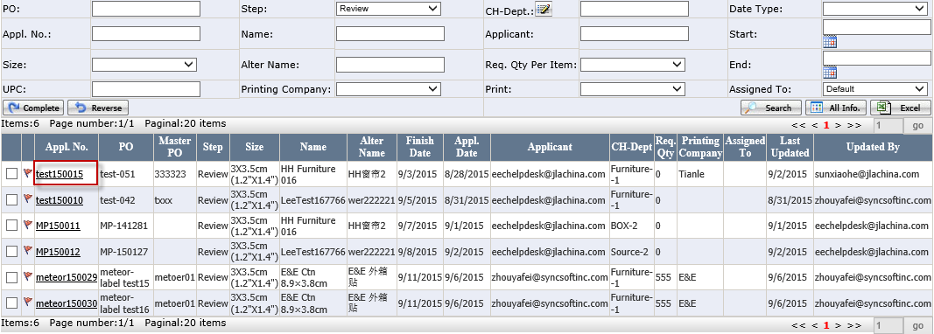

- It will open Label Detail Page
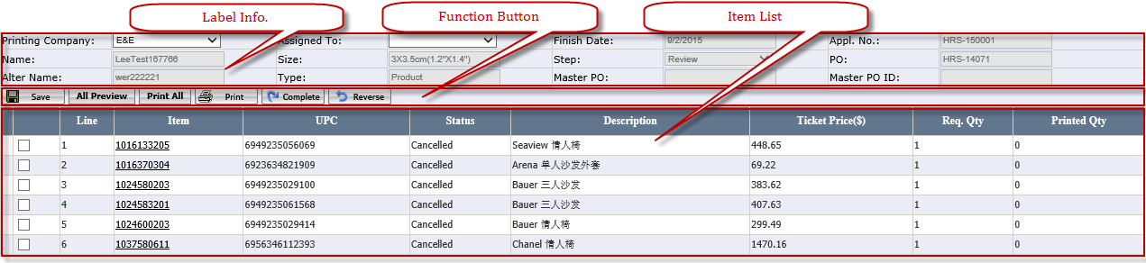

- Select Printing Company and Assigned To
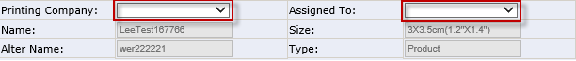

- Click Save and other Buttons will appear. System will not allow to save and will appear * unless Printing Company and Assigned To has been selected.
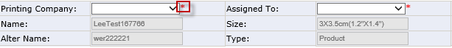

- Click All Preview to review all Labels (See Appendix E: Label PDF Page Layout Introduction.) Or click Item No can view this item zebra printed PDF (See Figure 4-6)
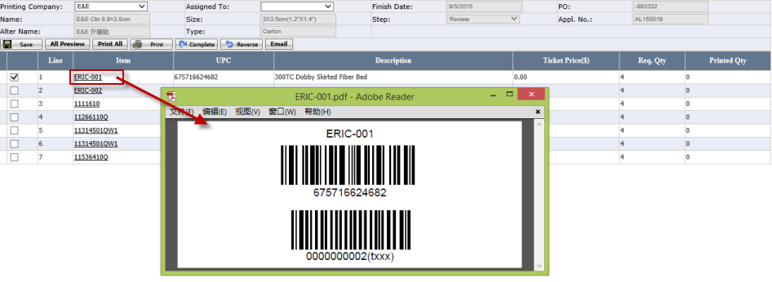

- If Printing Company is E&E, click Print All to print all item labels (See Appendix E: Label PDF Page Layout Introduction.)
- If Printing Company is the third vendor, the user do not need to click Print All.

- Put a check for an item, click Print to open Print Label Page.
- Enter New Print Qty. to print an individual item. If the sum (=New Print Qty. + Printed Qty.)>Req. Qty., system will warn “The summary of Printed Label is over the Req. Qty., Are you sure to continue?"
- The Initial value of New Print Qty. = Req. Qty. – Printed Qty. If Initial value is < 0, system will auto set New Print Qty. as 0 and
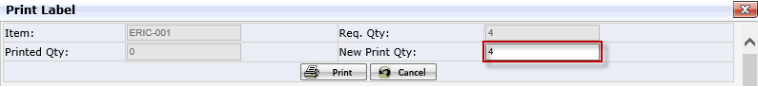

- If Printing Company is the third vendor, click Email to send a email with PDF.(See Figure 14-3 Email for the third vendor)

How to Maintain the label？
- Click “Label Name” under Label Mgt
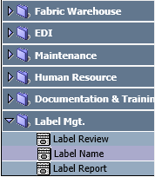

- System will open Label Name Page
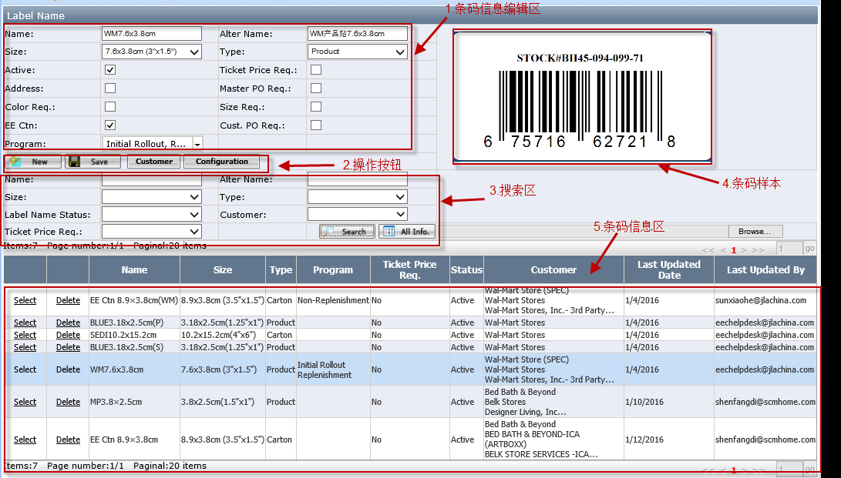
- User fill in fields per request 。（The detail field introduce please see Appendix A: Label Name Page Layout Introduction）

- Click Browse to upload Labels。
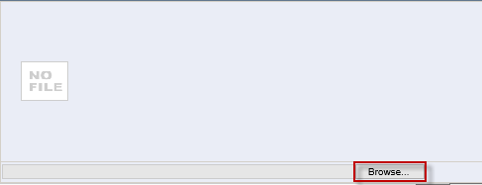
5）Developers click“Configuration”to configure the labels.
The labels can be used only after the configuration and the status become “Active”

Add Master PO in Purchase Order

What if PO information is changed
- If the PO is cancelled or deleted after the application is created, when UCT cancelled/delete PO, system will auto send the email to related the team.

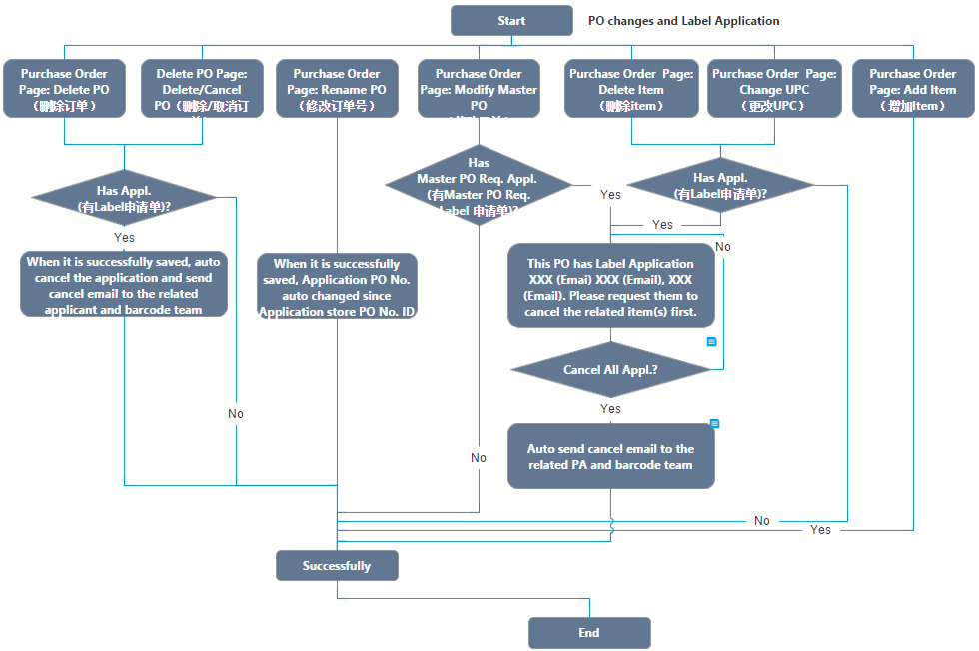
- If there is a label application existing when deleting item or changing UPC or modifying Master PO, UCT Team has to manually send the cancel items request email to the applicant. Only the related item in the application is cancelled or deleted, UCT can make those changes.
- If the item is added to PO after the application is created, please submit a new label application after the same name label application has been completed.

Master PO in Purchase Order
- Click Purchase Order under Production Management to Open Purchase Order Page.(See Figure 6-1)
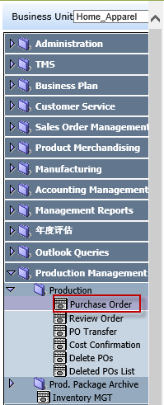
Figure 6-1 Purchase Order Page Path

Purchase Order Page add the Master PO to solve the problem that if the E&E PO is separated, label need to print again (See Figure 6-2)
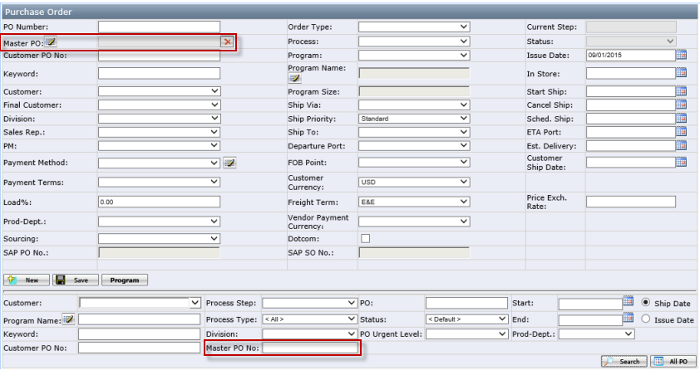
Figure 6-2 Master PO

- If the Order Type is Standard and Process is Domestic: Warehouse or Intl.- Domestic: Warehouse, click Save and Master PO = PO No.
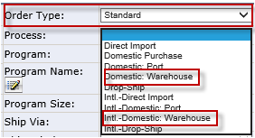
Figure 6-3

- Click the Pencil Iron to open the Master PO Page and Click the X to clean Master PO.(See Figure 6-4)
Figure 6-4

- When the user click Delete in Purchase order Page, system will auto send email to the related applicant and barcode team (See Figure 14-4 Email for delete in Purchase Order or Delete POs Page)
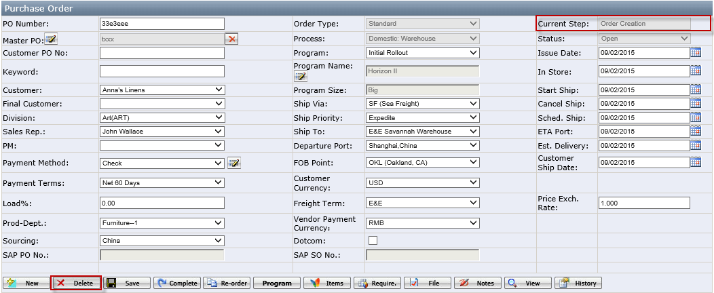
Figure 6-5

- Click Re-order and system will auto copy original Master PO.

Notes:
- Before PO ships, Master PO is allowed to modify.
- If the PO is the Re-order PO, the User needs modify the Master PO.
- If the spilled POs are assigned to different companies, the User needs to modify the Master PO.
- E.g. If PO WM-150541C is separated to PO WM-150541C, PO WM-150541C-1, Master POs needs to be different. Otherwise, factory cannot normally take delivery of goods
- If the spilled POs are assigned to the same company, the User does not need to modify the Master PO.

Master PO Page
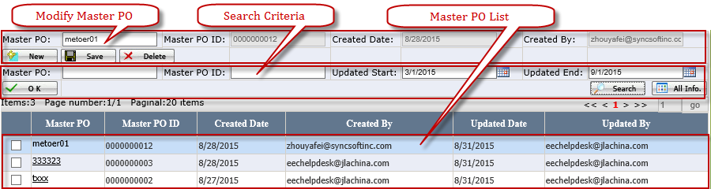
Figure 6-6 Master PO Page

Modify Master PO
- Master PO: a free text; user can type in as he/she likes.
- Master PO ID: it's automatically generated by EEC system. It begins with 0000000001.
- Created Date: the created date, automatically recorded by system.
- Created By: to record the user who created the master PO.
- Delete: Don't allow to delete master PO on Master PO Page if the master PO is used by one or more PO. When user tries to delete master PO which can't be deleted, pop up message: "Fail to delete since it's used in PO(s)."
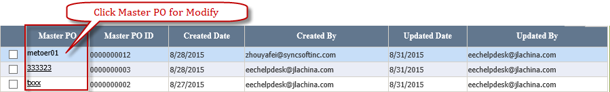
Figure 6-7

Search Criteria
- Updated Begin/Updated End: default search master PO updated in last 6 months.

Master PO List
- Put a check for Master PO and Click the OK to select Master PO for Purchase Order.
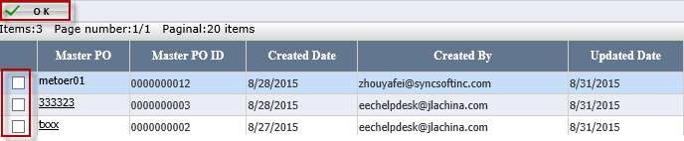
Figure 6-8

Master PO effect in Delete POs Page
- Click Delete POs under Production Management (See Figure 6-9) to open Delete POs Page(See Figure 6-10)
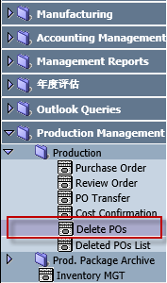
Figure 6-9

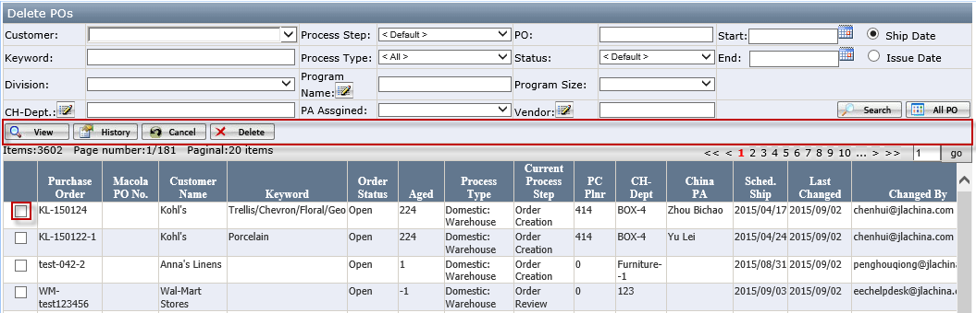
Figure 6-10

Report
- Click Label Name under Label Mgt. to Open Label Name Page (See Figure 7-1)
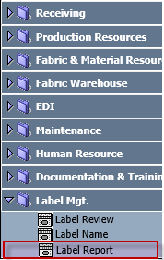
Figure 7-1 Report Page Path

- Open Report Page (See Figure 7-2)
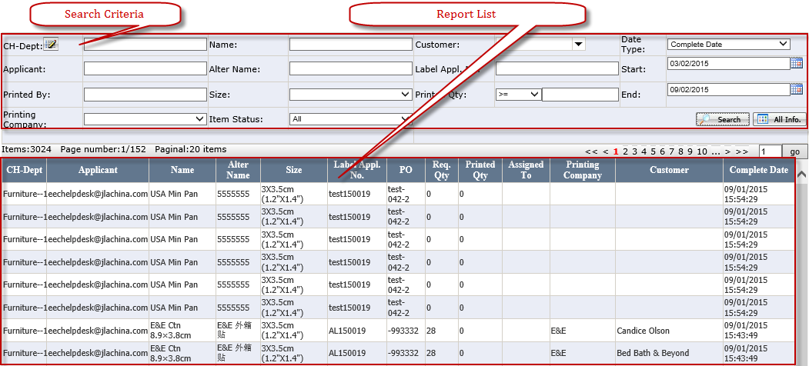
Figure 7-2 Report Page

Search Criteria
- CH-Dept.: when click the CH-Dept., it will open department popup window.
- Customer: it is multiple selection.
- Start and End: default to previous half year.
- Only list application whose Step is complete.
- Item Status: The drop down list contains All (Default), Open, Cancelled. The search result of Printed Qty. will be changed according to Item Status changes.
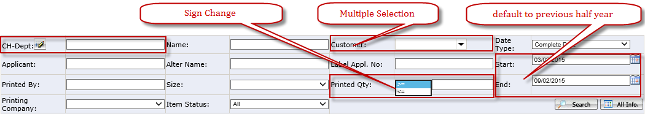
Figure 7-3

Report List
- Sort by: Complete Date > CH-Dept. >PO.
- Printed Qty.: It = actual Printed Qty. If Printing Company is the Third Vendor, Printed Qty. = Req. Qty.
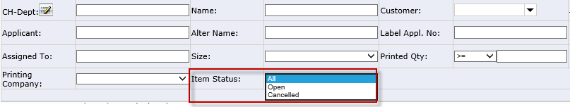
Figure 7-4
- The search result of Printed Qty. will be changed according to Item Status changes.
- E. g. If the Item Status is Open, System will auto screen All PO to select out part which Item Status is Open of each PO. If the Item Status is Cancelled, System will auto screen All PO to select out part of each PO which Item Status is cancelled. If the Item Status is All, Printed Qty. is sum of each PO.
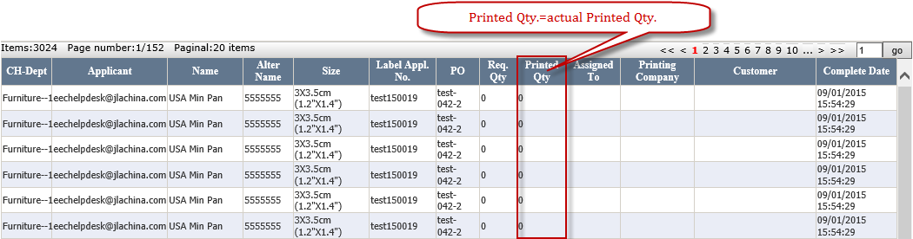
Figure 7-5 Report List

Appendix A: Label Name Page Layout Introduction
The layout is as below:
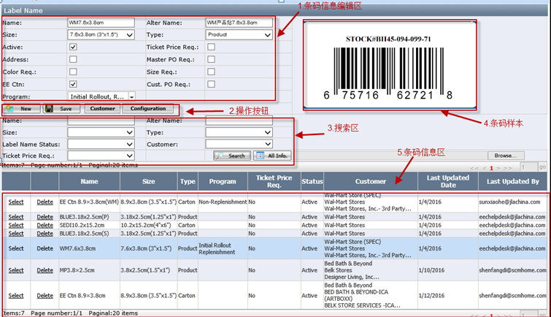

Label Name Info.
- Master PO Req.: its check box，if it’s checked, then the according po must have Master PO.
- Ticket Price Req.: its check box，if it’s checked, then user must fill ticket price on label application page.
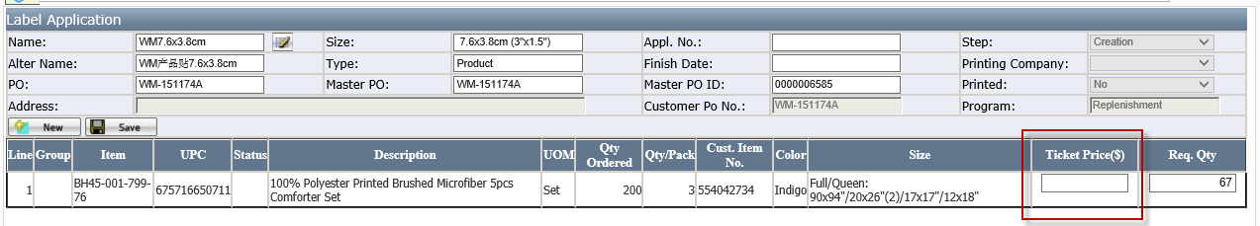
- Active: It’s checkbox, it will be checked automatically the system department finish configuring the label. User can uncheck it manually。
- Address: It’s checkbox, If its checked, the user will see “Address “button on Label Application page，User click this button to maintain the address that need to show on the label。
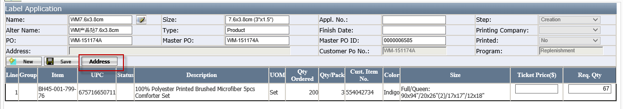
- Color Req/Size Req：It’s checkbox, If It’s checked，they will be editable on label Application page，and they will be printed on label.
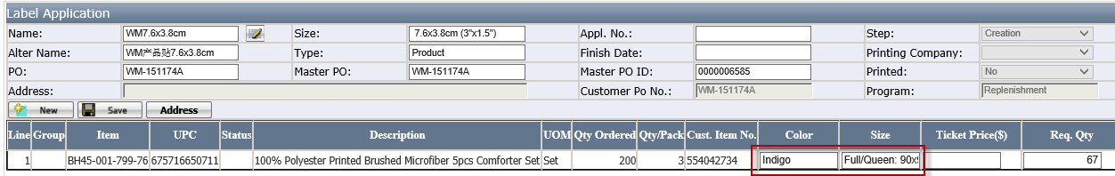
- EE Ctn：It’s check box. Walmart Label need to check this field。If it’s checked, then user can select program. If it’s not Walmart label, no need to check. System select the program “Initial Rollout”and“Replenishment”。
- Program：it is used together with EE Ctn, see above notes about EE Ctn.

Function Button
- Configuration: Open the window to configure label. Developer will do it.
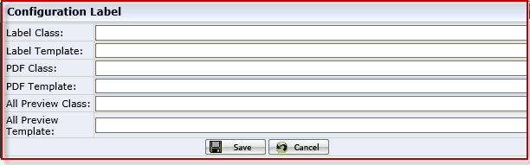
- Customer: User click this Button to select customers for label 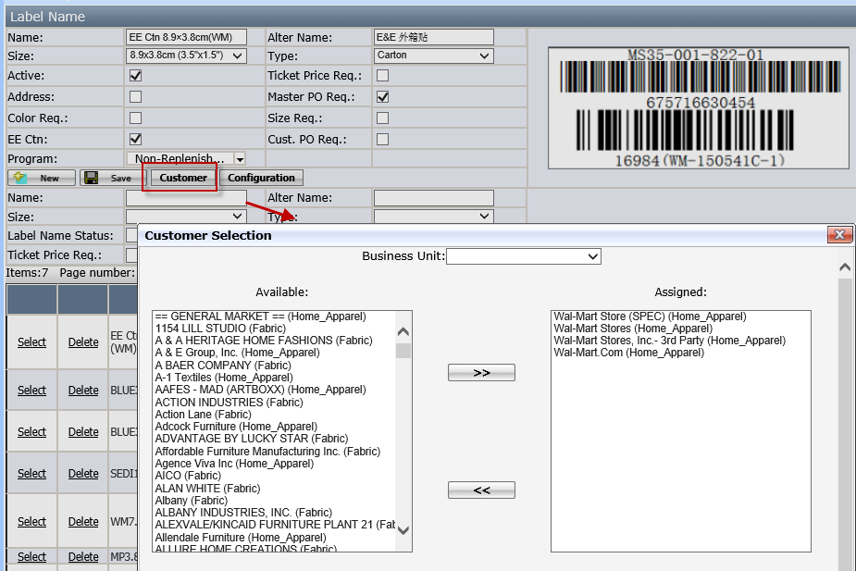

Label Name List
- Delete: If there’s PO has used the label, then the label can’t be deleted.
- Select: click Select to maintain the label.。
- Customer: If having more than three customers, there will appear three dots. The user can select Label Name to view all selected customers.

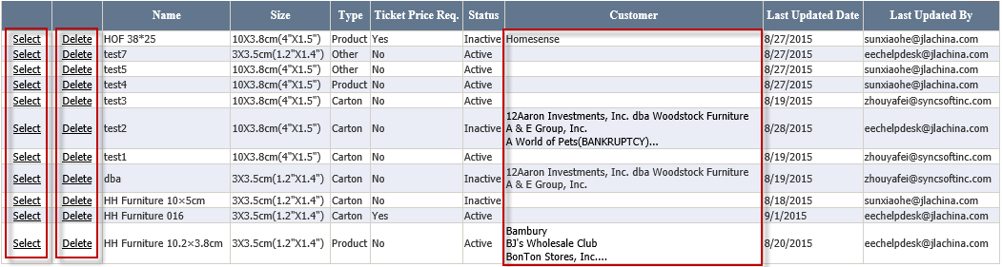

Appendix B: Label Application Page Layout Introduction
(See Figure 2-3 Label Application Page Layout)

Label Info.
- Name: Click the Pencil Iron to open the Label Selection Page.
(See Appendix C for Label Selection Page Layout Introduction)
- Size, Alter Name, Type: Auto generate according to the related Label Name and a only read field.
- Finish Date: When the application complete from Creation to Review, system will auto calculate Finish Date. Submit Date + 5 working day (excluding weekend) e. g submit date= 8/21, finish date=8/28.
- Appl. No: System will auto generate if Complete successfully.
- PO, Master PO and Master PO ID: System will auto bring according to the selected Purchase Order. (See Master PO in the Purchase Order)

Function Button
- Save: allow the user to save selected Label Name and save Req. Qty. and Ticket Price. The Initialization Button and Complete Button will be visible after the application is successfully saved. (See Figure 9-1)
Figure 9-1

- Initialization: Click it and system will pop up the Initialization Page. (See Figure 9-2)
Req. Qty. = Qty. Ordered × Ratio No ÷ Qty. / Pack
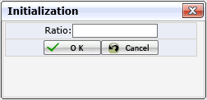
Figure 9-2 Initialization Page

- Complete: If complete successfully, the Cancel Button will be visible and the Save, the Complete Button, Initialization Button will be hidden.(See Figure 9-3)
Figure 9-3

- Cancel: It is multiple selection. If items are cancelled successfully, the Item Status will change to Cancelled and system will auto send Email. (See Appendix D for Email Page Layout Introduction)
Figure 9-4

- Delete: Allow to delete the application when the step is Creation
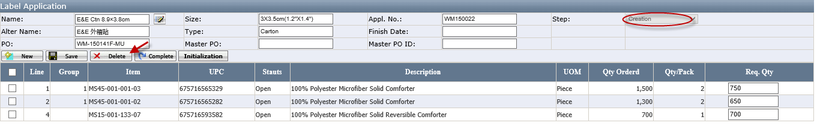
Figure 9-5

Item List (See Figure 9-6)
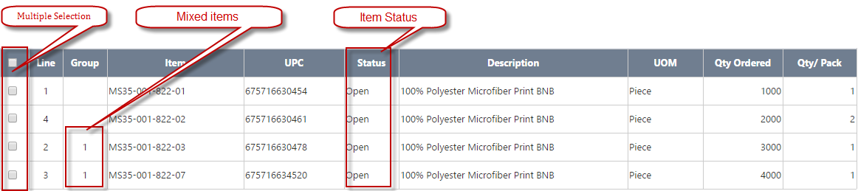
Figure 9-6 Item List

- Mixes Items: If group is not blank, system will not allow enter Req. Qty. >0 due to label application does not support the mixed items.
- Default sort is by Line No.
- If Save successfully, Req. Qty. and Ticket Price will appear. (See Figure 9-7). Ticket Price only appears when the selected label required Ticket Price.
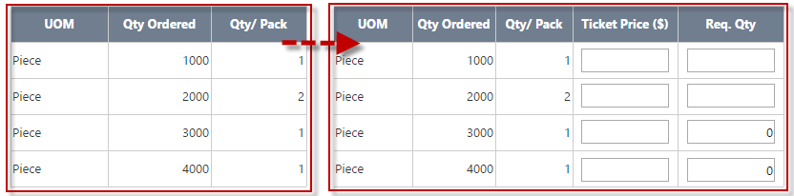
Figure 9-7 Table change

Appendix C: Label Review Page Layout Introduction
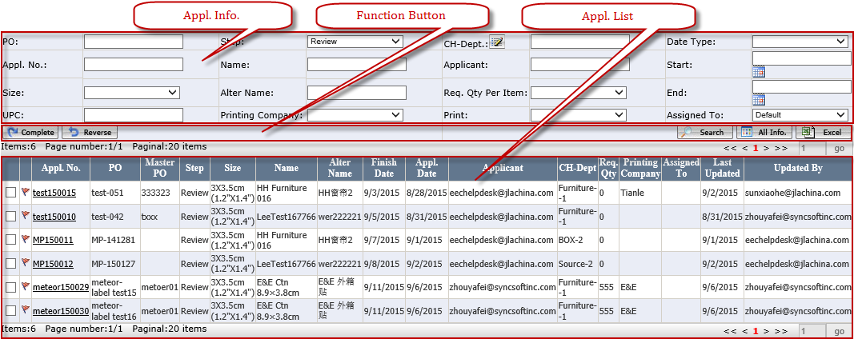
Figure 10-1 Label Review Page

Appl. Info.
- Step: It is one selection.
- Assigned To: Default to Default. The Default means the Appl. No has not been assigned to and has assigned to the person who is using at current (See Figure 10-2)
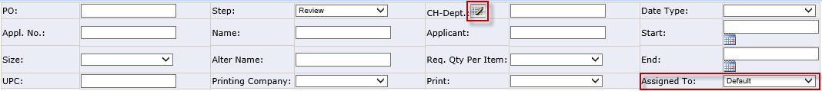
Figure 10-2

- CH-Dept.: Click it to open Select Department Page (See Figure 10-3)
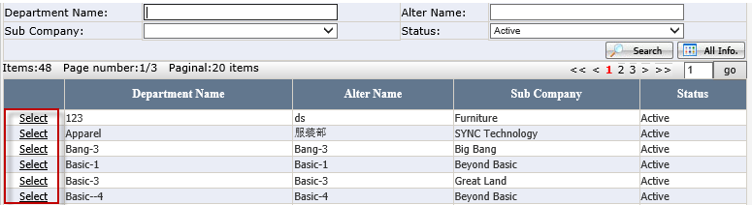
Figure 10-3 Select Department Page

Function Button
- Complete: If the Printing Company is E&E, click it and Step will change from Review to Complete. System will auto send Email (See Figure 14-2 Email for Complete)
- Reverse: one selection and allow to reverse the application to previous step.

Appl. List
- Red Flag: Display it when Finish Date - Today <=2, No print date, step <> complete.
- Checkbox: One selection.
- Default sort: Red Flag, Finish Date, Step.
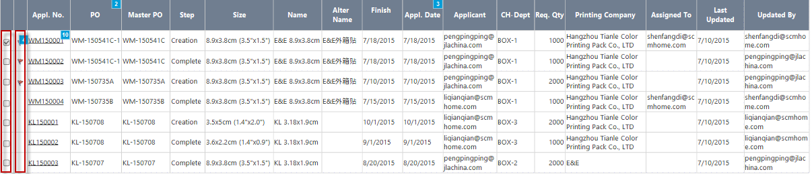
Figure 10-4

Appendix D: Label Selection Page Layout Introduction. (See Figure 11-1)
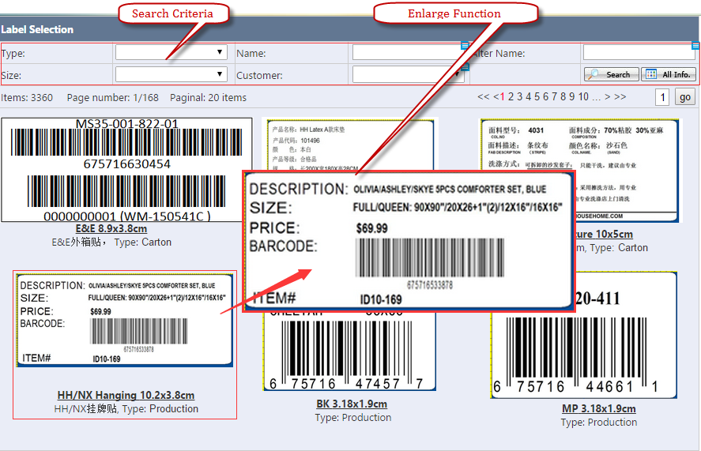
Figure 11-1 Label Selection Page

Search Criteria
- Default to the selected PO customer.
- Customer: It is multiple selection.( See Figure 11-2 )
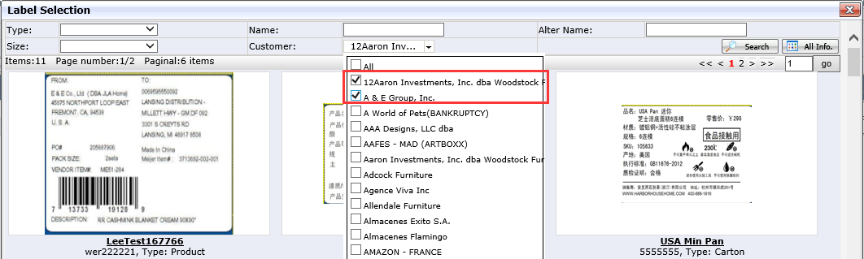
Figure 11-2 Label Selection

Enlarge Function
- Cursor move on the picture and system will auto pop the enlarged Picture (enlarge 1.5—2 times) in the best suitable position. (See Figure 11-1 Label Selection Page)

Appendix E: Label Detail Page Layout Introduction.

Label Detail Info.
- Printing Complete and Assigned To: It is required.
- Finish Date: If Printing Company is the Third Vendor, it is allowed to be modify; otherwise, it is grayed out.
- Other information will attain from Appl. No

Function Button
- Save: Only Printing Company and Assigned To is selected can save successfully. If saving successfully, other Buttons will appear.
Figure 12-2
- All Preview: Pop up PDF file (See Appendix E for Label PDF Page Layout Introduction)
- Print All: Print all items Label.
- Print: Click it and system will pop up Print Label Page. If the New Print Qty. is changed and the sum (=New Print Qty. + Printed Qty.)>Req. Qty., system will warn “The summary of Printed Label is over the Req. Qty., Are you sure to continue?" If the No. <0, Default to blank. (See Figure 12-3).
Figure 12-3 Print Label

- Reverse: The Step will Change from Review to Creation.
- Complete: If Printing Company is E&E and complete successfully, the Step will change from Creation to Review and auto send Email (See Figure 14-2 Email for Complete). Otherwise, only change the Step.
- Email: It is visible when the Printing Company is the Third Vendor. Click it and system will auto send Email (See Figure 14-3 Email for the third vendor).

Item List
- Default sort: By item line No.
- Plus Iron: When click it, system will open the print detail which includes Req. Qty., Printing By, Printing Date.
- Item No. Hyperlink: Open this item zebra printed PDF Preview.
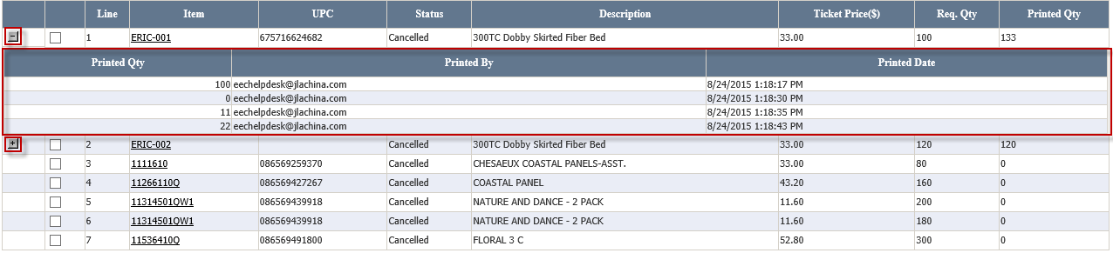
Figure 12-4 Item List

Appendix F: Label PDF Page Layout Introduction.
- If the Printing Company is E&E, the All Preview like this:
E&E PDF: one page can have multiple different items and each item label count=1.
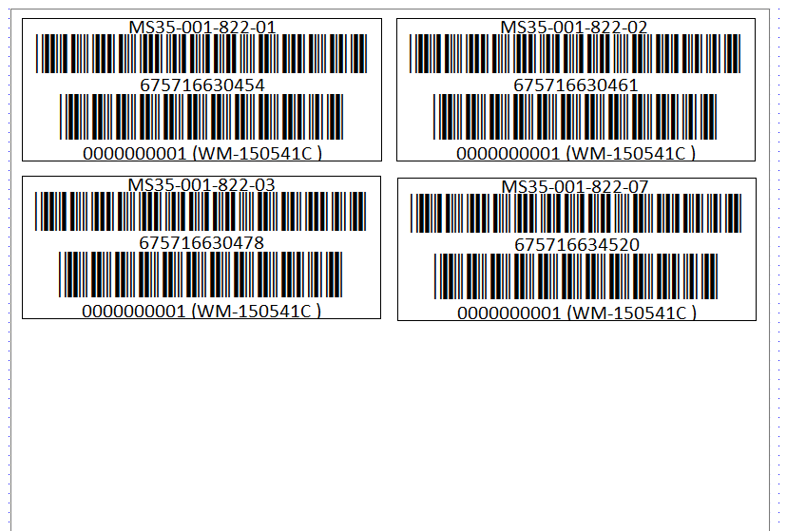
Figure 13-1

- If the Printing Company is the Third Vendor, the All Preview like this:
Third Vendor PDF: A3 Paper(30x42cm) list 3x10=30 same item labels.

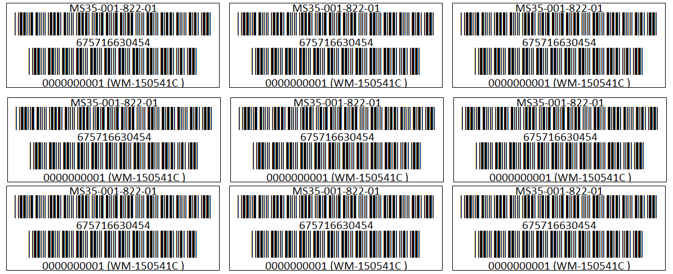
Figure 13-2

Appendix G: Email Page Layout Introduction.

Email for Cancelled items
- If cancel successfully, system will auto send to the related applicant.
- Salutation will reset according to the applicant.
- Whether Ticket Price exist or not depending on the category of Application. E.g. If there is Ticket Price in the Application, the content of Email includes Ticket Price.
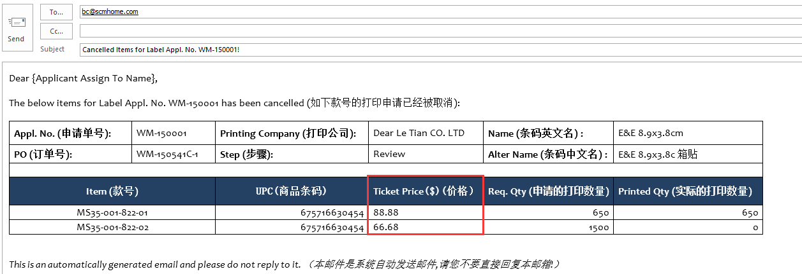
Figure 14-1 Email for Cancelled items

Email for Complete
- Salutation and Addresser will reset according to the applicant.
- Whether Ticket Price exist or not depending on the category of Application. E.g. If there is Ticket Price in the Application, the content of Email includes Ticket Price.
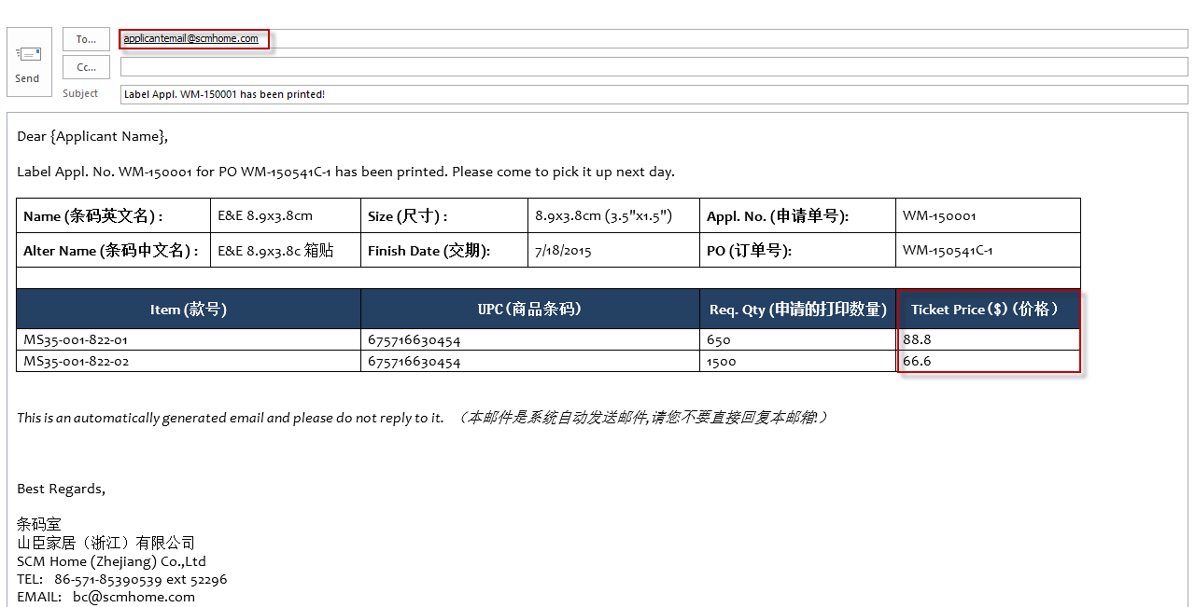
Figure 14-2 Email for Complete

Email for the Third Vendor
- Whether Ticket Price exist or not depending on the category of Application. E.g. If there is Ticket Price in the Application, the content of Email includes Ticket Price.
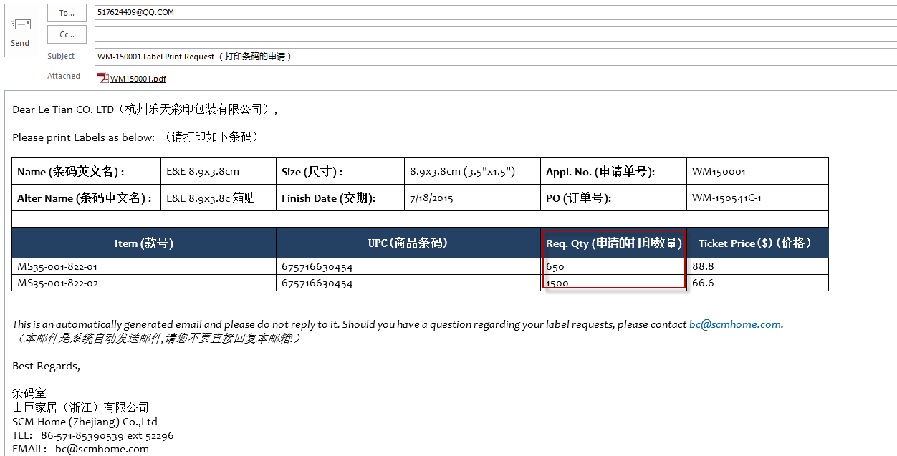
Figure 14-3 Email for the third vendor

Email for delete in Purchase Order or Delete POs Page
- Whether Ticket Price exist or not depending on the category of Application. E.g. If there is Ticket Price in the Application, the content of Email includes Ticket Price.
- Salutation and Addresser will reset according to the applicant.
- If there has not been assigned to, only appear Applicant Name.
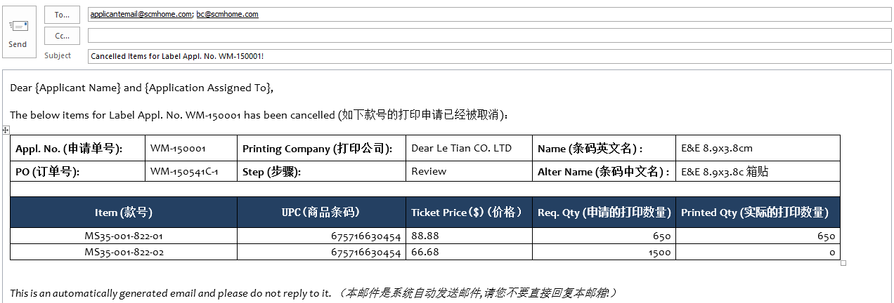
Figure 14-4 Email for delete in Purchase Order or Delete POs Page

Where to get the help if you have question or problem
If you have any questions and issues during the process, please send email directly to eechelpdesk@jlachina.com

