How to print Olliix Price Tag
Print Olliix Product Info Barcode card
- Entry Page EECUS Sales Order ManagementGenerate UPC Barcode:
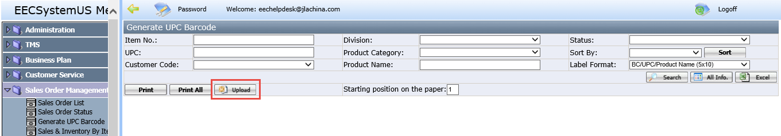
- Click Upload button, the following popup window coming:
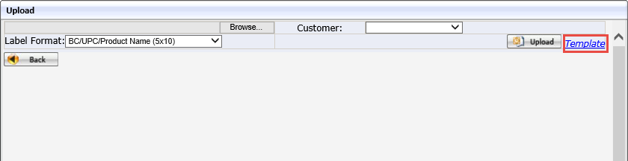
- Click Template button to download the template and save it in local:
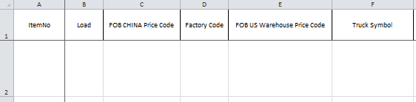
- Fill the item No and item information which you want print in the Template.
4.1 Don’t change the Head column names.
4.2 Normally user should fill all the contents in all the columns, especially for ItemNo.
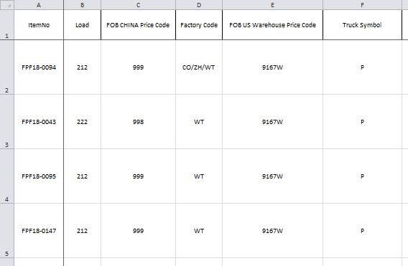
- Add one Note sheet to guide user how to fill the data normally.
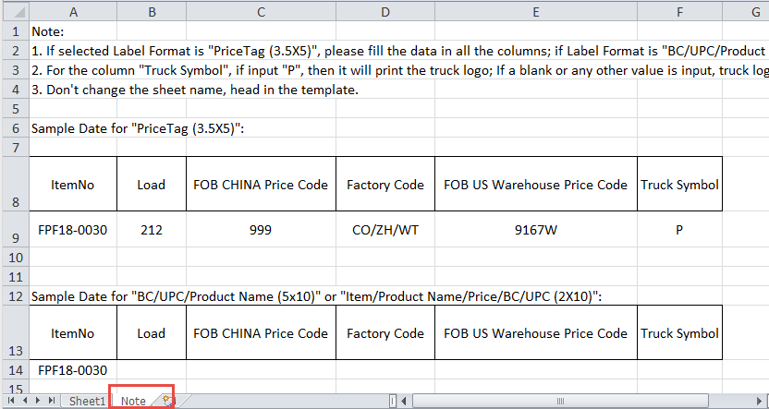
- Choose Label Format as “PriceTag (3.5X5)”, choose Customer as “OLLIIX”, click Browse button to find the local template file then click upload button.
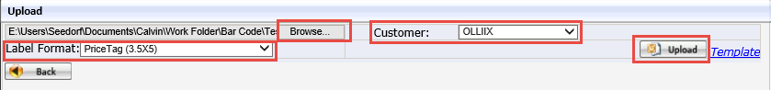
- If everything is fine, the following successful message will come.
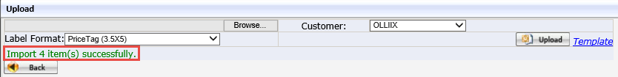
If any item no. is not there in EEC for Olliix, the following message will come and the remaining items exists in EEC for Olliix still will upload successfully.
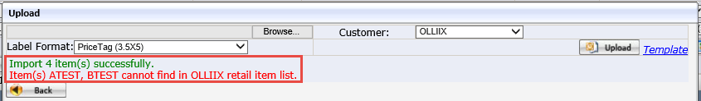
- Click Back button to return the main page, the uploaded items are also fetched in the main page automatically. The Label Format also changed to the “PriceTag (3.5X5)” which is the same selection in the popup window. It is the format which is used for Olliix Product InfoBarcode card.
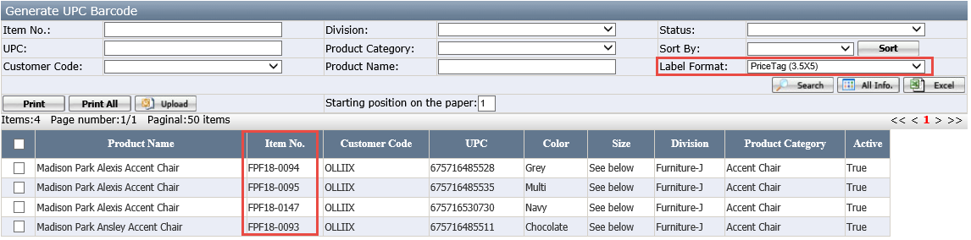
- Select the items which you want to print, then click Print button. If you want to print all items, then can click Print All button directly.
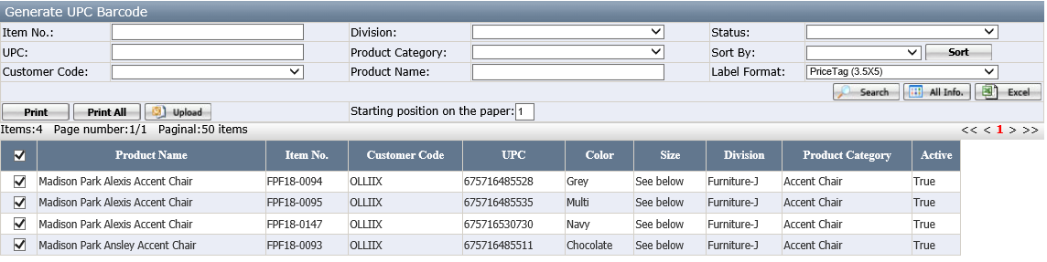
- The PDF is generated and the size for each item is 3.5" x 5". There are 2*2 items in one PDF; you can continue to print it in the letter paper size.
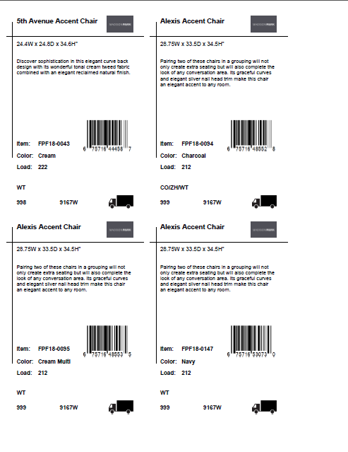
- The Retail Brand logo in the upper right hand corner is maintained in the in “Retail Brand” page in EEC, EEC can find the Retail Brand logo based on the Retail Brand property of the Retail Item.
