How to Manage Project on SyncsoftCosting

The Syncsoft Costing System is to let Managers manage projects.

Project status
A project has 5 statuses, including “Creation”, “Quotation”, “In Progress”, “Cancelled”, and “Complete”. The work follow is as below
Process Step | Operation | Responsible Person
Creation | To create a new project in project Mgt page | Analyst Role
Quotation | To quotation based on project in quotation list page
In Progress | To follow the project and can update the actual start date and end date, also can assign users | Analyst Role
Complete | To complete the project when it finished. | System

Notes
Role with Analyst only can complete or cancel projects which are created by himself/herself.
If a project is cancelled, then managers can't use it again.

Page Introduce

Project Mgt Page
Go to SyncSoft costingProject Mgt page, Click “New” button to open the project Mgt:
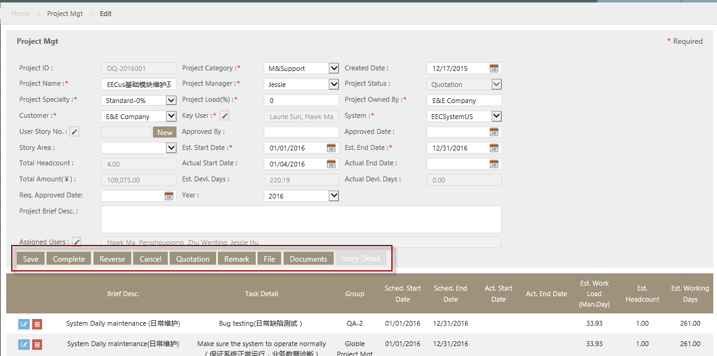

Key Fields
- Project ID: generated by system.
- Project Category: a dropdown list, including “New Development”, “Optimization”, “Maintenance”, “Enhancement”, “System Support”,”M&Support”,”Implementation”.
- Project Name: Text field. User can type in the project name.
- Project Manager: a dropdown list. Options are all project managers maintained in “Project Manager”.
- Project Status: the project’s status, it’s a read-only text field.
- Project Specialty: it’s a dropdown list. Options include “Standard-0%” “Tech-Challenged”, “Time-Challenged”, “TT-Challenged” (means Tech and Time Challenged), “User-Challenged”, “Longstanding” and “Imp&Tedious”.
- Project Load: Text field. but only allow to type in digit. Managers fill the profit rate here.
- Project Own by: Text filed. Managers can fill in user names here.
- Customer: a dropdown list. Options include all customers maintained in Customer page.
- Key User: a read-only text field. User can select one or more users by clicking the pencil icon after “Key User” field
- System: a dropdown list. Options are all systems maintained in “System Maintenance”
- User Story No.: This field is a read-only field. If the project already has user story in TFS, user can select by clicking the pencil icon, if the project has NO user story in TFS, user can create a user story for this project by clicking “new” button.
- Approved By: Text field. Managers can fill in the names that approved it.
- Story Area: a dropdown list. Options include “EECSystem” and “ChinaDev”. It’s a requested field if “User Story No.” or “User Story Link” is not null.
- “Est. Start Date”, “Est. End Date”: The dates that the estimates start (end) date of the project .all are date type; user can select a date from the calendar icon.
- “Act. Start Date”: The date that the actual starts date of the project. When the project is completed to "Quotation" step. System will automatically set actual start date = system date.
- “Act. End Date”: It's read-only field. When the project is completed to "Complete" step. System will automatically set actual end date = system date.
- “Total Amount(￥)”: A read-only text. It’s sum of each task’s ext. Price.
- Total Headcount: a read-only text. System will automatically count how many users are assigned to the project and display in “Total Headcount” field.
- Est. Devl. Days: a read-only text. Its sum of each task’s Est. Man. Day.
- Act. Devl. Days: a read-only text. Its sum of each task’s Act. Man. Day.
- Project Brief Desc.: Text field. To enter the project brief descriptions.
- Assigned Users: Managers can click the pencil icon and assign users to this project. If assign A and B to the project, then A and B will be responsible for this project. In weekly report page, A and B can see this project and enter the hours.
Key button
- Add Task: It’s only shown after the project is created successfully. This button is used to add a task for this project.
- Template: It’s only shown after the project is created successfully. It’s used to select a template for this project. The common template has been maintained in template page.
- Complete: It’s only shown after the project is created successfully. When user clicks “Complete” button, it will complete the projects to next status.
- Cancel: It’s only shown when the project status is “Creation”. It’s to cancel the project. After user cancels the project, the status is changed to “Cancelled”.
- Quotation: it’s only shown when the project’s status is “Quotation” or after “Quotation”. When user clicks this button, system will open quotation page.
- Remark: It’s only shown after the project is created successfully. It’s to add remarks.
- File: It’s only shown after the project is created successfully. It’s to upload files.
- Document: this button is used to enter the documents of this projects.
- Story Detail：It’s only shown after the project is created successfully. It’s view or edit the Story detail.

Project Task
Click “Add task” on Project Mgt page to open the project task detail page.
- If the project category=New development, Optimization, Enhancement and Implementation, the project task page is as below:
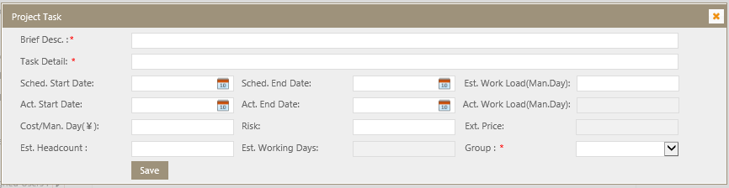
Key Fields
- Brief Desc.: text field and enter by user.
- Task Detail: text field and enter by user.
- Group: dropdown and options are from group maintenance page/group name.
- Est. Work Load: it's Text field. But only allow to fill in digits.
- Act. Work Load (Man.Day): it’s actual man day. It’s a read-only text, it’s automatically calculated by system and it equals to (its total working hours/8). Total working hours is the sum of all working hours which are filled by assigned users on weekly report page.
- Cost/Man. Day: it’s cost per man day. Text field and enter by user with digitals.
- Est. Headcount: Text field. But only allow to type in integers.
- Risk: It is used to balance the est.work load field. The project Risk Factor is generally set between 1.0 ~1.5
- Est. Working days: it's a read-only field. Est.working days= Est. Work Load/Est. Head Count
- Ext. Price: it's a read-only field. Ext. Price= Est. Work Load*Cost/Man.Day* Risk
- If the project category=Maintenance, System Support and M&Support, the project task as below
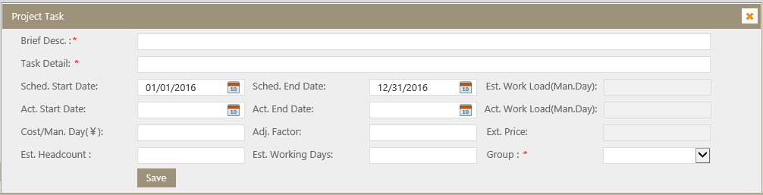

- Est. Work Load(Man.Day): It is read-only field. Est.Work load=Est. Working Days*Est. Headcount*Adj. Factor.
- Est. Working Days: it's Text field. But only allow to fill in digits.
- Ext. Price: it's a read-only field. But it equals to "Est. Work Load"*"Cost/Man.Day"
- Adj.Factor: It is used to adjust the working time consumed on a project per day, the value is set as 0<x<=1. When the Adj. Factor =1, it means 1 man day on this project.

Weekly Report
On this page, user can fill in or view total hours he/she contributes to projects. It Default display weekly reports for all projects which are assigned to current user and status are “In Progress”.
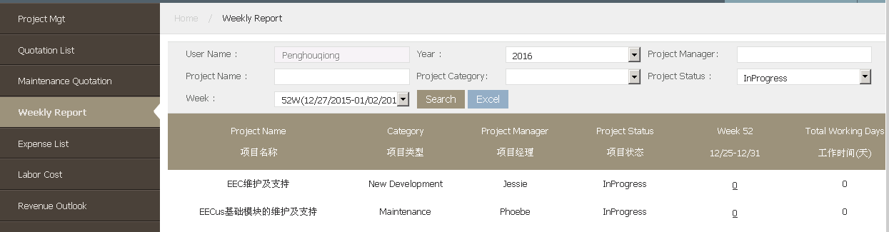
Key fields
- Week column: the column name is changeable. Its name is selected options of “Week” in search area. For example, select “39W(09/20/2015-09/26/2015)”, then column name is “39W(09/20/2015-09/26/2015)”. This column is to display the sum of working hours which current user fills in for this project.
- Total working days: its unit is “Day”. The value = value in week column/8.

How to manage a Project

How to create a project
- Go to Syncosting System-->Project Mgt page, Click “New” button
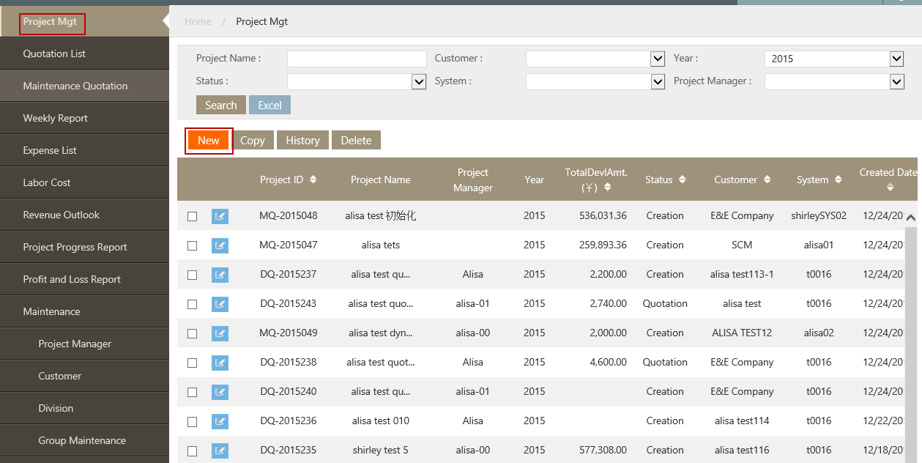
- System will pop up project Mgt page, see below
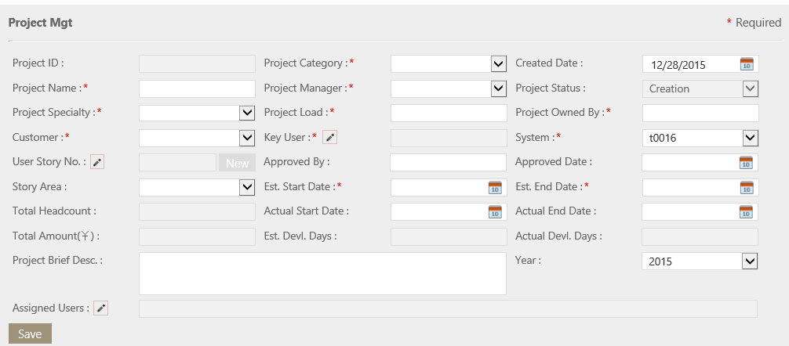
Fill the fields per request, and click “Save”, then the other buttons will appear, the page will be as below:
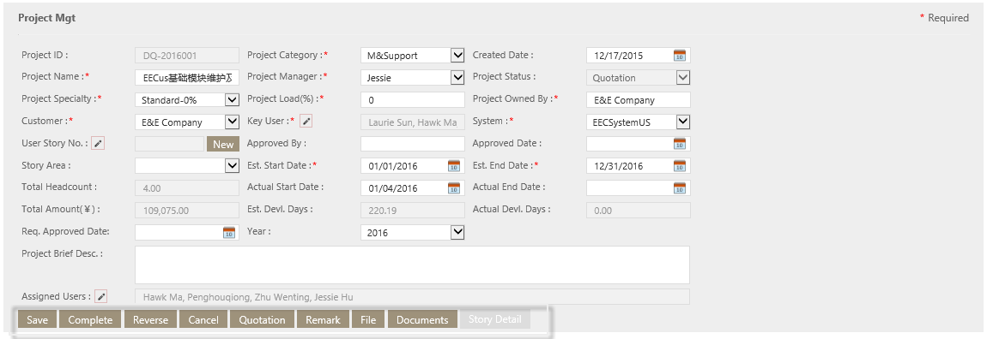

- Users need to add task to his/her projects; there are two ways to add project tasks.
Case1. Use “Add Task” to create a project task.
- On Project Mgt Edit page, click “Add Task” button to add a new project task detail. System will pop up Edit Project Detail page, see below:
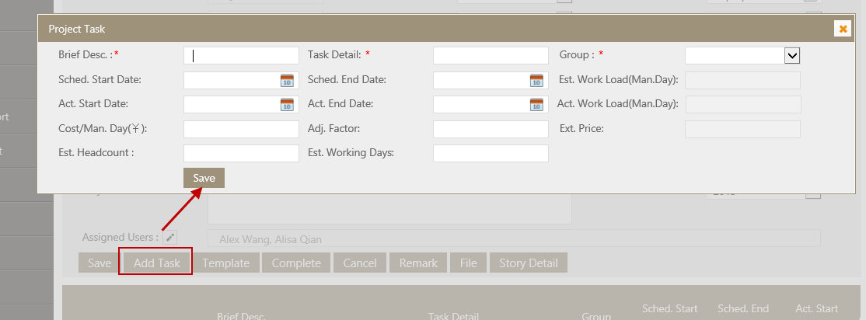
- Type in brief decs. Task detail, group, Sched. Start date etc. required field. the detail can refer to <Project Task> part.
- Click “Save” button to save it.
Case2: Using maintained templates to create project task.
- Click “Template” button on Project detail page. System will pop up template page as below:
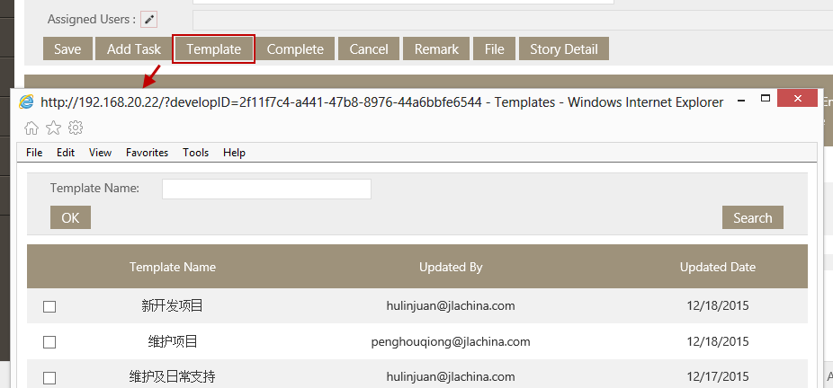
- Selects one templates, then clicks “OK” button. All Task details in selected templates are added in this project and display on project Mgt page. See below
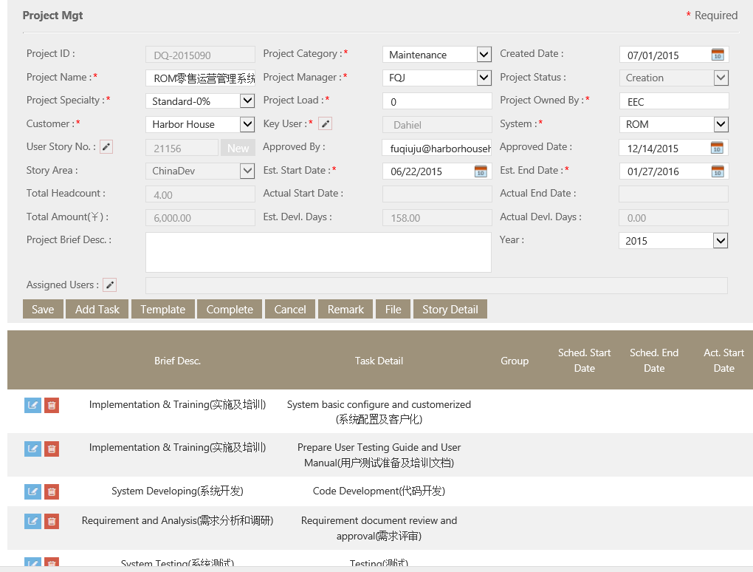

- User can edit or delete tasks as need.
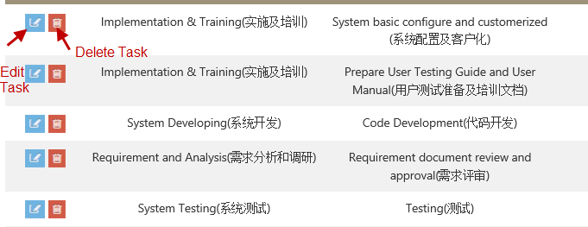

How to add remark for the project
User can add, edit or delete remarks to his/her projects, step as below:
- On Project Mgt Edit page, Click “Remark” button, system will pop up remark page, see below.
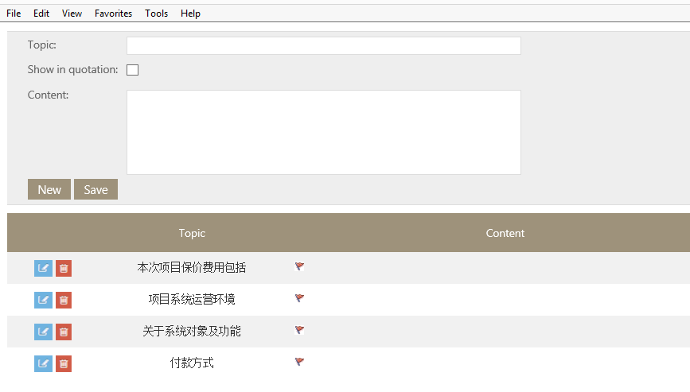
Fields:
- Topic: text field and enter by user.
- Show in quotation: checkbox. If this box is checked, it means this remark will be shown in quotation page.
- Content: text field and enter by user.
Notes:
Here, some topics are default. The detail see above screenshot and user can delete or edit it according to project.

How to Complete a Project
On Project Mgt Edit page, click “complete” button to complete it to next status
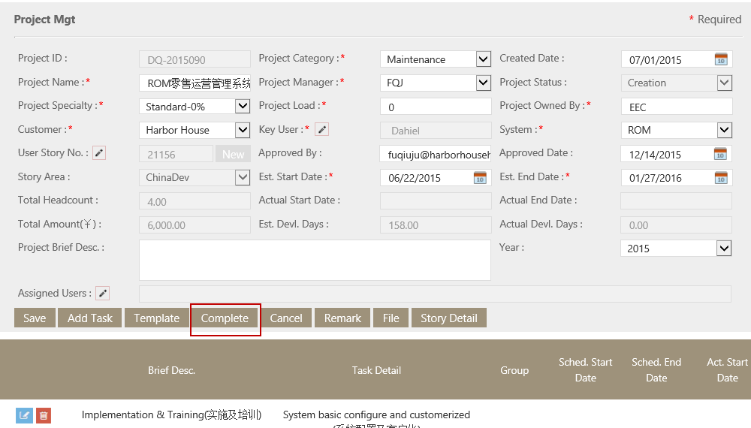

How to manage weekly report
Weekly report is used to record the working hours for each project. The detail operation as below.
- Go to Synccosting System-->weekly report page, search out the project which has assigned to user.
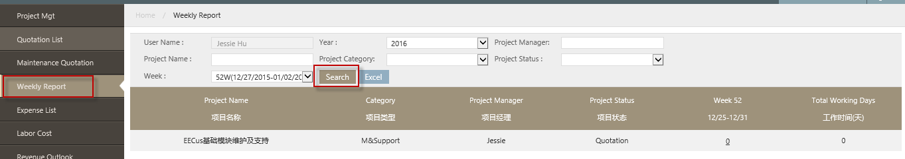
Button:
- Excel: It is used to export the excel file for search out projects.
- Select the links to open the working hours page.
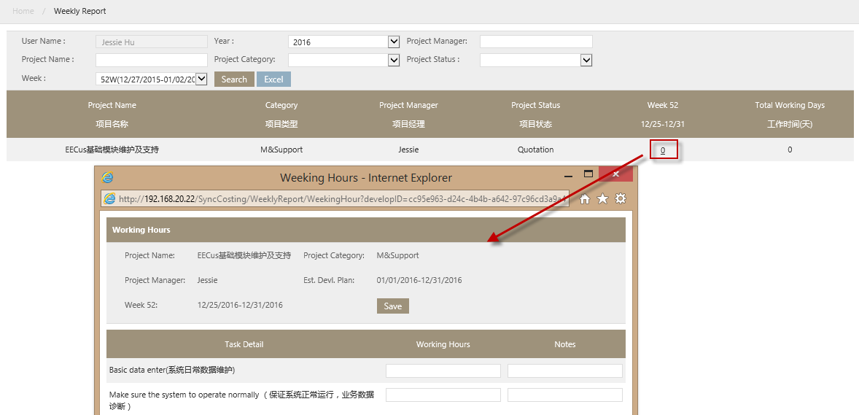
- Enter the working hours for each task. Then, save it.
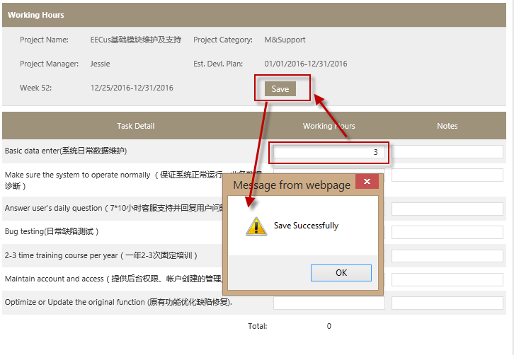
- After entering all task hours, then go back the weekly report page. the hours will be shown in the list.
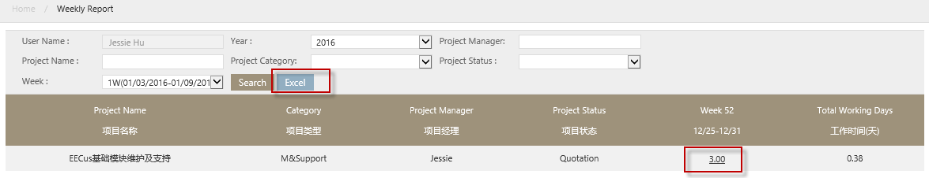
- Click <Excel> button to export the weekly report.
