How to update tracking# on wholesale shipment detail page
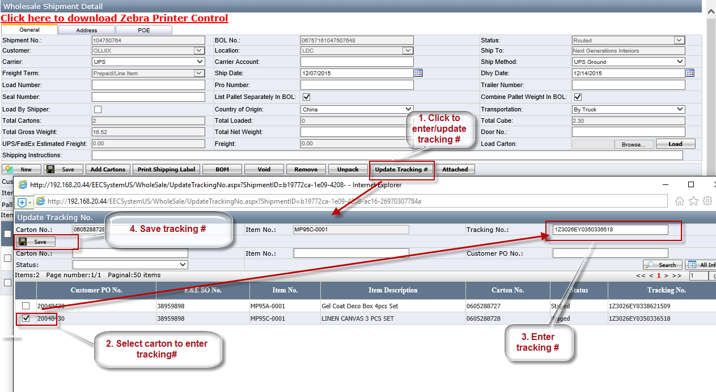

Notes:
- This is used when user failed to print shipping label from EEC. User can print shipping label outside EEC, and enter tracking # into system.
- Only warehouse manager can do this.

