Preconfig User Manual

Set the Preconfig for sales order
Follow the normal wholesale order process, before the order create batch, you can see a “PnP Type” button on the Wholesale Order List webpage. For Preconfig process, you should select your order first, click the “PnP Type” button and select “Preconfig”, click “OK”. Now, your order’s PnP Type has been changed to “Preconfig”.
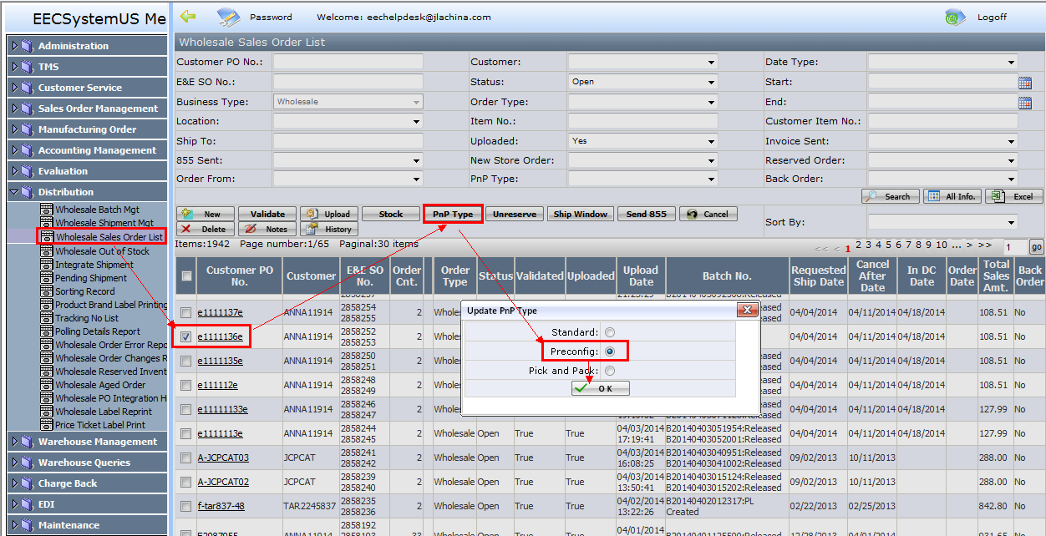
Notes:
Standard = po is in full case packed and shipped
Preconfig = Factory pack the po
Pick and Pack =

Create Batch of Preconfig Orders
Distribution team will do the preconfig orders.
2.1 When you create batch, please make sure the “PnP Type” is changed to “Preconfig”.
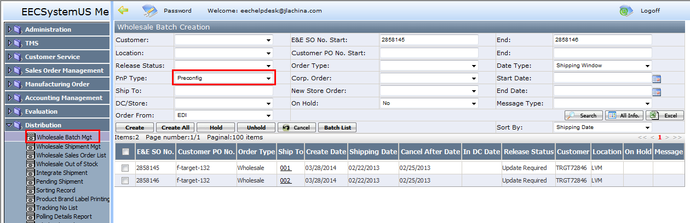
2.2 Select the batch you just created which “PnP Type” is Preconfig, you will find a “Preconfig” button right after “Edit” button. Click the “Preconfig” button.
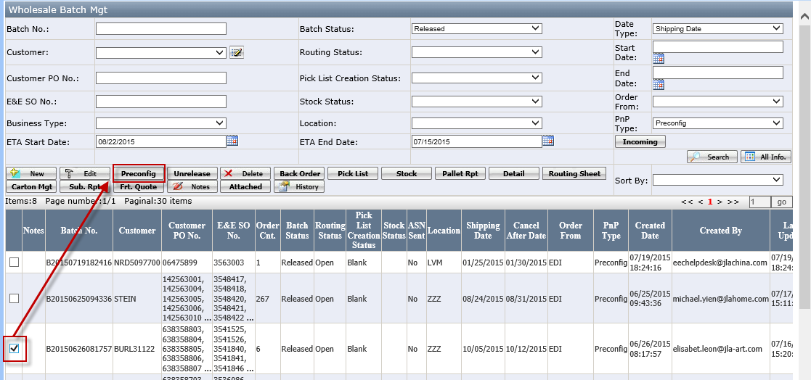
2.3 Now you can see a webpage like below, click “New” button, select your E&E SO No. and suitable Carton Size, the carton weight will be generated based on select carton. And you can also choose an Item No. to name this carton, though this is not necessary. Click “Save” to save it.
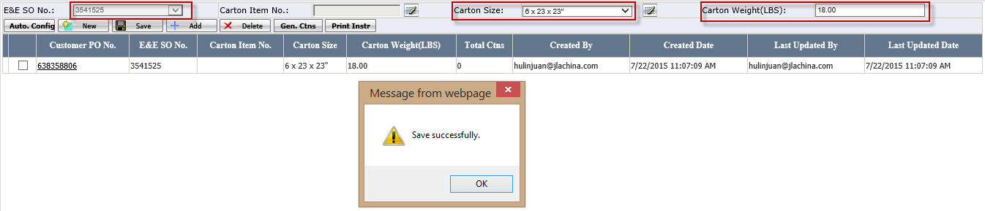
- Auto.Config: select one carton and click auto config button to generate the cartons for all the orders with the same items and same structure of selected carton.
Buttons
  - New: to create a new carton size for one macola order.
  - Add: to add the item into this carton
  - Gen.Ctns: to print out the carton UCC-128 Carton label.
  - Print Instr: to print out the pack instruction document.
Fields
- Carton Item No.: it is used if we have the carton size item in our item master list. When it is select, the carton size and carton weight value will be default value based on carton item no.
- Icon besides carton size
This icon is to pop up the carton added page and user can add a new carton size.
2.4 select the carton you just created, click “Add” button. You will see an Add webpage, there will be all the items here you can add it to this carton, and you can also readjust the case pack qty. to make sure they are just can be packed in full case. Then click “Add” button on Add webpage. System will prompt the message as “Add successfully”.
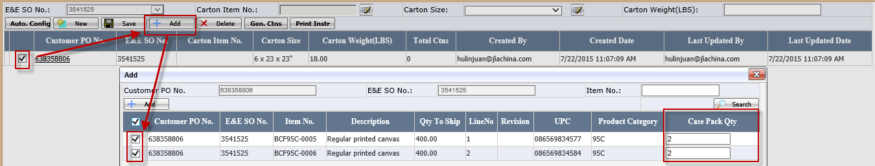
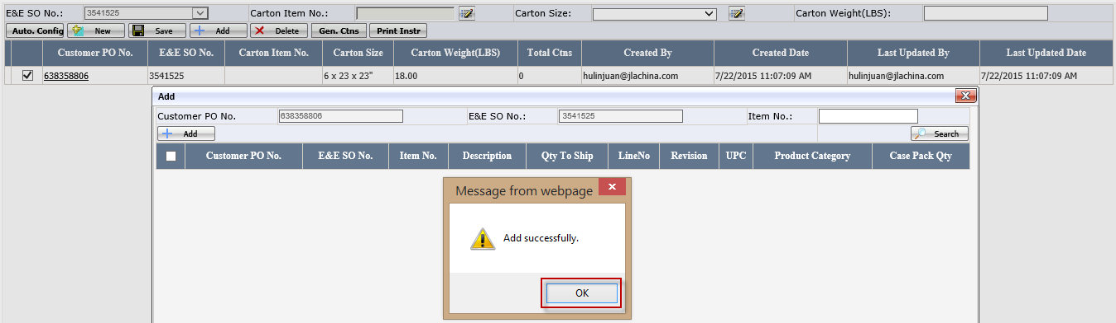
Click ok button and go back below pages
Total crtns=Item Qty to ship/Case pack qty
2.5 Repeat last step until all the E&E So No. belong to this order have been done this, then select one of those cartons records, click “Gen. Ctns” button. Now you have generated all the cartons successfully, in other words, you have pre-configured all the cartons completely. You can click Export button to export carton structure to warehouse user to help them pack the carton.
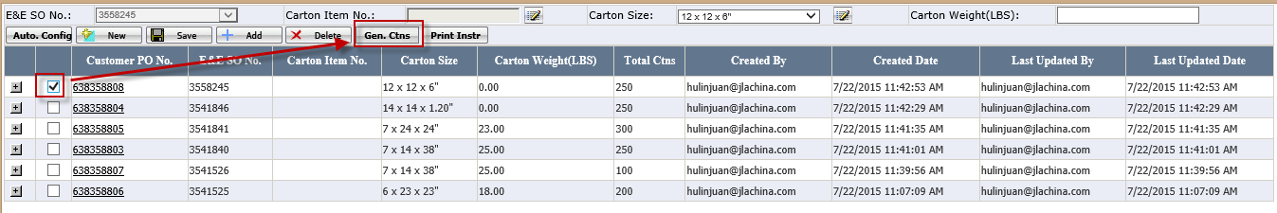
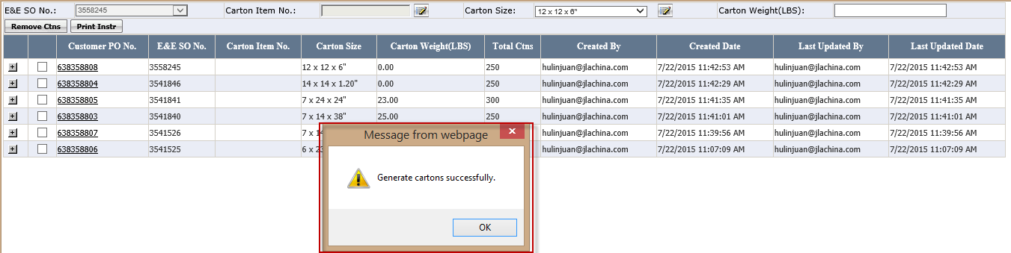
If the preconfig carton size is not correct, please click <Remove Ctns> to go back to reset it.
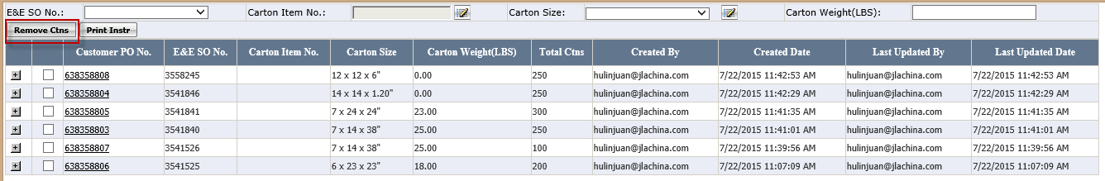
Then the page will be change as below
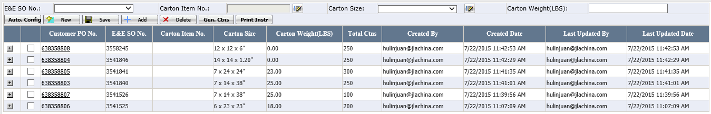

Print carton Label and print Pack Instruction
For warehouse person, the preconfig order need to print out the carton label and pack instructions.
3.1. Go to wholesale batch Mgt page and select one batch, click <Preconfig> button
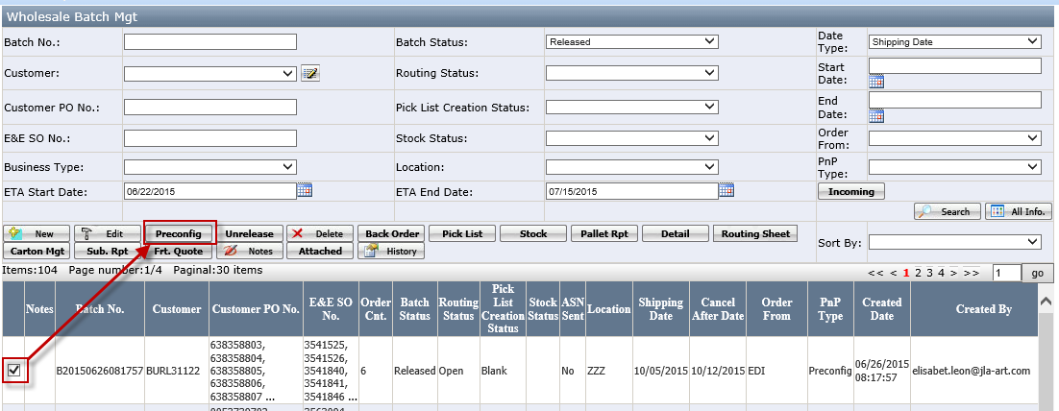
3.2 Now it will open below page. Select one customer po no and click <Gen.Ctns> to generate carton information.
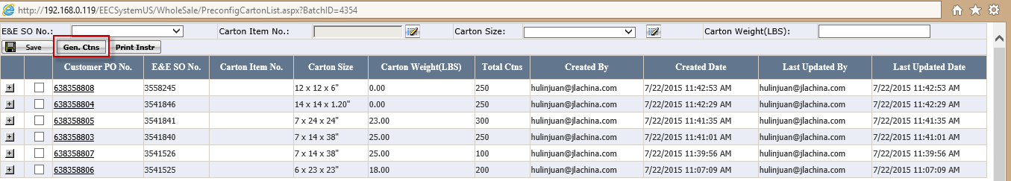
After that, go back to Wholesale Batch Mgt webpage, Select your batch, click <Carton Mgt> button to see the carton details you just pre-configured.
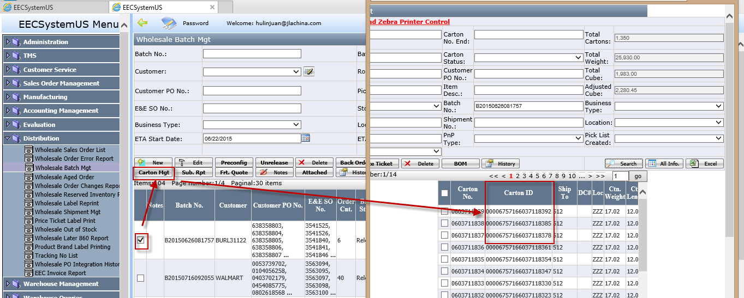

3.3 After generated the carton label, click <Print Instr.> to print out the pack instructions. This will help warehouse to pack the orders
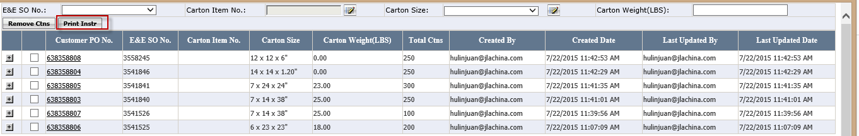
The pack instruction as below
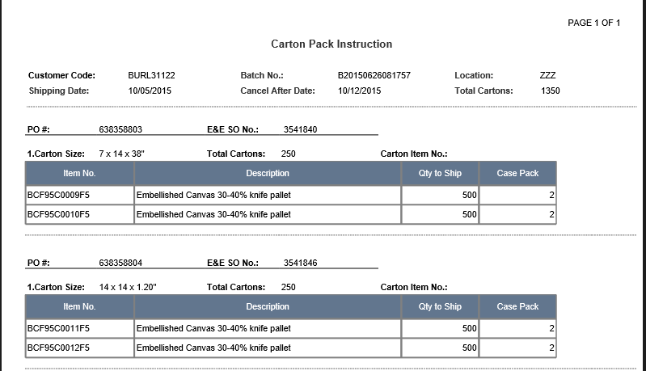
Warehouse need to follow the carton pack instruction to pack the cartons.
3.4 If the preconfig carton size is not correct, please click <Remove Ctns> to move back and ask Distribution to re-set the correct carton size.
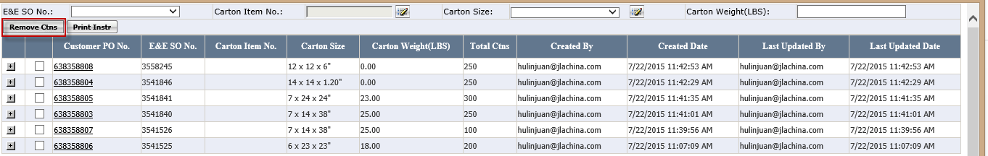
The remaining steps are the same as normal wholesale order. It can see WMS Manual.docx
Note: Manual order also support Preconfig function.

