How to remove SCM orders from shipment?
Currently, EEC system allows users to remove SCM orders from certain shipment. Detail as below:
Case1: if the shipment has more than one order, user can click “Delete” button on shipment edit page to remove SCM orders. Take below case as an example.
Step1: Search out the shipment on shipment page, see Pic1.
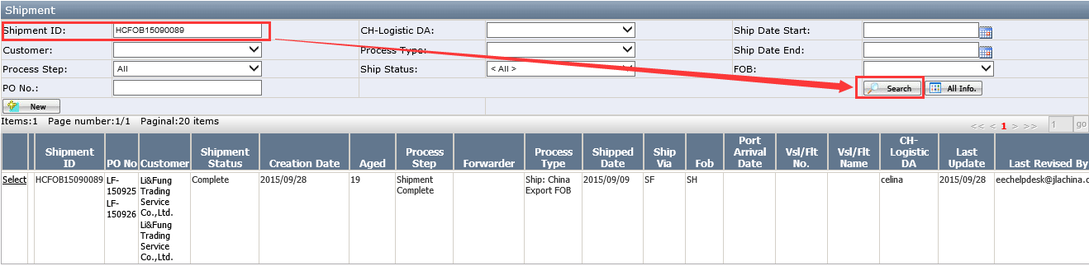
Pic1
Step2: Open shipment edit page, see Pic2; click “Detail” button.
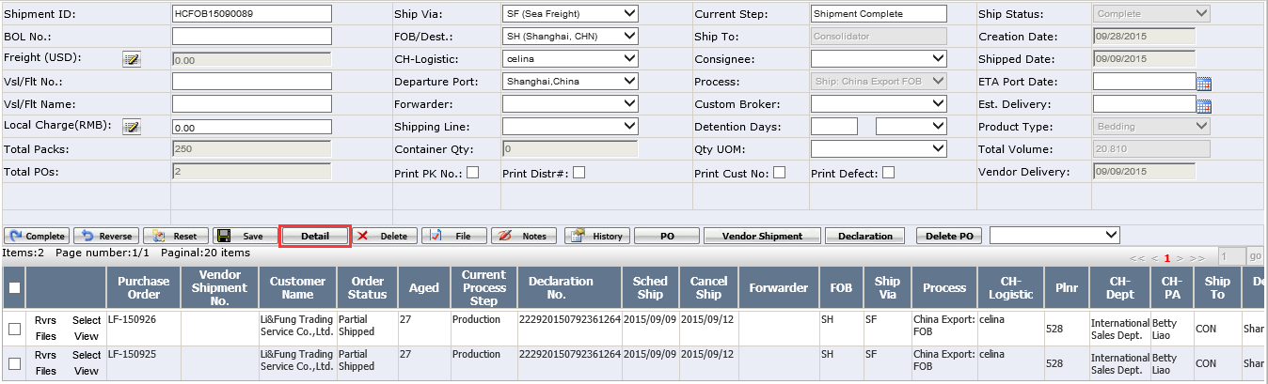
Pic2
Step3: Select an SCM order, then click “Delete” to remove selected order from this shipment. See Pic3.
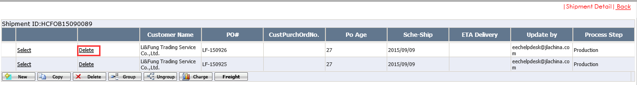
Pic3
Notes: “Delete” button only show when shipment is in “Shipment Complete” button and process type is "Ship: China Export FOB", "Ship: China Export CIF", "Ship: China Drop Ship" or "Ship: China Warehouse".
Step4: System will pop up below message, see Pic4. Click “OK” button to continue.
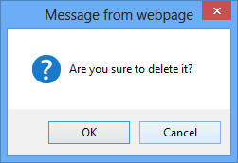
Pic4
Step5: If selected order has customer invoices or vendor invoices, system will pop up below message, see Pic5. Please contact accounting team and ask them to delete customer invoices or vendor invoices.
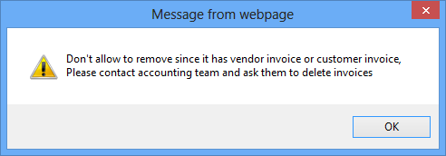
Pic5
Step6: If accounting team didn’t delete related orders in SAP system, system will pop up below message, see Pic6. Please contact accounting team and ask them to delete orders in SAP system.
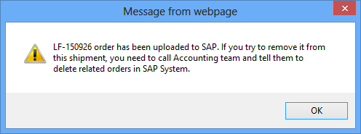
Pic6
Step7: If accounting team delete related orders in Sap system, system will pop up below message, see Pic7. It means that selected order is successfully removed from this shipment.
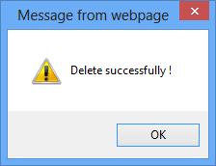
Pic7
Step8: If selected order has other shipment, please follow step1~Step7 to remove it from its shipments as need.
Step9: User can set up a new shipment for selected order. And also, user can reverse selected order in order to edit order information.
Notes: After remove selected order from shipments, if want to reverse orders, please contact UTC team and ask them to reverse and edit order information.
Case2: If the shipment only has one order, please reverse this shipment by clicking “Reverse” button.
Step1: search out the shipment and open shipment edit page. Then click “Reverse” button to reverse this shipment as need. See Pic8.
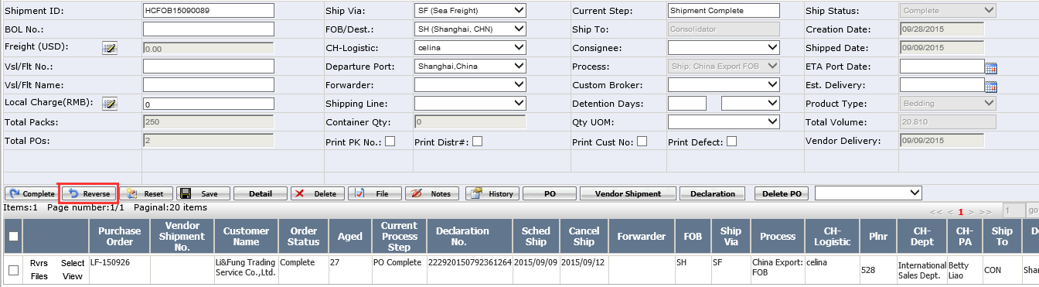
Pic8
Noted: If the shipment is uploaded to SAP, only allow GM-assistant to reverse it. And of course, accounting team have to delete related orders in SAP if GM-assistant reverses it.
Step2: User can set up a new shipment for selected order. And also, user can reverse selected order in order to edit order information.
If the shipment only has one order, user clicks “Delete” button to remove the order. See below example in Pic9.
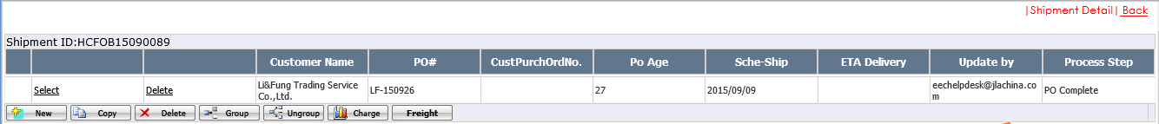
Pic9
System won’t allow to remove the order since there is only one order in the shipment. See Pic10.
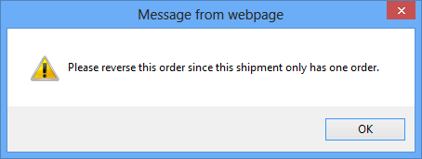
Pic10

