Label Application User Guideline
Version: 1.0 9-9-2015

How to log into EEC
- In IE browser, type EEC Testing address: https://192.168.20.41/EECSystem
- In EEC Login Page, type your User Name, Password and Check Code. (See Figure 1-1). EEC Helpdesk will send you user name and password if you do not have an account. If you have a user ID but forgot the password, please click Forgot Your Password to reset your password.
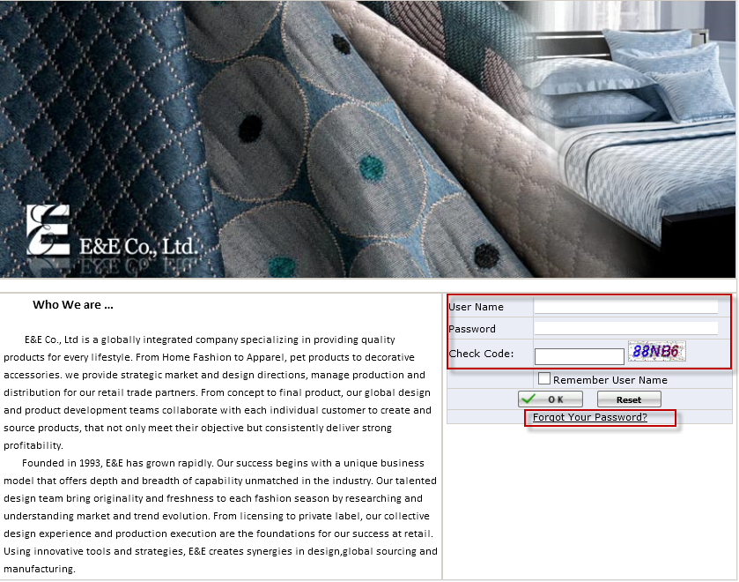
Figure 1-1 EEC Login Page

How to create a Label Application
- Click Review Order under Production Management to Open Review Order Page. (See Figure 2-1)
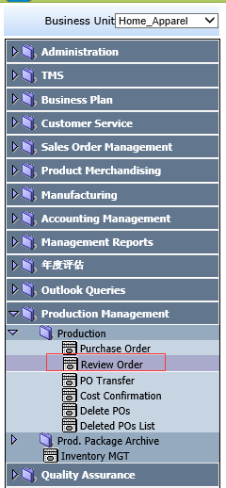
Figure 2-1 Review Order Page Path

- Put a check for a PO and Click New Label (See Figure 2-2)
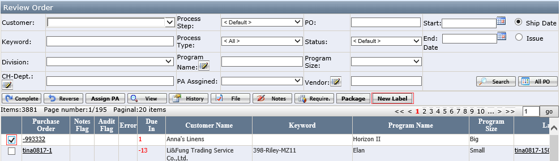
Figure 2-2 Review Order Page

- It will open Label Application Page. (See Figure 2-3)
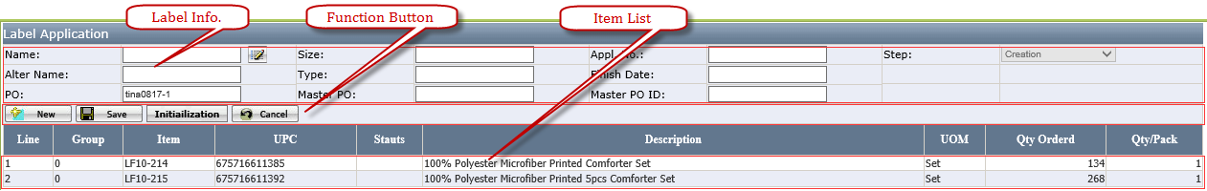
Figure 2-3 Label Application Page (See Appendix A for Label Application Page Layout Introduction)

- Click the Pencil iron near to Name to select Label Name you request (See Figure 2-4). (See Appendix C for Label selection Page Layout Introduction)
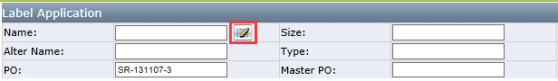
Figure 2-4 Name Selection Page

- Click Save. The user can enter Req. Qty. and Ticket Price manually (See Figure 2-5). Ticket Price only appears when the selected label required Ticket Price.
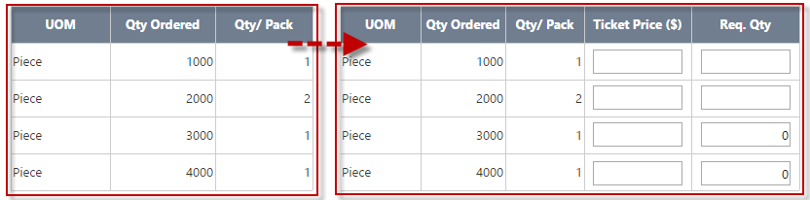
Figure 2-5

- Or click Initialization to set all initial Req. Qty. In the Initialization Page, the user enters Ratio No and click OK (See Figure 2-6). System will auto calculate the initial Req. Qty. accordingly (See Figure 2-7 ). Req. Qty. = Qty. Ordered × Ratio No ÷ Qty. / Pack. The user can further modify the initialized Req. Qty. and click Save.
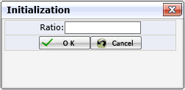
Figure 2-6 Initialization Page

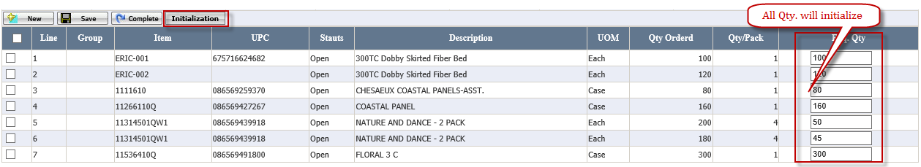
Figure 2-7 System auto calculates Req. Qty. Req. Qty. = Qty. Ordered × Ratio No ÷ Qty. / Pack

- Click Complete to submit the application. The application status will auto changed from Creation to Review.
- Once the application is successfully complete, you will be able to click View button to view the printed label layout (See Figure 13-1)

- After the application submitted, if finding some items information is wrong, the user can either select items and clicks Cancel to cancel some items or send email to barcode team bc@scmhome.com to request them to reverse the application. Once the item is cancelled, the item Status will change from Open to Cancelled. (See Figure 2-8 ) and system will also auto send Email to notify the related persons (See Figure 14-1 Email for Cancelled items). If the item is not printed, the barcode team will not print the cancelled items.
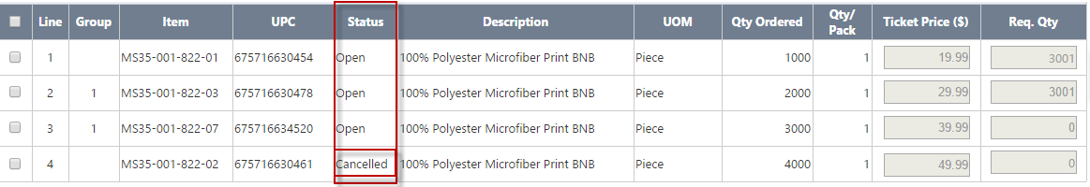
Figure 2-8 Item Status

- If the application is created wrongly, the user can click Delete to delete the application (See Figure 2-9). Delete is only visible when the application step is in Creation.
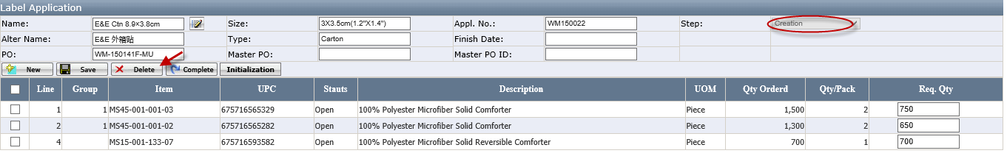
Figure 2-9 Delete the application

- If complete successfully, the View Button will appear. The user click the View to open the PDF file.
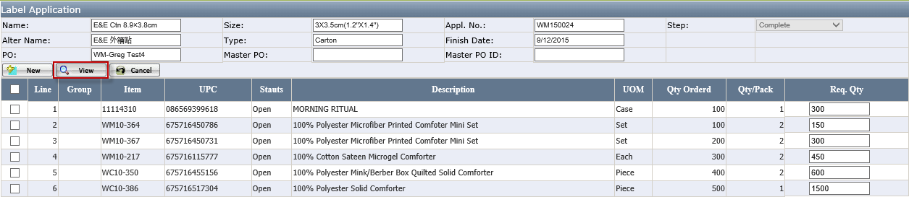
Figure 2-10

When to pick the printed labels
- If it is printed by our E&E Company, once the label is printed, you will get the email to request you to pick the label next day. (See Figure 14-2 Email for Complete)

- If the labels is printed by third printing company, you will get the email to follow it up (See Figure 14-3 Email for the third vendor )

How to Print Label (Label Team)
- Click Label Review under Label Mgt. to Open Label Review Page (See Figure 4-1)
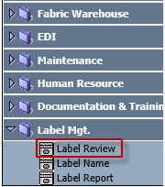
Figure 4-1Label Review Page Path

- Click the Appl. No to open the Label Detail Page
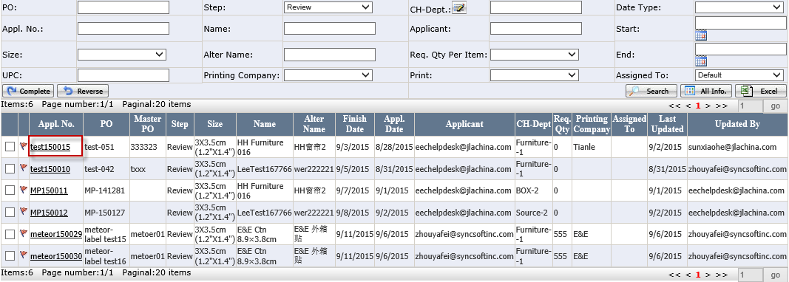
Figure 4-2 Label Review Page (See Appendix B for Label Review Page Layout Introduction)

- It will open Label Detail Page
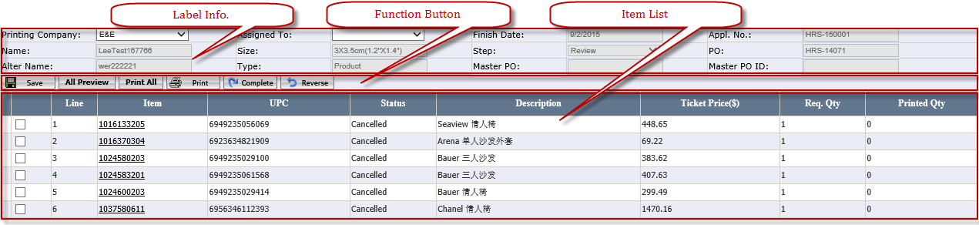
Figure 4-3 Label Detail Page (See Appendix D for Label Detail Page Layout Introduction)

- Select Printing Company and Assigned To
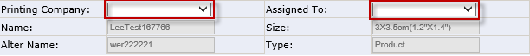
Figure 4-4

- Click Save and other Buttons will appear. System will not allow to save and will appear * unless Printing Company and Assigned To has been selected.
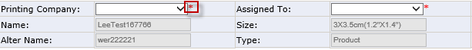
Figure 4-5

- Click All Preview to review all Labels (See Appendix E: Label PDF Page Layout Introduction.) Or click Item No can view this item zebra printed PDF (See Figure 4-6)
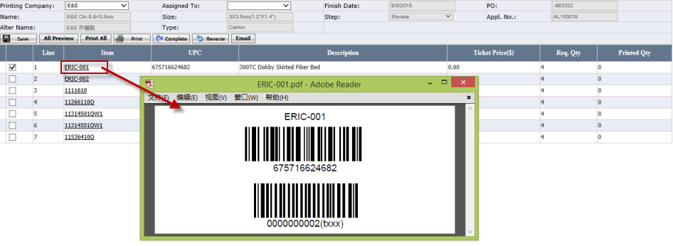
Figure 4-6

- Click Print All to print all item labels (See Appendix E: Label PDF Page Layout Introduction.)
- Check Checkbox (Single Selection), Click and system will pop up Print Page. Field the New Print Qty. to print item Label.
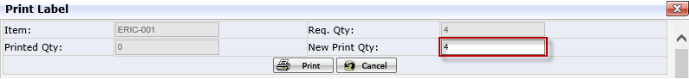
Figure 4-7

- If the Item is printed by the Third Vendor, the User need to click Email Button and then system will auto send Email (See Figure 14-3 Email for the third vendor)
Figure 4-8

How to update a Label Name
- Click Label Name under Label Mgt. to Open Label Name Page (See Figure 5-1)
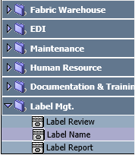
Figure 5-1 Label Name Page Path

- It will open Label Name Page
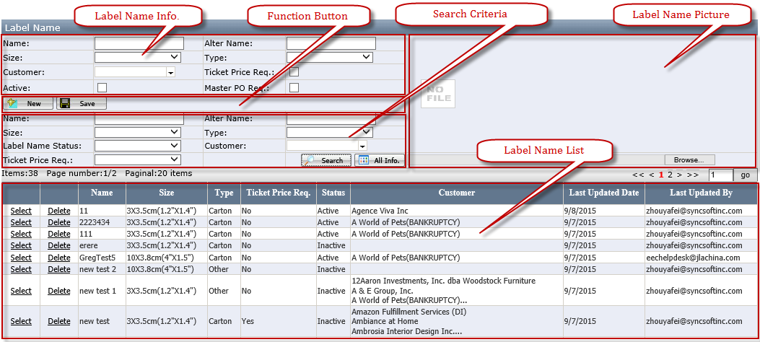
Figure 5-2 Label Name

- Fill in the Name, Size, and Type necessarily and Fill in Alter Name, Customer alternatively.
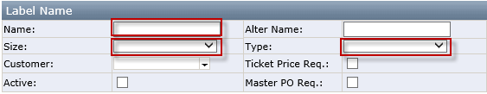
Figure 5-3

- Put a check for Ticket Price Req. or Master PO Req.
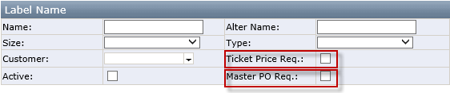
Figure 5-4

- Update a Label Picture
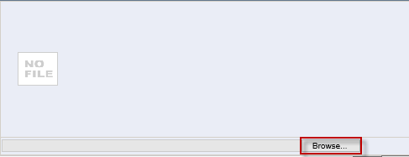
Figure 5-5

- Click Save and system will give massage if save successfully.
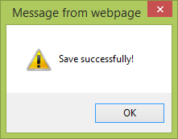
Figure 5-6

Label Name Info.
- Name, Size, Type: It is required.
- Alter Name: It is not required and repeat is not allowed.
- Customer: It is allowed to select multiple customers.
- Master PO Req.: If it is checked, the PO that want to create the Application is required to have Master PO No. If the Master PO Req. is checked but there is not Master PO in the PO, system is not allowed to save in the Label Application page.
- Ticket Price Req.: default no check. When it is check, it will show Ticket Price on Label Application and Label Detail.
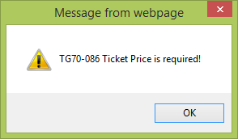
Figure 5-7

- Active: default no check. It check and will show label selection page.

Function Button
- Save: Once it is saved successfully, it will display upload picture in the top right corner.
- New: Click it to create a new label Name.
- Configuration: Click this Button, system will open the Configuration Label Page.
Figure 5-8

- Configuration Label Page (See Figure 5-10)
Only Configure Label Page is successfully saved, user can put the check for active. If it is missing configuration information, give the message "Fail to save due to missing label configuration.
- Label Class: It is not required and it is used to confirm what the content of the selected label is.
- Label Template: It is not required and it is used to confirm where the every part of label content is put.
- PDF Class: It is not required
- PDF Template: It is not required
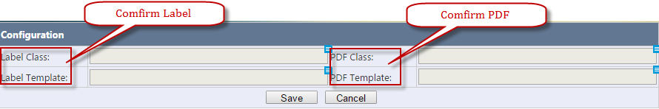
Figure 5-9 Configuration Label Page

Search Criteria
- Customer: It is allowed to select multiple customers.
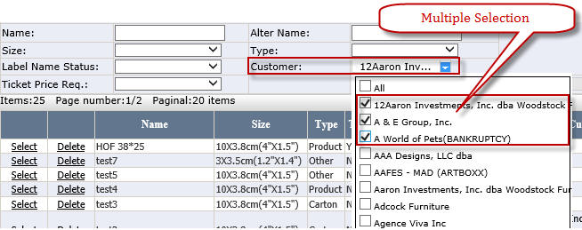
Figure 5-10

Label Name List
- Delete: Once it is used by any application and cannot be deleted and warning message "Failed to delete since it has been used.” Otherwise, it is allowed to delete.
- Select: Click it to modify Label Name.

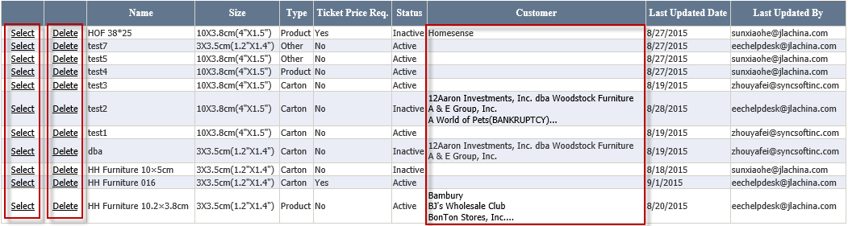
Figure 5-11

- Customer: If the Customer column is more than three customers, system will not show all customers. The user can select Label Name to open Customer Selection for query.
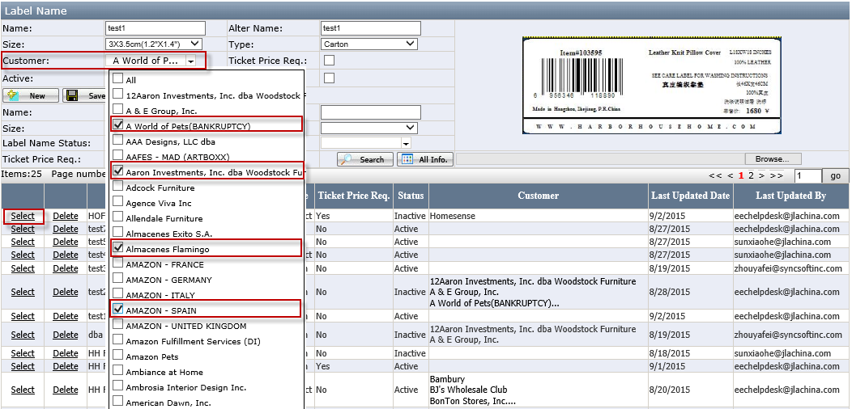
Figure 5-12

Add the Master PO in Purchase Order

What if PO information is changed
- If the PO is cancelled or deleted after the application is created, when UCT cancelled/delete PO, system will auto send the email to related the team.

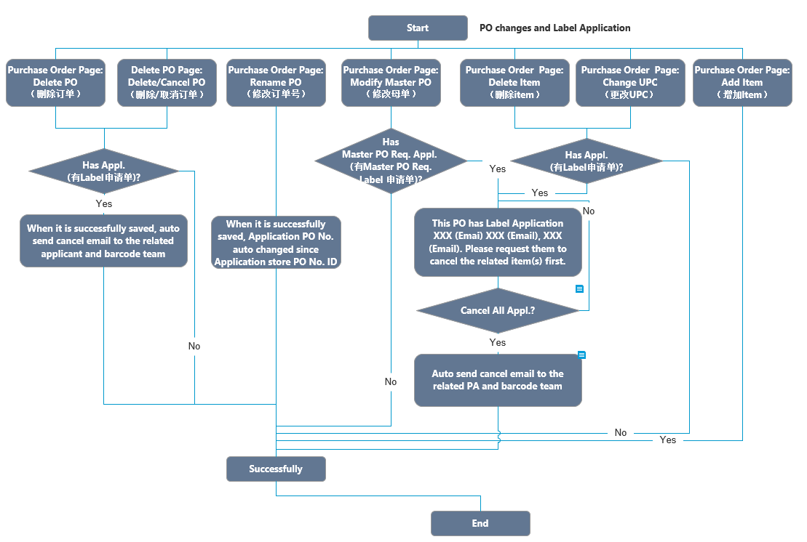
- If there is a label application existing when deleting item or changing UPC or modifying Master PO, UCT Team has to manually send the cancel items request email to the applicant. Only the related item in the application is cancelled or deleted, UCT can make those changes.
- If the item is added to PO after the application is created, please submit a new label application after the same name label application has been completed.

Master PO in Purchase Order
- Click Purchase Order under Production Management to Open Purchase Order Page.(See Figure 6-1)
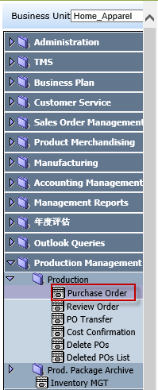
Figure 6-1 Purchase Order Page Path

- Purchase Order Page (See Figure 6-2)
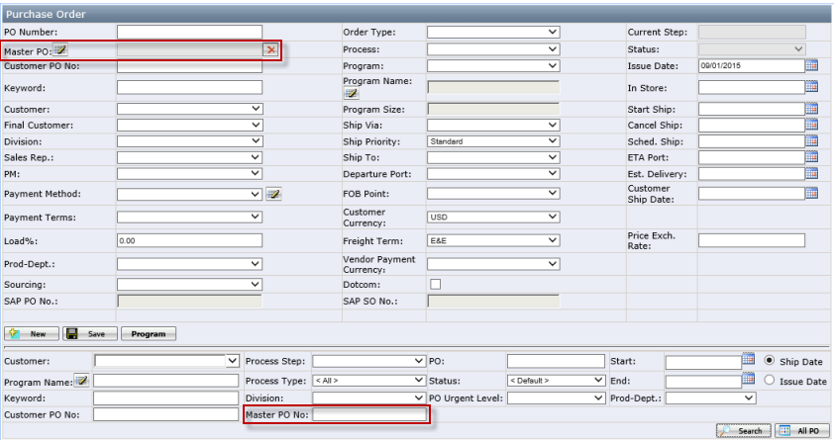
Figure 6-2 Master PO

- If the Order Type is Standard and Process is Domestic: Warehouse or Intl.- Domestic: Warehouse, Master PO is required.(See Figure 6-3)
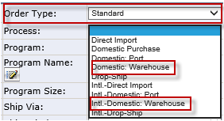
Figure 6-3

- Click the Pencil Iron to open the Master PO Page and Click the X to clean Master PO.(See Figure 6-4)
Figure 6-4

- When the user click Delete in Purchase order Page, system will auto send email to the related applicant and barcode team (See Figure 14-4 Email for delete in Purchase Order or Delete POs Page)
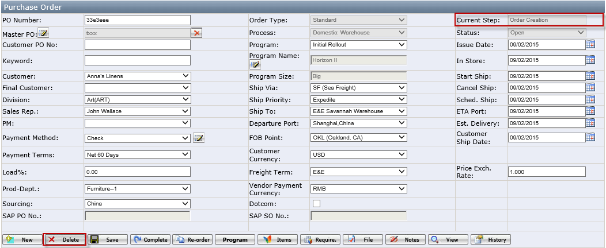
Figure 6-5

Master PO Page
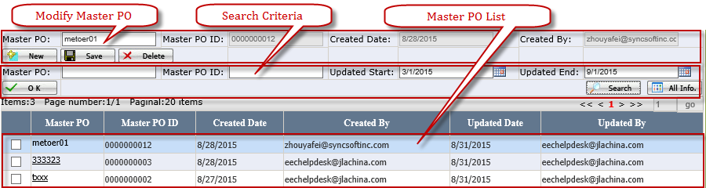
Figure 6-6 Master PO Page

Modify Master PO
- Master PO: a free text; user can type in as he/she likes.
- Master PO ID: it's automatically generated by EEC system. It begins with 0000000001.
- Created Date: the created date, automatically recorded by system.
- Created By: to record the user who created the master PO.
- Delete: Don't allow to delete master PO on Master PO Page if the master PO is used by one or more PO. When user tries to delete master PO which can't be deleted, pop up message: "Fail to delete since it's used in PO(s)."
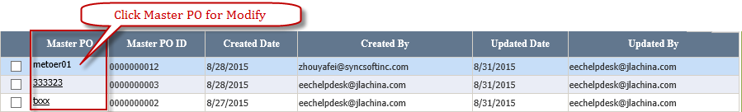
Figure 6-7

Search Criteria
- Master PO and Master PO ID: are auto complete fields.
- Updated Begin/Updated End: default search master PO updated in last 6 months.

Master PO List
- Check the checkbox and Click the OK to select Master PO for Purchase Order.
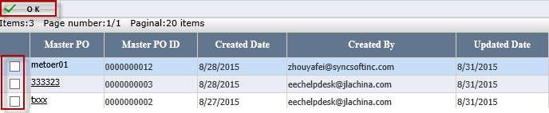
Figure 6-8

Master PO effect in Delete POs Page
- Click Delete POs under Production Management to Open Delete POs Page (See Figure 6-9)
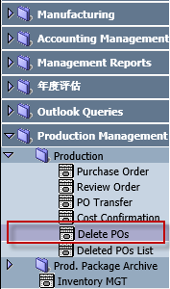
Figure 6-9

- The Delete POs Page (See Figure 6-10)
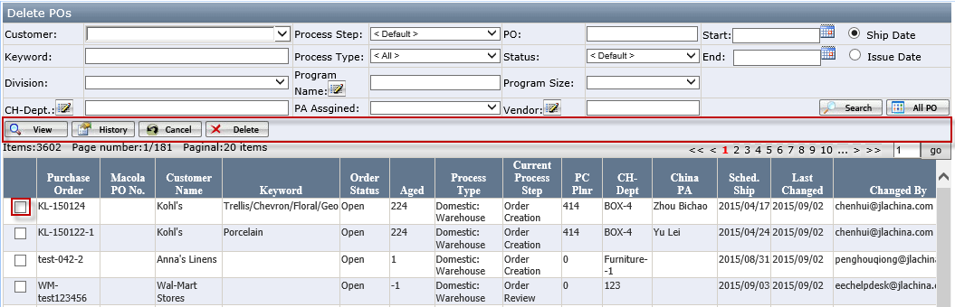
Figure 6-10

- Cancel and Delete: system will auto send email to the related applicant and barcode team (See Figure 14-4 Email for delete in Purchase Order or Delete POs Page)

Report
- Click Label Name under Label Mgt. to Open Label Name Page (See Figure 8-1)
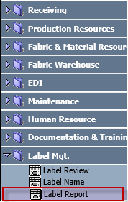
Figure 7-1 Report Page Path

- Open Report Page (See Figure 7-2)
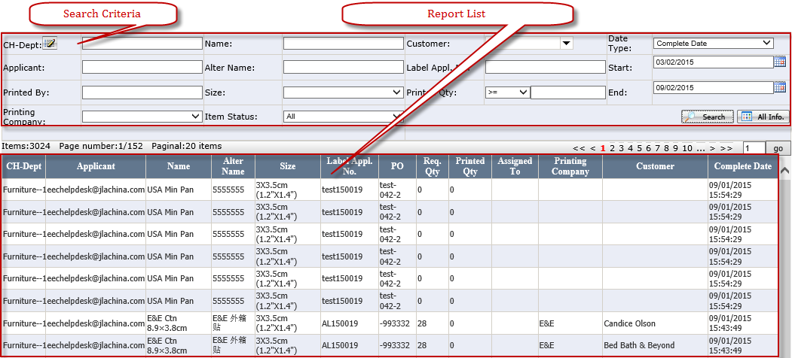
Figure 7-2 Report Page

Search Criteria
- CH-Dept.: when click the CH-Dept., it will open department popup window.
- Customer: it is multiple selection.
- Start and End: default to previous half year.
- Only list application whose Step is complete.
- Item Status: The drop down list contains All (Default), Open, Cancelled. The search result of Printed Qty. will be changed according to Item Status changes.
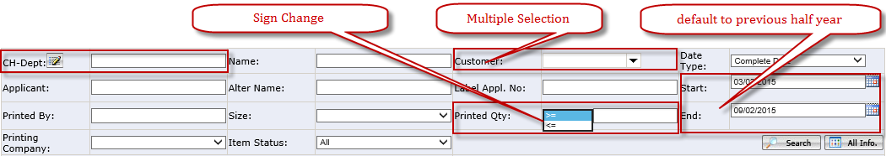
Figure 7-3

Report List
- Sort by: Complete Date > CH-Dept. >PO.
- Printed Qty.: It = actual Printed Qty. If Printing Company is the Third Vendor, Printed Qty. = Req. Qty.
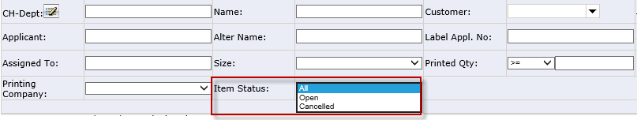
Figure 7-4
- The search result of Printed Qty. will be changed according to Item Status changes.
- E. g. If the Item Status is Open, System will auto screen All PO to select out part which Item Status is Open of each PO. If the Item Status is Cancelled, System will auto screen All PO to select out part of each PO which Item Status is Cancelled. If the Item Status is All, Printed Qty. is sum of each PO.
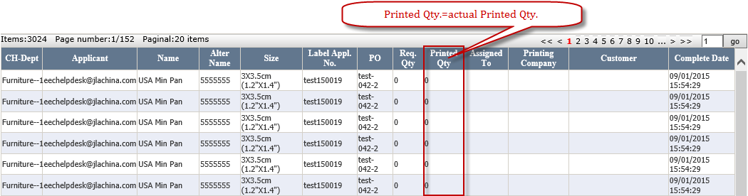
Figure 7-5 Report List

Where to get the help if you have question or problem
If you have any questions and issues during the process, please send email directly to eechelpdesk@jlachina.com

Appendix A: Label Application Page Layout Introduction
(See Figure 2-3 Label Application Page Layout)

Label Info.
- Name: Click the Pencil Iron to open the Label Selection Page.
(See Appendix C for Label Selection Page Layout Introduction)
- Size: If the Name is selected, the Size will auto create according to the Name.
- Alter Name: It is probably blank and exist Chinese character. The Alter Name will auto create according to the Name.
- Type: The Type will auto create according to the Name.
- Finish Date: If complete successfully, the system will auto create. Step change from Creation to Review Date + 5 working day (excluding weekend) e. g submit date= 8/21, finish date=8/28.
- Appl. No: System will auto create if Complete successfully.
- PO, Master PO and Master PO ID: System will auto bring according to the selected Purchase Order.

Function Button
- Save: allow the user to save selected Label Name and save Req. Qty. and Ticket Price. The Initialization Button and Complete Button will be visible after the application is successfully saved. (See Figure 9-1)
Figure 9-1

- Initialization: Click it and system will pop up the Initialization Page. (See Figure 9-2)
Req. Qty. = Qty. Ordered × Ratio No ÷ Qty. / Pack
Figure 9-2 Initialization Page

- Complete: If complete successfully, the Cancel Button will be visible and the Save, the Complete Button, Initialization Button will be hidden.(See Figure 9-3)
Figure 9-3

- Cancel: It is multiple selection. If items are cancelled successfully, the Item Status will change to Cancelled and system will auto send Email. (See Appendix D for Email Page Layout Introduction)
Figure 9-4

- Default sort is by Line No.,
- Delete: Allow to delete the application when the step is Creation
Figure 9-5

Item List (See Figure 9-6)
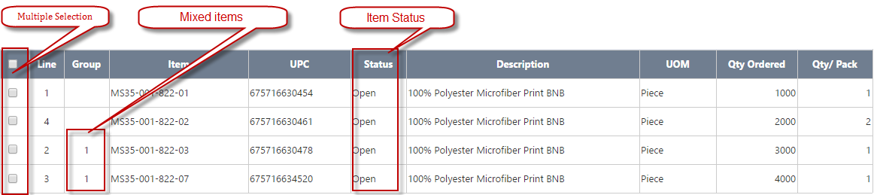
Figure 9-6 Item List

- Mixes Items: If group is not blank, system will not allow enter Req. Qty. >0 due to label application does not support the mixed items.
- If Save successfully, Req. Qty. and Ticket Price will appear. (See Figure 9-7). Ticket Price only appears when the selected label required Ticket Price.
Figure 9-7 Table change

Appendix B: Label Review Page Layout Introduction
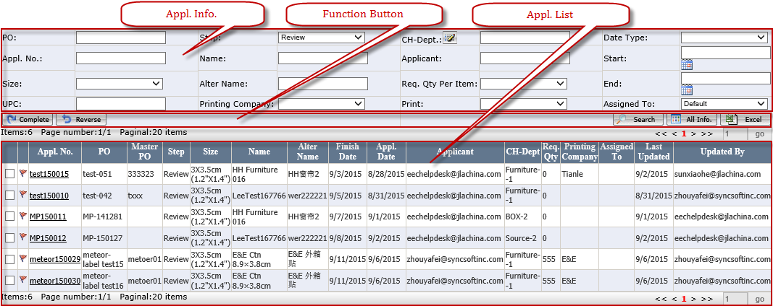
Figure 10-1 Label Review Page

Appl. Info.
- Step: It is one selection.
- Assigned To: Default to Default. The Default means the Appl. No has not been assigned to and has assigned to the person who is using at current (See Figure 10-2)
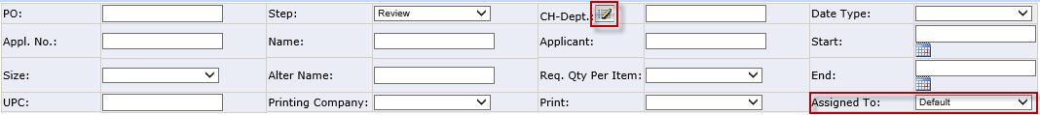
Figure 10-2

- CH-Dept.: Click it to open Select Department Page (See Figure 10-3)
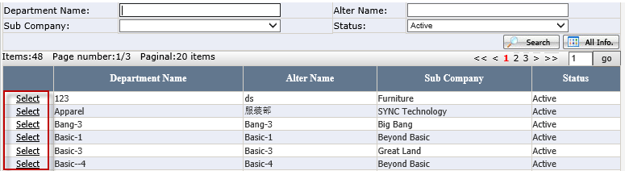
Figure 10-3 Select Department Page

Function Button
- Complete: Click it and Step will change to Complete. System will auto send Email (See Figure 14-2 Email for Complete)
- Reverse: one selection and allow to reverse the application to previous step.

Appl. List
- Red Flag: Display it when Finish Date - Today <=2, No print date, step <> complete.
- Checkbox: One selection.
- Default sort: Red Flag, Finish Date, Step.
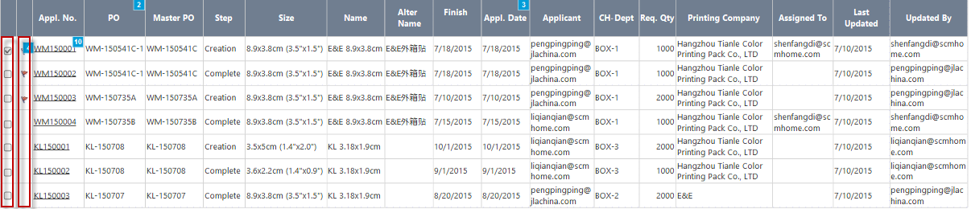
Figure 10-4

Appendix C: Label Selection Page Layout Introduction. (See Figure 11-1)
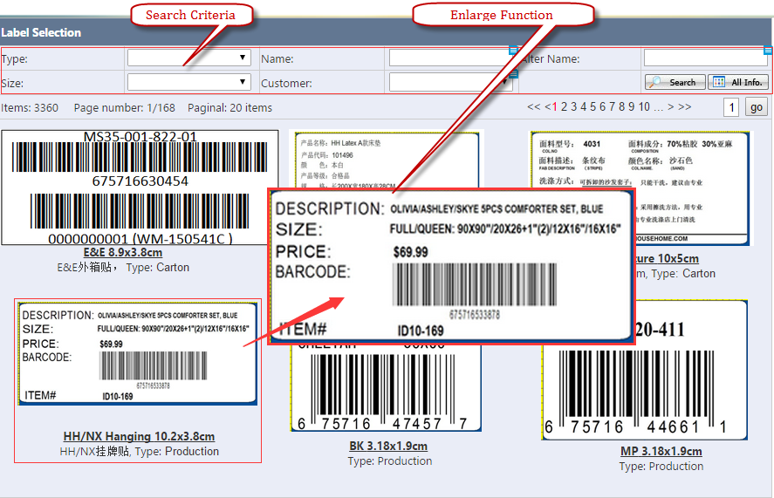
Figure 11-1 Label Selection Page

Search Criteria
- Default to show Labels which match the Customer in PO.
- Customer: It is multiple selection.( See Figure 11-2 )
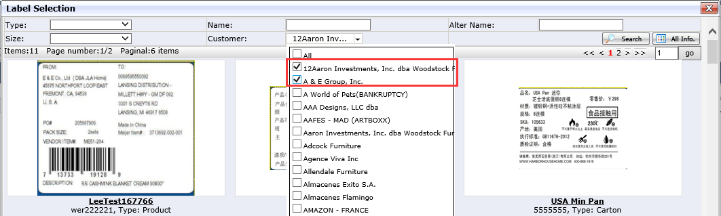
Figure 11-2 Label Selection

Enlarge Function
- Cursor move on the picture and system will auto pop the enlarged Picture (enlarge 1.5—2 times) in the best suitable position. (See Figure 11-1 Label Selection Page)

Appendix D: Label Detail Page Layout Introduction.

Label Detail Info.
- Printing Complete and Assigned To: It is required.
- Finish Date: If Printing Company is the Third Vendor, it is allowed to be modify; otherwise, it is grayed out.
- Other information will attain from Appl. No

Figure 12-1 Label Detail Info.

Function Button
- Save: Only Printing Company and Assigned To is selected can save successfully. If save successfully, other Buttons will appear.
Figure 12-2
- All Preview: Click it and system will auto pop up PDF file (See Appendix E for Label PDF Page Layout Introduction)
- Print All: Click it and system will print all items Label.
- Print: Click it and system will pop up Print Label Page. If the New Print Qty. is changed and the sum (=New Print Qty. + Printed Qty.)>Req. Qty., system will warn “The summary of Printed Label is over the Req. Qty., Are you sure to continue?" If the No. <0, Default to blank. (See Figure 12-3).
Figure 12-3 Print Label

- Reverse: The Step will Change from Review to Creation.
- Complete: If Printing Company is E&E and complete successfully, the Step will change from Creation to Review and auto send Email (See Figure 14-2 Email for Complete). Otherwise, only change the Step.
- Email: It is visible when the Printing Company is the Third Vendor. Click it and system will auto send Email (See Figure 14-3 Email for the third vendor).

Item List
- Default sort: Line and not show the item whose Req. Qty. =0.
- Checkbox: It is not allowed to multiply select.
- Plus Iron: When click it, system will open the print detail which includes Req. Qty., Printing By, Printing Date.
- When clicking Item No., it will open this item zebra printed PDF Preview.
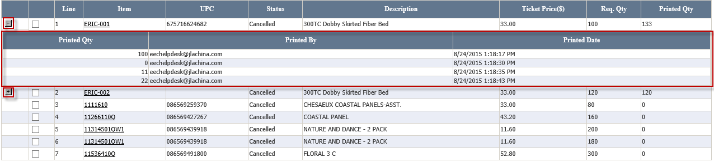
Figure 12-4 Item List

Appendix E: Label PDF Page Layout Introduction.
- If the Printing Company is E&E, the All Preview like this:
E&E PDF: It is A4 Paper and one page can have multiple different items and each item label count=1.
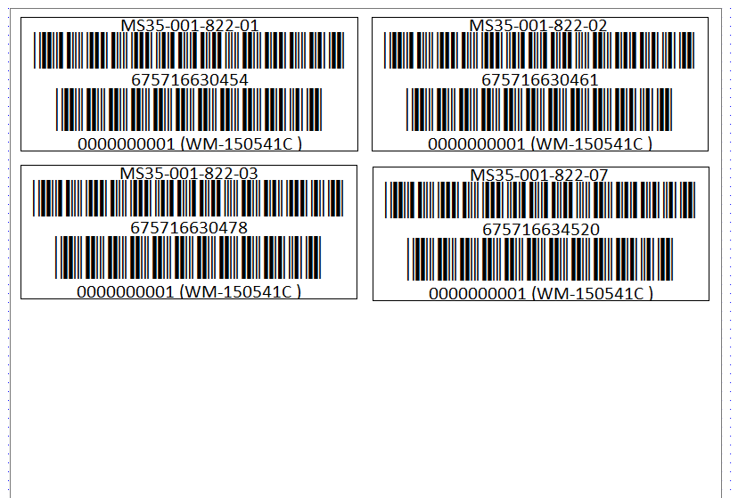
Figure 13-1

- If the Printing Company is the Third Vendor, the All Preview like this:
Third Vendor PDF: 1 item Per Page on A3 Paper, Paper Size 30x42cm. This Paper need to list 3x10=30 same item labels (3 columns, each column fit 10 labels)

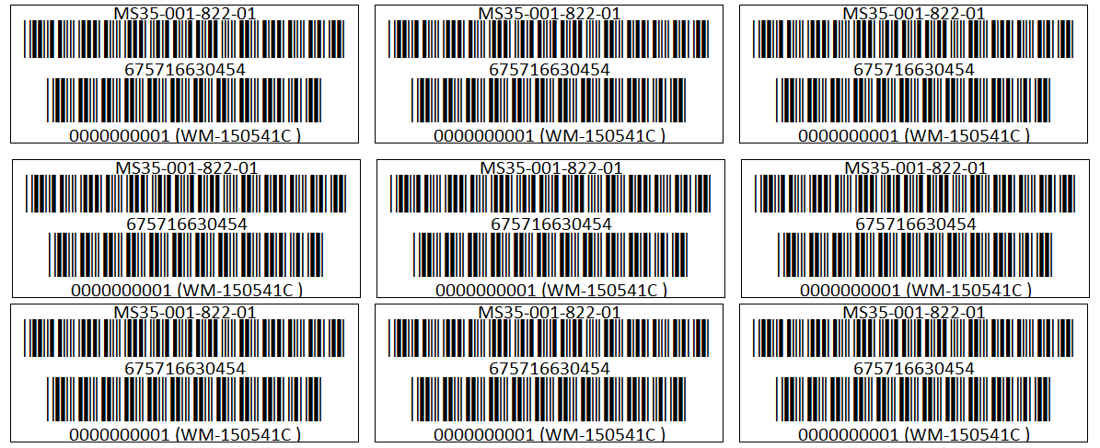
Figure 13-2

Appendix F: Email Page Layout Introduction.

Email for Cancelled items
- If cancel successfully, system will auto send to the related applicant.
- Salutation will reset according to the applicant.
- Whether Ticket Price exist or not depending on the category of Application. E.g. If there is Ticket Price in the Application, the content of Email includes Ticket Price.
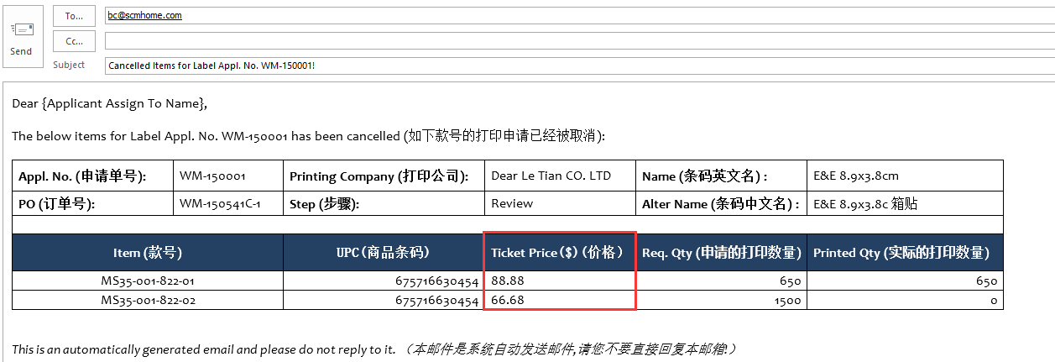
Figure 14-1 Email for Cancelled items

Email for Complete
- Salutation and Addresser will reset according to the applicant.
- Whether Ticket Price exist or not depending on the category of Application. E.g. If there is Ticket Price in the Application, the content of Email includes Ticket Price.
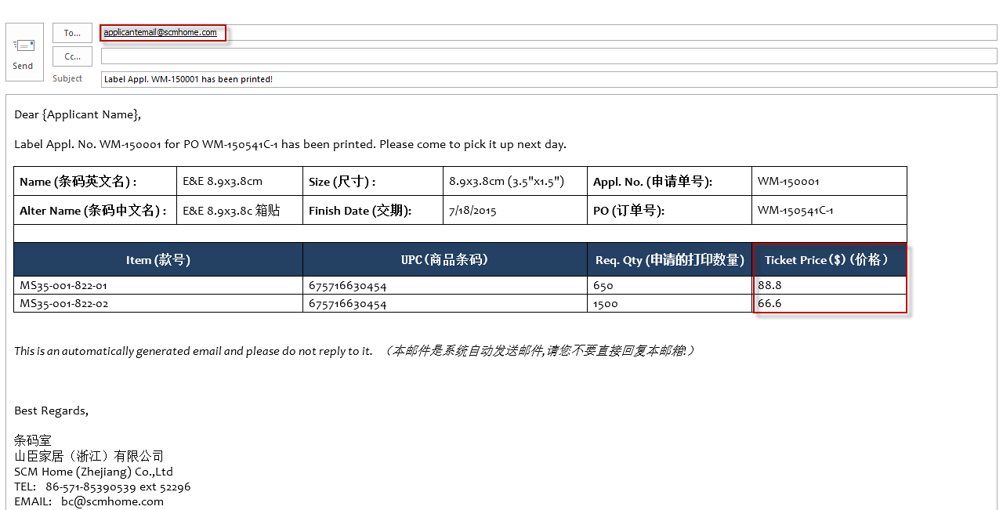
Figure 14-2 Email for Complete

Email for the Third Vendor
- Whether Ticket Price exist or not depending on the category of Application. E.g. If there is Ticket Price in the Application, the content of Email includes Ticket Price.
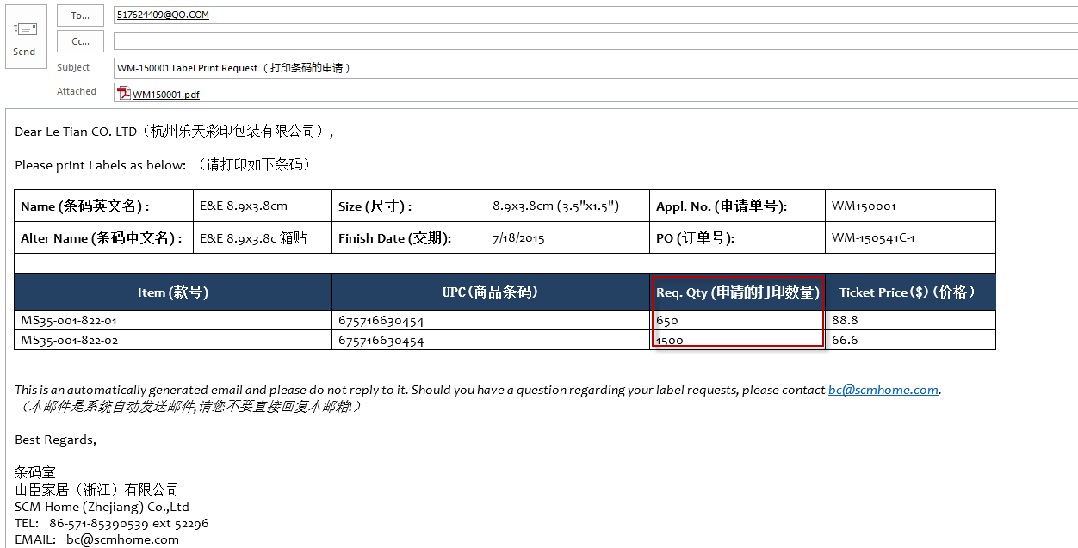
Figure 14-3 Email for the third vendor

Email for delete in Purchase Order or Delete POs Page
- Whether Ticket Price exist or not depending on the category of Application. E.g. If there is Ticket Price in the Application, the content of Email includes Ticket Price.
- Salutation and Addresser will reset according to the applicant.
- If there has not been assigned to, only appear Applicant Name.
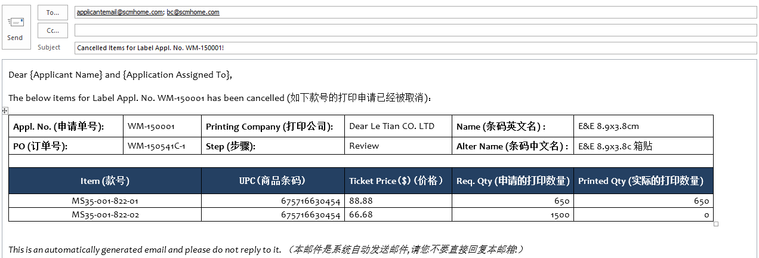
Figure 14-4 Email for delete in Purchase Order or Delete POs Page

