Replenish Inventory Location to Location

Replenish Layout

Repl.Manual Entry
This page is used to make replenish inventory manually.
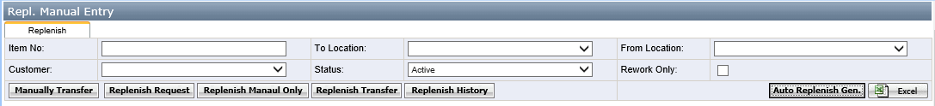
Buttons:
- Auto Replenish Gen.: this button to transfer the inventory automatically according to the stock calculated rules. The rules and contents are same as Replenish quantities page--> pick list generated rules.
- Manually Transfer: For warehouse person to make the inventory transfer or replenish the inventory manually
- Replenish Request: it is linked to replenish request page. For planning team to make the replenish item.
- Replenish Manual Only: It is linked to repl. manual request only page.
- Replenish Transfer: this button is used to transfer inventory. After run the service "Macola Stock Transfer" to update the database inventory table value
- Replenish History: This button is linked to replenish history page.

Repl. Manual Request Only
This page is used to add the item which needs to replenish. In this page, the user can decide the “From bin” and “To Bin”. This page is used by BDM Team and the replenish request from warehouse person.
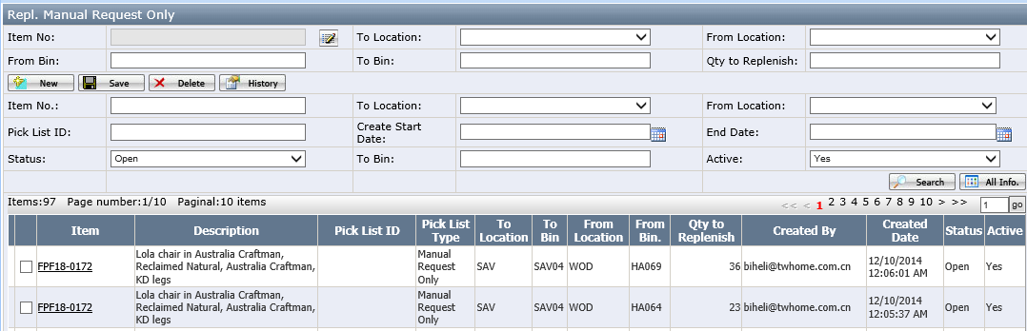

Repl. Quantities
This page is used to review pick list or print pick list by warehouse person
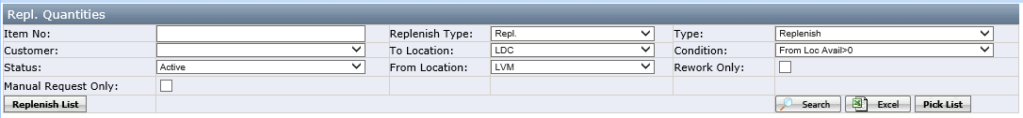
Click replenish list to open below page. in this page, user can review pick list and print pick list.
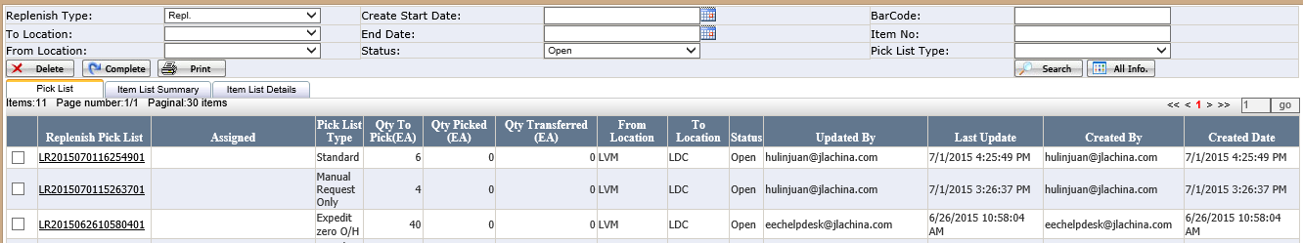

Repl. Request
This page is to add replenish items which item list is planning team and user just needs to select the item, enter to location and from location. System will decide the “From bin”.
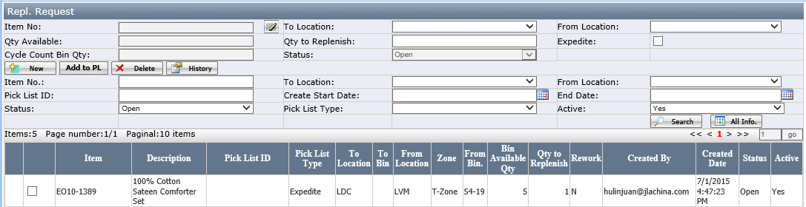
Notes:
- Add to PL: to add this item to pick list.
- From bin field in the grid: this field value is decided by system.

How to generate replenish pick list
The replenish pick list can be generated by two ways: by manually or by system based on rules.
There are different types of pick list based on the different conditions
- Standard: it is the standard replenish pick list
- Expedit zero O/H: It is the top urgent replenish pick list. It means the” To location “ item On hand quantity =0.
- Manual Request Only: It is generated by repl. Manual request only and it is suitable from batch replenish from one location to another location such as from WD2 to TDC before.
- Rework: It is the special pick list and the picked item need to rework.
- Container: It is the special pick list, when generate pick list in repl Manual Entry/Manually replenish page, the container pick list is checked.
----need to check with Duane, this type seems no useful now

Generate pick list manually-Case1
- Go to Warehouse Management/Replenish-Manual Entry page and click <Manually Transfer> button. See below screenshot.
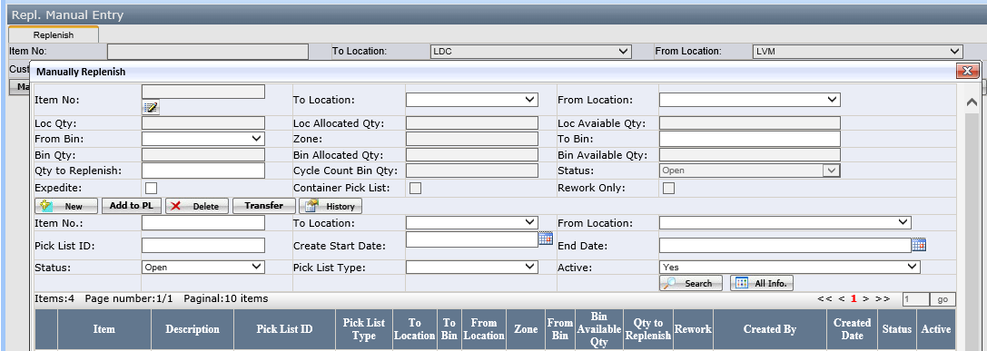

[Pict-1]
- Select one item, then to select the “To Location" and "From Location". Fill in the "Qty to Replenish" etc. fields.
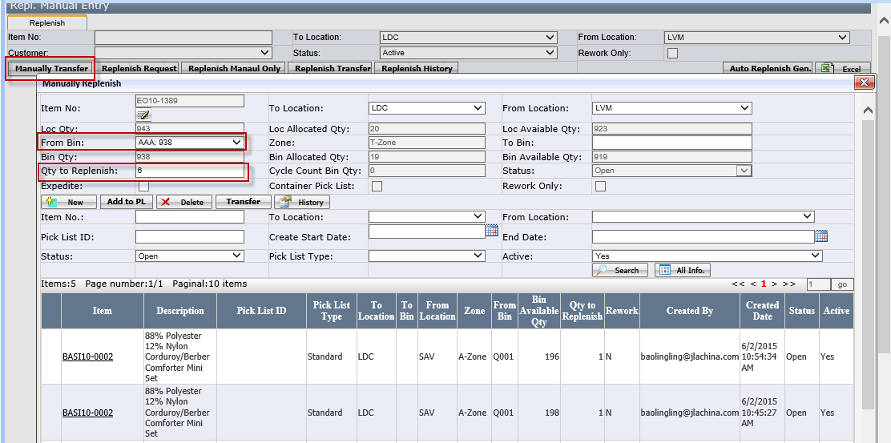
[pict-2]
Fields
- The selected item must exist in "To location" and "From location", otherwise you can't replenish this item.
- Qty to replenish： enter by user
- Expedite: Checkbox. If checked it, it means this item is urgent and user should replenish as soon as possible.
- Container pick list: checkbox, if it is checked, the pick list will be container type pick list.
- Rework only: checkbox, if it is checked, the pick list will be rework type pick list.
- To Bin: this bin type should be set “Transfer” type. If no transfer bin in "To Location", the “To bin” dropdown will be blank. The user should set up the transfer bin type in bin location page.
- Cycle Count Bin Qty: This field is to display the 'from location' item no. on hand quantity of Cycle Count Bin.
Buttons
- Add to PL: add the item to pick list page in "Replenish Quantity" page. Click this button and the item will be added to pick list in "Warehouse Management-->Replenish Quantities" page.
Notes: this button is only available from wholesale location to Drop ship location. E.g. from LVM to LDC. If it is from LDC to LVM, this button will not available.
- Delete: to delete the added items.
- Transfer: This button function is same as the button "Replenish Transfer". Click this button and run the EEC Service "Macola Stock Transfer", the inventory will be update in database table directly.
- Click<Add to PL> to add this item to the pick list.
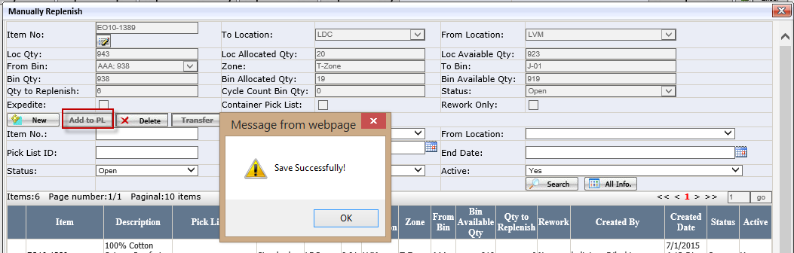
[Pict-3]
- After the item has been added successfully and go to “Repl.Quantities” page.
In repl. quantities page, select to location and from location, click <pick list> button to generate pick list.
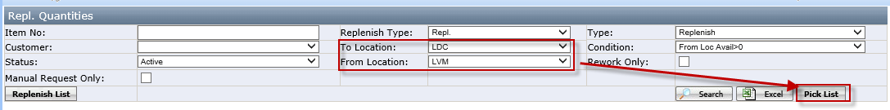
[Pict-4]
- The following step is same as <generate pick list manually-case2>
[Pict-5]
After print
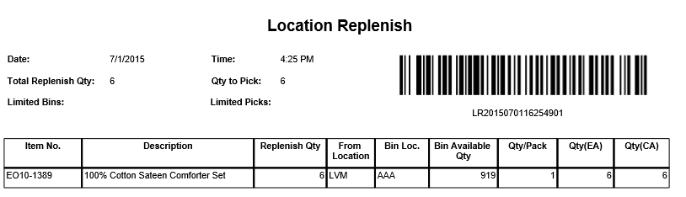

Generate pick list manually-case2
It is suitable for large products moving from one location to another such as from WDC to TDC
- Go to Repl. Manual Request Only, Enter the item no, to location, From location, from bin, To Bin and Qty to Replenish and save it, the item will be list in the grid.
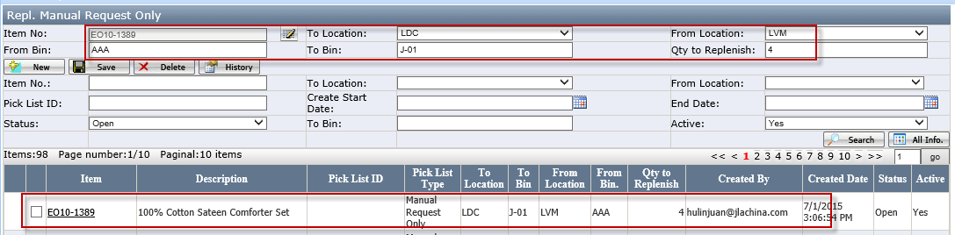
Notes: From bin and to bin are entering by user can system don’t check the bin no is existed or not. It controls by user.
- After the item has been added successfully and go to “Repl.Quantities” page.
In repl.quantities page, check manual request only, then select to location and from location, click <pick list> button to generate pick list
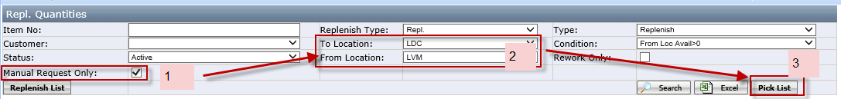
- Pop up the window and select to bin, then click ok button to generate pick list.
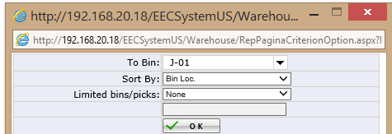
After click <ok> button.
- Click <print> button to print out the pick list as below
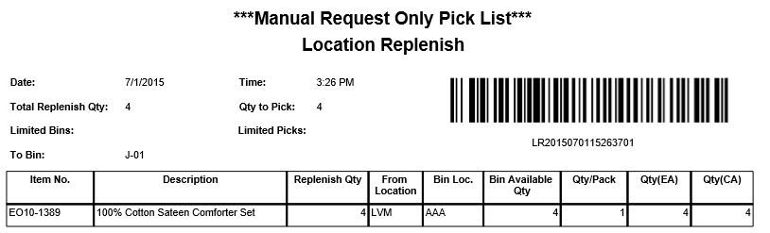
- The user can review this pick list in repl.manual request only page
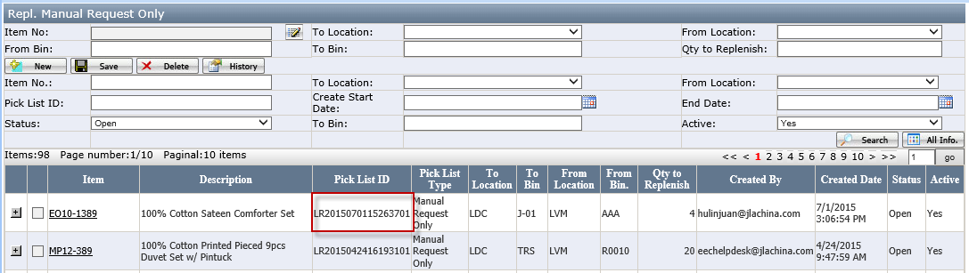
Or In repl.quantities page, click <Replenish list> button
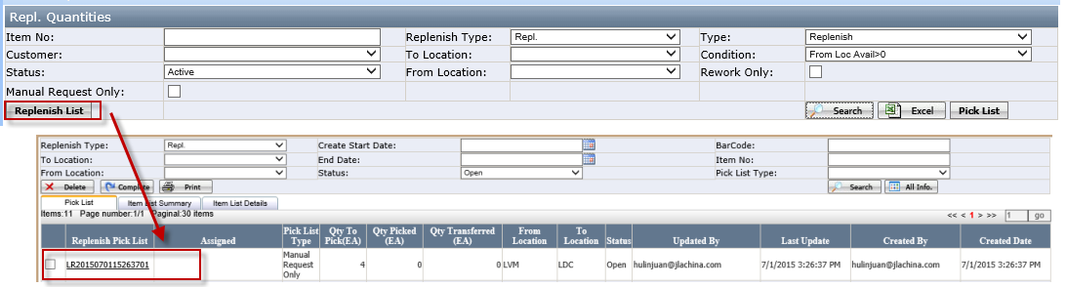

Generate pick list manually-case3
- Go to Repl. Request page
- From bin field in the grid: this field value is decided by system.
- Select one item, select to location and from location, then, enter the qty to replenish, then click <add to PL>, this item will be add into pick list.
- After that, follow the <Generate pick list manually-case1> to generate pick list in repl. Quantities page.

Generate replenish pick list automatically
- Go to "Warehouse ManagementReplenishRepl. Quantities" page
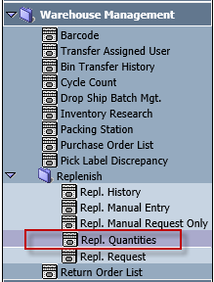
- For Replenish, select Replenish Type “Repl.” and search by Item No. or Location. If the items “Customer On Orders” > “On Hand Quantity”, that means this item in this location is out of stock. For the below example, the quantity on order of item BL51-0619 is 3 and On hand is 0, lack 3. So we have to replenish BL51-0619 from other location (LVM has 300).
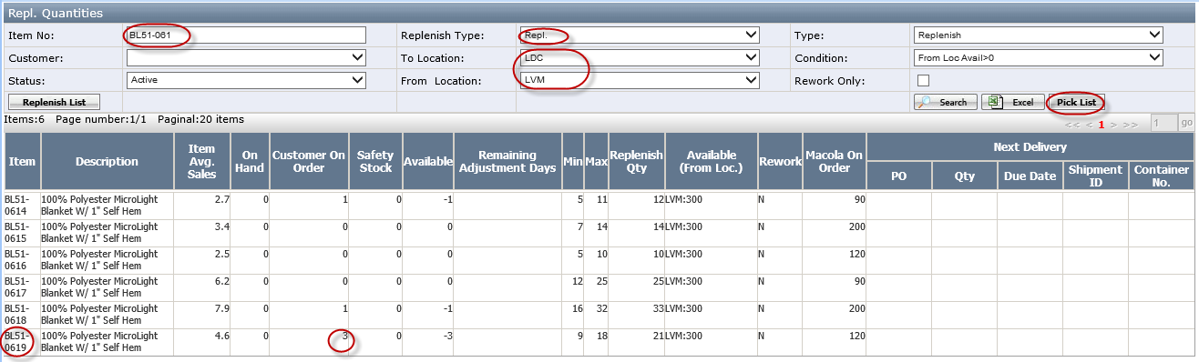
Replenish Qty=Max-Available

- For Reverse Replenish, select Replenish Type “Reverse Repl.” and search by Item No. or Location. If the items “Customer On Orders” > “On Hand Quantity”, that means this item in this location is out of stock. For the below example, the quantity on order of item MP10-146 is 5 and On hand is 0, lack 5. So we have to replenish MP10-146 from other location (LDC has 7).
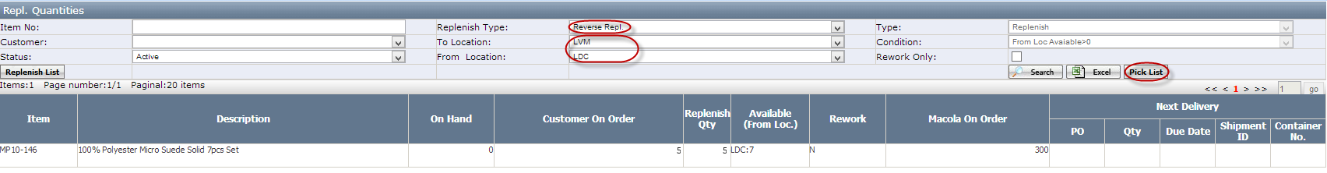
- Click <Pick List>button to generate the pick list based special rules. In the below pop up window, leave sort by “Bin Location” and Limited bins/picks to “None” and click <OK>.
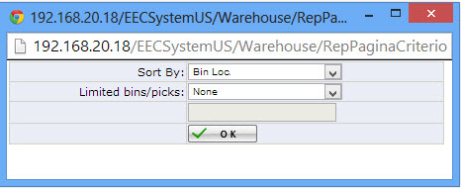
- Sort By has two options (Bin Loc./Item No.)
- Limited bins/picks has three options (None/Bins/Picks).
- Click <Print> button. If you see the below pop up window, click Open.
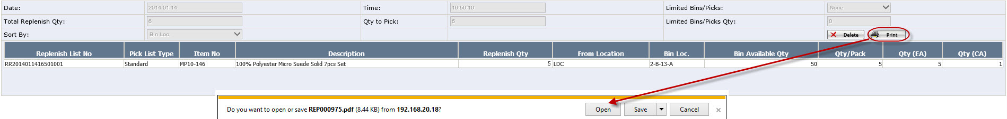
- After reviewing the below pick list, print it out. This document will be used for replenishment wireless application.
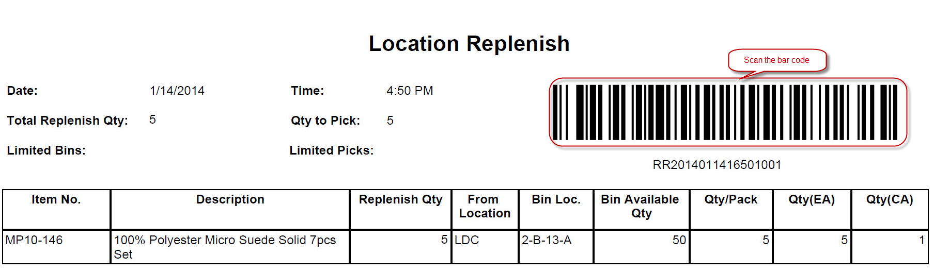

Notes:
a.) DC Inventory Control can create the pick list from wholesale warehouse to Retail warehouse.
b.) Dot Com Inventory Control role only can create the pick list “Replenish type=Reverse Repl."

How to do auto-Replenish Inventories
- Go to "Warehouse Management-->Replenish-Manual Entry" page, Select "To Location" and "From Location" , then click “Auto Replenish Gen.”, All the items that need to replenish will be listed ( See below screenshot for example)
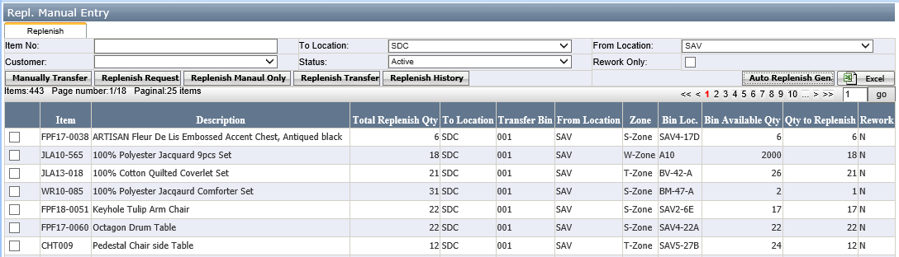
[Pict-1]
- Auto Replenish Gen: Click this button to list all the items which need to replenish.
Notes:
- These items that available Qty is less than Min Qty in "To Location" should be replenish and will be listed in the grid after click the <Auto Replenish Gen> button.
- Auto generate replenish list only support from wholesale location to drop ship location.

- Select one line item and click the <replenish Transfer> button to replenish quantity for selected item:
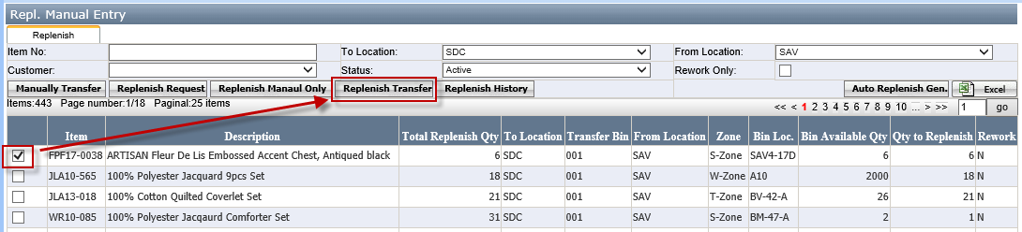
[Pict-2]
- Run the EEC service “Macola Stock Transfer” and transfer the inventory successfully. You can click the Replenish History button to see the replenish record.
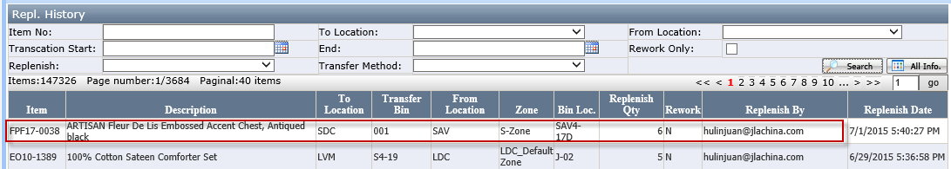

How to do replenishment manually
- Go to Warehouse Management/Replenish-Manual Entry page and click <Manually Transfer> button. See below screenshot.
[Pict-1]
- Select one item, then to select the “To Location" and "From Location". Fill in the "Qty to Replenish" etc. fields and click <Transfer> button to transfer button.
[pict-2]
- Then run the service “Macola Stock Transfer” and transfer the inventory successfully. You can click the Replenish History button to see the replenish record.

How to do replenishment by scanner
- Click Start Programs
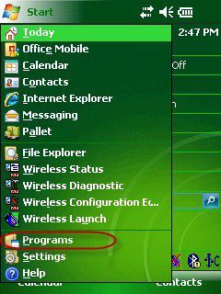
- Click <Replenishment Transfer> to open replenishment wireless application.
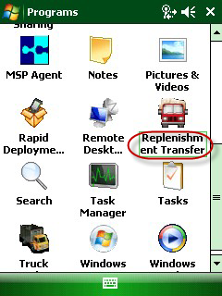

- The picker scan the user email bar code to log in.
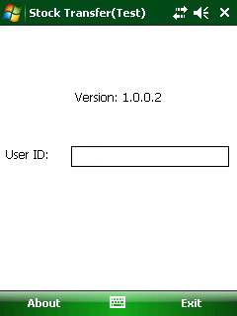
- In the pick list, scan <replenish pick list> barcode.
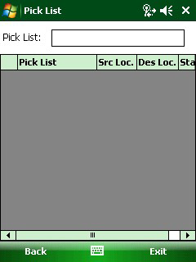

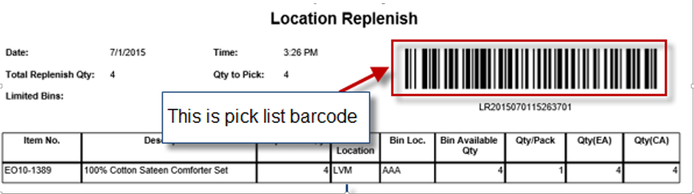
Notes: how to generate the pick list to refer to <how to generate replenish pick list manually> or < how to generate replenish pick list automatically>.
- The replenish list information will be scanned into wireless picking device and the default status is open as below:
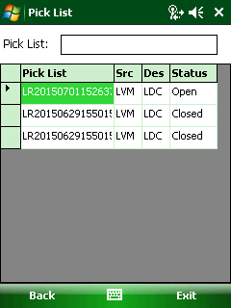

- Click the pick list no to go to the item list page. The first location tab is transfer from location.
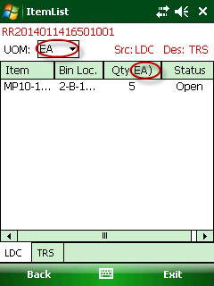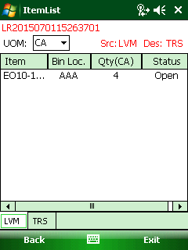
From location=Dropship Location From location=Wholesale location
Notes:
a.) If the from Location=Drop ship location such as LDC, the default UOM is EA (Each) which means it will move item by Each to “To location”; it is allowed to change UOM, if CA and Each changed formula is Case=Each/(Qty/Pack);
b.) If the from location=wholesale location such as LVM, the default UOM is CA,which means it will move the item by Carton to ”To location”.
- Select one item to open Transfer page and fill Qty Picked.
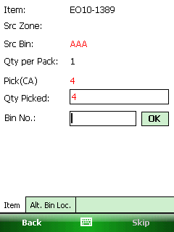
Button:
- Alt. Bin Loc.: This button to open the related bins which has this item. We will use the Alt Bin Location when we find the current bin is not enough quantity to transfer.
- Skip: Use to skip the item.
- In item transfer page, enter the transfer qty and scan Bin Barcode in Bin No. After scanning successfully, it will pop up messages: ”Previous Item xxx is scanned into intransit bin successfully.
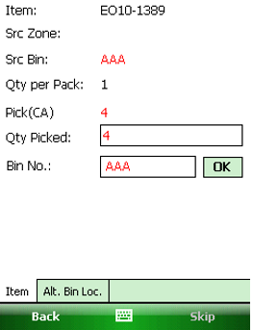

- After that, click back to item list page and see the item is at “Instransit” status.
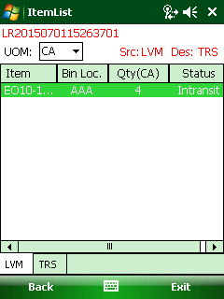

- After that, Click <TRS> tab, it will see the item status is Intransit.
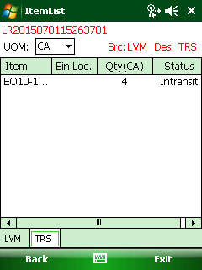
- Click the item to go to the Transfer page
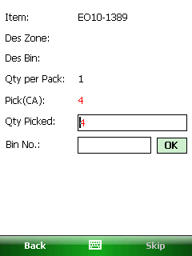

- Enter the "Qty Picked" and scan Transfer Bin Barcode in Bin No.
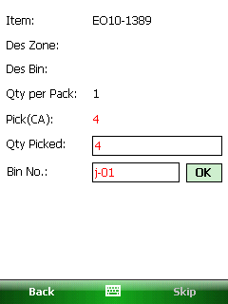
Notes: the bin has to be set as “Transfer” bin type. If the bin is not a transfer bin, it will pop up message:” xx is not a transfer bin, please scan a transfer bin to complete the transfer.
- After scanning successfully and click back to Itemlist, the item will be transferred status.
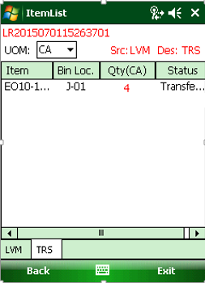
- Run the service ”Macola Stock Transfer”, the inventory will be updated in database too and the pick list status will be closed.
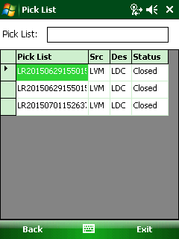

Appendix

How to install replenish wireless application
- Click Start Internet Explorer, in the address bar type https://192.168.0.94/m/. If you see the below message, click <Yes>
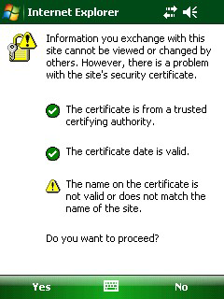
[Pict-1]

- Click <Replenishment Transfer>
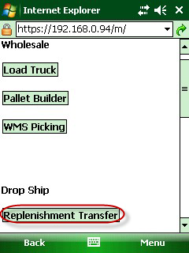
[Pict-2]

- In the download window, Click <Yes>
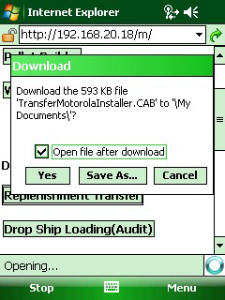
[pict-3]
- In Choose location to install, click <Install>
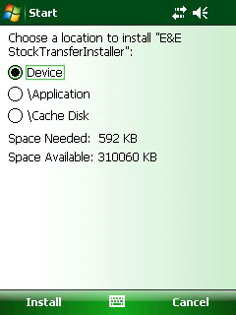

- When you successfully installed it, it will give the below message.
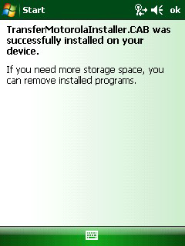
- Install the below dispatch.
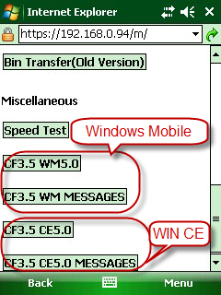
Notes: CF3.5 WM5.0 and CF3.5 WM Message is from windows mobile operation environment.
CF3.5 CE5.0 and CF3.5 CE5.0 Message is from Win CE operation environment.

