Replenish Inventory

Replenish inventory-Warehouse
If the item has not inventory, warehouse person should replenish the inventory.
It is warehouse daily work.
- Go to "Warehouse ManagementReplenishRepl. Quantities" page
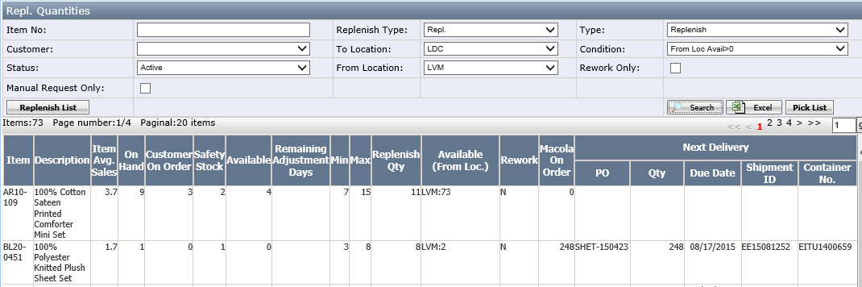
Search Area
- Replenish Type: two types “Repl.” and “Reverse Repl.”
Repl. Type is replenishing from wholesales warehouse to retail warehouse.
Reverse repl. Type is replenishing from retail to wholesales.
- Rework Only: It means this item need to rework and the item had marked “Rework” in item mater page and it is only used for repl. Type replenish list.
Grid:
- Item AVG-Sales: the value is from Item Avg.sales page of this item.
- Available field(to location): this field=(On Hand) - (Customer On Order) - (Safety Stock)
- Replenish Qty=Max-Available
- Enter the search condition ”replenish type”, “To Location”, ”From Location” and “Type” and “condition”, then click <Pick list>.
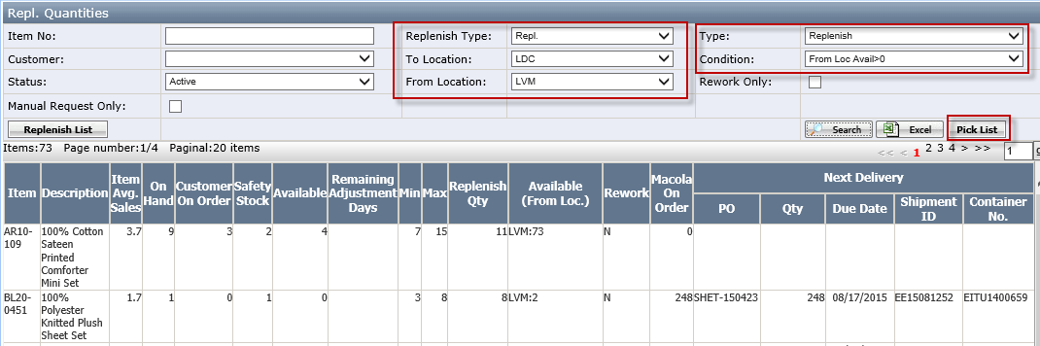
Notes:
If the replenish type=Repl. It is to transfer from wholesale to retail such as from SAV to SDC.
If the replenish type=Reverse Repl., it is to replenish from retail to wholesales such as from SDC to SAV.

- Click <Pick List>button to pop up below window, leave sort by “Bin Location” and Limited bins/picks to “None”
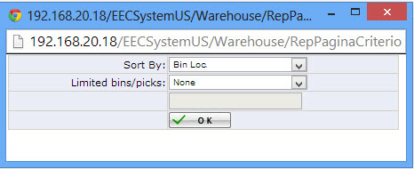
- Sort By has two options (Bin Loc./Item No.)
- Limited bins/picks has three options (None/Bins/Picks).
- Click <OK> to generate the pick list based on the search criteria as below:
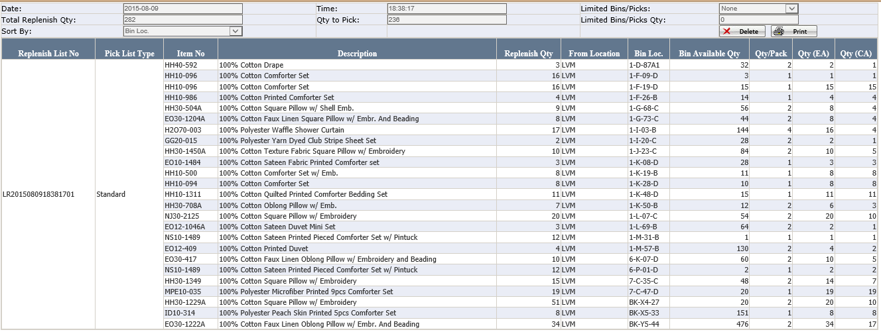
- <Print>: to print out the pick list.
- <Delete>: to delete the pick list.
- Also, go to Repl.Quantities page and click <Replenish List> button to review the generate pick list:
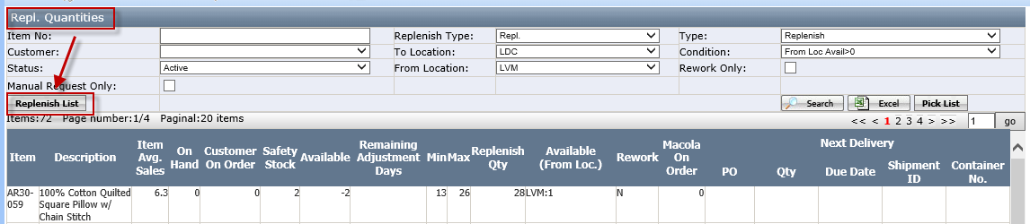
The pick list will be shown in replenish list page
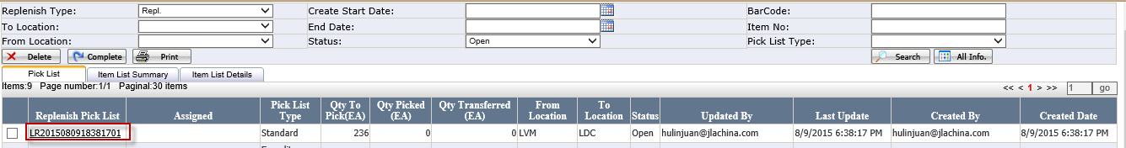
- Print out the pick list as below, this document will be used for replenishment wireless application.
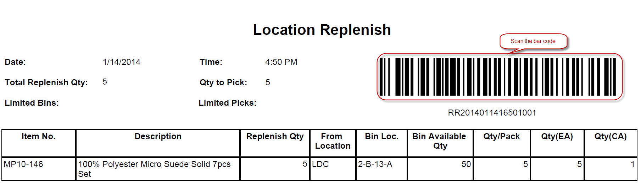

Notes:
a.) DC Inventory Control can create the pick list from wholesale warehouse to Retail warehouse.
b.) Dot Com Inventory Control role only can create the pick list “Replenish type=Reverse Repl."
- User < Replenishment Transfer> application to transfer inventory. The detail see <how to do replenishment by scanner>

How to do replenishment by scanner
- Click Start Programs
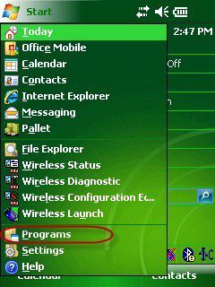
- Click <Replenishment Transfer> to open replenishment wireless application.
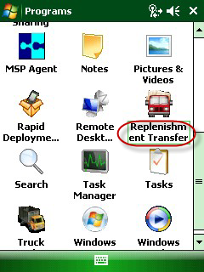

- The picker scan the user email bar code to log in.
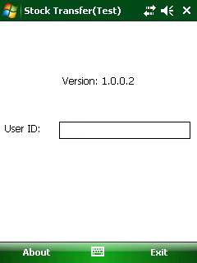
- In the pick list, scan <replenish pick list> barcode.
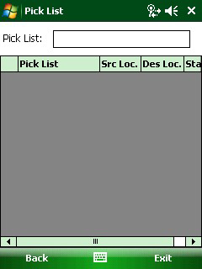

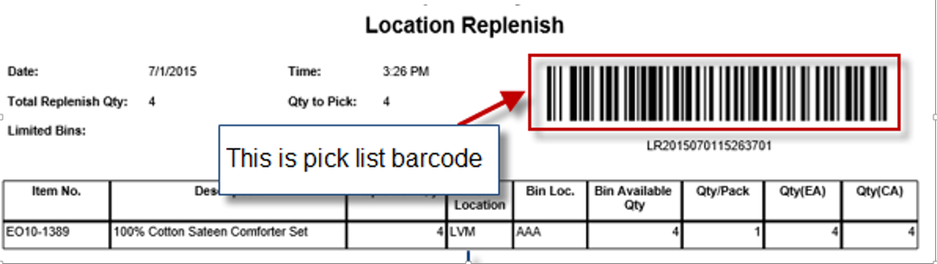
Notes: how to generate the pick list to refer to <how to generate replenish pick list manually> or < how to generate replenish pick list automatically>.
- The replenish list information will be scanned into wireless picking device and the default status is open as below:
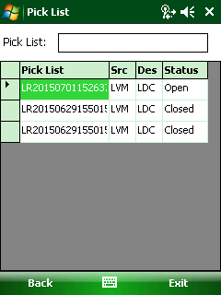

- Click the pick list no. to go to the item list page. The first location tab is transfer from location.
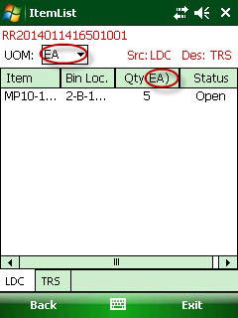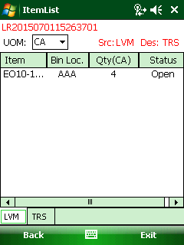
From location=Dropship Location From location=Wholesale location
Notes:
a.) If the from Location=Drop ship location such as LDC, the default UOM is EA (Each) which means it will move item by Each to “To location”; it is allowed to change UOM, if CA and Each changed formula is Case=Each/(Qty/Pack);
b.) If the from location=wholesale location such as LVM, the default UOM is CA,which means it will move the item by Carton to ”To location”.
- Select one item to open Transfer page and fill Qty Picked.
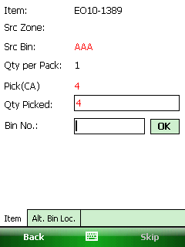
Button:
- Alt. Bin Loc.: This button to open the related bins which has this item. We will use the Alt Bin Location when we find the current bin is not enough quantity to transfer.
- Skip: Use to skip the item.
- In item transfer page, enter the transfer qty and scan Bin Barcode in Bin No. After scanning successfully, it will pop up messages: ”Previous Item xxx is scanned into intransit bin successfully.
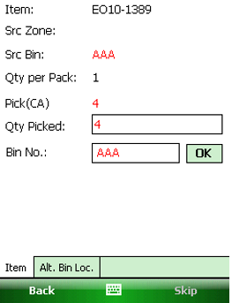

- After that, click back to item list page and see the item is at “Instransit” status.
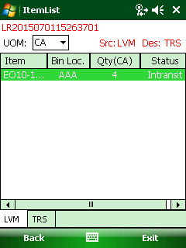

- After that, Click <TRS> tab, it will see the item status is Intransit.
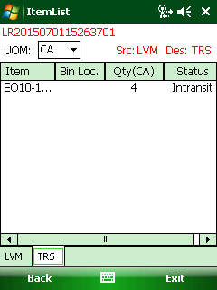
- Click the item to go to the Transfer page
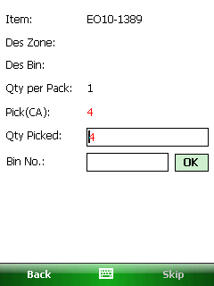

- Enter the "Qty Picked" and scan Transfer Bin Barcode in Bin No.
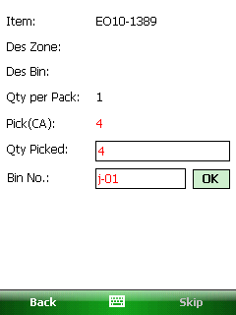
Notes: the bin has to be set as “Transfer” bin type. If the bin is not a transfer bin, it will pop up message:” xx is not a transfer bin, please scan a transfer bin to complete the transfer.
- After scanning successfully and click back to Itemlist, the item will be transferred status.
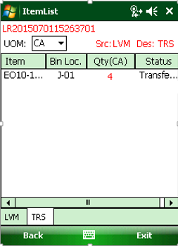
- Run the service ”Macola Stock Transfer”, the inventory will be updated in database too and the pick list status will be closed.
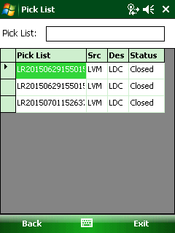

Replenish Inventory-Distribution Team
When the inventory is not enough and the sales order is urgently to ship. The distribution team will add the replenish item task in replenish-manual entry page.
- Go to Warehouse Management/Replenish-Manual Entry page and click <Manually Transfer> button. See below screenshot.
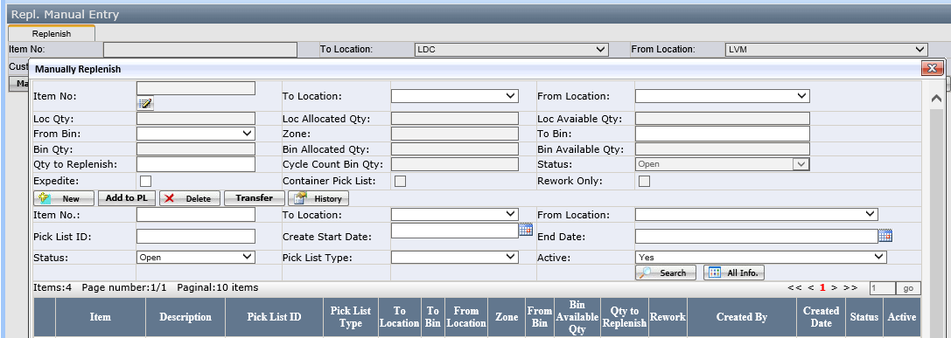
[Pict-1]
- Select one item, then to select the “To Location" and "From Location". Fill in the "Qty to Replenish" etc. fields.
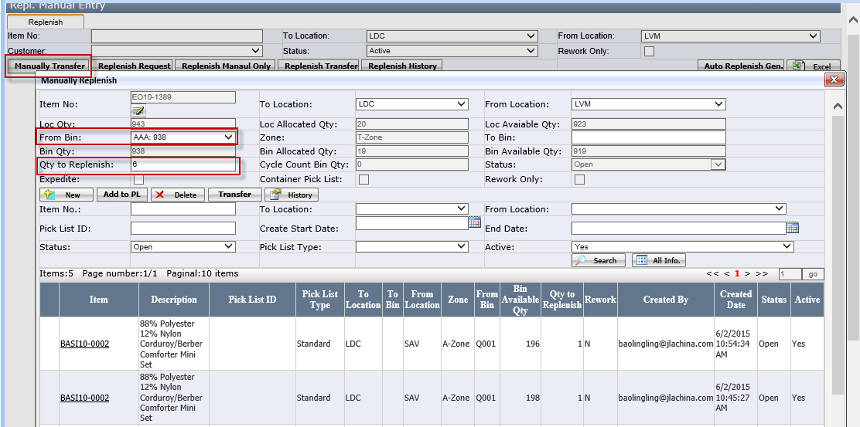
[pict-2]
Fields
- The selected item must exist in "To location" and "From location", otherwise you can't replenish this item.
- Qty to replenish： enter by user
- Expedite: Checkbox. If checked it, it means this item is urgent and user should replenish as soon as possible.
- Container pick list: checkbox, if it is checked, the pick list will be container type pick list.
- Rework only: checkbox, if it is checked, the pick list will be rework type pick list.
- To Bin: this bin type should be set “Transfer” type. If no transfer bin in "To Location", the “To bin” dropdown will be blank. The user should set up the transfer bin type in bin location page.
- Cycle Count Bin Qty: This field is to display the 'from location' item no. on hand quantity of Cycle Count Bin.
Buttons
- Add to PL: add the item to pick list page in "Replenish Quantity" page. Click this button and the item will be added to pick list in "Warehouse Management-->Replenish Quantities" page.
Notes: this button is only available from wholesale location to Drop ship location. E.g. from LVM to LDC. If it is from LDC to LVM, this button will not available.
- Delete: to delete the added items.
- Transfer: This button function is same as the button "Replenish Transfer". Click this button and run the EEC Service "Macola Stock Transfer", the inventory will be update in database table directly.
- Click<Add to PL> to add this item to the pick list.
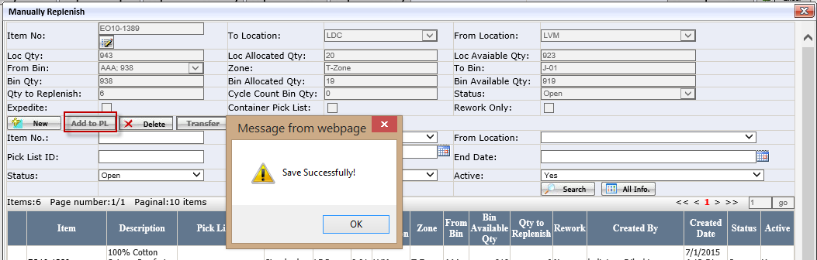
[Pict-3]
- After the item has been added successfully and go to “Repl.Quantities” page.
In repl. quantities page, select to location and from location, click <pick list> button to generate pick list.
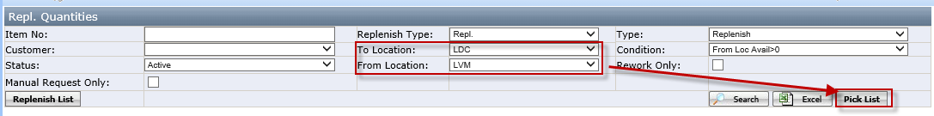
[Pict-4]
- The following steps refer to do in repl.quantities page to print out the pick list and use wireless application to replenish the inventory.

Replenish Inventory-Multiple items
It is suitable for large products moving from one location to another such as from WDC to TDC. Normally, the container will be treated as a special bin.
- Go to Repl. Manual Request Only, Enter the item no, to location, From location, from bin, To Bin and Qty to Replenish and save it, the item will be list in the grid.
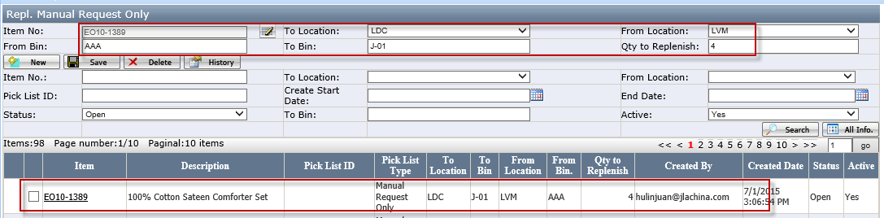
Notes: From bin and to bin are entering by user can system don’t check the bin no is existed or not. It controls by user. Normally, the “To Bin” will be truck and marked truck1, truck2 etc.
- After the item has been added successfully and go to “Repl.Quantities” page.
In repl.quantities page, check manual request only, then select to location and from location, click <pick list> button to generate pick list
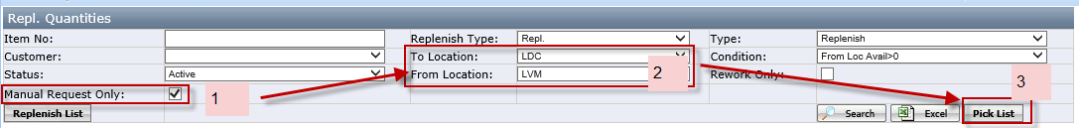
- Pop up the window and select to bin, then click ok button to generate pick list.
- Click <print> button to print out the pick list as below
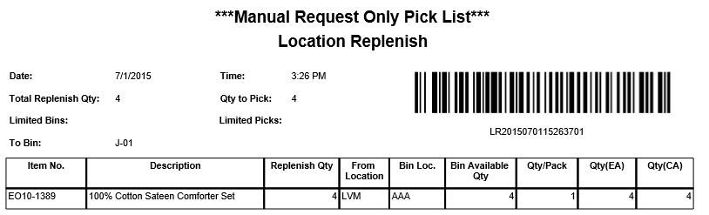
- The user can review this pick list in repl.manual request only page
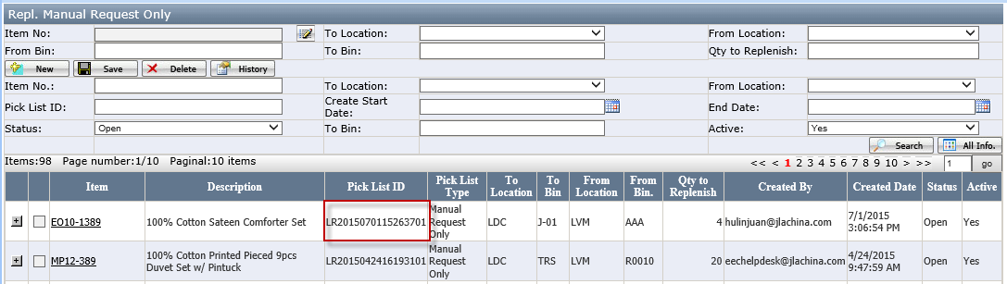
Or In repl.quantities page, click <Replenish list> button
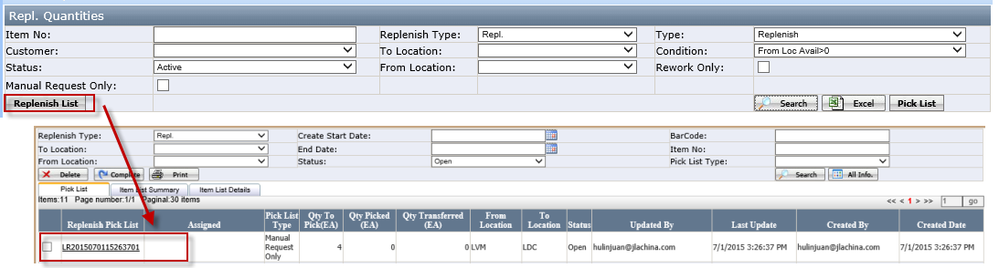

- After print out the pick list, It is used wireless application to replenish the inventory.

Replenish Inventory-From Planning
Such replenish request is from planning team and BDM team will help to enter the replenish item. The detail as below
- Go to Repl. Request page
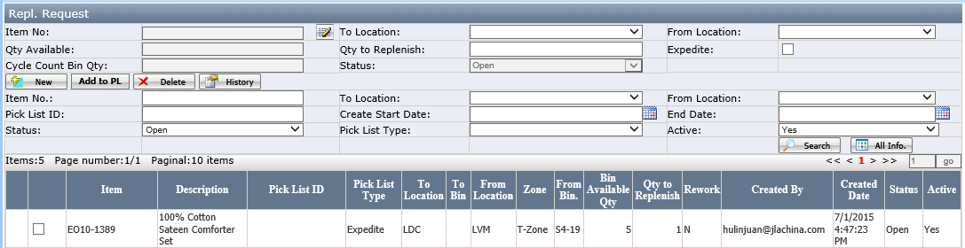
- From bin field in the grid: this field value is decided by system.
- Select one item, select to location and from location, then, enter the qty to replenish, then click <add to PL>, this item will be add into pick list.
- After that, go to “Repl. Quantities” page, and select to location and from location, click <pick list> button to generate pick list. the warehouse user will print out this replenish requirement and use wireless application to replenish it.

Appendix

How to install replenish wireless application
- Click Start Internet Explorer, in the address bar type https://192.168.0.94/m/. If you see the below message, click <Yes>
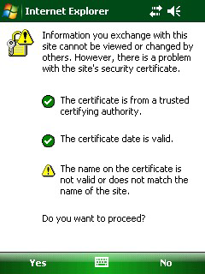
[Pict-1]

- Click <Replenishment Transfer>
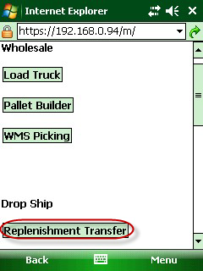
[Pict-2]

- In the download window, Click <Yes>
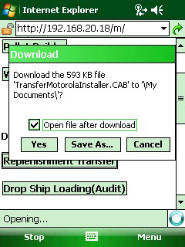
[pict-3]
- In Choose location to install, click <Install>
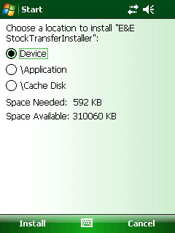

- When you successfully installed it, it will give the below message.
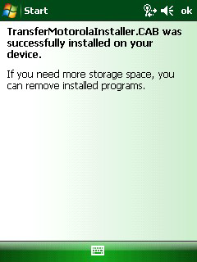
- Install the below dispatch.
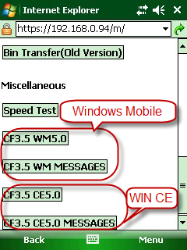
Notes: CF3.5 WM5.0 and CF3.5 WM Message is from windows mobile operation environment.
CF3.5 CE5.0 and CF3.5 CE5.0 Message is from Win CE operation environment.

Pick list Type
There are different types of pick list based on the different conditions
- Standard: it is the standard replenish pick list
- Expedite zero O/H: It is the top urgent replenish pick list. It means the” To location” Item On hand quantity =0. Such pick list have to finish it as soon as possible.
- Expedite: It is urgent replenish pick list too. But it is less urgent than expedite zero O/H.
- Manual Request Only: It is generated by repl. Manual request only and it is suitable from batch replenish from one location to another location such as from WD2 to TDC before.
- Rework: It is the special pick list and the picked item need to rework, the item has checked rework in item master page.
- Container: It is the special pick list. It means the item will replenish from container instead of physical bin. If the item transfer from “Bin Type”=receiving, such replenish item will be into container pick list.

