How to do Bin transfer(Put Away)
- Go to start menu--> Bin Transfer (Stock Put Away) on wireless application
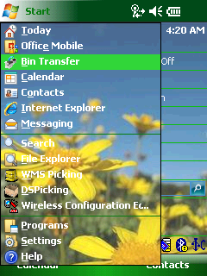
- In Login page, scan User ID to log in.
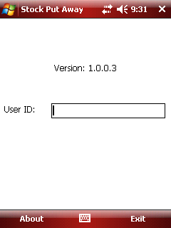
- Once the user logs in, it will open Transit Tab.
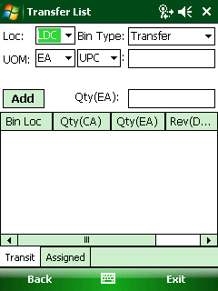
Fields:
- Loc: dropdown list and the values are all the locations assigned to the user.
- Bin Type: dropdown field with two options “Tranfer” and “Receving”. The bin to bin transfer to select “Transfer”
- UOM: it is linked with location. The drop ship location is default as “each”; the wholesale location such as “LVM” is default as CA.

- Select the location and scan the item’s UPC which needs to transfer. In this example, Select “LDC” location and scan item’s UPC. Then all transfer bin locations No. and quantity for this item will be listed in the grid. See below:
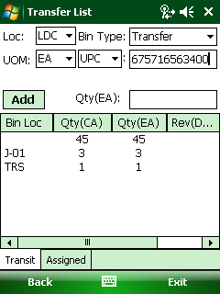
- Select one Bin Loc which need to transfer, the Qty is default as the selected transfer bin Qty and allow user to change it.
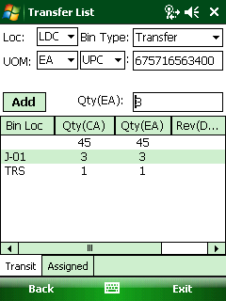
Note: Qty =default the selected bin’s qty.
- Then, change the qty to “2” and click the <Add>button, the message “Bin:xxx QTY：xx is added” will pop up. It means that the item has been added to In-Transit Bin successfully.
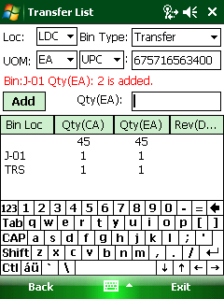
- Click Assigned Tab to view all items in “In-Transit” bin. If the item status is intransit, it means this item need to transfer. It can review the item by UPC or by item no
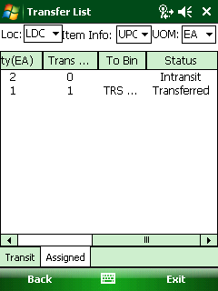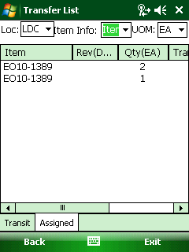
[By UPC] [By Item no]
- Select the item which needs to transfer from “In-Transit” to physical bin.
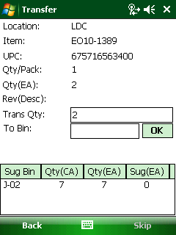
Note:
- Trans Qty: it is default as Qty(ctn) and allow user to change it.
- To bin: it is used to enter the bin no.
- Sug Bin lists all available Bin Locations for selected item, the bin type is “Standard” or “NFC”. If there is no available bin location for this item, it will default to New.
- Select the sug bin or scan the bin which the user want to transfer, the bin no will be shown in to bin.
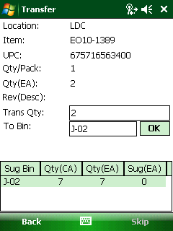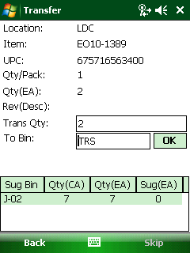
[select sug bin] [scan the bin]
- After scan the bin, and click ok to go back the transfer list page and the “Status” is changed from intransit to “transferred”
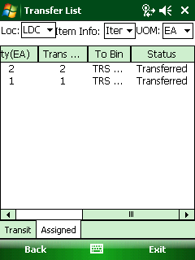
- After that, run the EEC Service ”Macola Stock Transfer” and the inventory has been update in inventory table in database.

