Drop Ship Process
Drop ship process is used to handle retail sales orders. It has below process steps:
Steps | Process | Detail Process | Operation Team
1 | Create SO | Create sales order | EDI or BDM Team
2 | Validate SO | Validate sale orders | System
3 | Upload SO | Upload to Macola | System
4 | Shipment | Create Batch | System Service or Warehouse
 |  | Generate Pick list | Warehouse
 |  | Picking | Warehouse
 |  | Sorting(NFC need it) | Warehouse
 |  | Packing(NFC need it) | Warehouse
 |  | Loading | Warehouse
 |  | Shipped | System service
 |  | Complete | System service
The detail see below manual

Create sale orders
It is to see <How to create sales order>. For the kit item order, in the sale order detail page, the user can know the kit item with item type. See below

Validate sales order
System will do the validate issues and if the order has problems, it will show error in sales order list page.
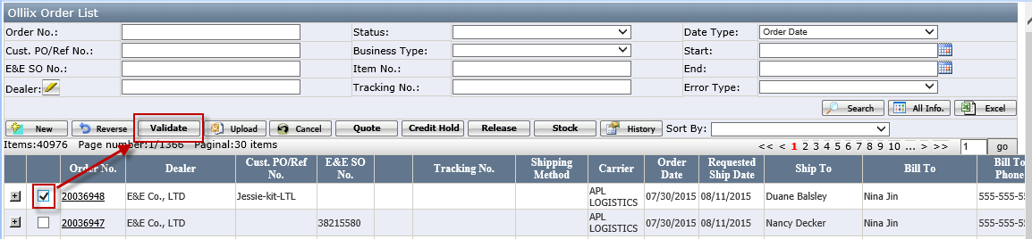

Upload sales order
It is upload to Macola system and generate a macola order number.
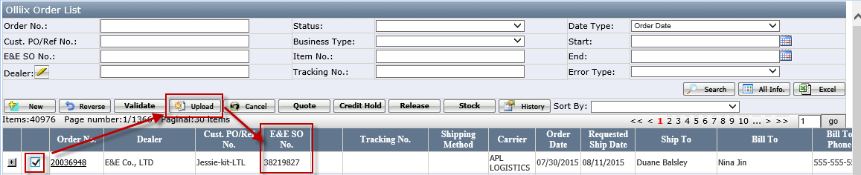

Drop ship order’s shipment

Shipment Process flowchart

Create the batch.
- Go to drop ship batch Mgt page, click <New> button to create a batch or use service ”Generate DS Batch” to auto-generate the batch.
Here, click < New> button to create a batch
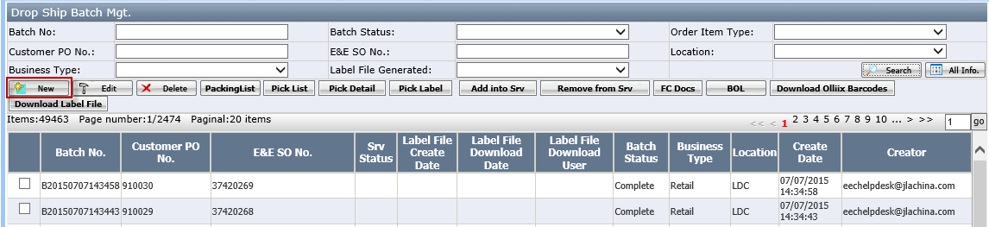
- And open the below batch creation page, select the po and click<Create> button.
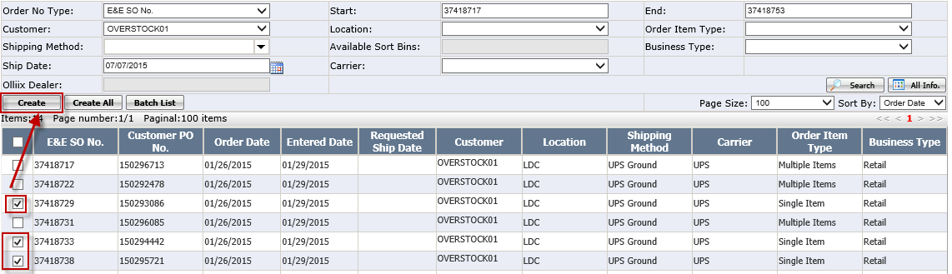
- Go back to drop ship batch Mgt and the batch has been created and the status is “Pre-Prepare ship Doc” status.
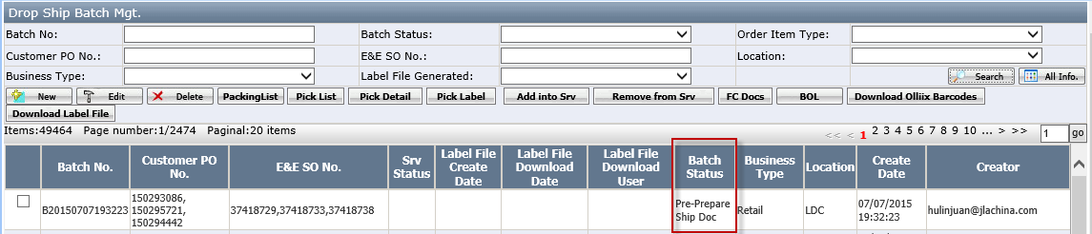
Button:
- Packing list: it is used to print out packing list
- Add into Srv
- Remove from Srv
- BOL: it is used to print out BOL documents

Generate the pick list
- Go to drop ship batch Mgt page, select one batch and click <Pick list> button to generate the pick list.
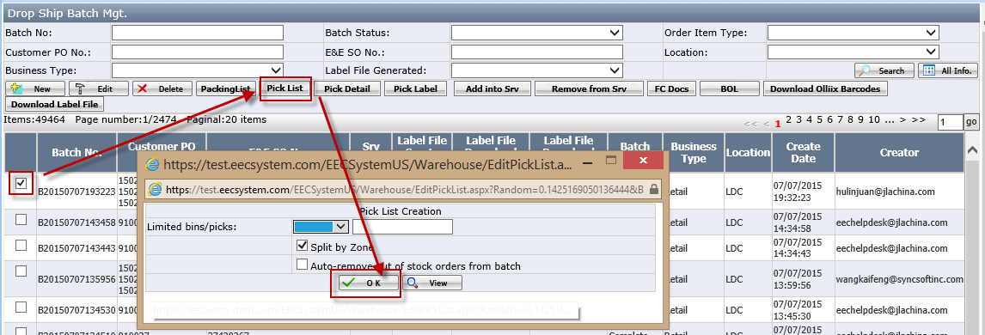
- Limited bins/picks: this field is used to decide how many item in one pick list. It can based on bins or based on picks.
- After generated the pick list, the batch status will be at “Labels Generated” status.
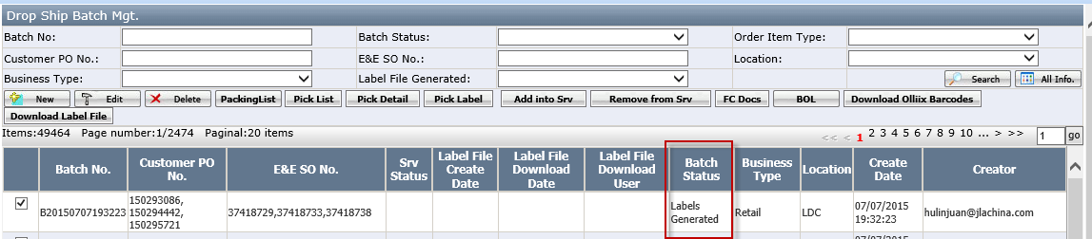
- In pick list review page, there is a column “pick type”.
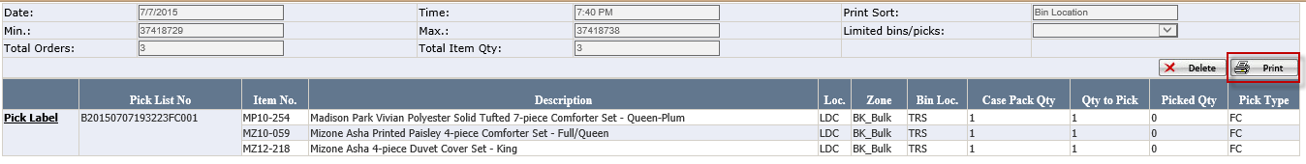
- If pick type=FC, it means this item is FC item and needn’t print pick ticket, only need to print out the shipping label by <FC Docs>
- If pick type=NFC, it means this item is NFC item and need to print pick ticket.

- Print out the pick list
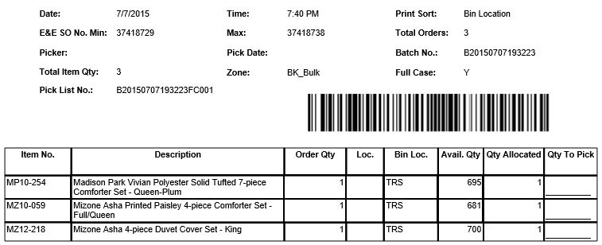
[FC Item--pick list]

Print out shipping label for FC Item
- In drop ship batch Mgt page, select one batch and click <FC Docs> button
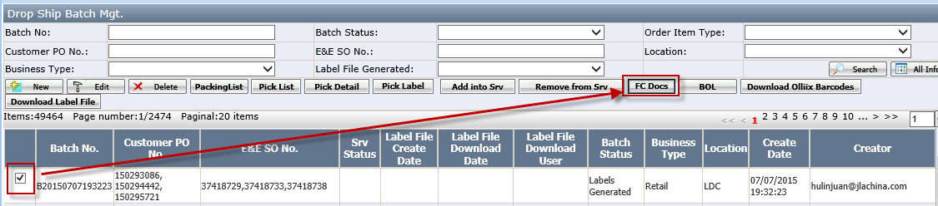
- In FC Docs page, select ship by and click <Gen.Pack> button
<Gen.pack> it is used to generate the carton information, the detail as below
- Click <Gen.Ship Label> to generate shipping label and tracking.
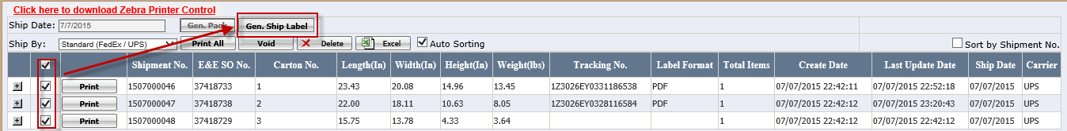
Buttons:
- Gen.Ship Label: to generate shipping label and tracking no.
- Print All: to print shipping label
- Void: to void the tracking no. when the carrier is allowed to void period.
If it is not these period, click void button and it pop up below message: ”No shipment found within the allowed void period.” In this case, it has to go to USwarehouse application and use “Unpack” button to void the tracking no.
- Delete: to delete the carton information.
- Click print button to print out shipping label with packing list
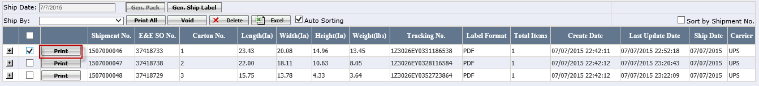

The print out shipping label
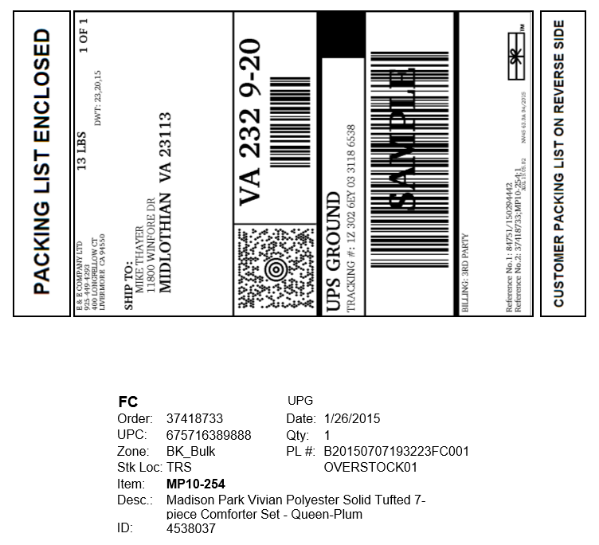
Notes: For the FC item, when print out the shipping label, the packing list will be print out two. It is two sides document.
The picker will put the shipping label and packing list on box when they are picking.

Print out pick ticket for NFC Item
- In drop ship batch Mgt page, select one batch and click <Pick Label > button
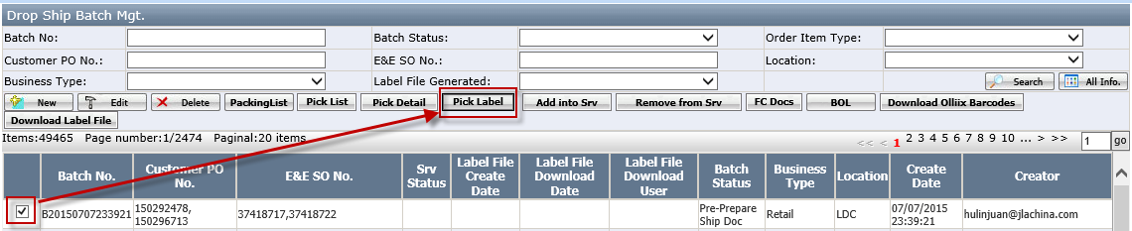
- In pick Label pop up page, click <Print> button to print out pick ticket
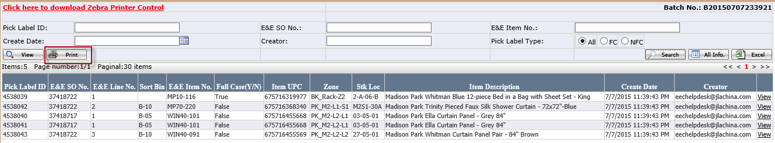
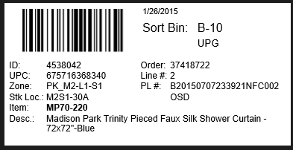
[Pick ticket]

Picking
There are four item types: FC item, NFC Item, SFC item and One item. The different item types, the picking process have a slight difference.
- If the item type is FC and SFC, before the picking, below documents should be print out
- Pick list
- Shipping Label.
- If the item type is NFC or One Item, below documents should be print out
- Pick list
- Pick Label
The detail see <How to do drop ship picking>

Sorting
It can use wireless application < SortingStation> to operate it or just manually do it.
Please see <How to sorting and loading for DS>. This step is only required for NFC item.
Notes: For FC Item or SFC item, it needn’t this step.

Packing
The detail see manual<Packing Station>. This step is only required for NFC item.
Notes: For FC Item or SFC item, it needn’t this step.

Loading
It is using wireless application < PackageAudit> to load it. Please see < How to sorting and loading for DS> or go to packing station and click <load> button to load it.
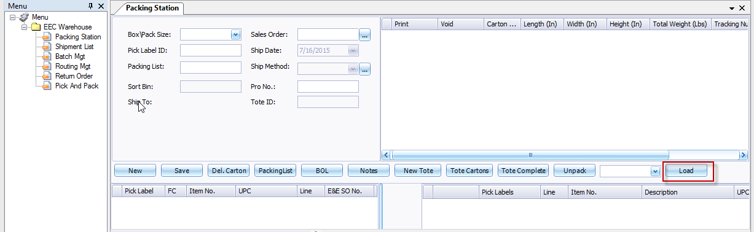

Shipped
- Run <EEC Ship> service to ship it and the batch status will be shipped. The EEC shipped date will be set up in packing station/shipment page
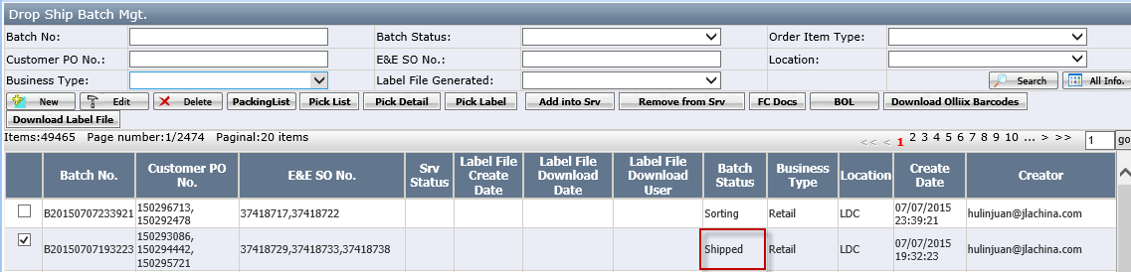
Notes: The user can user <Packing list> button to print the packing list or print the packing list on packing station.
- Run <Generate ship confirm>service to send out the ASN. The ASN Send date will be set up.
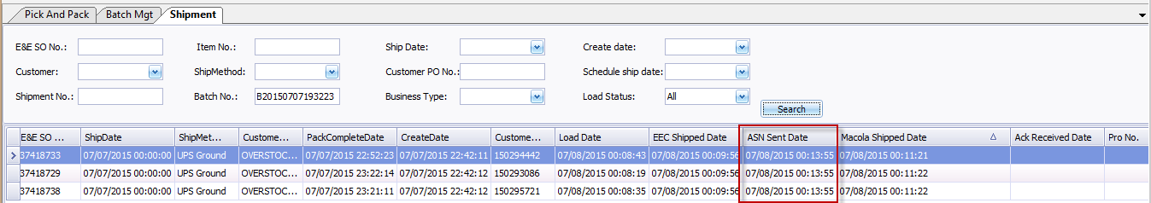
At the same time, the batch status will be “wait Ack.”
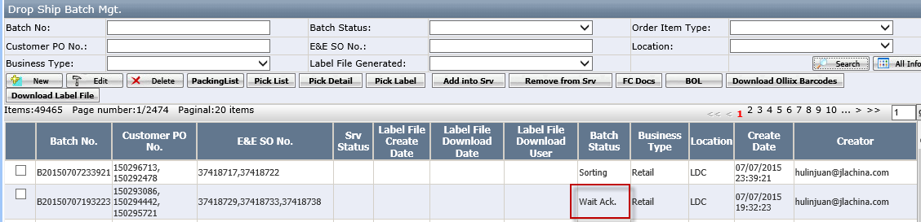
If the customer received our ASN, the Ack Received date will be set in packing station and the batch status will be complete.

How to do kit item by drop ship process

What is the kit item
Kit item is made up of multiple component items. In business process, it will purchase by component item, also in warehouse, it is only saved component inventory instead of kit item. But it sells based on kit item.

How to do kit item by drop ship process
For the kit item, all process is same as normal drop ship process, the difference are as below:
- Validate the sales order
To validate the kit inventory, it is validating the kit’s component item inventory instead of kit item. So, if the error is out of stock, it should replenish the component item inventory.
The user can review the sales order detail page to know the kit item
- Print the pick list
In the pick list, it is to pick kit’s component item instead of kit item, see below:
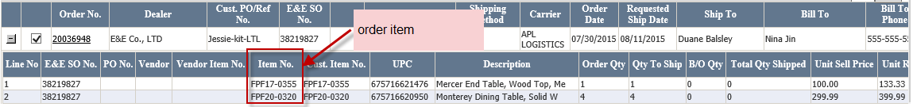
[Order item is FPF17-0355(Kit item)]
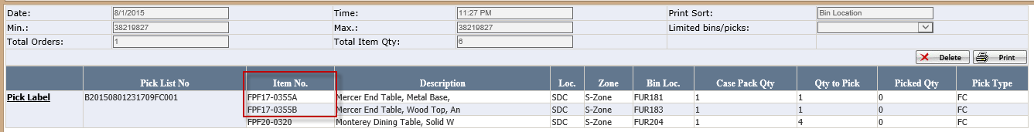
[Pick List]
In pick list, it is listed kit’s component item FPF17-0355A and FPF17-0355B too.
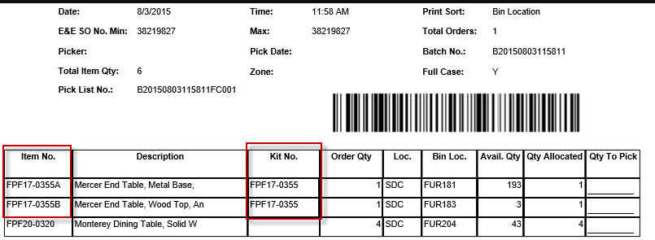
Notes: If the kit item cancelled, all components items should be cancelled into the pick list. In this sample, the FPF17-0355A and FPF17-0355B should be cancelled together.
- Generate Carton information and Ship label. The carton information and ship label is also based on component item for kit item.
a.) For FC Item, it should use <FC Docs> to generate carton information)
In drop ship batch mgt page, select the batch and click <FC Docs> to generate carton and print ship label.
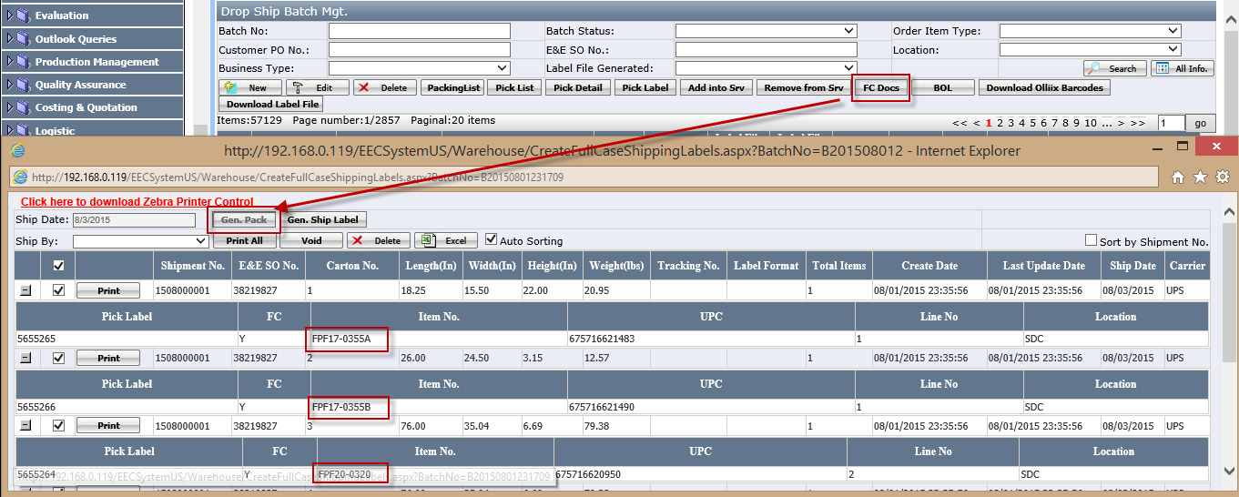
Select the ship by and click<Gen.ship label> to generate ship label for FC item.
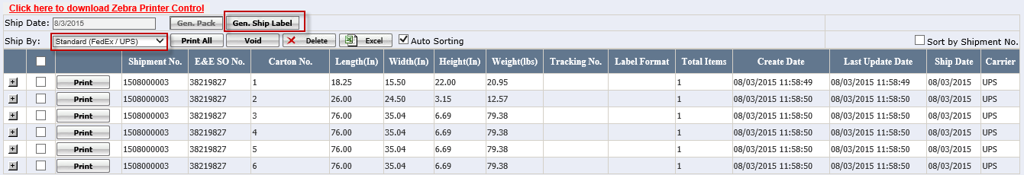
Then the tracking no will be generated. For the kit item, the ship label is based on kit’s component item too, see below:
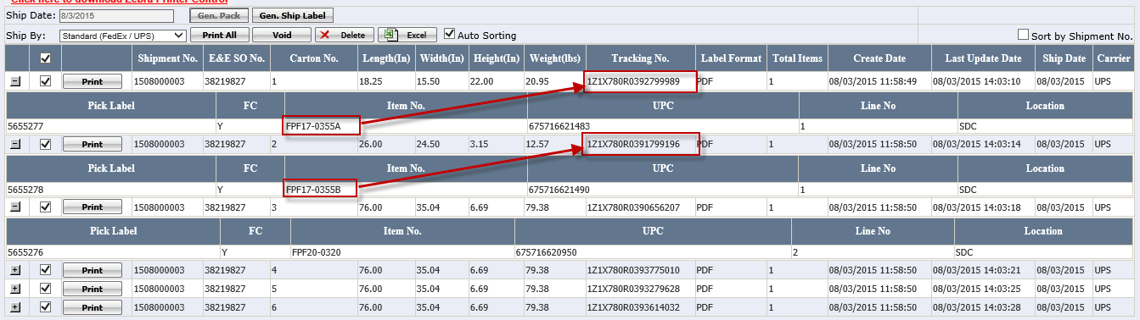

b.) For NFC Item, Use“Packing Station (USwarehouse)”to generate the carton information and print the ship label.
Go to Packing station, the pack item is component item instead of kit item
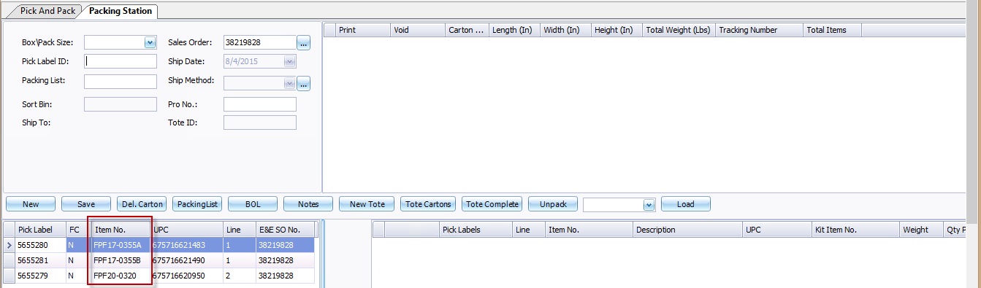
Select one carton to pack it, it will show the item no=kit’s component item and kit item as below
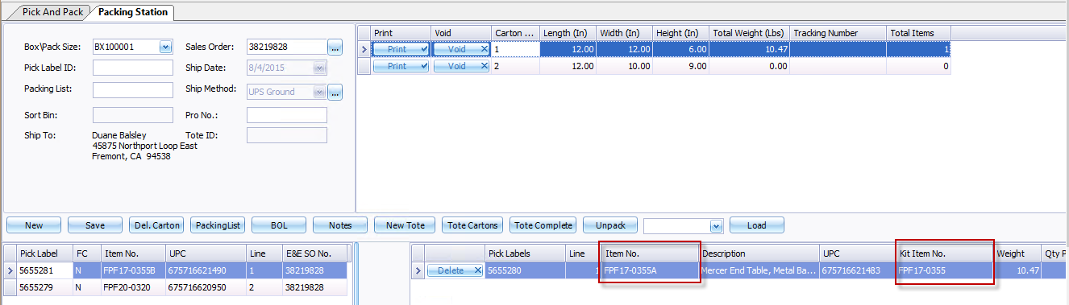
Click <print> to print out the ship label and the tracking no is generated.
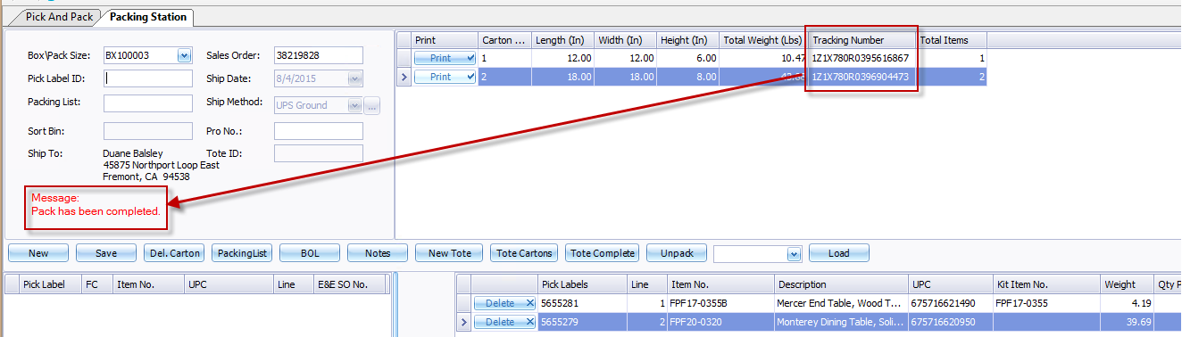
Notes: to cancel the kit item before pack, it should cancel all component items for this kit. See below sample
If one component item of this kit is packed and one is not pack, see below
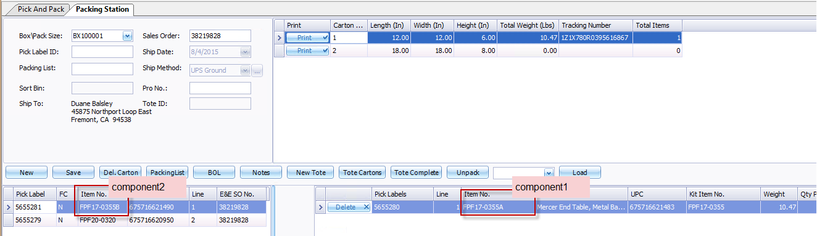
Go to sales order detail page, click the cancel item will pop up message:”Failed to cancel this item since component item has been partial packed.”
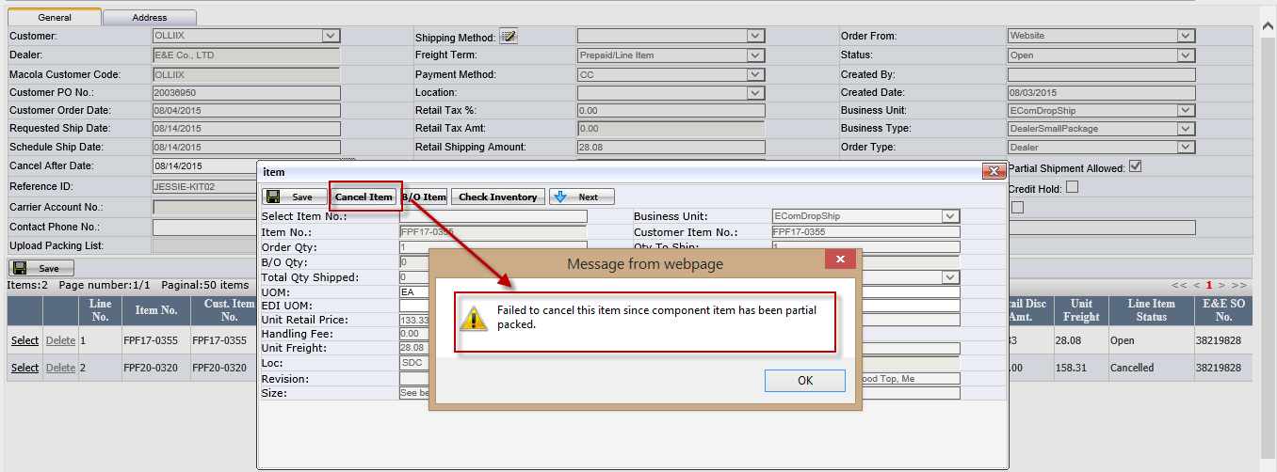

- After that, loading the order as the normal order.

Item Type

FC Item
- FC Item definition
The item sales quantity is based on case, that is say the one case is the sales unit.
Such item will be define the FC.
- FC item pick ticket.
It will be marked “FC” (see below). Totally, the FC item needn’t print the pick ticket and just need to print out the shipping label.
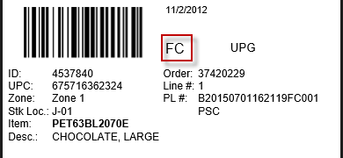
[FC Item Pick ticket]
- FC Item shipping label . It can use button <FC Docs> to print out.
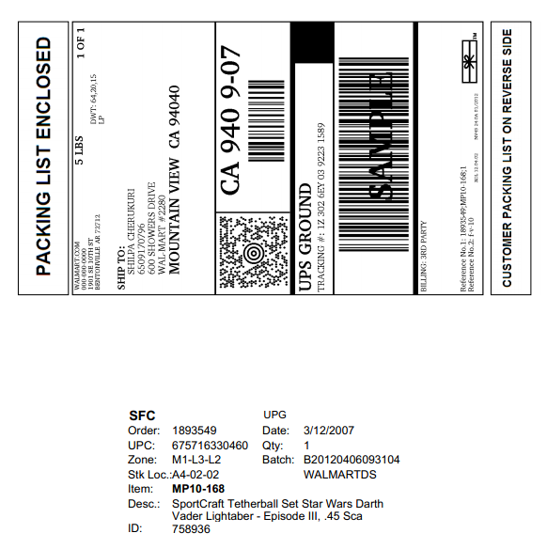
[FC Item shipping label format]

One item
- One Item definition
If the order only has one item and this item is not full case, or the orders have multiple item, after the order quantity/case pack,only one item is not full case. such item will be defined the One item.
- One item pick ticket
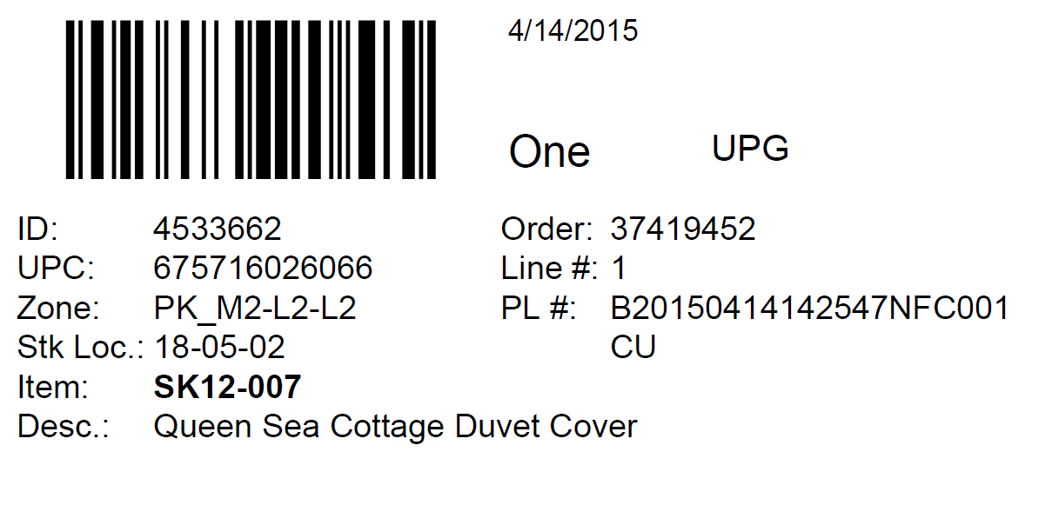
One time needn’t make the second picking by sort bin, it can send to packing station directly, only take a bag and print out the packing list and ship label to send.

SFC Item
- SFC Item definition
The item marked “Sing FC” in retail item list page and also it is the one item. Such item is defined by SFC.
The SFC item will be shipped same as FC
- SFC Item pick ticket
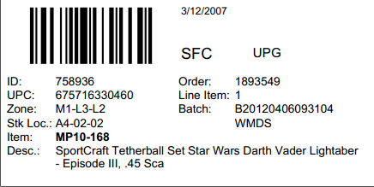

NFC Item
- NFC Item definition
The item sales quantity is not based on case, that is say the item need to break carton and pick it from the carton. Such item will be define the NFC.
- Pick ticket for NFC Item
It can print out by <pick label >button in drop ship batch Mgt page.
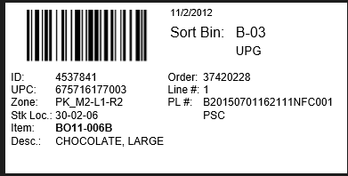

Batch Status
batch Status | Detail Operation
Pre-Prepare Ship Doc | generate the batch
Labels Generated | Use <pick list> to generate pick list .  Print the pick list and user wireless to pick it.
Sorting | print the pick ticket and operation sorting wireless application
Packing | 1.For NFC, do it on packing station.  2.For FC, Do it in EEC Drop ship Mgt page and use <FC Doc> to print out the shipping label.
Shipped | Run <EEC Ship> service and batch status is Shipped.
Wait Ack. | Run "Generate ship confirm" service to send ut the ASN
Complete | 1. Run "MacolaShip(DropShip)" service to set up Macola order as "Shipped" status.  2. Customer received our ASN and sent 997 to us

